Upcycling tannery sludge into superior micro/nano protein fibers to reinforce the mechanical and flame retardant properties of cellulose-based film

Jiang Wei¹, Ting He¹, Mengke Liu¹, Fanyu Kong¹, Xin Feng¹, Xiaohua Lu¹, Lilong Zhang^{1*}, Kai Zhang^{2*}, Jiahua Zhu ^{1*}
¹State Key Laboratory of Materials-Oriented Chemical Engineering,
College of Chemical Engineering, Nanjing Tech University, Nanjing, 211816, China
²State Key Laboratory of Biobased Material and Green Papermaking, Qilu University of Technology, Jinan, China.
*Corresponding authors: Zhang Lilong (zhanglilong@njtech.edu.cn);
Zhang Kai (zhangkai2018@qlu.edu.cn);
Zhu Jiahua (jhzhu@njtech.edu.cn)
Table of Contents
Support Information
- Method detail.
- Preliminary single factor analysis.
- Response surface analysis.
- The change trend of particle size distribution of protein fiber clusters
- The wide-scan XPS spectra of protein fiber and high resolution XPS spectra of Cr for protein fiber.
- Atomic Force Microscopy ( AFM ) Images of Protein Fibers
- Scanning electron microscopy ( SEM ) images of protein fibers after freeze-drying
- Data sources for Life Cycle Assessment(LCA).
- Combustion process of film containing protein fiber.
Supplementary Figures.
Fig S1 Preliminary judgment of the effect of alkali amount on the degree of reaction.
Fig S2 Preliminary judgment of the effect of oxygen consumption on the degree of reaction.
Fig S3 Preliminary judgment of the effect of temperature on the degree of reaction.
Fig S4 Effect of temperature on chromium retention.
Fig S5 Effect of temperature on fiber size and chromium retention rate.
Fig S6 Correlation between predicted and experimental values for yield.
Fig S7 Correlation between predicted and experimental values for Chromium retention rate.
Fig S8 The change trend of particle size distribution of protein fiber clusters
Fig S9 The wide-scan XPS spectra of protein fiber and high resolution XPS spectra of Cr for protein fiber.
Fig S10 AFM images of protein fiber clusters
Fig S11 SEM images of freeze-dried protein fibers
Fig S12 Comparison of combustion time of films.
Supplementary Tables.
Table S1 ANOVA results for the applied face centered composite design of yield analysis.
Table S2 ANOVA results for the applied face centered composite design of Chromium retention rate analysis.
Supplementary Movie
Movie S1 Comparison of combustion time of films.

- Method detail
  - Material
The tannery sludge used in this experiment was provided by Fujian Weishui Group. Characterization of the basic components of tannery sludge : The sludge ( average three times ) was placed in a beaker, dried in an oven at 100 ºC for 48 h, and weighed again to measure its water content. The sludge ( three times on average ) was placed in a crucible, and the muffle furnace temperature was set to 600 ºC for calcination for 6 h, and the ash content was measured again.
Determination of chromium content in raw materials by inductively coupled plasma optical emission spectrometry.A certain amount of samples were randomly weighed in a polytetrafluoroethylene beaker, and 10ml nitric acid and 10ml hydrofluoric acid : perchloric acid ( 10 : 1 ) were added to the 2θ-degree electric heating plate for heating and digestion until the solid substance was completely digested ( at least 4h ). The solution was evaporated to dryness, and then 10 ml aqua regia was added for extraction. In the determination process, according to the content of different elements, different dilution multiples are used to ensure that the elements to be tested are within the curve range.
1.2.Alkali-oxygen cooking
Each time, 3 g of tannery sludge was weighed, and the required NaOH was dissolved in 100 ml of distilled water. All of them were added to the reactor and the required oxygen was introduced. After the reactor was assembled, the heating rate was set at 20oC / min, and each experiment was kept for 60 min. After the experiment, the reactor was cooled to room temperature and disassembled to remove the cooking slurry.
1.3.Ultrasound
The slurry after alkali-oxygen cooking was placed in a beaker, and the horn of the ultrasonic crusher ( JY99-IIDN Shanghai Jipu Electronic Technology Co., Ltd. ) was set to 20, and treated at 540 w output power for 10 min. The protein fibers were fully dispersed to obtain a network structure of fiber clusters.
1.4.Particle size analysis
In order to evaluate the reaction progress, the size of protein fiber clusters was tested. The particle size analyzer ( Dandong Baite Bettersize2600E ) was used to test the particle size of the ultrasonically broken protein fiber clusters. The template was selected as the egg, the rotation speed was set to 1100r / min, and the ultrasonic power was 50w. The test was stopped when the particle size was stable, and the result was based on the volume diameter.
1.5.Scanning Electron Microscopy (SEM)
Imaging with scanning electron microscopy (VEGA3-SBH, TESCAN) was performed.Samples were freeze-dried prior to imaging and mounted on aluminum stubs using conductive carbon tape. The stubs were then sputter-coated with approximately 10 nm of gold sputter coater (SBC-12,KYKY Technology Co., Ltd, Beijing, China). The imaging was performed with a beam accelerating voltage of 10 kV.
1.6.Transmission Electron Microscope (TEM)
Drops of the protein fiber suspension after each stage were deposited into glow-discharged carbon-coated TEM grids. The excess liquid was absorbed by a piece of filter paper. After the specimen has been completely dried, it was observed using a Jeol Jem 2100f electron microscope operated at 10 kV.
1.7.Atomic force microscope (AFM)
Three-dimensional morphology characterization of protein fiber samples were conducted by atomic force microscope (AFM, Bruker, Germany).The protein fiber samples suspensions were dispersed in ethanol solution, then dropped on a single-sided polished silicon wafer (10 mm×10 mm).Dry naturally at room temperature for 24h.The morphologies of the three fillers were characterized by tapping mode of RTESP-300(300 kHz, 40 N/m) probe.
1.8.X-Ray Diffraction (XRD) and Fourier Transform Infrared Spectrometer(FTIR)
In order to examine and compare the crystal structure of sludge fibrils and fibers at different stages of treatment，X-ray diffraction (XRD) was performed on an Empyrean diffractometer (PANalytical B.V, Almelo, Holland) with CuKα radiation that had a wavelength (λ) (Kα 1) of 0.15406 nm generated at 40 kV and 40 mA. The sludge raw materials were spread, and the samples at each stage of the reaction were freeze-dried before testing.The scans were obtained from 2θ values of 10° to 90° at a scanning speed of 5° per min.FTIR analysis was conducted using Fourier transform infrared (ATR-FTIR) spectroscopy (Tensor 27-IR, Bruker, USA).
1.8.Preparation of films.
The protein fibers were mixed into nanocellulose, and 50 ml of water was added and fully stirred and mixed evenly.In order to prevent the loss of fibers during the membrane preparation process and ensure the flatness of the fiber film, a nanofiltration membrane ( D = 4 cm, 0.45 μm PE ) was added to the sintered glass filter, and the cellulose-protein fiber composite membrane was prepared at 140 g / m² under 0.08 MPa vacuum suction.
1.9.Thermogravimetric analysis (TGA)
Cut the film into small pieces,TGA analyses were performed with a high sensitivity thermogravimetric analyzer(Qs650 TGA, TA Instruments) operating from ambient temperature to 800 °C at a heating rate of 10 °C min-1 .
1.10.Microcalorimetry test
Microscale combustion calorimetry (MCC) was used to investigate the flammability of the films. About 7 mg of samples were heated in an N2(80 mL/min⁻¹) atmosphere at a constant heating rate of 1 ºC/s from room temperature to 650 ºC. The pyrolysis products were mixed with oxygen(20 mL/min⁻¹) and then combusted in a combustion furnace at 900 ºC.
1.11.Tensile test
Tensile strength of the film was examined by an (C24.104, Xinsansi Co., Ltd,Shanghai, China) testing machine following the TAPPI standard method (TAPPI T497). The tensile test experiment was carried out under a temperature of 25 ºC with a relative humidity(RH) of 50 %. The initial distance between the two clamps was set to 20 mm and the cross head speed was maintained at 5 mm/min. The cellulose paper were cut into 1 cm × 2 cm segments..
1.11 Vertical light transmittance of the cellulose samples paper
The vertical light transmittance of the films are analyzed by a UV/Vis spectroscopic instrument (UV8453, Agilent, USA).In detail, the clean and smooth composite film was placed vertically in the middle of the light path.Then,Irradiated the film by the light at the wavelength range of 400-900 nm and recorded the decrement signature of vertical light transmitted intensity (i.e., absorbance).
- Preliminary single factor analysis.
In order to preliminarily judge the influence of various factors on the degree of reaction, a single factor experiment was designed for analysis. The pulp after alkaline oxygen cooking was filtered, and the fiber mass passing through the filter paper ( D = 4 cm, 0.45 μm PE ) was calculated to determine the degree of reaction. The higher the transmittance, the smaller the fiber size.
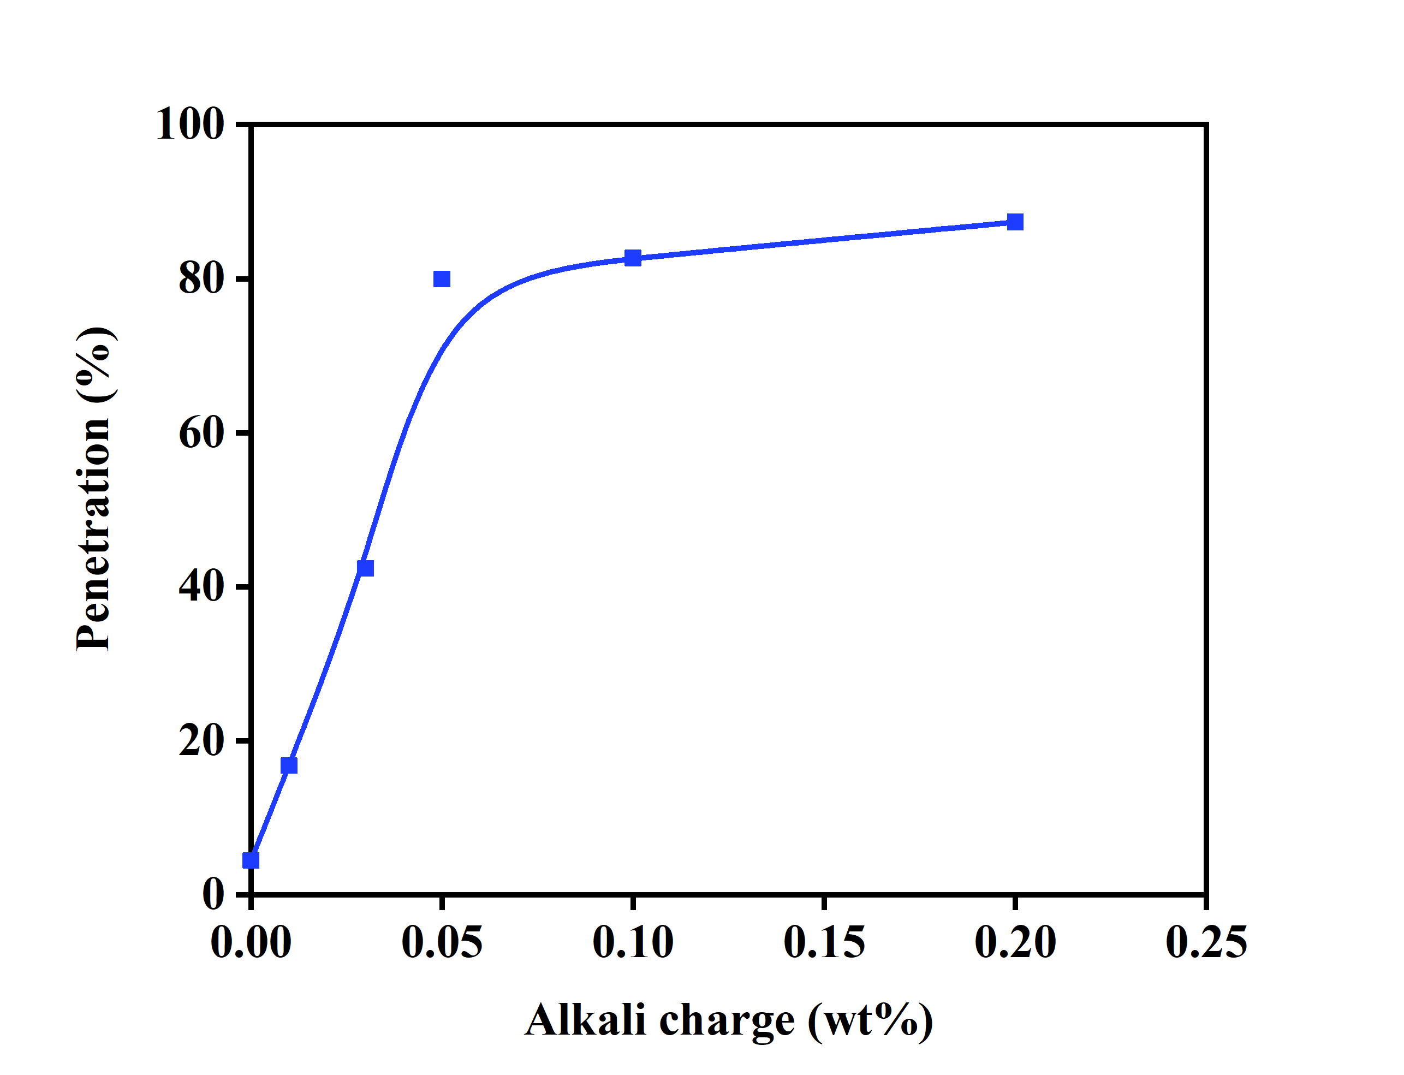
Fig. S1. Preliminary judgment of the effect of alkali amount on the degree of reaction.

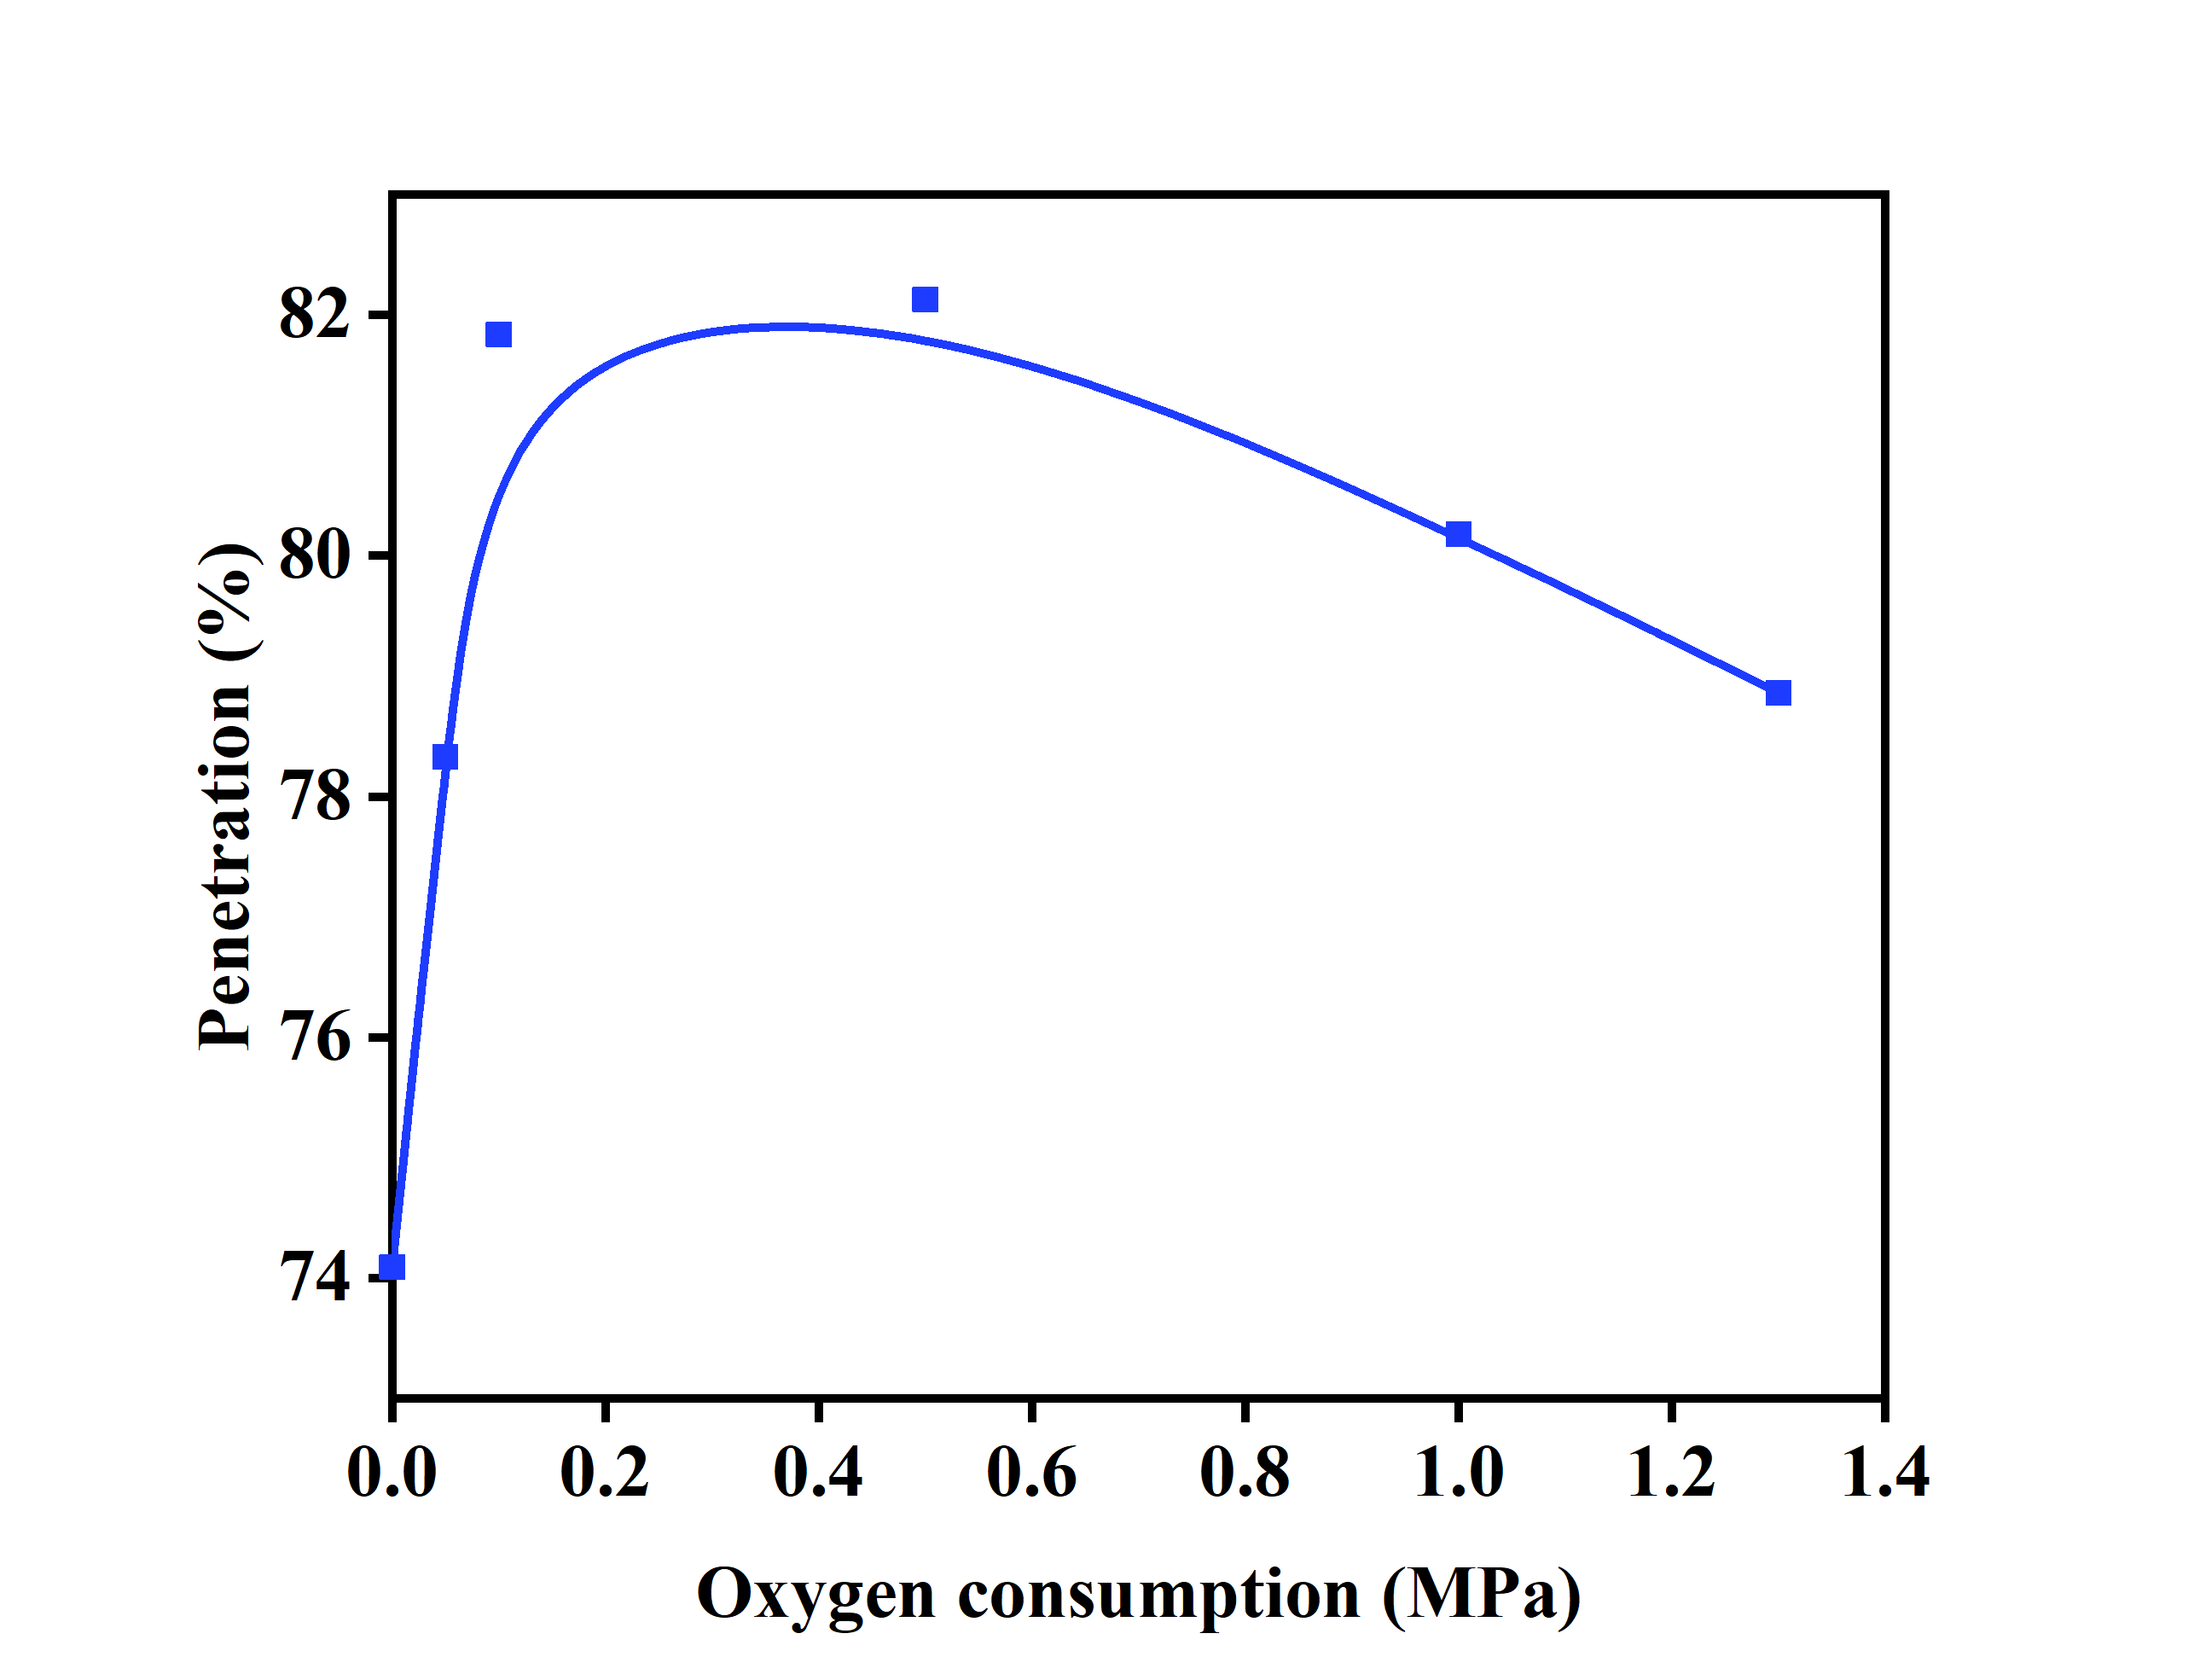
Fig. S2. Preliminary judgment of the effect of oxygen content on the degree of reaction.

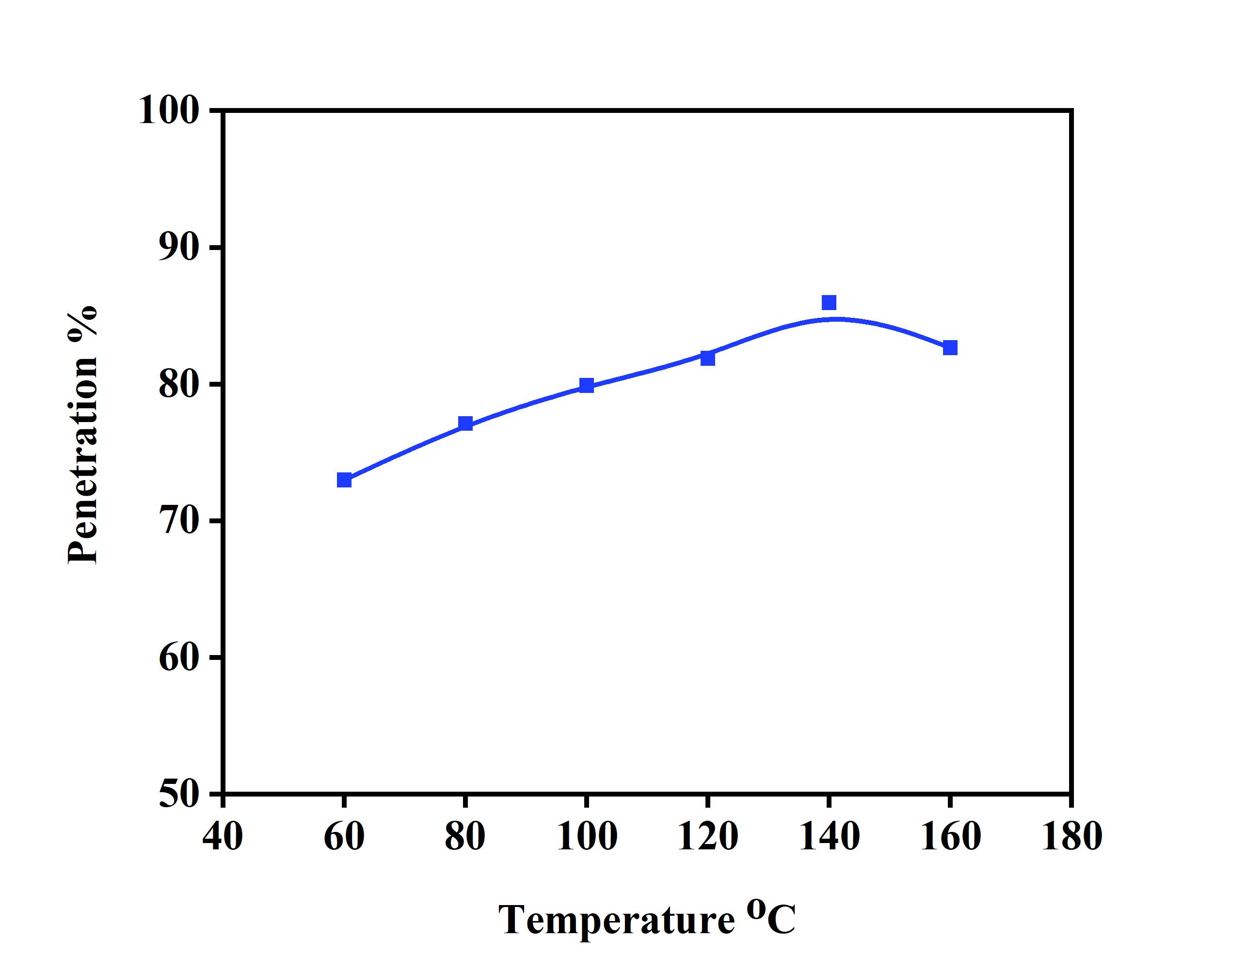
Fig. S3. Preliminary judgment of the effect of temperature on the degree of reaction.

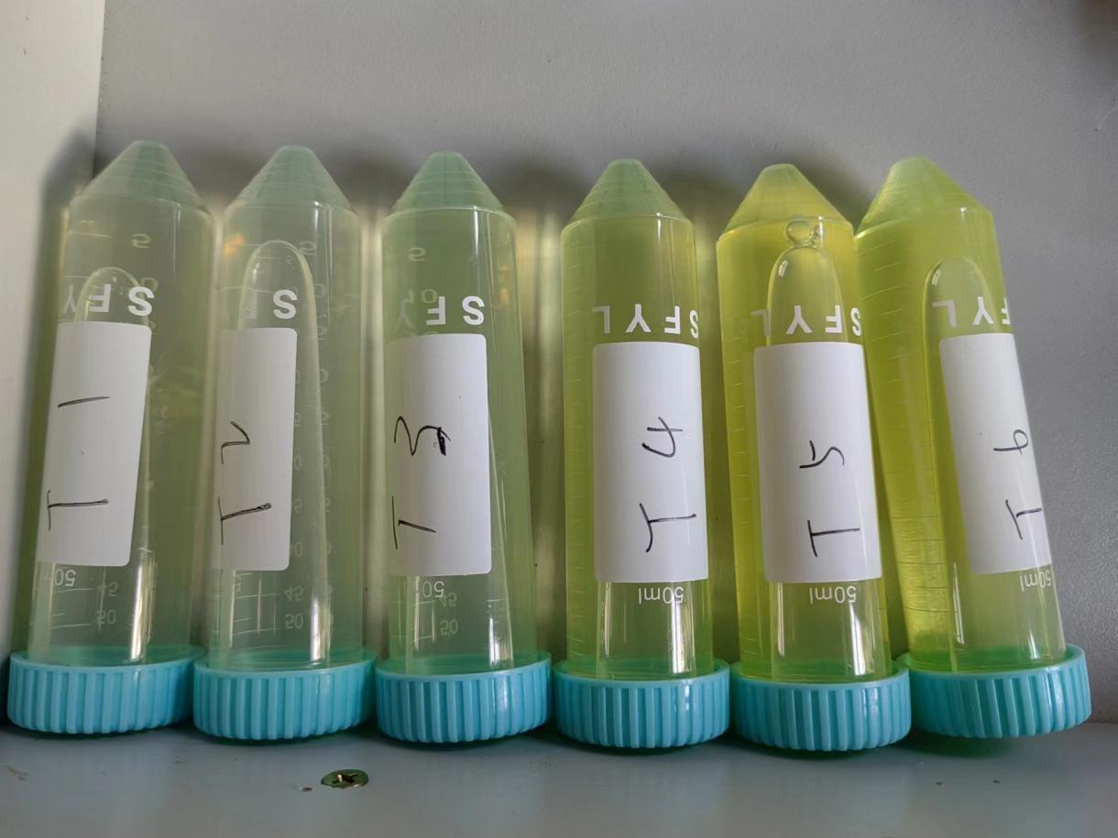
Fig. S4. Effect of temperature on chromium retention.
As the reaction temperature increases, the color of the cooking slurry gradually deepens, indicating that more chromium is released into the solution. The particle size and chromium retention rate after different reaction temperatures are calculated, as shown in Figure S5.

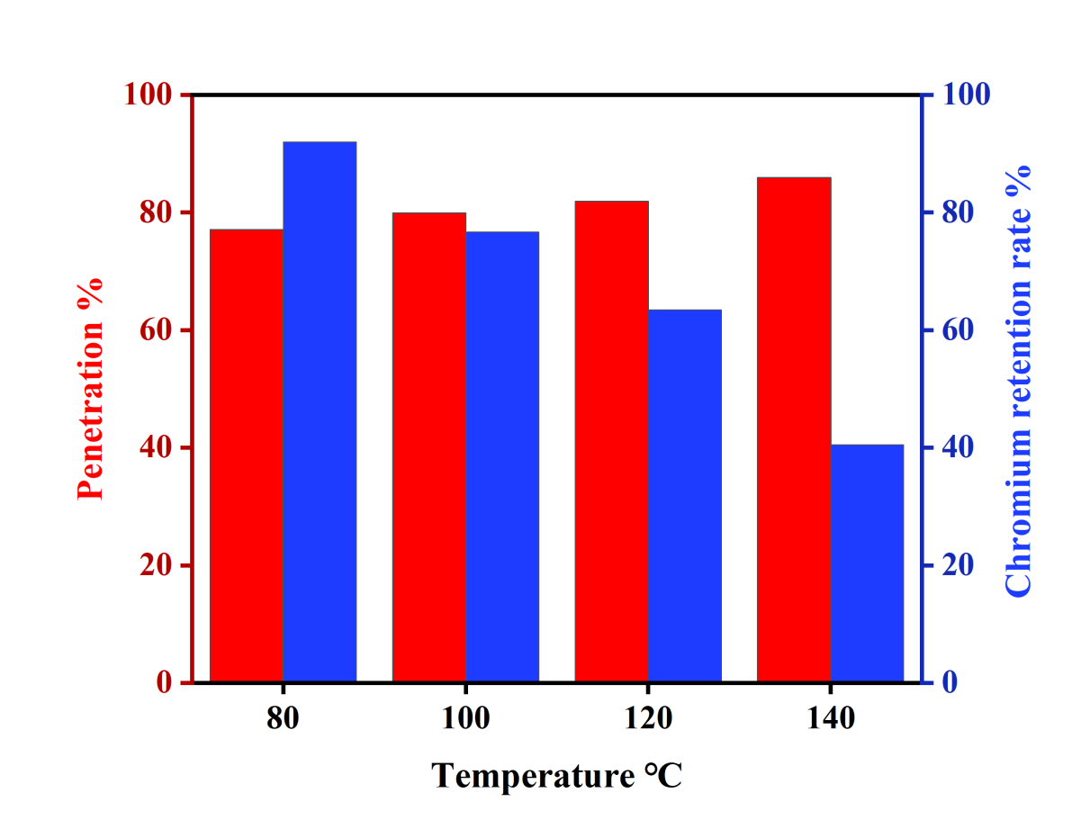
Fig. S5. Effect of temperature on fiber size and chromium retention rate.
In the single factor experiment, with the increase of reaction temperature, the fiber transmittance gradually increased and the retention rate of chromium in the fiber gradually decreased. This change is beneficial to the design and prediction of response surface experiments.

- Response surface analysis.
The analysis results of the experimental data by Design expert-12 software are shown in Table S1 and Table S2. For the yield of protein fiber, the effect of alkali amount ( A ) was the most significant, while the effect of oxygen ( B ) was not significant. According to the results of variance analysis, the results were fitted by multiple linear regression ( MLR ) model. For Y1, the regression model is :Y1=-17.03+156.54*A+3.16*B+0.25*C+18.12*AB-0.87*AC-0.04*AC-234.26*A²-2.17*B²。
As shown in Table S2, for the analysis of chromium retention rate, the amount of oxygen ( B ) and the reaction temperature ( C ) are extremely significant factors, and the effect of the amount of alkali ( A ) is also significant. Among the other items, the p value less than 0.005 is the interaction between the amount of alkali and temperature ( AC ), the interaction between the amount of oxygen and temperature ( BC ), and the quadratic term C2. The regression model is :Y2=9.53-0.22*A-0.33*B-0.48*C-0.15*AB-0.50*AC-0.57*BC+0.03*A²+0.11*B²-0.35C²。
In order to test whether the data conforms to the normal distribution, we evaluate the correlation coefficient ( denoted by R2 ). The correlation coefficients of the polynomial model were 0.7744 and 0.9774, indicating that the established model can predict the size distribution of protein fibers and the retention rate of chromium based on the values of the main factors.The good correlation between the predicted values and the actual experimental data, is pointed out in Fig. S1 and Fig. S2. The plot of normal probability of internally studentized residuals indicated that there were almost no serious exogenous observations and confirmed that the residuals were normally and independently distributed, since data are plotted in such a way that they follow a straight line.

Table S1. ANOVA results for the applied face centered composite design of yield analysis.
Source | Sum of Squares | Degree of freedom | Mean Square | F-value | P-value
Model | 58.15 | 9 | 6.46 | 7.10 | 0.0085 | significant
Alkali charge(wt/wt sludge)-A | 20.64 | 1 | 20.64 | 22.69 | 0.0021
Oxygen consumption(MPa)-B | 2.00 | 1 | 2.00 | 2.20 | 0.1812
Temperature(ºC)-C | 13.77 | 1 | 13.77 | 15.14 | 0.0060
AB | 0.8208 | 1 | 0.8208 | 0.9022 | 0.3738
AC | 12.01 | 1 | 12.01 | 13.20 | 0.0084
BC | 2.31 | 1 | 2.31 | 2.54 | 0.1552
A² | 1.44 | 1 | 1.44 | 1.59 | 0.2481
B² | 1.24 | 1 | 1.24 | 1.37 | 0.2807
C² | 3.26 | 1 | 3.26 | 3.58 | 0.1003
Residual | 6.37 | 7 | 0.9097
Lack of Fit | 5.18 | 3 | 1.73 | 5.81 | 0.0611 | not significant
Pure Error | 1.19 | 4 | 0.2973
Cor Total | 64.52 | 16
Adjusted R²=0.7744
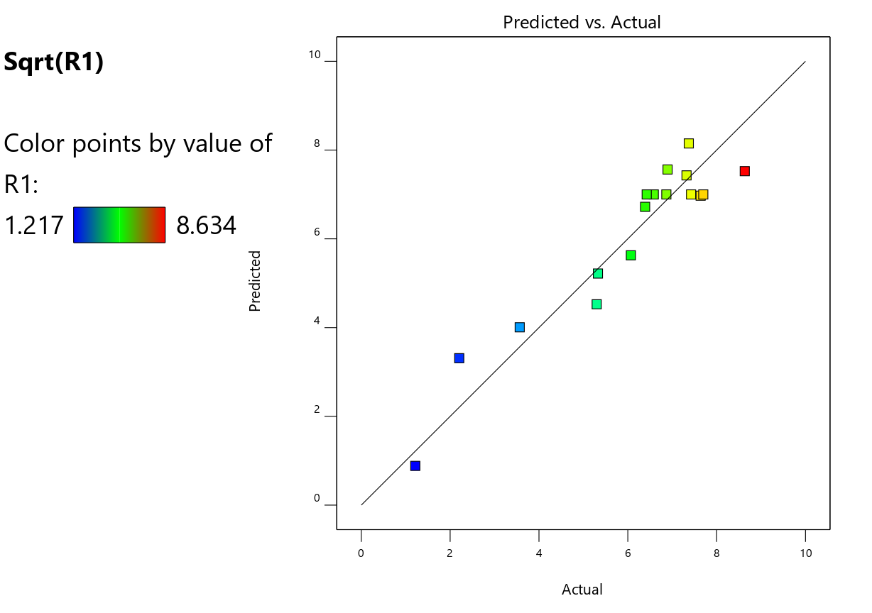
Fig. S6. Correlation between predicted and experimental values for yield.

Table S2. ANOVA results for the applied face centered composite design of Chromium retention rate analysis.
Source | Sum of Squares | Degree of freedom | Mean Square | F-value | P-value
Model | 6.02 | 9 | 0.6691 | 77.85 | <0.0001 | significant
Alkali charge-A | 0.3829 | 1 | 0.3829 | 44.55 | 0.0003
Oxygen consumption-B | 0.8654 | 1 | 0.8654 | 100.70 | <0.0001
Temperature-C | 1.84 | 1 | 1.84 | 213.57 | <0.0001
AB | 0.0905 | 1 | 0.0905 | 10.53 | 0.0142
AC | 0.9776 | 1 | 0.9776 | 113.74 | <0.0001
BC | 1.31 | 1 | 1.31 | 152.09 | <0.0001
A² | 0.0032 | 1 | 0.0032 | 0.3694 | 0.5625
B² | 0.0471 | 1 | 0.0471 | 5.48 | 0.0518
C² | 0.5297 | 1 | 0.5297 | 61.63 | 0.0001
Residual | 0.0602 | 7 | 0.0086
Lack of Fit | 0.0454 | 3 | 0.0151 | 4.09 | 0.1036 | not significant
Pure Error | 0.0148 | 4 | 0.0037
Cor Total | 6.08 | 16
Adjusted R²=0.9774
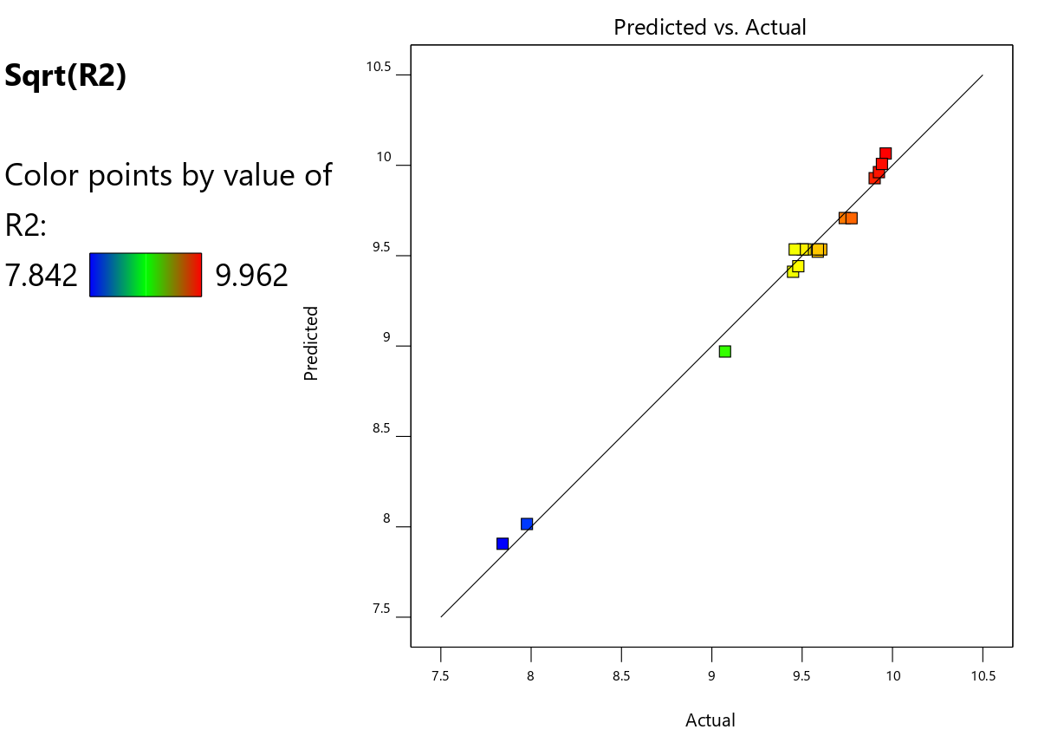
Fig. S7. Correlation between predicted and experimental values for Chromium retention rate.
- The change trend of particle size distribution of protein fiber clusters
Representative data were selected from the response surface experiment. With the change of reaction conditions, the particle size distribution of protein fiber clusters changed significantly.
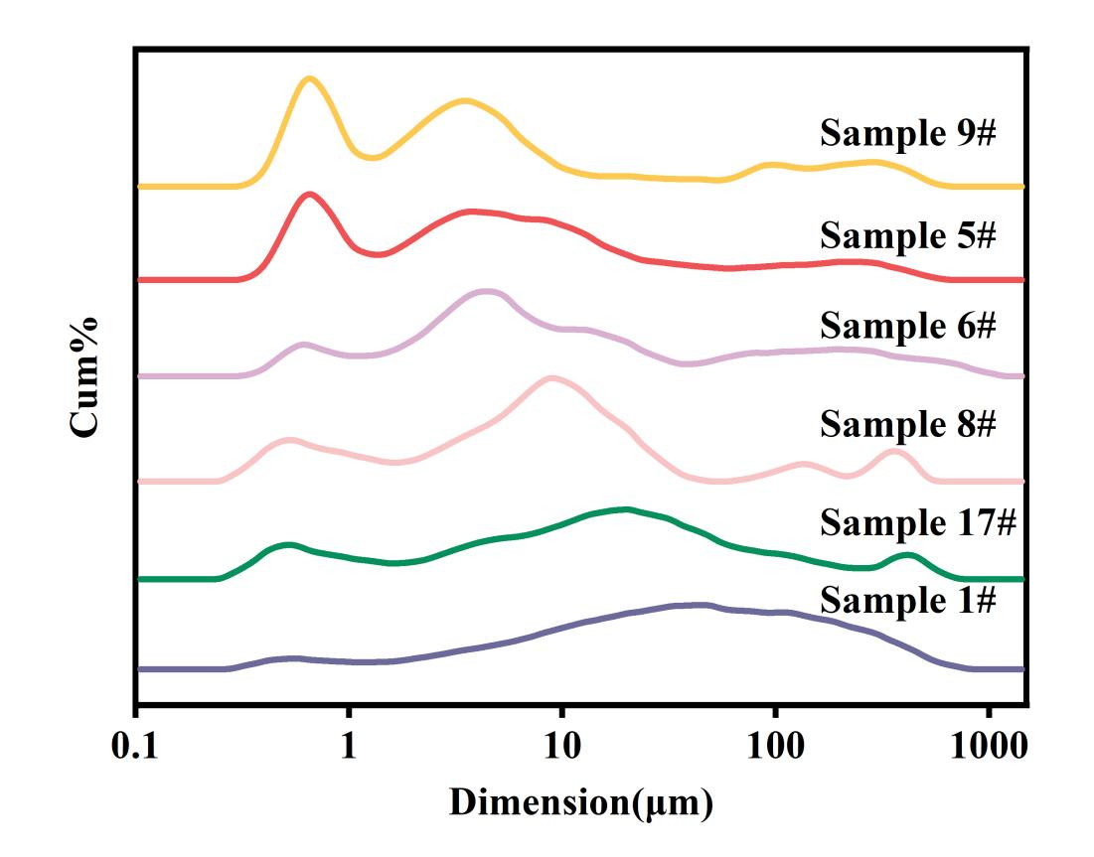
Fig. S8. The change trend of particle size distribution of protein fiber clusters

- The wide-scan XPS spectra of protein fiber and high resolution XPS spectra of Cr for protein fiber.
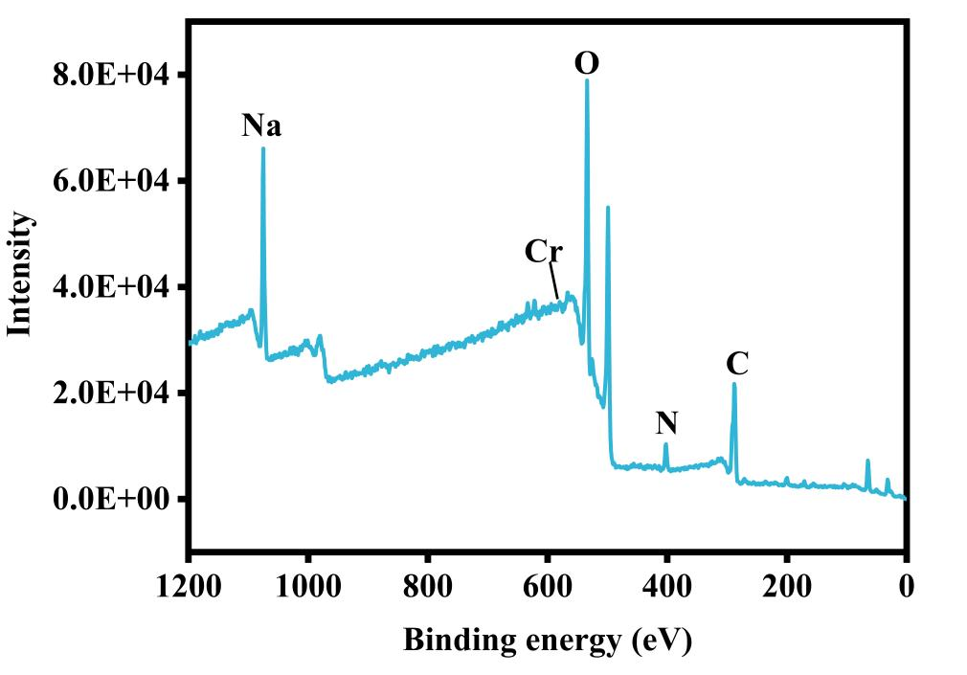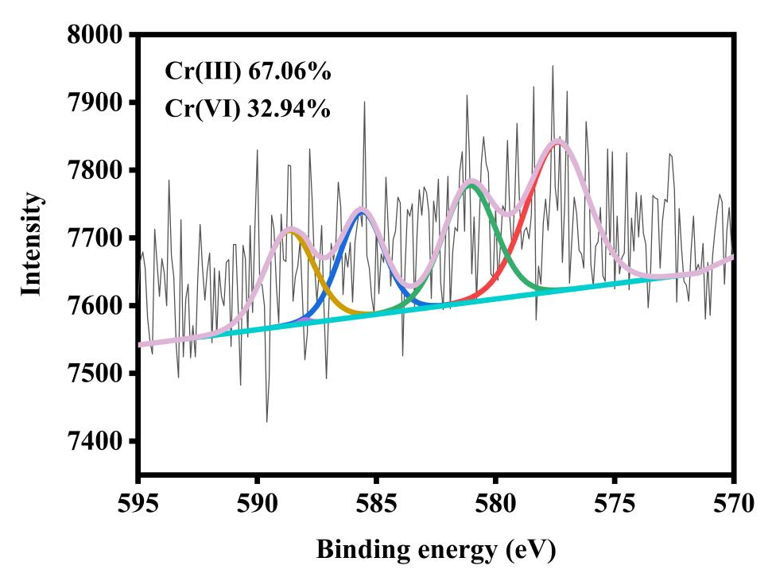
Fig. S9. The wide-scan XPS spectra of protein fiber and high resolution XPS spectra of Cr for protein fiber.
Figure S9 displays wide-scan XPS spectra of protein fiber and high resolution XPS spectra of Cr for protein fiber. The results showed that C, N, O and Na elements in protein fibers reflected obvious peak intensity, and the peak area corresponding to Cr(III) (67.06%) is larger than Cr(VI) (32.94%). This is consistent with our expected results, that is, the alkali-oxygen cooking process does not oxidize a large amount of chromium to a more toxic high valence state.

- Atomic Force Microscopy ( AFM ) Images of Protein Fibers
The ultrasonic protein fiber solution was diluted and dropped onto a flat mica sheet to dry naturally for AFM shooting.The cluster structure formed by protein fibers can be observed from the AFM image, and the white part of the image may be salt.
Fig. S10. AFM images of protein fiber clusters

- Scanning electron microscopy ( SEM ) images of protein fibers after freeze-drying
The protein fiber solution was freeze-dried and the microstructure was observed by SEM. Because the fiber material is prone to self-assembly during the freeze-drying process, SEM observation shows that some fibers are assembled to form a sheet structure, and some fibers are still fibrous after assembly.
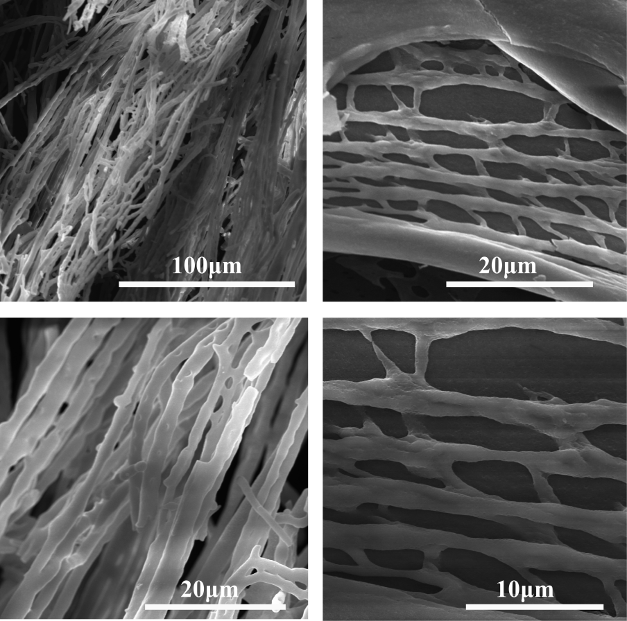
Fig. S11. SEM images of freeze-dried protein fibers
- Data sources for Life Cycle Assessment(LCA).
The LCA calculation method[1] and the two protein fiber preparation methods used for comparison refer to the published work[2, 3].
- Combustion process of film containing protein fiber.
The films doped with different proportions ( 0-20 wt % ) of protein fibers were ignited, and the films doped with protein fibers burned slower and self-extinguished.Because the self-extinguishing phenomenon will occur during the combustion process, the angle of the film is adjusted so that the combustion is complete.The burning video is shown below.
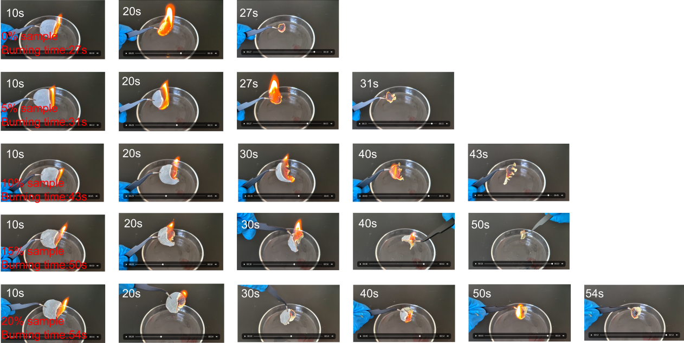
Fig. S12. Comparison of combustion time of films.

Reference
[1] X. Shi, Z. Wang, S. Liu, Q. Xia, Y. Liu, W. Chen, H. Yu, K. Zhang., 2024. Scalable production of carboxylated cellulose nanofibres using a green and recyclable solvent, Nature Sustainability, 7, 315-325.
[2] S. Sinha-Ray, Y. Zhang, A.L. Yarin, S.C. Davis, B. Pourdeyhimi., 2011. Solution Blowing of Soy Protein Fibers, Biomacromolecules, 12, 2357-2363.
[3] S. Goyal, M. Dotter, E. Diestelhorst, J.L. Storck, A. Ehrmann, B. Mahltig., 2022. Extraction of keratin from wool and its use as biopolymer in film formation and in electrospinning for composite material processing, Journal of Engineered Fibers and Fabrics, 17, 15589250221090499

*Corresponding author. Tel (+86) 25-83587184, Fax (+86) 25-58139215. Email address: zhanglilong@njtech.edu.cn (Lilong Zhang) zhangkai2018@qlu.edu.cn (Kai Zhang) jhzhu@njtech.edu.cn (Jiahua Zhu).

