Supplementary Material for “High prediction skill of North Atlantic and East Pacific tropical cyclones ten years ahead in the Met Office’s decadal prediction system DePreSys4”

Paul-Arthur Monerie, Xiangbo Feng, Kevin Hodges, Ralf Toumi

Supplementary discussion
We evaluate the ability of DePreSys4 to simulate tropical cyclones (TCs). In the main text, we show how DePreSys4 simulates track density and track density variability with respect to ERA5. Another important aspect of TC simulation is the simulation of TC genesis. Figure S1 shows that DePreSys4 underestimates TC genesis over the North Atlantic, West Africa, the Sahel, and Central America. The bias in TC genesis is consistent with the bias in track density (Figure 1c).
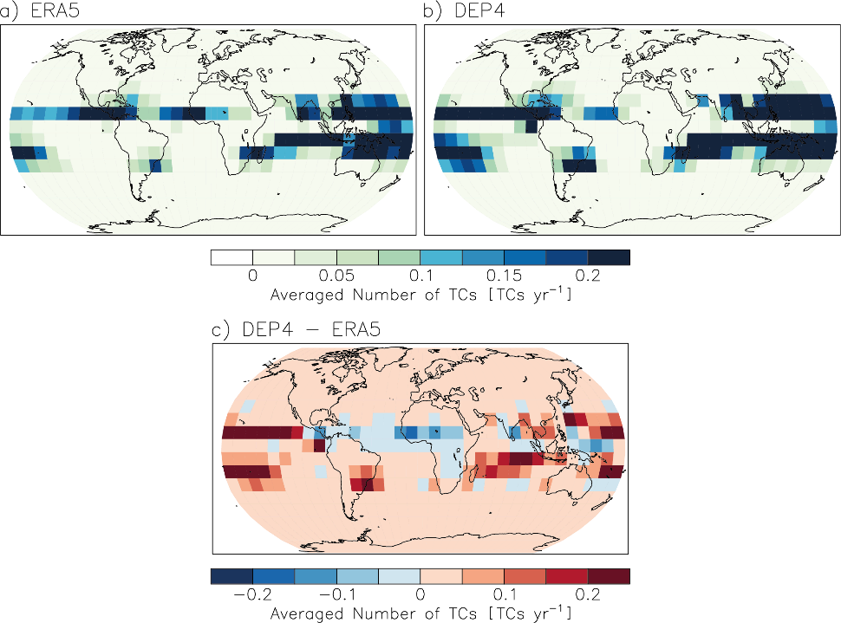
Supplementary Figure 1: Tropical cyclone genesis [1960-2021; TC year⁻¹] for (a) ERA5, (b) DePreSys4 and (c) for the bias (DePreSys4 - ERA5). Results are given for JASO in the Northern Hemisphere and DJFM in the Southern Hemisphere.

In the main text, we relate the ability of DePreSys4 to predict TC track density and genesis over the Atlantic to the effect of the North Atlantic surface temperature on the vertical wind shear over the tropical Atlantic. We assess the effect of the North Atlantic on the tropical Atlantic vertical wind shear by calculating the coefficient correlation between the North Atlantic surface air temperature [0-60°N; 80°W-0°E] and the vertical wind shear (U200-U850) for the 2–9-year forecast lead time. We removed a quadratic linear trend before calculating the coefficient correlation to account for the effects of North Atlantic temperature without assessing the effect of the externally forced response on vertical wind shear. Figure S2 shows that a warming of the North Atlantic is associated with a decrease in vertical wind shear over the tropical Atlantic and, hence, an increase in TC formation and storm tracks. The similarity between ERA5 and DePreSys4 in the influence of the North Atlantic on the vertical wind shear in the tropical Atlantic is consistent with the conclusion that a good forecast of the North Atlantic temperature can lead to a good forecast of TC genesis and storm tracks over the tropical Atlantic.
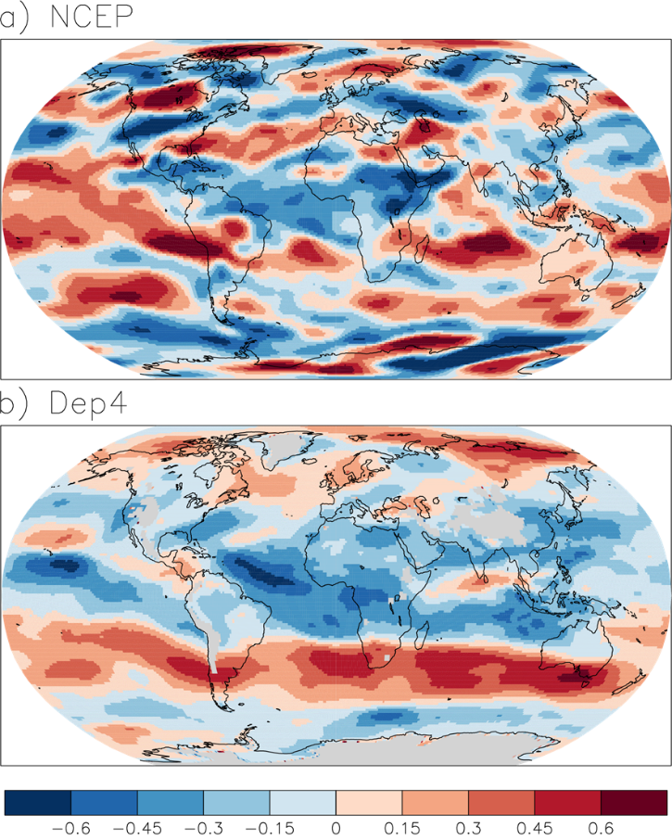
Supplementary Figure 2: Coefficient correlation between the effect of the North Atlantic Ocean [0-60°N; 80°W-0°E] and the vertical wind shear (U200-U850) for the 2-9-year forecast lead time. We removed a quadratic linear trend before calculating the coefficient correlation.
In the main text, we assess the ability of DePreSys4 to simulate TC track density and genesis relative to ERA5. We assess the ability relative to ERA5 because the same tracking algorithm was used to define TCs from ERA5 and DePreSys4. In addition to ERA5, we show the number of TCs obtained by IBTrACS (Figure S3). The results from IBTrACS are not directly comparable with those from ERA5 and DePreSys4 due to differences in TC extraction. The number and variability of TCs differ between ERA5 and IBTrACS (Fig. 4a and Fig. 4b; Fig. S3). However, there are similarities between ERA5, DePreSys4 and IBTrACS. The number of TCs increases over the Northeast Pacific in IBTrACS, although the decadal variability is high (Figure S3a). The number of TCs over the tropical Atlantic Ocean follows a multi-decadal pattern, decreasing until the 1980s and then increasing (Figure S3b).

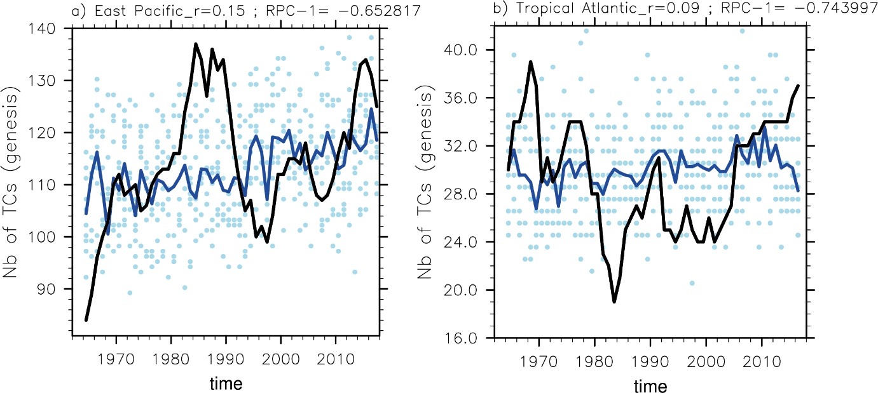
Supplementary Figure 3: The number of tropical cyclones (genesis) in IBTrACS (black line) and the DePreSys4 ensemble mean (blue line) for the (a) eastern Pacific Ocean and (b) eastern tropical Atlantic Ocean for the total number of TC in the 2-9-year forecast lead time. All individual ensemble members are shown with a blue dot. The ACC and RPC values are shown.

In addition to IBTrACS and ERA5, we replicate the analysis using JRA-3Q³⁹ (Figure S4). JRA-3Q (the Japanese Reanalysis for the Three Quarters of a Century) is the third long-term reanalysis product developed by the Japan Meteorological Agency. JRA-3Q covers the period from September 1947 to the present and has a horizontal resolution of ~40 km.

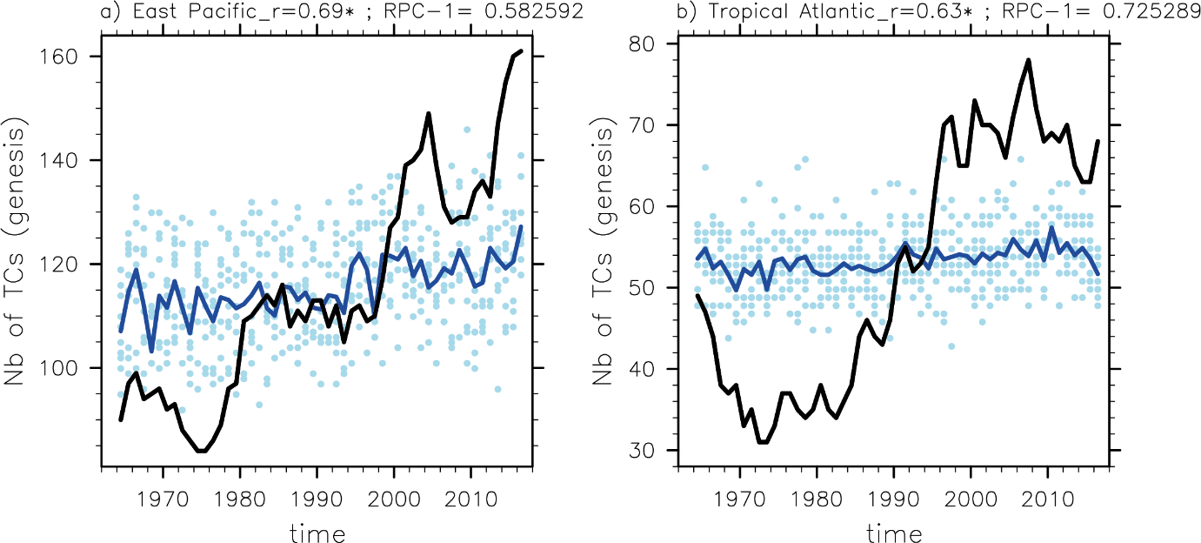
Supplementary Figure 4: The number of tropical cyclones (genesis) in JRA-3Q (black line) and the DePreSys4 ensemble mean (blue line) for the (a) eastern Pacific Ocean and (b) eastern tropical Atlantic Ocean for the total number of TC in the 2-9-year forecast lead time. All individual ensemble members are shown with a blue dot. The ACC and RPC values are shown.

