SUPPORTING INFORMATION

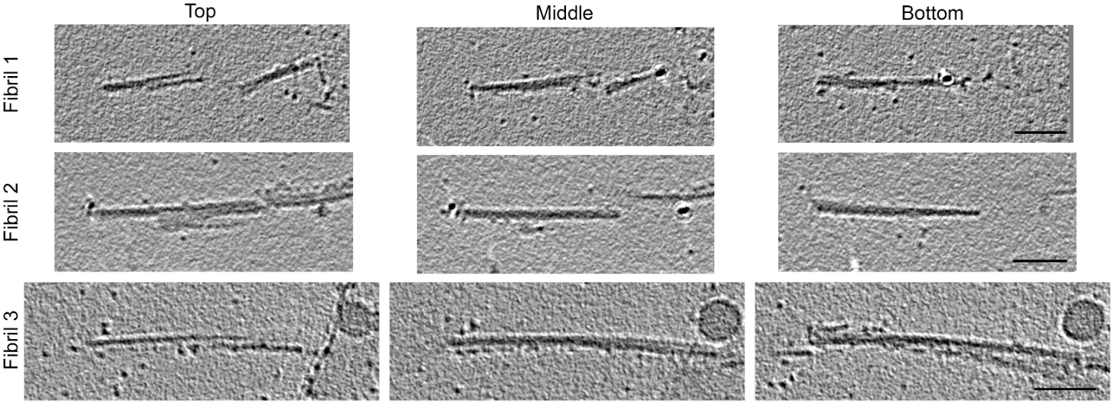

Fig S1 Cryo-EM tomography of CWD fibrils. Representative images of three fibrils showing top, middle and bottom slices through the tomograms, indicating left-handed twist in each fibril. The small dark spheres are gold fiducials. Scale bars: 50 nm.

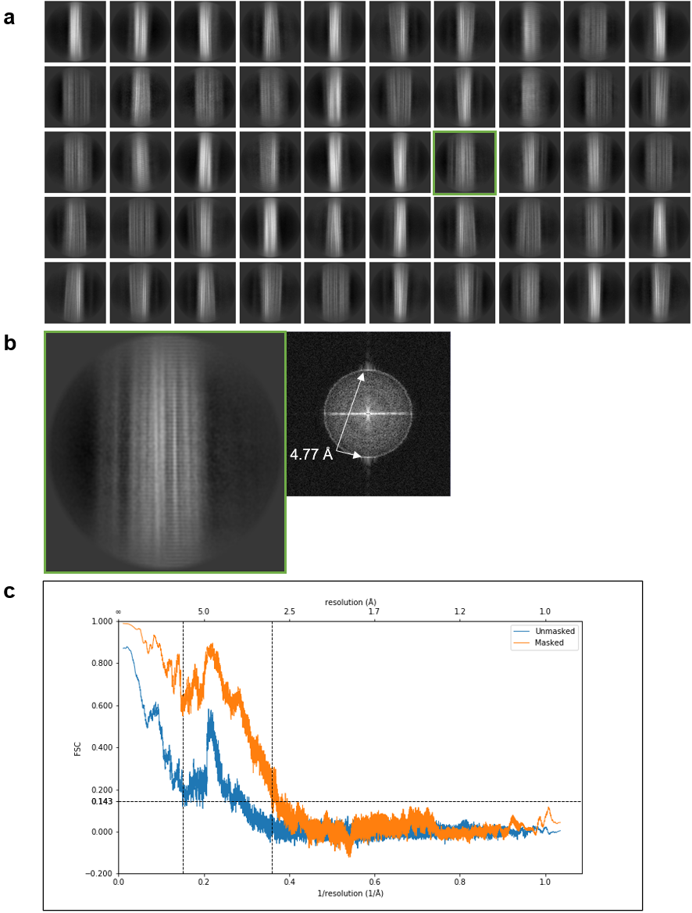

Fig S2 a Representative 2D class averages showing lateral views of CWD fibril segments. The enlargement of the class average boxed in green allows easier visualization of the fine horizontal bands running perpendicular to the fibril axis. b Fast Fourier transform of 2D class average boxed in green indicating signals at ~4.77 Å that correspond to the spacing between the bands. c Fourier shell correlation plots of masked and unmasked models indicating, from the masked trace, a maximal resolution of 2.8 Å.

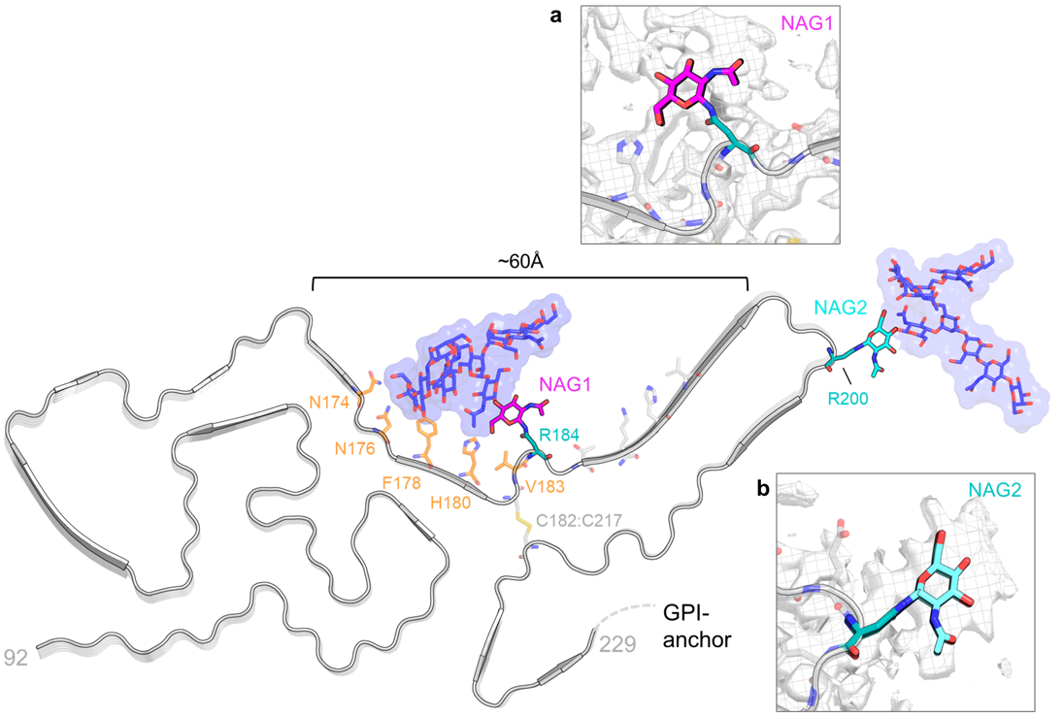
Fig. S3 Glycosylation of CWD PrP^{Sc}. Overview of the CWD structure with the two resolved N-acetylglucosamine residues NAG1 (magenta) and NAG2 (cyan). Representative tri-antennary glycans were modeled onto the NAG1 and NAG2 residues with CHARMM-GUI [20] and are depicted in dark blue (carbons) with red (oxygens). Residues forming potential interactions with the N-linked glycan attached to R184 are colored in orange. Width of the cleft between the N- and C-lobes is ~60Å. Inset (a): structure of NAG1 (magenta) on R184 (teal) against a mesh/surface plot of the cryo-EM density (grey). Inset (b): structure of NAG2 (cyan) on R200 (teal) against cryo-EM density.

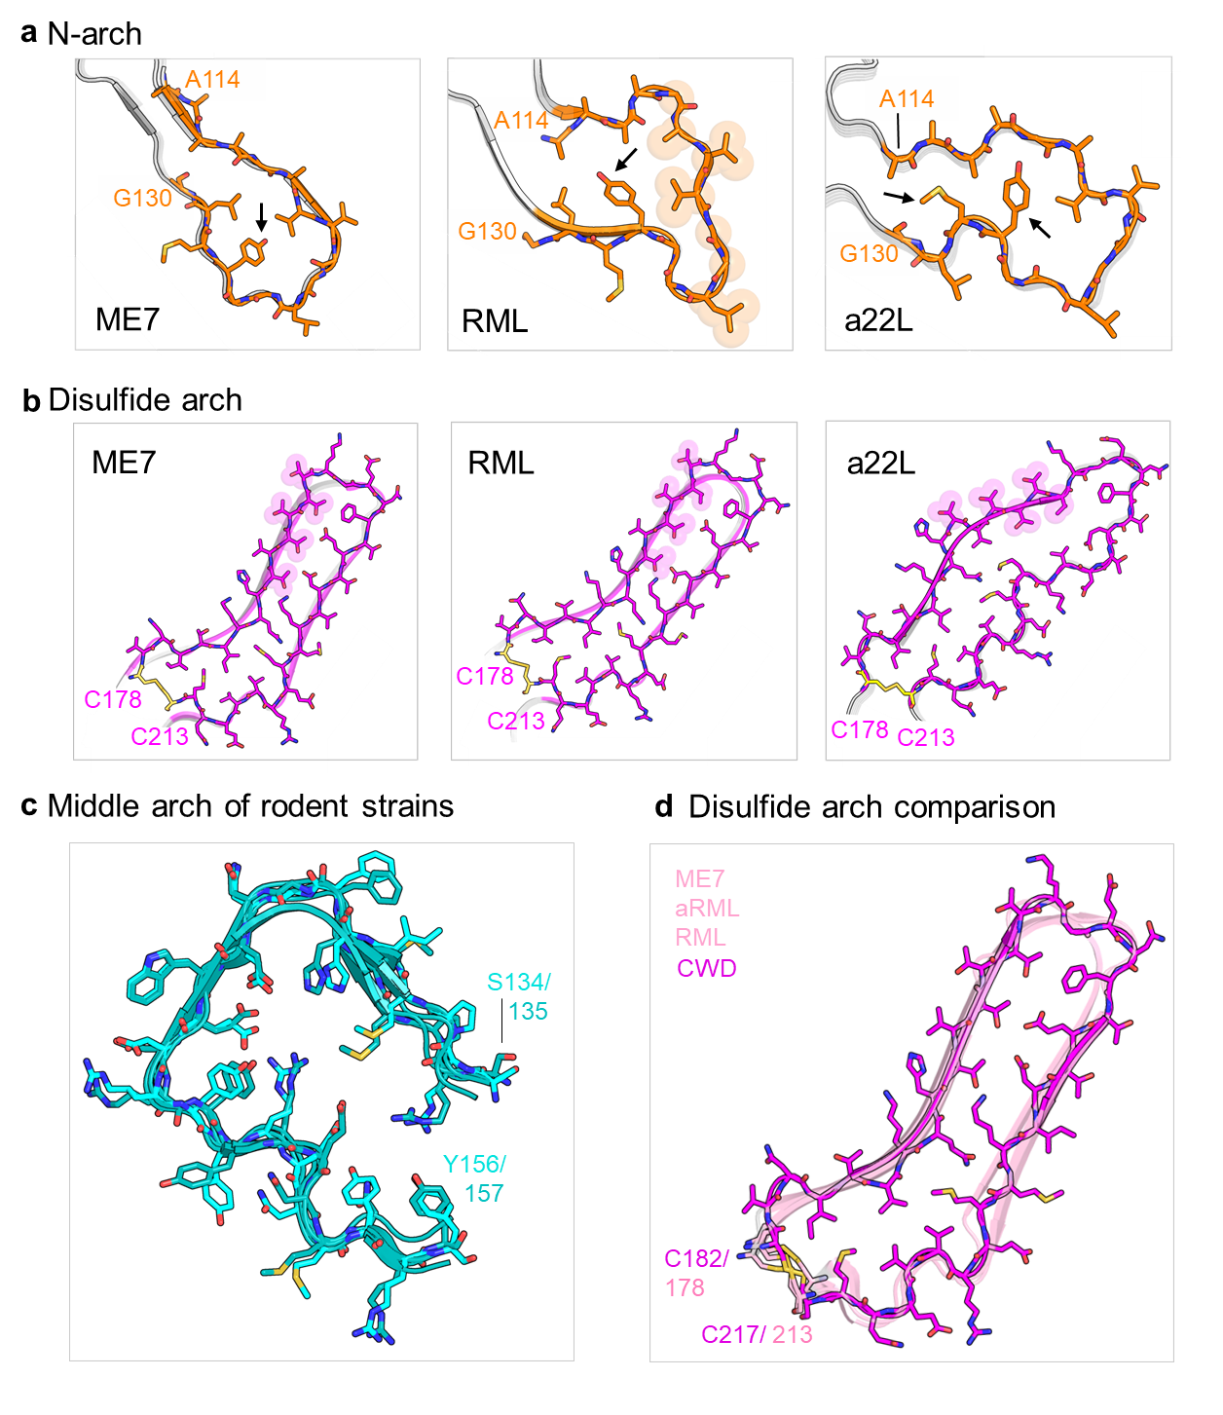
Fig. S4 Rodent-adapted prion strain comparison of major PrP^{Sc} structural motifs. a Residues 114-130, which comprise the N-arch in mouse strains ME7, RML and a22L. Highlighted residues span 119-124 and arrow marks Y120. b Disulfide arches of three mouse strains (ME7, RML and a22L), which begin at the disulfide bond formed by residues C178 and C213. The prominent stretches of 5 closely spaced threonine residues are highlighted. c Overlay of middle arches from five rodent strains (ME7, aRML, RML, a22L and 263K). Hamster residues are colored in teal and mouse residues are colored in cyan. d Comparison of CWD disulfide arch (magenta) with the disulfide arches of three mouse strains (pink; ME7, aRML and RML)
S1 Appendix Excel file with a summary of cryo-EM tomography twist results from all fibrils analyzed.

