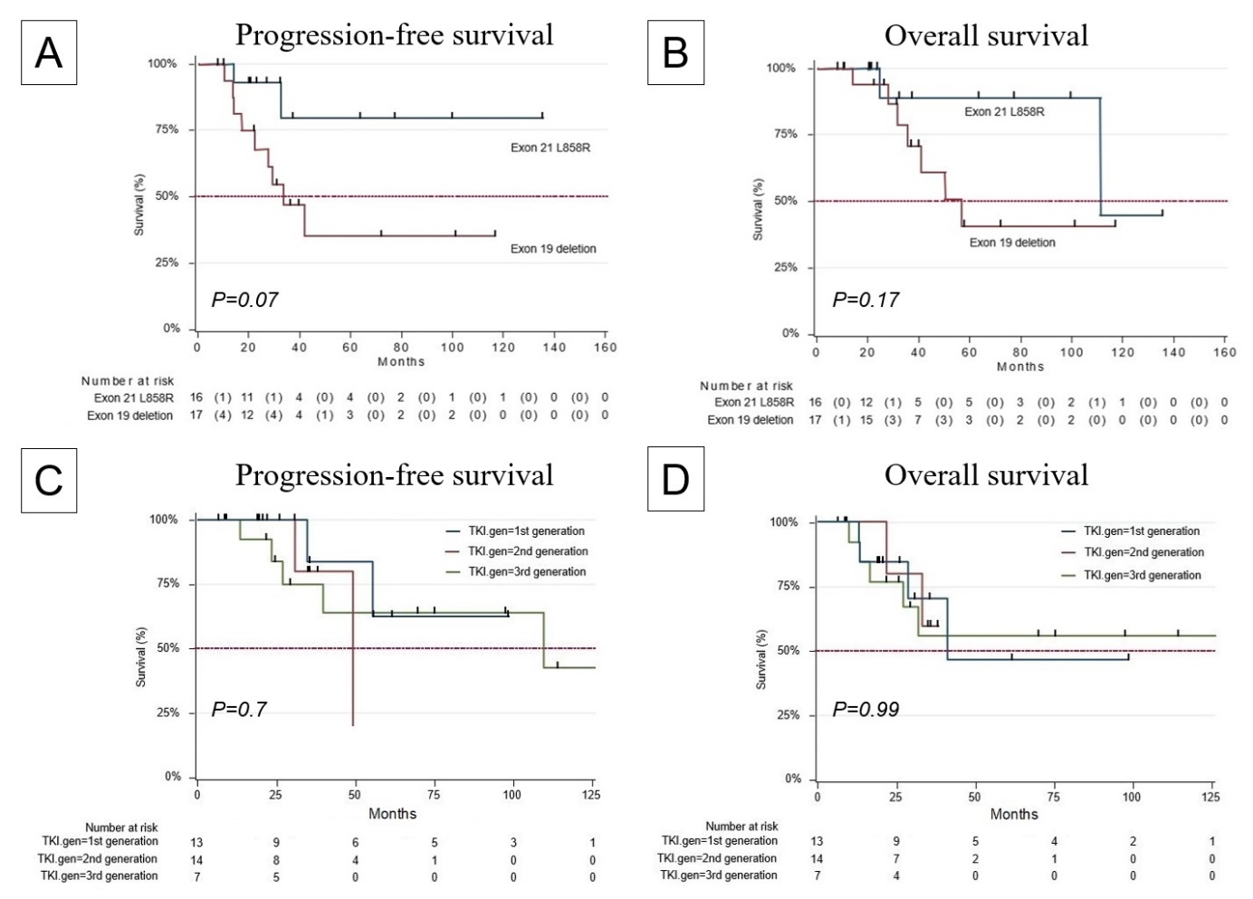
Supplemental Figure 1. Survival curves of patients after initiation of TKI treatment stratified by different EGFR mutation types and generations of TKI.

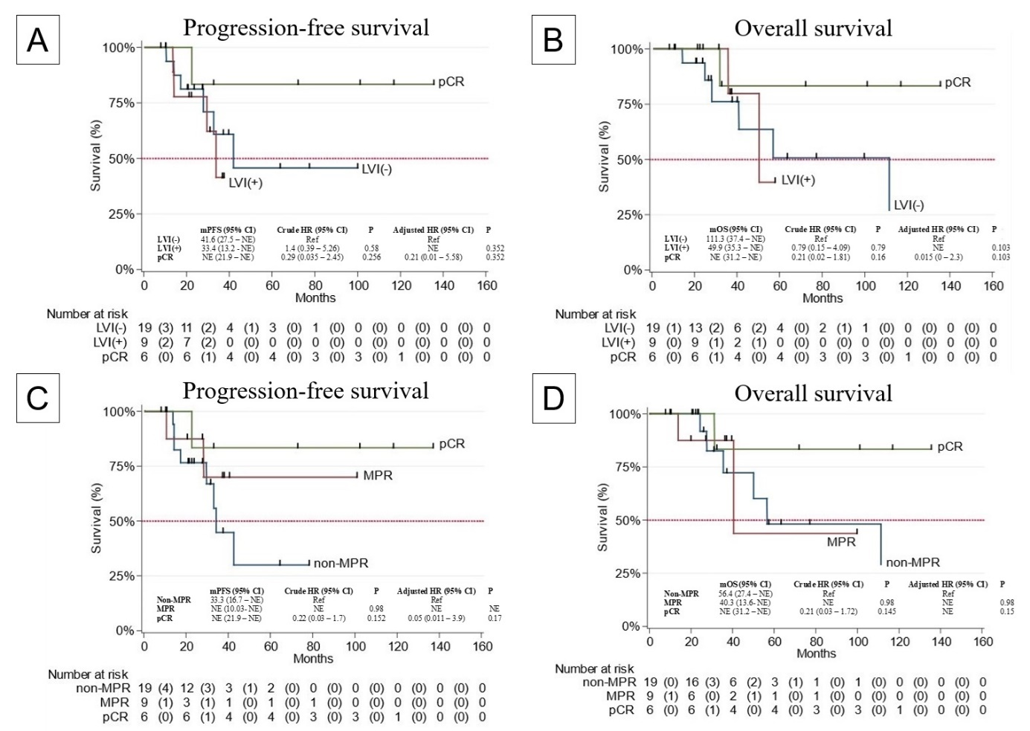
Supplemental Figure 2. Survival curves of patients after initiation of TKI treatment stratified by pathological factors of LVI, MPR, and pCR.
TKI, tyrosine kinase inhibitor; MPR, major pathological response; PCR, pathological complete response

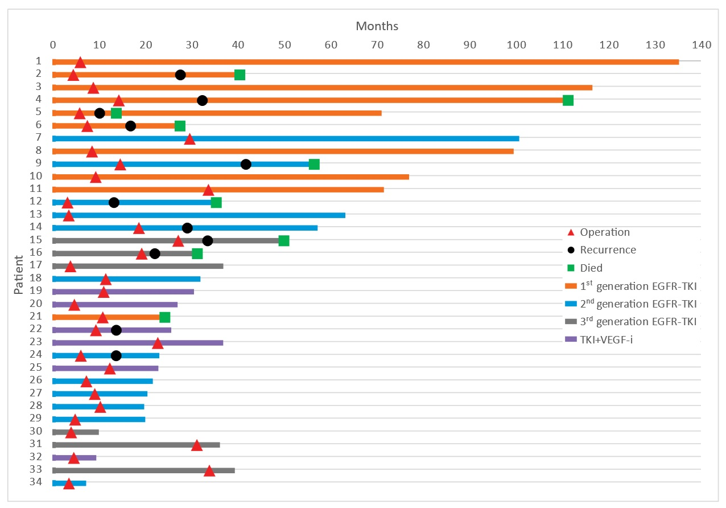
Supplemental Figure 3. Swimmer plot of postoperative treatments and outcomes of patients after salvage surgery.
TKI, tyrosine kinase inhibitor; EGFR, Epidermal Growth Factor Receptor; VEGF-I, vascular endothelial growth factor inhibitor

Supplemental table 1. Characteristics of the included patients according to different TKI generations
Variables | 1st Generation TKI  (n =13) | 2nd Generation TKI  (N =14) | 3rd Generation TKI  (n =7) | p-value
Age, y, median (range) | 63 (53 – 69) | 65 (45 – 81) | 60 (40 – 67) | 0.22
Gender, N (%)
Male | 6 (46.2) | 4 (28.6) | 2 (28.6) | 0.58
Female | 7 (53.8) | 10 (71.4) | 5 (71.4)
Smoking, N (%) | 5 (38.5) | 3 (21.4) | 0 | 0.07
Family history, N (%) | 4 (30.8) | 3 (21.4) | 1 (14.3) | 0.68
ECOG, N (%)
0 | 4 (30.8) | 8 (57.1) | 5 (71.4) | 0.17
1 | 9 (69.2) | 6 (42.9) | 2 (28.6)
Tumor diameter pre-TKI, cm, median (range) | 4.3 (2.9 – 10.3) | 4.1 (1.3 – 9.9) | 3.9 (1.8 – 7.8) | 0.98
Tumor diameter post-TKI, cm, median (range) | 2.1 (1.5 – 6.8) | 2.6 (0.5 – 5.8) | 2 (1.3 – 2.7) | 0.92
EGFR mutation, N (%)
Exon 21 (L858R) | 6 (46.2) | 8 (57.1) | 2 (28.6) | 0.36
Exon 19 deletion | 7 (53.8) | 5 (35.7) | 5 (71.4)
Exon 21 (L858R) + Exon 19 deletion | 0 | 1 (7.2) | 0
Duration from TKI to Surgery, months, median (range) | 9.2 (4.4 – 33.6) | 8.1 (3.1 - 29.5) | 19.2 (3.8 – 33.8) | 0.53
Type of resection, N (%)
Lobectomy | 11 (84.6) | 8 (57.1) | 5 (71.4) | 0.16
Segmentectomy | 1 (7.7) | 2 (14.3) | 2 (28.6)
Wedge resection | 1 (7.7) | 4 (28.6) | 0
Positive surgical margin (R1), N (%) | 0 | 2 (14.3) | 0 | 0.15
Operative time, min, median (range) | 170 (100 – 300) | 140 (30 – 340) | 200 (150 – 240) | 0.58
Hospital stay, days, median (range) | 5 (3 – 9) | 4.5 (2 – 8) | 4 (3 - 7) | 0.50
ASA grade, N (%)
II | 7 (53.8) | 4 (28.6) | 5 (71.4) | 0.14
III | 6 (46.2) | 10 (71.4) | 2 (28.6)
Blood loss, mL, median (range) | 25 (5 – 500) | 22.5 (10 – 375) | 20 (20 – 40) | 0.82
N1 number, median (range) | 1 (0 – 5) | 2 (0 – 13) | 4 (0 – 5) | 0.58
N2 number, median (range) | 4 (0 – 23) | 4.5 (0 – 20) | 3 (0 – 25) | 0.49
Dissected LNs, median (range) | 5 (0 – 27) | 12.5 (0 – 27) | 8 (1 – 30) | 0.25
STAS, N (%) | 5 (38.5) | 5 (35.7) | 1 (14.3) | 0.47
LVI, N (%) | 1 (7.7) | 6 (42.9) | 2 (28.6) | 0.10
Pathological response, N (%)
pCR + MPR, N (%) | 5 (38.5) | 5 (35.7) | 5 (71.4) | 0.25
Non-MPR, N (%) | 8 (61.5) | 9 (64.3) | 2 (28.6)
Disease progression after surgery, N (%) | 5 (38.5) | 4 (28.6) | 2 (28.6) | 0.83
Death, N (%) | 2 (15.4) | 2 (14.3) | 2 (28.6) | 0.35
ECOG, Eastern Cooperative Oncology Group; AJCC, American Joint Committee on Cancer; EGFR, Epidermal Growth Factor Receptor; TKI, Tyrosine Kinase Inhibitor; LNs, Lymph Nodes; ASA, American Society of Anesthesiologists; STAS, Spread through air space, and LVI, Lymphovascular Invasion; MPR, Major Pathological Response; pCR, Pathological Complete Response

