Supplementary Data
DNA sequential logic circuits for counters and bioinformatics repositories
Tianci Xie^{a,b,1}, Changjiang Li^{a,1}, Minghao Hu^{a,1}, Xingyu Zhong^{c}, Junbin Xiaoª, Zhen Zhang^{d}, Ze Wang^{e}, Tongbo Wu^{a,} *
ª School of Pharmacy, Tongji Medical College, Huazhong University of Science and Technology, Wuhan, 430030, China.
^{b} GI Cancer Research Institute, Tongji Hospital, Tongji Medical College, Huazhong University of Science and Technology, Wuhan, 430030, China.
^{c} Department and Institute of Urology, Tongji Hospital, Tongji Medical College, Huazhong University of Science and Technology, Wuhan, 430030, China.
^{d} The First Affiliated Hospital, and College of Clinical Medicine, Henan University of Science and Technology, Luoyang, China, 471003
^{e} Orthopedics Department, Wuhan Children's Hospital (Wuhan Maternal and Child Healthcare Hospital), Tongji Medical College, Huazhong University of Science & Technology, Wuhan, 430015, China.

Supplementary figures
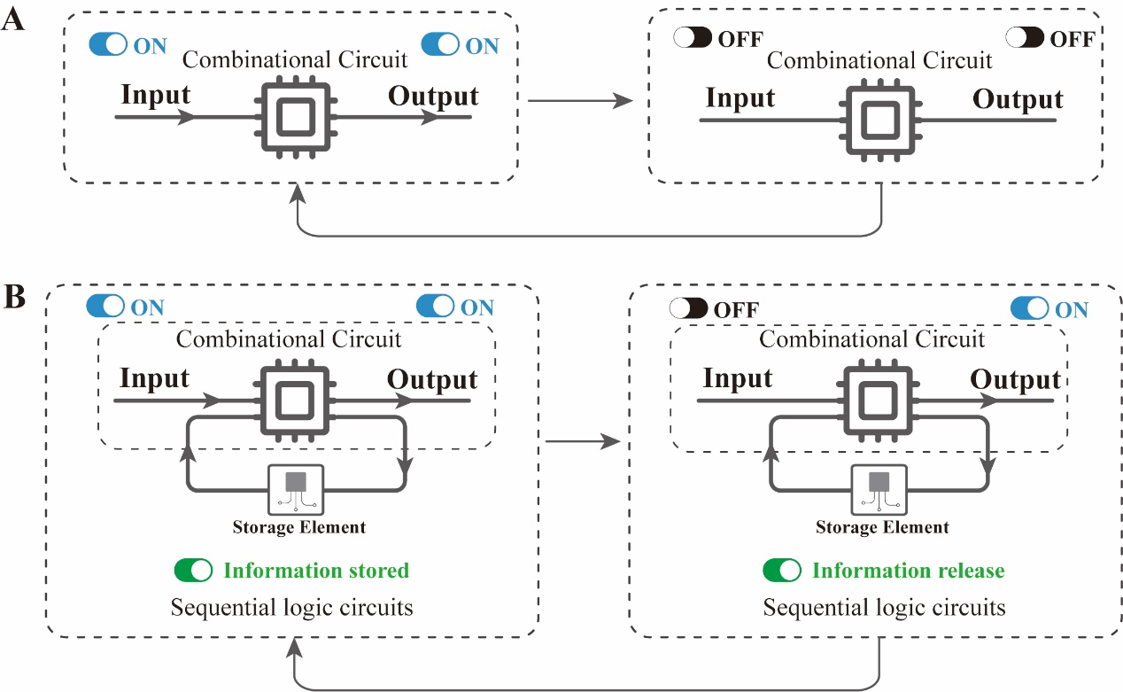
Supplementary Figure S1. Schematic diagram of Combinational Logic Circuit and Sequential Logic Circuit. (A) The operation of combinational logic circuits requires a continuous input and once aborted, the information is lost. (B) Sequential logic circuits consist of combinational logic circuits and storage elements. The output of the sequential logic circuit is determined by both the input and the information stored in the storage element. Even though there is no input, an output can be made based on the information stored in the storage element.
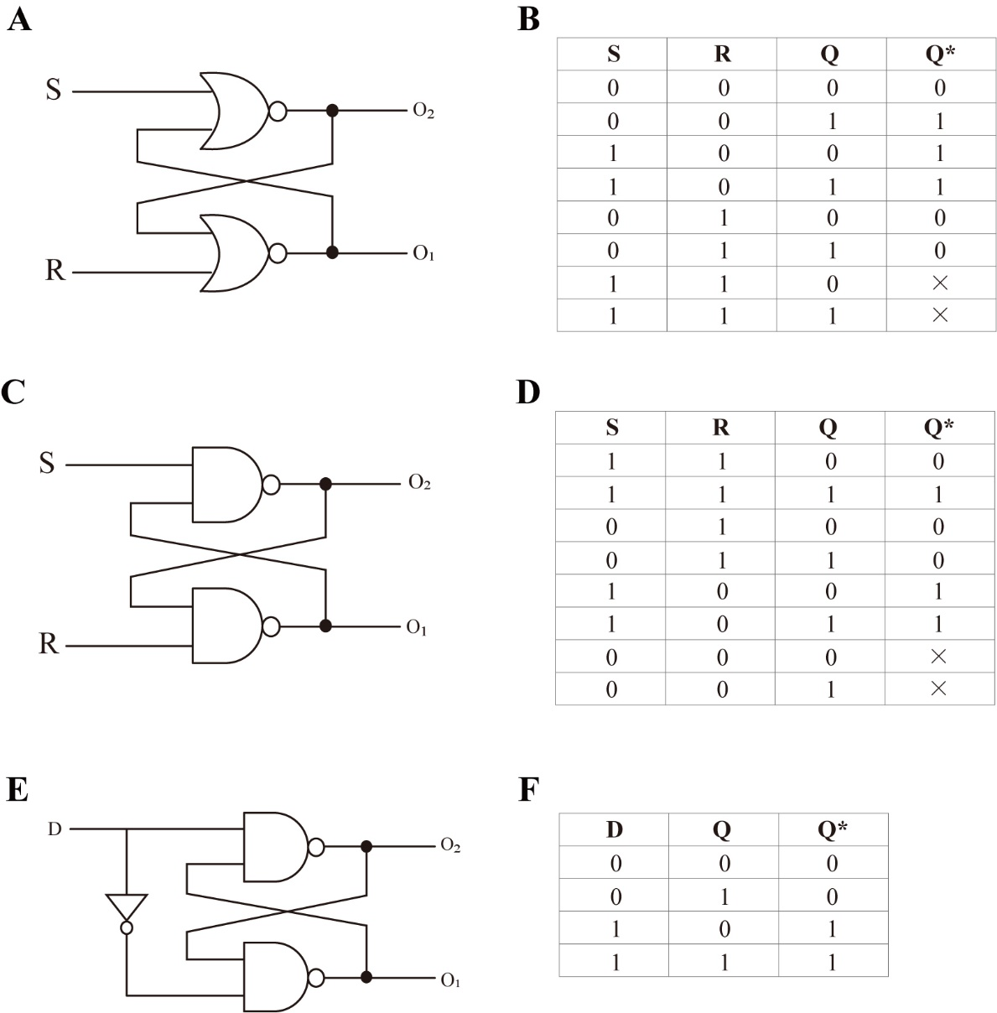
Supplementary Figure S2. Circuit diagram and truth table for the latch. In order to conveniently describe the relationship between the change of state of the latch under the input, the state of the latch before the action of the input is called the present state, denoted by Q, and the state after the action of the input is called the secondary state, denoted by Q*. Accordingly, defining Output₁ (O₁) =1 and Output₂ (O₂) =0 indicates that the stored data is 1 (Q or Q*=1), and defining O₁=0 and O₂=1 indicates that the stored data is 0 (Q or Q*=0). × represents the "holding or undefined" state. (A) Circuit diagram of the SR-latch consisting of the NOR-gate. (B) Truth table of the SR-latch consisting of the NOR-gate. (C) Circuit diagram of the SR-latch consisting of the NAND-gate. (D) Truth table of the SR-latch consisting of the NAND-gate. (E) Circuit diagram of the D-latch. (F) Truth table of the D-latch.
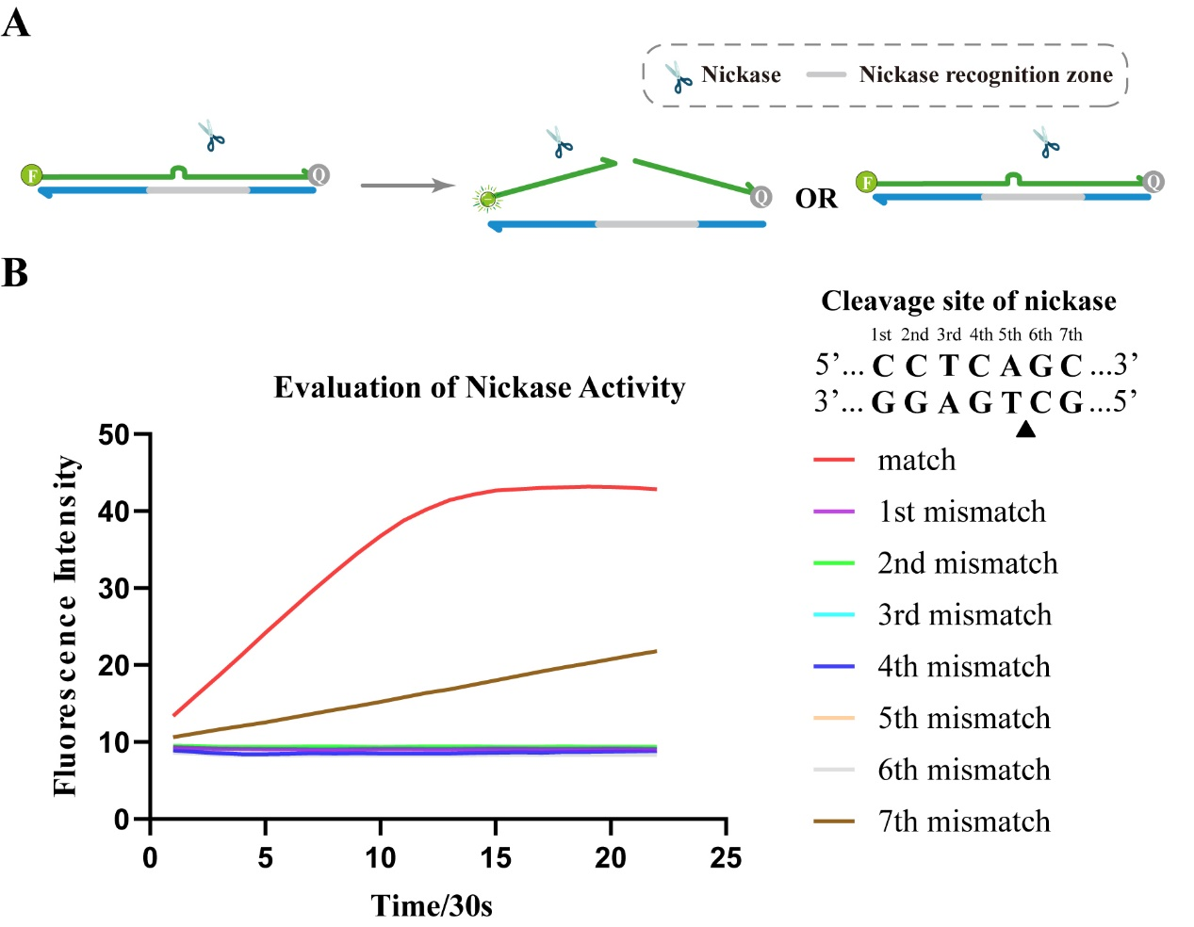
Supplementary Figure S3. The effect of inhibition of cleavage activity of mispairing of different bases on the nickase recognition site. (A) Schematic diagram of the principle. (B) Fluorescence results were plotted. The results show that all the site mismatches except the seventh site mismatch on the nickase recognition site can completely inhibit the cleavage enzyme activity.

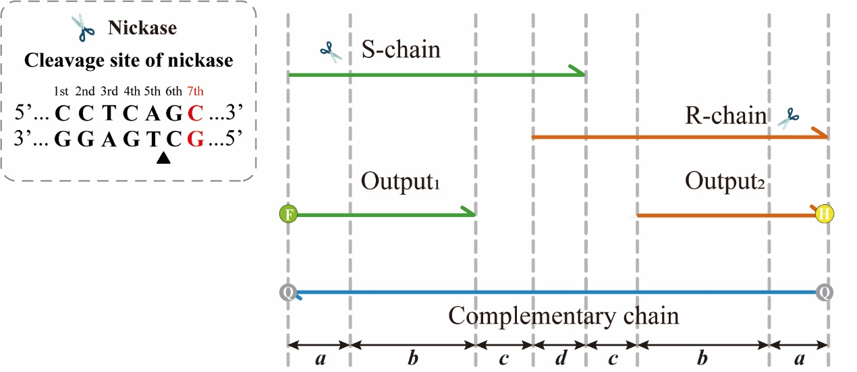
Supplementary Figure S4. Schematic diagram of the symmetrical component.

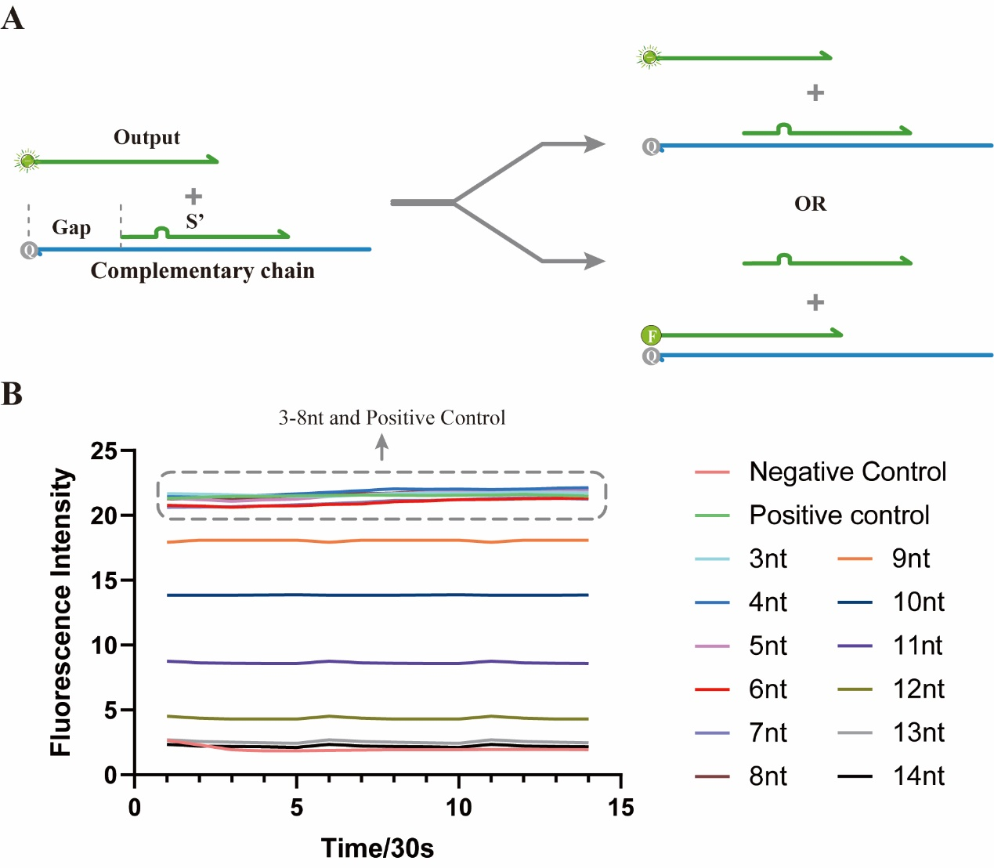
Supplementary Figure S5. Optimize the length of the gap exposed at the 3' end of the complementary chain after the Input-S has been cleaved by the nickase. The goal is that the Output strand cannot displace the cut Input-S’. (A) Schematic diagram of the optimized reaction. (B) Optimization result plots.
As shown by the results in Supplementary Figure S3, the mismatch between the Output and the complementary can be at any position on the nickase recognition region, except the seventh position. Thus, if the mismatch site on the Input-S is set n bases from the 5’ end. Due to the symmetry of the elements, the mismatch site on the Input-R is also n bases from the 3’ end. Since the mismatch site cannot be the seventh position of the nickase recognition region, this gives n-5<a<n at the 3’ end of Complementary , while n-1≤a≤n+4 at the 5’ end of Complementary. Therefore, the final result should be n-1≤a≤n.
As shown in Supplementary Figure S5. Because the subsequent reaction requires the Input-S’ to be displaced by the combined action of the Output₁ and Input-R, we need to realize the obstruction to the combination of the Output₁ and the complementary with the Input-S’ as short as possible. Therefore, we choose the gap length to be 8nt, i.e. a = 8.
To summarize, n can only be equal to 8 or 9.
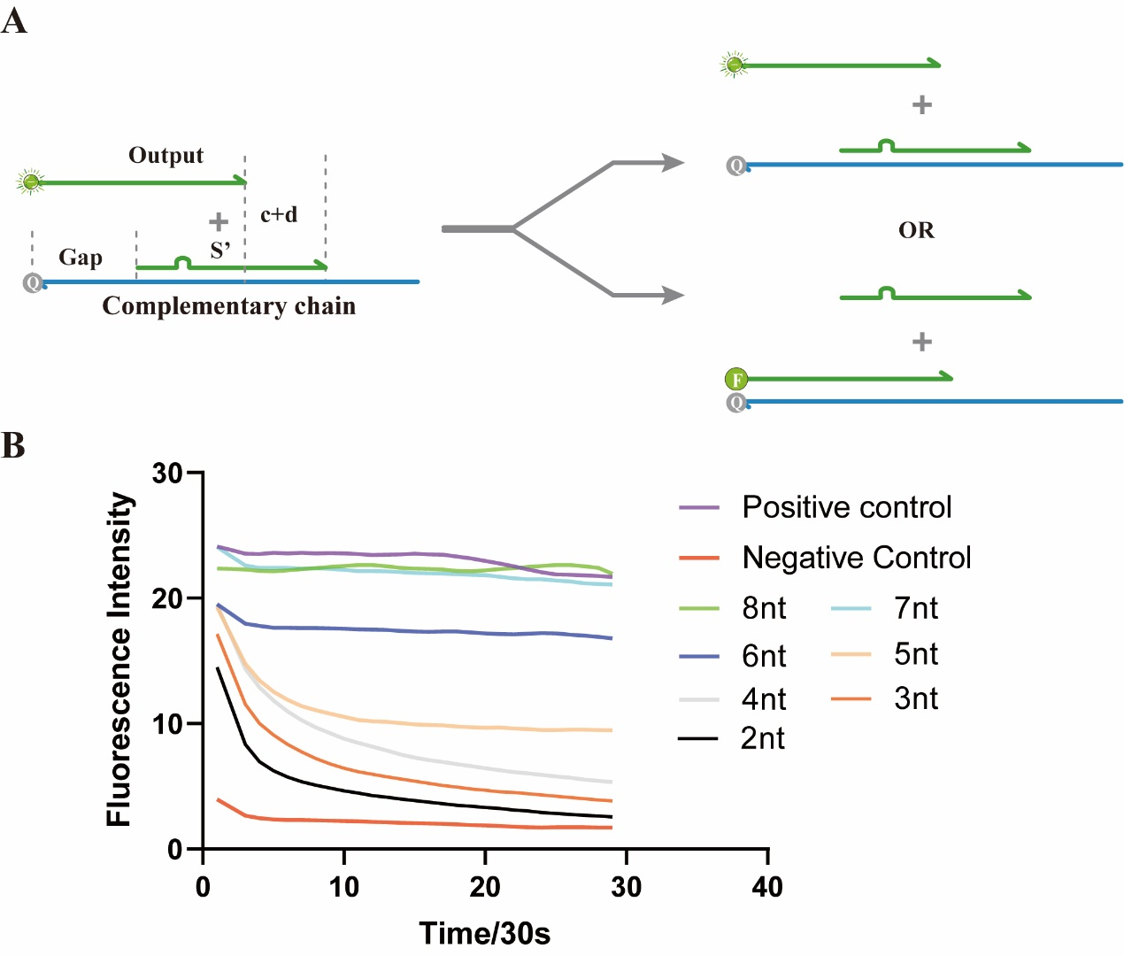
Supplementary Figure S6. Optimize the value of c+d. (A) Schematic diagram of the optimized reaction. (B) Optimization result plots. To ensure that the Input-S’ is not displaced by the Output₁, we optimize the length of the notch at the 5' end of the Input-S’ in the experiments supplementing FigureS4, but it is also closely related to the 3' length of the Input-S’ (i.e., the c+d value). And in order to subsequently ensure that the Input-S’ can be displaced by both the Output and the Input-R, the c+d value should be as small as possible, so we optimized c+d = 7.

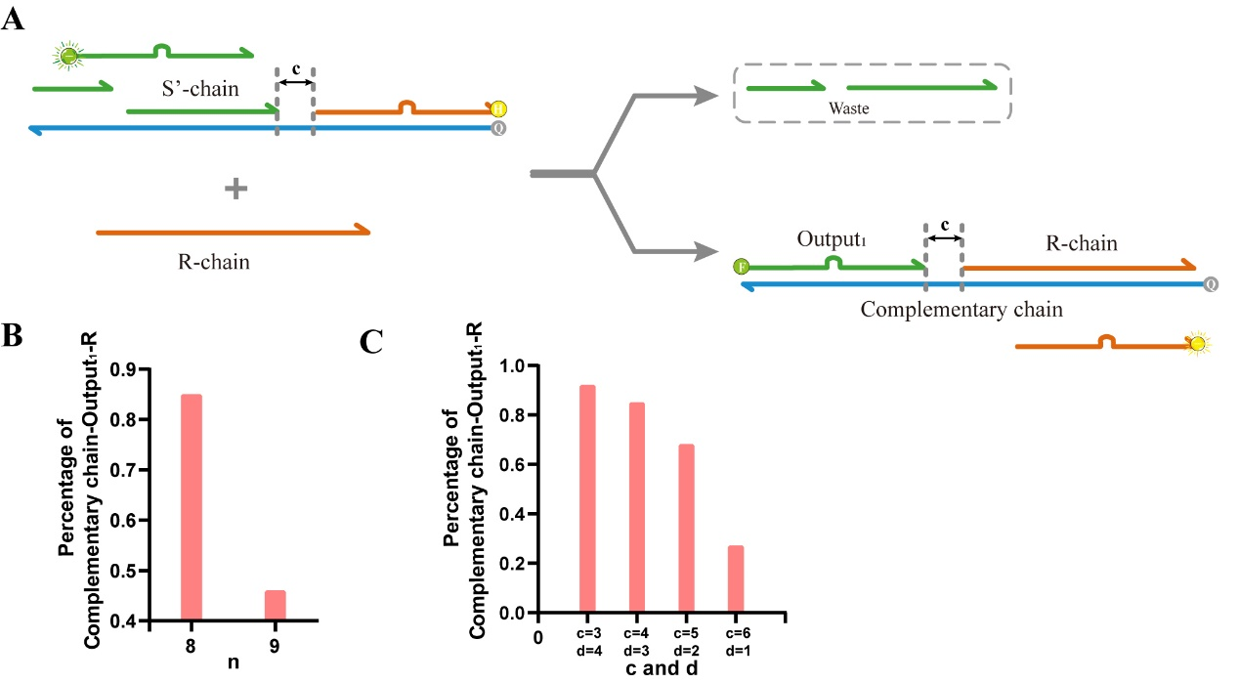
Supplementary Figure S7. Choose the value of n, c and d. (A) Schematic diagram of the optimized reaction. (B, C) NUPACK was utilized to predict the reaction process in which the Output₁, together with the Input-R, displaces the cleaved Input-S’. (B) In summary, we choose n = 8. (C) Considering that area c is the toehold area for subsequent strand replacement, it should not be too short, so c=4, d=3 is chosen.

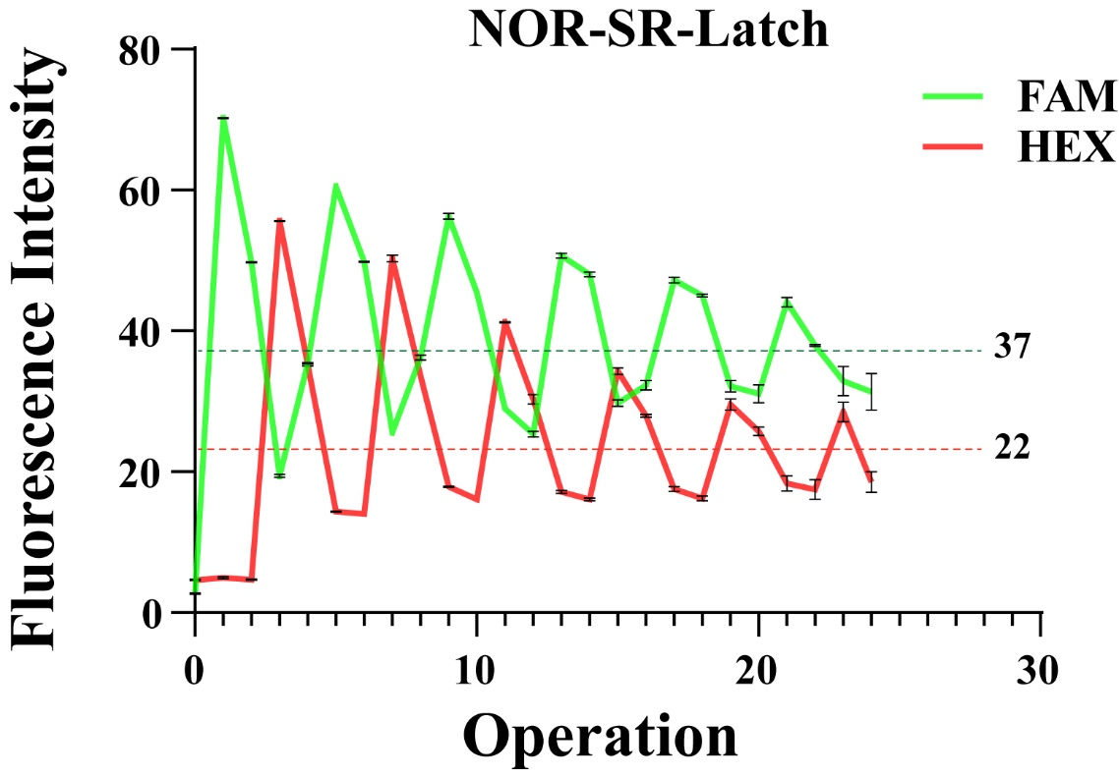
Supplementary Figure S8. Functional verification result diagram of SR latch consisting of NOR gates, after considering the effect of volume on the results.
For the test results of the SR-latch consisting of NOR gates, when the 24th operation started, the average of the lowest fluorescence value when the output of the first 23 operations was 1 (22nd operation of the FAM channel and 20th operation of the HEX channel) and the highest fluorescence value when the output was 0 (8th operation of the FAM channel and 22nd operation of the HEX channel) was taken as the threshold value. Accordingly, following the completion of the reaction, if the fluorescence intensity surpasses 37 in the FAM channel, it indicates the 1 state of O₁. Similarly, a fluorescence intensity exceeding 22 in the HEX channel signifies the 1 state of O₂. The output₂ of the HEX channel after the 24th operation is 1 in theory, but its fluorescence value is lower than 37 in the FAM channel, so output₂ is actually 0 and the experiment was stopped after the 24th operation.

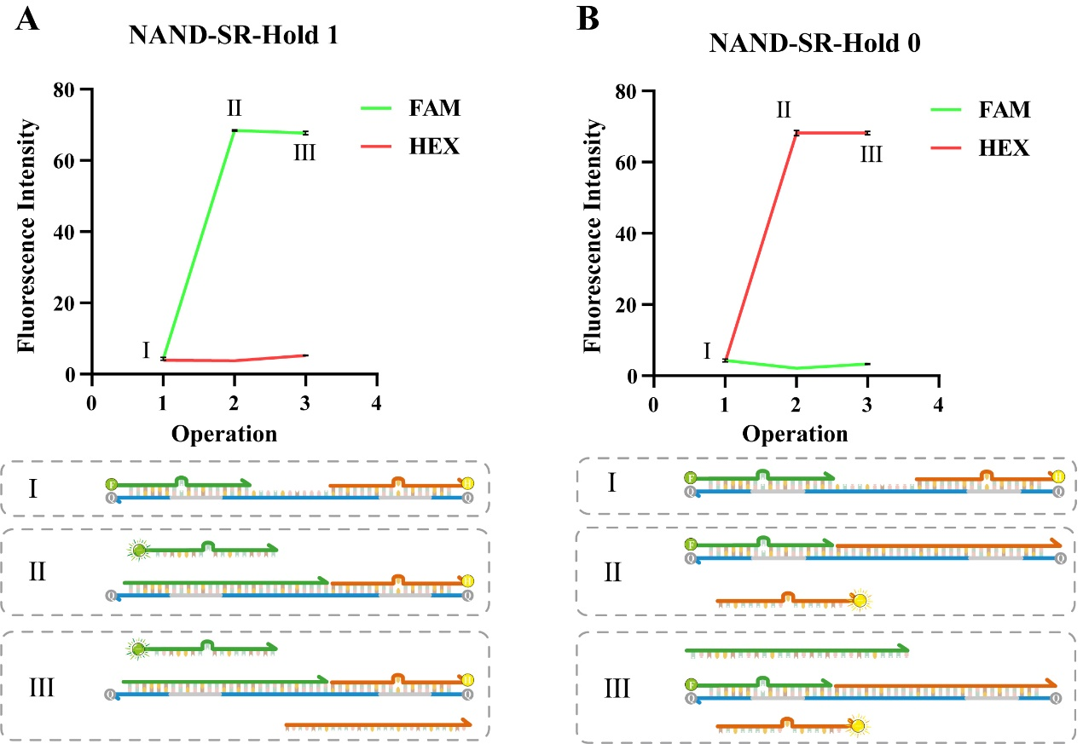
Supplementary Figure S9. NAND-SR-Latch hold function. (A) Hold 1. (B) Hold 0.

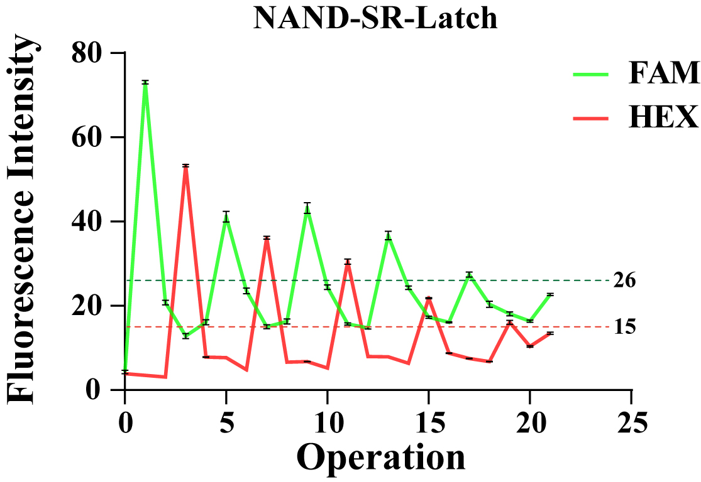
Supplementary Figure S10. Functional verification result diagram of SR-latch consisting of NAND gates, after considering the effect of volume on the results.

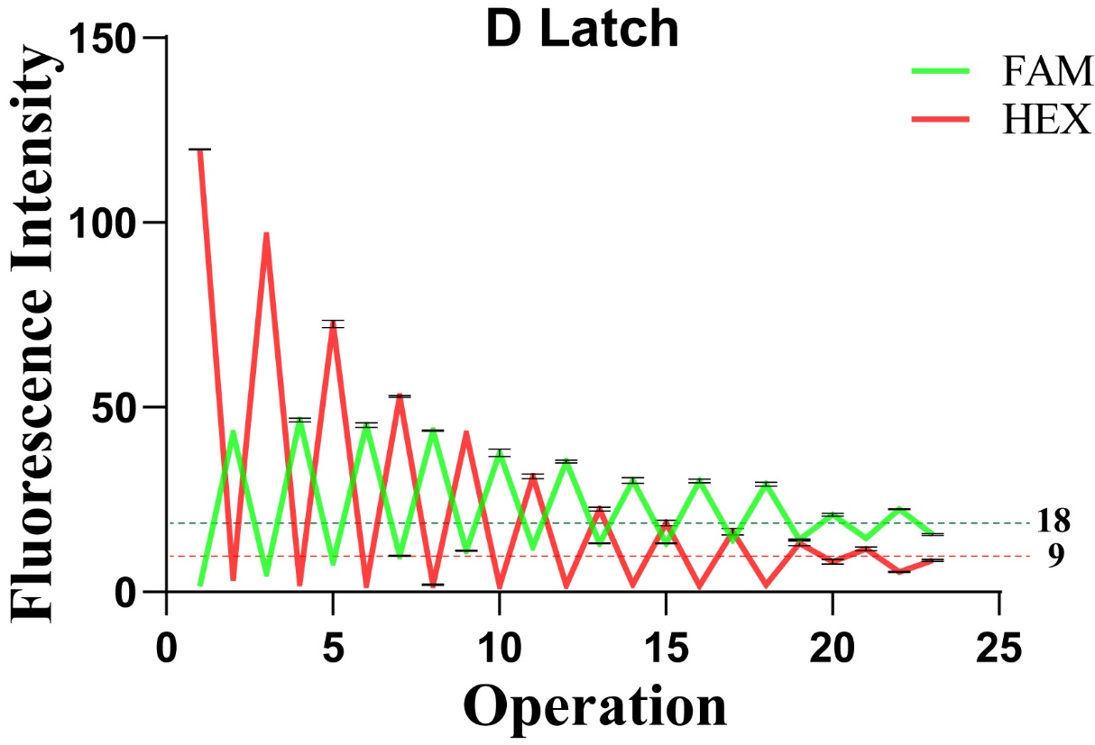
Supplementary Figure S11. Functional verification result diagram of D-latch, after considering the effect of volume on the results

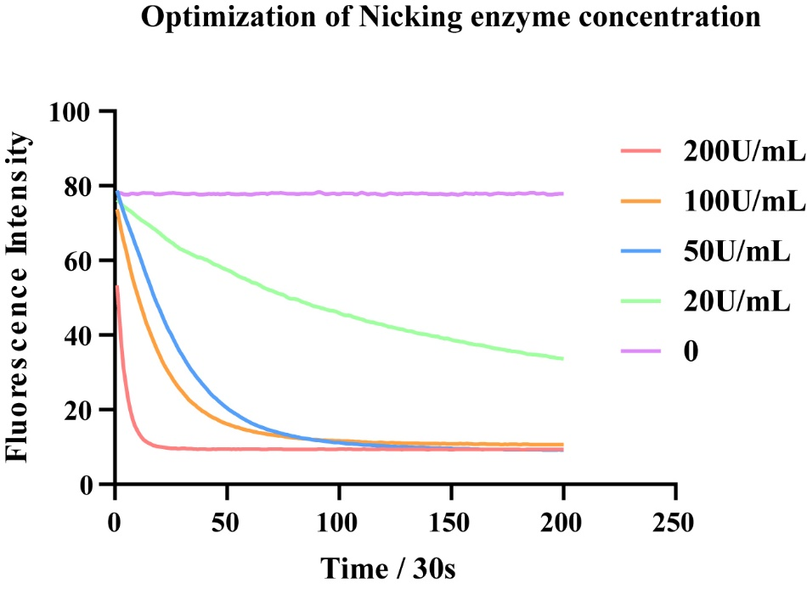
Supplementary Figure S12. Optimization of Nicking Enzyme concentration in subtractive methods. We chose its concentration to be 100 U/mL.
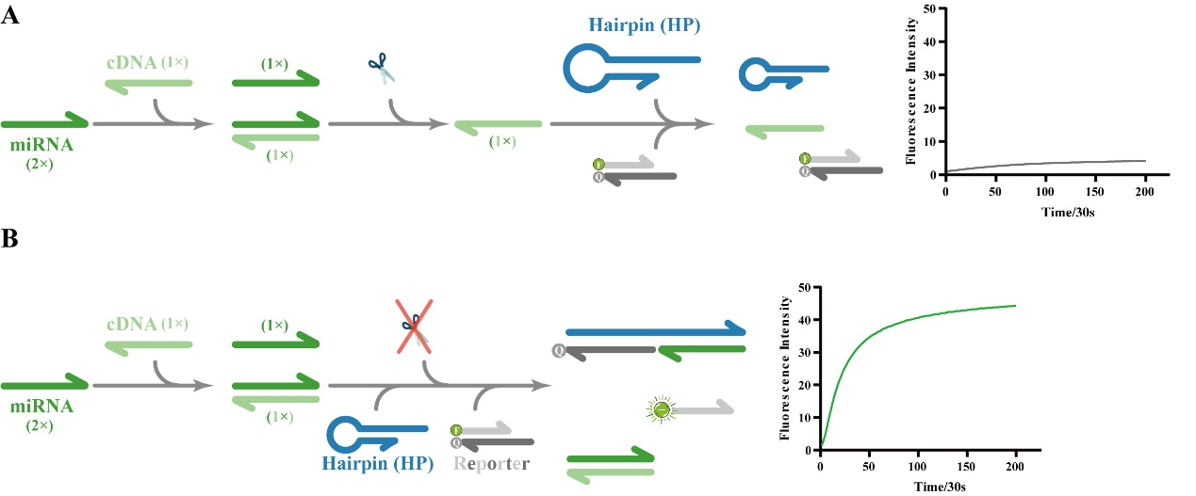
Supplementary Figure S13. (A) The RNA degradation process does not trigger the hairpin. (B) The presence of the free target RNA can trigger the hairpin.

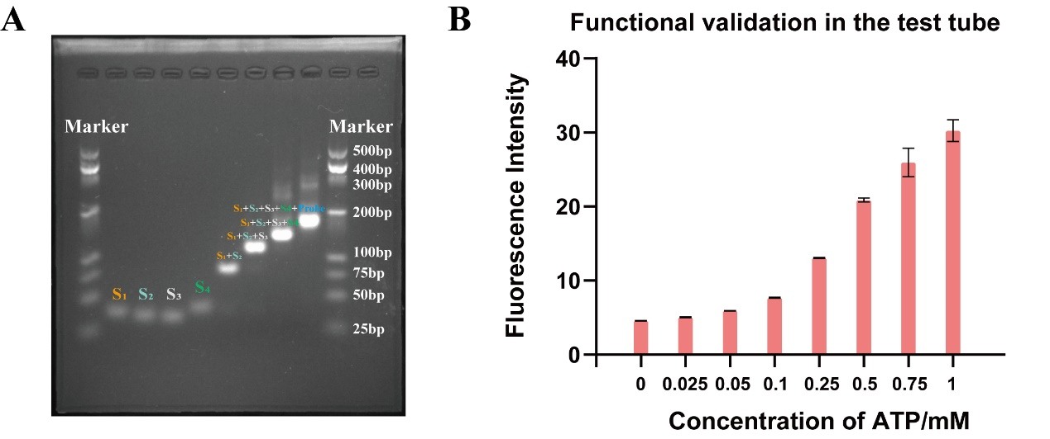
Supplementary Figure S14. (A) Electrophoretic verification of the structure of latches bound to nucleic acid tetrahedra. (B) Functional validation of the "latch-nucleic acid tetrahedron" complex in vitro.

Supplementary tables
Supplementary Table S1 Sequences of the oligonucleotides used in this work
Name | Sequences (5’-3’)
The SR Latch using NOR gate
SR-NOR-Output₁ | FAM-GCTAATGGTGAGGTCTG
SR-NOR-Output₂ | CTACTGAGCAGAGGATC-HEX
SR-NOR-Complementary | BHQ1-GATCCTCAGCTCAGTAGAGTGACCGAGACAGACCTCAGC  ATTAGC-BHQ1
SR-NOR-S | GCTAATGCTGAGGTCTGTCTCGGT
SR-NOR-R | GGTCACTCTACTGAGCTGAGGATC
The SR Latch using NAND gate
SR-NAND-Output₁ | FAM-GCTAATGGTGAGGTCTG
SR-NAND-Output₂ | TGAGGGAGCAGAGGATC-HEX
SR-NAND-Complementary | BHQ1-GATCCTCAGCTCCCTCAGCCCTCAGCGACAGACCTCAGC  ATTAGC-BHQ1
SR-NAND-S | GCTAATGCTGAGGTCTGTCGCTGAGGGC
SR-NAND-R | TCGCTGAGGGCTGAGGGAGCTGAGGATC
The D Latch
D-Complementary | HEX-AAGACCTCAGCAGAAGAG-FAM
D-Output | BHQ1-CTCTTCTGCTGAG
D-D chain | CTCTTCTGCTGAGGTCTT-BHQ1
Addition counter, subtraction counter and reversible counter
Counter-Complementary | AAGACCTCAGCAGAAGAG-FAM
Counter-Output | BHQ1-CTCTTCTGCTGAG
Counter-Input | CTCTTCTGCTGAGGTCTT
Nucleic acid information recorder
Hairpin | TCAACATCAGTCTGATAAGCTAGATACTGGTTCGCTATAGAGTGCTTATCAGACTGA
miRNA-21 | UAGCUUAUCAGACUGAUGUUGA
cDNA | TCAACATCAGTCTGATAAGCTA
Reporter-FAM | FAM-GGTTCGCTATAGAGTGCTTAT
Reporter-BHQ | AGTCTGATAAGCACTCTATAGCGAACC-BHQ1
Toxin sensor
Complementary | TGTCCGATGCTTTTTTTTTTTTTTTTTTTTTTTTTTTTTTTACAACACGTGCAC
AFB1-Aptamer | GTGCACGTGTTGTCTCTCTGTGTCTCGTGC
OTA-Aptamer | GATCGGGTGTGGGTGGCGTAAAGGGAGCATCGGACA
Bioinformation (ATP) storage
S1 | ACATTCCGTCTGAAACATTACATGCTACACGAGAAGAGCCATAGTATTTTTTACCTGGGGGAGTATTGCGGAGGAAGGT-BHQ1
S2 | TATCACCCAGTTGACAGTGTAGCATGTAATAGATGCGAGCCAATACTTTTTTACCTGGGGGAGTATTGCGGAGGAAGGT-BHQ1
S3 | TCAACTGGGTGATAAAACGACACTTGGGAATCTACTATGGCTCTTCTTTTTTACCTGGGGGAGTATTGCGGAGGAAGGT-BHQ1
S4 | TTCAGACGGAATGTGCTTCCCAAGTGTCGTTTGTATTGGCTCGCATTTTTTTACCTGGGGGAGTATTGCGGAGGAAGGT-BHQ1
Probe | FAM-A*C*C*T*T*C*C*T*C*C*G*C*A*A (*-Phosphorothioate)
Supplementary Figure S3. Evaluation of nicking enzyme
Nickase-Complementary | FAM-AAGAGCTGAGGAGAA-BHQ
Nickase-match | TTCTCCTCAGCTCTT
Nickase-1st mis | TTCTGCTCAGCTCTT
Nickase-2nd mis | TTCTCGTCAGCTCTT
Nickase-3rd mis | TTCTCCACAGCTCTT
Nickase-4th mis | TTCTCCTGAGCTCTT
Nickase-5th mis | TTCTCCTCTGCTCTT
Nickase-6th mis | TTCTCCTCACCTCTT
Nickase-7th mis | TTCTCCTCAGGTCTT
Supplementary Figure S5. Optimize the length of the gap
Gap-Complementary | CTGATAAGCTAGAAGACCCGAGACAGAAGTGAGCCTCAGC-BHQ1
Gap-Output | FAM-GCTGACGCTCACTTCTG
Gap-S’-3nt | GAGGCTCACTTCTGTCTCGGGT
Gap-S’-4nt | AGGCTCACTTCTGTCTCGGGT
Gap-S’-5nt | GGCTCACTTCTGTCTCGGGT
Gap-S’-6nt | GCTCACTTCTGTCTCGGGT
Gap-S’-7nt | CTCACTTCTGTCTCGGGT
Gap-S’-8nt | TCACTTCTGTCTCGGGT
Gap-S’-9nt | CACTTCTGTCTCGGGT
Gap-S’-10nt | ACTTCTGTCTCGGGT
Gap-S’-11nt | CTTCTGTCTCGGGT
Gap-S’-12nt | TTCTGTCTCGGGT
Gap-S’-13nt | TCTGTCTCGGGT
Gap-S’-14nt | CTGTCTCGGGT
Supplementary Figure S6. Optimize the value of c+d
c+d-Complementary | CTGATAAGCTAGAAGACCCGAGACAGAAGTGAGCCTCAGC-BHQ1
c+d-Output | FAM-GCTGACGCTCACTTCTG
c+d-8nt | TCACTTCTGTCTCGGGT
c+d-7nt | TCACTTCTGTCTCGGG
c+d-6nt | TCACTTCTGTCTCGG
c+d-5nt | TCACTTCTGTCTCG
c+d-4nt | TCACTTCTGTCTC
c+d-3nt | TCACTTCTGTCT
c+d-2nt | TCACTTCTGTC
Supplementary Figure S7. Choose the value of n, c and d
n=8-Complementary | BHQ1-GATCCTCAGCTCAGTAGAGTG ACCGAGA CAG ACCTCA GCATTAGC-BHQ1
n=8-Output₁ | FAM-GCTAATGGTGAGGTCTG
n=8-Output₂ | CTACTGAGCAGAGGATC-HEX
n=8-S | GCTAATGCTGAGGTCTGTCTCGGT
n=8-R | GGTCACTCTACTGAGCTGAGGATC
n=9-Complementary | BHQ1-GATCCTCAGCTCAGTAGAGTGACCGAGA CAG ACCTCA GCATTAGC-BHQ1
n=9-Output₁ | FAM-GCTAATGCAGAGGTCTG
n=9-Output₂ | CTACTGAGGTGAGGATC-HEX
n=9-S | GCTAATGCTGAGGTCTGTCTCGGT
n=9-R | GGTCACTCTACTGAGCTGAGGATC
c3d4-Complementary | BHQ1-GATCCTCAGCTCAGTAGATGACGCGAACAGACCTCAGCA  TTAGC-BHQ1
c3d4-Output₁ | FAM-GCTAATGGTGAGGTCTG
c3d4-Output₂ | CTACTGAGCAGAGGATC-HEX
c3d4-S | GCTAATGCTGAGGTCTGTTCGCGT
c3d4-R | GCGTCATCTACTGAGCTGAGGATC
c4d3-Complementary | BHQ1-GATCCTCAGCTCAGTAGAGTGACCGAGACAGACCTCAGC  ATTAGC-BHQ1
c4d3-Output₁ | FAM-GCTAATGCAGAGGTCTG
c4d3-Output₂ | CTACTGAGGTGAGGATC-HEX
c4d3-S | GCTAATGCTGAGGTCTGTCTCGGT
c4d3-R | GGTCACTCTACTGAGCTGAGGATC
c5d2-Complementary | BHQ1-GATCCTCAGCTCAGTAGAAAAA CCAAAAACAGACCTCA GCATTAGC-BHQ1
c5d2-Output₁ | FAM-GCTAATGGTGAGGTCTG
c5d2-Output₂ | CTACTGAGCAGAGGATC-HEX
c5d2-S | GCTAATGCTGAGGTCTGTTTTTCC
c5d2-R | GTTTTTTCTACTGAGCTGAGGATC
c6d1-Complementary | BHQ1-GATCCTCAGCTCAGTAGAGGGGGAGGGGGACAGACCTC  AGCATTAGC-BHQ1
c6d1-Output₁ | FAM-GCTAATGGTGAGGTCTG
c6d1-Output₂ | CTACTGAGCAGAGGATC-HEX
c6d1-S | GCTAATGCTGAGGTCTGTCCCCCT
c6d1-R | TCCCCCTCTACTGAGCTGAGGATC

Supplementary Table S2. Comparison of existing sequential logic circuits
Study | Uniform Inputs | Reusable | Expandability in DNA circuits (Input and Output are DNA strands)
(1) | × | × | ×
(2) | √ | × | √
(3) | × | × | ×
(4) | × | × | √
(5) | × | × | √
(6) | × | × | √
This | √ | √ | √

Reference
1. Zhang, C., Shen, L., Liang, C., Dong, Y., Yang, J. and Xu, J. (2016) DNA Sequential Logic Gate Using Two-Ring DNA. ACS Appl Mater Interfaces, 8, 9370-9376.
2. Tang, W., Zhong, W., Fan, J., Tan, Y., Huang, Q. and Liu, Y. (2019) Addressable activated cascade DNA sequential logic circuit model for processing identical input molecules. Chem Commun (Camb), 55, 6381-6384.
3. Zhao, J., Pokhilko, A., Ebenhöh, O., Rosser, S.J. and Colloms, S.D. (2019) A single-input binary counting module based on serine integrase site-specific recombination. Nucleic Acids Res, 47, 4896-4909.
4. Scalise, D., Rubanov, M., Miller, K., Potters, L., Noble, M. and Schulman, R. (2020) Programming the Sequential Release of DNA. ACS Synth Biol, 9, 749-755.
5. Guo, Z., Zhang, X. and Zhou, S.H. (2023) Sequential logic circuit built on λ exonuclease for cross inhibition. New Journal of Chemistry, 47, 8925-8932.
6. Zhang, M., Yancey, C., Zhang, C., Wang, J., Ma, Q., Yang, L., Schulman, R., Han, D. and Tan, W. (2024) A DNA circuit that records molecular events. Sci Adv, 10, eadn3329.

