Extended Data Figures
Extended Data Fig. 1
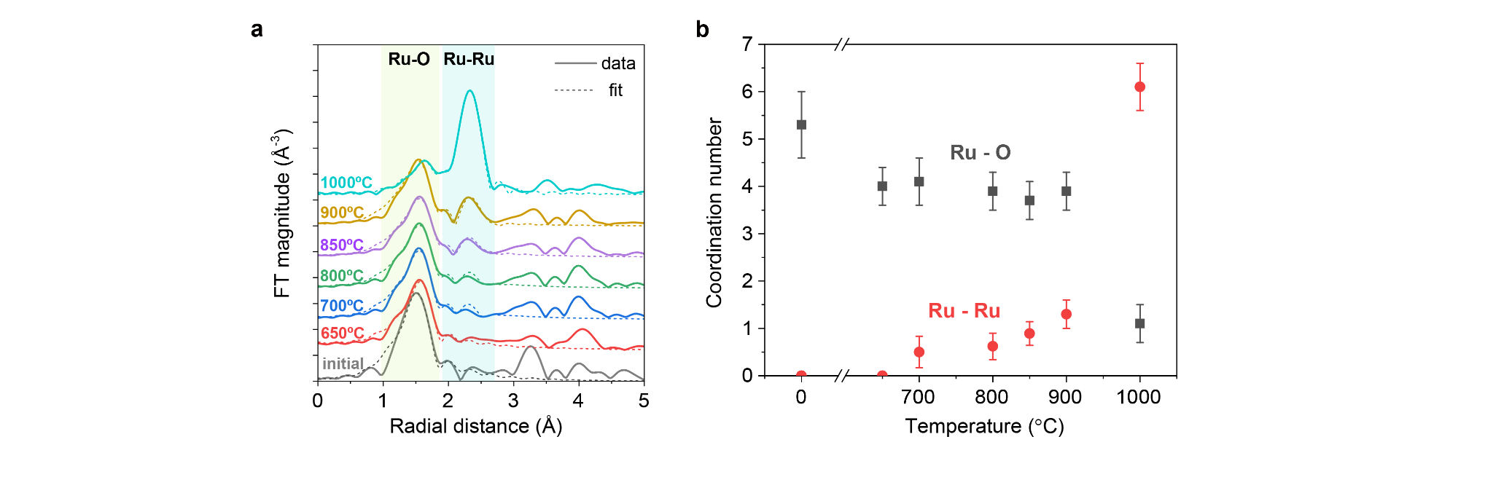
Extended Data Fig. 1 | Ru K edge EXAFS analyses. a, Fourier transformed k²-weighted EXAFS oscillations (FT-EXAFS) of the Ru-doped-BCY at initial, 650, 700, 800, 850, 900, and 1000 °C reduction treatments. Lines indicate experimental data and dash lines indicate fitted results. b, Coordination numbers of Ru-Ru (red) and Ru-O (black) bonds from EXAFS fitting.
Extended Data Fig. 2
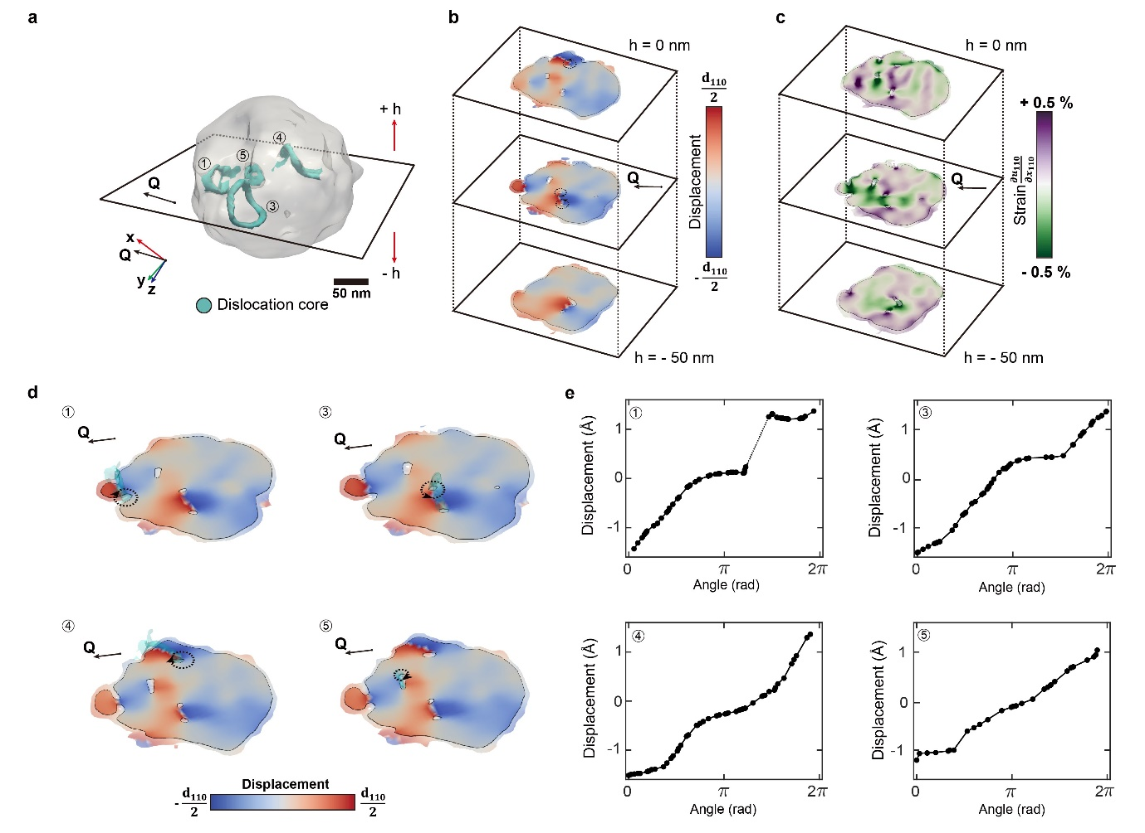
Extended Data Fig. 2 | Dislocation topology and Burger vector analysis for another example. a, 3D dislocation topology after exsolution (210 min after H₂ exposure). Semi-transparent surface represents 20% iso-surface and cyan regions show a dislocation line. b, c, Displacement field (k) and strain field (i) along Q are mapped on the three slices in different positions. A black solid line indicates 20% iso-level and opaque regions indicate 10% iso-level with low Bragg electron density near the dislocation core. A total of four dislocations are resolved. d, Cross-section of displacement field at each of four dislocation cores. e, Magnitude of displacement field along the radial coordinates at 20 nm from two singular spirals. A missing part of the radial plot due to the dislocation termination is represented as a dashed line. Note that a 10 nm radius was used for dislocation #5 because of the small size. Overall dislocations show net displacement corresponds to d₁₁₀ whereas dislocation #5 shows net displacement corresponds to the d₁₀₀ projected onto Q = [110] with a 45° interplanar angle implying b = a[100], which is another primary Burgers vector in the perovskite structure.

Extended Data Fig. 3
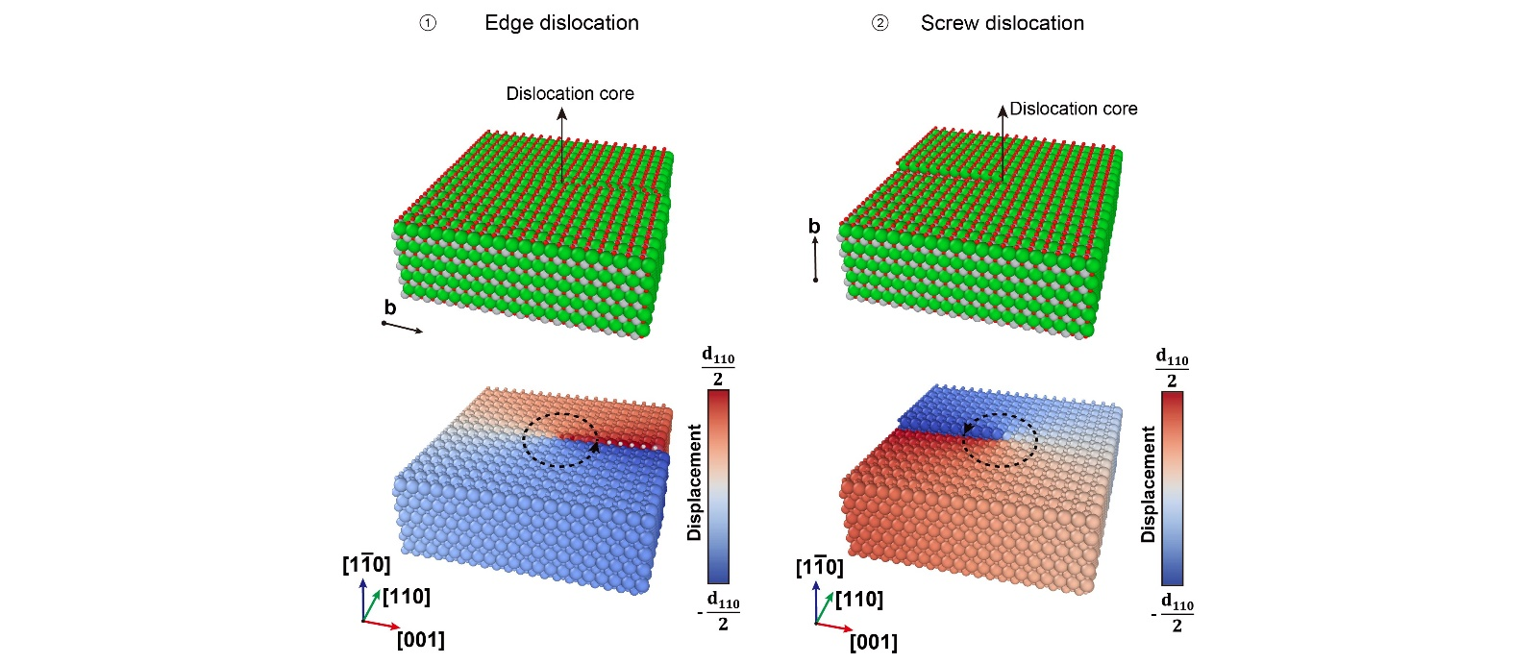
Extended Data Fig. 3 | Identifications of Burgers circuit in BCDI. Modeling of edge and screw dislocations in a perovskite lattice system. The displacement fields for both dislocation types are depicted below. The radial-line integral of displacement around the dislocation core corresponds to the length of the Burgers circuit projected onto Q. Therefore, a net displacement equivalent to d₁₁₀ indicates b = $\frac{a}{2}$[110] which is parallel to the Q.

Extended Data Fig. 4
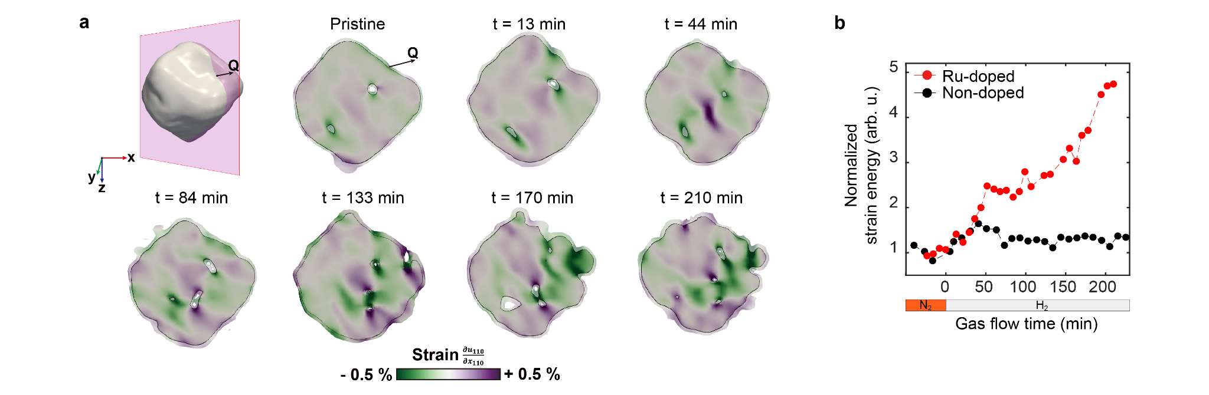
Extended Data Fig. 4 | In situ strain evolution for another Ru-doped BCY for another example. a, In situ strain evolution as a function of time. The Q-including slices are taken at the center of the NP (red frame). 20% and 10% iso-level slices are represented by solid lines and opaque regions, respectively. Evolution of strain and consequent dislocation nucleation are depicted. b, Normalized strain energy for Ru-doped and undoped NP. Note that each strain energy is normalized with average strain energy at the pristine state.
Extended Data Fig. 5
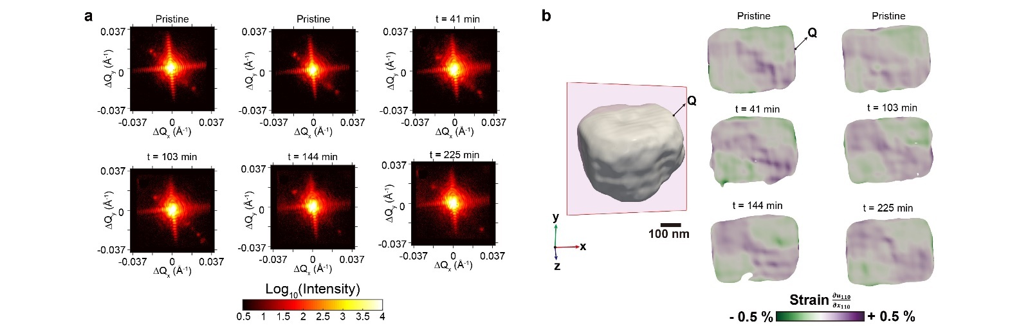
Extended Data Fig. 5 | Comparisons with non-doped BCY. a, CXD patterns along H₂ exposure time. Four-fold symmetric feature at the pristine states is maintained as a function of time, indicating no structural deformation exists. Note that all CXD patterns are projected along the ΔQ_{z} rotation direction. b, In situ strain evolution as a function of time for non-doped BCY. The Q-including slices are taken at the center of the NP (red frame). There are no significant changes in the strain field after exposure to the atmosphere.

Extended Data Fig. 6
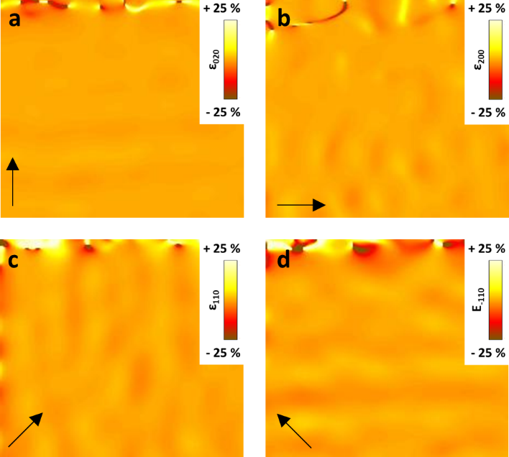
Extended Data Fig. 6 | Strain analyses at non-dislocation region. Calculated strain maps for a, (020), b, (200), c, (110), and d, (-110) reflections from non-dislocation area (where far from dislocations), divulging no significant strain, which demonstrates strains near dislocation area are the result of relevant structure distortions.

Extended Data Fig. 7
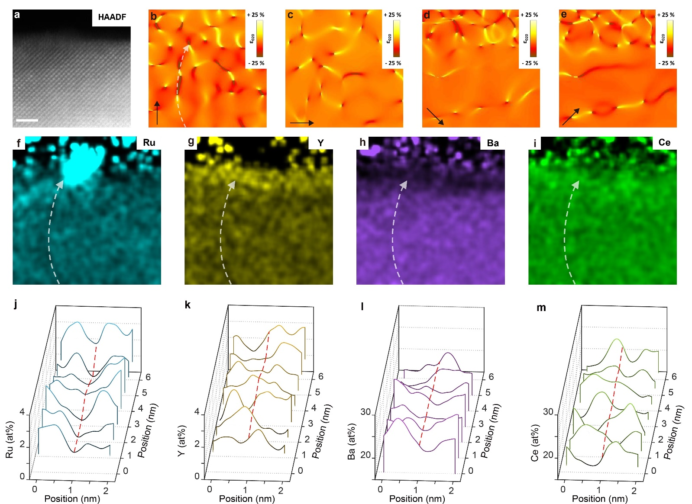
Extended Data Fig. 7 | Detailed strain and elemental analyses at mixed dislocation. a, High-resolution STEM-HAADF micrograph at mixed dislocation core for strain analyses and elemental maps. Corresponding calculated strain maps for b, (020), c, (200), d, (1-10), and e, (110). Quantified EDS maps of f, Ru, g, Y, h, Ba, i, and Ce; corresponding line-integration profiles across the dislocation cores for j, Ru, k, Y, l, Ba, and m, Ce. (scale bar = 2 nm)

Extended Data Fig. 8
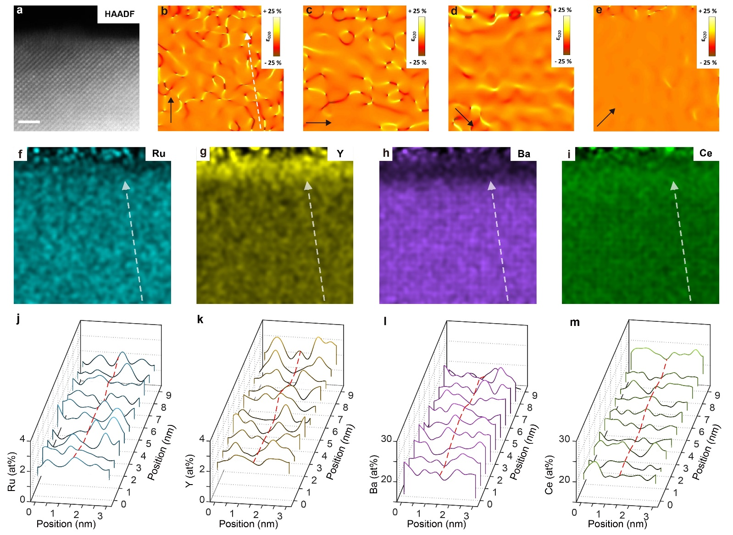
Extended Data Fig. 8 | Detailed strain and elemental analyses at edge dislocation. a, High-resolution STEM-HAADF micrograph at mixed dislocation core for strain analyses and elemental maps. Corresponding calculated strain maps for b, (020), c, (200), d, (1-10), and e, (110). Quantified EDS maps of f, Ru, g, Y, h, Ba, i, Ce; corresponding line-integration profiles across the dislocation cores for j, Ru, k, Y, l, Ba, and m, Ce. (scale bar = 2 nm.)

Extended Data Fig. 9
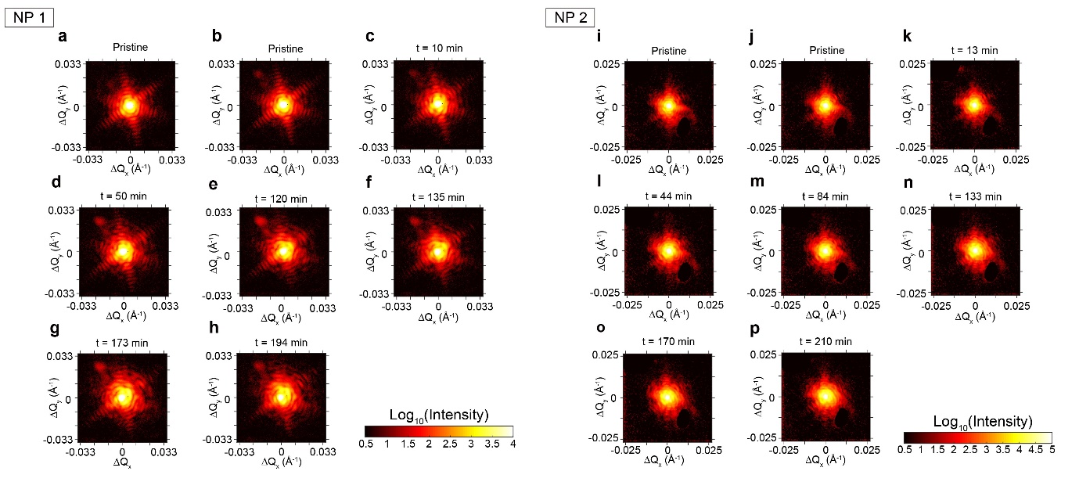
Extended Data Fig. 9 | CXD pattern changes during exsolution for NP 1 and 2. a-h, CXD patterns along H₂ exposure time. Three-fold symmetric feature at the pristine states is distorted with exsolution. Note that all CXD patterns are projected along the ΔQ_{z} rotation direction. i-p, CXD pattern changes along with reduction for another NP. Likewise, the symmetric feature at the pristine states is distorted with exsolution. Note that the blank region at the bottom right of the CXD patterns is removed because of alien signals from neighboring crystals.

Extended Data Fig. 10
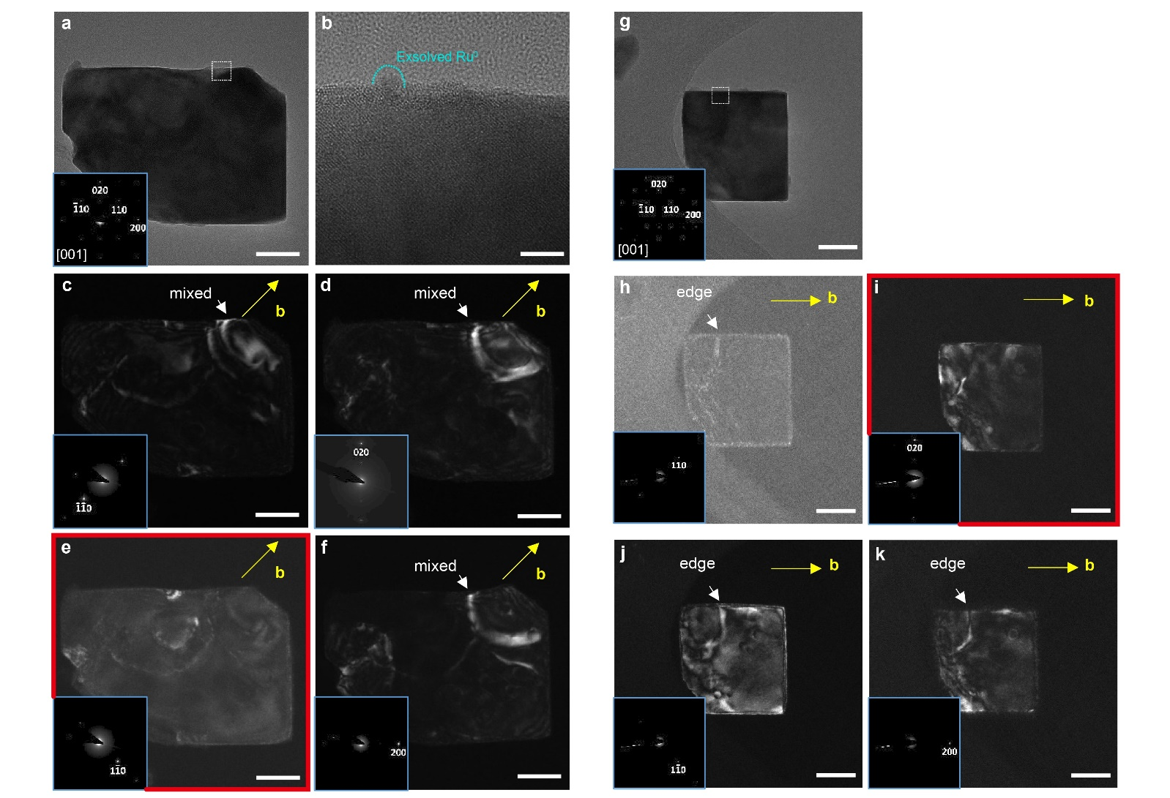
Extended Data Fig. 10 | Determination of dislocation classification using WBDF imaging. a, BF-TEM of a single matrix (doped); inset of (a) shows selected area electron diffraction (SAED) with indexed at [001] zone-axis (mixed dislocation). b, high-resolution (HR) TEM micrographs of the highlighted area on (a) were observed at normal conditions to show an exsolved Ru nanoparticle. Weak-beam dark-field (WBDF) TEM images with c, (-1-10), d, (020), e, (1-10), and f, (200) reflections. g, BF-TEM of one more single matrix (doped); inset of (g) presents SAED with indexed at [001] zone-axis (edge dislocation). WBDF TEM micrographs with h, (110), i, (020), j, (1-10), and k, (200) reflections. Note that scale bar = 50 nm for (a) and (c-k) and = 5 nm for (b). The g vectors with no dislocation visibility are marked with red frames (e and i).

