Supplementary Information

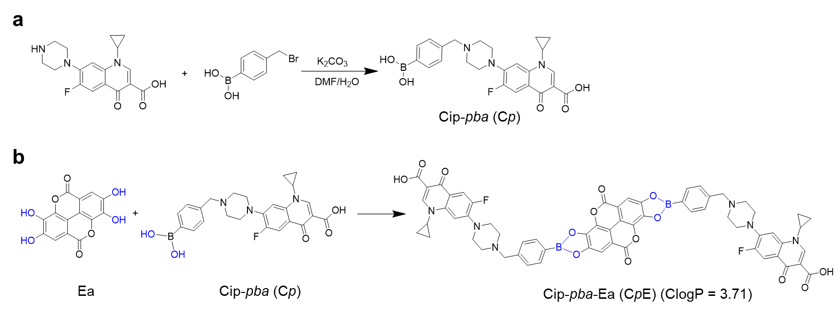
Supplementary Fig. 1 Synthetic route of Cp and CpE.

Supplementary Fig. 2 NMR and mass spectrum of prodrug Cp and CpE. a ¹¹B NMR spectrum of Cp and CpE measured by NMR spectroscopy (AVANCE III 400 MHz, Bruker, Germany) in DMSO-d₆. b Mass spectrum of CpE measured by mass spectrum (Agilent 6520Q, California, USA). c,d ¹H-¹H COSY (c) and ¹H-¹H NOSY (d) spectra of CpE determined by NMR spectroscopy (AVANCE III 400 MHz, Bruker, Germany) in methanol-d₄.

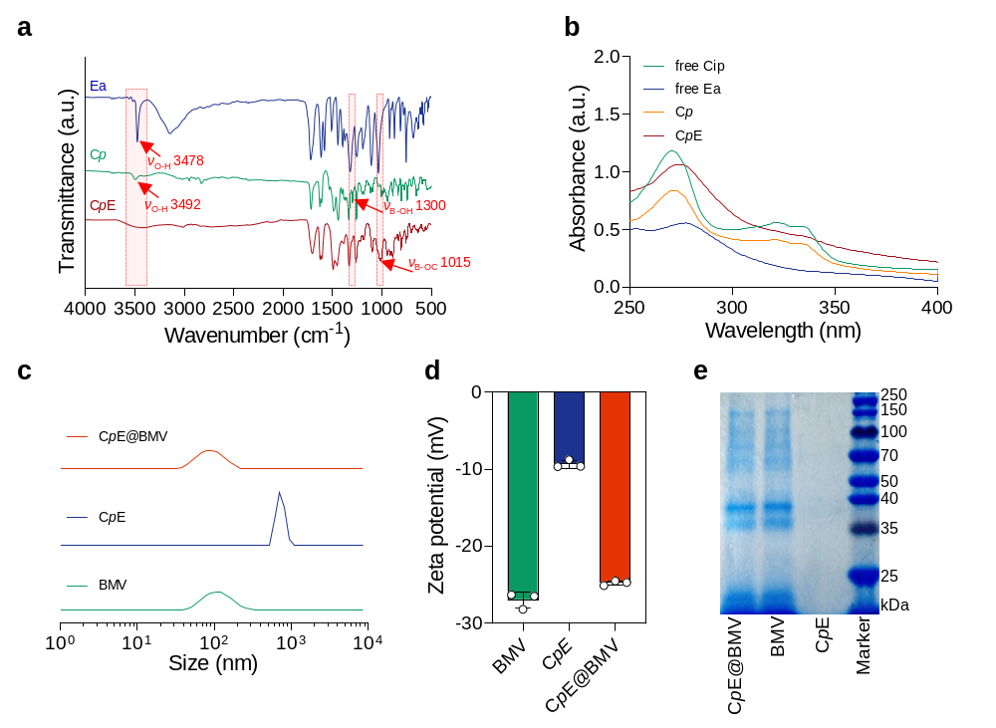
Supplementary Fig. 3 Characterizations of CpE and CpE@BMV. a FT-IR spectrum of Ea, Cp, and CpE were measured by Tensor II spectrometer (Bruker, Germany). The arrows around 3478 cm⁻¹ and 3492 cm⁻¹ represent the O-H bond of Ea and Cp, respectively. b UV-vis absorption spectra of Cip, Ea, Cp, and CpE. c,d Size distributions (c) and zeta potential (d) of BMV, CpE, and CpE@BMV as determined by Malvern Zetasizer Nano ZS90 (Malvern, UK) (n = 3 biological replicates). e SDS-PAGE electrophoresis of the total proteins of CpE@BMV. The proteins were stained with Coomassie Brilliant Blue.

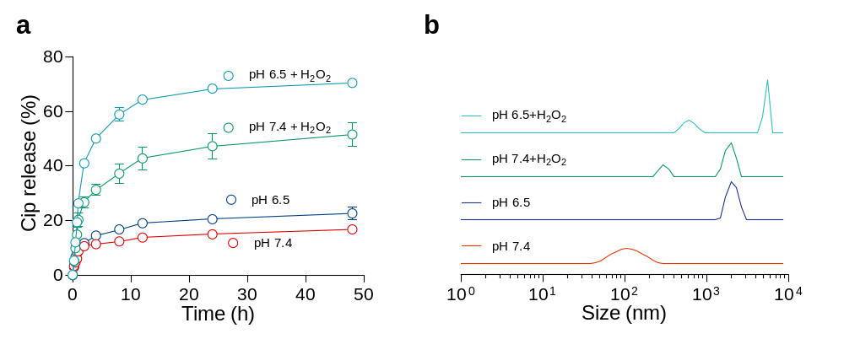
Supplementary Fig. 4 pH/H₂O₂ sensitivity of CpE@BMV. a,b Cumulative Cip release (a) and size distribution (b) of CpE@BMV after incubation with PB buffer (pH 7.4 or 6.5) with or without H₂O₂ (100 µM) (n = 3 biological replicates).

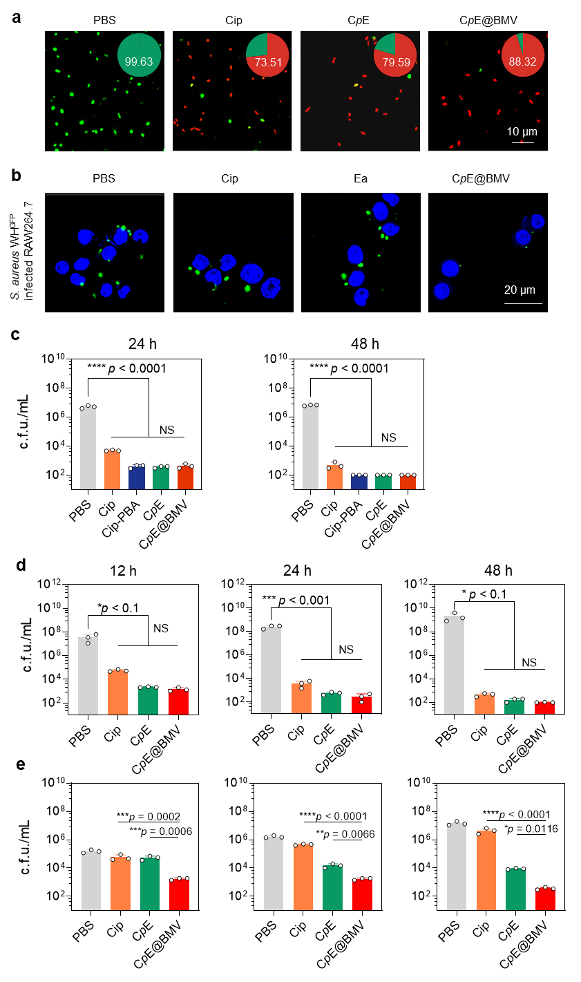
Fig S5. CpE@BMV eradicates planktonic S. aureus WH^{GFP}, intracellular S. aureus WH^{GFP} and E. coli Xen14. a, Representative CLSM images of E. coli Xen14 after various treatments, followed by live/dead staining. Pie charts show the percentage of green and red fluorescence. b, CLSM images of S. aureus WH^{GFP} inside RAW 264.7 cells after various treatments. c, Statistical analysis of the c.f.u. of S. aureus WH^{GFP} outside RAW 264.7 macrophages after different treatments for 24 hours and 48 hours. d,e, Quantification of the c.f.u. of E. coli Xen14 remaining in the supernatant (d) and intracellular (e) compartments at different time intervals in the co-cultures of E. coli Xen14, RAW 264.7 macrophages, and various formulations. Statistical significance was determined by one-way ANOVA with Tukey’s multiple comparisons test.
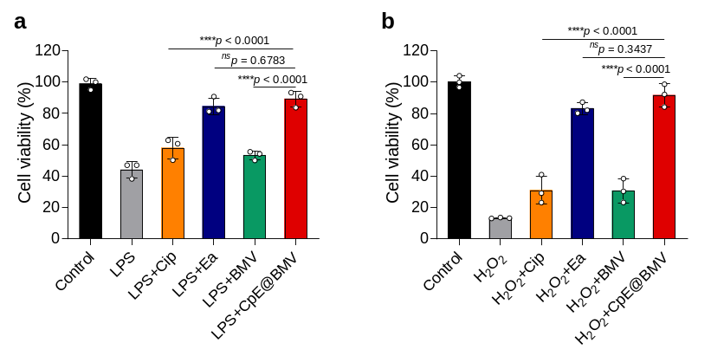
Supplementary Fig. 6 Cell viability of RAW 264.7. RAW 264.7 was pretreated with LPS (2 μg/mL) (a) and H₂O₂ (1 mM) (b) for 2 h, and further incubated with Cip, Ea, BMV, and CpE@BMV for 24 hours (n = 3 biological replicates). The cell viability was analyzed by CCK-8. Data are presented as means ± s.d. Statistical significance was determined by one-way ANOVA with Tukey’s multiple comparisons test.

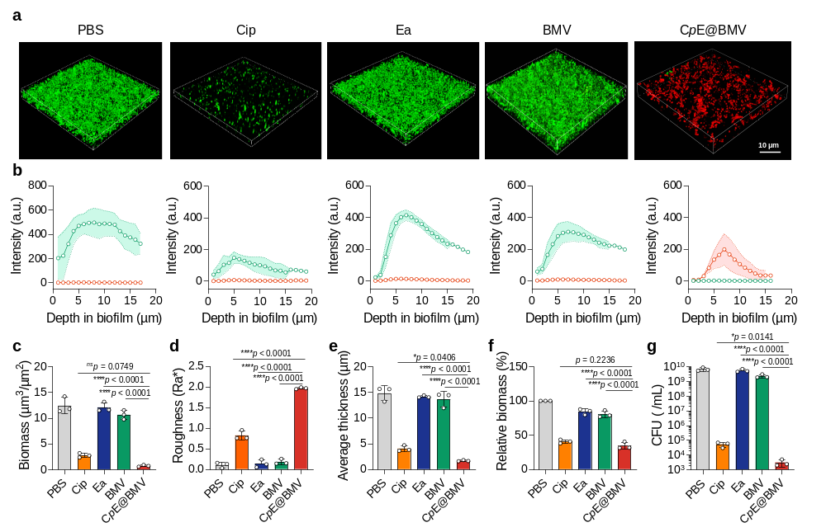
Supplementary Fig. 7 CpE@BMV eradicate E. coli Xen14 biofilms. a Representative 3D CLSM image of E. coli biofilms exposed to various treatments. b, Quantified fluorescence intensity in each CLSM plane as a function of depth in biofilm. c-e, Biomass (c), roughness (d), and average thickness (e) calculated using Comstat 2.1 ImageJ plugin (n = 3 biological replicates). f Relative biomass of E. coli biofilms after different treatments and crystal violet staining (n = 3 biological replicates). g c.f.u. enumeration of E. coli biofilms after various treatments (n = 3 biological replicates). Data are presented as means ± s.d. Statistical significance was determined by one-way ANOVA with Tukey’s multiple comparisons test.

Mature Biofilm Dispersal
To grow mature biofilms, briefly, a bacterial suspension of E. coli Xen14 (1 mL, 2×10⁸ bacteria/mL) was added to each dish and incubated at 37 °C for another 1 h to allow the adhesion of bacteria. The bacterial suspension was removed carefully, and the dishes were washed with PBS (1 mL × 3). Then LB medium (2 mL) was added to each dish and incubated at 37 °C for 12 h. To study the interactions of PMBA4 assemblies with bacterial biofilms, a suspension of PBS containing Cip, Ea, BMV and CpE@BMVs with an equal Cip concentration of 0.44 μg/mL was added to the resultant biofilms and incubated at 37 °C for 4 h. The supernatants were removed, and the biofilms were stained with SYTO™ 9 and PI for 15 min, fixed with a 4% fixative solution (Solarbio, Beijing), and observed on a Nikon A-1 (Nikon, Japan) confocal laser scanning microscope. The ImageJ software (version 1.8.0) was used to reconstruct the 3D images of biofilms, analyze the fluorescence intensity in each confocal plane, and construct the green fire blue images of the representative confocal plane at a depth of 6 μm from the biofilm bottom. Biofilms treated with PBS served as the control.
For CFU counting, The remaining biofilms were dispersed with PBS (200 µL), homogenized by a pipet, serially diluted, and spread on BHI agar plates. The bacterial colony grown overnight on the agar plates were recorded and compared. For viability calculation, after incubation, 100 µL of crystal violet solution (0.20 mg/mL) was added to the corresponding well. After further incubation at room temperature for 20 min, the crystal violet solution was removed. An aliquot of 100 µL of 90% ethanol was added to each well to solubilize the purple solid, and then the OD value was collected at 570 nm on a microplate reader. Wells containing only BHI medium were used as the blank. The percentage of surviving cells within the biofilm was calculated from
$Biofilm \left(\%\right)=\frac{A_{570}^{Sample}}{A_{570}^{Control}}$× 100%
Where $A_{570}^{Sample}$ denotes the absorbance at 570 nm of samples, $A_{570}^{Control}$ denotes the absorbance at 570 nm of control.

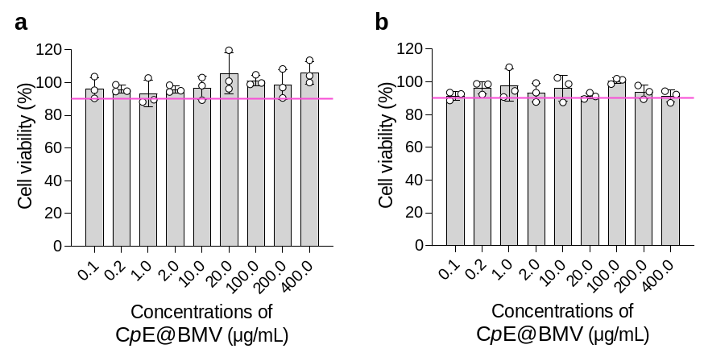
Supplementary Fig. 8 Cell viability of RAW 264.7 (a) and L929 (b). RAW 264.7 and L929 cells were seeded into 96-well plates overnight, and incubated with various concentrations of CpE@BMV for 24 h. Cell viability was measured by CCK-8. Data are presented as means ± s.d.

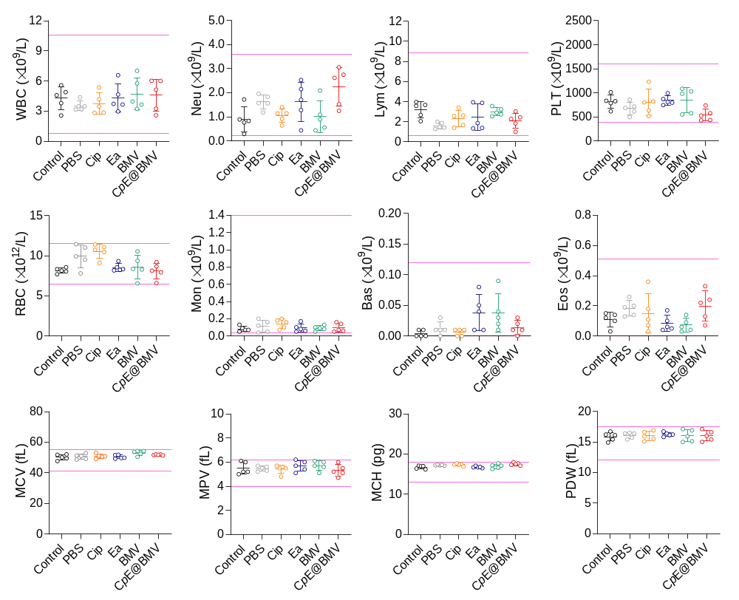
Supplementary Fig. 9 Hematological parameters of pneumonia-bearing BALB/c mice after receiving various treatments. WBC: white blood cells, Neu: neutrophils, Lym: lymphocytes, PCT: platelet count, RBC: red blood cells, Mon: monocytes, Eos: eosinophils, Bas: basophils, MCV: mean corpuscular volume, MPV: mean platelet volume, MCH: mean corpuscular hemoglobin, and PDW: platelet distribution width. The value between two purple lines indicates the normal range. Data are presented as means ± s.d.

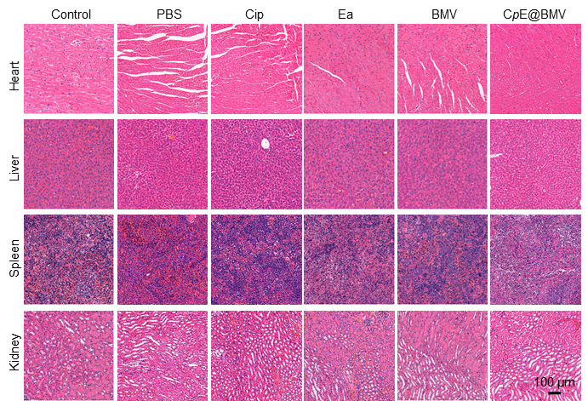
Supplementary Fig. 10 Representative H&E images of the heart, liver, spleen, and kidney. E. coli-infected pulmonary model was established in female BALB/c mice, and various formulations were administrated on days 1, 2, 3, and 6. The injected Cip, Ea, and BMV doses were 1.76 mg/kg, 0.76 mg/kg, and 1.12 mg/kg, respectively. Scale bar: 100 µm.

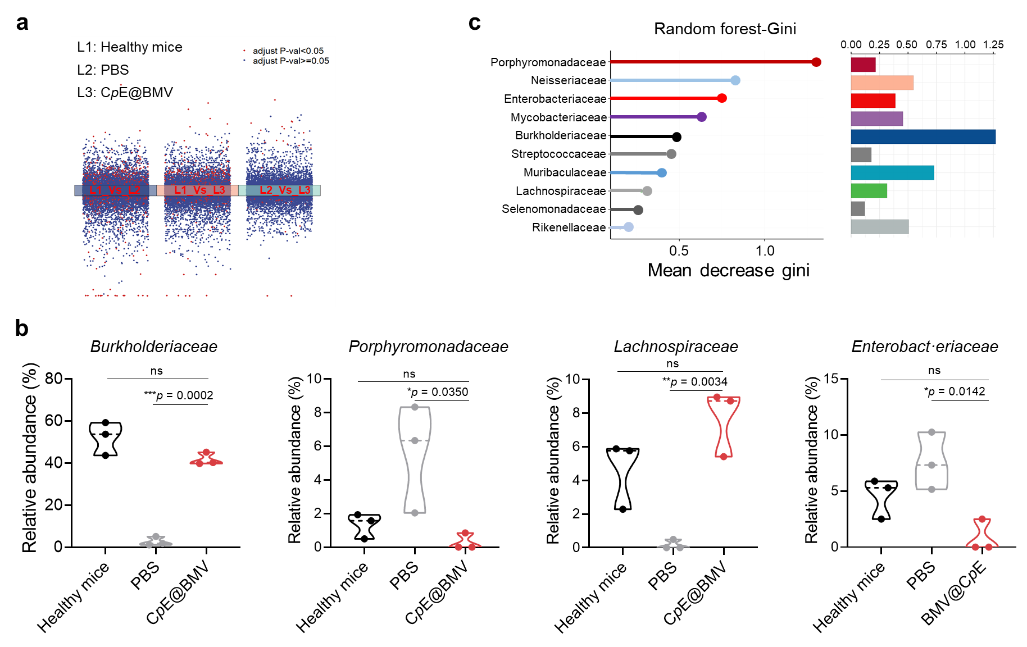
Supplementary Fig. 11 RNA-seq and microbiota analysis. a Average log fold change of the genes in the tissues collected from mice receiving various treatments in the pneumonia model. b Family-level taxonomy of Burkholderiaceae, Porphyromonadaceae, Lachnospiraceae, and Enterobacteriaceae in the mice receiving different treatments. Data are shown as mean ± S.D (n = 3 biological replicates). c Family-level importance point plot. The horizontal axis represents the criteria for measuring importance, while the vertical axis displays the family-level names sorted by importance. The bar chart displays the relative abundance at the family level, with Burkholderiaceae showing the highest abundance.

Supplementary Fig. 12 Gating strategy to identify immune cells in the spleen. Cell population of M1-phenotype macrophages (a), M2-phenotype macrophages (b), mature DC (c), T cells (d), Treg cells (e), plasmablasts (f), and memory B cells (g). Spleen tissues were collected, and the immune cells were stained with antibody cocktails.
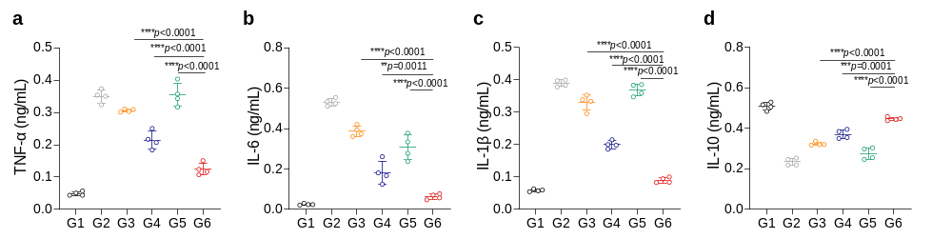
Supplementary Fig. 13 Cytokine concentrations of serum in the peritonitis model. The serum was collected from E. coli infected peritonitis model after treated with various formulations and measured by ELISA. Data are shown as mean ± S.D (n = 4 biological replicates). Statistical significance was determined by one-way ANOVA with Tukey’s multiple comparisons test.

Supplementary Table 1 Summary of the Minimum Inhibitory Concentration (MIC) and Minimum Bactericidal Concentration (MBC) (in µg/mL) of various formulations against S. aureus WH^{GFP} and E. coli Xen14.

Formulations | S. aureus WH^{GFP} |  | E. coli Xen14
 | MIC | MBC | MIC | MBC
Cip | 0.44 | 0.44 | 0.22 | 0.44
Ea | >1000 | >1000 | >1000 | >1000
CpE | 0.44 | 0.44 | 0.22 | 0.44
OMV | >125 | >125 | >125 | >125
CpE@BMV | 0.11 | 0.22 | 0.22 | 0.22

Supplementary Movie 1. Simulation of CpE assembly during a 100 ns observation period.

Supplementary Movie 2. Simulation of CpE assembly in the presence of BMV during a 100 ns observation period.

