Supporting Information

On-surface synthesis and characterization of linear and cyclic C₆
Luye Sun^{1,2}, Yuan Guo^{1,2}, Wenzhi Xiang¹, Wei Xu¹*
¹Interdisciplinary Materials Research Center, School of Materials Science and Engineering, Tongji University, Shanghai 201804, People’s Republic of China.
²These authors contributed equally
*Corresponding author. Email: xuwei@tongji.edu.cn

Table of Contents
Figs. S1 to S6

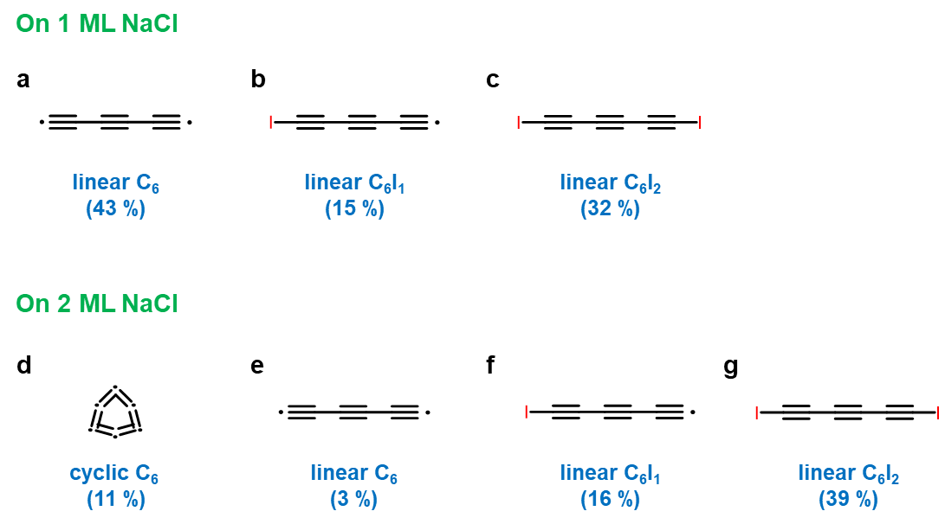
Fig. S1. Linear and cyclic products generated on 1 ML and 2 ML NaCl surface. (a to c) Linear products generated on 1 ML NaCl surface, including linear C₆ (a), linear C₆I₁ intermediate (b), and linear C₆I₂ intermediate (c). We have attempted 164 precursors and successfully generated 70 linear C₆ (yield: 43 %), 24 linear C₆I₁ intermediate (yield: 15 %), 53 linear C₆I₂ intermediate (yield: 32 %). Other attempted precursors were missing during manipulation. (d to g) Cyclic and linear products generated on 2 ML NaCl surface, including cyclic C₆ (d), linear C₆ (e), linear C₆I₁ (f), and linear C₆I₂ (g). We have attempted 97 precursors and successfully generated 11 cyclic C₆ (yield: 11 %), 3 linear C₆ (yield: 3 %), 16 linear C₆I₁ (yield: 16 %), 38 linear C₆I₂ (yield: 39 %). Other attempted precursors were missing during manipulation.
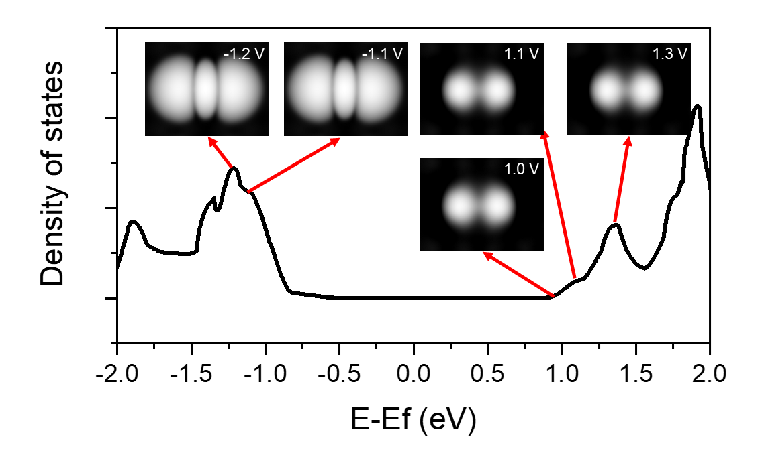
Fig. S2. Density of states (DOS) calculations of linear C₆ on NaCl surface. STM simulations calculated at various bias voltage (V = -1.2 V, -1.1 V, 1.0 V, 1.1 V, 1.3 V) are shown.

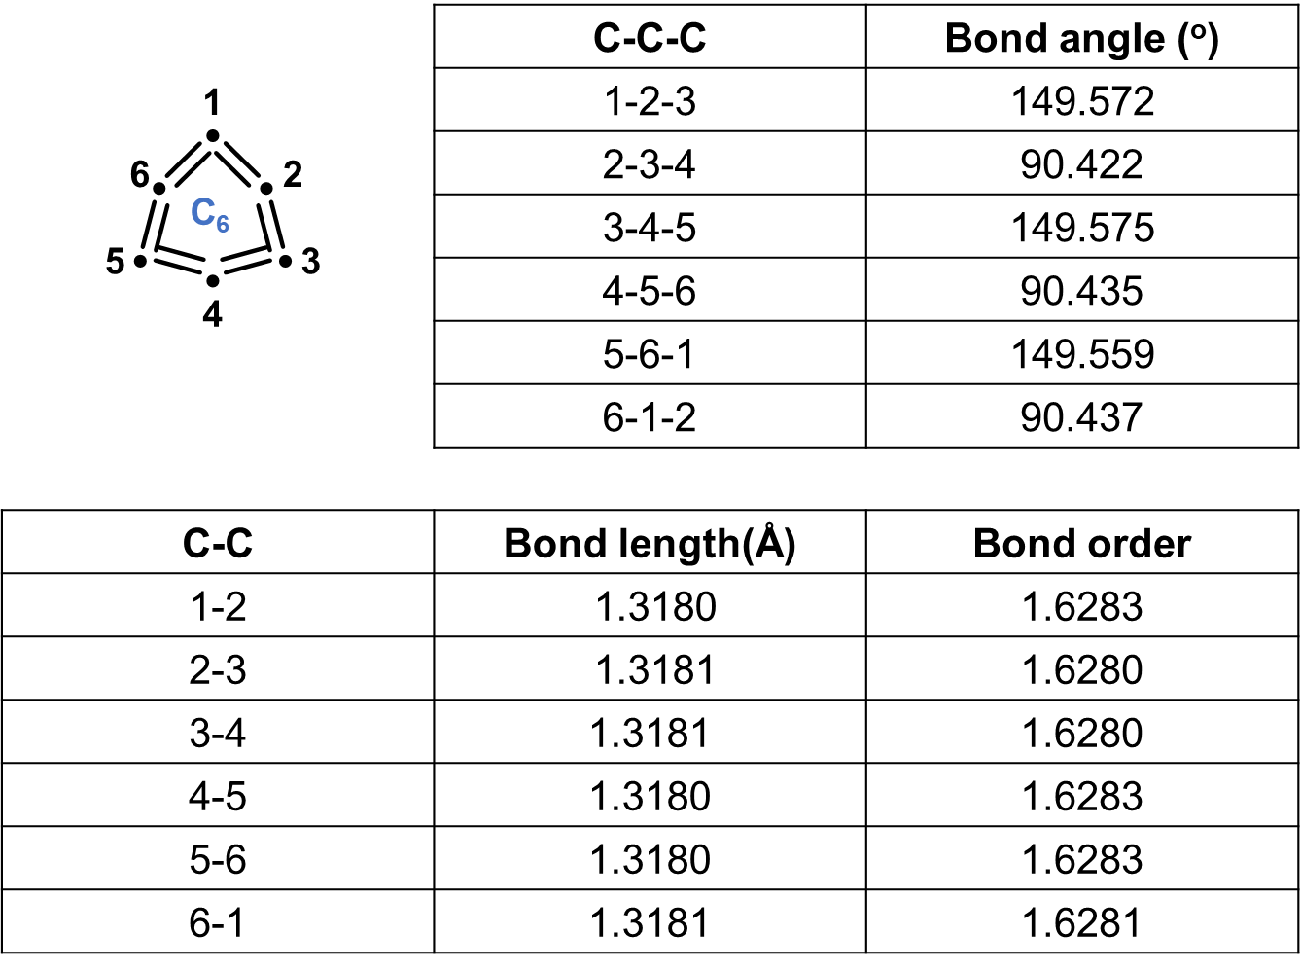
Fig. S3. The bond lengths, Mayer bond orders, and bond angles in a cyclic C₆. Calculations were conducted at the ωB97XD/def2-TZVP level, revealing a cumulenic structure of cyclic C₆ (BLA = 0, BAA = 59.1°).
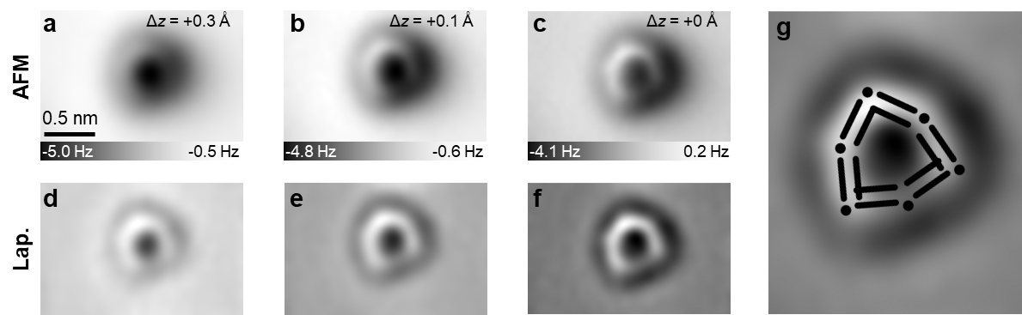
Fig. S4. AFM images of cyclic C₆ at different tip heights. AFM images (a to c) and Laplace-filtered AFM images (d to f) of cyclic C₆ at different tip heights (Δz) acquired with a CO-terminated tip. (g) Laplace-filtered AFM image of cyclic C₆ with superimposed model. Reference set point of Δz: I = 0.5 pA, V = 0.3 V.

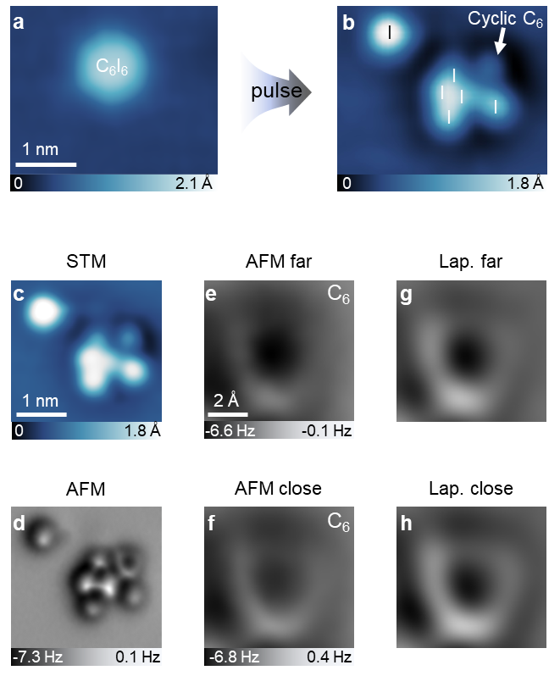
Fig. S5. Generated cyclic C₆ on a 2 ML NaCl surface with six dissociated iodine atoms aside. (a) STM images of a C₆I₆ precursor. (b) After applying voltage pulses, the cyclic C₆ product (indicated by a white arrow) and six dissociated iodine atoms are shown. (c) Zoom-in STM image. (d) Corresponding AFM image. (e to h) Zoom-in AFM far (e), Laplace-filtered far (g), AFM close (f), and Laplace-filtered close (h) images of cyclic C₆ are shown. STM set point: I = 0.5 pA, V = 0.3 V for a, b, and c. AFM tip offsets Δz: + 0.1 Å, +0.2 Å, +0 Å for d, e, and f. Reference set points of Δz: I = 0.5 pA, V = 0.3 V for d, e, and f.

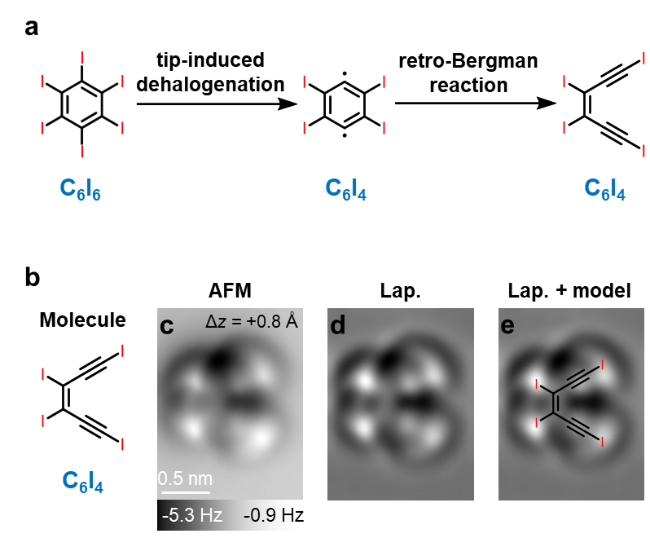
Fig. S6. Retro-Bergman reaction of a single molecule. (a) Scheme of retro-Bergman reaction based on C₆I₆ molecule. (b to e) Molecule, AFM image, Laplace-filtered image and with superimposed model of a C₆I₄ product from a retro-Bergman reaction. Reference set point of Δz: I = 0.5 pA, V = 0.3 V.

