SUPPLEMENTARY MATERIALS

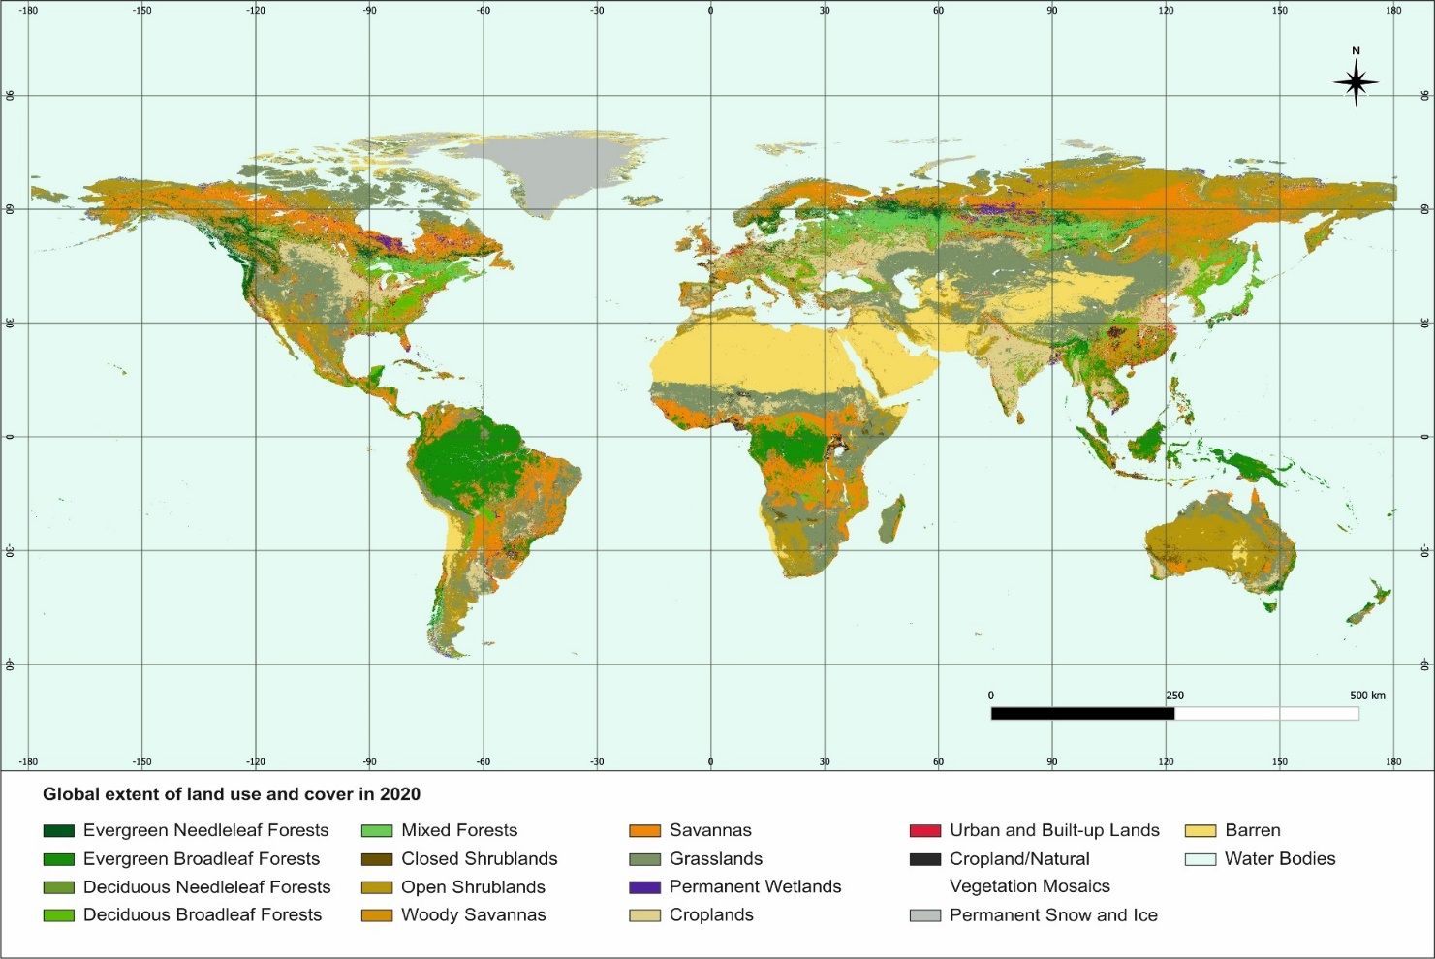

Figure S1. Global land uses and land covers in 2020
Source: MODIS satellite.

Table S1. Establishment costs of sustainable land management (SLM) technologies (average values), USD per ha
SLM technology groups | Africa | Americas | Asia | Europe | Average
Agroforestry | 1,573 | 1,142 | 1,014 | 1,435 | 1,291
Protected area | 899 | 61 | 768 | - | 576
Terraces and bunds | 221 | 865 | 640 | 140 | 467
Forest management | 1,133 | 1,373 | 713 | 5,328 | 2,137
Improving ground cover | 426 | 1,972 | 910 | 1,573 | 1,220
Integrated crop-livestock management | 5,584 | - | 4,913 | 10,788 | 7,095
Integrated soil fertility management | 384 | 163 | 595 | 1,426 | 642
Irrigation and water management | 780 | 1,233 | 663 | 1,230 | 977
Minimum tillage | 394 | 744 | 243 | 1,339 | 680
Grazing land management | 304 | - | 281 | 243 | 276
Crop rotations | 35 | 799 | 2,502 | 2,940 | 1,569
Water harvesting | 1,142 | - | 1,028 | - | 1,085
Average | 1,073 | 928 | 1,189 | 2,644
Source: WOCAT et al. (2022)

Table S2. Annual maintenance costs of SLM technologies (average values), USD per ha
SLM technology groups | Africa | Americas | Asia | Europe | Average
Agroforestry | 137 | 432 | 327 | 906 | 451
Protected area | 74 | 2 | 58 | - | 45
Terraces and bunds | 28 | 56 | 28 | 16 | 32
Forest management | 239 | 334 | 178 | 299 | 263
Improving ground cover | 96 | 14 | 150 | 103 | 91
Integrated crop-livestock management | 463 | - | 816 | 50 | 443
Integrated soil fertility management | 140 | 80 | 108 | 20 | 87
Irrigation and water management | 43 | - | 46 | 58 | 49
Minimum tillage | 166 | - | 11 | 14 | 64
Grazing land management | 34 | - | 22 | 115 | 57
Crop rotations | 30 | 256 | 486 | 480 | 313
Water harvesting | 97 | - | 11 | - | 54
Average | 129 | 167 | 186 | 206
Source: WOCAT et al. (2022)

Table S3. Costs and benefits of land restoration in Africa, in billions of USD

Ecosystem to be restored | Cost of restoration | Benefit of restoration | Benefit–cost ratio
Forests | 215 | 355 | 1.68
Wetland | 10 | 20 | 2.11
Shrublands, woody savannas, and savannas | 498 | 393 | 0.81
Cropland with agroforestry | 55 | 56 | 1.04
Standard cropland | 155 | 148 | 0.96
Grassland | 3 | 13 | 4.46
Total of profitable restoration opportunities | 283 | 445 | 1.57

Table S4. Costs and benefits of land restoration in Asia, in billions of USD

Ecosystem to be restored | Cost of restoration | Benefit of restoration | Benefit–cost ratio
Forests | 487 | 1,568 | 7
Wetland | 73 | 82 | 1.49
Shrublands, woody savannas, and savannas | 2,316 | 1,101 | 0.65
Cropland with agroforestry | 191 | 192 | 1
Standard cropland | 0.2 | 5 | 19.76
Grassland | 1,092 | 2,503 | 8.85
Total of profitable restoration opportunities | 1,844 | 4,351 | 2.36

Table S5. Costs and benefits of land restoration in Europe, in billions of USD

Ecosystem to be restored | Cost of restoration | Benefit of restoration | Benefit–cost ratio
Forests | 212 | 762 | 3.82
Wetland | 39 | 31 | 1.1
Shrublands, woody savannas, and savannas | 754 | 973 | 1.47
Cropland with agroforestry | 73 | 47 | 0.64
Standard cropland | 0.02 | 0.019 | 0.96
Grassland | 65 | 291 | 8.90
Total of profitable restoration opportunities | 1,071 | 2,058 | 1.92

Table S6. Costs and benefits of land restoration in North America, in billions of USD

Ecosystem to be restored | Cost of restoration | Benefit of restoration | Benefit–cost ratio
Forests | 797 | 2,679 | 3.74
Wetland | 538 | 1,007 | 2.28
Shrublands, woody savannas, and savannas | 1,622 | 1,885 | 1.28
Cropland with agroforestry | 64 | 46 | 0.72
Standard cropland | 0.03 | 0.032 | 1.06
Grassland | 154 | 863 | 13.18
Total of profitable restoration opportunities | 3,113 | 6,436 | 2.07

Table S7. Costs and benefits of land restoration in North America, in billions of USD

Ecosystem to be restored | Cost of restoration | Benefit of restoration | Benefit–cost ratio
Forests | 779 | 1,188 | 2.56
Wetland | 99 | 99 | 1.08
Shrublands, woody savannas, and savannas | 2,934 | 2,169 | 1.22
Cropland with agroforestry | 88 | 83 | 0.94
Standard cropland | 0.008 | 0.035 | 4.10
Grassland | 255 | 542 | 4.33
Total of profitable restoration opportunities | 4,068 | 4,000 | 0.98

Table S8. Costs and benefits of land restoration in Oceania, in billions of USD

Ecosystem to be restored | Cost of restoration | Benefit of restoration | Benefit–cost ratio
Forests | 126 | 259 | 2.85
Wetland | 12 | 13 | 1.46
Shrublands, woody savannas, and savannas | 1,388 | 1,055 | 0.95
Cropland with agroforestry | 16 | 15 | 0.94
Standard cropland | 0.001 | 0.042 | 4.10
Grassland | 131 | 276 | 3.75
Total of profitable restoration opportunities | 270 | 549 | 2.03

Table S9. Costs and benefits of land restoration in Russia, in billions of USD

Ecosystem to be restored | Cost of restoration | Benefit of restoration | Benefit–cost ratio
Forests | 817 | 2,964 | 3.82
Wetland | 902 | 630 | 0.73
Shrublands, woody savannas, and savannas | 1,572 | 1,751 | 1.18
Cropland with agroforestry | 59 | 38 | 0.64
Standard cropland | 0.008 | 0.007 | 0.96
Grassland | 61 | 296 | 8.46
Total of profitable restoration opportunities | 2,451 | 5,012 | 2.04

Table S10. Values of ecosystem services in different regions of the world (per hectare)
 |  | Africa | Asia | Europe | North America | Oceania | Southern America
Evergreen needleleaf forests: dominated by evergreen conifer trees (canopy >2m). Tree cover >60%. | 1 | 2,152 | 7,044 | 13,942 | 13,942 | 9,270 | 4,976
Evergreen broadleaf forests: dominated by evergreen broadleaf and palmate trees (canopy >2m). Tree cover >60%. | 2 | 2,152 | 7,044 | 13,942 | 13,942 | 9,270 | 4,976
Deciduous needleleaf forests: dominated by deciduous needleleaf (larch) trees (canopy >2m). Tree cover >60%. | 3 | 2,152 | 7,044 | 13,942 | 13,942 | 9,270 | 4,976
Deciduous broadleaf forests: dominated by deciduous broadleaf trees (canopy >2m). Tree cover >60%. | 4 | 2,152 | 7,044 | 13,942 | 13,942 | 9,270 | 4,976
Mixed forests: dominated by neither deciduous nor evergreen (40–60% of each) tree type (canopy >2m). Tree cover >60%. | 5 | 2,152 | 7,044 | 13,942 | 13,942 | 9,270 | 4,976
Closed shrublands: dominated by woody perennials (1–2m height) >60% cover. | 6 | 629 | 2,841 | 7,673 | 7,673 | 3,714 | 3,714
Open shrublands: dominated by woody perennials (1–2m height) 10–60% cover. | 7 | 629 | 2,841 | 7,673 | 7,673 | 3,714 | 3,714
Woody savannas: tree cover 30–60% (canopy >2m). | 8 | 629 | 2,841 | 7,673 | 7,673 | 3,714 | 3,714
Savannas: tree cover 10–30% (canopy >2m). | 9 | 629 | 2,841 | 7,673 | 7,673 | 3,714 | 3,714
Grasslands: dominated by herbaceous annuals (<2m). | 10 | 370 | 5,504 | 4,354 | 4,354 | 3,409 | 3,409
Permanent wetlands: permanently inundated lands with 30–60% water cover and >10% vegetated cover. | 11 | 3,187 | 6,676 | 6,046 | 17,093 | 5,303 | 5,303
Croplands: at least 60% of area is cultivated cropland. | 12 | 589 | 2,874 | 956 | 1,055 | 598 | 1,720
Urban and built-up lands: at least 30% impervious surface area including building materials, asphalt, and vehicles. | 13 | - | - | - | - | - | -
Cropland/natural vegetation mosaics: mosaics of small-scale cultivation 40–60% with natural tree, shrub, or herbaceous vegetation. | 14 | 920 | 4,483.44 | 1,491.36 | 1,645.8 | 932.88 | 2,683.2
Permanent snow and ice: at least 60% of area is covered by snow and ice for at least 10 months of the year. | 15 | 0 | 0 | 0 | 0 | 0 | 0
Barren: at least 60% of area is non-vegetated barren (sand, rock, soil) areas with less than 10% vegetation. | 16 | 0 | 0 | 0 | 0 | 0 | 0
Water bodies: at least 60% of area is covered by permanent water bodies. | 17 | - | - | - | - | - | -

