Supplementary Materials
Table of Contents
1. Animal workflow. 2
2. Agarose gel of the HR origami 2
3. Next generation sequencing 3
4. Standard curves for the bare rod HR origami 4
5. Standard curves for the PEGylated rod HR origami 5
6. Fitted ligated LSPs blood concentrations for bare rod origami via IV injection 6
7. Fitted ligated LSPs blood concentrations for PEGylated origami via IP injection 7
8. Model curves for IP injections 8
9. Artificially generated kinetic profile for a repeated dose 9

Animal workflow.
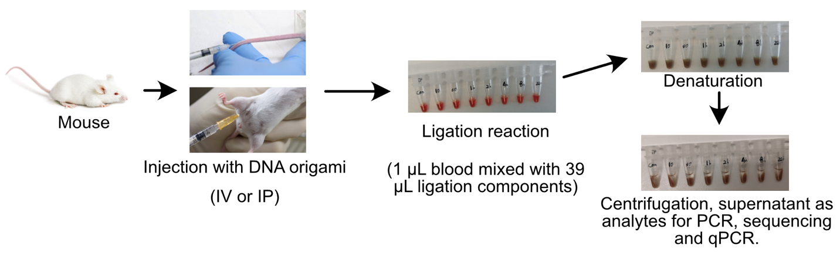
Supplementary Fig.1. The actual steps to collect the blood samples from mouse and the following reactions.

Agarose gel of the HR origami
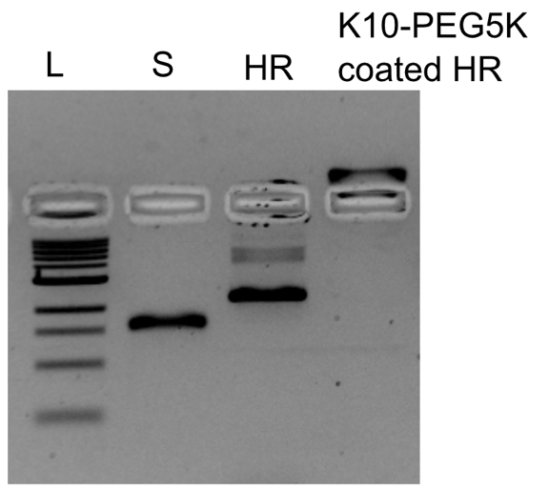
Supplementary Fig.2. Agarose gel electrophoresis showing the successful PEGylation of rod origami structures. L: 1kb DNA ladder, S: scaffold, HR: bare rod origami, K₁₀-PEG_{5K} coated HR: PEGylated rod origami.

Next generation sequencing
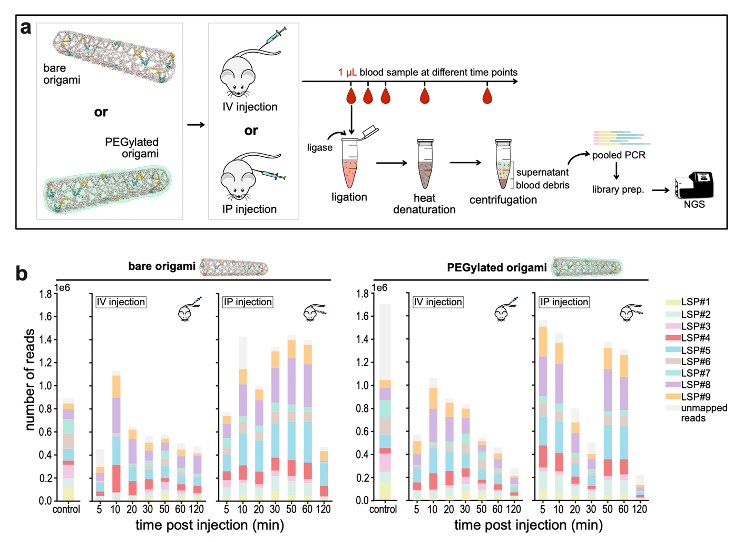Supplementary Fig.3. (a) The experimental workflow of PLASTIQ with blood samples from the same animal and the following PCR, gel assay and sequencing. (b) Illumina sequencing reveals all LSPs can be ligated and amplified after origami structure injections. Sequencing libraries were obtained from blood samples processed through the PLASTIQ workflow. As the control, origami structure in vitro in test tube was submitted for PLASTIQ and the following library preparations for Illumina sequencing.

Standard curves for the bare rod HR origami

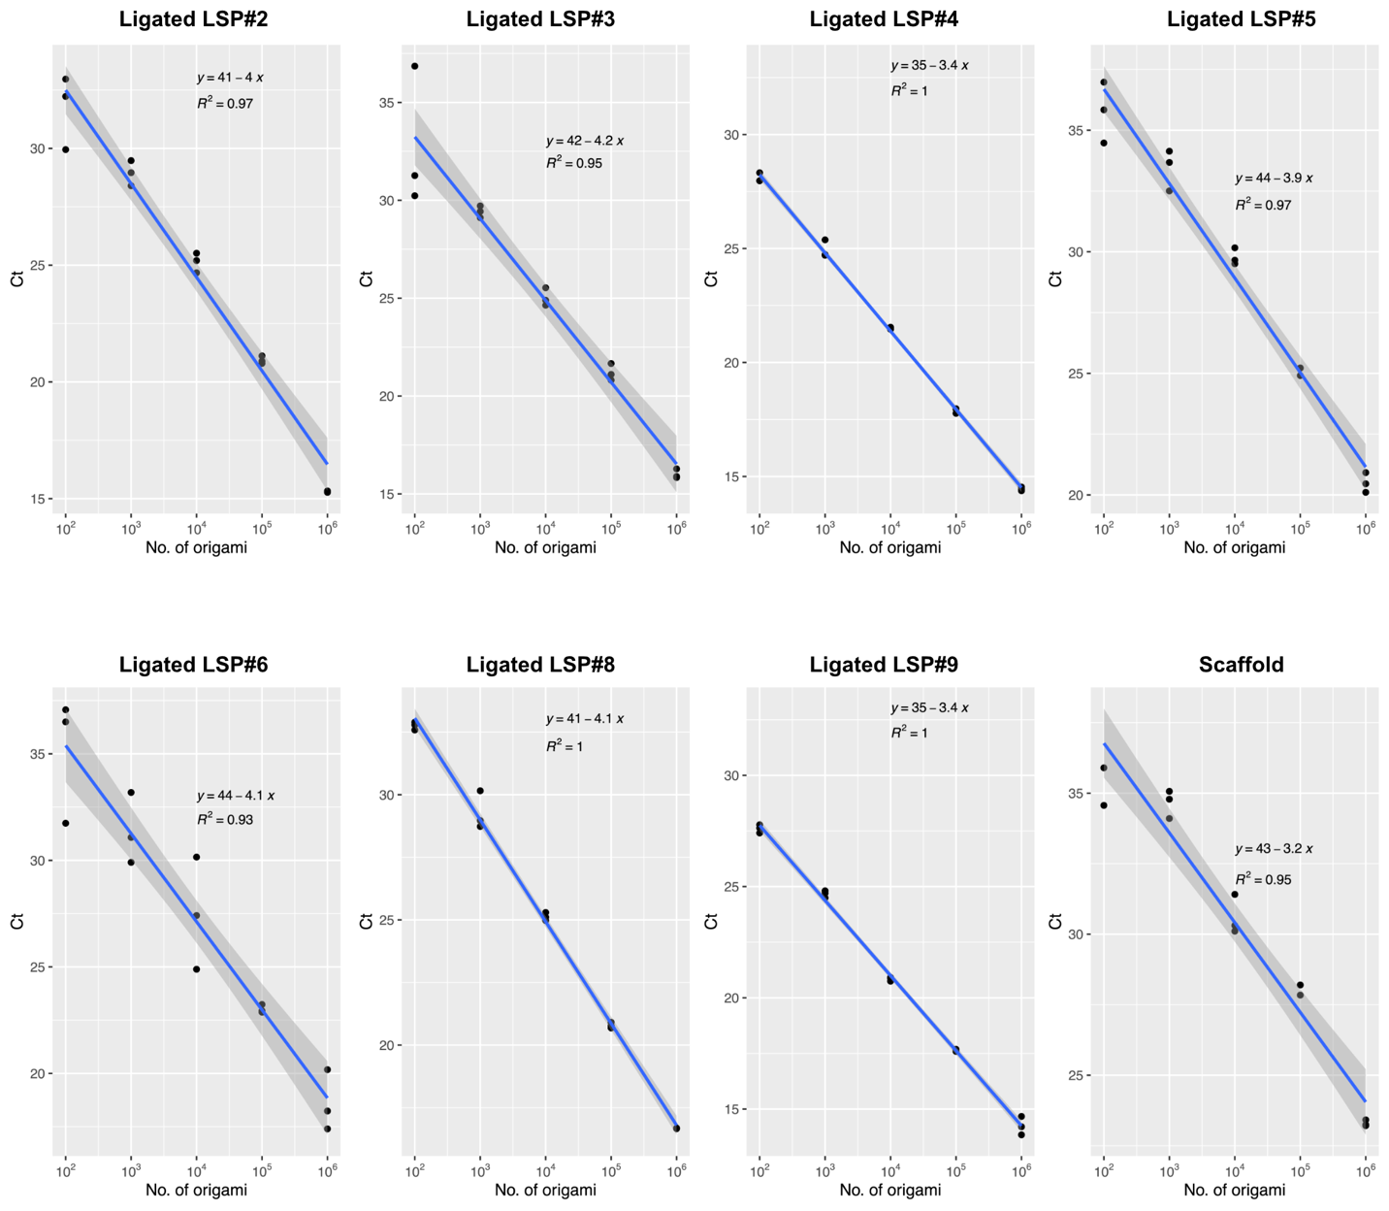Supplementary Fig.4. Standard curves of the bare rod origami for qPCR.

Standard curves for the PEGylated rod HR origami
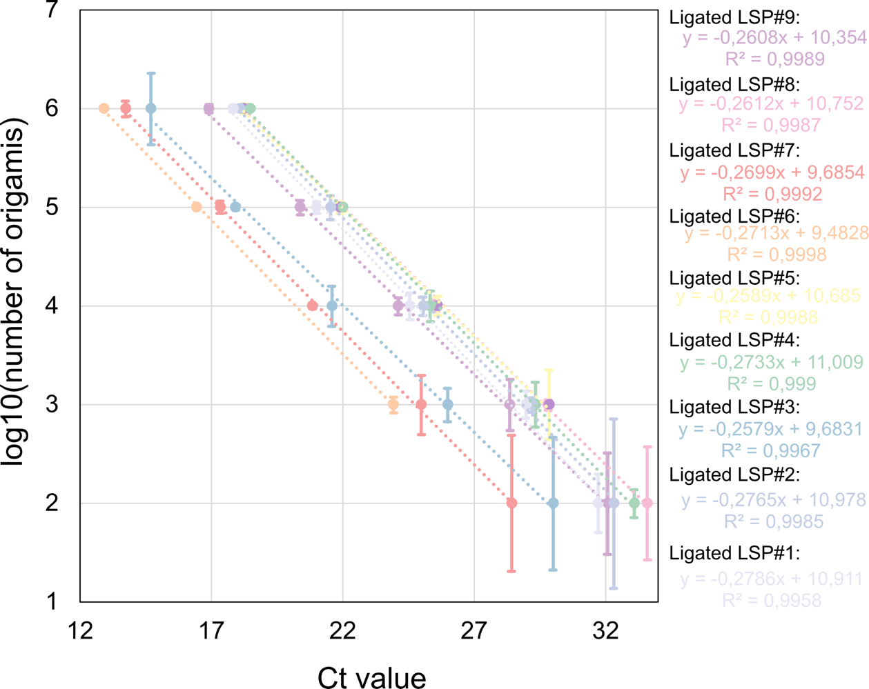
Supplementary Fig.5. Standard curves of the PEGylated rod origami for qPCR.

Fitted ligated LSPs blood concentrations for bare rod origami via IV injection
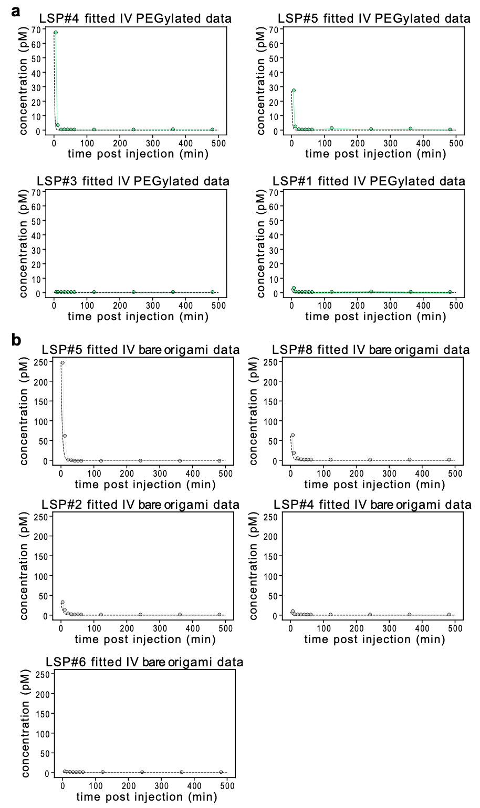
Supplementary Fig.6. Fitted ligated LSP blood concentration profiles for each ligated LSP (indicated with #) plotted on top of data for the PEGylated origami (a) and bare origami (b) for the IV injection samples.

Fitted ligated LSPs blood concentrations for PEGylated origami via IP injection
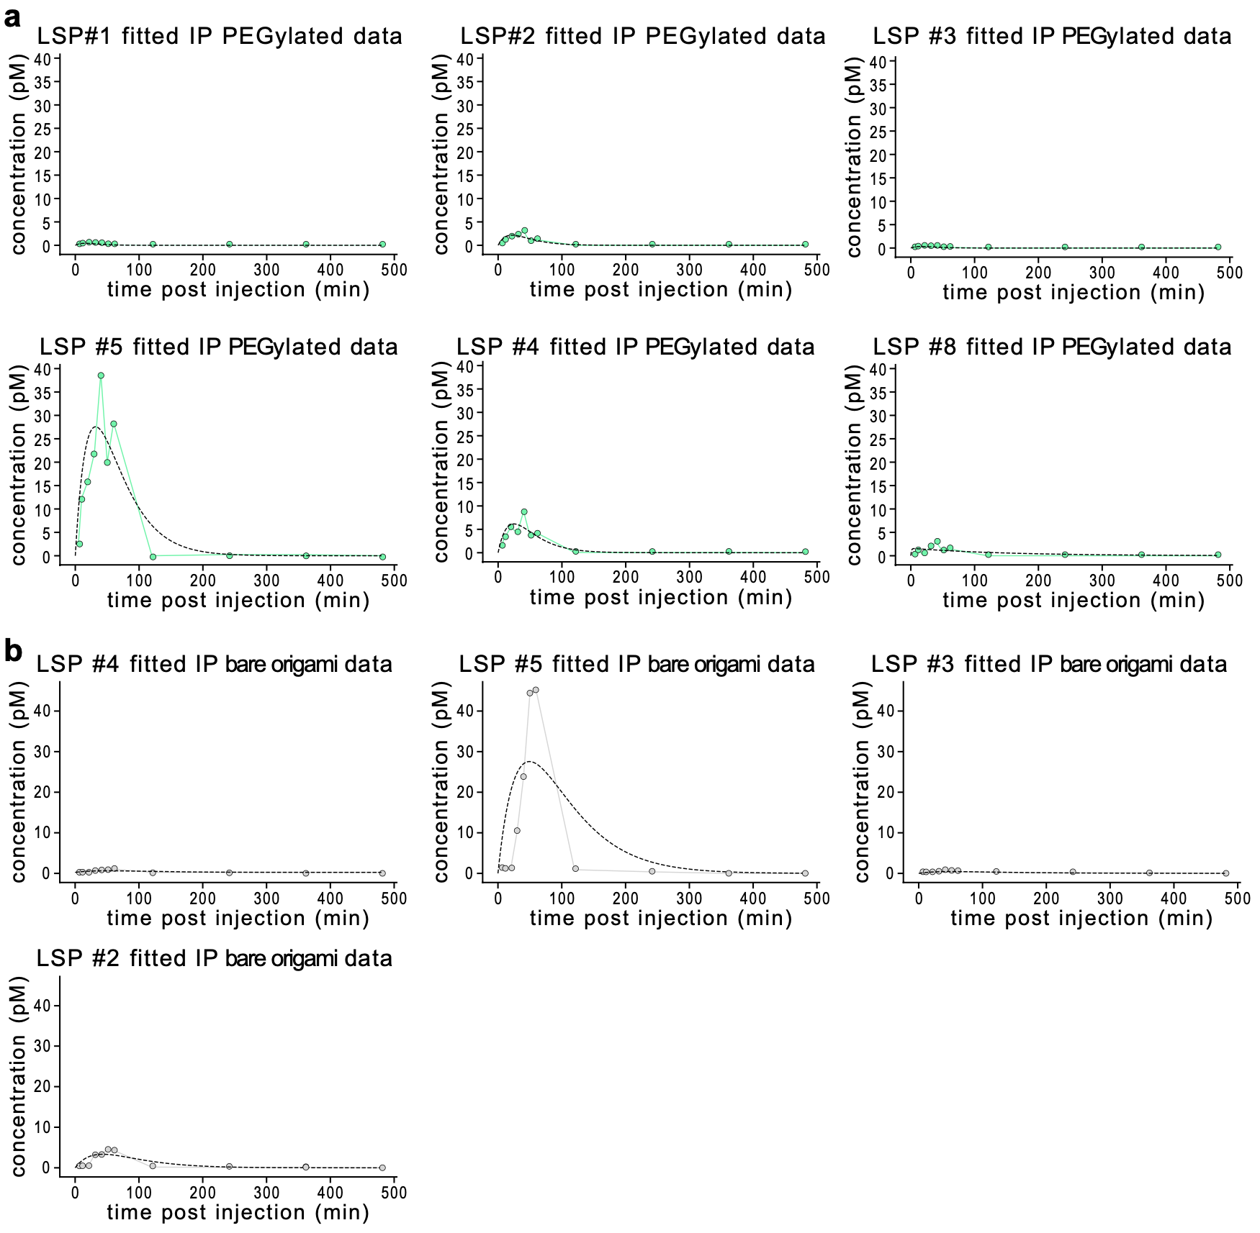
Supplementary Fig.7. Fitted ligated LSP blood concentration profiles for each ligated LSP (indicated with #) plotted on top of data for the PEGylated origami (a) and bare origami (b) for the IP injection samples.

Model curves for IP injections

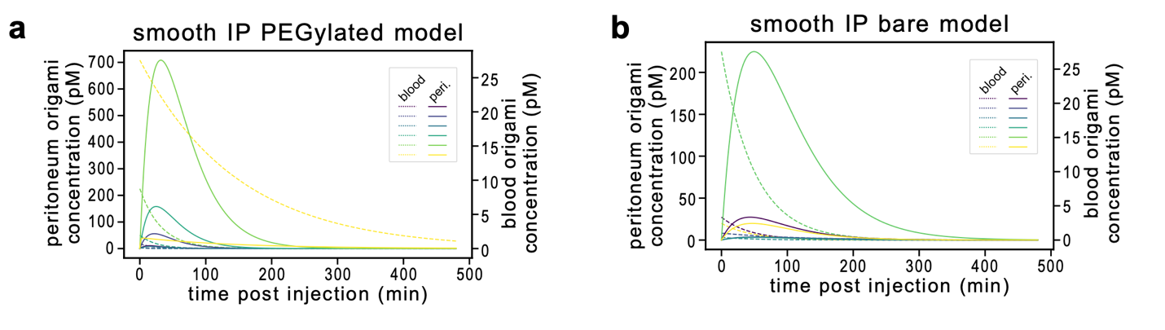Supplementary Fig.8. Plot of model curves for IP injection case, showing the observable blood concentration profile and the hidden inferred peritoneal concentration profile for the PEGylated (a) and bare origami cases (b).

Artificially generated kinetic profile for a repeated dose
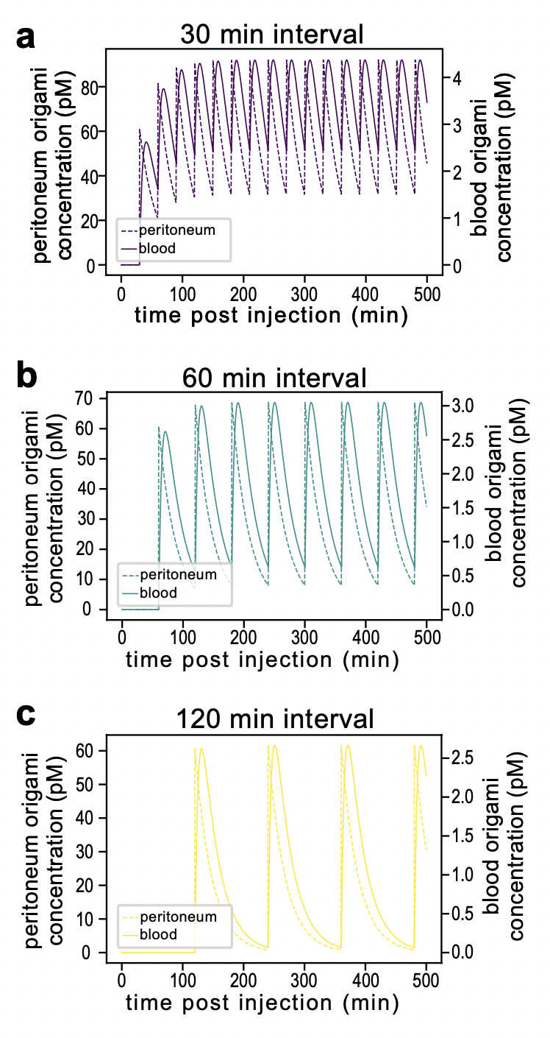
Supplementary Fig.9. Artificially generated kinetic profile for a repeated dose with 30-minute (a), 60-minute (b), and 120-minute (c) interval, plotted using mean fitted parameter values for the PEGylated origami, IP case.

Supplementary Table 1.
Parameters, goodness of fit values for pharmacokinetic model.
 | $$k_{a}$$ | $$k_{e}$$ | $$C_{0}$$ | $$R^{2}$$ | $$RMSE$$
IV origami (N=6) | -- | 0.24 ± 0.09 | 59 ± 90 | 0.98 ± 0.03 | 0.33 ± 0.2
IV pegylated (N=5) | -- | 0.49 ± 0.1 | 21 ± 30 | 1.00 ± 0.01 | 0.11 ± 0.1
IP origami (N=5) | 0.019 ± 0.005 | 0.024 ± 0.006 | 57 ± 80 | 0.64 ± 0.07 | 2.6 ± 4
IP pegylated (N=6) | 0.036 ± 0.01 | 0.19 ± 0.3 | 61 ± 80 | 0.78 ± 0.09 | 1.3 ± 2

