Supplementary data file

- Sample size calculation

Sample size calculations were done based on a pilot experiment in which 8 samples, including 4 samples or each growth pattern, were sequenced using paired-end chemistry and aiming form library sizes of 50 million reads. Using the BioConductor-package EdgeR, the interclass biological coefficient of variation (BCV) was calculated. The BCV represents the amount of variation that would remain between biological replicates if sequencing depth could be increased indefinitely thereby eliminating any technical, sequencing-based expression bias. Large BCV values, like large standard deviation values, indicate that larger samples sizes are required in order to obtain significant differences given a preset power value. In our pilot experiment, the BCV was estimated to be around 40% in both classes (i.e. replacement and desmoplastic). To perform a sample size calculation, we analyzed a pool of more than 1.000 publically available breast cancer expression profiles that were classified according to the molecular subtypes (i.e. Basal-like, HER2 enriched, Luminal A, Luminal B and Normal-like). For each molecular subtype, the BCV was calculated. We noted that ER+ and ER- subtypes (i.e. Luminal A and Luminal B samples vs. Basal-like, HER2-enriched and Normal-like) have BCV values similar to the once noted in our liver metastases series (i.e. around 40%). Next, we performed a differential expression analysis between different series of ER+ and ER- breast tumors with variable and balanced sample sizes (e.g. 10 vs. 10). The aim was to call at least 80% of the 2-fold expression differences significant at a nominal P-value of 5%, which was already achieved when analyzing a series of 40 breast cancer samples that were evenly distributed according to their ER status. Therefore, in the context of this project, we propose to include 20 liver metastases for each growth pattern and we hypothesize that 80% of the 2-fold expression differences in this series will be called significant at a nominal P-value of 5%.

- Validation of variant calling pipeline.

Data preprocessing.

To detect somatic mutations, RNA-sequencing reads from 57 liver metastases were mapped against the human reference genome (hg38) with Hisat2 in standard settings. Resulting SAM-files were converted into BAM-files, coordinated-sorted, and indexed using samtools (v.1.9). Reads overlapping with 46 genes recurrently mutated in CRC were selected using the bedtools (v.2.29.2) intersect-command retaining the full read in the original BAM-file (-wa option). Non-reference alleles were identified using the haplotype-based variant detector freebayes (v.1.3.2; Garrison E, Marth G. Haplotype-based variant detection from short-read sequencing. arXiv preprint arXiv:1207.3907 [q-bio.GN] 2012) in standard settings and indel positions were left-aligned and normalized using the bcftools (v.1.9) norm-command. Resulting VCF-files were annotated using SnpEff (v.5.1) for functional annotations and SnpSift (v.5.1) for human genetic variation using dbSNP (build 154), ClinVar (release 05/09/2022) and COSMIC (v96). Annotated VCF files were further manipulated using the SnpSift filter-command retaining only missense, frameshift and stop-gain mutations that were not reported as a common variant in the 1000 genomes project (minor allele frequency>1%) and that were not classified as benign or likely benign according to ClinVar.

Comparison of RNA and DNA based KRAS genotype calls.

To validate our mutation calls, we focused on variants identified in the KRAS gene. The distribution of the KRAS mutations according to their codon (A) and according to their mutation type (B) are provided in Figure 1. About 50% of the liver metastases are KRAS mutated predominantly at codon 12 and 13. In line with the oncogenic function of KRAS, missense mutations represent the dominant mutation type (i.e. 85%). The reported frameshift and stop-gain mutations are likely due to sequencing errors.

KRAS genotypes obtained from RNA-sequencing data were compared to DNA-based results that were available from clinical records for 35/57 liver metastases. Importantly, the latter were limited to exome 2 codon 12 or 13 mutations in all patients but one (i.e. 20170444.bam; p.Ala146Thr). The resulting data are shown in Table 1, which reports the RNA-sequencing based KRAS mutation status for each of the 35 samples included in this analysis. Replicate samples from identical patients, highlighted in blue, green or orange, have similar KRAS genotypes except for samples 20150658 and 20160073 (blue) that belong to a patient with a documented p.Gly12Val mutation, which was recovered in only one sample. KRAS genotypes identified during routine diagnostics were recalled in 26/35 cases (i.e. accuracy of 74%) with a specificity of 83% on 18 wild-type (WT) samples and a sensitivity of 65% on 17 KRAS mutant samples. When considering all variants except for those classified as “variant of unknown significance” (i.e. all but p.Ala146Thr), mutations were recalled in 25/32 cases (i.e. accuracy of 78%; sensitivity of 63%; specificity of 94%). The lower sensitivity levels may be due to technological differences (i.e. RNA vs. DNA-sequencing, targeted sequencing vs. full exome sequencing), or testing of a different tissue sample (i.e. metastases vs. primary), amongst others.

Next, the effect of introducing a filter step on the minimal number of variant reads on the accuracy of RNA-sequencing based KRAS mutation calls was evaluated. Call sets containing either all variants or only variants that are not of unknown significance were considered. Results in terms of sensitivity and specificity, obtained by comparing RNA and DNA based mutation calls, are shown in Figure 2. Specificity levels increase only when considering all variants supported by at least 20 reads. For variants of known significance, specificity levels remain invariant across various cut-off levels on the minimal number of variant reads. In parallel, sensitivity levels drop drastically when increasing the number of minimal variant reads above 5, and this is observed for both call sets. In addition, at any cut-off level on the minimal number of variant reads, the sensitivity level obtained on the call set excluding variants of unknown significance is always lower as compared to the sensitivity level obtained on all variants. Given the fact that sensitivity levels are already low, a mutation will be considered when supported by at least 5 variant reads and no additional filter on the mutation class was introduced.

Evaluation of mutation frequencies.

Based on the above criteria, 17 genes mutated at least once in our series of 57 liver metastases were identified. The observed mutation frequencies were compared to those reported in the MSKCC data set (Yaeger et al., Cancer Cell, 2018) covering 1.134 colorectal cancer metastases including 238 liver metastases samples and results are presented in Table 2. From this analysis, two important observations have been made. First, APC, TP53 and SMAD4 (highlighted in blue) mutations have been detected at a lower frequency as compared to the MSKCC data set, which can be explained in terms of differences between DNA- and RNA based mutation analysis. The nature of genomic perturbations in APC, TP53 and SMAD4 (i.e. deletions and frameshift mutations) implies that the variant allele is often not expressed (e.g. through nonsense mediated decay). Therefore, RNA-sequencing will only assess transcripts that originate from the WT allele resulting in lower mutation frequencies as compared to DNA-sequencing based results.

Second, for some genes (highlighted in red), the mutations frequencies in the RNA-sequencing data are markedly higher as compared to the MSKCC series. These genes are often affected by frameshift mutations caused by indels that may reflect sequencing errors. The fact that these frameshift mutations represent sequencing errors is corroborated by the observation that double frameshift mutations are reported in several samples, particularly for MSH6 (i.e. 12 samples). In order to be able to filter out putative sequencing errors, we inspected 1.100 frameshift mutations identified in our RNA-sequencing data set and without records in dbSNP or ClinVar. In this set of mutations, indels secondary to sequencing errors will arguably be more prevalent. The average of variant reads in this call set was 4 with a standard deviation of 6.41. From these data, a novel cut-off on the minimal number of variant reads specific for frameshift mutations was calculated (i.e. 4 + 1.96 * 6.41 = 17), allowing to filter out 95% of these putative false positive variants.

Overview of mutated genes in liver metastases.

Based on the above information (i.e. minimal number of 5 variant reads for missense and nonsense mutations, and 17 for frameshift variants), the final call set for all genes evaluated in this analysis was generated and the resulting oncoprint is shown in Figure 3. All identified mutations are provided in Table 3. Patterns of mutual exclusivity, visible in the top 4 rows of the oncoprint, were analysed using the R-package discover and identified for TP53 and KRAS (OR=0.218), for TP53 and PIK3CA (OR=0.090) and for TP53 and BRCA2 (OR=0.400). Mutual exclusivity between TP53 on the one hand and KRAS or PIK3CA was also observed in the MSK-series of 1516 primary colorectal carcinoma samples (Cercek et al., JNCI, 2021) as well as in the MSK-series of 1134 metastatic colorectal carcinoma samples (Yaeger et al., Cancer Cell, 2018), thus lending credit to the mutational patterns identified in our series. Also, in the TCGA series (Firehose legacy) of 526 primary colorectal cancer samples, mutual exclusivity between TP53 and PIK3CA was identified.

Comparison of mutation-induced gene expression changes in primary CRC and liver metastases

To validate the identified variants at a more biological level, we evaluated if gene expression patterns associated with mutations in several key genes in our liver metastases series are similar to those identified in primary CRCs. For this analysis, we focused only on TP53, KRAS, PIK3CA and APC as these were mutated in at least 10% of both the primary CRC and liver metastases samples. This was done in order to ensure that differentially expressed genes can be identified reliably and thus that the extracted gene lists represent genuine expression differences.

Genes overexpressed in primary CRCs with mutations in TP53, KRAS, PIK3CA and APC relative to WT samples were downloaded from the cBioPortal website (i.e. TCGA Firehose Legacy that contains 220 primary CRCs with CNV, mutation and gene expression data). For the liver metastases, gene expression differences between samples with and without mutations in TP53, KRAS, PIK3CA and APC were determined using generalized linear models as described elsewhere in this manuscript. The resulting vectors of fold changes, representing the gene expression profiles associated with mutations in TP53, KRAS, PIK3CA or APC in liver metastases, were then analyzed for enrichment of the genes overexpressed in mutated primary CRCs. The resulting enrichment plots are shown in Figure 4 and clearly demonstrate that for any of the 4 evaluated genes, gene expression differences between mutated and WT in liver metastases and primary CRCs are similar.

Finally, to investigate associations between KRAS mutations and the CMS and CRIS subtypes, gene expression data of liver metastases were subjected to the CMScaller algorithm. The distribution of KRAS mutations according to the CRIS and CMS subtypes is provided in Figure 5 in panel A and B respectively (Chi-square test; P=0.006 and P=0.085 respectively). With respect to the CRIS subtypes, particularly the absence of KRAS mutations in the CRIS-C category stands out, which agrees with literature.
Figures to the supplementary data file

Figure 1

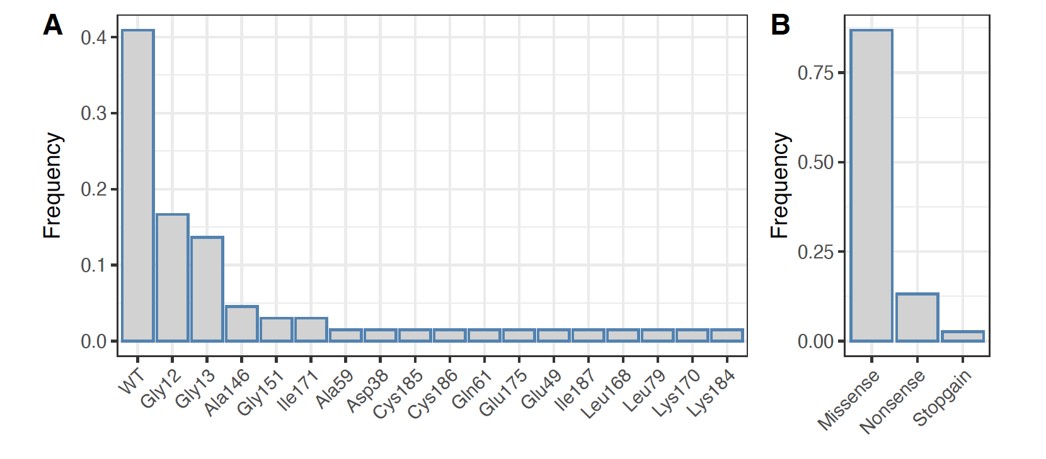
Figure 1: Frequencies of the KRAS mutations classified according to codon (A) and according to mutation type (B) in the full series of 57 liver metastases are shown in bar plot format. Classifications are shown in the X-axis, and frequencies are indicated in the Y-axis. From these data, is can be seen that codon 12 and 13 mutations are most frequent as well as missense mutations.

Figure 2

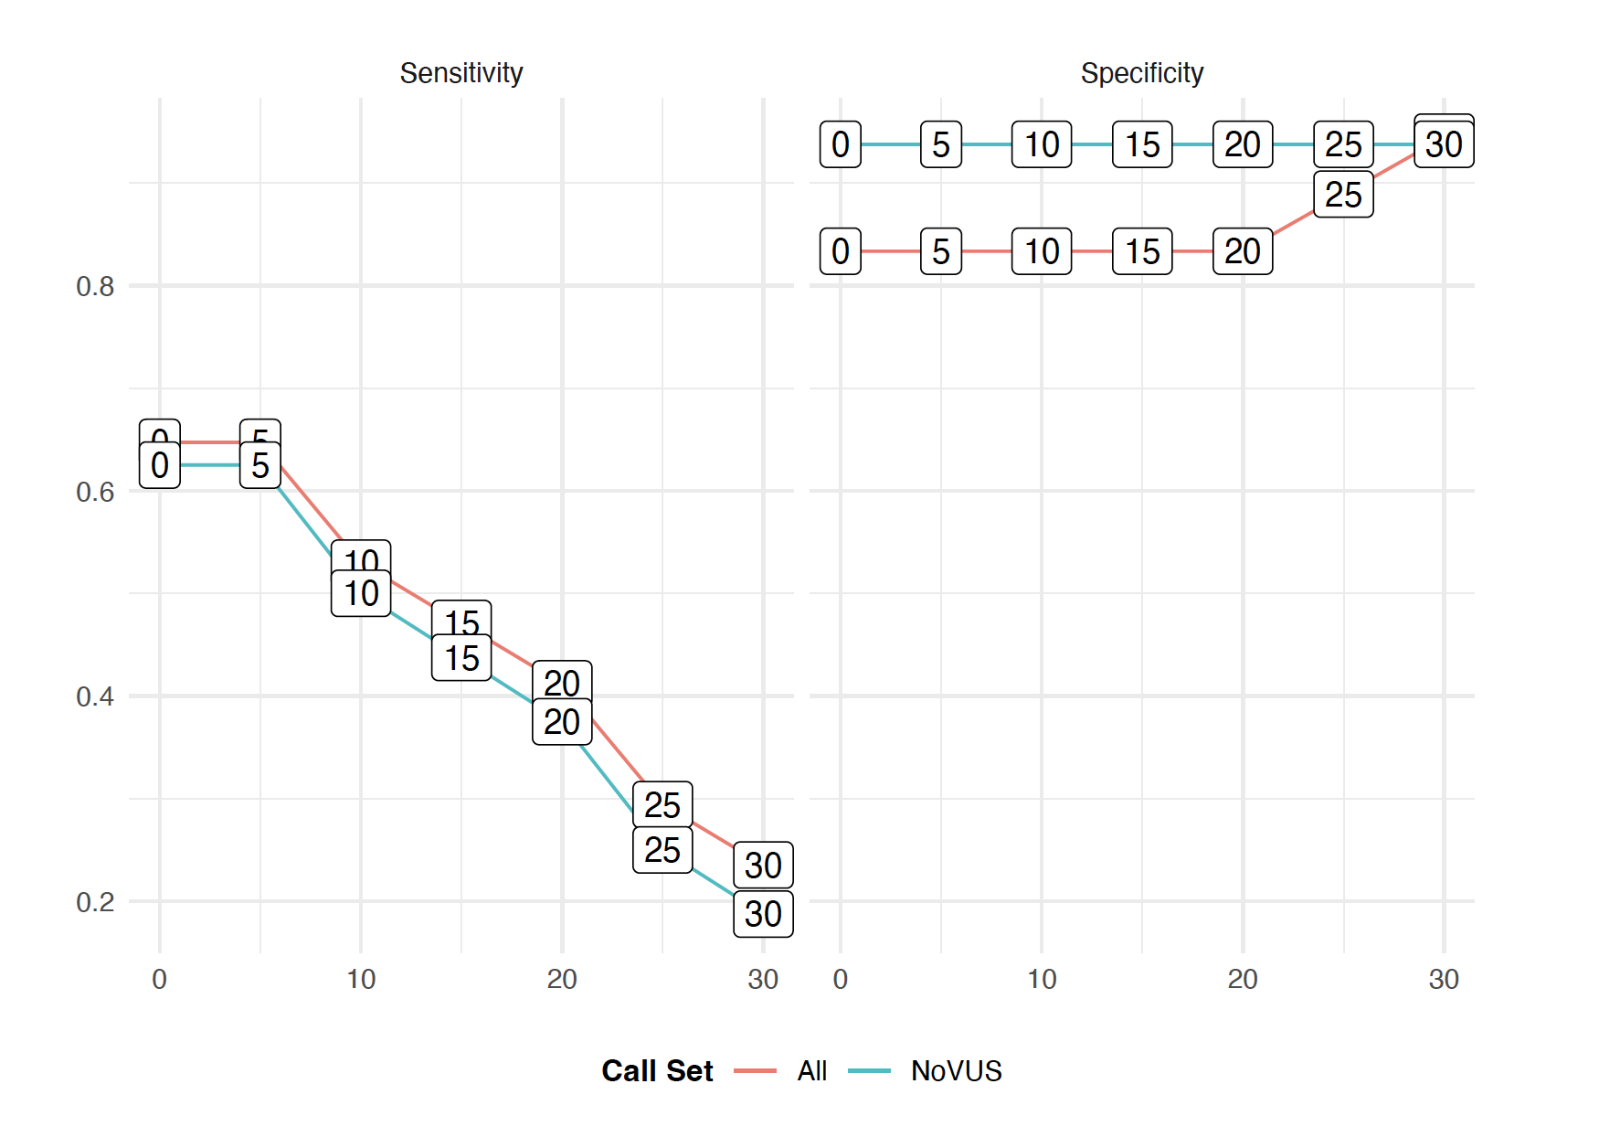
Figure 2: Plots representing sensitivity (left) and specificity (right) levels on the Y-axis in function of different cut-off values on the minimal number of variant reads (X-axis). Results obtained for call sets containing either all variants or variants excluding those of unknown significance are color-coded red and blue respectively.

Figure 3

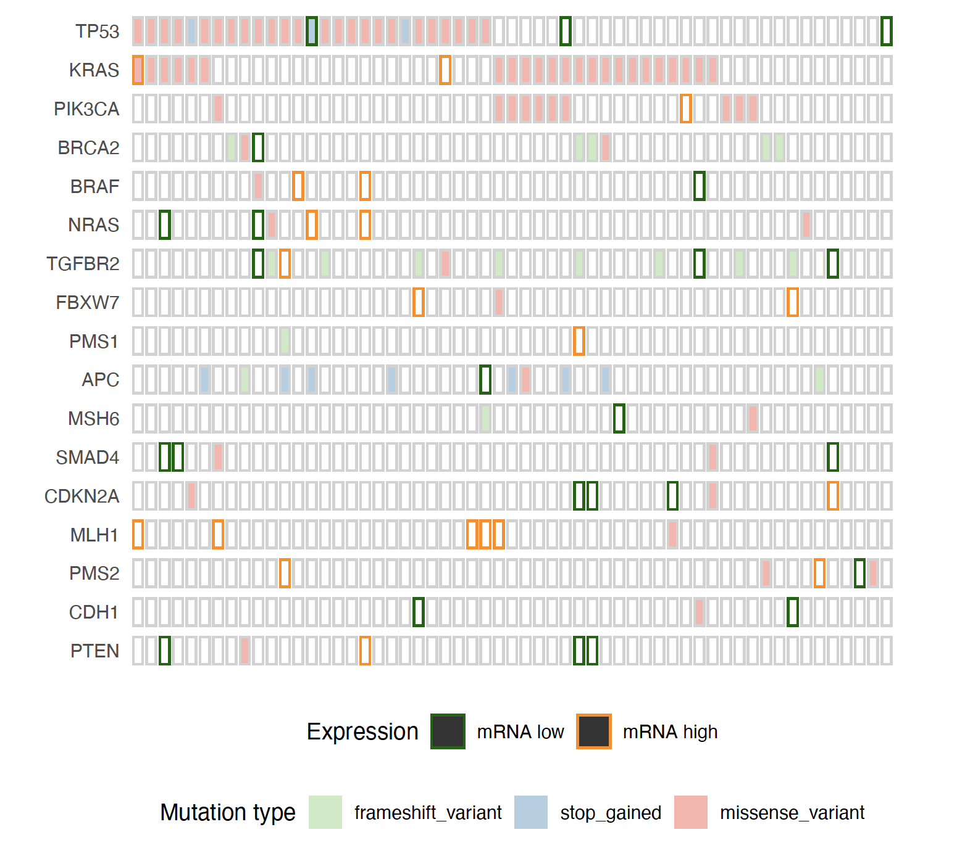
Figure 3: Overview of RNA-sequencing based mutations in CRC genes in liver metastases are shown in oncoprint format. Samples are ordered along the X-axis based on patterns of mutual exclusivity and mutated genes are listed along the Y-axis. Mutation types (i.e. frameshift, stop-gained, missense) are color-coded as shown in the legend. In addition, for each gene, an indication of over- or underexpression is provided using orange or green borders respectively. Over- and underexpression is determined by thresholding the z-score transformed vector of expression levels relative to values of 2 and -2 respectively.

Figure 4

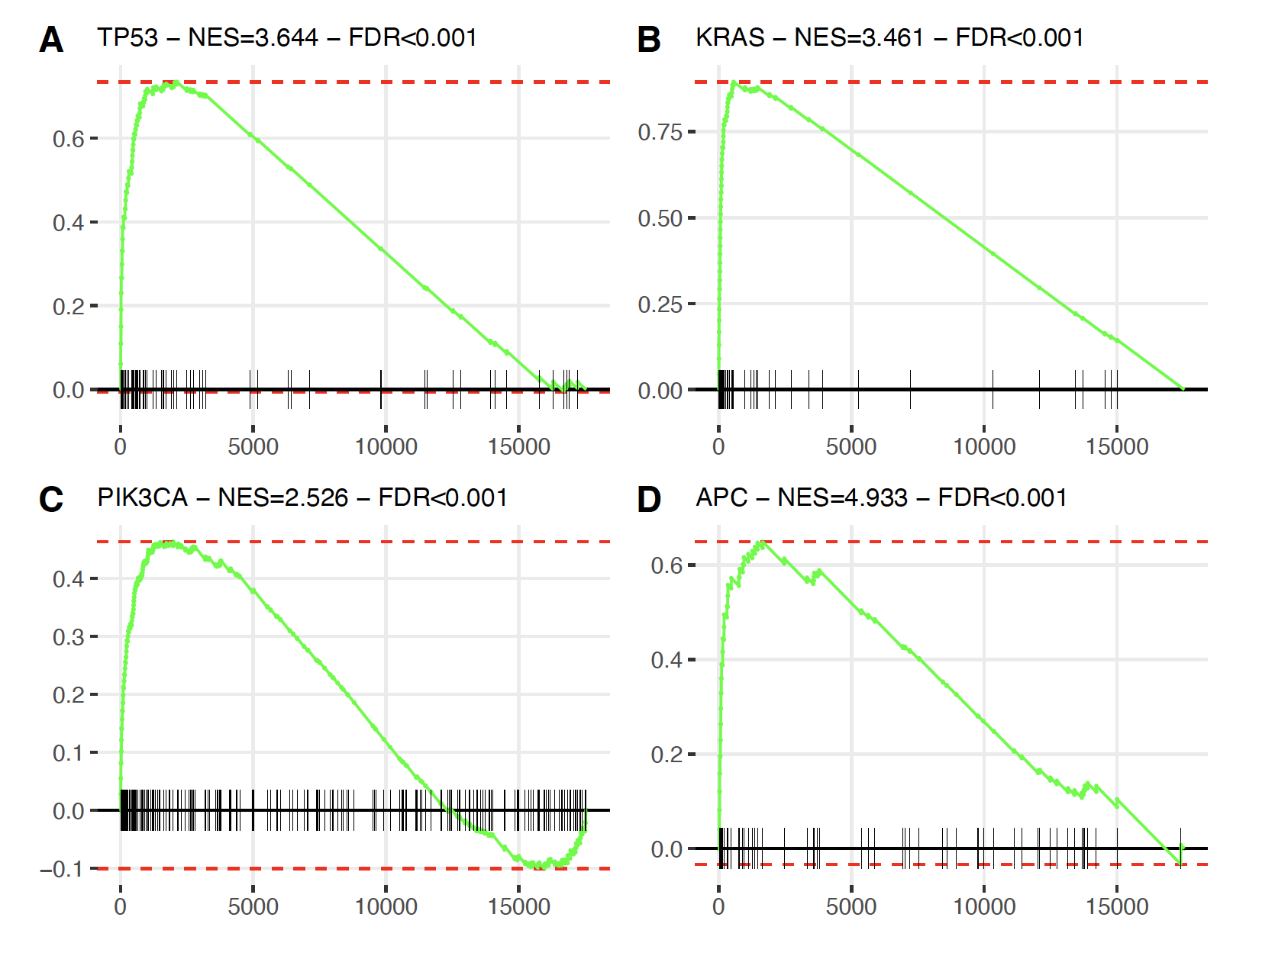
Figure 4: Gene enrichment plots for TP53 (A), KRAS (B), PIK3CA (C), and APC (D) for genes overexpressed in respectively TP53, KRAS, PIK3CA and APC mutated vs. wild-type primary colorectal cancers. The vector of fold-changes representing gene expression changes between mutated and wild-type liver metastases in our series of liver metastases is represented along the X-axis with gene overexpressed in mutated and wild-type samples ordered from left to right. In this vector of fold-changes, the positions of the genes overexpressed in mutated relative to wild-type primary colorectal cancer samples that was obtained from cBioPortal are indicated by black vertical ticks. The density distribution of these positions is indicated using a green line. The enrichment score, calculated from the peak of this density distribution, is indicated using a horizontal red dashed line that intersects the Y-axis. The normalized enrichment score, which is the enrichment score normalized by the length of the gene set, and its significance level, estimated using 1.000 random gene label permutations, are shown in the title of the plots.

Figure 5

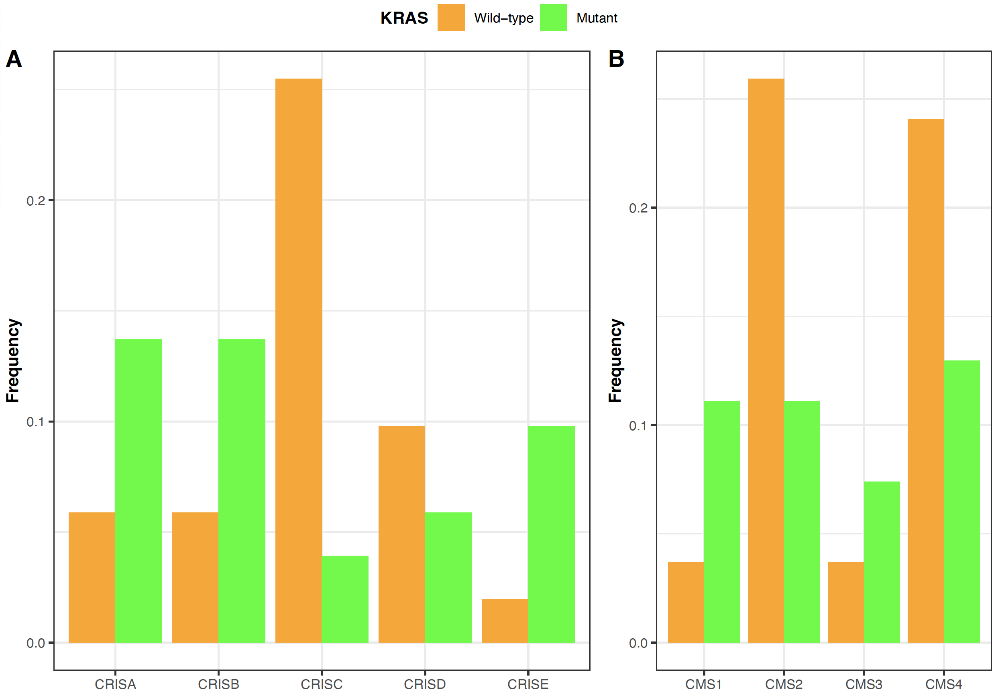
Figure 5: Frequency distributions of the KRAS mutant and wild-type samples according to the CRIS (A) and CMS subtypes (B) in the full series of 57 liver metastases are shown in bar plot format. Molecular subtype classifications are shown in the X-axis, and frequencies are indicated in the Y-axis. KRAS mutant and wild-type samples are color-coded as shown in the legend.
Tables to the supplementary data file

Table 1: Overview of KRAS genotypes in 35 samples with clinically reported KRAS mutation status. Records include, from left to right, the bam-file name, KRAS RNA mutation status, the pHGVS annotation, the ClinVar classification, the number of reference and variant RNA-sequencing reads, the resulting variant allele frequency (VAF), and the KRAS mutation status based on DNA sequencing.
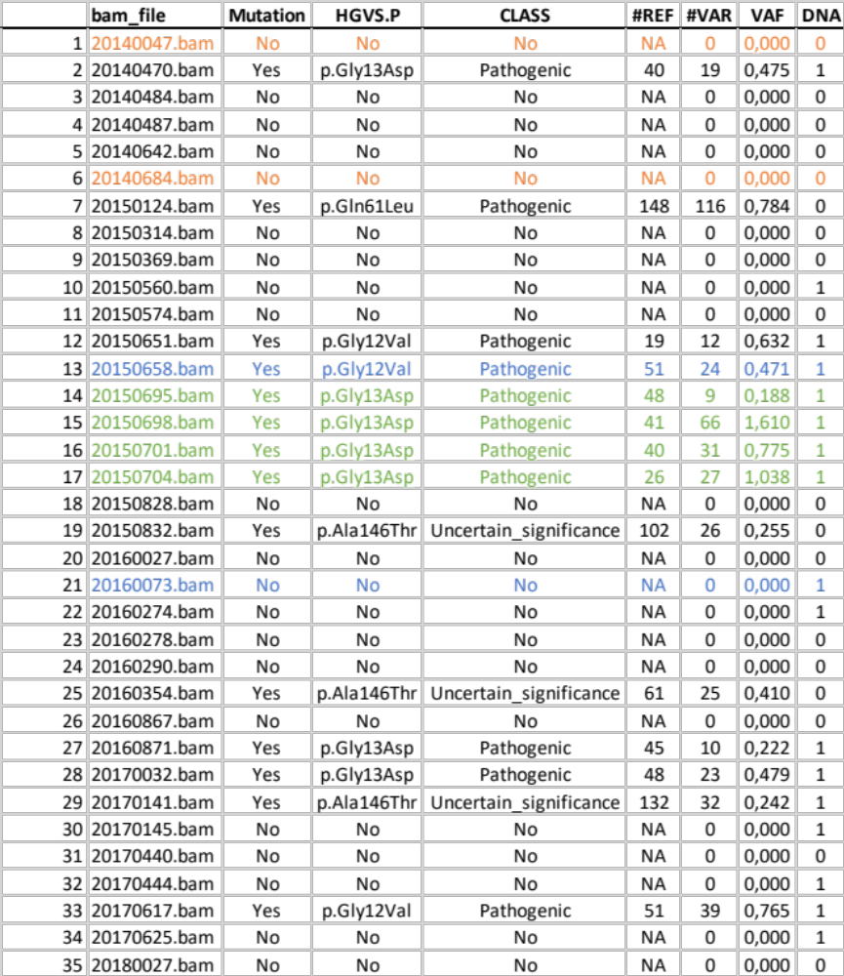

Table 2: Comparison of mutation frequency distributions with MSKCC data set. Records include from left to right, the gene symbol, the mutation types, the mutation frequencies in our liver metastases series and in the MSKCC series, and the number of samples with double frameshift or missense mutations per gene.
