Supporting Information

Multifunctional PVA/PNIPAM conductive hydrogel sensors enabled Human-Machine interaction intelligent rehabilitation training

Yanlong Zhao, Xichong Zhang, Yilin Hao, Yinghe Zhao, Peng Ding, Wei Zhai, ∗ Kun Dai, ∗ Guoqiang Zheng, Chuntai Liu, Changyu Shen

Y. L. Zhao, Y. H. Zhao, P. Ding, W. Zhai, Prof. K. Dai, Prof. G. Q. Zheng, Prof. C. T. Liu, Prof. C. Y. Shen
School of Materials Science and Engineering, Key Laboratory of Materials Processing and Mold (Zhengzhou University), Ministry of Education; Zhengzhou University, Zhengzhou, 450001, P. R. China
E-mail: weizhai@zzu.edu.cn (W. Z.); kundai@zzu.edu.cn (K. D.)

Y. L. Hao
Advanced Intelligent Manufacturing Lab Nano Opto-mechatronics and Biomedical Engineering Lab (AIM-NOBE Lab), (Zhengzhou University), Ministry of Education; Zhengzhou University, Zhengzhou, 450001, P. R. China

X. C. Zhang,
School of Computer Science and Technology, University of Science and Technology of China, Hefei, P. R. China

Firstly, the prepared PPP hydrogel was frozen at -20 °C for 5 h and then freeze-dried in a freeze-dried machine at an atmospheric pressure of 100 Pa for 72 h. The freeze-dried PPP hydrogel was treated in liquid nitrogen for half an hour, and then the PPP hydrogel was kept in liquid nitrogen and cut off with a scalpel. The three-dimensional pore structure at the truncation of PPP hydrogel is shown in Fig. S1. Before freeze-thaw conditioning, PPP hydrogels are in a flowing solution state (Fig. S2).
As shown in Fig. S3, the hydrogel is cut into long square strips with sandpaper at both ends and tightly clamped to the fixture of the stretcher to prevent slipping during the stretching process.

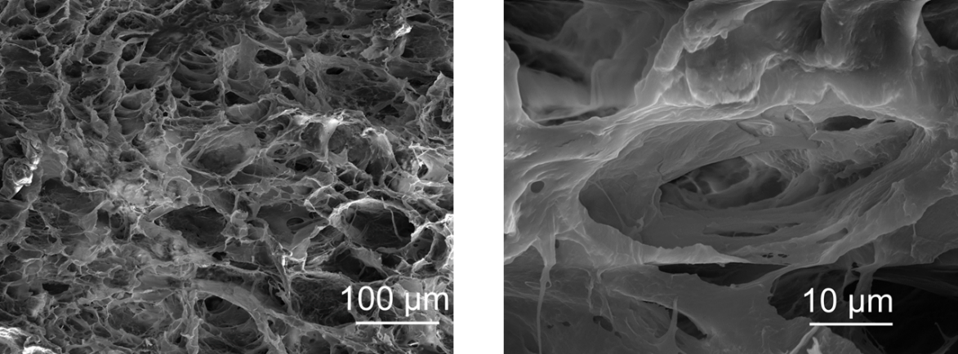
Fig. S1. Cross-section SEM images of PPP hydrogel.
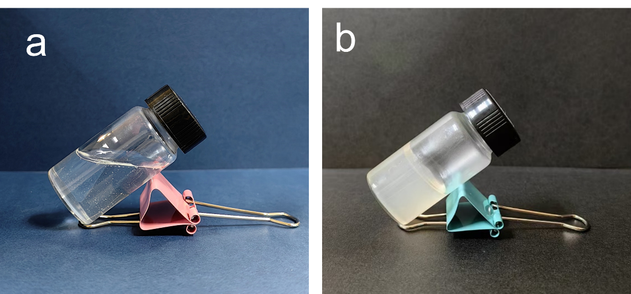
Fig. S2. The images of the PPP hydrogels. a) before freeze-thaw treatment, and b) after freeze-thaw treatment.
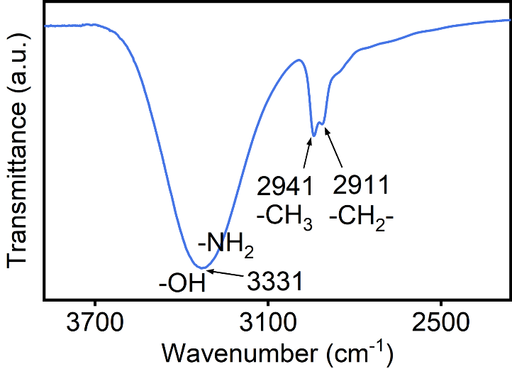
Fig. S3. FTIR spectrum of PPP hydrogels.
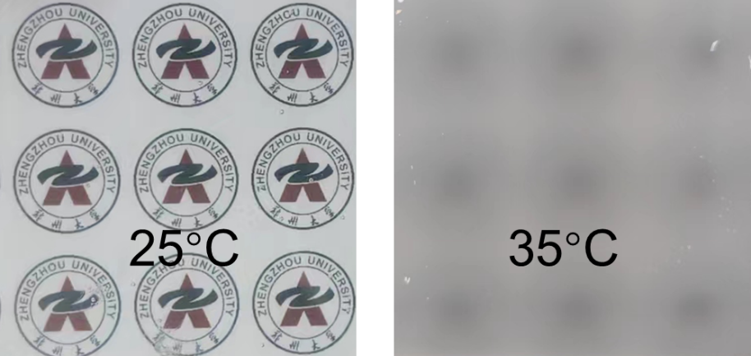
Fig. S4. Graphic information is displayed/hidden in different temperature environments.
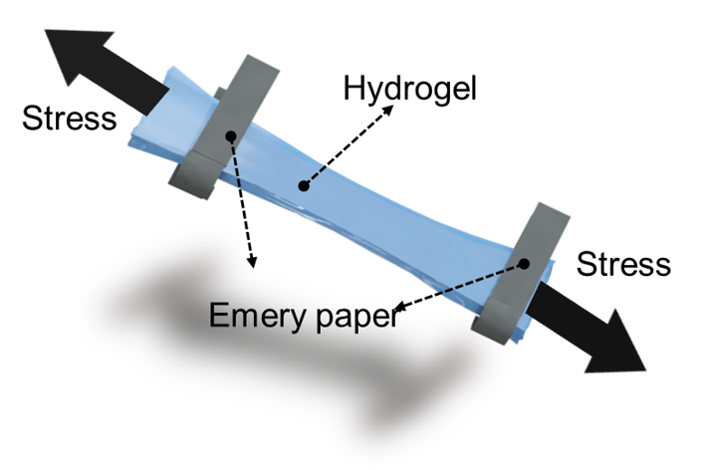
Fig. S5. Diagram of PPP hydrogels during tensile test.
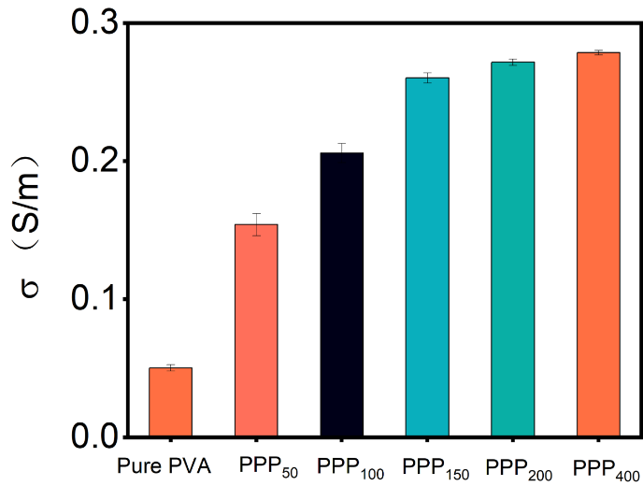
Fig. S6. Conductivity of PPP hydrogels with different qualities (0-400 mg) of PEDOT: PSS polymer solutions.
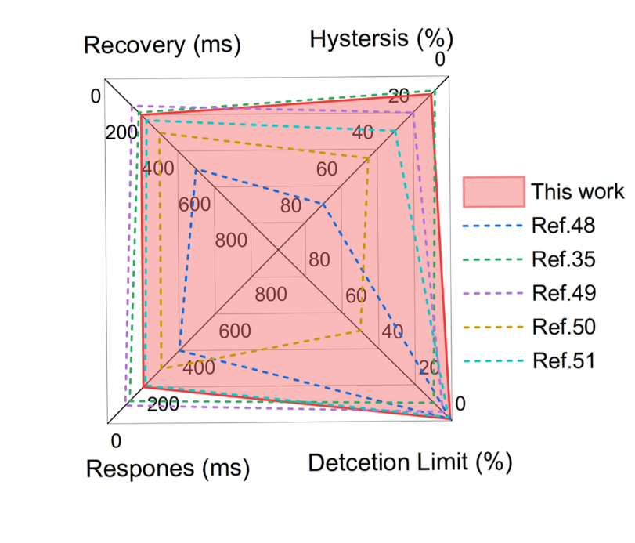
Fig. S7. Advantages of PPP hydrogels as sensor applications compared to other work.
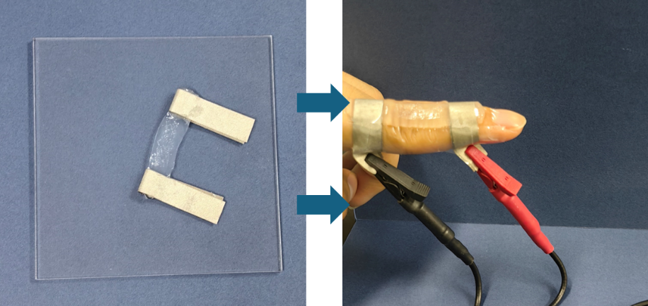
Fig. S8. The diagram of PPP hydrogel sensor and the application on hand knuckle.
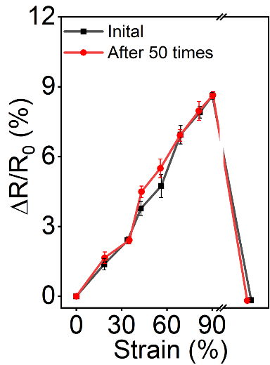
Fig. S9. Schematic diagram of electrical signal changes of PPP hydrogel sensor under different strains before and after bending 50 times.
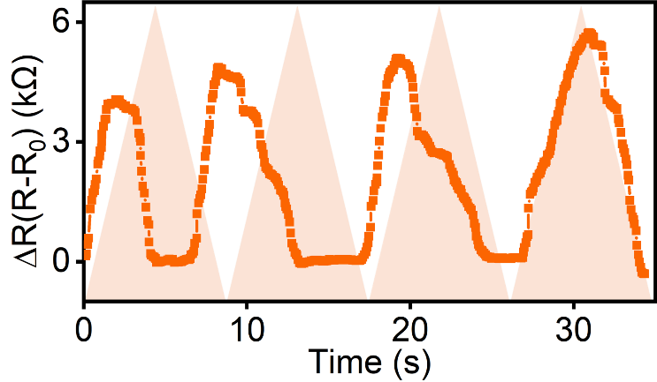
Fig. S10. The bending waveform of an individual with impaired control displaying deviations from the guidance diagram.
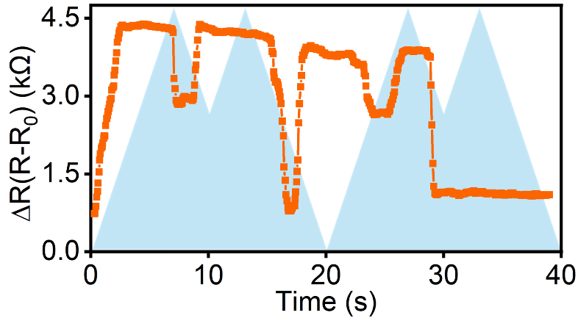
Fig. S11. The diagram of the waveform of a person with stiff finger joints.

[1] Wang. Y, Zhang. Y, Ren. P, Yu. S, Cui. P, Nielsen. C. B, Abrahams. I, Briscoe. J, Lu. Y (2024) Versatile and recyclable double-network PVA/cellulose hydrogels for strain sensors and triboelectric nanogenerators under harsh conditions, Nano Energy 125 109599. DOI: 10.1016/j.nanoen.2024.109599.
[2] Luo. Y, Yu. M, Zhang. Y, Wang. Y, Long. L, Tan. H, Li. N, Xu. L, Xu. J (2022) Highly sensitive strain sensor and self-powered triboelectric nanogenerator using a fully physical crosslinked double-network conductive hydrogel, Nano Energy. 104 107955. DOI: 10.1016/j.nanoen.2022.107955.
[3] Chen. K, Liang. K, Liu. H, Liu. R, Liu. Y, Zeng. S, Tian. Y (2023) Skin-Inspired Ultra-Tough Supramolecular Multifunctional Hydrogel Electronic Skin for Human-Machine Interaction, Nanomicro Lett. 15 (1) 102. DOI: 10.1007/s40820-023-01084-8.
[4] He. X, Dong. J, Zhang. X, Bai. X, Zhang. C, Wei. D (2022) Self-Healing. Anti-Fatigue. antimicrobial ionic conductive hydrogels based on Choline-Amino acid polyionic liquids for Multi-Functional sensors, Chem. Eng. j. 435 135168. DOI: 10.1016/j.cej.2022.135168.
[5] Yu. Y, Feng. Y, Liu. F, Wang. H, Yu. H, Dai. K, Zheng. G, Feng. W (2023) Carbon Dots-Based Ultrastretchable and Conductive Hydrogels for High-Performance Tactile Sensors and Self-Powered Electronic Skin, Small. 19 (31) 2204365. DOI: 10.1002/smll.202204365.

