Supplementary Material
Supplementary Figure S2. The response of intestinal organoid according to TNFα concentration in culture medium.

(A) Morphological changes in control jejunal organoids with incremental increases in the TNFα concentration (n = 2).
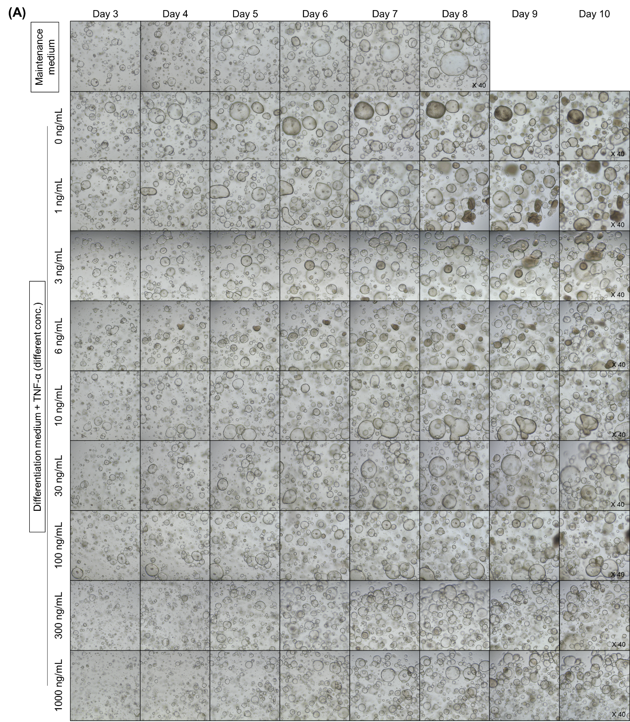
(B) Morphological changes in ileal organoids with incremental increases in the TNFα concentration (n = 2).
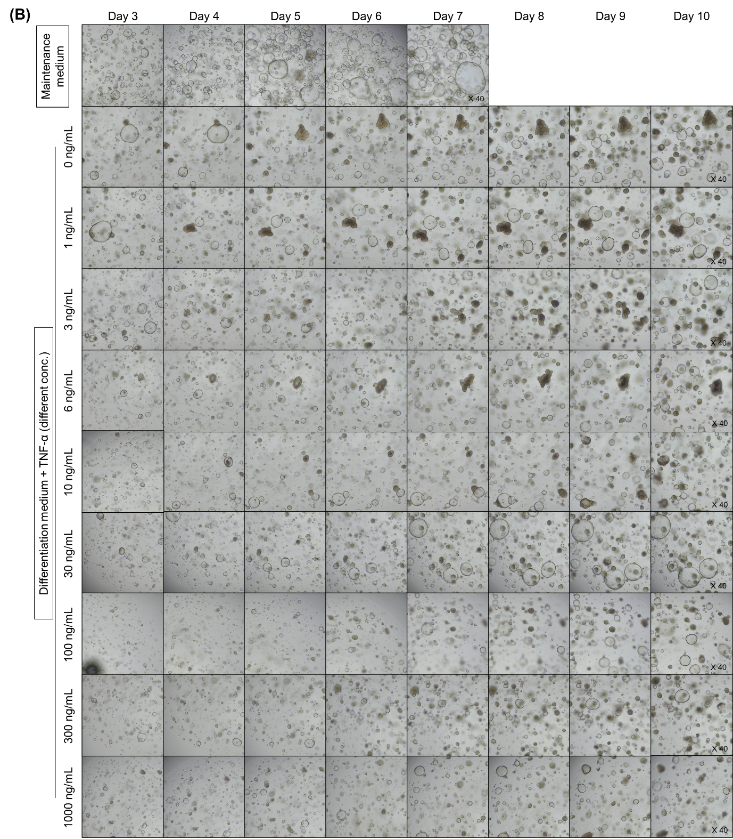

(C) MTT assay for organoid viability (n = 4).

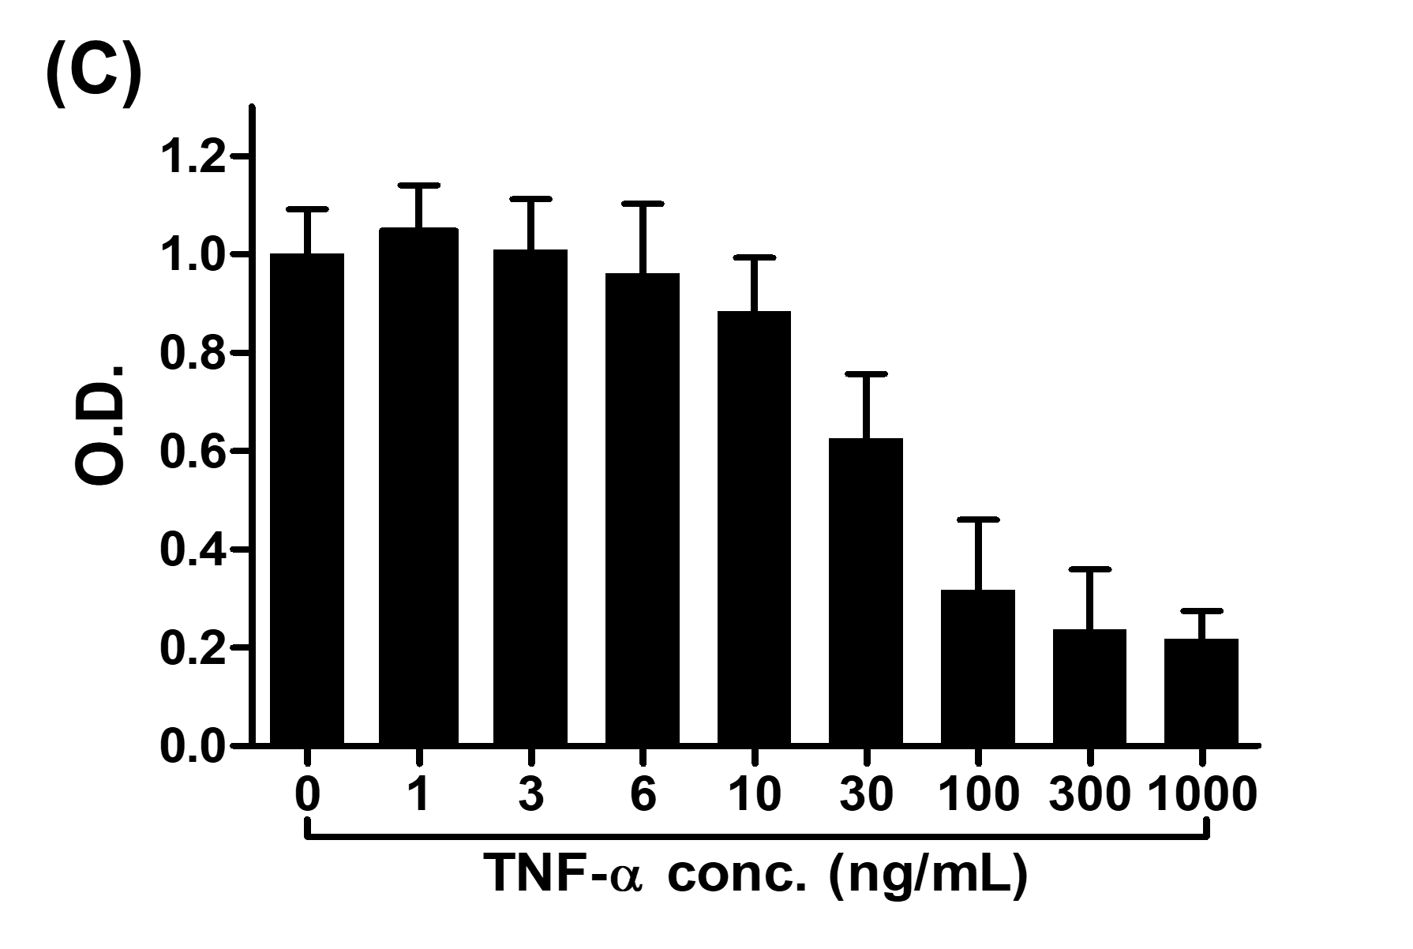
(D) Enteroid/spheroid ratio of human intestinal organoids (n = 4).
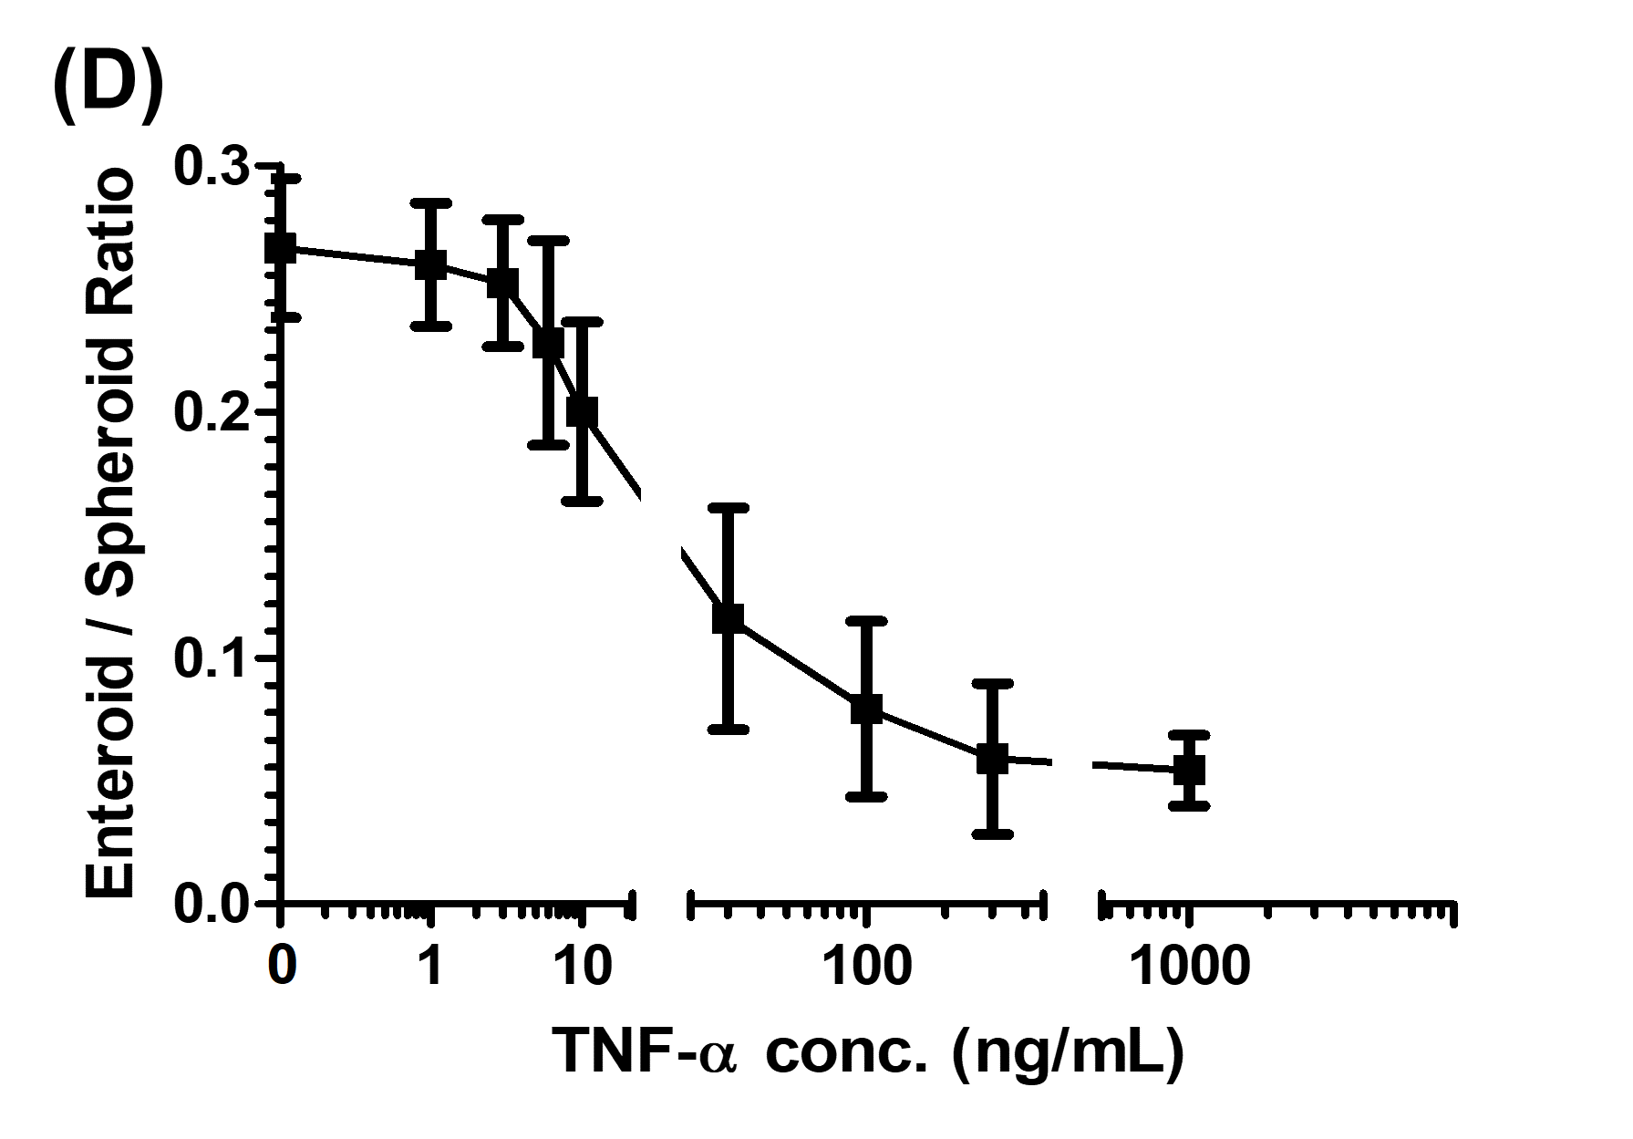

Supplementary Figure S2. Distribution of EdU+ cells 2, 4, 6, 12, and 24 h after EdU administration in control enteroids

