Table S1
Topological properties analysis of hydrogen bonds at the corresponding BCPs (a.u.) and hydrogen bond CVB index, as well as energies (kJ/mol).
BCP | Connected atoms | Bond lengths | $$ρ(r)$$ | $$∇^{2}ρ(r)$$ | $$G(r)$$ | $$V(r)$$ | $$H(r)$$ | $$\left|V\left(r\right)\right|/G(r)$$ | CVB | E_{HB}
[Emim][CH₃SO₃]
1 | H22--O6 | 2.53027 | 0.0096 | 0.0363 | 0.0073 | -0.0056 | 0.0017 | 0.7671 | 0.0637 | -17.7749
2 | H23--O7 | 2.51746 | 0.0094 | 0.0333 | 0.0068 | -0.0052 | 0.0016 | 0.7647 | 0.0615 | -17.5960
3 | O--N | 3.02916 | 0.0088 | 0.0349 | 0.0069 | -0.0051 | 0.0018 | 0.7391
4 | H13--O7 | 2.24843 | 0.0172 | 0.0639 | 0.0134 | -0.0108 | 0.0026 | 0.8060 | 0.0445 | -28.3778
5 | H27--O8 | 2.55716 | 0.0087 | 0.0312 | 0.0063 | -0.0048 | 0.0015 | 0.7619 | 0.0599 | -16.5164
6 | H19--O8 | 2.47704 | 0.0101 | 0.0402 | 0.0081 | -0.0061 | 0.0020 | 0.7531 | 0.0661 | -18.4809
[Emim][BF₃(CH₃SO₃)]
1 | H27--F10 | 2.45323 | 0.0081 | 0.0305 | 0.0063 | -0.0049 | 0.0013 | 0.7778 | 0.0712 | -15.7088
2 | O--C | 3.04560 | 0.0078 | 0.0343 | 0.0068 | -0.0050 | 0.0018 | 0.7353
3 | H17--F9 | 1.96352 | 0.0225 | 0.0921 | 0.0204 | -0.0177 | 0.0027 | 0.8676 | 0.0411 | -35.8045
4 | O--C | 2.95688 | 0.0105 | 0.0388 | 0.0081 | -0.0065 | 0.0016 | 0.8025
5 | H31--F9 | 2.55315 | 0.0064 | 0.0248 | 0.0050 | -0.0039 | 0.0012 | 0.7800 | 0.0727 | -13.3589
6 | O--C | 3.16401 | 0.0077 | 0.0271 | 0.0056 | -0.0044 | 0.0012 | 0.7857
7 | H31--O6 | 2.59995 | 0.0074 | 0.0283 | 0.0056 | -0.0042 | 0.0015 | 0.7500 | 0.0679 | -14.7188
8 | H23--O6 | 2.50049 | 0.0096 | 0.0376 | 0.0075 | -0.0056 | 0.0019 | 0.7467 | 0.0662 | -17.7621
9 | H4--F11 | 2.40455 | 0.0098 | 0.0391 | 0.0080 | -0.0062 | 0.0018 | 0.7750 | 0.0630 | -18.0610
[Emim][EtSO₄]
1 | H26--O2 | 2.33893 | 0.0125 | 0.0475 | 0.0096 | -0.0074 | 0.0022 | 0.7708 | 0.0552 | -21.9057
2 | O--N | 3.00156 | 0.0089 | 0.0377 | 0.0074 | -0.0055 | 0.0020 | 0.7432
3 | O--C | 2.81535 | 0.0159 | 0.0578 | 0.0123 | -0.0102 | 0.0021 | 0.8293
4 | H31--O3 | 2.60672 | 0.0074 | 0.0252 | 0.0051 | -0.0040 | 0.0012 | 0.7843 | 0.0641 | -14.7917
5 | O--N | 3.02160 | 0.0087 | 0.0357 | 0.0070 | -0.0052 | 0.0019 | 0.7429
6 | H31--O4 | 2.72668 | 0.0067 | 0.0249 | 0.0050 | -0.0038 | 0.0012 | 0.7600 | 0.0699 | -13.7338
7 | H23--O4 | 2.43527 | 0.0109 | 0.0435 | 0.0088 | -0.0067 | 0.0021 | 0.7614 | 0.0640 | -19.6063
[Emim][BF₃(EtSO₄)]
1 | H31--F15 | 2.35806 | 0.0098 | 0.0377 | 0.0078 | -0.0061 | 0.0016 | 0.7821 | 0.0662 | -18.1508
2 | O--C | 3.20020 | 0.0058 | 0.0252 | 0.0049 | -0.0035 | 0.0014 | 0.7143
3 | H21--F16 | 1.93223 | 0.0243 | 0.0983 | 0.0221 | -0.0196 | 0.0025 | 0.8869 | 0.0361 | -38.2180
4 | O--C | 3.07293 | 0.0087 | 0.0330 | 0.0068 | -0.0053 | 0.0015 | 0.7794
5 | O--C | 3.08508 | 0.0088 | 0.0320 | 0.0067 | -0.0054 | 0.0013 | 0.8060
6 | H34--F16 | 2.50698 | 0.0069 | 0.0273 | 0.0055 | -0.0043 | 0.0013 | 0.7818 | 0.0714 | -14.1236
7 | H34--O2 | 2.61188 | 0.0071 | 0.0270 | 0.0054 | -0.0040 | 0.0014 | 0.7407 | 0.0755 | -14.3761
8 | H26--O3 | 2.55738 | 0.0085 | 0.0323 | 0.0065 | -0.0049 | 0.0016 | 0.7538 | 0.0684 | -16.2687
9 | H6--F14 | 2.28305 | 0.0119 | 0.0478 | 0.0098 | -0.0077 | 0.0021 | 0.7857 | 0.0639 | -20.9425
[Emim][HSO₄]
1 | H24--O4 | 2.63029 | 0.0071 | 0.0240 | 0.0049 | -0.0038 | 0.0011 | 0.7755 | 0.0652 | -14.3011
2 | H25--O5 | 2.72839 | 0.0066 | 0.0248 | 0.0050 | -0.0038 | 0.0012 | 0.7600 | 0.0699 | -13.6895
3 | H17--O5 | 2.45936 | 0.0104 | 0.0427 | 0.0086 | -0.0065 | 0.0021 | 0.7558 | 0.0666 | -18.9622
4 | O--N | 2.95323 | 0.0097 | 0.0403 | 0.0080 | -0.0059 | 0.0021 | 0.7375
5 | H11--O4 | 2.36320 | 0.0155 | 0.0564 | 0.0120 | -0.0098 | 0.0021 | 0.8167 | 0.0528 | -26.0527
6 | H21--O6 | 2.30484 | 0.0133 | 0.0502 | 0.0102 | -0.0079 | 0.0023 | 0.7745 | 0.0526 | -22.9607
[Emim][BF₃(HSO₄)]
1 | H23--F8 | 2.39847 | 0.0090 | 0.0345 | 0.0071 | -0.0056 | 0.0015 | 0.7887 | 0.0691 | -16.9868
2 | O--C | 3.05186 | 0.0075 | 0.0338 | 0.0067 | -0.0049 | 0.0018 | 0.7313
3 | C--F | 3.07412 | 0.0070 | 0.0299 | 0.0060 | -0.0045 | 0.0015 | 0.7500
4 | N--F | 3.03863 | 0.0069 | 0.0325 | 0.0064 | -0.0046 | 0.0018 | 0.7188
5 | O--C | 2.91384 | 0.0110 | 0.0403 | 0.0085 | -0.0068 | 0.0016 | 0.8000
6 | H29--F10 | 2.49319 | 0.0073 | 0.0292 | 0.0059 | -0.0045 | 0.0014 | 0.7627 | 0.0711 | -14.6735
7 | H29--O5 | 2.53457 | 0.0079 | 0.0313 | 0.0062 | -0.0045 | 0.0017 | 0.7258 | 0.0677 | -15.4648
8 | H21--O5 | 2.60086 | 0.0077 | 0.0299 | 0.0060 | -0.0044 | 0.0015 | 0.7333 | 0.0714 | -15.2347
9 | H3--F9 | 1.91748 | 0.0240 | 0.0946 | 0.0216 | -0.0196 | 0.0020 | 0.9074 | 0.0249 | -37.8706
[Emim][Tos]
1 | H18--O2 | 2.26237 | 0.0141 | 0.0551 | 0.0112 | -0.0086 | 0.0026 | 0.7679 | 0.0528 | -24.0527
2 | H23--O3 | 2.47559 | 0.0095 | 0.0325 | 0.0067 | -0.0052 | 0.0014 | 0.7761 | 0.0560 | -17.7157
3 | H23--O4 | 2.79130 | 0.0062 | 0.0234 | 0.0047 | -0.0035 | 0.0012 | 0.7447 | 0.0725 | -13.0338
4 | H9--O3 | 2.11779 | 0.0208 | 0.0761 | 0.0164 | -0.0138 | 0.0026 | 0.8415 | 0.0310 | -33.4105
5 | H15--O4 | 2.35336 | 0.0124 | 0.0487 | 0.0098 | -0.0075 | 0.0024 | 0.7653 | 0.0588 | -21.6839
[Emim][BF₃(Tos)]
1 | H32--F8 | 2.50054 | 0.0087 | 0.0350 | 0.0071 | -0.0055 | 0.0016 | 0.7746 | 0.0716 | -16.6254
2 | H27--O2 | 2.57863 | 0.0077 | 0.0292 | 0.0058 | -0.0043 | 0.0015 | 0.7414 | 0.0665 | -15.1443
3 | H19--O2 | 2.51797 | 0.0093 | 0.0357 | 0.0071 | -0.0054 | 0.0018 | 0.7606 | 0.0662 | -17.3760
4 | H27--F6 | 2.61639 | 0.0057 | 0.0220 | 0.0045 | -0.0034 | 0.0011 | 0.7556 | 0.0746 | -12.3726
5 | H13--F6 | 1.92284 | 0.0247 | 0.1000 | 0.0226 | -0.0201 | 0.0024 | 0.8894 | 0.0353 | -38.8625
6 | O--C | 2.98325 | 0.0101 | 0.0376 | 0.0078 | -0.0063 | 0.0016 | 0.8077
7 | O--C | 3.09227 | 0.0071 | 0.0311 | 0.0061 | -0.0045 | 0.0017 | 0.7377
8 | H23--F7 | 2.44132 | 0.0084 | 0.0316 | 0.0065 | -0.0051 | 0.0014 | 0.7846 | 0.0704 | -16.0899

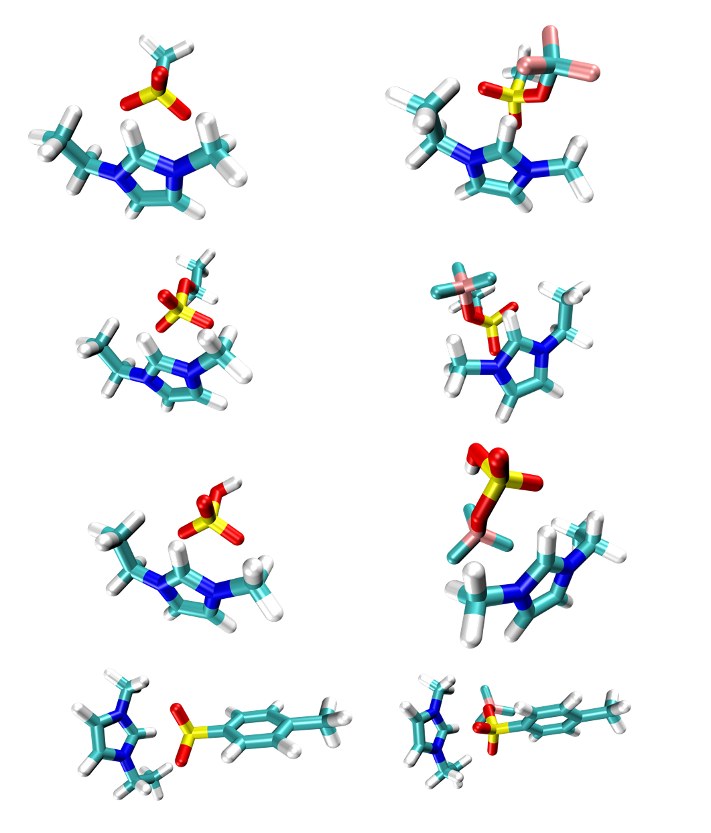
Fig S1. The optimized geometries of eight ion pairs based on B3LYP-D3/aug-cc-pVTZ. (a). [Emim][CH₃SO₃], (b). [Emim][BF₃(CH₃SO₃)], (c). [Emim][EtSO₄], (d). [Emim][BF₃(EtSO₄)], (e). [Emim][HSO₄], (f). [Emim][BF₃(HSO₄)], (g). [Emim][Tos], (h). [Emim][BF₃(Tos)].
(a)
(b)
(c)
(d)
(e)
(f)
(g)
(h)
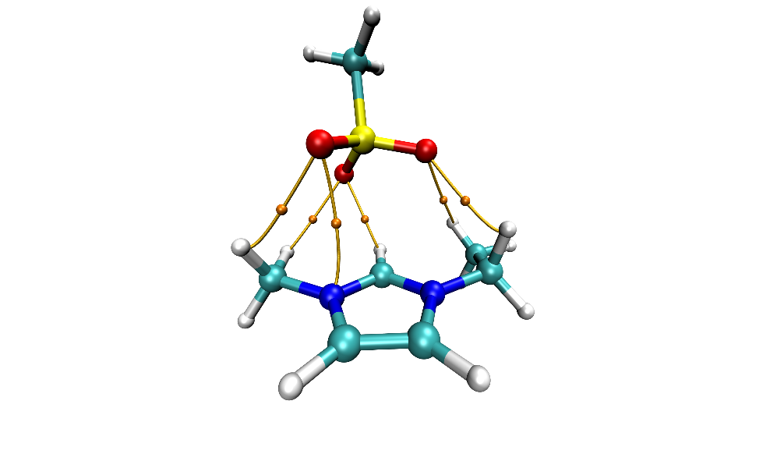
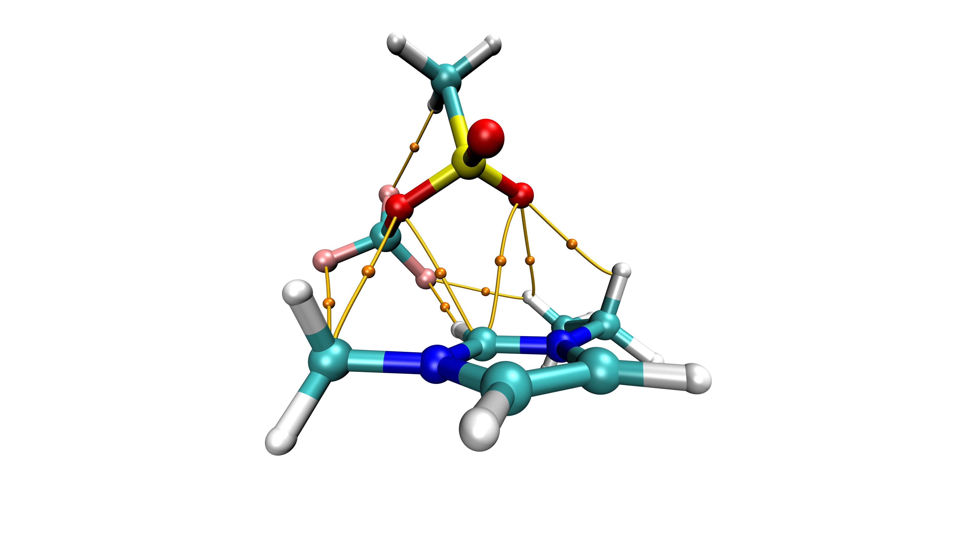
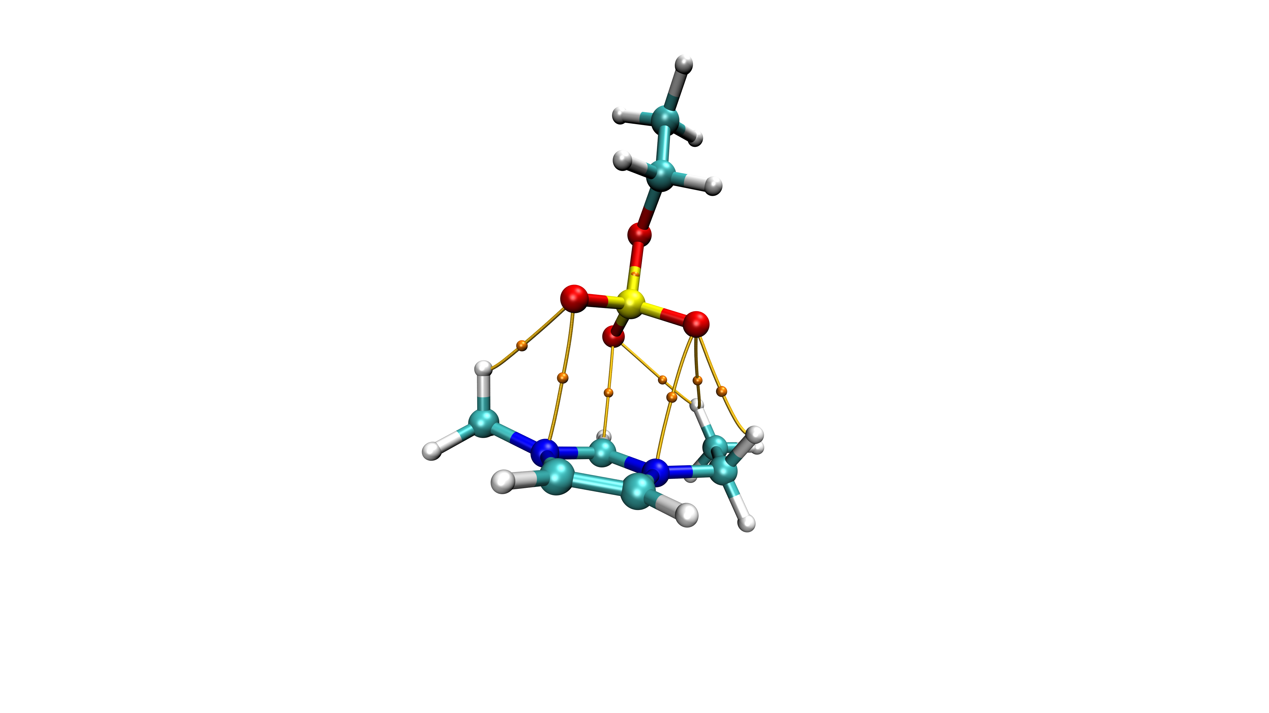
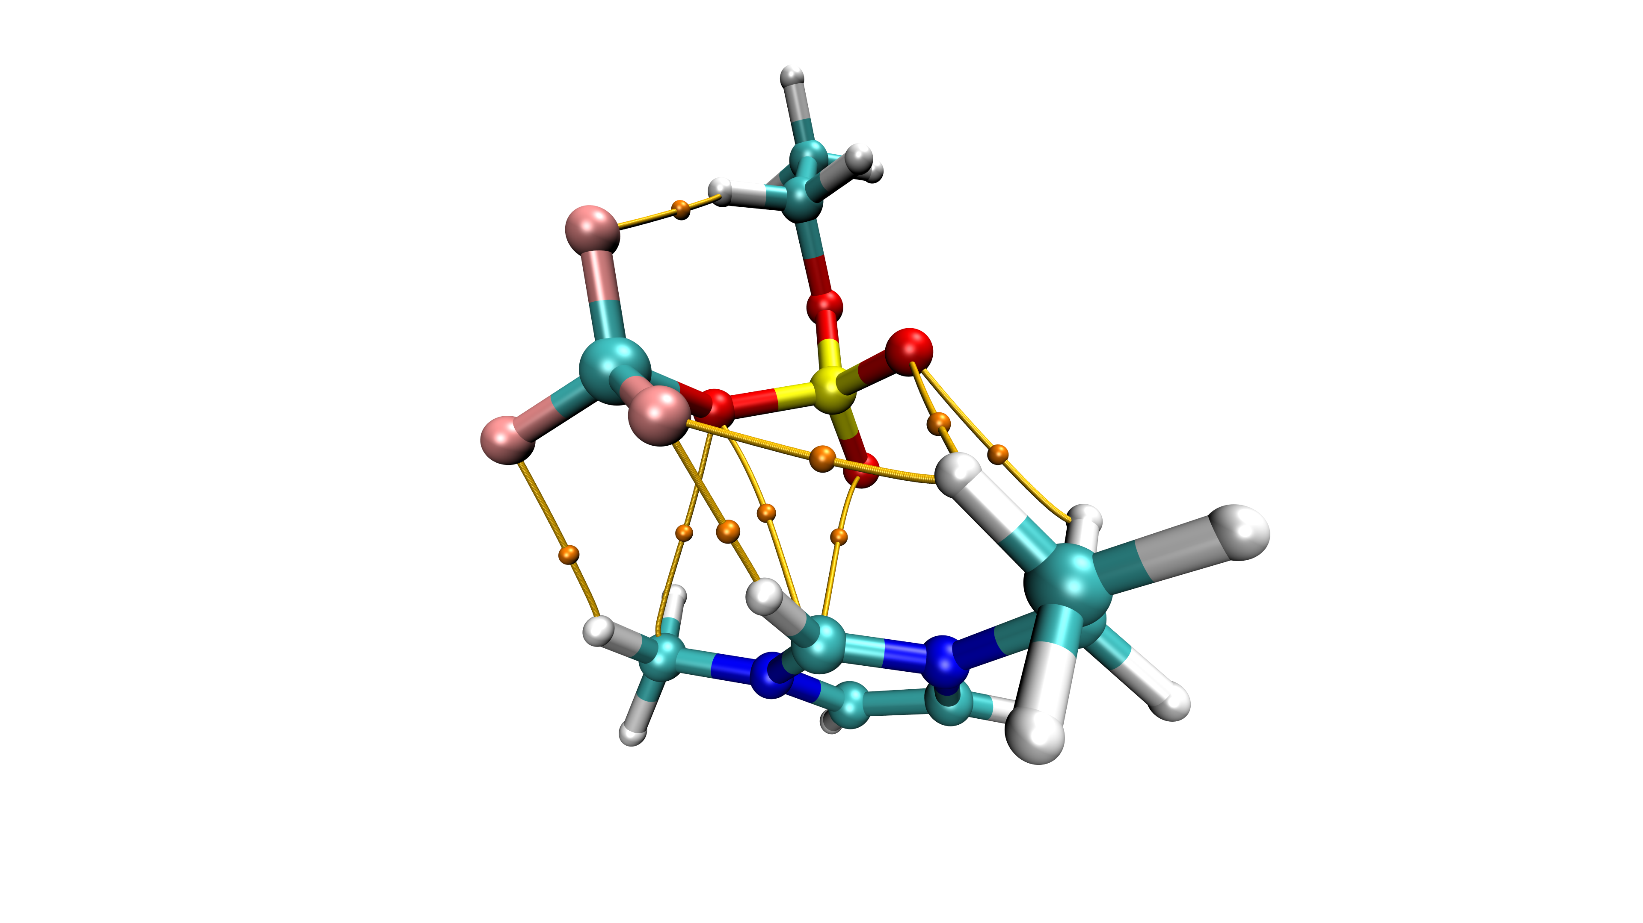
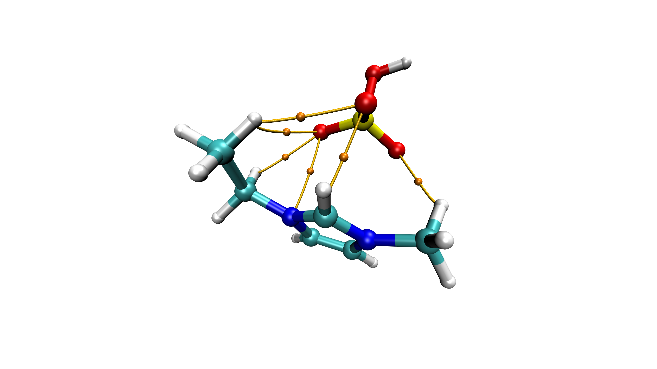
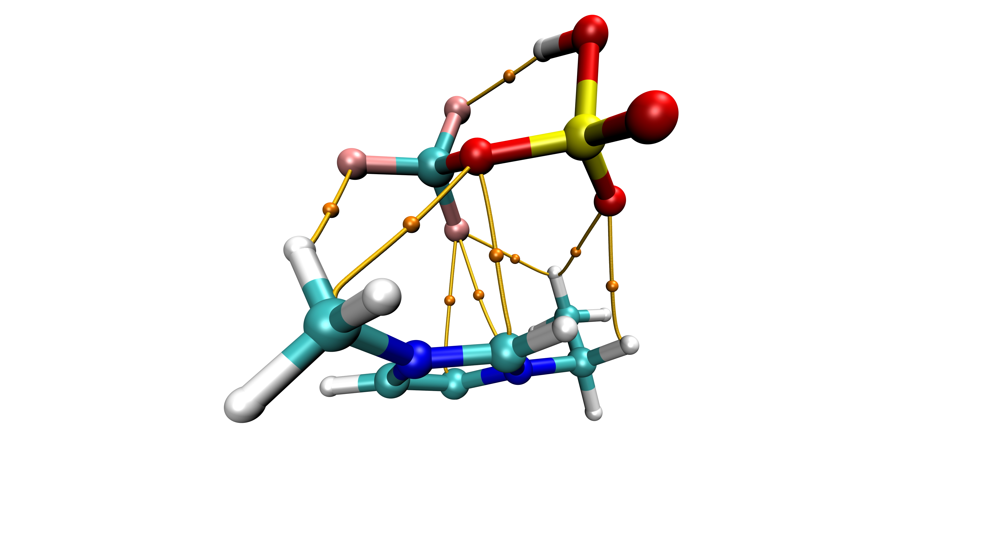
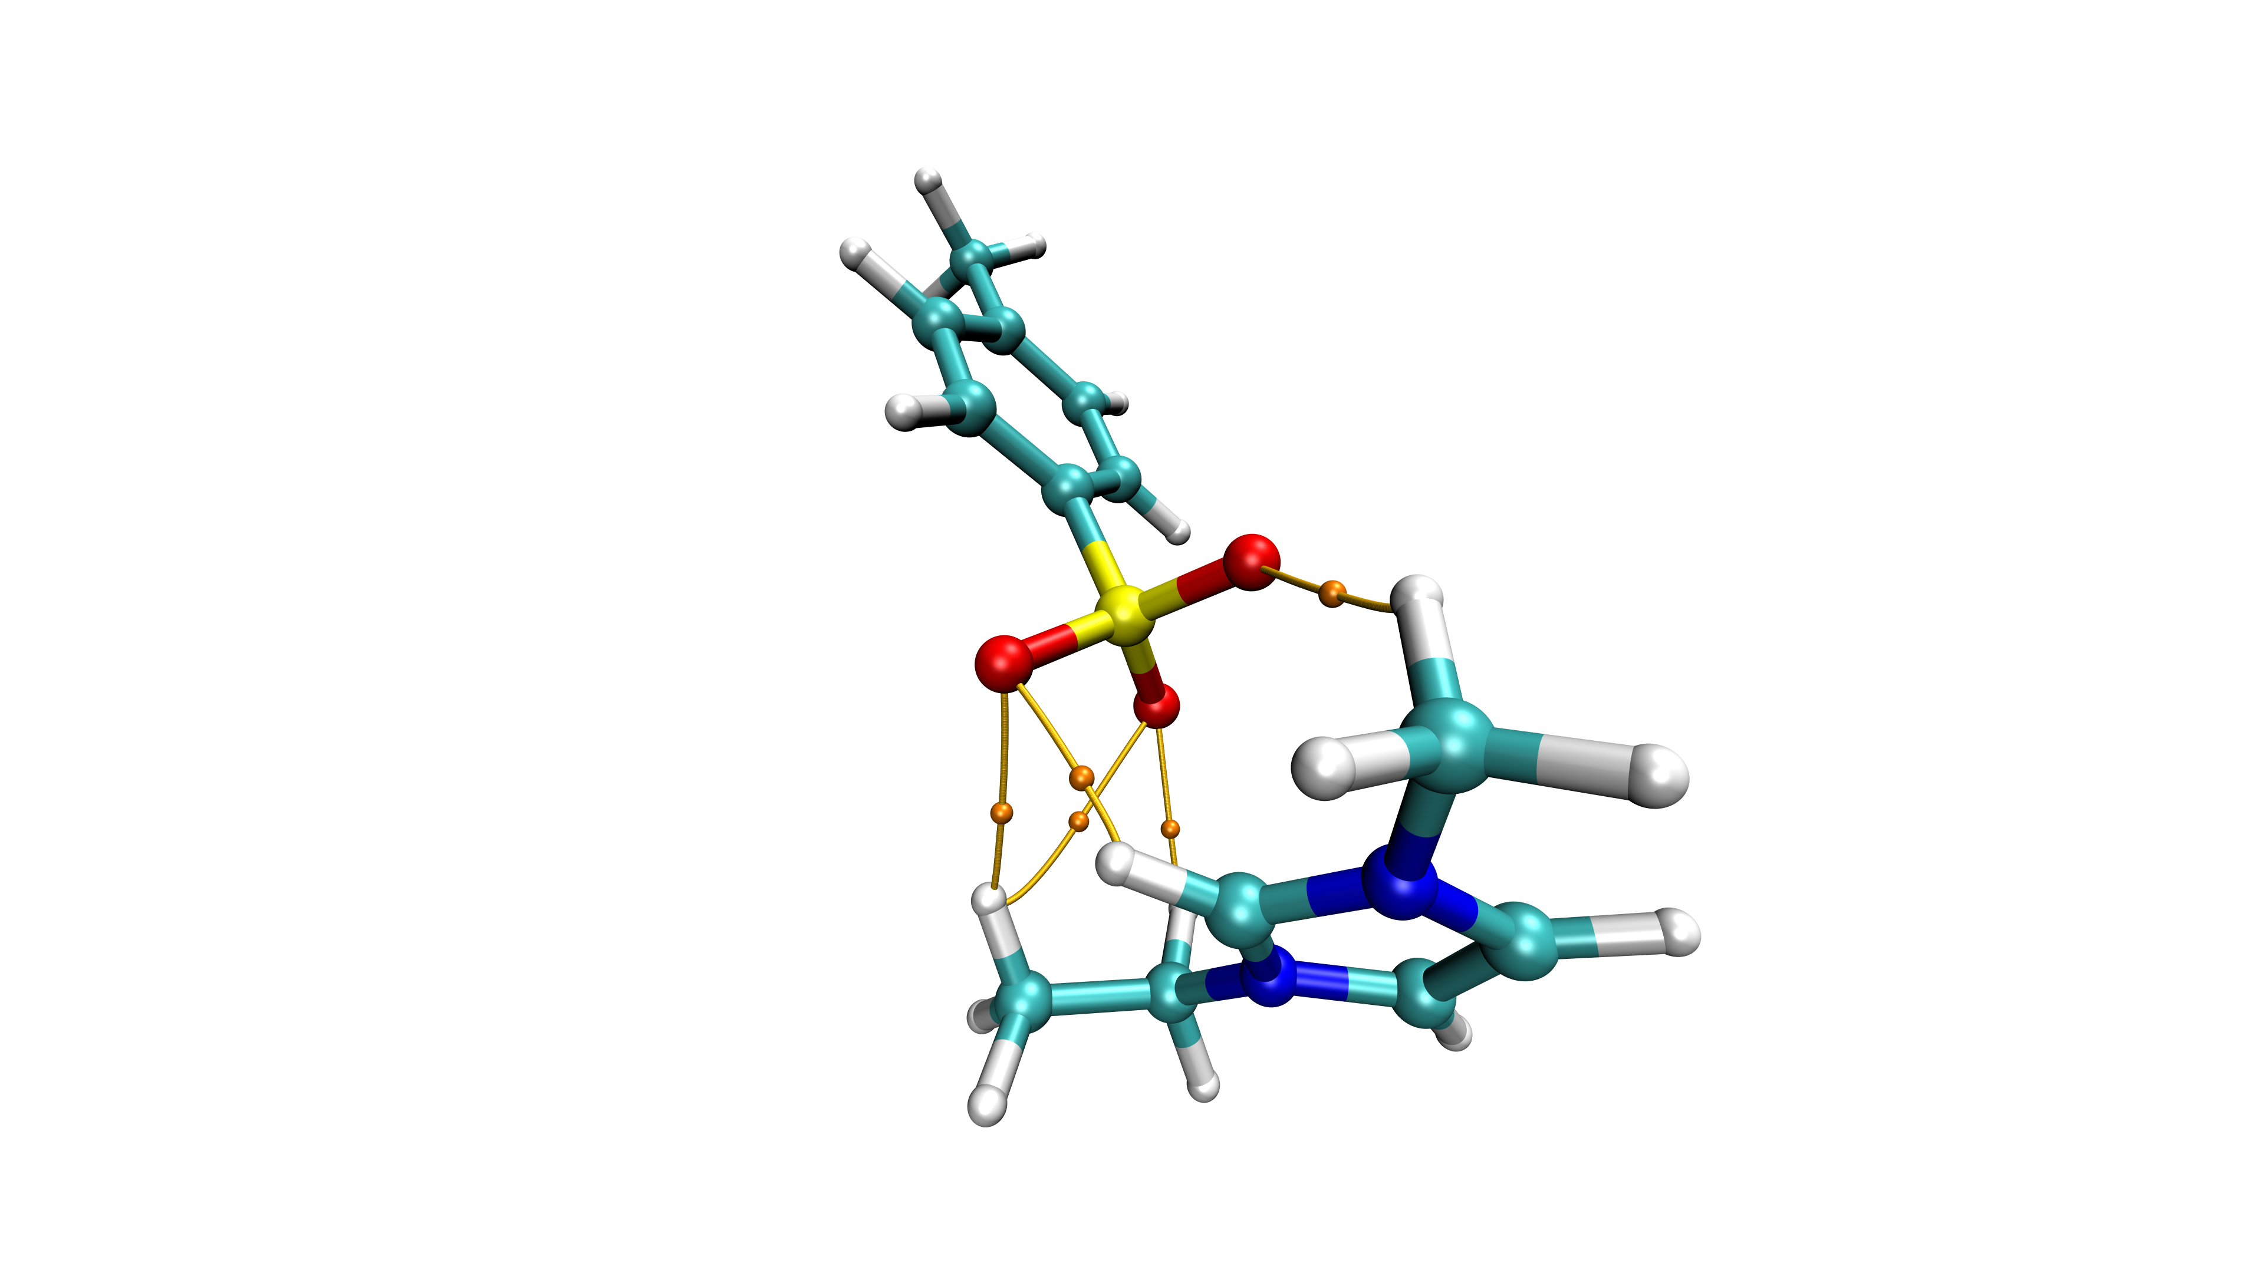
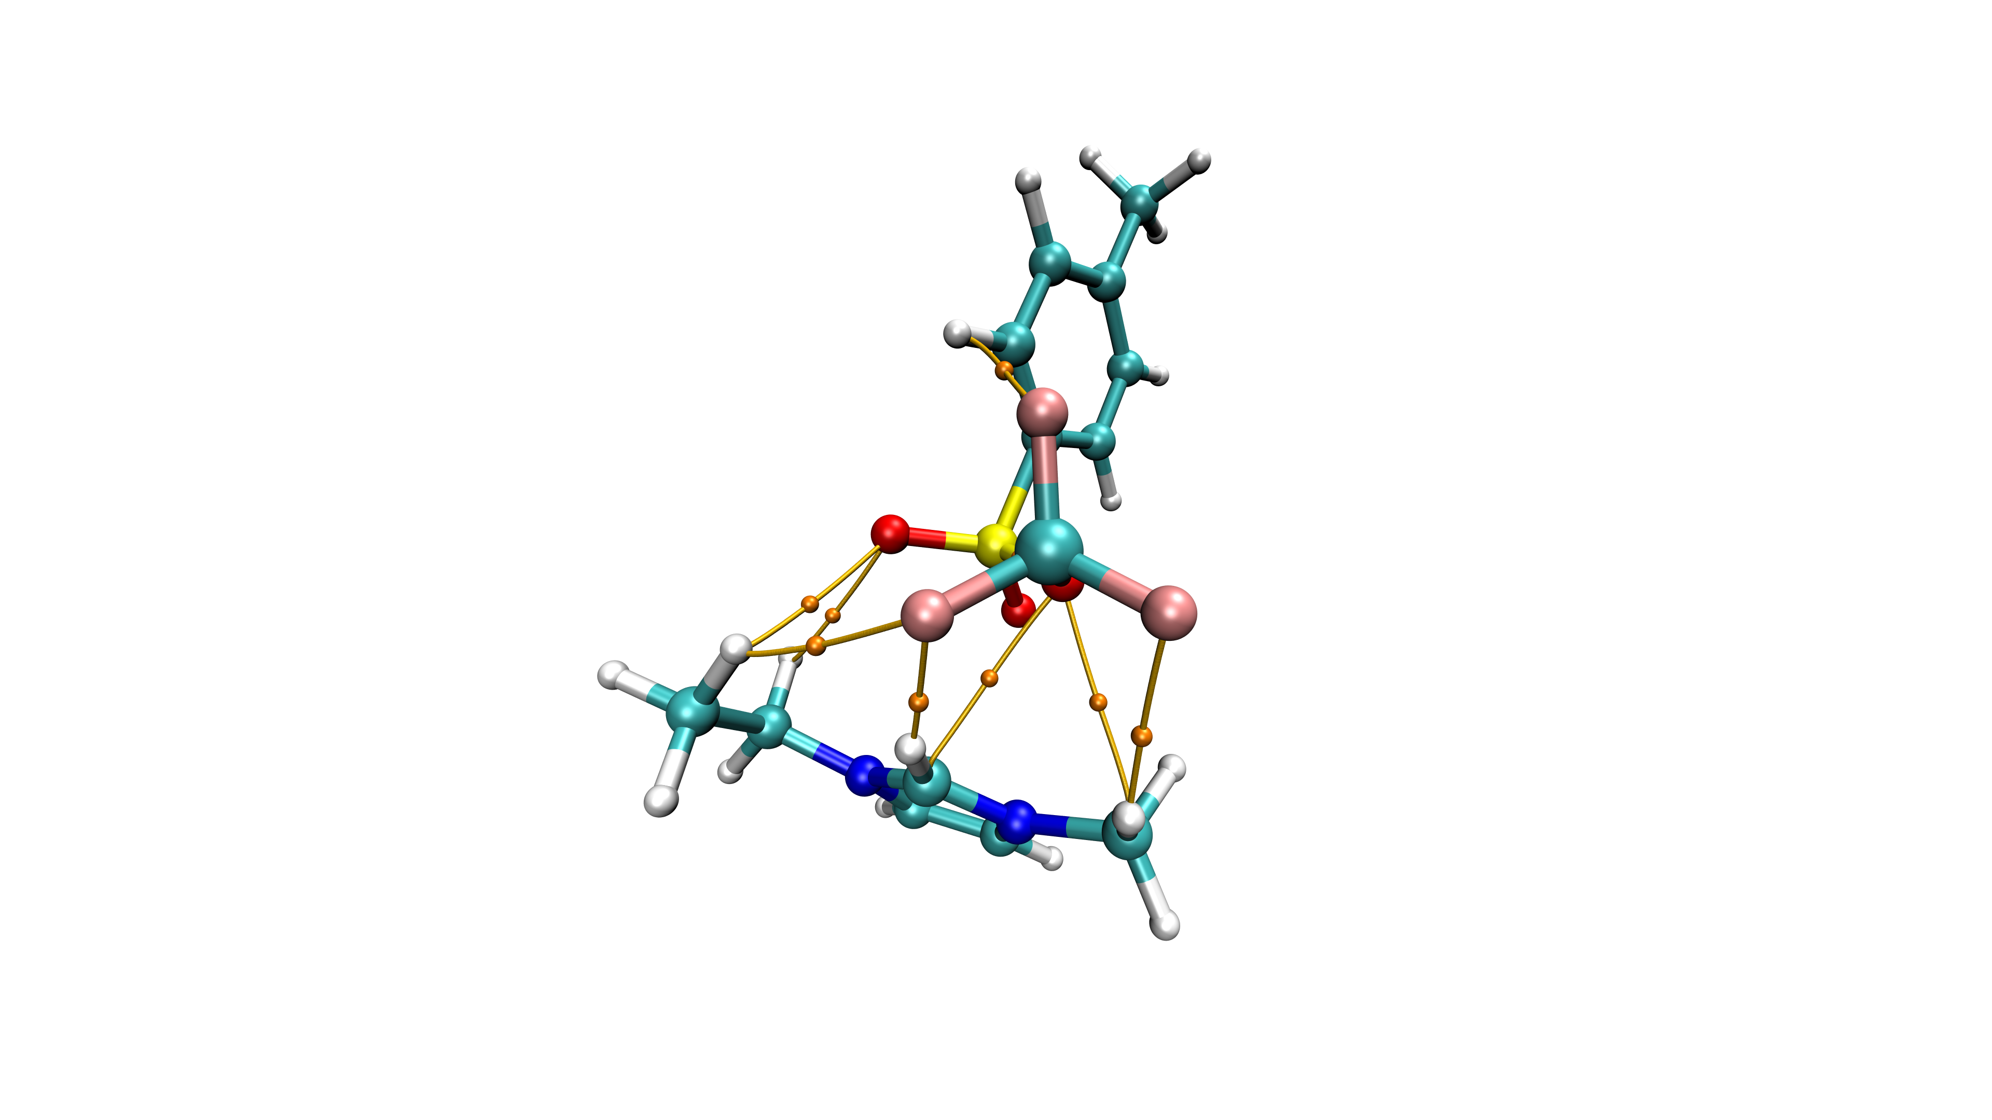
Fig S2. Graphical illustration of the weak interaction between cation and anion. Orange spheres and lines denote BCPs and paths, respectively.
(a)
(b)
(c)
(d)
(e)
(f)
(g)
(h)
1
4
3
2
5
6
1
2
3
4
5
6
7
8
9
1
2
3
4
5
6
7
1
2
3
4
5
6
7
8
9
1
2
3
4
5
6
1
2
3
4
5
6
7
8
9
1
2
3
4
5
1
2
3
4
5
6
7
8

