Collagen-Coated Superparamagnetic Iron Oxide Nanoparticles as a Sustainable Catalyst for Spirooxindole Synthesis
Shima Ghanbari¹, Maryam Esmkhani¹, Shahrzad Javanshir ^{1*}
¹ Heterocyclic Chemistry Research Laboratory, Department of Chemistry, Iran University of Science and Technology, 16846-13114, Tehran, Iran

Figure S 1: FT-IR spectra of the Fe₃O₄@SiO₂/ECH/IG, Fe₃O₄@SiO₂, Fe₃O₄ and reused Fe₃O₄@SiO₂/ECH/IG. 2
Figure S 2: BET analysis of Fe₃O₄@SiO₂/ECH/IG. 2
Figure S 3: Recyclability of Fe₃O₄@SiO₂/ECH/IG 3
Table S 1: Effect of solvent on model reaction in the presence of Fe₃O₄@SiO₂/ECH/IG 4
Table S 2: Investigation of different types of catalyst in model reaction 4
Table S 3: Investigation the amount of catalyst 4

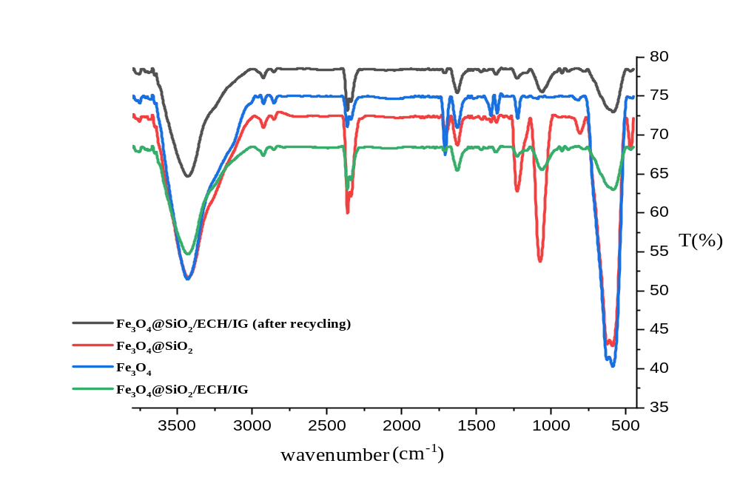
Figure S 1: FT-IR spectra of the Fe₃O₄@SiO₂/ECH/IG, Fe₃O₄@SiO₂, Fe₃O₄ and reused Fe₃O₄@SiO₂/ECH/IG.

Figure S 2: BET analysis of Fe₃O₄@SiO₂/ECH/IG.

Figure S 3: Recyclability of Fe₃O₄@SiO₂/ECH/IG

Table S 1: Effect of solvent on model reaction in the presence of Fe₃O₄@SiO₂/ECH/IG
Entry | Solvent | Time(min) | Yield(%)
1 | Ethanol | 30 | 92
2 | water | 30 | 83
3 | EtOH/water (1:1) | 30 | 94
4 | CH₃CN | 30 | 21
5 | CHCl₃ | 30 | 17
6 | MeOH | 30 | 61
*Reaction condition: Isatin 1 (1 mmol), 2 (1 mmol), 1,3-dicarbonyl 3 (1 mmol), 10 mg catalyst, and 3 ml solvent at 60 °C.

Table S 2: Investigation of different types of catalyst in model reaction
Entry | Catalyst | (C°)Temperature | (%)yield
1 | Fe₃O₄@SiO₂/ECH/IG | rt | Trace
2 | Fe₃O₄@SiO₂/ECH/IG | 40 | 69ª
3 | Fe₃O₄@SiO₂/ECH/IG | 60 | 83ª
4 | Fe₃O₄@SiO₂/ECH/IG | 80 | 78ª
5 | Fe₃O₄@SiO₂/ECH/IG | 60 | 94ª
6 | IG | 60 | 91^{b}
7 | Fe₃O₄ | 60 | 74^{b}
8 | Fe₃O₄@SiO₂ | 60 | 75^{b}
9 | Fe₃O₄@SiO₂-ECH | 60 | 85^{b}
*Reaction conditions: isatin (1 mmol), malononitrile (1 mmol), dimedone (1 mmol), catalyst (0.01 g) in EtOH/water (1:1) 3ml
ª 10min ^{b} 30min

Table S 3: Investigation the amount of catalyst
Entry | (mg) Catalyst | (%)Yield
1 | 3 | 66
2 | 5 | 79
3 | 10 | 94
4 | 15 | 94
*Reaction condition: Isatin 1 (1 mmol), 2 (1 mmol), 1,3-dicarbonyl 3 (1 mmol), and 3 ml solvent at 60°C for 30 min.

