Supplementary Table 1. Growth duration, yield, and grain quality of cultivar used in the cropping systems trial
Cropping system | Crop | Cultivar | Growth duration | Yield (t/ha) | Grain/pod quality
R-F-R | Aman | Gutiswarna | 140-150 | 4.5-5.5 | Bold/Coarse
R-F-R | Boro | Suballota | 140-145 | 5.5-7.0 | Medium fine
R-M-R | Aman | Binadhan-7 | 110-120 | 4.0-5.5 | Medium bold/Coarse
R-M-R | Mustard | BARI Sarisha14 | 75-80 | 1.4-1.6 | Small grain
R-M-R | Boro | BRRI dhan50 | 155-160 | 5.0-6.5 | Thin and slender with aroma (PQR)
R-L-M | Aman | Binadhan-7 | 110-120 | 4.0-5.5 | Medium bold/Coarse
R-L-M | Lentil | BARI Masur4 | 105-110 | 1.6-1.7 | Medium bold
R-L-M | Mungbean | BARI Mung-6 | 60-65 | 1.2-1.5 | Medium bold
R-W-M | Aman | Binadhan-7 | 110-120 | 4.0-5.5 | Medium bold/Coarse
R-W-M | Wheat | BARI gom-26 | 105-110 | 3.5-4.5 | Medium bold
R-W-M | Mungbean | BARI mung-6 | 60-65 | 1.2-1.5 | Medium bold
R-RM-R | Aman | BRRI dhan34 | 130-135 | 3.0-3.5 | Small grain with aroma (PQR)
R-RM-R | Relay Mustard | Tori-7 | 70-80 | 1.1-1.2 | Small grain
R-RM-R | Boro | BRRI dhan50 | 155-160 | 5.0-6.5 | Thin and slender with aroma (PQR)
R-F-R, Rice-Fallow-Rice; R-M-R, Rice-Mustard-Rice; R-L-M, Rice-Lentil-Mustard, R-W-M, Rice-wheat-Mustard; R-RM-R, Rice-Relay mustard-Rice; PQR, premium quality rice

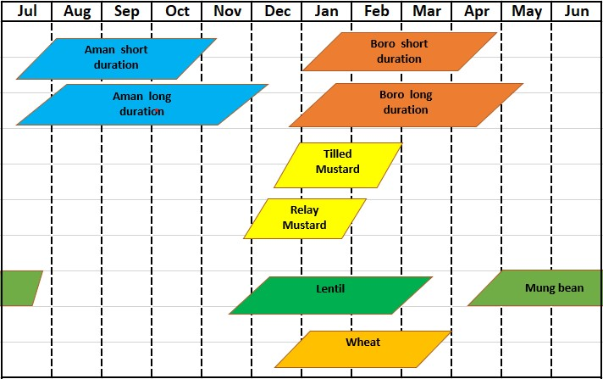
Supplementary Fig. 1. Duration of each crop in a system

