Supplementary Material for
Randomized Controlled Trial of 4,4′-diaminodiphenyl sulfone for COVID-19 ARDS

Section 1. Information Disclosure Claim Response Form 4
○ Response to Information Disclosure Claim-7767726 (2021. 4. 15.) of Sorokdo National Hospital 4
Section 2. IRB 5
The Ethics and Administrative Committee of Hunt Regional Hospital 5
The Criteria for SARS-CoV-2 ARDS 5
Protocol for administration 6
Indication: 6
Categories: 6
Protocol for administration: 6
Recommended Dosage: 7
Section 3. Statistical analysis for cross-sectional study 8
Period 2: Case series with or without intervention; cross-sectional study 8
The chi-square statistics 9
1.1. The comparison was made assuming that only the case of decreased FIO₂ was influential in the entire dapsone (+) group and dapsone (-) group. 9
1.2. The comparison was made assuming that cases of decreased FIO₂ and no further progression were influential in the dapsone (+) group and the dapsone (-) group as evidence of improvement. 9
1.3. The comparison was made assuming that only the case of decreased FIO₂ was influential in the entire dapsone (+) group and dapsone (-) group, which was applicable to only the ARDS onset stage. 9
1.4. The comparison was made assuming that only the case of decreased FIO₂ was influential in the ARDS onset and aggravated stage dapsone (+) group and ARDS onset and aggravated stage dapsone (-) group. 9
1.5. The comparison was made assuming that the dapsone (+) group and the dapsone (-) group in the ARDS onset stage were influential in the case of decreased FIO₂ and no further progression. 10
1.6. The comparison was made assuming that the dapsone (+) group and the dapsone (-) group in the ARDS onset and aggravated stages were influential in the case of decreased FIO₂ and no further progression. 10
Fischer's exact test 11
Fischer's exact test Study 2-1 11
Fischer's exact test Study 2-2 11
Fischer's exact test Study 2-3 11
Fischer's exact test Study 2-4 12
Section 4. Randomized controlled trial of ARDS mortality 13
T-Test Calculator for 2 Independent Means: Mortality 13
Mortality at the ARDS-Onset stage from Hunt Regional Hospital in Greenville, TX 13
Mean and Standard Deviation for randomized controlled trial (RCT) 15
T-Test Calculator for randomized controlled trial (RCT): Mortality 16
Effect Size Calculator for T-Test 18
The chi-square statistics for mortality 18
Relative Risk and Odds Ratio 19
Case 1 20
Case 2 20
Case 3 21
Case 4 22
Case 5 23
Section 6. STROBE Statement 24
Checklist of items that should be included in reports of case-control studies 24
References 31

Section 1. Information Disclosure Claim Response Form

○ Response to Information Disclosure Claim-7767726 (2021. 4. 15.) of Sorokdo National Hospital

-Regarding the ``Corona 19 infection status among Hansen people of Sorokdo National Hospital'' requested by the claimant as follows

We are pleased to inform you that there are no patients infected with Corona 19 among Hansen People at Sorokdo National Hospital.

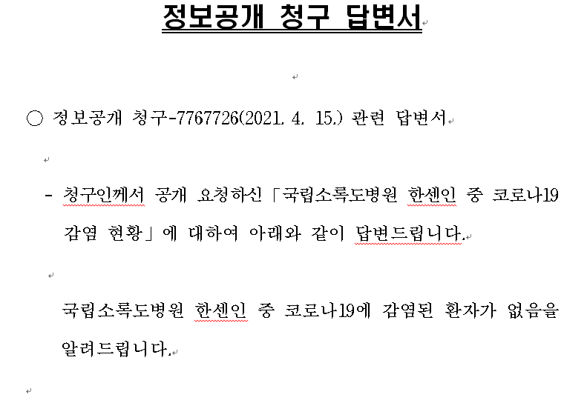

Section 2. IRB

The Ethics and Administrative Committee of Hunt Regional Hospital

The Ethics and Administrative Committee of Hunt Regional Hospital in Greenville, TX, approved this clinical treatment based on the World Medical Association’s Declaration of Helsinki. All patients (or their parents or guardians) provided written informed consent.

The Criteria for SARS-CoV-2 ARDS

The criterion for ARDS onset was the requirement of FIO₂ via simple nasal cannulation of up to 15 L/min. The criteria for aggravated cases of ARDS were FIO₂ administered via an HFNC (high-flow nasal cannula) of 95-100% and/or bilevel positive airway pressure (BiPAP). The criterion for severe ARDS was the need for mechanical ventilation.

Onset | FIO₂ requirement  via simple nasal  cannulation of up to  15 L/min
Aggravated | FIO₂ administered  via an HFNC of 95-100%  and/or BiPAP
Severe | requiring mechanical ventilation

Protocol for administration

Written informed consent should be obtained, and potential side effects should be explained. The common side effects are haemolytic anaemia (in patients with G6PD deficiency), methemoglobinemia, and allergic reaction.

Indication:
- The clinician should consider COVID-19 patients increasing Oxygen requirements from 6l/min to as high as 100% with high flow nasal cannula: Dapsone administration.

Categories:
- Onset: FIO₂ requirement, Via Simple Nasal, The cannula of up to 15L/min
- Aggravated: FIO₂ administered Via HFNC FIO2 95-100%, And/or BiPAP
- Severe: Requiring Mechanical Ventilation

Protocol for administration:
- The clinician should obtain written informed consent with an explanation of side effects. The clinician must mention the essential side: hemolytic anaemia (in patients with G6PD deficiency) [1], methemoglobinemia, and allergic reaction. The clinician should also inform that currently, G6PD is a send-out test and can take up to 5-7 days.
- Cimetidine 400 mg orally TID will be currently administered to counter Dapsone methemoglobinemia side effects [2].
- The clinician should check a venous methemoglobin level every day. Patients tolerate mild methemoglobin level 2-10% [3]. The clinician should discontinue Dapsone if the level reaches 15 or above.

Recommended Dosage:
- Starting dose is Dapsone 100 mg orally daily. It could be increased up to 300 mg orally daily in severe or worsening hypoxia cases.
- Follow-up maintenance dose is Dapsone 50-100 mg orally daily to prevent SARS-CoV-2 inflammasome reactivation, and sequelae care.

Section 3. Statistical analysis for cross-sectional study

Period 2: Case series with or without intervention; cross-sectional study

1. A total of 22 patients were treated with standard COVID-19 therapy (with dapsone)
Categories | Decrease in FIO₂ | Progression of hypoxia | No further progression of hypoxia
Onset  (FIO₂ requirement  via simple nasal  cannulation of up to  15 L/min)  Aggravated  (FIO₂ administered  via an HFNC of 95-100%  and/or BiPAP)  Severe  (requiring mechanical ventilation) | 7/22  6/22  0/22 | 0/22 (no deaths)  3/22 (all deaths)  2/22 (both deaths) | 1/22  3/22  0/22
Total | 13 | 5 | 4

2. A total of 22 patients treated with standard COVID-19 therapy (without dapsone)
Categories | Decrease in FIO₂ | Progression of hypoxia | No further progression of hypoxia
Onset  (FIO₂ requirement  via simple nasal  cannulation of up to  15 L/min)  Aggravated  (FIO₂ administered  via an HFNC of 95-100%  and/or BiPAP)  Severe  (requiring mechanical  ventilation) | 8/22  1/22  0/22 | 8/22 (all deaths)  1/22  0/22 | 4/22  0/22  0/22
Total | 9 | 9 | 4

The chi-square statistics

1.1. The comparison was made assuming that only the case of decreased FIO₂ was influential in the entire dapsone (+) group and dapsone (-) group.
Study 1 | dec FIO₂ | others |  |  |  |  | Row Totals
Dapsone (+) | 13 (11.00) [0.36] | 9 (11.00) [0.36] |  |  |  |  | 22
Dapsone (-) | 9 (11.00) [0.36] | 13 (11.00) [0.36] |  |  |  |  | 22
Column Totals | 22 | 22 |  |  |  |  | 44 (Total)
The chi-square statistic is 1.4545. The p-value is .2278. The result is not significant at p < .05

1.2. The comparison was made assuming that cases of decreased FIO₂ and no further progression were influential in the dapsone (+) group and the dapsone (-) group as evidence of improvement.
Study 2 | dec FIO₂+No progress | progression |  |  |  | Row Totals
Dapsone (+) | 17 (15.00) [0.27] | 5 (7.00) [0.57] |  |  |  | 22
Dapsone (-) | 13 (15.00) [0.27] | 9 (7.00) [0.57] |  |  |  | 22
Column Totals | 30 | 14 |  |  |  | 44 (Total)
The chi-square statistic is 1.6762. The p-value is .195431. The result is not significant at p < .05.

1.3. The comparison was made assuming that only the case of decreased FIO₂ was influential in the entire dapsone (+) group and dapsone (-) group, which was applicable to only the ARDS onset stage.
Study 3 | dec FIO₂ | others |  |  |  | Row Totals
Dapsone (+) onset | 7 (4.29) [1.72] | 1 (3.71) [1.98] |  |  |  | 8
Dapsone (-) onset | 8 (10.71) [0.69] | 12 (9.29) [0.79] |  |  |  | 20
Column Totals | 15 | 13 |  |  |  | 28 (Total)
The chi-square statistic is 5.1836. The p-value is .022801. The result is significant at p < .05.

1.4. The comparison was made assuming that only the case of decreased FIO₂ was influential in the ARDS onset and aggravated stage dapsone (+) group and ARDS onset and aggravated stage dapsone (-) group.
Study 4 | dec FIO₂ | others |  |  |  | Row Totals
Dapsone (+) onset + aggravated | 13 (10.48) [0.61] | 7 (9.52) [0.67] |  |  |  | 20
Dapsone (-) onset + aggravated | 9 (11.52) [0.55] | 13 (10.48) [0.61] |  |  |  | 22
Column Totals | 22 | 20 |  |  |  | 42 (Total)
The chi-square statistic is 2.4376. The p-value is .11846. The result is not significant at p < .05.

1.5. The comparison was made assuming that the dapsone (+) group and the dapsone (-) group in the ARDS onset stage were influential in the case of decreased FIO₂ and no further progression.
Study 5 | dec FIO₂ + no progress | progression |  |  |  | Row Totals
Dapsone (+) onset | 8 (6.21) [0.52] | 1 (2.79) [1.15] |  |  |  | 9
Dapsone (-) onset | 12 (13.79) [0.23] | 8 (6.21) [0.52] |  |  |  | 20
Column Totals | 20 | 9 |  |  |  | 29 (Total)
The chi-square statistic is 2.4202. The p-value is .119776. The result is not significant at p < .05.

1.6. The comparison was made assuming that the dapsone (+) group and the dapsone (-) group in the ARDS onset and aggravated stages were influential in the case of decreased FIO₂ and no further progression.
Study 6 | dec FIO2 + no progress | progression |  |  |  | Row Totals
Dapsone (+) onset + aggrav | 17 (14.29) [0.52] | 3 (5.71) [1.29] |  |  |  | 20
Dapsone (-) onset + aggrav | 13 (15.71) [0.47] | 9 (6.29) [1.17] |  |  |  | 22
Column Totals | 30 | 12 |  |  |  | 42 (Total)
The chi-square statistic is 3.4459. The p-value is .063409. The result is not significant at p < .05.

Fischer's exact test

When using the chi-square test, there were cases where 0 was entered into the cell, so this was replaced with 1. Fisher’s test was again conducted to compensate Statistics 1.

Fischer's exact test Study 2-1
 | dec FIO₂ | others | Marginal Row Totals
Dapone (+) onset | 7 | 1 | 8
w dap agg + severe | 6 | 8 | 14
 | 13 | 9 | 22 (Grand Total)
The Fisher exact test statistic value is 0.0743. The result is not significant at p < .05.

Fischer's exact test Study 2-2
 | Dec FIO₂+no progress | progression | Marginal Row Totals
Dapone (+) onset | 8 | 0 | 8
Dapone (+) agg + severe | 9 | 5 | 14
 | 17 | 5 | 22 (Grand Total)
The Fisher exact test statistic value is 0.1154. The result is not significant at p < .05.

Fischer's exact test Study 2-3
 | dec FIO₂ | others | Marginal Row Totals
Dapone (+) onset + aggrav | 13 | 7 | 20
Dapone (+) severe | 0 | 2 | 2
 | 13 | 9 | 22 (Grand Total)
The Fisher exact test statistic value is 0.1558. The result is not significant at p < .05.

Fischer's exact test Study 2-4
 | Dec FIO₂+no progress | progression | Marginal Row Totals
Dapone (+) onset + aggrav | 17 | 3 | 20
Dapone (+) severe | 0 | 2 | 2
 | 17 | 5 | 22 (Grand Total)
The Fisher exact test statistic value is 0.0433. The result is significant at p < .05

With the chi-square test (Studies 2-4), on the basis of decreased FIO₂ and no further progression of hypoxia, the addition of dapsone to standard COVID-19 treatment was more effective in ARDS-onset cases than in severe cases.
The 22 patients who received dapsone were divided into onset and aggravated (onset + aggravated) and severe (severe) groups. With Fisher’s exact test, on the basis of decreased FIO₂ and no further progression of hypoxia, dapsone was useful, and the results were statistically significant.
Additionally, when the dapsone-treated group was compared with the ARDS onset group and the other groups, there was no meaningful result regardless of whether the criterion for determining the effect was only decreased FIO₂ or included no further progression of hypoxia.
Finally, to judge whether the effects of this dapsone treatment (name: Soon-Joe treatment) are meaningful, it is more appropriate to conduct Fischer’s exact test than the chi-square test. Of course, the statistic results were the same.

Section 4. Randomized controlled trial of ARDS mortality

The focus of this study is a period when treatment effects change dramatically, so patients with COVID-19 ARDS onset must be carefully analysed. All COVID-19 ARDS onset patients meet random allocation criteria for the observer. Here's why:
For 19 cases in the first period, the dapsone trial results did not classify the patient's ARDS condition as mild or severe. The treatment progress was observed by the observer, so it was a random allocation. In the second cross-sectional study, patients were randomly allocated because of when dapsone could be administered. The hospital manager determined when the administration was prohibited. In the third period, two medical staffs were infected while treating, corresponding to random allocations.

T-Test Calculator for 2 Independent Means: Mortality

Mortality at the ARDS-Onset stage from Hunt Regional Hospital in Greenville, TX
 | Decrease in FIO₂ |  |  | Progression of hypoxia |  |  | No further progression of hypoxia |  |  | Mortality
Period | 1st | 2nd | 3rd | 1st | 2nd | 3rd | 1st | 2nd | 3rd
ARDS onset (death) | 6 | 7 | 2 | 0 | 0 | 0 | 1 | 1 | 0 | 0/17
ARDS onset (death) | 0 | 8 | 0 | 0 | 8 (8) | 0 | 0 | 4 | 0 | 8/20

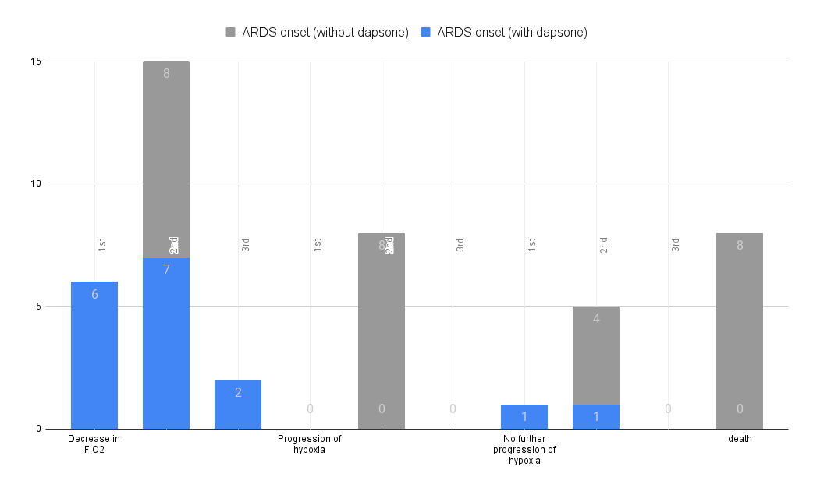

Mean and Standard Deviation for randomized controlled trial (RCT)

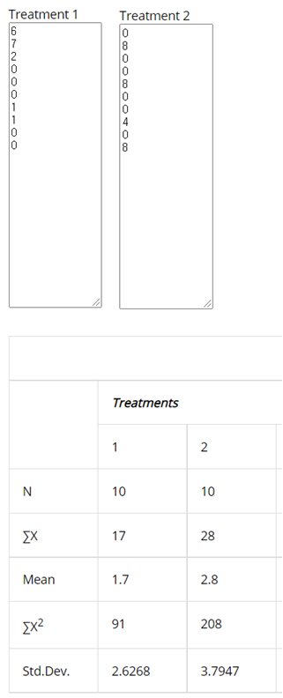

T-Test Calculator for randomized controlled trial (RCT): Mortality
Significance Level: 0.10, One-tailed hypothesis
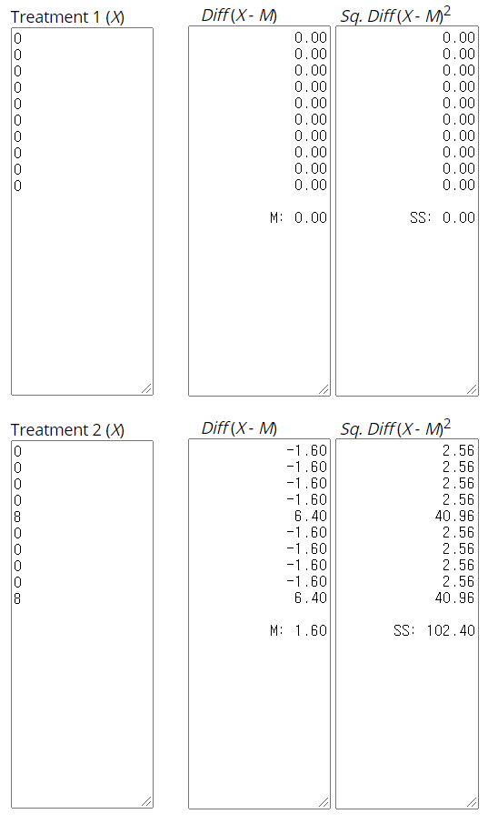
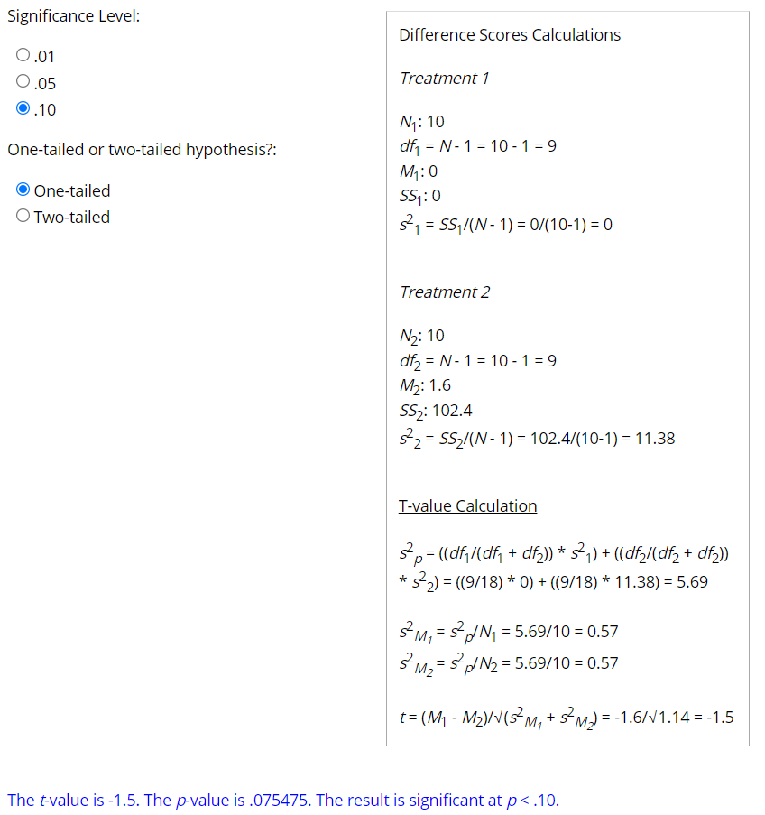

Effect Size Calculator for T-Test
We've got different sample sizes, so we should use Hedges' g.

Hedges' g = (17 - 2.8) ⁄ 3.312299 = 4.287052.

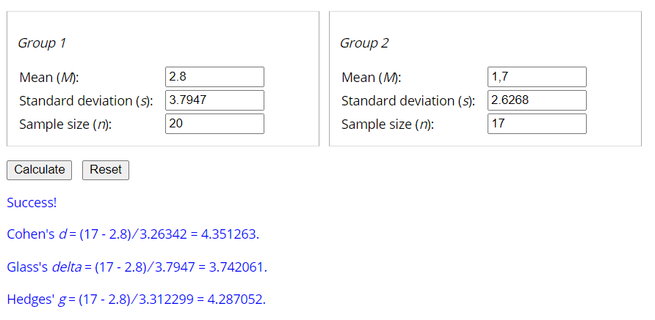

The chi-square statistics for mortality
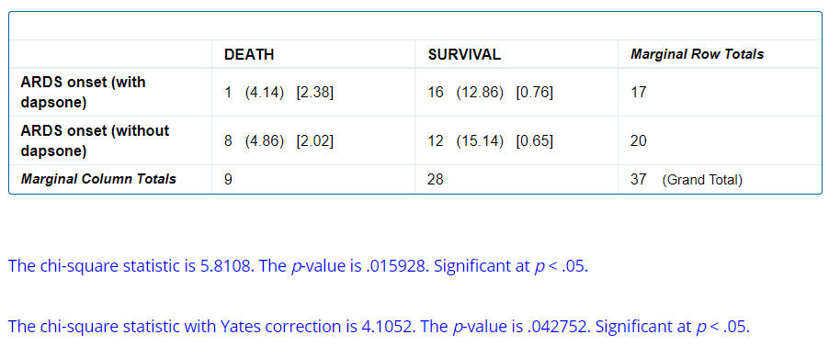

Relative Risk and Odds Ratio

Relative Risk = 0.15.

Odds Ratio = 0.09.
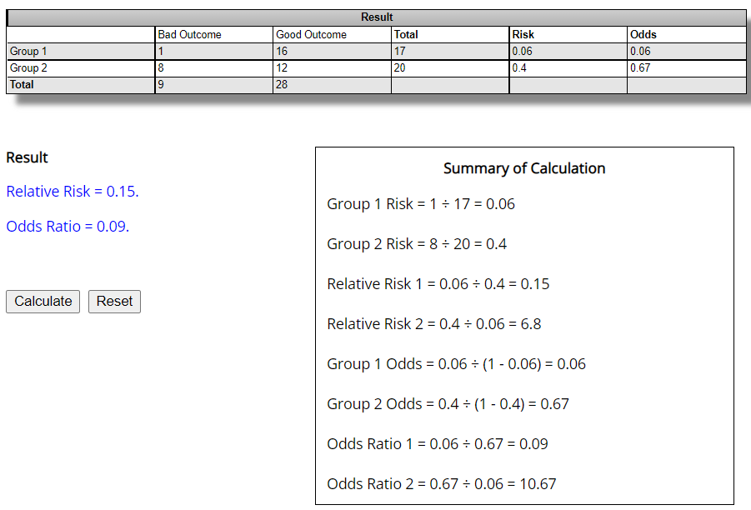
Section 5. Case Reports.

Case 1
65 y/o female with a history of hypertension, breast cancer in remission, and peripheral vascular disease. She was admitted for COVID-19 pneumonia, meds on admission, O₂ sat, p, r, bp, temp. Convalescent plasma, ceftriaxone, doxycycline and dexamethasone were started with improvement and discharged on room air after nine days. Two days after discharge, she returned with worsening dyspnea, productive cough, 36.8 °C, O₂ sat 83%, p 91, r 18. She was hypoxic and started on 3L/min. Bilateral infiltrates, and deteriorating status necessitated transfer to ICU on day 4. She required BiPAP with 100% O₂ and our standard COVID-19 therapy of, dexamethasone, ascorbic acid, zinc sulfate, and remdesivir, and convalescent plasma with cefepime.
After progressive dyspnea and worsening desaturation, a pattern we see portending fatal outcome, with no further standard treatments to offer, we started oral Dapsone 100 mg on hospital day 4. Seventy-two hours after starting Dapsone, O₂ requirement was 80% O₂ sat was 91%..p 92.r 20. On hospital day 13, dapsone dose was increased to 200 mg PO daily. 24 hours later O₂ sat was 92%, r 19 ..p 82...on 75% O₂. At 48 after dapsone increase, O₂ was 65%...r 22..p 88. The patient was discharged from the ICU to a general medical ward with complete full resolution.

Case 2
71 y/o male with a history of Type II diabetes mellitus, hypertension, coronary artery disease, and obesity presented to ER on Nov 7, 2020, with worsening dyspnea, cough, and fatigue for one week. His wife was diagnosed with COVID 10 days previously. After admission, with bilateral infiltrates on the chest film, and O₂ sat. 90%, 2L/min O₂ was started. The temperature was 37.1 °C, BP 140/71, and respirations 21/min. COVID-19 was PCR positive. In the attempt to reverse the progressing dyspnea with increasing O₂ Dapsone 100 mg PO daily was started with standard COVID-19 therapy. One day later, O₂ requirement went up to 10L/min. Dapsone dose was increased to 200 mg/day. On 11/17, the patient was symptomatically better, and O₂ requirement decreased to 8 L/min, O₂ sat was increased. On discharge on hospital day, discharge meds were prescribed.

Case 3
A 62 y/old female with well-treated hypothyroidism, presented to the emergency room with a several day history of progressively worsening chills, non-productive cough, dyspnea and malaise. Several days prior to admission her family doctor started her on amoxicillin/clavulanate and methylprednisolone after diagnosing COVID19 based on a positive PCR test. BP was 110/54, P 59, R 18, and temperature 36.7 C. On admission to hospital, oxygen saturation was 85% with 8 L/min 100% O₂ by nasal cannula (NC). She was started on enoxaparin, ascorbic acid 1,000 mg twice daily, Vitamin D3 1,000 units p.o. twice daily, and dexamethasone 4 mg IV every 12 hours. Azithromycin 500 mg IV daily and ceftriaxone 2 G IV daily was added after her CT chest showed bilateral extensive infiltrates. WBC were 6.6, C-reactive protein 147 [normal <10]. She remained afebrile.
Remidesivir and convalescent plasma were added on hospital day 3. She was transferred to ICU due to increasing FiO₂ requirements. See the Table for an overview of her changing oxygenation status. In ICU she was started on BiPAP 15/5 cm H₂O, FiO₂ 90%, alternating with high flow nasal cannula (HFNC) O₂ 50 L/min and FiO2 95%. O2 saturation varied from 88 to 94%.
On day 8, O2 saturation was 89% on above medicines and ventilation support. She presented a deteriorating picture that we commonly see in COVID19 cases that do not end well. After thorough discussion of the risks and unproven value of dapsone, this was added at 100 mg p.o. daily. Twenty-four hours later, FiO₂ requirement decreased to HFNC 50 L/min and FiO₂ 80%, with O₂ saturation 94-97% allowing decrease of FiO₂ to 50%.
On day 11, the fourth day of dapsone, patient was transferred out of ICU on FiO₂ 8 L/min NC, O₂ saturation 93-96%, P 69, R17. Dapsone was stopped on day 13 after five doses. On day 15 she was discharged to home on 2 L/min via NC with temperature 36.8 C, P 78, BP 120/77, R 19. Her C reactive protein 2 days prior to discharge was 0.5. Her discharge medications were ascorbic acid 1,000 mg twice daily, vitamin D3 5,000 units daily, dexamethasone 6 mg daily on a taper schedule.

Case 4
59 years old healthy Hispanic female without any medical problems. She presented on 11/11/202 to our ER after being diagnosed 11 days ago at another facility with COVID-19. She was experiencing worsening shortness of breath, and her room air pulse Ox was in the 50% range. Her Heart rate, 97/min, BP, 137/57, RR 30/min, and temperature 37.3 °C.
She was started on HFNC at 50LMP flow and 100% FIO₂ and admitted to the intensive care unit. CT chest revealed no PE, bilateral ground-glass opacities. She initiated our standard combo medicine for COVID. The patient was desaturating on HFNC into low 80s and high 70s but without apparent distress. On 11/12/2020, she was offered Dapsone, but she declined. However, it was started on 11/13/2020 at 200 mg daily following internal discussion on compassionate grounds. The patient remained stable on HFNC 50L/min and 100% FIO₂ during the day and BiPAP with 100% FIO₂ during the night until 11/24/2020 with SaO₂ 88-92%. On 11/24/2020 patient appeared cyanotic. Methemoglobin was checked, and it was 11.2. The patient started Cimetidine 400 mg PO TID. On 11/25/2020, her Dapsone dose was increased to 300 mg daily. Due to worsening hypoxia, chest CT was done repeatedly. It revealed bilateral PE with RV strain. The patient has currently treated with TPA 100 mg.

Case 5
67 y/o male with a history of hypertension, testicular carcinoma in remission was admitted with a COVID-19 diagnosis and treated with the standard Covid-19 treatment. After six days he was discharged to home on O₂% sat, and discharge meds. Post-discharge he was readmitted with dyspnea, non-productive cough and fatigue, O₂sat 80% BP 152/78, p 91/min, R 18/min and temperature 37.1 °C. Bilateral ground-glass opacities with right lower lung pulmonary embolism was diagnosed. 15L/min O₂ was inadequate, necessitating intubation with 100% O2 by high-frequency mech vent He was treated with enoxaparin. The patient was later moved to BiPAP with 100% FIO₂. On 11/02/202, due to worsening Hypoxia despite BiPAP and respiratory distress patient was intubated. After intubated patient required 75-100% O₂ and PEEP 12-15 cm of H₂O to maintain SaO₂ in low 90s, his course was complicated by GI bleed and renal failure.
0n 11/11/2020, Dapsone was initiated at 100 mg daily dose. There was no meaningful improvement observed in the FIO₂ requirement. The patient expired on 11/15/2020.

Section 6. STROBE Statement

Checklist of items that should be included in reports of case-control studies
 | Item No | Recommendation | No
Title and abstract | 1 | (a) Indicate the study's design with a commonly used term in the title or the abstract:  The Ethics and Administrative Committee of Hunt Regional Hospital approved this clinical treatment based on the World Medical Association’s Declaration of Helsinki. All patients (or their parents or guardians) provided written informed consent.
Title and abstract | 1 | (b) Provide in the abstract an informative and balanced summary of what was done and what was found:  There was a substantial difference in ARDS treatment results in the onset group when dapsone was prescribed compared with when it was not prescribed. ARDS due to transient bulbar palsy and SARS-CoV-2-activated inflammasomes can be treated with dapsone.
Introduction
Background/rationale | 2 | Explain the scientific background and rationale for the investigation being reported:  4,4′-Diaminodiphenyl sulfone (dapsone, DDS) is useful in the molecular regulation of the Nod-like receptor family pyrin domain-containing 3 (NLRP3) inflammasome activators that are important in mild cognitive impairment (MCI)[4], Alzheimer's disease (AD)[5], and SARS-CoV-2 adult respiratory distress syndrome (ARDS)[6].
Objectives | 3 | State-specific objectives, including any prespecified hypotheses  A COVID-19 committee at Hunt Regional Medical Center reviewed the use of dapsone use as an off label medication based upon treatment adjuncts[7] and inflammasome theory[6, 8]. After RNA virus infection, NLRP3 inflammasomes are activated by the mitochondrial protein mitofusin 2[9]. The mitochondrial antiviral signalling protein (MAVS) with NLRP3 and SAMHD1 (SAM and HD domain containing deoxynucleoside triphosphate triphosphohydrolase 1) are associated with the NF-kB pathway[10] and NLRP3 to regulate the inflammasome activity[11].
Methods
Study design | 4 | Present critical elements of study design early in the paper  Dapsone also acts on neuron as an NLRP3 inflammasome competitor. Based on the relative prevalence of AD in patients who have been prescribed dapsone and those who have not, this drug appears to have a preventive effect against AD[4, 8]. The action of dapsone as an inflammasome competitor in neuronal cells can be conjectured by comparing the AD prevalence in HD patients who have been prescribed dapsone and those who have not.
Setting | 5 | Describe the environment, locations, and relevant dates, including periods of recruitment, exposure, follow-up, and data collection  The Ethics Committee of Hunt Regional Medical Center in Greenville, TX, approved this clinical treatment based on the World Medical Association’s Declaration of Helsinki. All patients (or their parents or guardians) provided written informed consent.  We have used dapsone in 43 patients: 19 patients in the first period, 22 in the second period, and 2 (Dr Badar and his wife) in the third period. (In the first period, 19 patients were included in the analysis.)  We established objective criteria for improvements, including reducing the FIO₂ requirement and a decrease in the progression of hypoxia.  The results from the medical treatment from 21 December to 29 December 2020 (Supplement 1 – 22/22 subjects) have been statistically analysed.
Participants | 6 | (a) Give the eligibility criteria and the sources and methods of case ascertainment and control selection. Give the rationale for the choice of cases and controls  Cases of ARDS were based on FIO₂ requirements via simple nasal cannulation of up to 15 L/min. The criteria for aggravated cases were FiO₂ administered via an HFNC (high-flow nasal cannula) of 95-100% and/or BiPAP (bilevel positive airway pressure). The criterion for severe cases of ARDS was the need for mechanical ventilation.  Protocol for administration: Written informed consent should be obtained, and potential side effects should be explained. The common side effects are haemolytic anaemia (in patients with G6PD deficiency)[12], methemoglobinemia, and allergic reaction. The patients should also be informed that currently, G6PD is a send-out test and can take up to 5-7 days. Cimetidine 400 mg orally TID will now be administered to counter dapsone methemoglobinemia side effects[13]. The venous methemoglobin level should be checked every day, and a mild methemoglobin level of 2-10%[14] is tolerated well. Dapsone should be discontinued if the level reaches 15 or above.  Simultaneously, in the same hospital ICU, we examined results of standard COVID-19 treatment of ARDS without dapsone.
Participants | 6 | (b) For matched studies, give matching criteria and the number of controls per case\  We examined the results of standard COVID-19 treatment of ARDS without dapsone in the same hospital ICU.  22 patients with dapsone/22 patients without dapsone
Variables | 7 | Clearly define all outcomes, exposures, predictors, potential confounders, and effect modifiers. Give diagnostic criteria, if applicable  Almost all patients started to feel better within 24 hours. The progression of ARDS in onset and aggravated cases was stopped. We stopped prescribing dapsone for two weeks, determined the prescribing guidelines for dapsone[15], and started redosing again. The results of the first period[16] and the second period were almost identical. There was a considerable difference in ARDS treatment results in the ARDS-onset group when dapsone was prescribed compared with when dapsone was not prescribed.  Table 1: The results of treating ARDS-onset cases were as follows: decreased FIO₂ in 7 patients and no worsening in 1 patient. The results of treating aggravated ARDS cases were as follows: decreased FiO₂ in 6 patients and no worsening in 3 patients. The results of treating severe ARDS cases were as follows: no response in 2 patients. There were three deaths in the aggravated ARDS group treated with dapsone. At the same time, there were no deaths in the ARDS-onset dapsone-treated group.  Table 2: Simultaneously, in the same hospital ICU, we examined the results of standard COVID-19 treatment of ARDS without dapsone. There were eight deaths in the ARDS-onset group not treated with dapsone, with progressing hypoxia, and almost all of these patients died before reaching the criteria for aggravated ARDS.
Data sources/measurement | 8* | For each variable of interest, give sources of data and details of methods of assessment (measurement). Describe comparability of assessment methods if there is more than one group  1.1. The comparison was made assuming that only the case of decreased FIO₂ was influential in the entire dapsone (+) group and dapsone (-) group.  1.2. The comparison was made assuming that cases of decreased FIO₂ and no further progression were influential in the dapsone (+) group and the dapsone (-) group as evidence of improvement.  1.3. The comparison was made assuming that only the case of decreased FIO₂ was influential in the entire dapsone (+) group and dapsone (-) group, which was applicable to only the ARDS onset stage.  1.4. The comparison was made assuming that only the case of decreased FIO₂ was influential in the ARDS onset and aggravated stage dapsone (+) group and the ARDS onset and aggravated stage dapsone (-) group.  1.5. The comparison was made assuming that the dapsone (+) group and the dapsone (-) group in the ARDS onset stage were influential in the case of decreased FIO₂ and no further progression.  1.6. The comparison was made assuming that the dapsone (+) group and the dapsone (-) group in the ARDS onset and aggravated stages were influential in the case of decreased FIO₂ and no further progression.
Bias | 9 | Describe any efforts to address potential sources of bias  When using the chi-square test, there were cases where 0 was entered into the cell, so this was replaced with 1. Fisher’s test was again conducted to compensate Statistics 1.
Study size | 10 | Explain how the study size was arrived at  The hospital stopped prescribing dapsone (first period) for two weeks (standard COVID-19 treatment group without dapsone (22)) and rigorously revalidated its effectiveness. Furthermore, during this week (standard COVID-19 treatment group with dapsone (22)), 44 (22/22) patients with ARDS in the intensive care unit were re-examined. Our study found that the condition of patients prescribed an NLRP3 competitor for ARDS treatment in the ARDS-onset stage did not worsen but recovered.  In the Hunt Regional Hospital ICU, the doctors treating COVID-19 patients change approximately every eight days. Dr Badar was reevaluated in the hospital for two weeks after the first period. He was ordered to stop prescribing dapsone. Dapsone could then be prescribed in the treatment of ICU patients. Therefore, the case-control balance is symmetrical (22/22).
Quantitative variables | 11 | Explain how quantitative variables were handled in the analyses. If applicable, describe which groupings were chosen and why  The treatment setting for all SARS-CoV-2-associated ARDS patients was the same as for standard care, and treatment was randomised. However, there were set periods for allowing and not allowing dapsone administration. Therefore, there were no other variables.
Statistical methods | 12 | (a) Describe all statistical methods, including those used to control for confounding  We performed the statistical analysis of the results presented in Tables 1 and 2. The chi-square statistic, p-value and statement of significance appear beneath the table.  To judge whether the effects of this dapsone treatment (name: Soon-Joe treatment) are meaningful, it is more appropriate to conduct Fischer's exact test than the above chi-square test.
Statistical methods | 12 | (b) Describe any methods used to examine subgroups and interactions  The chi-square statistic, p-value and statement of significance, and Fischer's exact test.
Statistical methods | 12 | (c) Explain how missing data were addressed  There are no missing data.
Statistical methods | 12 | (d) If applicable, explain how matching of cases and controls was addressed  Dr Badar was reevaluated in the hospital for two weeks after the first period. He was ordered to stop prescribing dapsone. Dapsone could then be prescribed in the treatment of ICU patients.
Statistical methods | 12 | (e) Describe any sensitivity analyses  Table 1 - 0/22 (no deaths)  Table 2 - 8/22 (all deaths)  Since we classified the ARDS treatment effect based on death, a sensitivity test was not required.
Results
Participants | 13* | (a) Report numbers of individuals at each stage of study—e.g. numbers potentially eligible, examined for eligibility, confirmed eligible, included in the study, completing follow-up, and analyzed  First period – 19 cases (only observation – follow-up, 19 cases; no response, 2 cases)  Second period – 22/22 cases (observation and dapsone (+) group/dapsone (-) group comparison study)
Participants | 13* | (b) Give reasons for non-participation at each stage  participation – all
Participants | 13* | (c) Consider the use of a flow diagram  It is a simple workflow treatment for three weeks.  First period  Second period  Third period  19 cases  22 cases  Stop medication  Control Group  22 cases  Trial Group  Allow medication  2 cases  Medical staffs of Trial Group
Descriptive data | 14* | (a) Give characteristics of study participants (e.g., demographic, clinical, social) and information on exposures and potential confounders  The ICU patients (immigrant to death) were suffering from ARDS during the pandemic period. All patients were receiving standard Covid-19 treatment. Dapsone was taken only with the consent of the patient's guardian. Consciousness was confused by ARDS. For patients with ICU ARDS, treatment may vary slightly from country to country. However, if the ARDS patient is determined with the standard of treatment for ARDS before receiving mechanical ventilation, like our staff, Onset, Aggravated, and Severe can be classified. It can be treated in transient bulbar palsy conditions when dapsone is administered in the onset stage. Scientists and medical staff should keep this in mind.
Descriptive data | 14* | (b) Indicate the number of participants with missing data for each variable of interest  There are no missing data
Outcome data | 15* | Report numbers in each exposure category, or summary measures of exposure  Dapsone (+) group 19/22/2  Dapsone (-) group 22

Main results | 16 | (a) Give unadjusted estimates and, if applicable, confounder-adjusted estimates and their precision (e.g., 95% confidence interval). Make clear which confounders were adjusted for and why they were included  The dapsone group and the non-dapsone group are only applicable to the ARDS-onset stage, assuming that only a decrease in FIO₂ indicates that the treatment is effective (Study 1.3).
Main results | 16 | (b) Report category boundaries when continuous variables were categorized  As with the chi-square test (Study 2-4), when it was judged that decreased FI O₂ and no further progression were adequate treatment effect criteria, dapsone was found to be more effective in ARDS-onset and aggravated ARDS cases than in severe cases.
Main results | 16 | (c) If relevant, consider translating estimates of relative risk into absolute risk for a meaningful time period  When decreased FIO₂ and no further progression of hypoxia were used as criteria for the effectiveness of dapsone, the results were statistically significant according to Fisher's exact test. Of course, the statistical results were the same according to the chi-square test.
Other analyses | 17 | Report other analyses are done—e.g., analyses of subgroups and interactions and sensitivity analyses  No further investigations were done.
Discussion
Key results | 18 | Summarise key results concerning study objectives  The findings for dapsone are important. SARS-CoV-2 might gain entry through the olfactory bulb to invade the brainstem[17]. Moreover, SARS-CoV-2 CNS access might also occur from the peripheral circulation through BBB compromise. Another possible SARS-CoV-2 CNS entry route could be its dispersal from the lungs into the vagus nerve via pulmonary stretch receptors, eventually reaching the brainstem[18, 19]. Brainstem involvement, especially pre-Bötzinger complex involvement, could explain the respiratory failure and high death rate of COVID-19 patients and the sudden recovery of patients after taking dapsone.
Limitations | 19 | Discuss the limits of the study, taking into account sources of potential bias or imprecision. Discuss both direction and magnitude of any potential bias  As for the empirical treatment results for each sex, better results were obtained in women. The difference in results cannot be analysed due to the small population, but treatment results may be better in a group with many women. This is related to the high incidence of AD in women. It is unethical to conduct a randomised cohort study among patients with ARDS in the intensive care unit. This study compares the results of the period of discontinuation of dapsone for 2 weeks.
Interpretation | 20 | Give a cautious overall interpretation of results considering objectives, limitations, the multiplicity of analyses, results from similar studies, and other relevant evidence  It is important to note that the results of this study are being repeated. Even a small population can be overcome.
Generalisability | 21 | Discuss the generalisability (external validity) of the study results  There have been no reports of SARS-CoV-2 infection in approximately 10,000 Hansen disease's patients in Korea[8]. This has been observed repeatedly in the pandemic period. However, as these patients started to smoke a lot, respiratory problems increased. This observation is consistent with the inflammasome competitor theory[8].
Other information
Funding | 22 | Give the source of funding and the role of the funders for the present study and, if applicable, for the original study on which the present article is based  No funding.

References
1. Jollow DJ, Bradshaw Tp, McMillan DC. Dapsone-Induced Hemolytic Anemia. Drug Metabolism Reviews. 1995;27(1-2):107-24.
2. Coleman M, Rhodes L, Scott A, Verbov J, Friedmann P, Breckenridge A, et al. The use of cimetidine to reduce dapsone‐dependent methaemoglobinaemia in dermatitis herpetiformis patients. British journal of clinical pharmacology. 1992;34(3):244-9.
3. Madke B, Kumar P, Kabra P, Singh AL. How to manage a side effect: Dapsone-induced methemoglobinemia. Indian Journal of Drugs in Dermatology. 2016;2(2):117.
4. Lee JH, Choi SH, Lee CJ, Oh SS. Recovery of dementia syndrome following treatment of brain inflammation. Dement Geriatr Cogn Dis Extra. 2020;10(1):1-12.
5. Leea JH, Leeb CJ, Parkc J, Leed SJ. The neuro-inflammasome in Alzheimer’s disease and cerebral stroke. OSF Prepr2020.
6. Rodrigues TS, De Sá KSG, Ishimoto AY, Becerra A, Oliveira S, Almeida L, et al. Inflammasomes are activated in response to SARS-CoV-2 infection and are associated with COVID-19 severity in patients. J Exp Med. 2021;218(3):e20201707.
7. Kast RE. Dapsone as treatment adjunct in ARDS. Exp Lung Res. 2020;46(5):157-61.
8. Lee JH, An HK, Sohn M-G, Kivela P, Oh S. 4,4′-diaminodiphenyl sulfone (DDS) as an inflammasome competitor. Int J Mol Sci. 2020;21(17):5953.
9. Ichinohe T, Yamazaki T, Koshiba T, Yanagi Y. Mitochondrial protein mitofusin 2 is required for NLRP3 inflammasome activation after RNA virus infection. Proc Natl Acad Sci U S A. 2013;110(44):17963-8.
10. Khan A, Sergi C. SAMHD1 as the potential link between SARS-CoV-2 infection and neurological complications. Front Neurol. 2020;11:562913.
11. Park S, Juliana C, Hong S, Datta P, Hwang I, Fernandes-Alnemri T, et al. The mitochondrial antiviral protein MAVS associates with NLRP3 and regulates its inflammasome activity. J Immunol. 2013;191(8):4358-66.
12. Jollow DJ, Bradshaw TP, McMillan DC. Dapsone-induced hemolytic anemia. Drug Metab Rev. 1995;27(1-2):107-24.
13. Coleman M, Rhodes L, Scott A, Verbov J, Friedmann P, Breckenridge A, et al. The use of cimetidine to reduce dapsone‐dependent methaemoglobinaemia in dermatitis herpetiformis patients. Br J Clin Pharmacol. 1992;34(3):244-9.
14. Madke B, Kumar P, Kabra P, Singh AL. How to manage a side effect: dapsone-induced methemoglobinemia. Indian J Drugs Dermatol. 2016;2(2):117.
15. Kanwar B, Sergi C, Lee J-h, Kast RE. Hunt regional medical center policy for dapsone administration of ARDS by SARS-CoV-2. OSF Prepr2020.
16. Kanwar B, Kast R, Sergi C, Lee J-h. Dapsone prevents aggravation of ARDS by SARS-CoV-2. 2020.
17. Meinhardt J, Radke J, Dittmayer C, Franz J, Thomas C, Mothes R, et al. Olfactory transmucosal SARS-CoV-2 invasion as a port of central nervous system entry in individuals with COVID-19. Nat Neurosci. 2020;24(2):168-75.
18. Dey J, Alam MT, Chandra S, Gupta J, Ray U, Srivastava AK, et al. Neuroinvasion of SARS‐CoV‐2 may play a role in the breakdown of the respiratory center of the brain. J Med Virol: Wiley; 2020.
19. Briguglio M, Bona A, Porta M, Dell'Osso B, Pregliasco FE, Banfi G. Disentangling the hypothesis of host dysosmia and SARS-CoV-2: the bait symptom that hides neglected neurophysiological routes. Front Physiol. 2020;11:671.

