Supplement Material

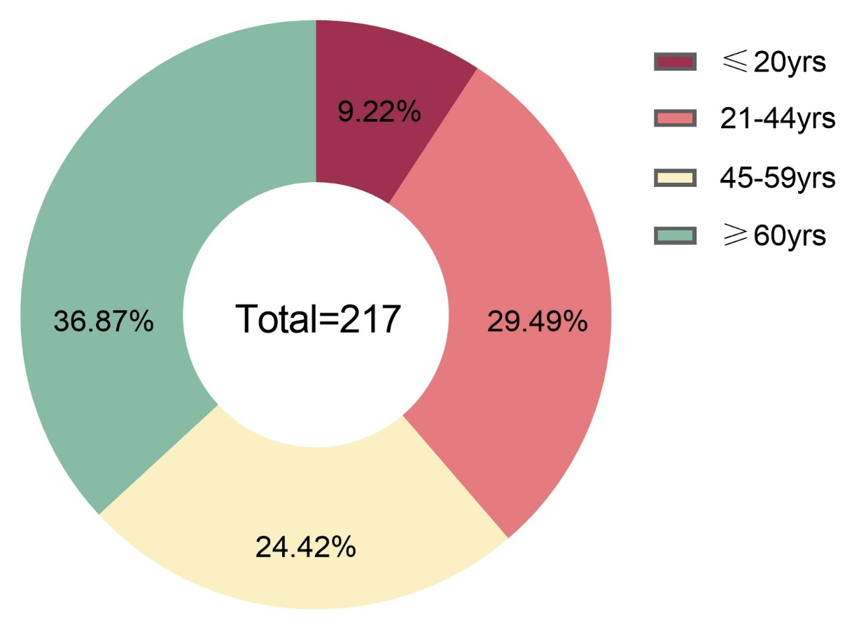
Fig. S1 Age distribution of patients with oral and maxillofacial space infection

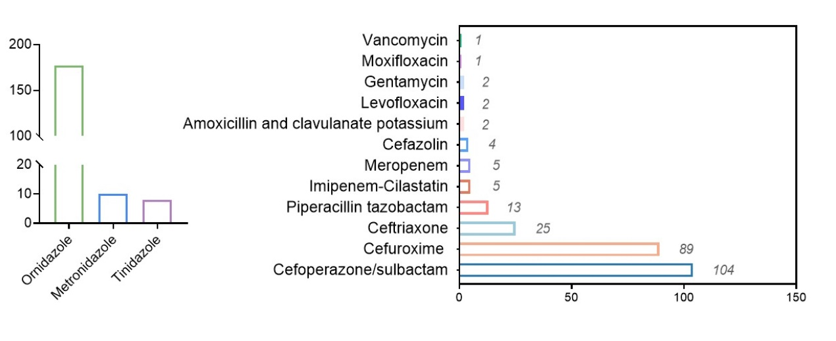
Fig. S2 Use of antibiotics against anaerobic and aerobic bacteria

Table S1. Surgery-related conditions
Type of anaesthesia | n
Local anaesthesia | 46
General anaesthesia | 169
Surgery complications | n
Intubation | 39
Extubation | 130

Table S2. Predictive Model Performance Metrics
Metric | Training Set | Validation Set
AUC (95% CI) | 0.726 (0.602–0. 850) | 0.712 (0.588–0.838)
Precision | 0.644 | 0.622
Recall | 0.935 | 0.903
F1-Score | 0.763 | 0.736

