Supplementary Material for “Community-based monitoring reveals the impacts of the permanent drought imposed by the Belo Monte Hydroelectric Power Plant at Volta Grande do Xingu, Amazonia”.

Writing methods:
To construct this collaborative research, meetings were held with ribeirinhos and Indigenous monitors (local researchers) to establish the fishing schedules and install water level rulers. One Indigenous person and one ribeirinho individual are responsible for tabulating these data. Periodic meetings are held to adjust the data sheets as needed.
For the construction of the article, a semi-presential meeting was held to present the results in graphs and discuss these results collectively. After writing the first draft, another in-person meeting was held where the local researchers once again discussed the results of the article and their interpretations. Based on these meetings, the impressions and discussions of the local researchers were included in the article. The final text was read (in Portuguese) to all local researchers for approbation.
To review the editor and reviewers’ suggestions another semi-presential meeting was held, to discuss the main points, and decisions to address the issues were made collectively. The final version of the manuscript was read (in Portuguese) to all local researchers for approbation.

Piracemas methods:
Sites for water level monitoring were chosen according to local knowledge. Water level scales were installed to monitor timing and persistence of flooding of riverbed and seasonally flooded forests in terms of arbitrary reference. Using wooden stakes, nails, and measuring tapes, driven into the ground, and spaced along the piracema’s bathymetric profile using a level hose, a sequence of scales was installed transversally to the stream channel to cover the entire amplitude of flooding as observed historically by ribeirinhos and Indigenous peoples of Volta Grande (Figure 1, main text). The water level scales follow the criteria of the Brazilian hydrometeorology monitoring network (https://rigeo.sgb.gov.br/handle/doc/22628). All rulers had their height calibrated with a professional-level measurer and were read daily by a local researcher living near the station. The data is recorded and then transferred to a digital spreadsheet, to be compared with monitoring data collected by ANA and Norte Energia. The minimum water level at which fish enter each piracema and the water level at which spawning occurs were determined based on local knowledge (historical observations) and field observations by the Indigenous and ribeirinhos researchers who carry out the monitoring.

Fishing Dynamics methods:
The CPUE values were tested for normality and homoscedasticity of variance, after which analysis of variance (ANOVA) was carried out to test for differences between sites, years, hydrological periods (drought, rising, flood, and falling waters), type of boat used and fishing gear. Whenever necessary, CPUE values were log-transformed to obtain the normality of the data. When the assumption of normality was not met, the non-parametric Kruskal-Wallis test was used. For significant differences, multiple comparison tests were carried out to determine which groups were different from each other. All analyses were conducted in R v.4.1.1 (R Core Team 2021).
The monthly data was grouped into four periods: rising (Dec, Jan, Feb), flood (Mar, Apr, May), falling (Jun, Jul, Aug), and dry (Sep, Oct, Nov). The boats were classified according to their physical characteristics and type of motorization into four categories: rowing canoe, rabeta (a boat with a small and low-power outboard motor), voadeira (an aluminum boat with outboard motor), and on foot (when no boat was used). Fishing gear was also grouped into four categories: Hook and Line, Gillnets, Other [harpoon, bow and arrow, puça (pike), tarrafa (cast net), etc.], and "more than one" when a combination of several gears was used. As the pre-dam socio-environmental diagnosis (Belo Monte HPP EIA) did not provide CPUE data by species, only catches in terms of fish mass (kg) per trip, the calculation was made in this way for comparative purposes.

References
Team RC. 2021. R: A Language and Environment for Statistical Computing. R Foundation for Statistical Computing. Available from https://www.R-project.org/.

Supplementary figures:

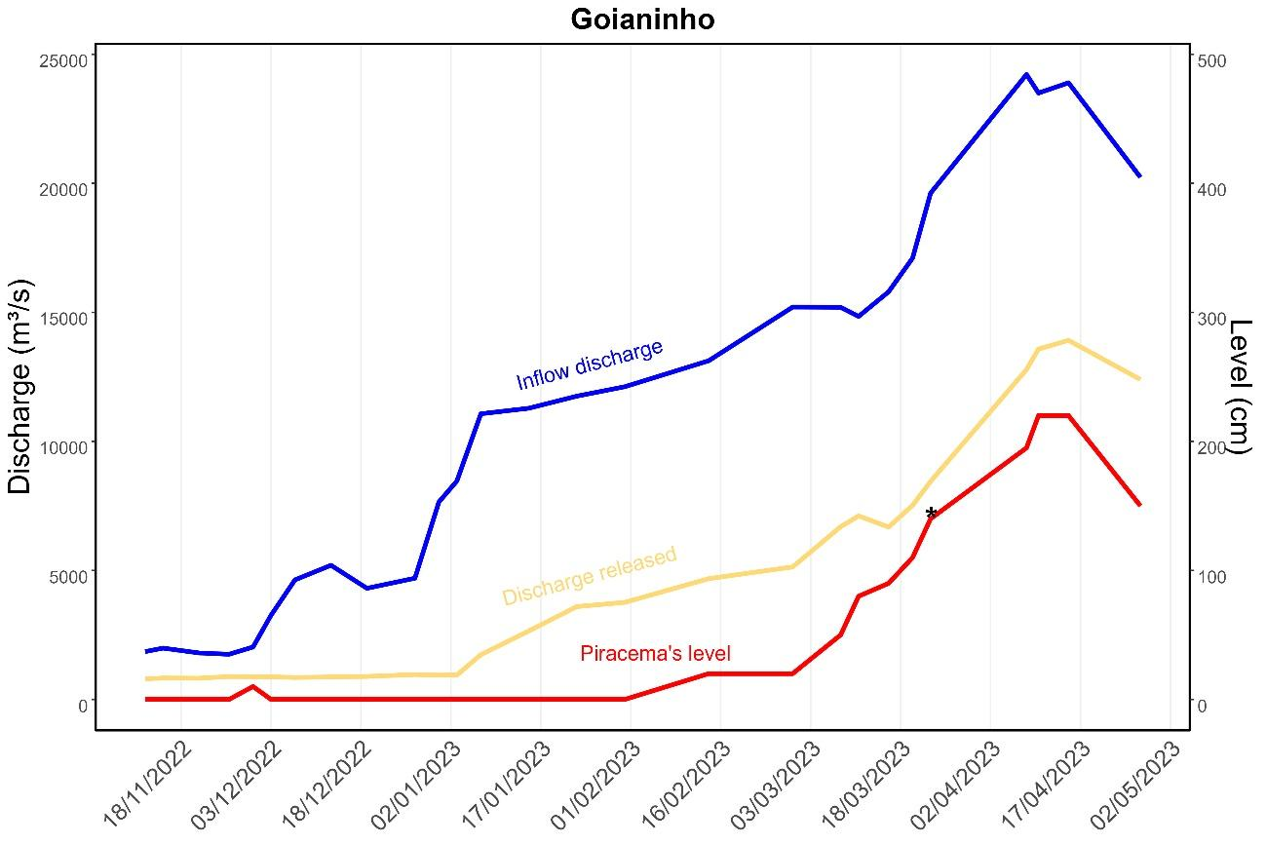
Figure S1. Daily water level in the Goianinho piracema (red line, right vertical axis) recorded during the flood-full period (November 2022-April 2023). Influent flow (blue line, left vertical axis) and released flow (effluent) to VGX (yellow line, left vertical axis) on the same dates. The single asterisk (*) indicates the water level at which fish entered the piracema, corresponding to a released flow of 8,450 m³/s. The daily influent flow measurement indicates that this level would have been reached in January 2023 under natural conditions, but due to water diversion, it was achieved in the second half of March 2023. According to hydrodynamic modeling presented in the Complementary Studies conducted by the Norte Energia S.A. company, among the analyzed flow values, water reaches this piracema from a flow of 8,000 m³/s, in agreement with MATI's observation (https://www.xingumais.org.br/observatorios/BeloMonte).

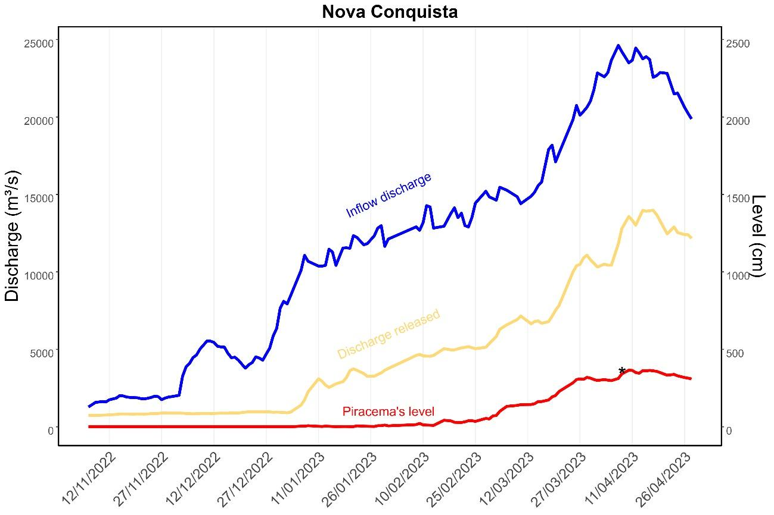
Figure S2: Water level in the Nova Conquista piracema (red line, right vertical axis) recorded daily during the flood-full period (November 2022-April 2023). Influent flow (blue line, left vertical axis) and released flow (effluent) to VGX (yellow line, left vertical axis) on the same dates. The single asterisk (*) indicates the water level at which fish entered the piracema, corresponding to a released flow of 12,786 m³/s. The daily influent flow measurement indicates that this level would have been reached in the second half of December under natural conditions, but due to flow control, it was only reached on April 8, 2023. According to hydrodynamic modeling from the Complementary Studies by Norte Energia S.A. company, water reaches this piracema at flow values between 8,000 and 10,000 m³/s, in agreement with MATI's observation (https://www.xingumais.org.br/observatorios/BeloMonte).

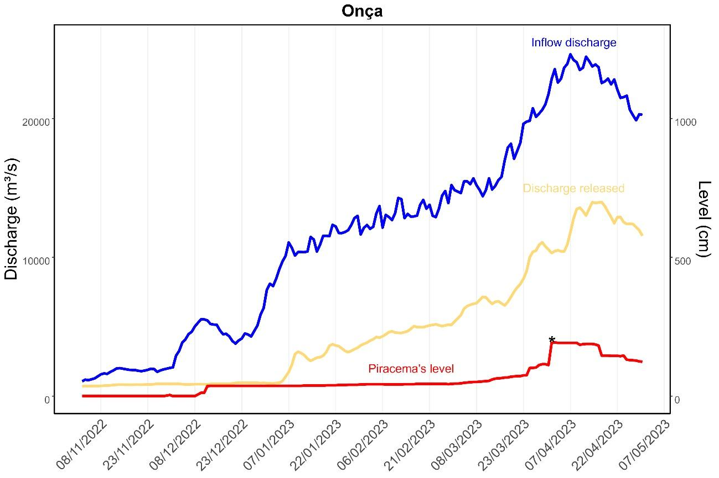
Figure S3: Water level in the Onça piracema (red line, right vertical axis) recorded daily during the flood period (November 2022-May 2023). Influent flow (blue line, left vertical axis) and released flow (effluent) to VGX (yellow line, left vertical axis) on the same dates. The single asterisk (*) indicates the water level at which fish entered the piracema, corresponding to a released flow of 10,134 m³/s. The daily influent flow measurement indicates that this water level would have been reached in January under natural conditions, but due to flow control, it was only reached in the second half of March. According to hydrodynamic modeling from the Complementary Studies by Norte Energia S.A. company, water reaches this piracema from a flow of 8,000 m³/s, in agreement with MATI's observation (https://www.xingumais.org.br/observatorios/BeloMonte).

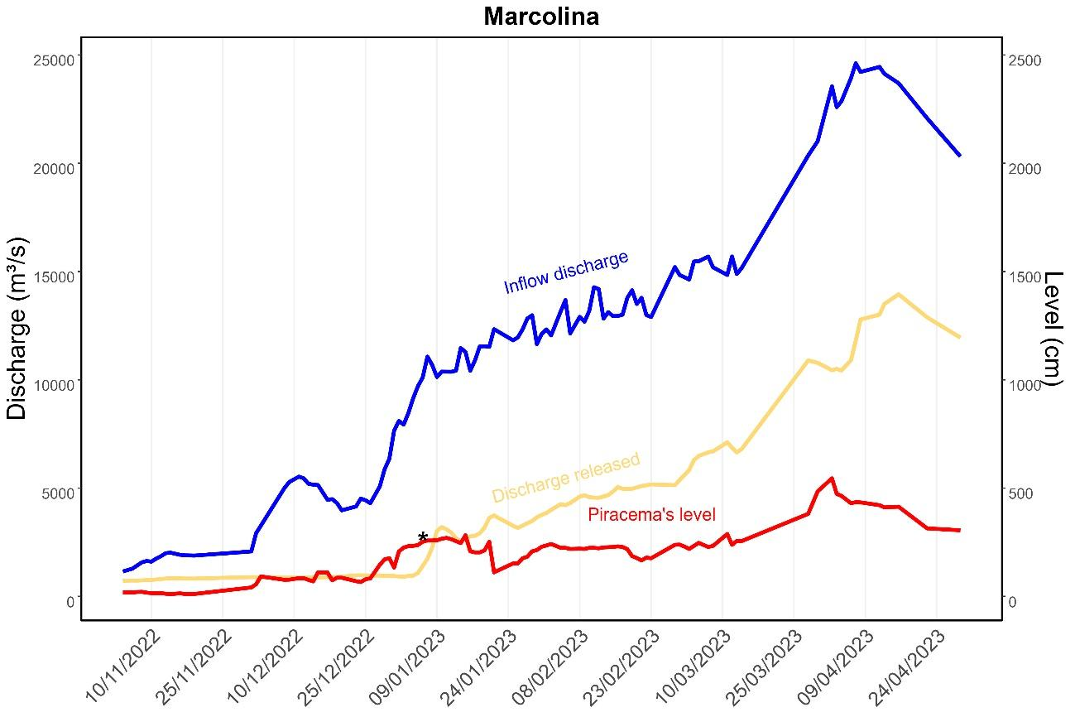
Figure S4: Water level in the Marcolina piracema (red line, right vertical axis) recorded daily during the flood period (November 2022-April 2023). Influent flow (blue line, left vertical axis) and released flow to VGX (yellow line, left vertical axis) on the same dates. The single asterisk (*) indicates the water level at which fish entered the piracema, corresponding to a released flow of 1,402 m³/s. The daily influent flow measurement indicates that this water level would have been reached in late November under natural conditions, but due to flow control, it was only reached in January. The level required for spawning was not reached until mid-March. According to hydrodynamic modeling from the Complementary Studies by Norte Energia S.A. company, water reaches this piracema from a flow of 4,000 m³/s, in agreement with MATI's observation (https://www.xingumais.org.br/observatorios/BeloMonte). It is important to highlight that this piracema is under influence of Bacajá River been less impacted by water diversion of Xingu River.

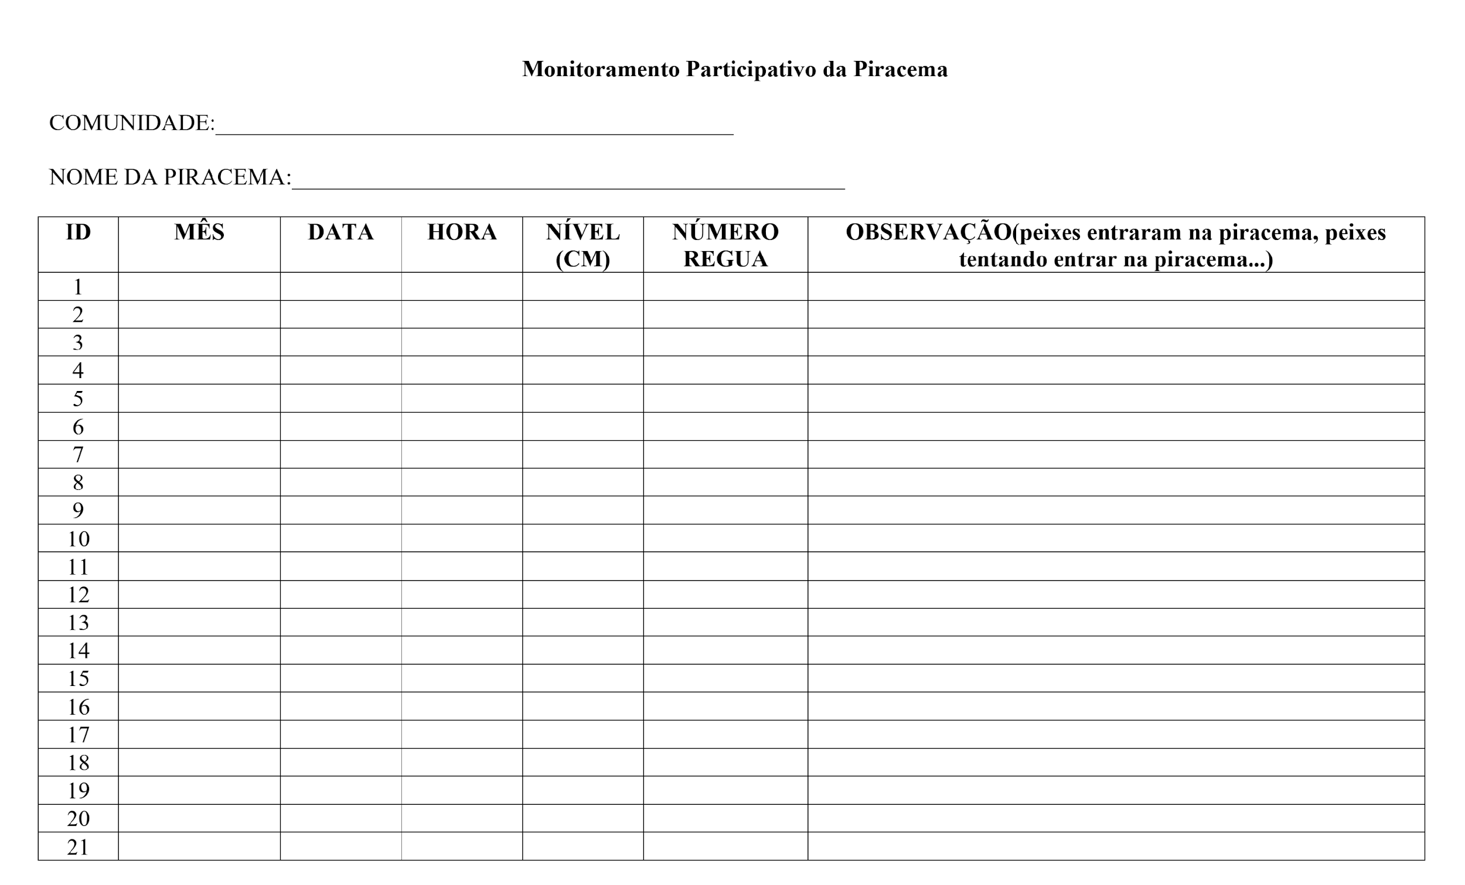
Figure S5. Table used by MATI-VGX’s local researchers to monitor piracemas’ flood levels.
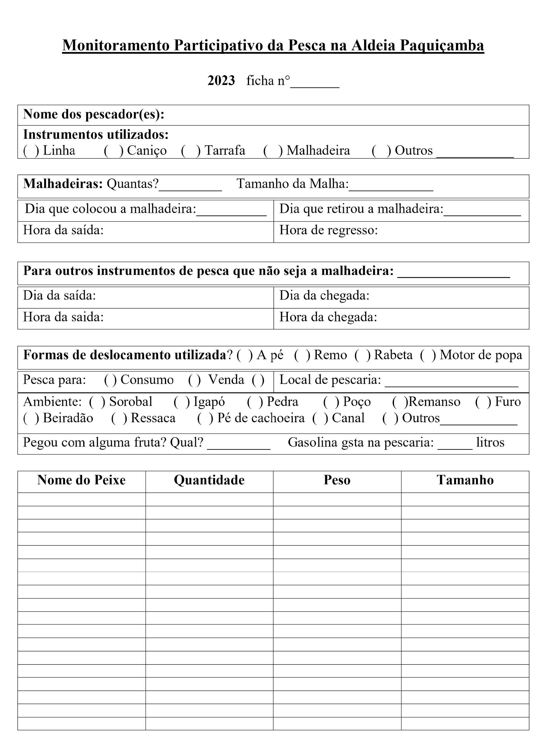
Figure S6. Fishing schedules used by MATI-VGX’s local researchers to monitor fish catchment.
Supplementary tables:
Table S1. Characteristics of the piracemas monitored by indigenous and ribeirinhos researchers in the VGX, from the Paquiçamba Indigenous Territory to the vicinity of the Jericoá waterfall, according to the collective classification made by indigenous and ribeirinhos researchers together with other fishermen who fished in the respective piracemas.
Name Piracema | Local classification | Fish, fishing and the piracema period before the dam | Margin | Community
Zé Maria | Elevation in relation to the river channel: Low  Island piracema, shaped like a horseshoe, which after 1.5 km returns to the Xingu River channel in another stretch. | -Curimatá, piau, pacu, trairão, surubim, piranha  -Fishing with a pole enclosure | Left bank | Mïratu Community,  IT Paquiçamba
Furo do Barracão | Elevation in relation to the river channel: Low  -Piracema island, with a lake inside* | -Curimatá, pacu, trairão, surubim  -Fishing with an enclosure | Left bank | IT Paquiçamba
Prego | -Elevation in relation to the river channel: High  -Piracema de grotão** | -Piau, curimatá, pacu, surubim, trairão  -Fishing with an enclosure | Left bank | IT Paquiçamba
Marcolina | -Elevation in relation to the river channel: High  -Piracema of terra-firme***, grotto, communicates with a lake | -Trairao, curimatá, fidalgo, pacu  - Fishing with a line  -Community fishing with a handline | Right bank | Bacajá
Onça | -Elevation in relation to the river channel: High  -Piracema connects with the Onça stream | -Tucunaré, trairão, curimatá, pacu  -Line fishing | Right Bank | Rio das Pedras
Nova Conquista | -Elevation in relation to the river channel: Low  -Piracema de grotão** | -Curimatá, pacu, pacu de seringa, ariduia  -Fishing with a longline | Right Bank | Nova Conquista
Caititu | -Elevation in relation to the river channel: High  -Piracema de igarapé**** | -Curimatá, tucunaré, piau-cabeça-gorda, piau-flamengo, pacu de seringa  -Fishing with a hook and line | Island in the middle  of the Xingu  River | Island of Love
Goianinho | -Elevation in relation to the river channel: Low  -Piracema of terra-firme that connects with the lake* | -Curimatá, pacu-branco, curupité, piau-flamengo, matrinxã, tucunaré  -Community fishing with enclosure | Right Bank | Goianinho
* Lake: lake depressions formed by abandoned meanders barred by sandbanks.
**Grotão: cavities in the riverbanks excavated by rain.
** *Terra-firme: valleys or gentle slopes where tributaries of the main river enter.
**** Igarapé: watercourse of medium length, reduced width with a well-defined basin.
*****Scientific names in the table S6.

Table S2. Average Catch Per Unit Effort (CPUE) and the confidence interval (CI) or standard deviation (SD) in kg.fisher.day-1 according to vessel type. For the pre-barring period (2001 to 2008), the fleet landing in Altamira was evaluated using the multiple comparison LSD test for LogCPUE. For the post-barring data (2020 to 2023) the data is from MATI with the result of the multiple comparison test, where different letters indicate significant differences (p < 0.05).
 | 2001 - 2008 (pre-dam) |  |  |  |  | 2020 - 2023 (post-dam)
Boat Type | CPUE | CI | N | % | Test | CPUE | SD | N | % | Test
Rowing canoe | 9.99 | 2.03 | 133 | 7 | C | 3.94 | 3.88 | 301 | 41.0 | A
Rabeta* | 12.61 | 0.64 | 1422 | 75 | B | 5.15 | 5.70 | 340 | 46.0 | B
Voadeira** | 14.65 | 1.77 | 340 | 18 | A | 3.53 | 4.78 | 68 | 9.00 | A
On foot*** |  |  |  |  |  | 1.99 | 1.18 | 3 | 0.00 | AB
On foot + Rabeta |  |  |  |  |  | 3.55 | NA | 1 | 0.00 | AB
Rowing canoe + Rabeta |  |  |  |  |  | 6.84 | 10.57 | 18 | 0.02 | AB
Rowing canoe + Voadeira |  |  |  |  |  | 2.89 | 1.85 | 3 | 0.00 | AB
Rabeta + Voadeira |  |  |  |  |  | 1.32 | 1.08 | 2 | 0.00 | AB
All | 12.79 | 0.6 | 1895 |  |  | 4.49 | 5.3 | 736
* a boat with a small and low-power outboard motor
** an aluminum boat with outboard motor
*** when no boat was used
Table S3. Average Catch Per Unit Effort (CPUE) and the confidence interval (CI) or standard deviation (SD) according to fishing gear. In the pre-barring period, the fishing yield of the fleet landing in Altamira was monitored using multiple comparisons for LogCPUE. For the post-barring period, the data comes from MATI with the multiple comparison results for LogCPUE, where different letters indicate significant differences (p < 0.05).
 | 2001 - 2008 (pre-dam) |  |  |  |  |  | 2020 - 2023 (post-dam)
 | CPUE | CI | N | % | Median | Test | CPUE | SD | N | % | Median | Test
Hook and Line | 9.88 | 0.62 | 910 | 47 | 7.5 | C | 2.27 | 1.90 | 262 | 35 | 1.94 | A
Gillnets | 16.75 | 1.56 | 415 | 22 | 12.5 | A | 6.29 | 6.08 | 345 | 47 | 4.75 | B
Multiples | 14.46 | 1.2 | 575 | 30 | 10 | B | 9.64 | 12.92 | 12 | 2 | 6.38 | ABC
Others | 10.8 | 6.37 | 19 | 1 | 6.5 | BC | 4.11 | 4.02 | 121 | 16 | 3.15 | C
All | 12.75 | 0.59 | 1919 |  | 8.89 |  | 4.49 | 5.30 | 740 |  | 2.85

Table S4. Average Catch Per Unit Effort (CPUE) and the confidence interval (CI) or standard deviation (SD) according to Indigenous communities and results of the multiple comparison for LogCPUE, where different letters indicate significant differences (p < 0.05).
Community | Mean | SD | N | Median | Teste
Furo Seco | 3.01 | 2.46 | 240 | 2.35 | A
Lakarika | 5.76 | 5.13 | 163 | 4.18 | BC
Miratu | 4.18 | 4.93 | 199 | 2.73 | AB
Paquiçamba | 6.18 | 7.40 | 158 | 4.04 | C
All | 4.88 | 5.30 | 760 | 2.86

Table S5. Monthly flows average of historical flows according (in blue), and the hidrograms: Hydrogram A (in orange) and Hydrogram B (in red) proposed by Norte Energia, the Provisional Hydrogram (in green) proposed by IBAMA, and the MATI proposal (in purple).
 |  | JAN | FEB | MAR | APR | MAY | JUN | JUL | AUG | SEP | OCT | NOV | DEC
Average of historical flows (1971-2019) |  | 8476 | 13544 | 18531 | 19088 | 14332 | 6743 | 3037 | 1632 | 1123 | 1169 | 1942 | 4036
Increase compared to the previous month (%) |  | 110.0 | 59.8 | 36.8 | 3.0 | -24.9 | -53.0 | -55.0 | -46.3 | -31.2 | 4.1 | 66.1 | 107.8
HIDROGRAM A | VGX | 1100 | 1600 | 2500 | 4000 | 1800 | 1200 | 1000 | 900 | 750 | 700 | 800 | 900
Increase compared to the previous month (%) |  | 22.2 | 45.5 | 56.3 | 60.0 | -55.0 | -33.3 | -16.7 | -10.0 | -16.7 | -6.7 | 14.3 | 12.5
HIDROGRAM B | VGX | 1100 | 1600 | 4000 | 8000 | 4000 | 2000 | 1200 | 900 | 750 | 700 | 800 | 900
Increase compared to the previous month (%) |  | 22.2 | 45.5 | 150.0 | 100.0 | -50.0 | -50.0 | -40.0 | -25.0 | -16.7 | -6.7 | 14.3 | 12.5
Provisional HIDROGRAM (Ibama) | VGX | 3100 | 10900 | 14200 | 13400 | 5200 | 1800 | 1300 | 900 | 750 | 760 | 1000 | 1200
Increase compared to the previous month (%) |  | 158.3 | 251.6 | 30.3 | -5.6 | -61.2 | -65.4 | -27.8 | -30.8 | -16.7 | 1.3 | 31.6 | 20.0
PROPOSAL (to be worked on) | VGX | 6200 | 10000 | 13500 | 14000 | 10500 | 5000 | 2500 | 1200 | 800 | 850 | 1500 | 3000
Increase compared to the previous month (%) |  | 106.7 | 61.3 | 35.0 | 3.7 | -25.0 | -52.4 | -50.0 | -52.0 | -33.3 | 6.3 | 76.5 | 100.0

Table S6. Examples of fish that used to occur in the Piracemas, as well as those that ensured the food sovereignty and income of local communities in the Volta Grande do Xingu. MATI showed a gradual reduction in these species in local fisheries following the damming and operation of the Belo Monte HPP.

Popular Names | Scientific Names
Aracu | Leporinus spp., Schizodon vittatus
Curimatá | Prochilodus nigricans
Curupité | Tometes spp.
Fidalgo | Ageneiosus inermis
Jaraqui, ariduia | Semaprochilodus brama
Matrinchã | Brycon amazonicus
Pacu | Mylopus spp., Myleus setiger
Pacu-branco | Myloplus rubripinnis
Pacu-de-seringa | Myloplus rhomboidalis
Pescada-branca | Plagioscium squamosissimus
Piau | Leporinus spp., Hypomasticus spp.
Piau-cabeça-gorda | Leporinus friderici
Piau-flamengo | Leporinus fasciatus
Piranha | Serrasalmus spp.
Surubim | Pseudoplatystoma punctifer
Trairão | Hoplias Aimara
Tucunaré | Cichla spp.

