Supplementary materials

Assessment of feather degrading activity of thermophilic bacilli isolated from Armenian geothermal springs

Mane Tadevosyan¹, Armine Margaryan^{1,2}, Hovik Panosyan^{1,2*}

¹Research Institute of Biology, Biology Faculty, Yerevan State University, Alex Manoogian 1, 0025, Yerevan, Armenia
²Department of Biochemistry, Microbiology and Biotechnology, Yerevan State University, Alex Manoogian 1, 0025, Yerevan, Armenia

*Correspondence: E-mail: hpanosyan@ysu.am, Tel.: +374 94 719590; fax: +374 10 554641

-

Table S1. Geographical location, physiochemical profiling and brief characteristic of main geothermal springs distributed on the territory of Armenia and Nagorno Karabakh.

Thermal springs | Spring GPS location | Altitude, m, above sea level | Temperature, °C | pH | Conductivity,  μS cm⁻¹ | Description
Arzakan | 40°27′36.10″ N, 44°36′17.76″ E | 1490 | 44 | 7.2 | 4378.3 | Hydrocarbonate sodium class of mineral springs with high concen tration of dissolved minerals. Slightly degassing. Silicate sands at bottom.
Zuar | 40°02′47.60′’ N; 46°14′09.30′’ E | 1520 | 42 | 7.0 | 4300 | Hydrocarbonate-sulphate sodium source. Clays and sand at the bottom.
Karvachar | 40° 17′41.00" N;  46°27′50.00" E | 1584 | 70 | 7.3 | 4600 | Hydrocarbonate-sulphate sodium source. Clear water and fine clays at the bottom.

Table S2. Amino acid content of the supernatant after whole degradation of feather in batch culture.

Amino acids | Free amino acid in cell free fermentation broth (μg ml⁻¹ )
Aspartic acid | 6.2
Glutamic acid | 0.2
Alanine | 0.3
Tyrosine | 0.3
Phenylalanine | 0.4
Isoleucine | 1.4
Leucine | 0.4

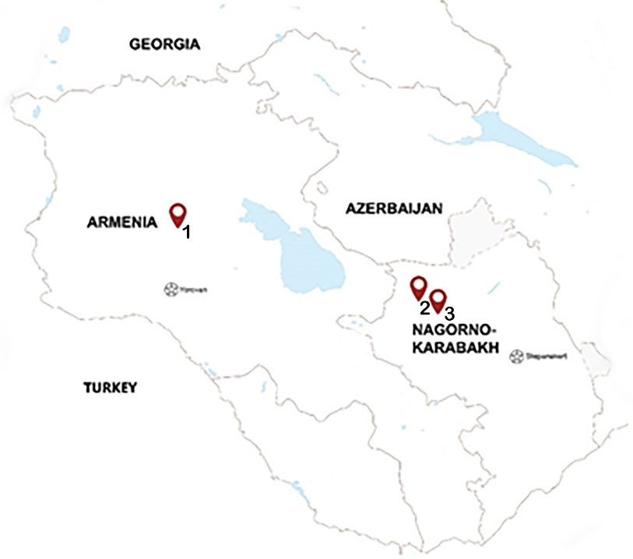
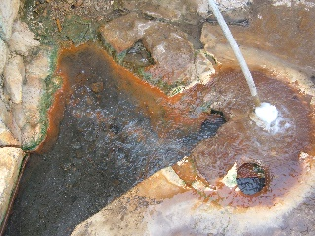
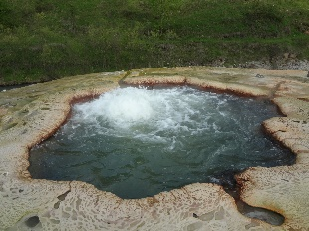
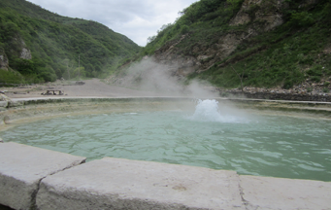
1
2
3

Fig. S1. Map of Armenia and Nagorno-Karabakh. The locations of studied geothermal springs are shown by red marks. Close up photographs of geothermal springs 1. Arzakan, 2. Zuar, 3. Karvachar. The source of the map is http://map-caucasus.com.

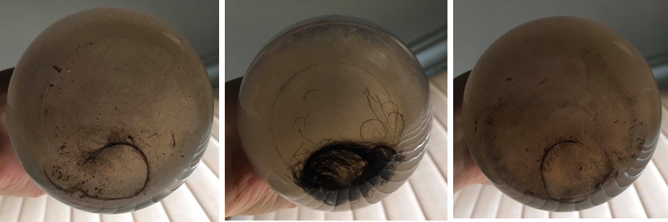
A B C
Fig. S2. Degree of feather decay after 72 h incubation in acidic (A) and alkaline (B) pretreated versions compared with untreated version (C),

Fig. S3. Morphology of colonies of the four most active strains. A. M3; B. M4; C.M12, D M14.

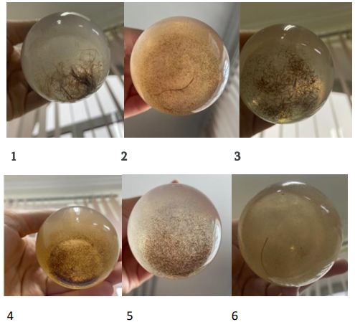
Fig. S4. Feather degradation by co-cultures after 48 h incubation at optimal growth conditions. 1. Co-culture of M3 and M4; 2. Co-culture of M3 and M12; 3. Co-culture of M3 and M14; 4. Co-culture of M4 and M12; 5. Co-culture of M4 and M14; 6. Co-culture of M12 and M14.

Fig. S5. Efficiency of feather degradation by different microbial co-cultures.
This figure shows the specific keratinolytic protease activity (blue bars) and the rate (%) of feather degradation (orange line) by various microbial co-cultures. The microbial combinations indicate different bacterial strains used in the co-cultures. Mix 1, co-culture of M3 and M4; mix 2, co-culture of M3 and M12; mix 3, co-culture of M3 and M14; mix 4, co-culture of M4 and M12; mix 5, co-culture of M4 and M14; mix 6, co-culture of M12 and M14.

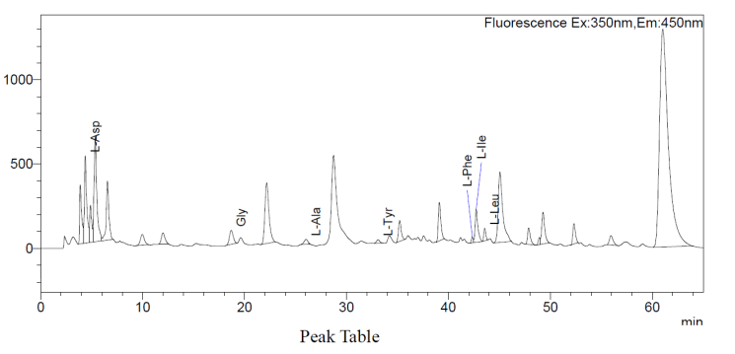
Fig․ S6. HPLC analysis of end products of feather bioconversion by B. borbori M14.

