Supplementary Information for

m-Benzisubporphyrins: The First Subcarbaporphyrin and Its B^{III} Complex with An Unprecedented Planar Tridentate 14π-Aromatic Network

Liu et al.

Supplementary Figures

Supplementary Figure 1. ¹H NMR spectrum of 6 in CDCl₃.
Supplementary Figure 2. ¹H NMR spectrum of 7 in CDCl₃.
Supplementary Figure 3. ¹H NMR spectrum of 8 in CDCl₃.
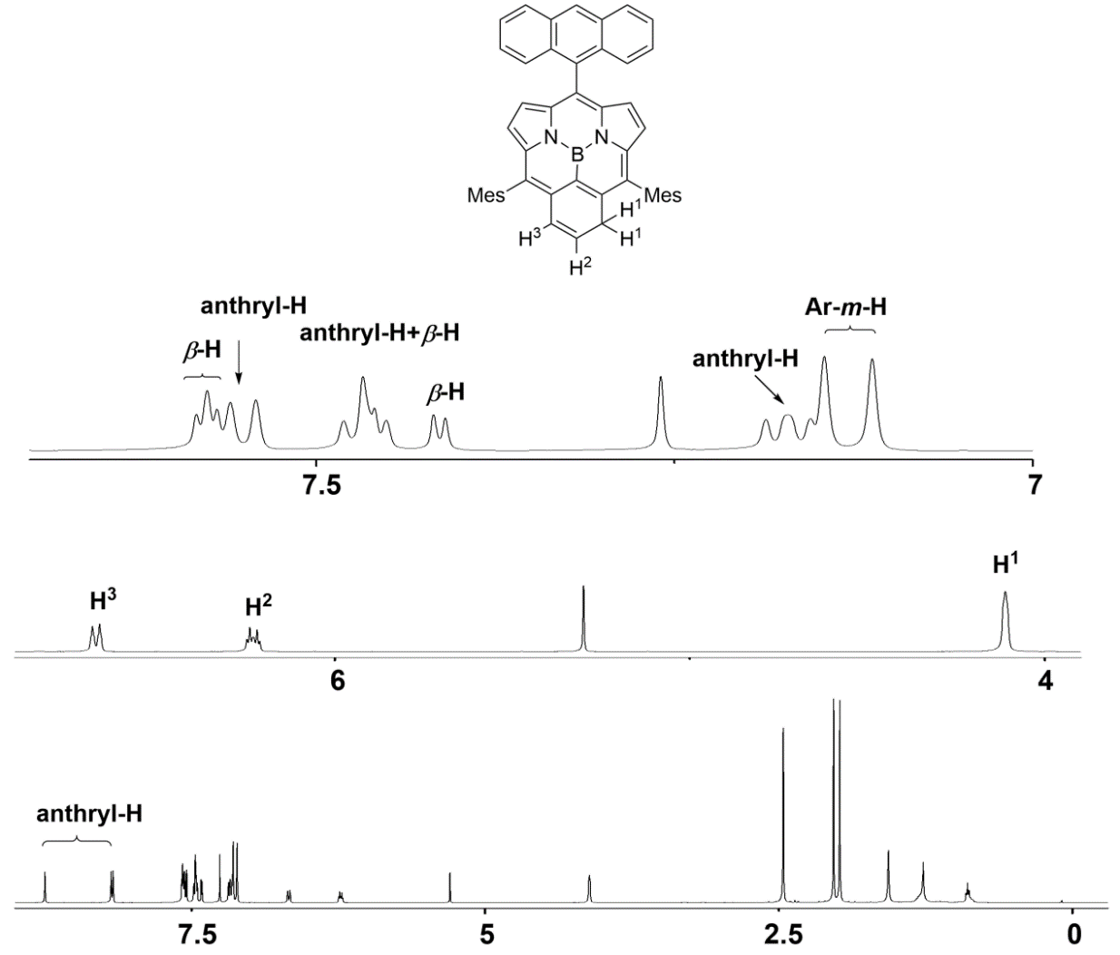
Supplementary Figure 4. ¹H NMR spectrum of 9 in CDCl₃.

Supplementary Figure 5. ¹H NMR spectrum of 10 in CDCl₃.

Supplementary Figure 6. ¹H NMR spectrum of 11 in CDCl₃.

Supplementary Figure 7. ¹H NMR spectrum of 12 in CDCl₃.

Supplementary Figure 8. Comparison of ¹H NMR spectra of 6 and 7 in CDCl₃.

Mass Spectra
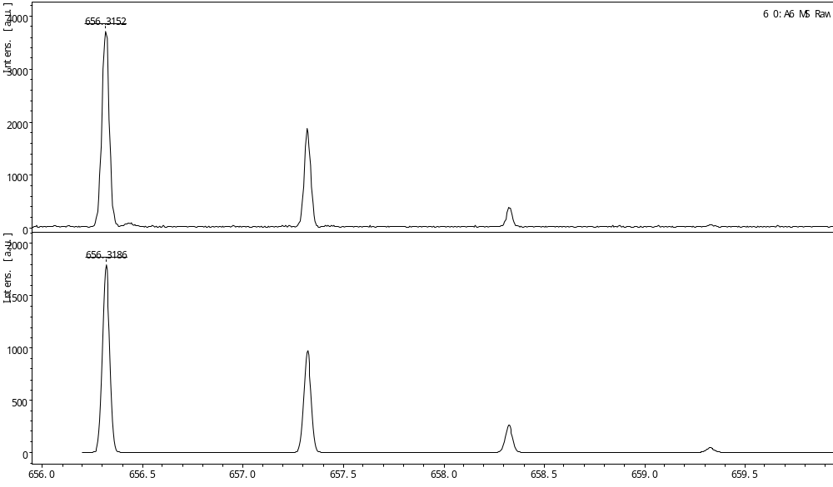
Supplementary Figure 9. MALDI-TOF-MS of 6. (Top: observed; Bottom: simulated)
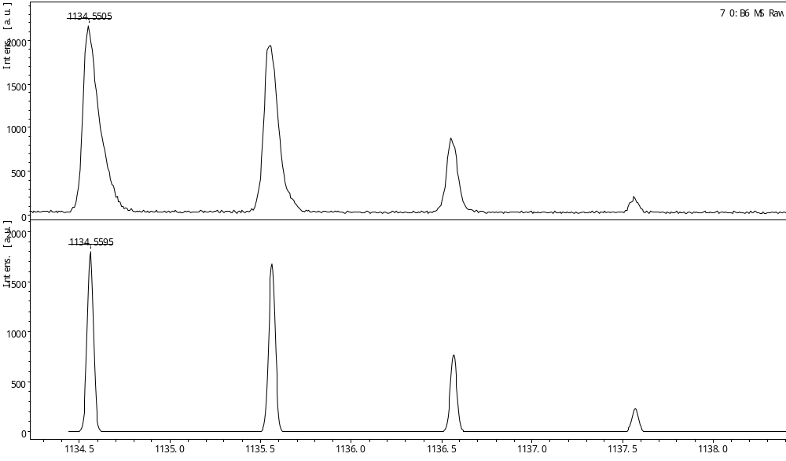
Supplementary Figure 10. MALDI-TOF-MS of 7. (Top: observed; Bottom: simulated)
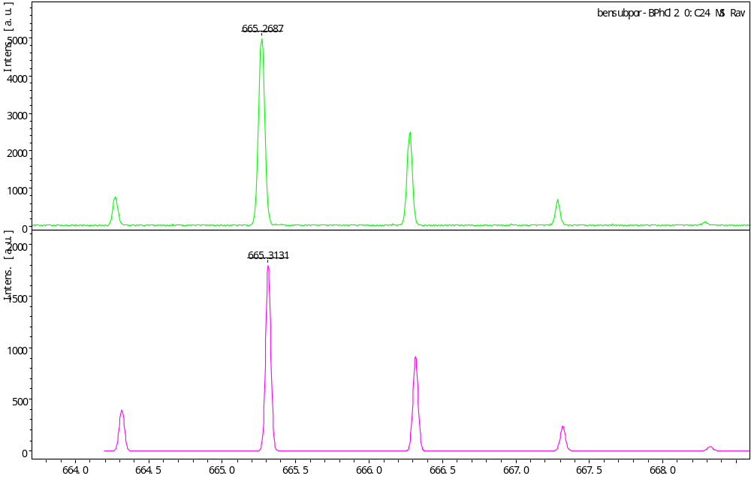
Supplementary Figure 11. MALDI-TOF-MS of 8. (Top: observed; Bottom: simulated)
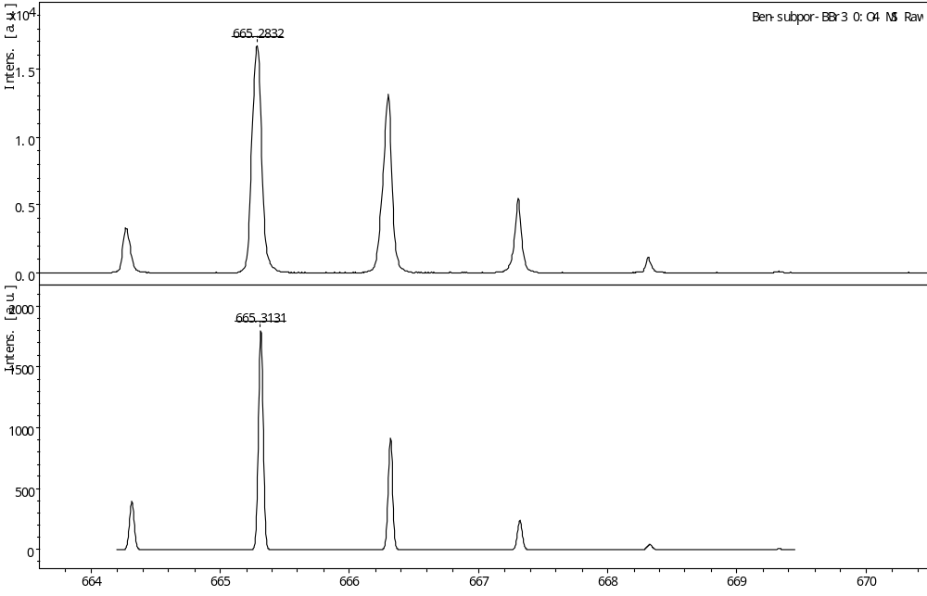
Supplementary Figure 12. MALDI-TOF-MS of 9. (Top: observed; Bottom: simulated)
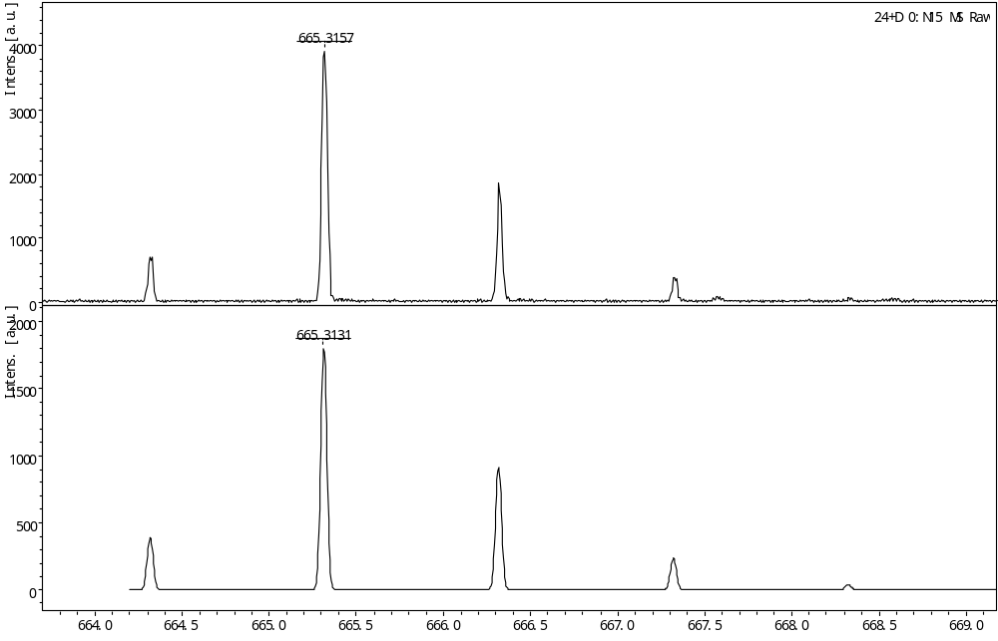
Supplementary Figure 13. MALDI-TOF-MS of 10. (Top: observed; Bottom: simulated)
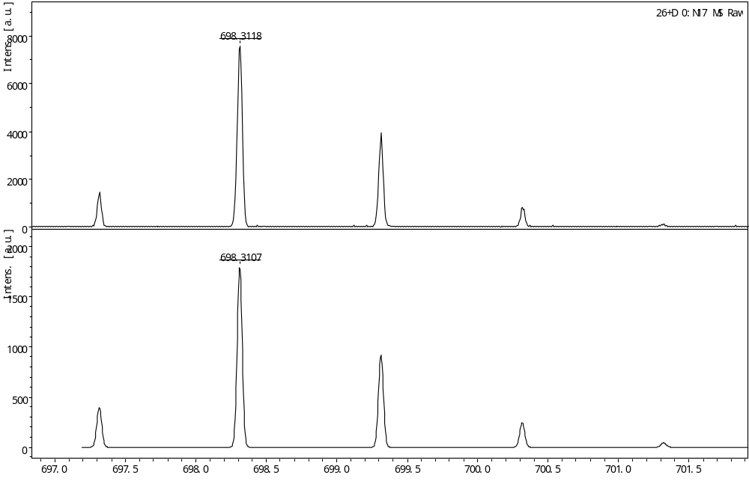
Supplementary Figure 14. MALDI-TOF-MS of 11. (Top: observed; Bottom: simulated)
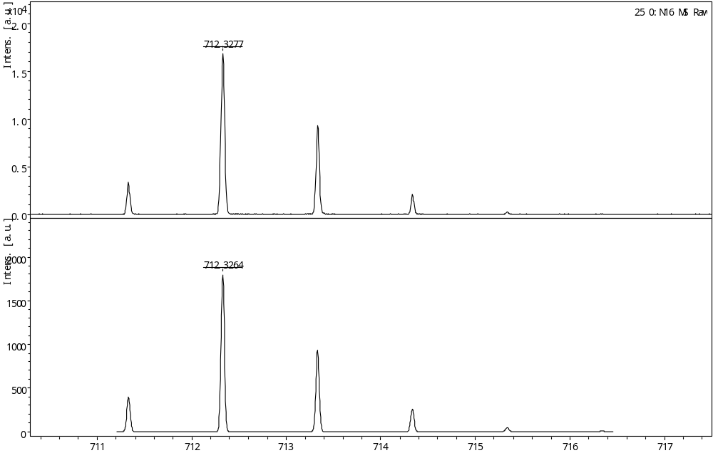
Supplementary Figure 15. MALDI-TOF-MS of 12. (Top: observed; Bottom: simulated)

Electrochemical Data
Cyclic voltammograms and differential pulse voltammograms were measured in DCM with 0.1 M ^{n}Bu₄NPF₆. Potentials were determined vs ferrocene/ferrocenium ion by differential pulse voltammograms. Working electrode: glassy carbon. Counter electrode: Pt wire. Reference electrode: AgNO₃.
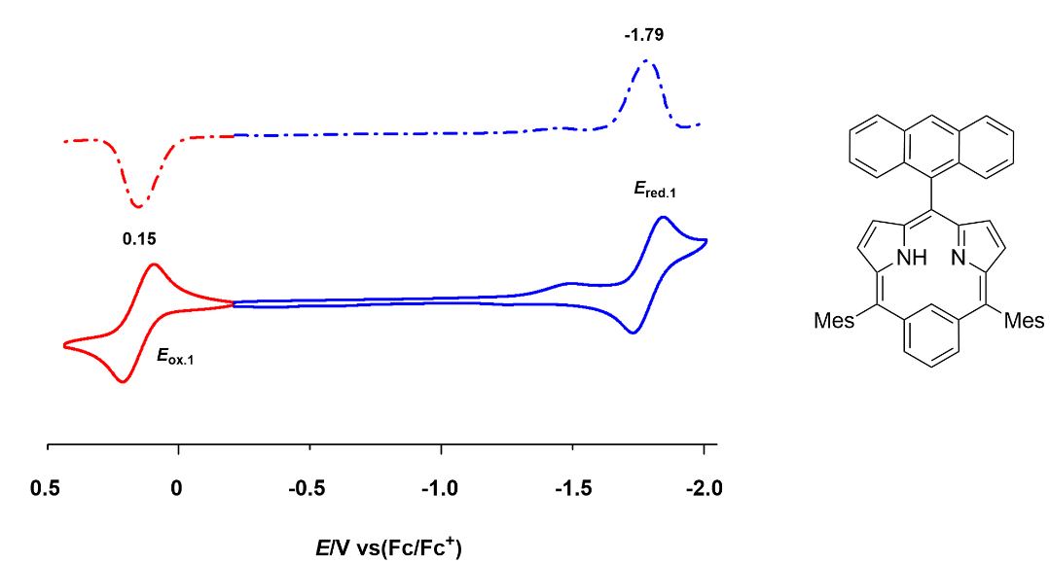
Supplementary Figure 16. Cyclic voltammogram and differential pulse voltammogram of 6.
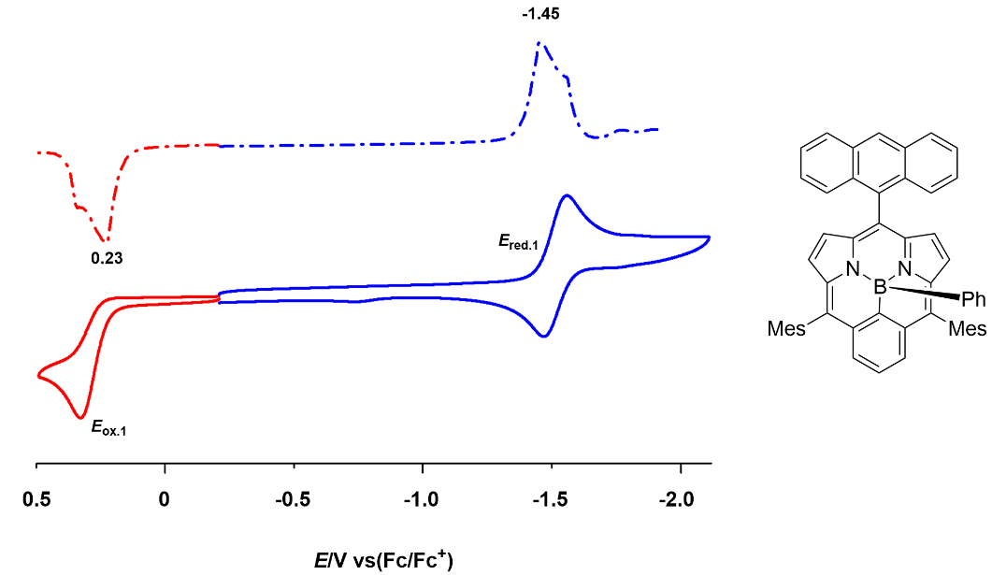
Supplementary Figure 17. Cyclic voltammogram and differential pulse voltammogram of 8.
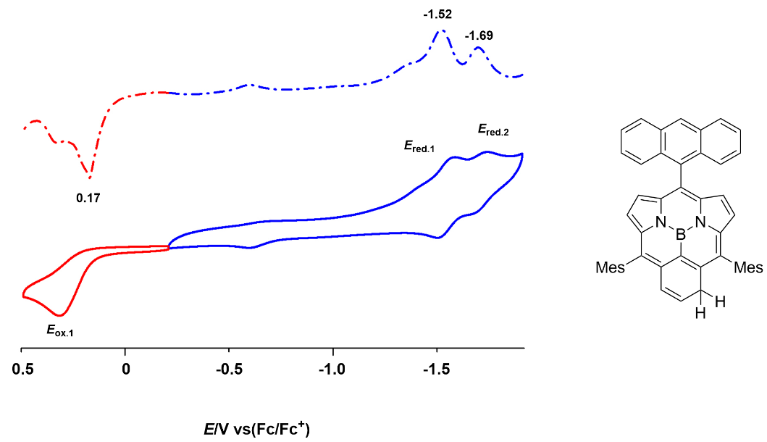
Supplementary Figure 18. Cyclic voltammogram and differential pulse voltammogram of 9.
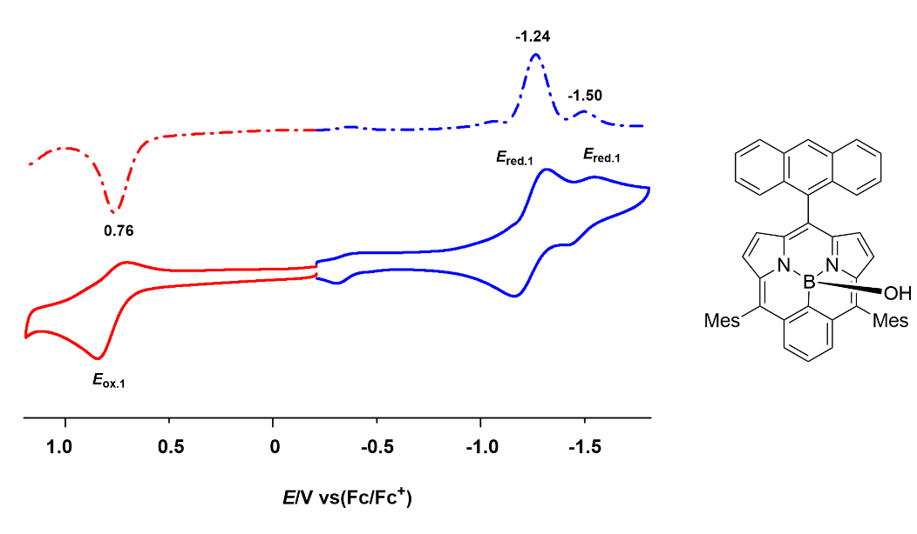
Supplementary Figure 19. Cyclic voltammogram and differential pulse voltammogram of 10.
Supplementary Figure 20. Cyclic voltammogram and differential pulse voltammogram of 11.
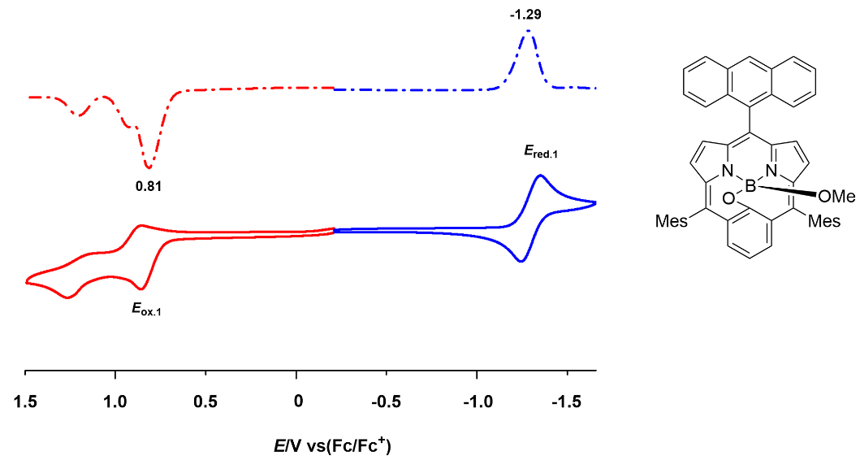
Supplementary Figure 21. Cyclic voltammogram and differential pulse voltammogram of 12.
Supplementary Table 1. Summary of the electrochemical potentials (V) and HOMO–LUMO gaps (eV).
samples | E_{ox.1} | E_{red.1} | E_{red.2} | △E_{HL}^{[b]}
6 | 0.15 | -1.79 | -- | 1.94
8 | 0.23 | -1.45 | -- | 1.68
9 | 0.17 | -1.52 | -1.69 | 1.69
10 | 0.76 | -1.24 | -1.50 | 2.00
11 | 0.82 | -1.29 | -- | 2.11
12 | 0.81 | -1.29 | -- | 2.10
ªIrreversible peaks. ^{b}ΔE_{HL} = e (E_{ox.1}–E_{red.1}) [eV]

X-Ray Crystal Data
Supplementary Figure 2. Crystal data and structure refinement for 6.
Identification code exp_3719
Empirical formula C51 H43 N3
Formula weight 697.88
Temperature 100.01(10) K
Wavelength 1.54184 Å
Crystal system Monoclinic
Space group P 1 21/n 1
Unit cell dimensions a = 12.0996(5) Å α= 90°.
b = 10.9016(5) Å β= 96.378(4)°.
c = 29.2496(12) Å γ = 90°.
Volume 3834.3(3) Å3
Z 4
Density (calculated) 1.209 Mg/m3
Absorption coefficient 0.535 mm-1
F(000) 1480
Crystal size 0.3 x 0.1 x 0.1 mm3
Theta range for data collection 3.040 to 66.597°.
Index ranges -14<=h<=8, -12<=k<=12, -29<=l<=34
Reflections collected 13633
Independent reflections 6772 [R(int) = 0.0534]
Completeness to theta = 66.597° 99.9 %
Absorption correction Semi-empirical from equivalents
Max. and min. transmission 1.00000 and 0.70836
Refinement method Full-matrix least-squares on F2
Data / restraints / parameters 6772 / 0 / 494
Goodness-of-fit on F2 1.047
Final R indices [I>2sigma(I)] R1 = 0.0575, wR2 = 0.1249
R indices (all data) R1 = 0.0889, wR2 = 0.1414
Extinction coefficient n/a
Largest diff. peak and hole 0.266 and -0.458 e.Å-3
CCDC number 2379624

Supplementary Figure 22. X-ray crystal structure of 6. (a) Top view and (b) side view. The thermal ellipsoids are 30% probability level.
Supplementary Figure 23. Structural analysis of 6.
Supplementary Table 3. Crystal data and structure refinement for 8.
Identification code exp_3472_sq
Empirical formula C55 H43 B N2
Formula weight 742.72
Temperature 100.01(10) K
Wavelength 1.54184 Å
Crystal system Triclinic
Space group P-1
Unit cell dimensions a = 12.2357(4) Å α= 78.284(3)°.
b = 13.4613(5) Å β= 77.397(3)°.
c = 14.9649(5) Å γ = 76.902(3)°.
Volume 2312.08(15) Å3
Z 2
Density (calculated) 1.067 Mg/m3
Absorption coefficient 0.464 mm-1
F(000) 784
Crystal size 0.2 x 0.2 x 0.2 mm3
Theta range for data collection 3.066 to 66.600°.
Index ranges -14<=h<=14, -16<=k<=14, -17<=l<=13
Reflections collected 14849
Independent reflections 8162 [R(int) = 0.0181]
Completeness to theta = 66.600° 100.0 %
Absorption correction Semi-empirical from equivalents
Max. and min. transmission 1.00000 and 0.89352
Refinement method Full-matrix least-squares on F2
Data / restraints / parameters 8162 / 0 / 529
Goodness-of-fit on F2 1.036
Final R indices [I>2sigma(I)] R1 = 0.0406, wR2 = 0.0999
R indices (all data) R1 = 0.0460, wR2 = 0.1039
Extinction coefficient n/a
Largest diff. peak and hole 0.689 and -0.254 e.Å-3
CCDC number 2379625

Supplementary Figure 24. X-ray crystal structure of 8. (a) Top view and (b) side view. The thermal ellipsoids are 30% probability level.

Supplementary Figure 25. Structural analysis of 8.

Supplementary Table 4. Crystal data and structure refinement for 9.
Identification code exp_3473_sq
Empirical formula C49 H39 B N2
Formula weight 666.63
Temperature 100.01(10) K
Wavelength 1.54184 Å
Crystal system Triclinic
Space group P-1
Unit cell dimensions a = 11.6677(12) Å α= 103.399(7)°.
b = 12.7694(11) Å β= 109.908(8)°.
c = 14.5328(8) Å γ = 94.935(7)°.
Volume 1948.0(3) Å3
Z 2
Density (calculated) 1.137 Mg/m3
Absorption coefficient 0.495 mm-1
F(000) 704
Crystal size 0.05 x 0.05 x 0.05 mm3
Theta range for data collection 3.368 to 66.600°.
Index ranges -13<=h<=9, -14<=k<=15, -17<=l<=17
Reflections collected 11838
Independent reflections 6887 [R(int) = 0.0516]
Completeness to theta = 66.600° 99.9 %
Absorption correction Semi-empirical from equivalents
Max. and min. transmission 1.00000 and 0.76183
Refinement method Full-matrix least-squares on F2
Data / restraints / parameters 6887 / 0 / 475
Goodness-of-fit on F2 1.047
Final R indices [I>2sigma(I)] R1 = 0.0815, wR2 = 0.2160
R indices (all data) R1 = 0.1166, wR2 = 0.2447
Extinction coefficient n/a
Largest diff. peak and hole 0.541 and -0.265 e.Å-3
CCDC number 2379626

Supplementary Figure 26. X-ray crystal structure of 9. (a) Top view and (b) side view. The thermal ellipsoids are 30% probability level.
Supplementary Figure 27. Structural analysis of 9.

Supplementary Table 5. Crystal data and structure refinement for 10.
Identification code exp_3736_sq
Empirical formula C49 H39 B N2 O
Formula weight 682.63
Temperature 99.98(10) K
Wavelength 1.54184 Å
Crystal system Triclinic
Space group P-1
Unit cell dimensions a = 11.9190(12) Å α= 104.186(8)°.
b = 12.5825(11) Å β= 110.328(9)°.
c = 14.8081(16) Å γ = 96.071(8)°.
Volume 1974.0(4) Å3
Z 2
Density (calculated) 1.148 Mg/m3
Absorption coefficient 0.519 mm-1
F(000) 720
Crystal size 0.1 x 0.05 x 0.05 mm3
Theta range for data collection 3.339 to 66.599°.
Index ranges -14<=h<=12, -14<=k<=14, -17<=l<=17
Reflections collected 12275
Independent reflections 6960 [R(int) = 0.0816]
Completeness to theta = 66.599° 99.8 %
Absorption correction Semi-empirical from equivalents
Max. and min. transmission 1.00000 and 0.59263
Refinement method Full-matrix least-squares on F2
Data / restraints / parameters 6960 / 6 / 485
Goodness-of-fit on F2 1.027
Final R indices [I>2sigma(I)] R1 = 0.0818, wR2 = 0.1879
R indices (all data) R1 = 0.1507, wR2 = 0.2274
Extinction coefficient n/a
Largest diff. peak and hole 0.334 and -0.663 e.Å-3
CCDC number 2379627

Supplementary Figure 28. X-ray crystal structure of 10. (a) Top view and (b) side view. The thermal ellipsoids are 30% probability level.

Supplementary Figure 29. Structural analysis of 10.

Supplementary Table 6. Crystal data and structure refinement for 11.
Identification code exp_3517_sq
Empirical formula C49 H39 B N2 O2
Formula weight 698.63
Temperature 100.00(10) K
Wavelength 1.54184 Å
Crystal system Monoclinic
Space group P 1 21/c 1
Unit cell dimensions a = 13.211(2) Å α= 90°.
b = 20.856(2) Å β= 114.86(2)°.
c = 15.732(3) Å γ = 90°.
Volume 3932.9(11) Å3
Z 4
Density (calculated) 1.180 Mg/m3
Absorption coefficient 0.552 mm-1
F(000) 1472
Crystal size 0.1 x 0.05 x 0.05 mm3
Theta range for data collection 3.688 to 66.597°.
Index ranges -15<=h<=15, -24<=k<=24, -18<=l<=18
Reflections collected 27391
Independent reflections 6939 [R(int) = 0.1325]
Completeness to theta = 66.597° 100.0 %
Absorption correction Semi-empirical from equivalents
Max. and min. transmission 1.00000 and 0.33807
Refinement method Full-matrix least-squares on F2
Data / restraints / parameters 6939 / 0 / 498
Goodness-of-fit on F2 0.778
Final R indices [I>2sigma(I)] R1 = 0.0543, wR2 = 0.1082
R indices (all data) R1 = 0.1272, wR2 = 0.1332
Extinction coefficient n/a
Largest diff. peak and hole 0.253 and -0.313 e.Å-3
CCDC number 2379628

Supplementary Figure 30. X-ray crystal structure of 11. (a) Top view and (b) side view. The thermal ellipsoids are 30% probability level.

Supplementary Figure 31. Structural analysis of 11.

Supplementary Table 7. Crystal data and structure refinement for 12.
Identification code exp_3498_sq
Empirical formula C50 H41 B N2 O2
Formula weight 712.66
Temperature 100.00(10) K
Wavelength 1.54184 Å
Crystal system Triclinic
Space group P-1
Unit cell dimensions a = 14.4553(6) Å α= 92.220(3)°.
b = 15.1300(6) Å β= 94.235(3)°.
c = 21.0270(7) Å γ = 98.658(4)°.
Volume 4528.2(3) Å3
Z 4
Density (calculated) 1.045 Mg/m3
Absorption coefficient 0.487 mm-1
F(000) 1504
Crystal size 0.2 x 0.2 x 0.05 mm3
Theta range for data collection 2.958 to 66.600°.
Index ranges -17<=h<=17, -17<=k<=18, -17<=l<=25
Reflections collected 29740
Independent reflections 15982 [R(int) = 0.0562]
Completeness to theta = 66.600° 99.9 %
Absorption correction Semi-empirical from equivalents
Max. and min. transmission 1.00000 and 0.62092
Refinement method Full-matrix least-squares on F2
Data / restraints / parameters 15982 / 78 / 1005
Goodness-of-fit on F2 1.029
Final R indices [I>2sigma(I)] R1 = 0.0622, wR2 = 0.1525
R indices (all data) R1 = 0.0881, wR2 = 0.1684
Extinction coefficient n/a
Largest diff. peak and hole 0.401 and -0.704 e.Å-3
CCDC number 2379629

Supplementary Figure 32. X-ray crystal structure of 12. (a) Top view and (b) side view. The thermal ellipsoids are 30% probability level.
Supplementary Figure 33. Structural analysis of 12.

DFT Calculation
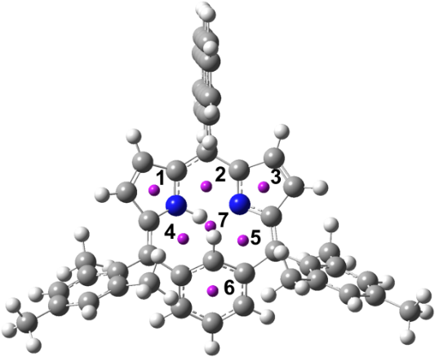
position | 1 | 2 | 3 | 4 | 5 | 6 | 7
6 | -4.0287 | 2.0801 | -2.6389 | 0.0419 | -0.6589 | -8.0409 | 1.5118
Supplementary Figure 34. NICS values at various positions of 6 on the optimized structure.
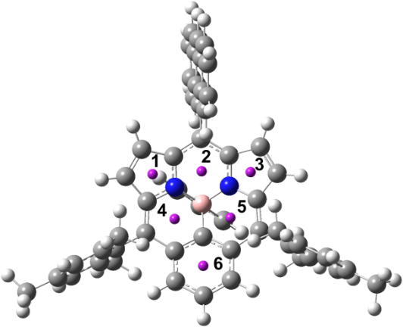
position | 1 | 2 | 3 | 4 | 5 | 6
8 | -1.8352 | 1.0489 | -2.2078 | 4.8300 | 5.5793 | -2.3629
Supplementary Figure 35. NICS values at various positions of 8 on the optimized structure.
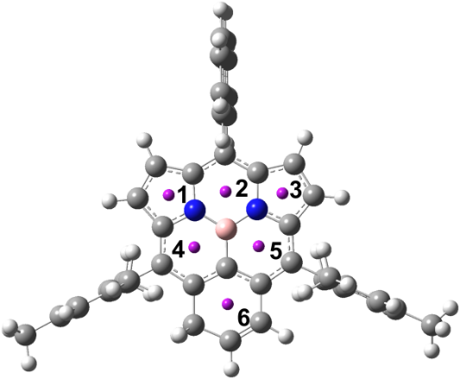
position | 1 | 2 | 3 | 4 | 5 | 6
9 | -13.5152 | -9.5777 | -14.5315 | -11.6418 | -10.4852 | 9.0935
Supplementary Figure 36. NICS values at various positions of 9 on the optimized structure.

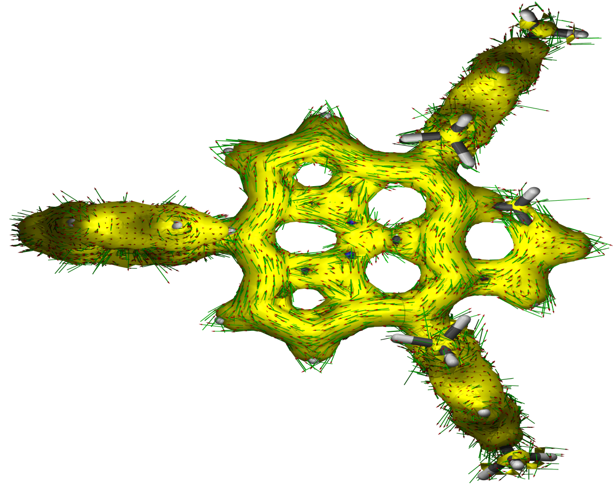
Supplementary Figure 37. ACID plot of 9 at isosurface value of 0.04. The external magnetic field was applied in the direction from the back of the paper to the surface.
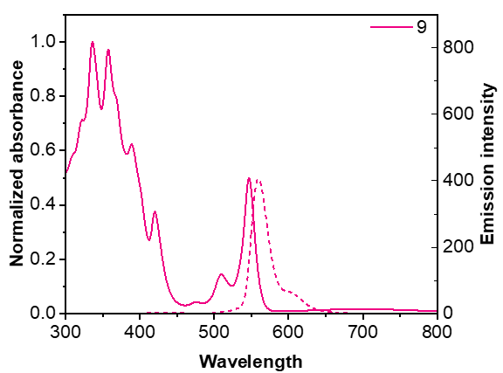
Supplementary Figure 38. UV-Vis and fluorescence spectra of 9 with solid and dotted lines, respectively.

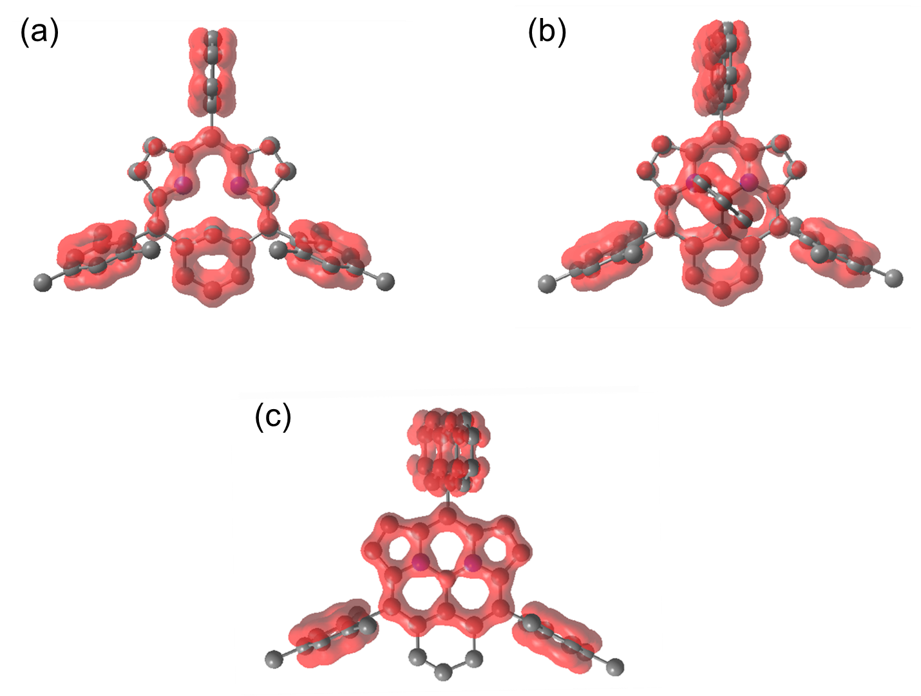
Supplementary Figure 39. EDDB plots of (a) 6, (b) 8, and (c) 9, where cyclic π-conjugation pathways are visualized with red-colored surface with an isovalue of 0.02.
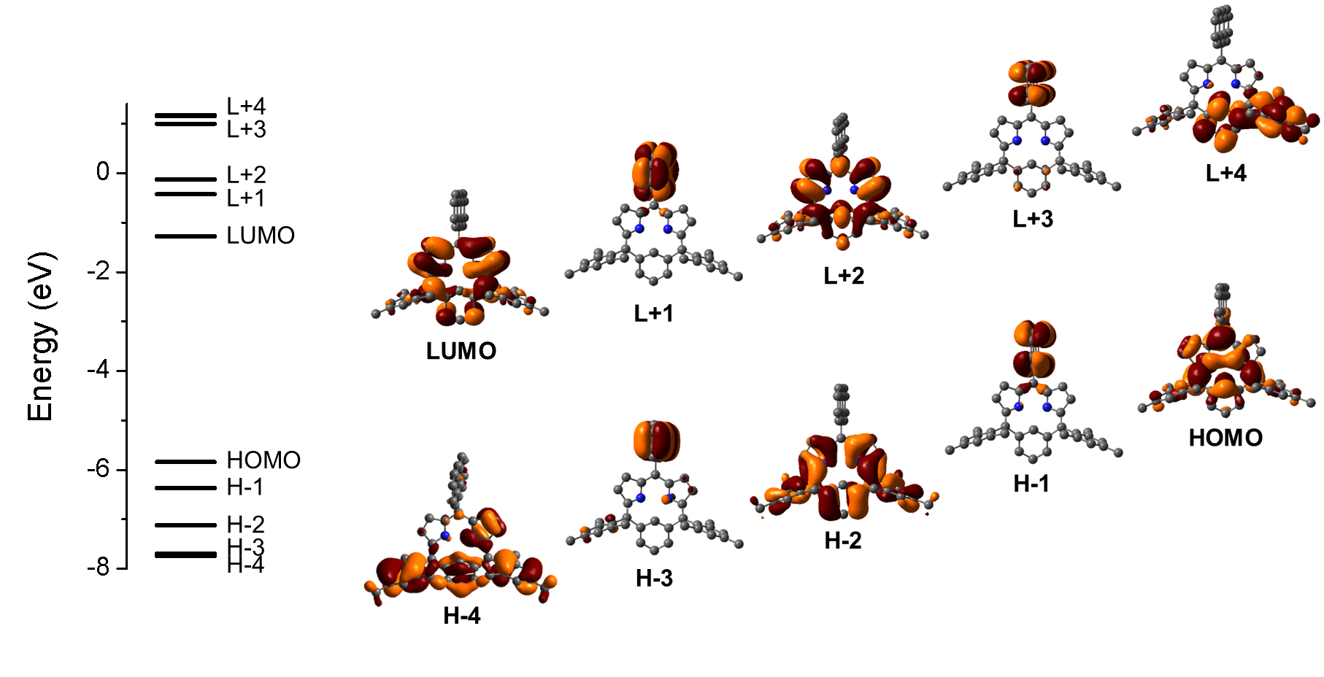
Supplementary Figure 40. MO energy diagram and electron density distribution of 6.

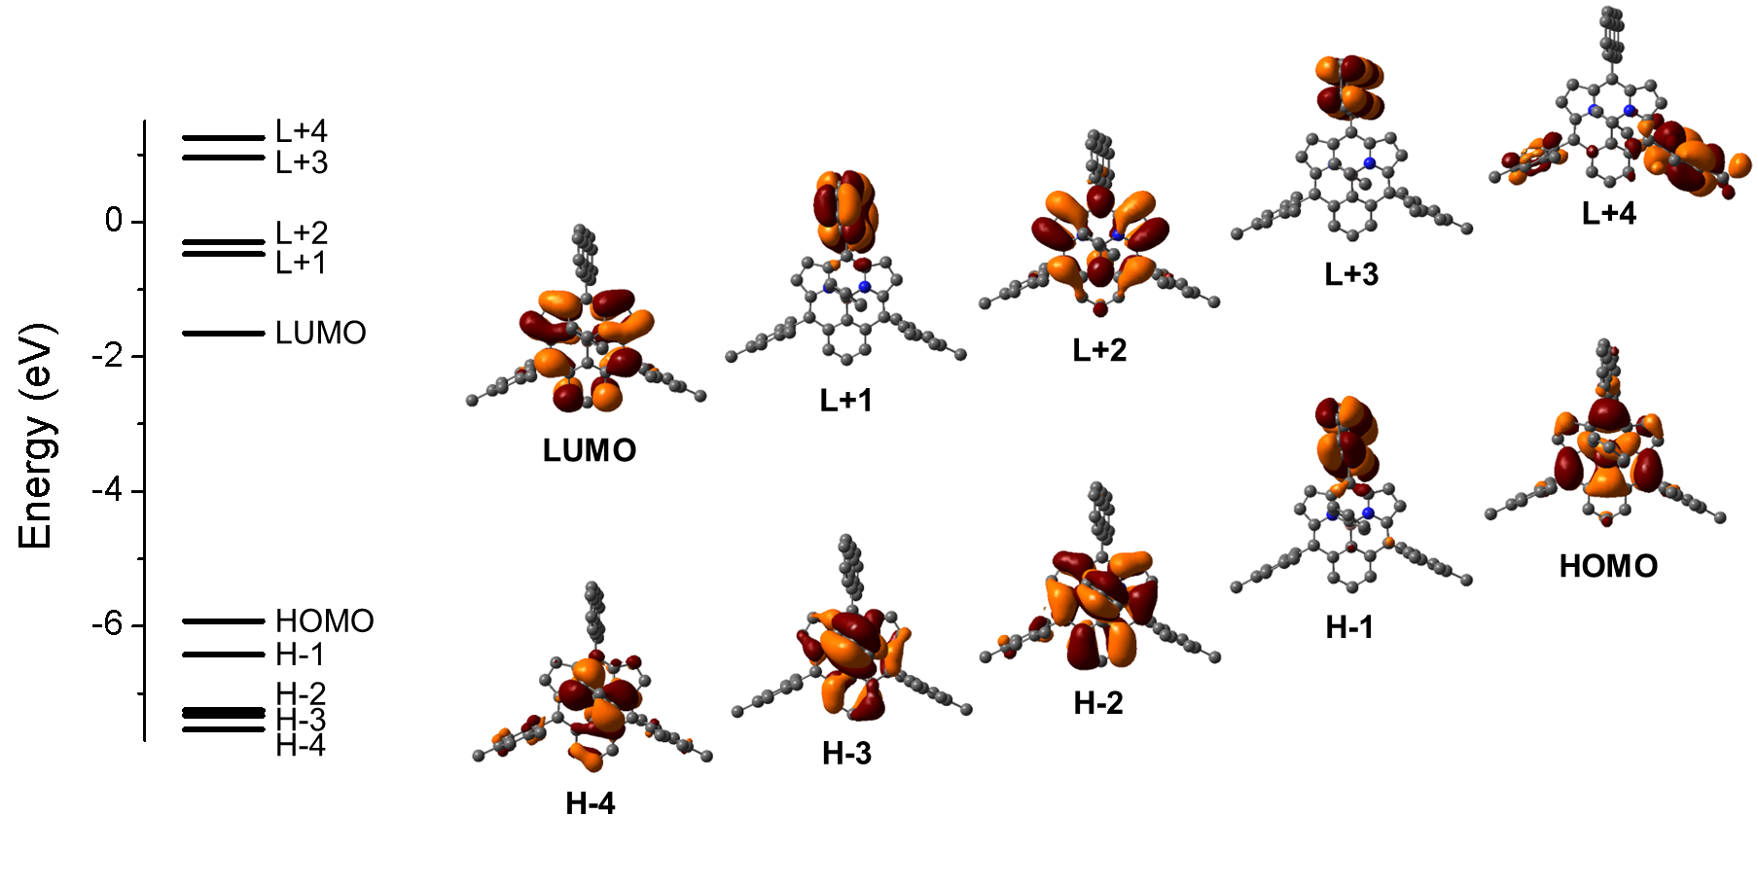
Supplementary Figure 41. MO energy diagram and electron density distribution of 8.

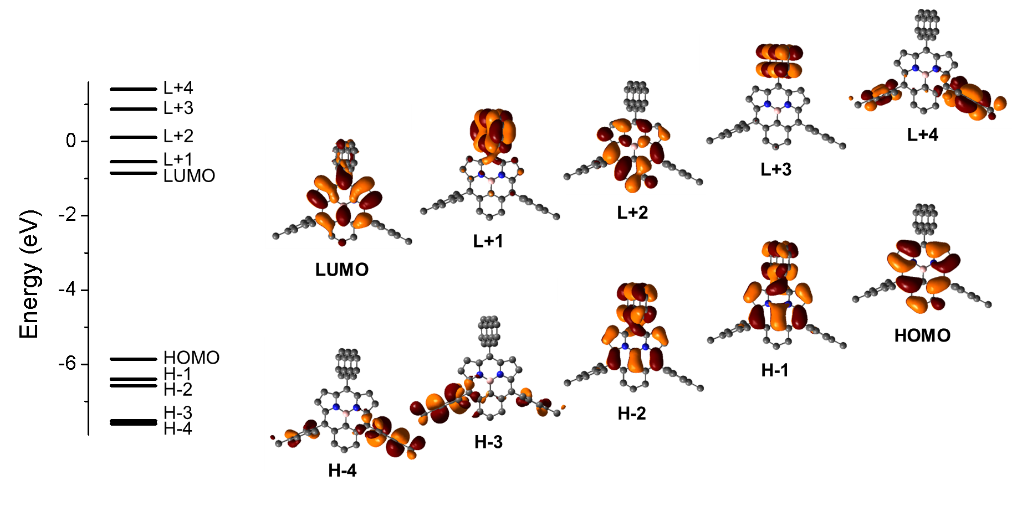
Supplementary Figure 42. MO energy diagram and electron density distribution of 9.

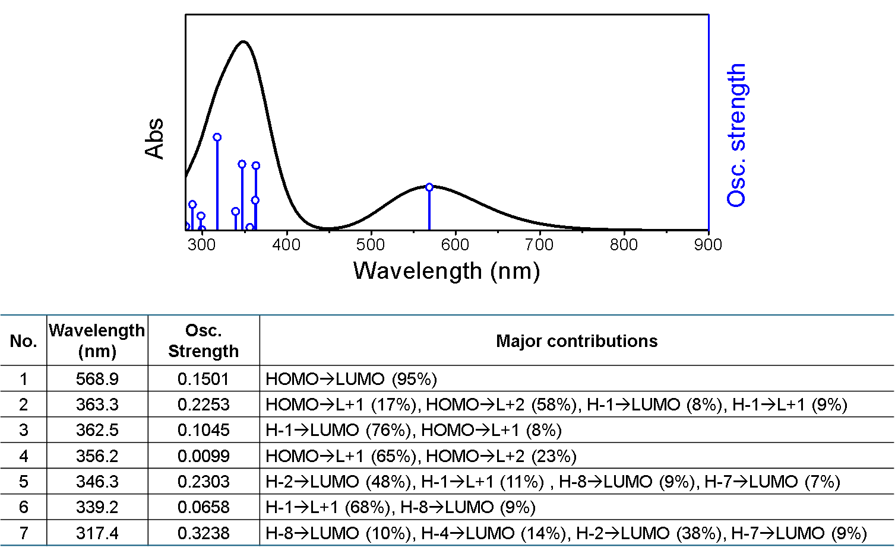
Supplementary Figure 43. Simulated absorption spectrum and MO contributions on electronic transitions of 6 (Contributions less than 6% are omitted for clarity).

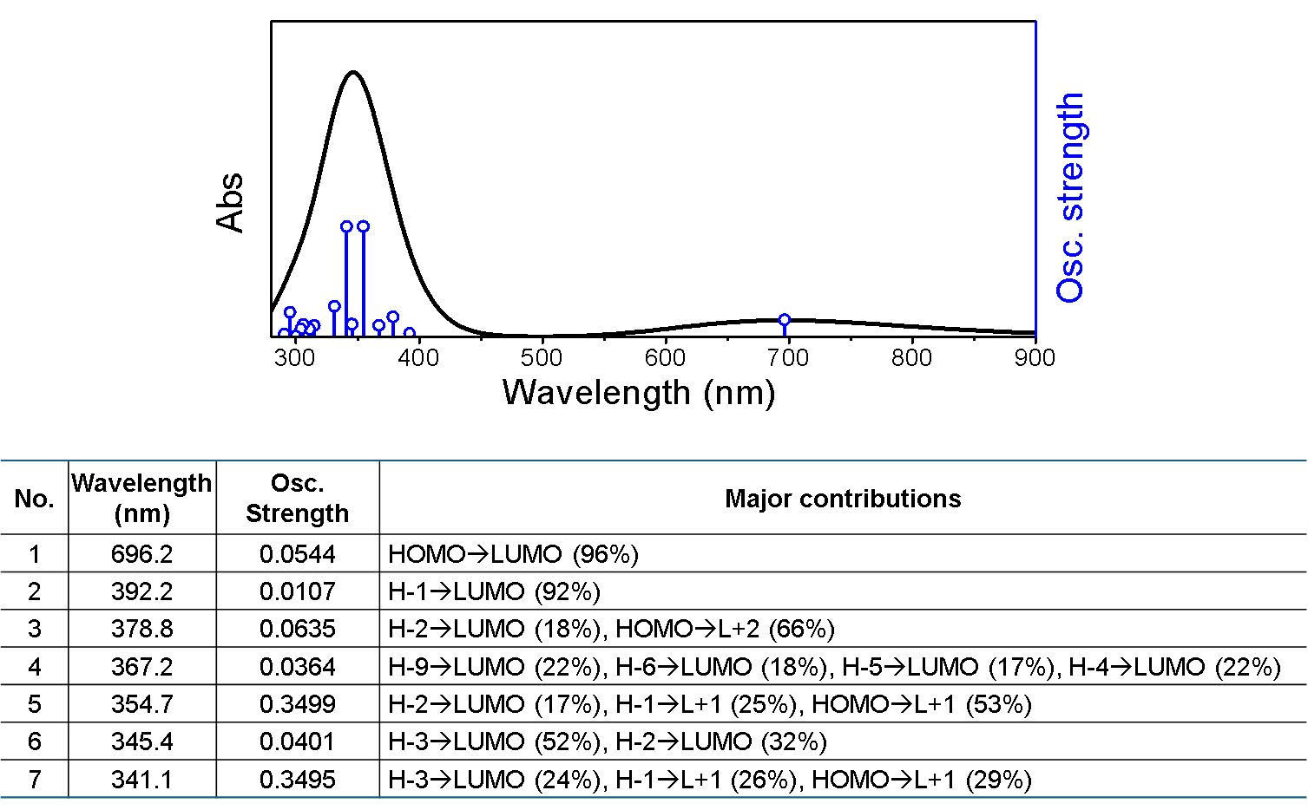
Supplementary Figure 44. Simulated absorption spectrum and MO contributions on electronic transitions of 8 (Contributions less than 6% are omitted for clarity).

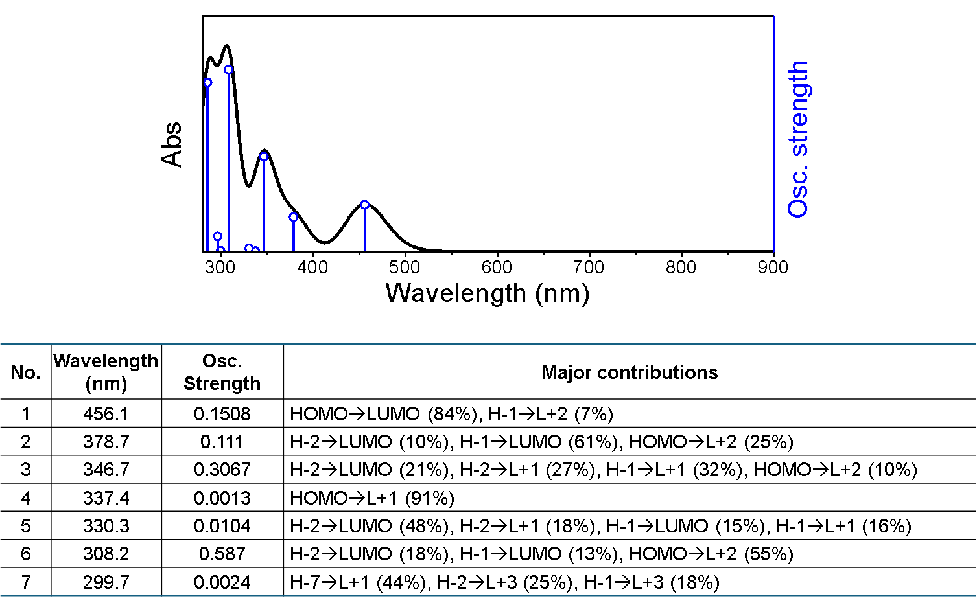
Supplementary Figure 45. Simulated absorption spectrum and MO contributions on electronic transitions of 9 (Contributions less than 6% are omitted for clarity).
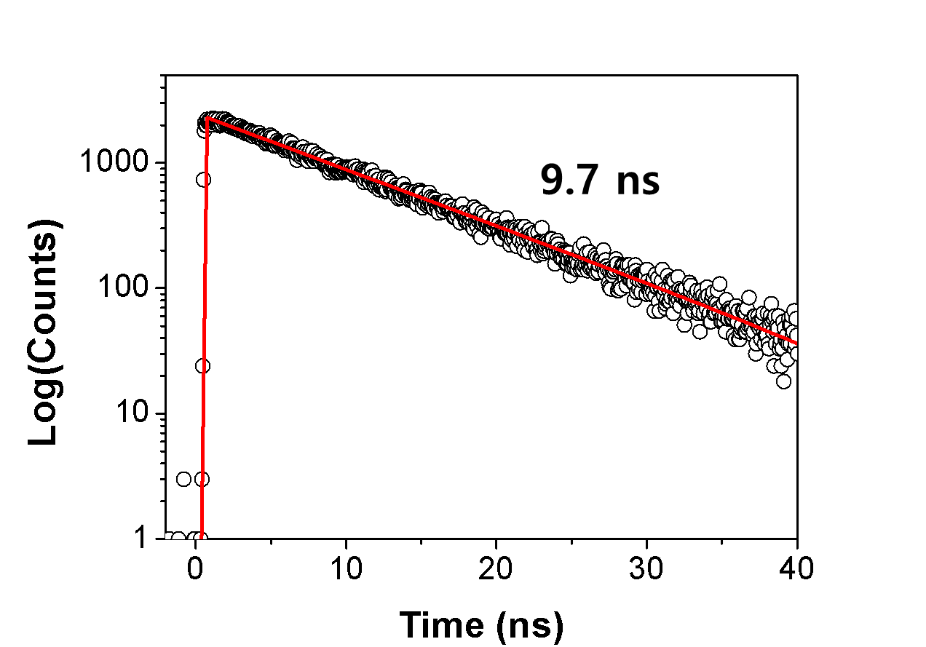
Supplementary Figure 46. Fluorescence decay profile of 9 in toluene at 560 nm (Photoexcitation at 420 nm).

Transient absorption measurement The femtosecond transient absorption (fs-TA) spectrometer consisted of an optical detection system and an optical parametric amplifier (OPA; Palitra, Quantronix) pumped by a Ti:sapphire regenerative amplifier system (Integra-C, Quantronix) operating at a 1 kHz repetition rate. White light continuum (WLC) probe pulses were generated using a sapphire window (4 mm thick). The intensities of the spectrally dispersed WLC probe pulses were monitored using a high-speed spectrometer (Ultrafast Systems). The cross-correlation full-width at half maximum in the pump-probe experiments was <200 fs. The nanosecond transient absorption (ns-TA) data were measured with the commercial spectrometer (EOS; Ultrafast Systems). After the TA experiments, the absorption spectra of all compounds were carefully examined to determine the presence of artifacts caused by any degradation or photo-oxidation of the samples (Z-202308028841 at the Research Support Center for Bio-Bigdata Analysis and Utilization of Biological Resources).
Computational methods Quantum mechanical calculations were performed by the Gaussian 16, Revision A.03 program suite. All (TD)DFT calculations were performed with camB3LYP/6-31(d,p) with dispersion correction method, DFT-D3(BJ).

