Supplementary Tables:
Table S1. A list of basic information about all vOTUs, hq-vOTUs, non-redundant hq-vOTUs and hq-vOTUs with phagCN taxonomic annotations.
Table S2. A list of completeness of all bins formed by binner selected and the vOTUs with the highest completeness in each bin.
Table S3. A list of the original number of contigs input for the two assembly improvement tools and the number of contigs that showed improved assembly results.

Supplementary Figures:

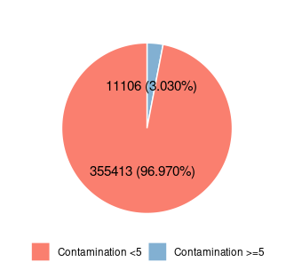
Figure S1. Pie chart showing the proportion of contamination greater than or equal to 5 and less than 5 for all vOTUs generated from the 12 assemblers.

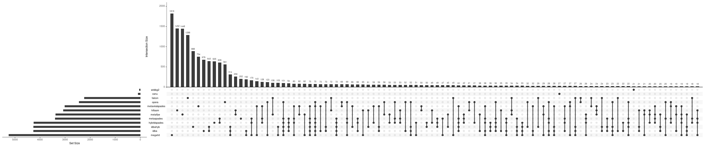
Figure S2. Upset plot shows assembler-specific hq-vOTUs of all assemblers. The connecting lines indicate the overlaps (hq-vOTUs present in a cluster when using a parameter of 95% sequence similarity for de-redundancy in our study) situation between the connected assemblers.

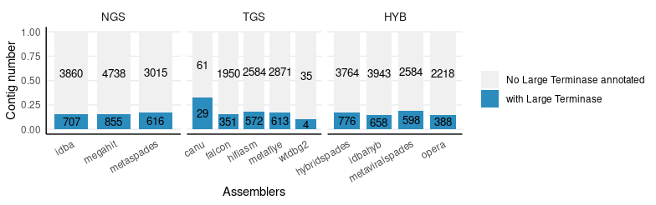
Figure S3. Barplot of the number and proportion of hq-vOTUs generated from each assembler that carry Large terminase gene or not.

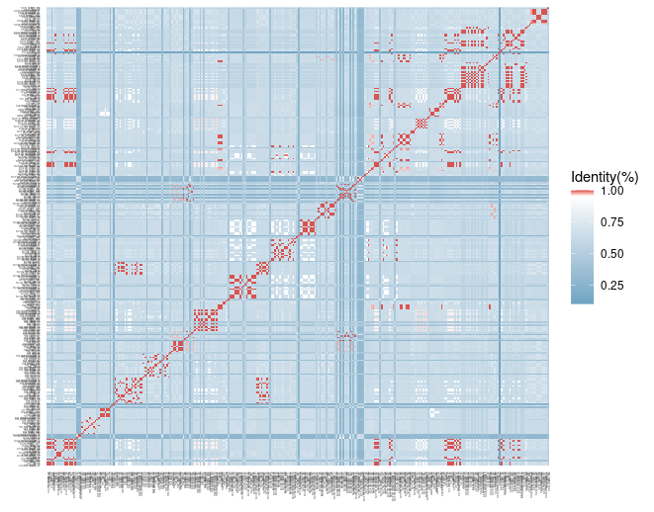
Figure S4. Heatmap showing the results of a sequence-by-sequence comparison of large terminase proteins from hq-vOTUs annotated as the Autographivirid family, with color shades indicating sequence similarity. The identity between 0 and 95 is represented in blue, while that above 95 is shown in red.

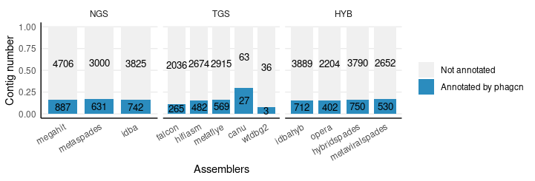
Figure S5. Barplot of the number and proportion of hq-vOTUs generated from each assembler that can be annotated by PhagCN to family level or not.

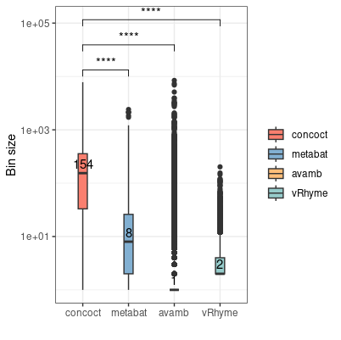
Figure S6. Boxplots showing the size of bins (number of vOTUs contained in the bin) generated by CONCOCT and MetaBAT2 using vOTUs recovered from the assemblers. Wilcoxon test; ****: p < 0.0001.

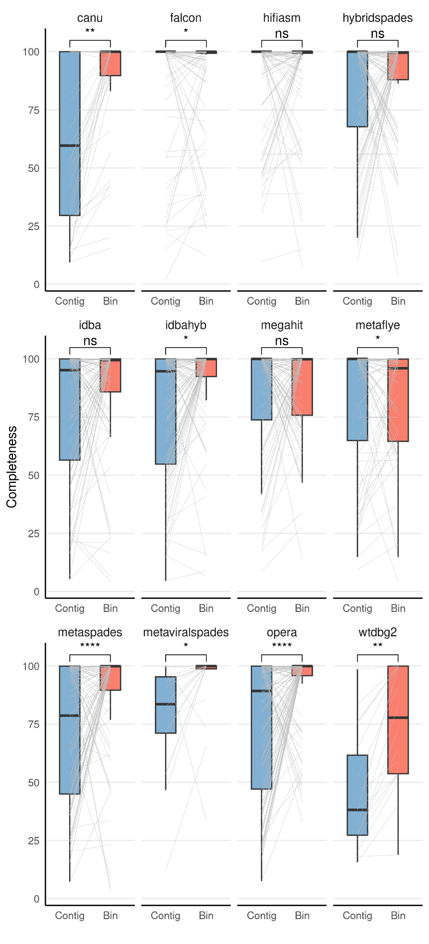
Figure S7. Boxplot showing completeness improvement of each assembler by CONCOCT. (The vOTU with the highest completeness in each bin is compared to the completeness of the entire bin). Pairwise Wilcoxon Rank Sum test; *: p < 0.05, **: p < 0.01, ****: p < 0.0001.

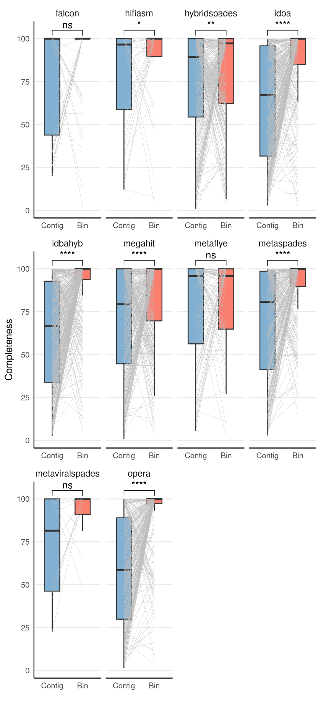
Figure S8. Boxplot showing completeness improvement of each assembler by MetaBAT2. (The vOTU with the highest completeness in each bin is compared to the completeness of the entire bin). Pairwise Wilcoxon Rank Sum test; *: p < 0.05, **: p < 0.01, ****: p < 0.0001.

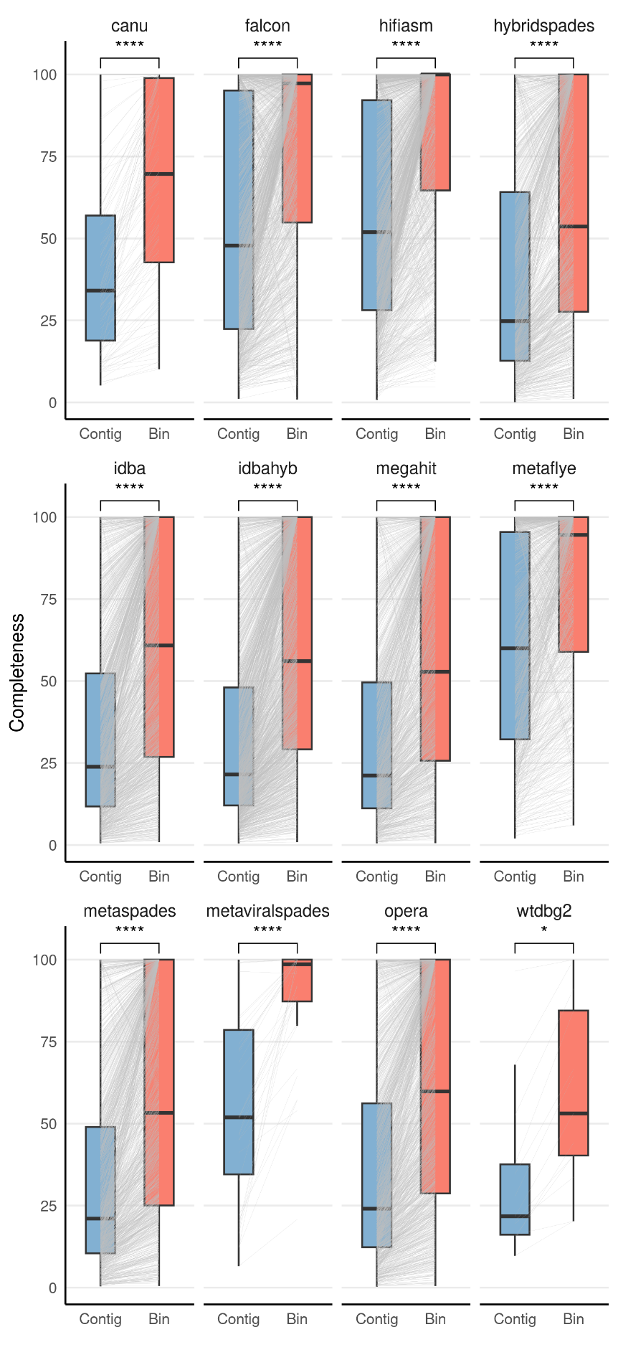
Figure S9. Boxplot showing completeness improvement of each assembler by AVAMB. (The vOTU with the highest completeness in each bin is compared to the completeness of the entire bin). Pairwise Wilcoxon Rank Sum test; *: p < 0.05, ****: p < 0.0001.

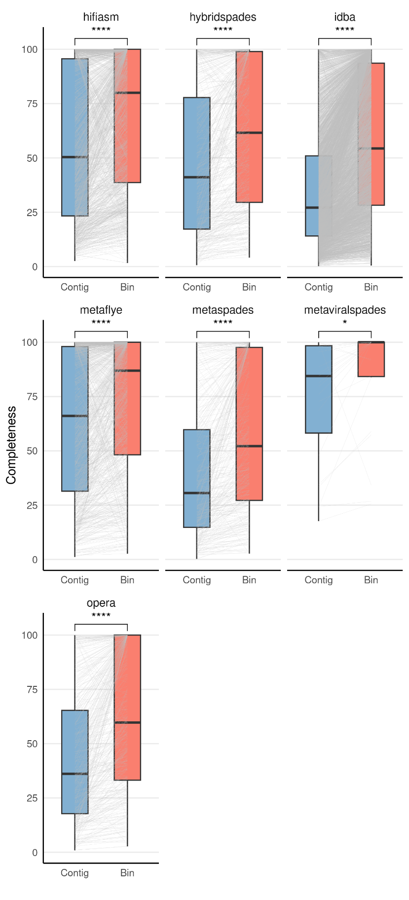
Figure S10. Boxplot showing completeness improvement of each assembler by vRhyme. (The vOTU with the highest completeness in each bin is compared to the completeness of the entire bin). Pairwise Wilcoxon Rank Sum test; *: p < 0.05, ****: p < 0.0001.

