Supplementary Figures

Title: Immune Microenvironment Spatial Landscapes of Tertiary Lymphoid Structures in Gastric Cancer
Supplementary Figures and Legends
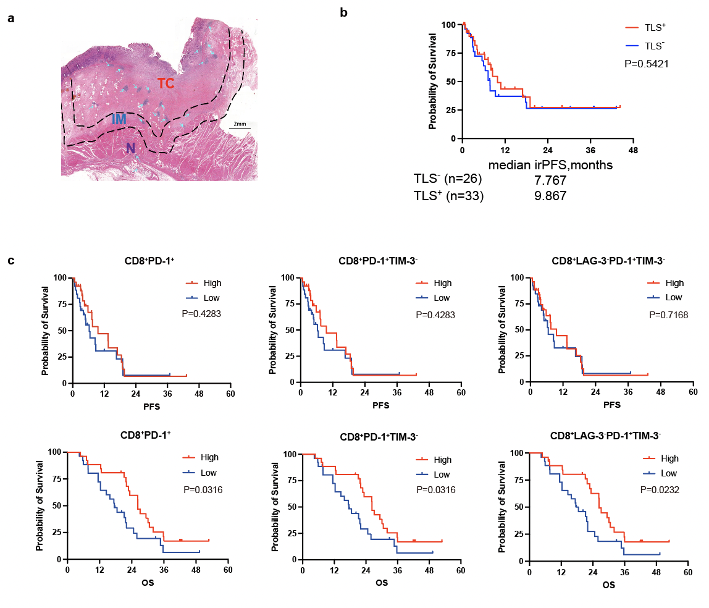
Supplementary Fig. 1. The presence of TC-TLS and CD8⁺PD-1⁺ T cells within TC-TLS are associated with a favorable prognosis.
(a) Selection of the regions of interest (ROIs) in representative images of haematoxylin and eosin (H&E)-stained formalin-fixed paraffin-embedded tissues. TC, tumour core; IM, invasion margin; N, normal tissue. Scale bar: 2 mm.
(b) Kaplan–Meier survival curves for irPFS of patients with and without TLS in the tumour core.
P-values are two sided.
(c) PFS and OS of patients with GC based on the density of tumour-infiltrating immune cells (TIICs). The individual TIICs were divided into high (>half of the patients; red line) or low density (≤half of patients; blue line). The log-rank (Mantel–Cox) test was used. A two-sided P < 0.05 was considered statistically significant.
GC, gastric cancer; TLS, tertiary lymphoid structure; irPFS, immune-related progression-free survival; PFS, progression-free survival; OS, overall survival.
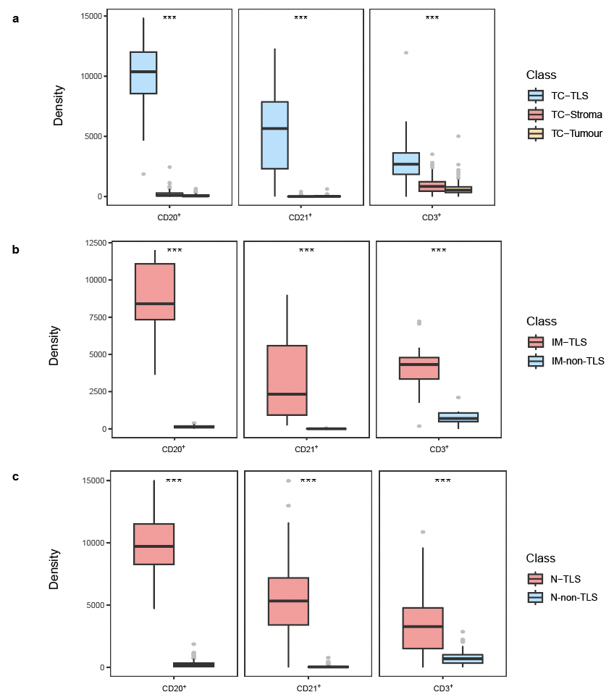
Supplementary Fig. 2. The immune composition inside and outside TLS in different regions.
(a–c). The density of main cell types of tumour core (a), invasion margin (b) and normal tissue (c). Box and whiskers represent mean ± 10–90 percentile. Three groups were compared: Kruskal–Wallis test with Dunn’s multiple comparison test. Two groups were compared: Wilcox test. Each point represents one patient. *p < 0.05, **p < 0.01, ***p < 0.001 and not significant (ns).
TLS, tertiary lymphoid structure; TC-TLS, TLS in the tumour core; TC-stroma, stromal regions in the tumour core; IM-TLS, TLS in the invasion margin; IM-Non-TLS, invasion margin excluding TLS; N-TLS, TLS in normal tissue; N-Non-TLS, normal tissue excluding TLS. TLS, tertiary lymphoid structure.

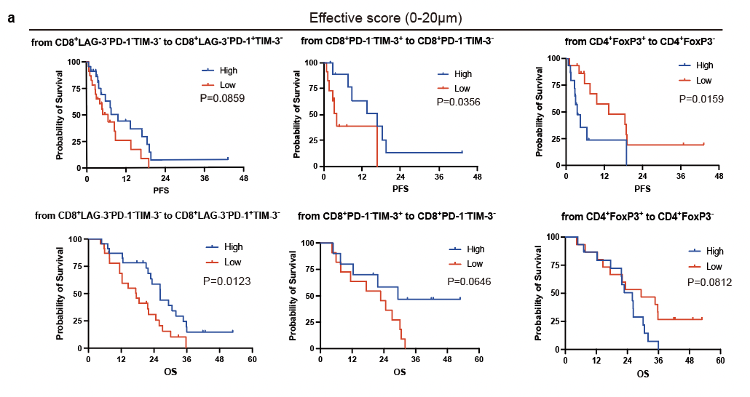
Supplementary Fig. 3. Survival analysis based on the effective scores.
(a) PFS and OS of patients with GC based on the effective scores of tumour-infiltrating immune cells (TIICs). The effective scores were divided into high (>half of the patients; red line) or low density (≤half of patients; blue line). Log-rank (Mantel–Cox) test was used. A two-sided p < 0.05 was considered statistically significant.
PFS, progression-free survival; OS, overall survival.

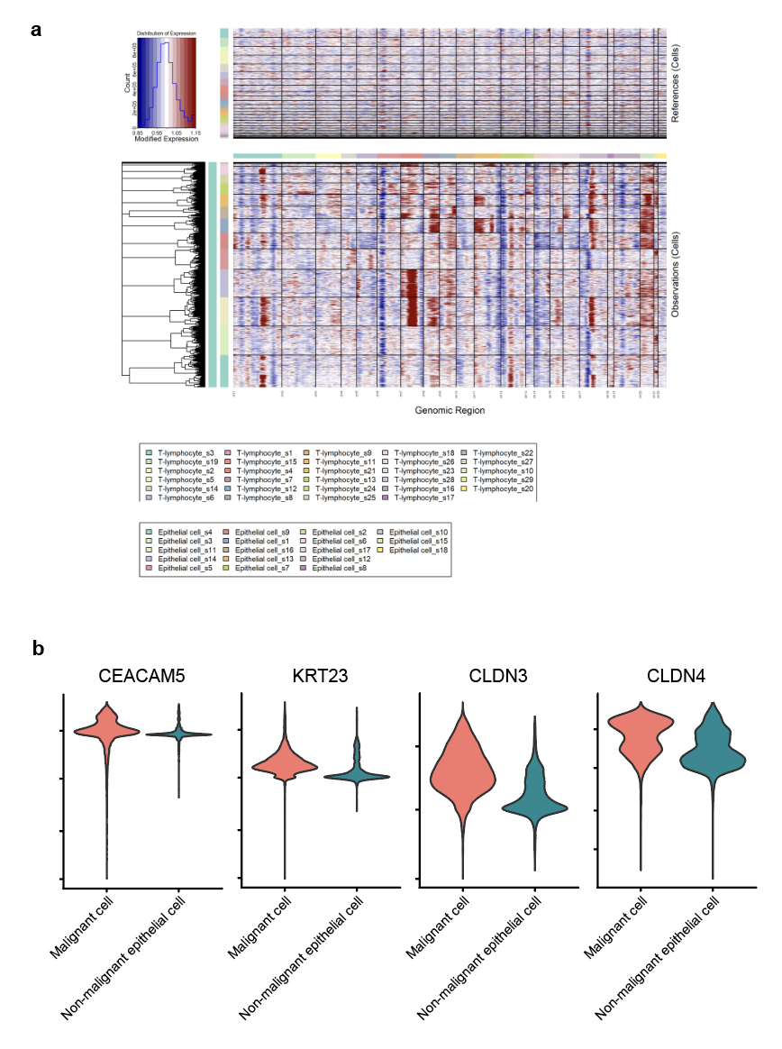
Supplementary Fig. 4. Malignant epithelial cells identified by CNV levels.
- The hierarchical heatmap showing large-scale CNVs in tumour lesions.
- Violin plots for marker genes of cancer cells (CEACAM5, KRT23, CLDN3, and CLDN4).

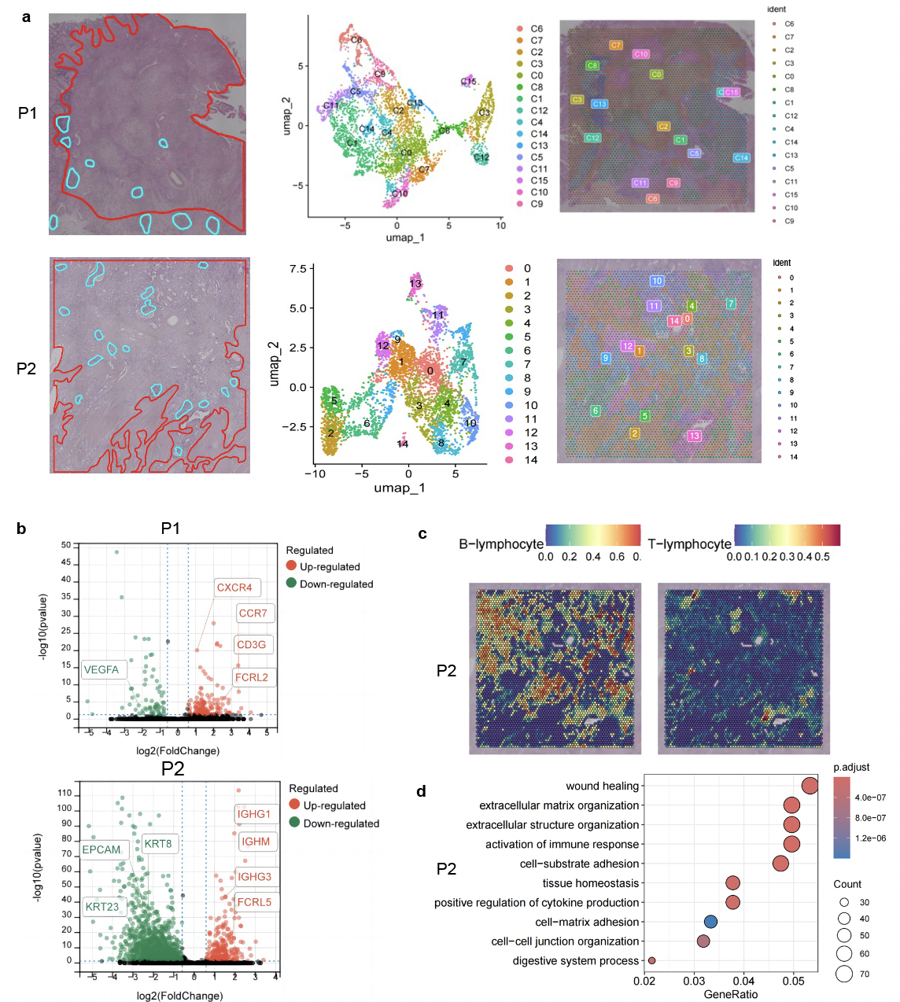
Supplementary Fig. 5. Spatial transcriptomic suggests a “hot” TME in GC.
(a) Left to right: Haematoxylin and eosin (H&E) stained tissues which are delineated into tumour (red) and TLS (blue), UMAP of the cluster identities, spatial distribution of the clusters in two cases of GC undergoing spatial transcriptomic sequencing.
(b) Volcano plot displayed the differentially expressed genes (DEGs) in TLS than the tumour regions.
(c) Spatial feature plots of signature score of B cells, and T cells in P2.
(d) Gene ontology (GO) analysis showing enriched biological process terms of DEGs in TLS than the tumour regions in P2. GC, gastric cancer; TLS, tertiary lymphoid structure; UMAP, Uniform Manifold Approximation and Projection.
Supplementary Tables
Supplementary Table 1. The baseline characteristics of 110 gastric adenocarcinoma patients
Characteristic | Total  (N=110)
Age at diagnosis
<65 | 59 (53.6)
≥65 | 51 (46.4)
Gender
Male | 68 (61.8)
Female | 42 (38.2)
Stage at diagnosis
I | 2 (1.8)
II | 4 (3.6)
III | 29 (26.4)
IV | 75 (68.2)
Tumor differentiation
High | 15 (13.6)
Moderate | 39 (35.5)
Poor | 52 (47.3)
Unknown | 4 (3.6)
Lauren classification
Intestinal type | 50 (40.7)
Mixed type | 23 (25.4)
Diffused type | 34 (30.5)
Unknown | 3 (3.4)
Location
GEJ | 63 (57.3)
Non-GEJ | 47 (42.7)
HER2 expression
Positive | 20 (18.2)
Negative | 90 (81.8)
EBER expression
Positive | 6 (5.5)
Negative | 101 (91.8)
Unknown | 3 (2.7)
Microsatellite status
Microsatellite instability (MSI) | 12 (10.9)
Microsatellite-stable (MSS) | 98 (89.1)
PD-L1 CPS
CPS<1 | 41 (37.3)
1≤CPS<5 | 15 (13.6)
5≤CPS<10 | 12 (10.9)
CPS>10 | 38 (34.5)
Unknown | 4 (3.6)
Line of therapy
1 | 61 (55.5)
≥2 | 49 (44.5)

Abbreviations: GEJ, gastro-esophageal junction; EGFR, epidermal growth factor receptor; HER2, human epidermal growth factor receptor 2; CPS, combined positive score; PD-1, programmed cell death protein 1; PD-L1, programmed death-ligand 1.

Supplementary Table 2. The baseline characteristics of gastric adenocarcinoma patients in spatial transcriptomic cohort(N=2)
Patient ID | Sex | Age | Location of the primary tumor | Lauren Classification | Differential
Patient 1 | Male | 42 | Non-GEJ | Diffuse | Low
Patient 2 | Male | 54 | Non-GEJ | Intestinal | Moderate
Abbreviations: GEJ, gastro-esophageal junction; TLS, tertiary lymphoid structure.

Supplementary Table 3. The baseline characteristics of gastric adenocarcinoma patients in single-cell sequencing cohort(N=12)
Patient ID | Sex | Age | Location of the primary tumor | Lauren Classification | Differential | Presence of TLS
Patient 1 | Male | 64 | Non-GEJ | Mixed | Low | Yes
Patient 2 | Male | 68 | Non-GEJ | Diffuse | Low | No
Patient 3 | Male | 76 | GEJ | Diffuse | / | Yes
Patient 4 | Female | 71 | GEJ | Intestinal | Low | No
Patient 5 | Male | 65 | GEJ | Intestinal | Moderate | No
Patient 6 | Male | 76 | GEJ | Intestinal | Moderate | No
Patient 7 | Male | 73 | GEJ | Intestinal | Moderate | No
Patient 8 | Male | 60 | GEJ | Intestinal | Low | No
Patient 9 | Male | 76 | GEJ | Intestinal | Low | No
Patient 10 | Male | 78 | Non-GEJ | Intestinal | Low | Yes
Patient 11 | Male | 61 | Non-GEJ | Mixed | Low | No
Patient 12 | Female | 72 | Non-GEJ | Mixed | Low | Yes
Abbreviations: GEJ, gastro-esophageal junction; TLS, tertiary lymphoid structure.

Supplementary Table 4. Summary of primary antibodies and secondary antibody used for multiplex immunohistochemistry.
Antibodies | Source | Identifier | Dilution
CD8 | Cell Signaling Technology | CST70306 | 1:400
LAG-3 | Cell Signaling Technology | CST15372 | 1:200
TIM-3 | Cell Signaling Technology | CST45208 | 1:300
PD-1 | Cell Signaling Technology | CST86163 | 1:200
PanCK | Cell Signaling Technology | CST4545 | 1:500
CTLA-4 | Abcam | ab237712 | 1:200
CD4 | Biolynx | BX22300130 | 1:2000
FoxP3 | Biolegend | BLG320202 | 1:80
PD-L1 | Cell Signaling Technology | CST13684 | 1:800
STING | Cell Signaling Technology | CST13647 | 1:2000
CD68 | ZSGB-BIO | ZM0060 | 1:500
CD163 | Cell Signaling Technology | CST93498 | 1:500
CD86 | Cell Signaling Technology | CST91882 | 1:200
CD66b | Gene Tex | GTX19779 | 1:400
CD21 | Abcam | ab75985 | 1:1000
CD56 | Cell Signaling Technology | CST3576 | 1:200
CD20 | Abcam | ab78237 | 1:1000
CD3 | Abcam | ab135372 | 1:400
α-SMA | Abcam | ab5694 | 1:400
FAP-α | Abcam | ab207178 | 1:500
Horseradish-peroxidase-conjugated anti-rabbit and anti-mouse antibody | PANOVUE | 10013001050

