VACmap: An Accurate Long-Read Aligner for Unraveling Complex Genomic Rearrangements

Dataset | Method | Run time(Hour) | Peak memory usage (GB)
Pacbio CLR 69X | VACmap | 6.2 | 13.5
Pacbio CLR 69X | NGMLR | 24 | 31
Pacbio CLR 69X | Winnowmap2 | 7.5 | 33
Pacbio CLR 69X | minimap2 | 3.3 | 29
Pacbio HiFi 30X | VACmap | 4.2 | 11.6
Pacbio HiFi 30X | NGMLR | 12 | 27
Pacbio HiFi 30X | Winnowmap2 | 4 | 24
Pacbio HiFi 30X | minimap2 | 1 | 24
ONT | VACmap | 5.8 | 14.7
ONT | NGMLR | 32 | 34
ONT | Winnowmap2 | 7.5 | 36
ONT | minimap2 | 3.5 | 33
Supplementary Table 1 The runtime and peak memory usage of the four mapping methods.

Tool | Purpose | Command
VACmap (v1.0) | Pacbio CLR or ONT read mapping  Pacbio CCS read mapping | vacmap -ref ref.fasta -read read.fasta -mode H -t 40 --markunbalancetra  vacmap -ref ref.fasta -read read.fasta -mode L -t 40 --markunbalancetra
minimap2 (v2.17) | Pacbio read mapping  ONT read mapping | minimap2 -t 40 -aYx map-pb ref.fasta read.fasta -o output.sam  minimap2 -t 40 -aYx map-ont ref.fasta read.fasta -o output.sam
winnowmap2 (v2.03) | Pacbio read mapping  ONT read mapping | winnowmap2 -t 40 -W repetitive k15.txt -aYx map-pb ref.fasta read.fasta -o output.sam  winnowmap2 -t 40 -W repetitive k15.txt -aYx map-ont ref.fasta read.fasta -o output.sam
NGMLR (v0.2.7) | Pacbio read mapping  ONT read mapping | ngmlr -t 40 -r ref.fasta -q read.fasta -o output.sam  ngmlr -t 40 -x ont -r ref.fasta -q read.fasta -o output.sam
SVIM (v1.4.2) | SV calling | svim alignment workdir sorted.bam ref.fasta --segment_overlap_tolerance 50
Truvari (v2.0.0) | SV evaluation | truvari bench -b base.vcf -c comp.vcf -o workdir --passonly -p 0 -P 0 -r 500 --multimatch
Supplementary Table 2 Command line parameter used for this study.

a
b
c
d
e
f
g
h
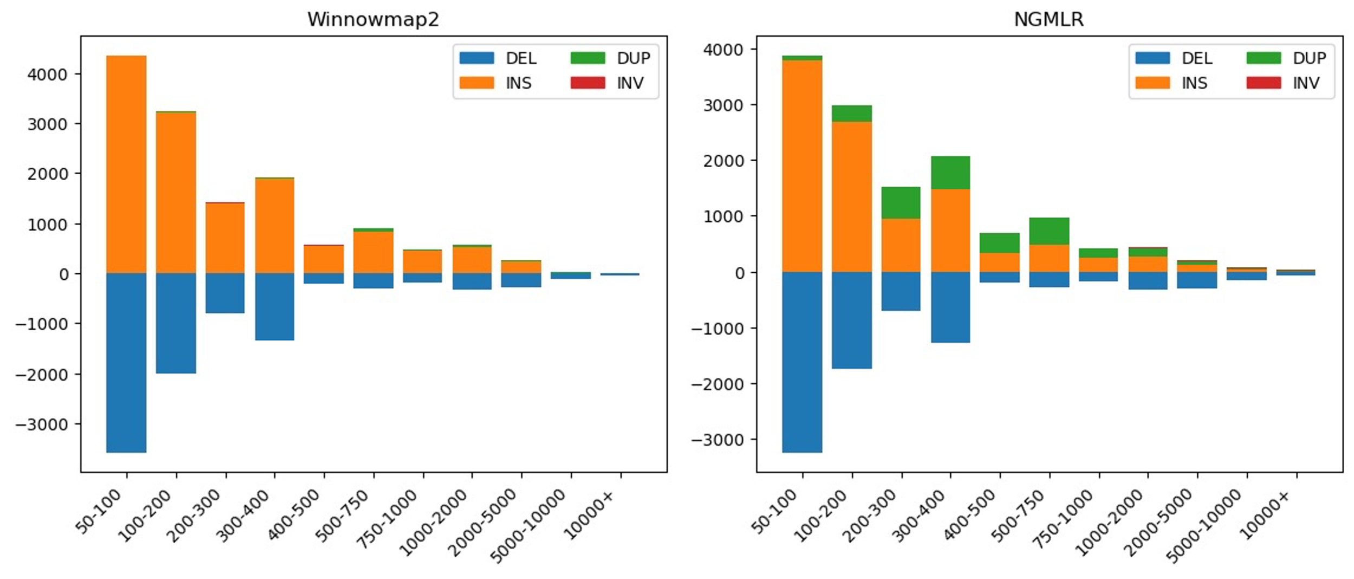
Supplementary Figure 1 The distribution of types and lengths among variants detected by SVIM on Winnowmap2 and NGMLR produced alignments.

Supplementary Figure 2 Characterization of a de novo VNTR in HG002 at chr14:23,280,711 (GRCh38). The VACmap alignments clearly show the de novo VNTR with different copy numbers in the child (HG002, n=5) and paternal parent (HG003, n=2) of the 109-bp repeat unit.

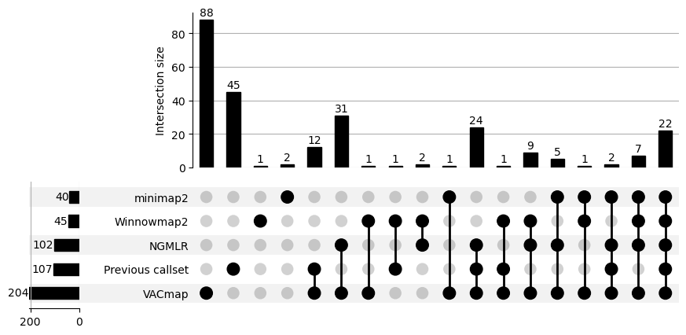
Supplementary Figure 3 The upset plot of inversion detected by SVIM on VACmap, NGMLR, Winnowmap2 and minimap2 produced alignments and previous reported inversion callset.

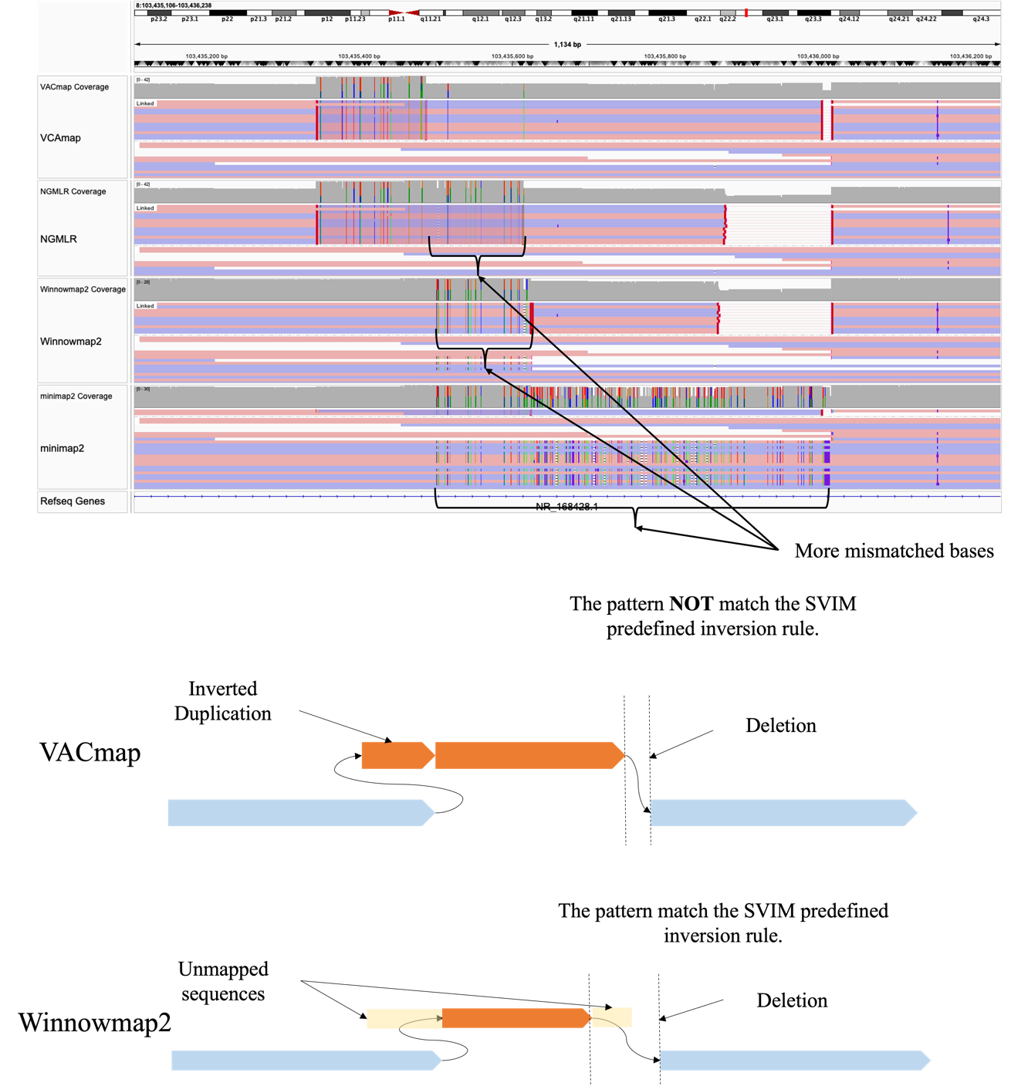
Supplementary Figure 4 A inversion missed by SVIM due to the inversion complexity (GRCh37). The VACmap-SVIM SV detection pipeline fails to identify this inversion because VACmap detected a more complex structure. VACmap's alignment suggests that the inversion is flanked by an inverted duplication and a deletion—an SV pattern that SVIM’s detection model is not designed to capture. This complex inversion pattern is also supported by NGMLR, though with less accuracy, as NGMLR's alignment indicates a higher number of mismatched bases compared to VACmap.

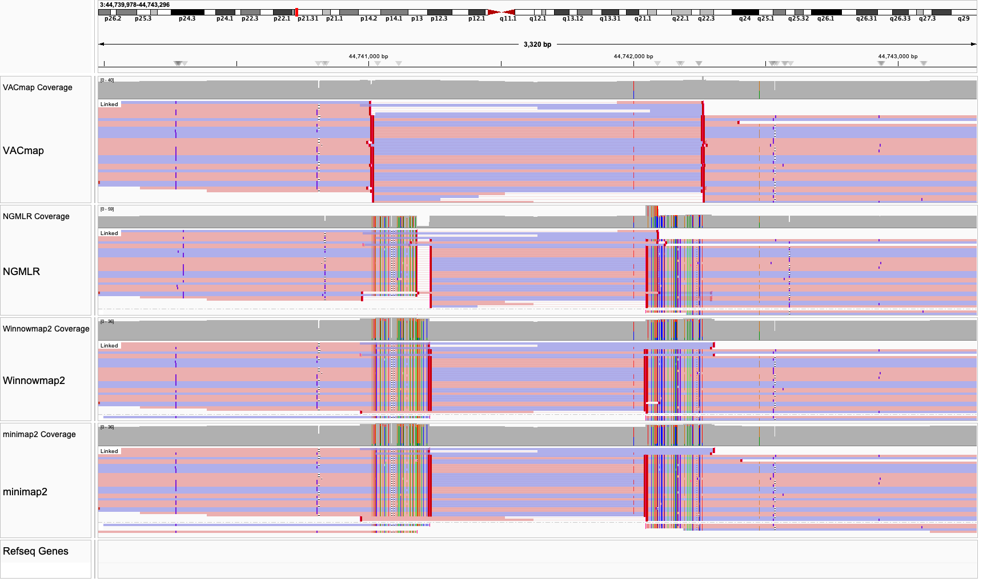
Supplementary Figure 5 VACmap precisely identifies inversion breakpoints and reduces alignment mismatches (GRCh37).

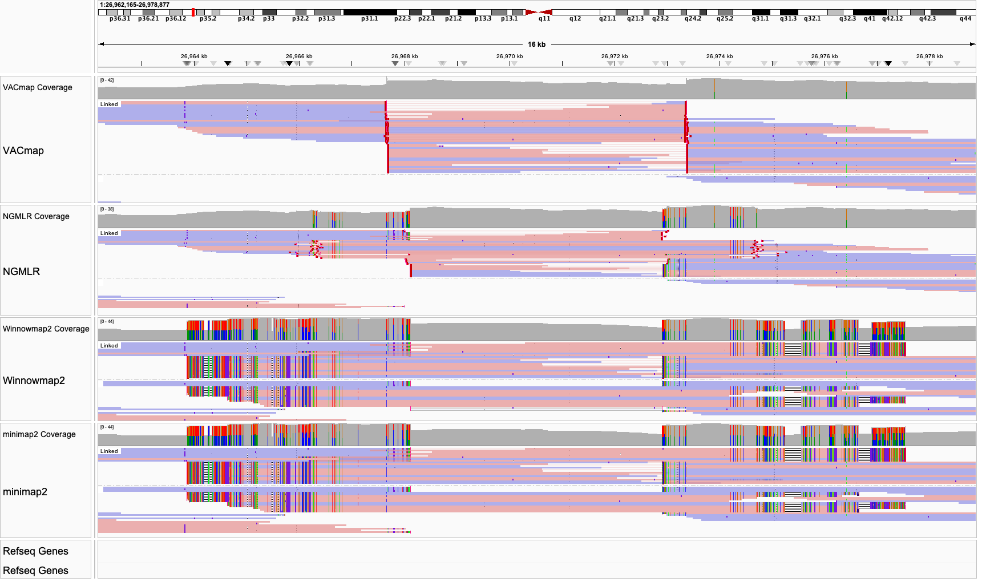
Supplementary Figure 6 VACmap precisely identifies inversion breakpoints and reduces alignment mismatches (GRCh37).

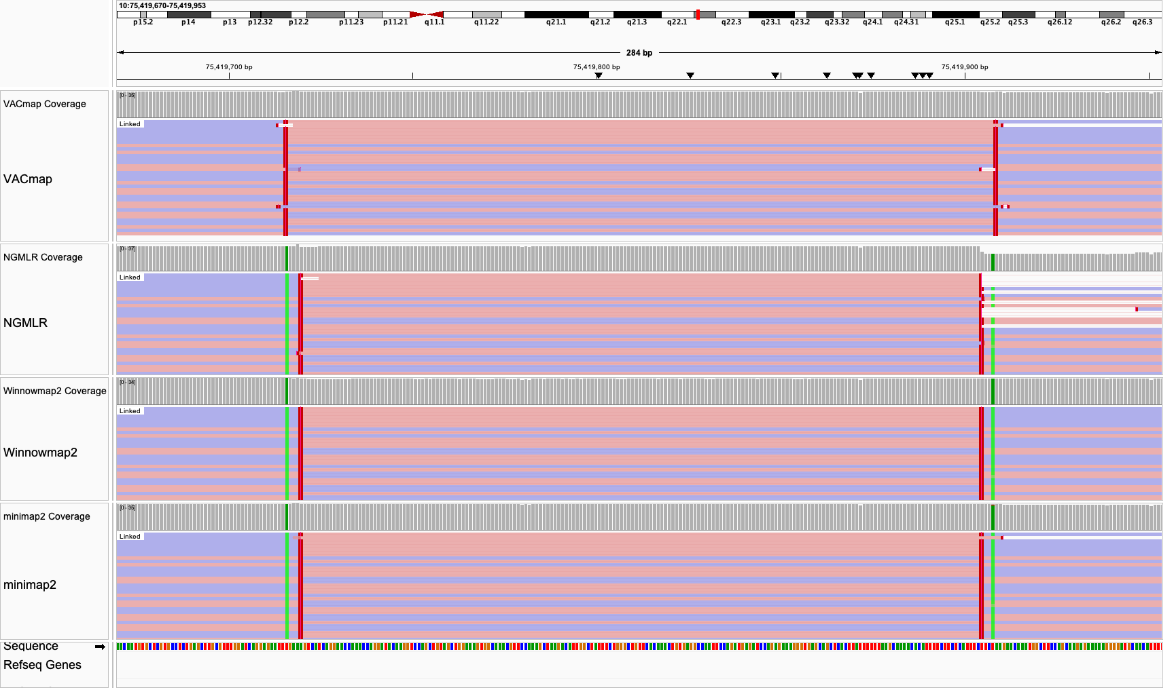
Supplementary Figure 7 VACmap precisely identifies inversion breakpoints and reduces alignment mismatches (GRCh37).

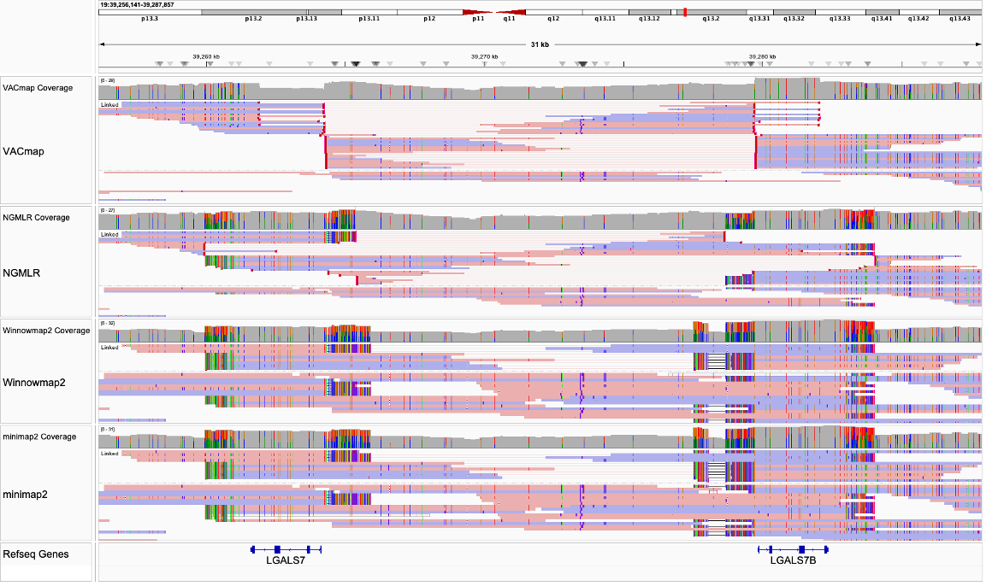
Supplementary Figure 8 VACmap precisely identifies inversion breakpoints and reduces alignment mismatches (GRCh37).

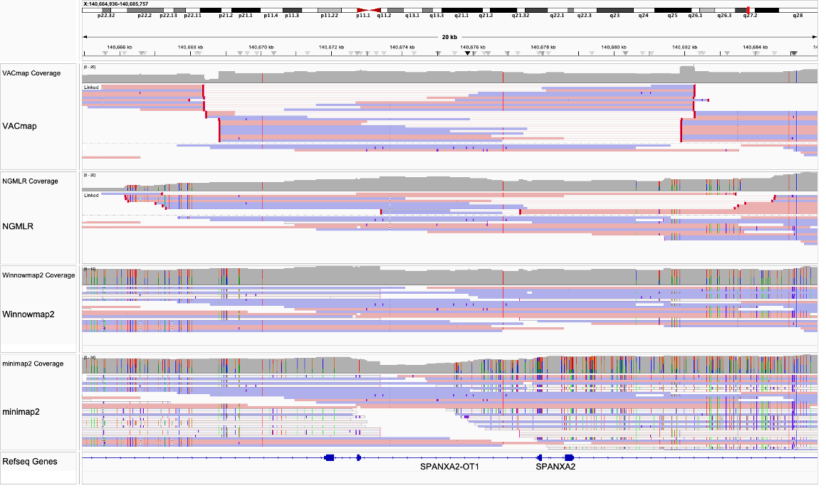
Supplementary Figure 9 VACmap precisely identifies inversion breakpoints and reduces alignment mismatches (GRCh37).

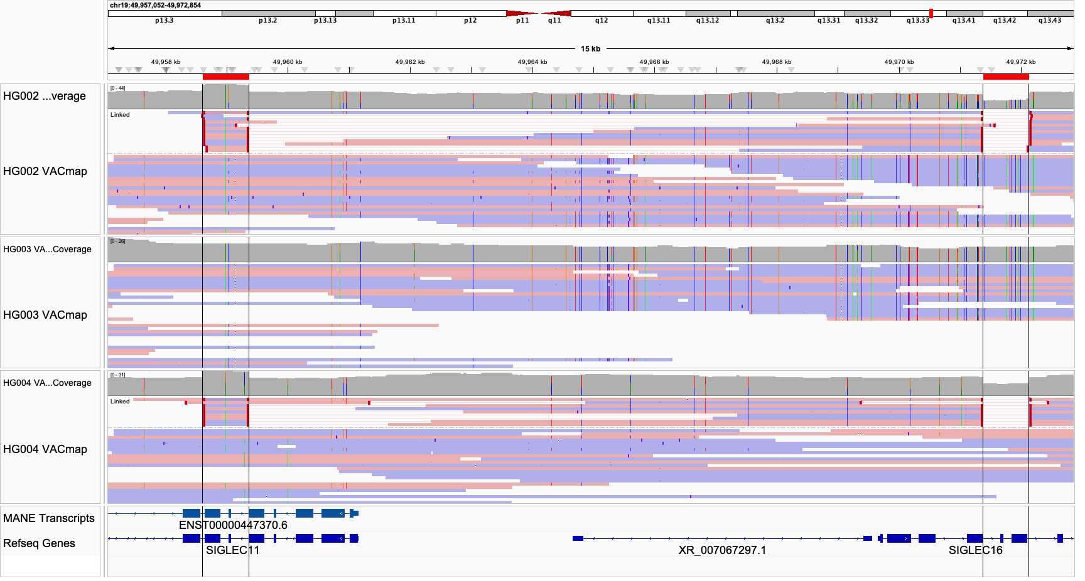
Supplementary Figure 10 Potential SIGLEC11 and SIGLEC16 gene conversion event in the maternal haplotype of HG002 (GRCh38).

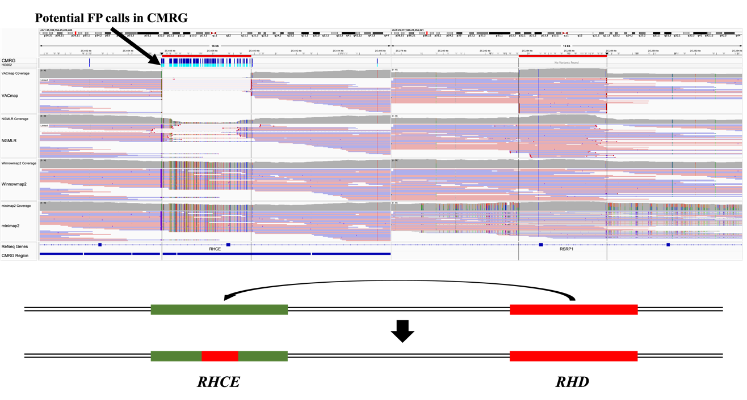
Supplementary Figure 11 VACmap accurately identifies a gene conversion event between RHCE and RHD in HG002 (GRCh38). This figure demonstrates VACmap's ability to precisely map a gene conversion event between the RHCE and RHD genes in HG002. The VACmap alignment clearly delineates the boundaries of the gene conversion region, which would be challenging to detect using standard alignment approaches.

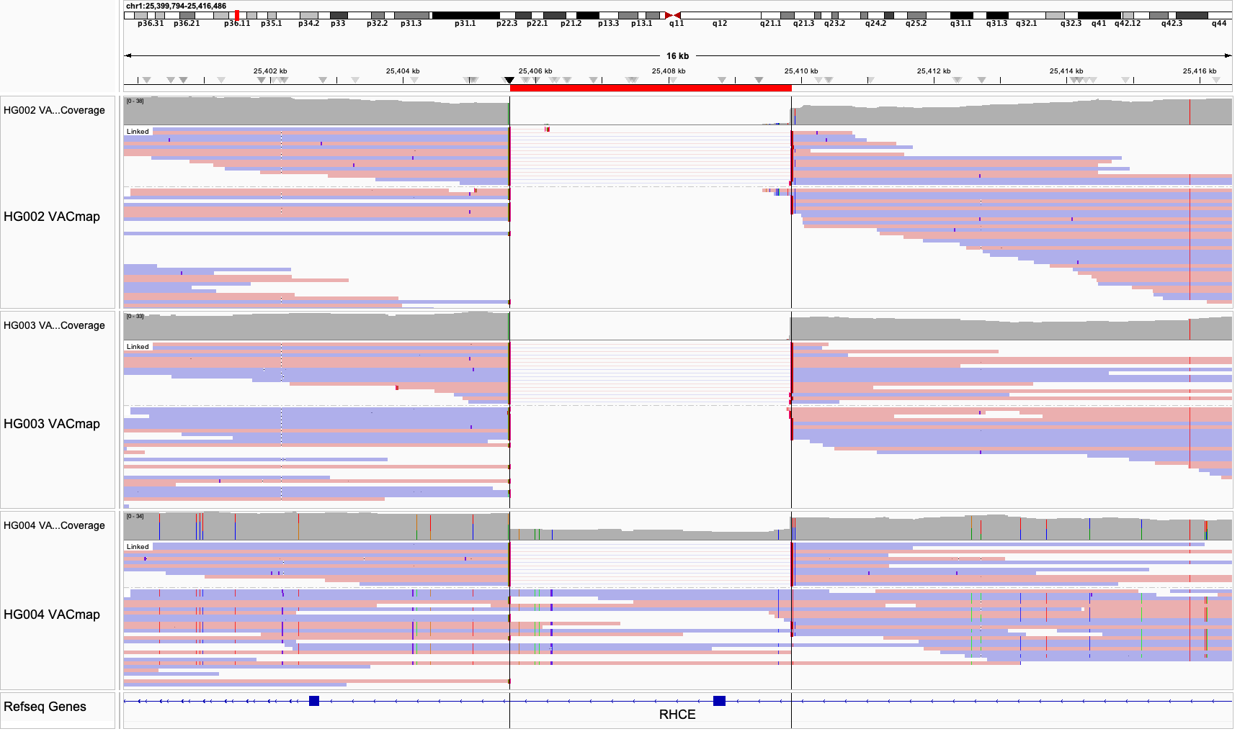
Supplementary Figure 12 VACmap identifies RHCE::RHD gene conversion events in HG002, HG003, and HG004 (GRCh38).
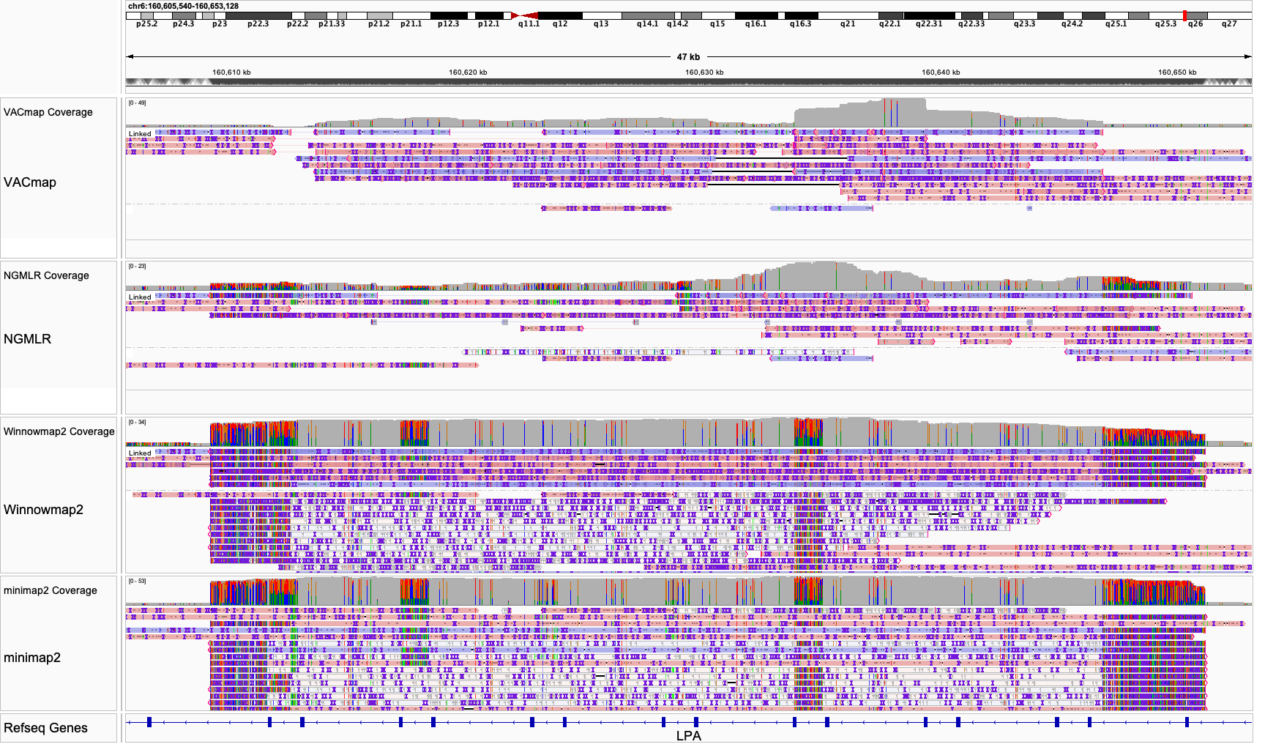
Supplementary Figure 13 The IGV visualization of CHM13 ONT alignments produced by four aligners under GRCh38 reference in the KIV-2 region (GRCh38).

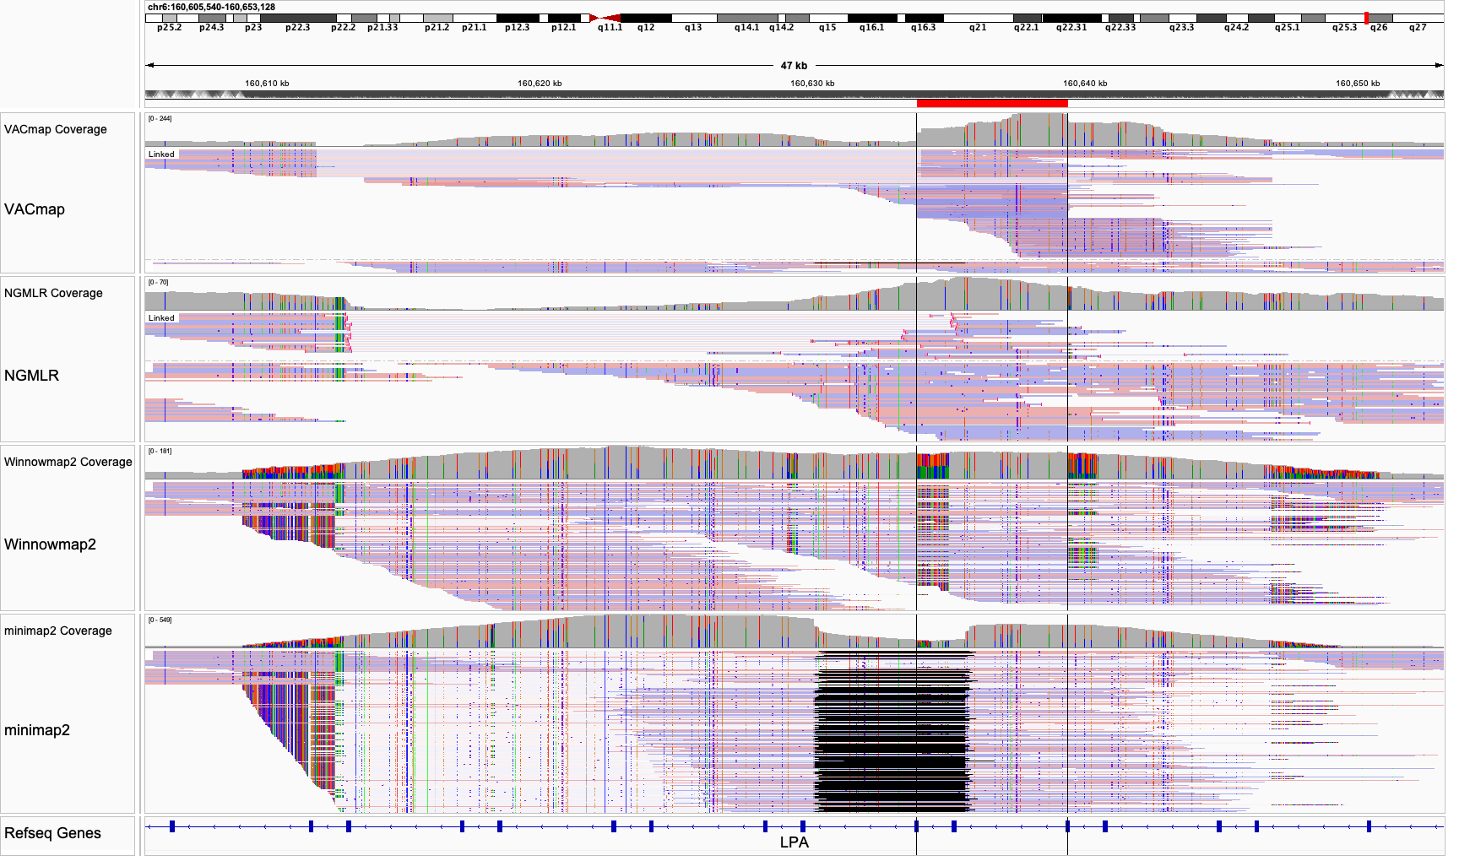
Supplementary Figure 14 The IGV visualization of HG002 HiFi alignments produced by four aligners under GRCh38 reference in the KIV-2 region (GRCh38).

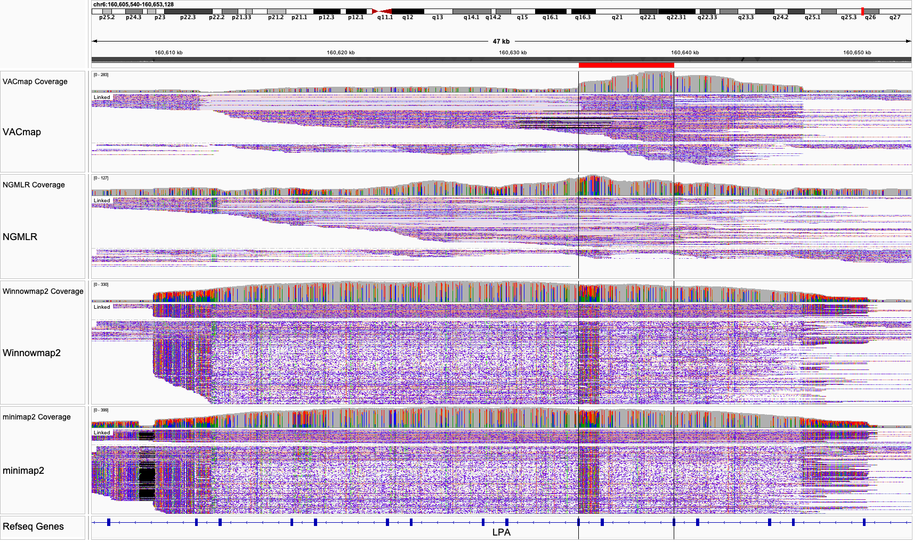
Supplementary Figure 15 The IGV visualization of HG002 ONT alignments produced by four aligners under GRCh38 reference in the KIV-2 region (GRCh38).

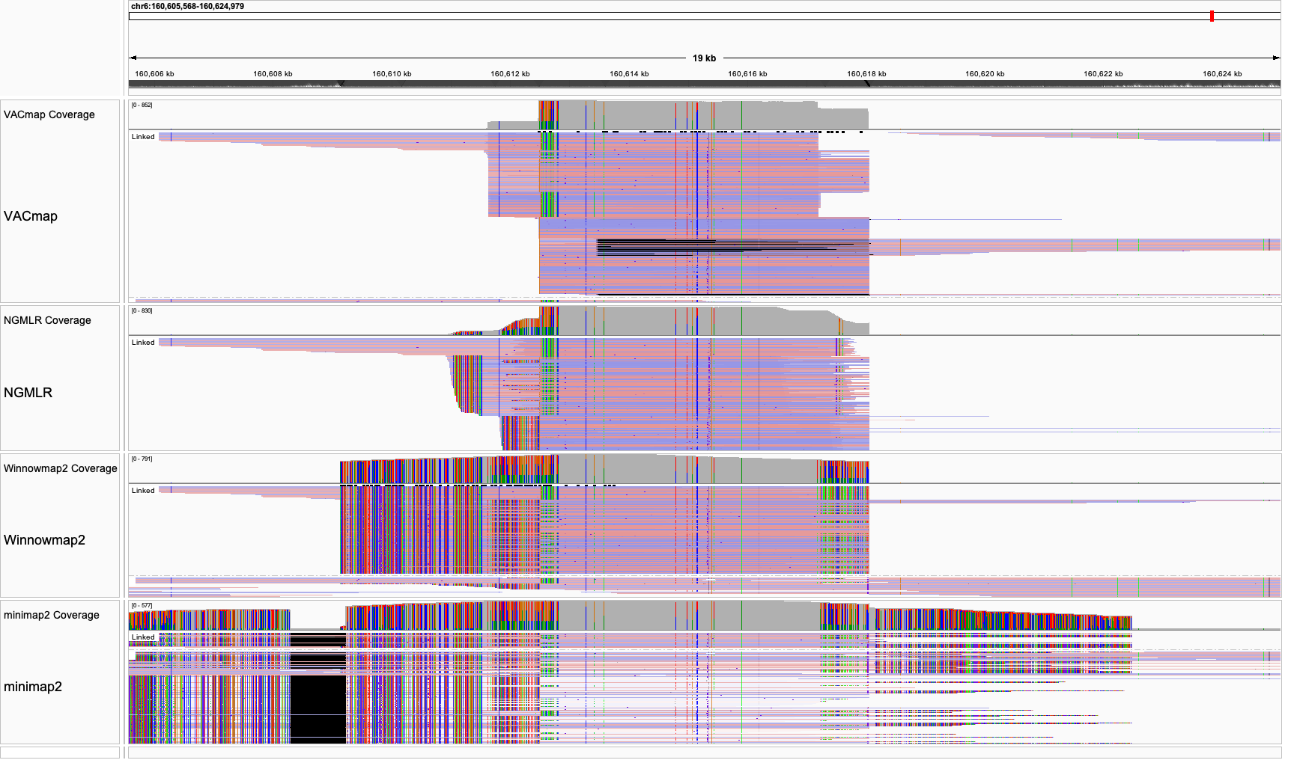
Supplementary Figure 16 The IGV visualization of CHM13 HiFi alignments produced by four aligners under modified GRCh38 reference in the KIV-2 region.

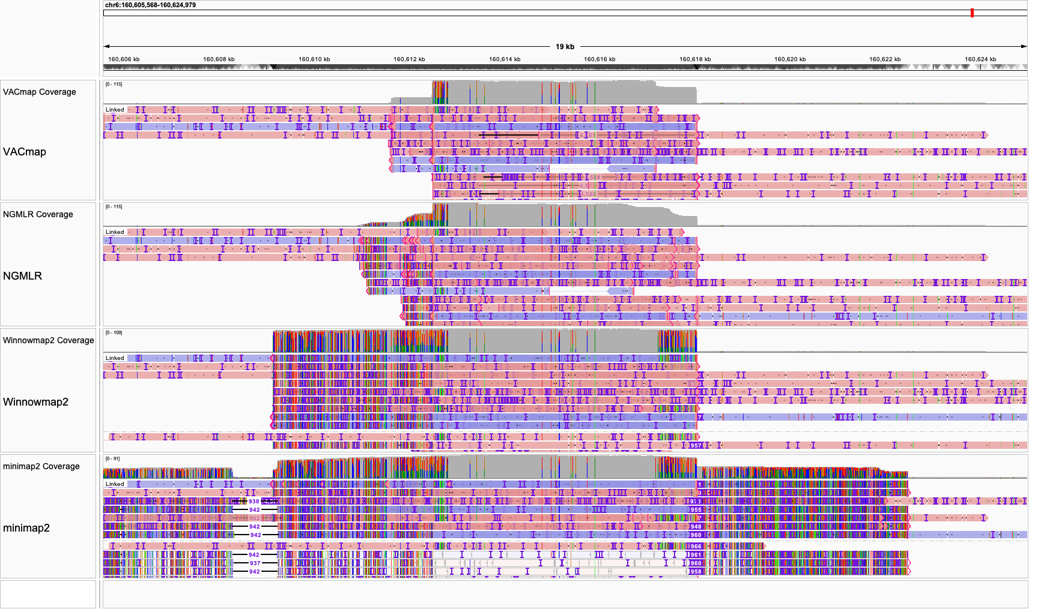
Supplementary Figure 17 The IGV visualization of CHM13 ONT alignments produced by four aligners under modified GRCh38 reference in the KIV-2 region.
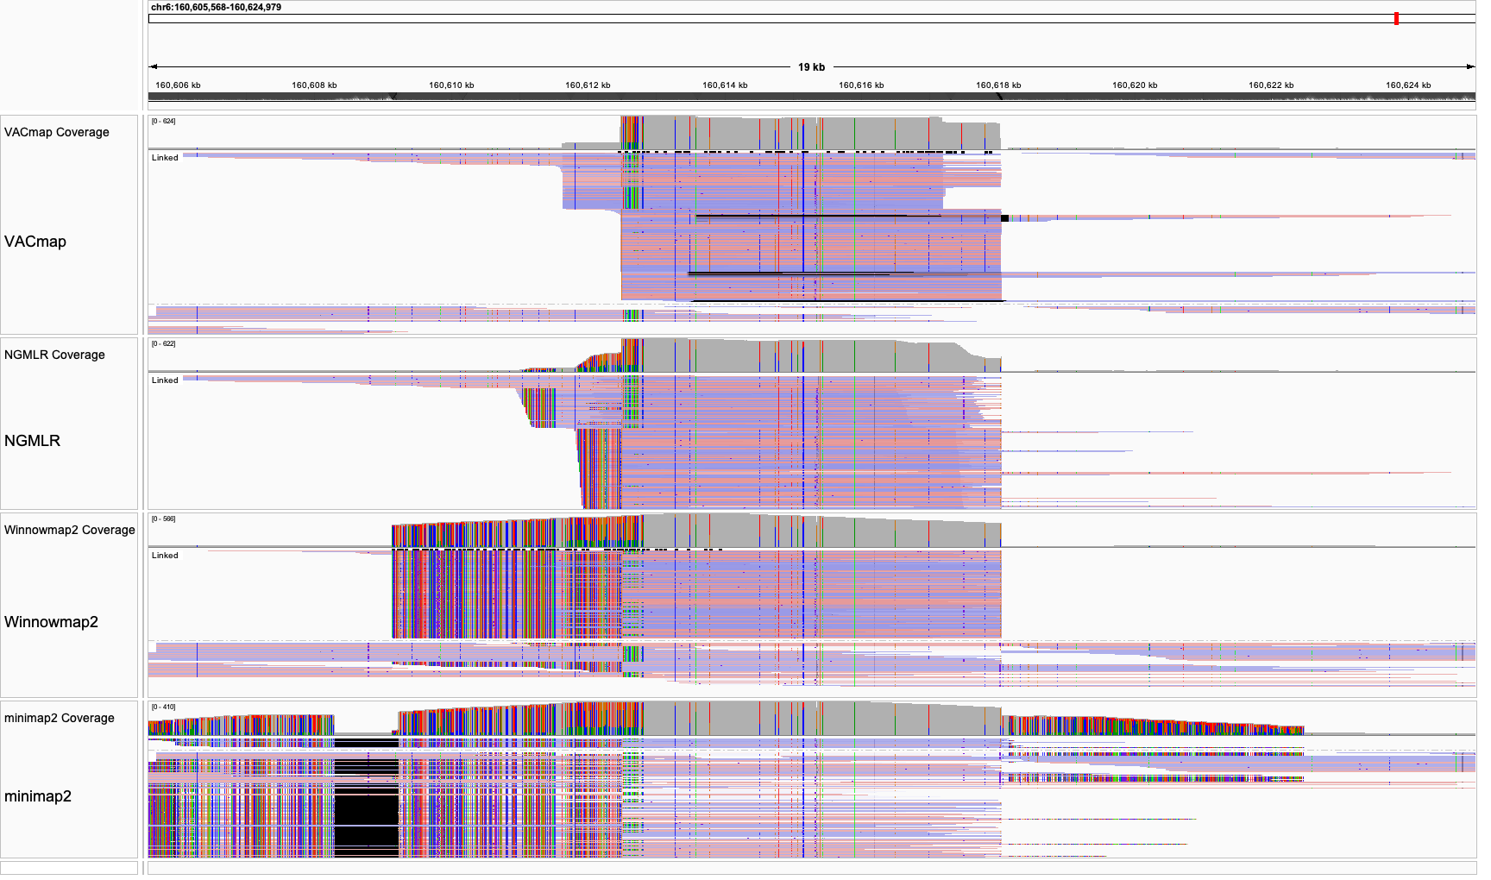
Supplementary Figure 18 The IGV visualization of HG002 HiFi alignments produced by four aligners under modified GRCh38 reference in the KIV-2 region.
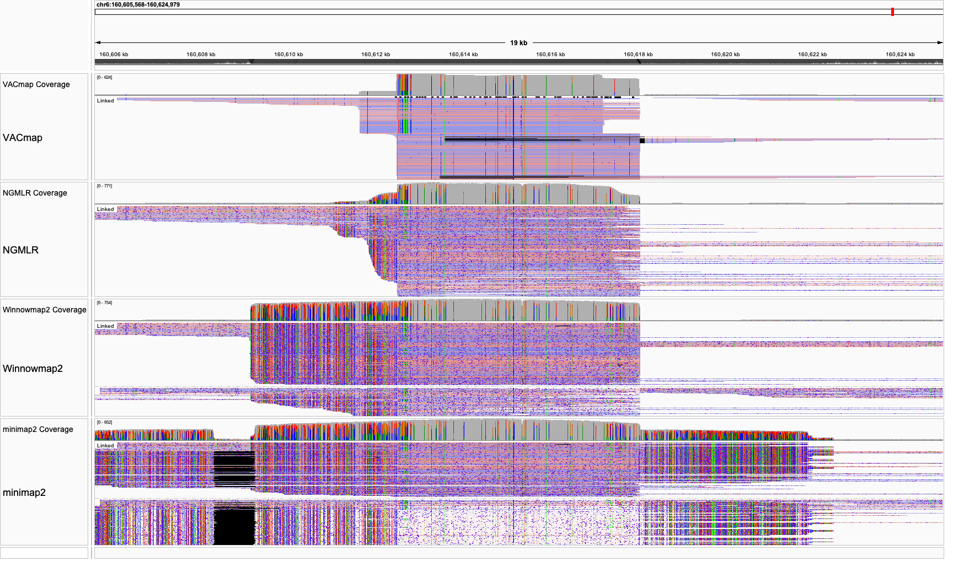
Supplementary Figure 19 The IGV visualization of HG002 ONT alignments produced by four aligners under modified GRCh38 reference in the KIV-2 region.
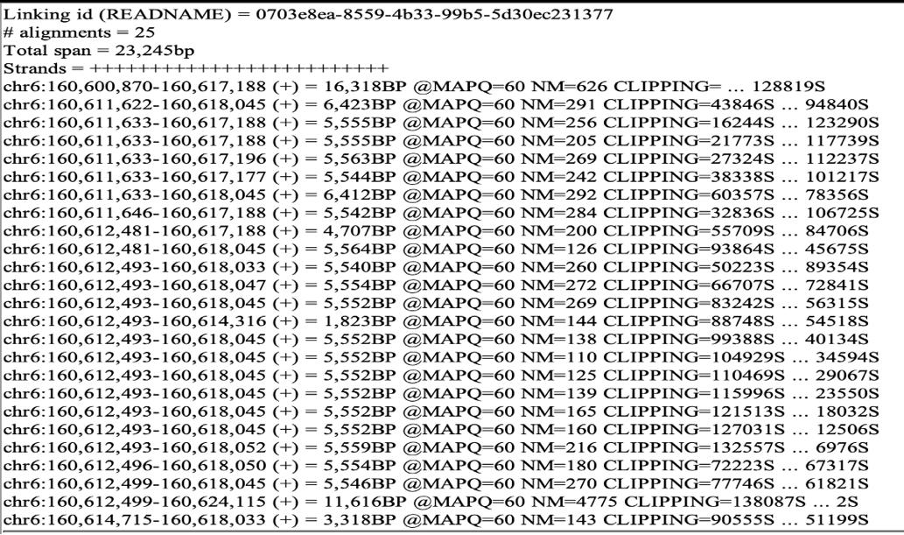
Supplementary Figure 20 The alignment detail of an ONT long read from CHM13 human sample resolved all 23 KIV-2 repeat units.

Supplementary Figure 21 The Examples for assigning normal (blue) or variation (red) edges in different scenarios.

