Supporting information
Synthesis of lipophilic gold nanorod superparticles and their size-dependent SERS performances
Gui-Lin Wu¹, Tian-Song Deng^{1,*}, Kun-Peng Wang¹, Er-Ji Zhang¹, Li-Yong Liu¹, Yu-Chun Cheng¹, Jia-Fei Gao¹, and Jie Liu¹
¹School of Electronics and Information Engineering, Hangzhou Dianzi University, Hangzhou 310018, P. R. China
* Corresponding author. E-mail: dengts@pku.edu.cn

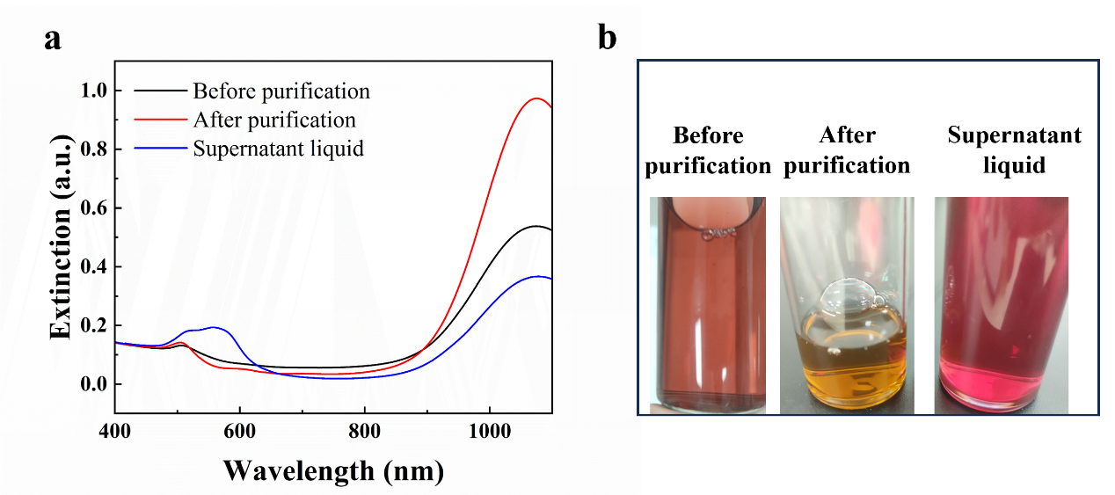
Figure S1 Extinction spectra characterization and physical comparison of gold nanorods before and after purification. (a) Extinction spectra of gold nanorods before purification (black), after purification (red), and the supernatant (blue). (b) Physical comparison of gold nanorods before purification, after purification, and the supernatant.
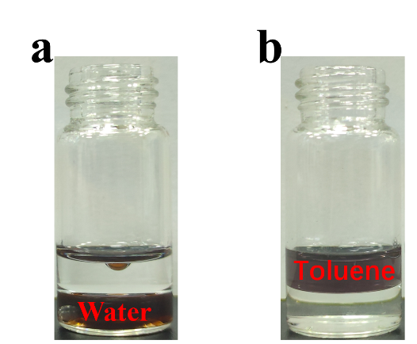
Figure S2 Comparison of Au-(CTAB) Aqueous Solution and Au-(PS-SH) Toluene Solution. (a) The upper layer is toluene, and the lower layer is the Au-(CTAB) aqueous solution. (b) The upper layer is the Au-(PS-SH) toluene solution. The distinct phase separation indicates that the surface modification of the gold nanorods was successful.

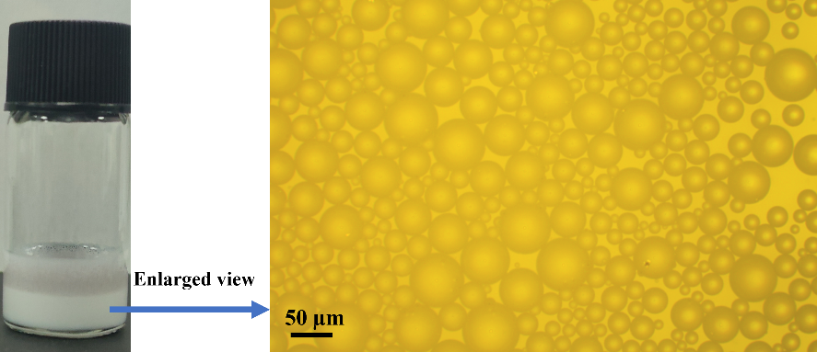
Figure S3 Microscope images of the water-in-toluene emulsions formed after ultrasonic mixing of toluene and water.

Figure S4 Comparison of SERS test results of superparticles using different dyes.

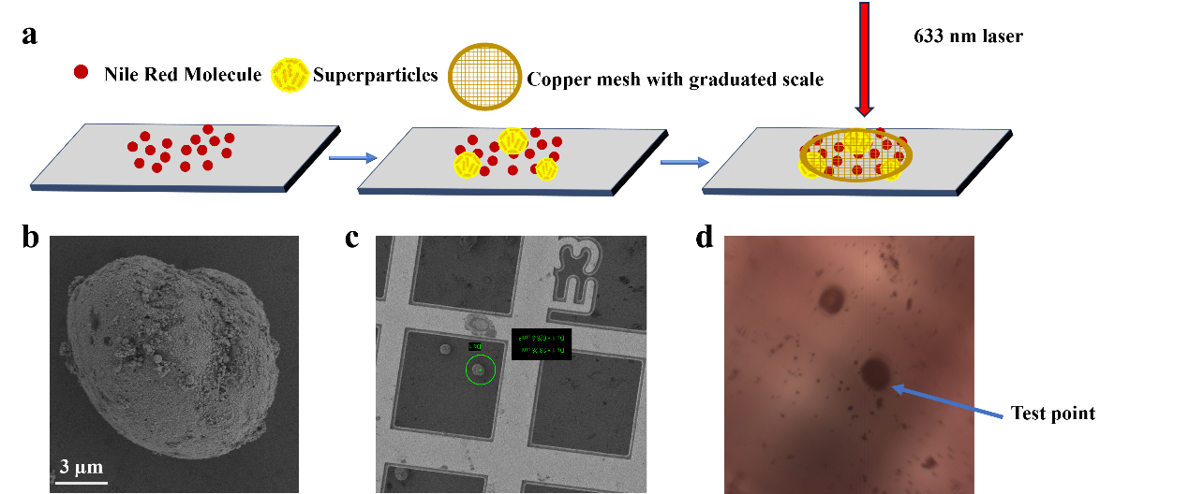
Figure S5 Localized SERS testing of superparticles. (a) Schematic illustration of the localized testing steps. First, Nile red dye is dropped onto a clean silicon wafer. After drying, a superparticle aqueous solution is added. After drying again, a copper grid with scales is placed on top for testing. (b) Scanning electron microscope (SEM) image of superparticles. (c) Magnified SEM image showing the copper grid scales clearly. (d) Optical microscope image taken during the actual testing.

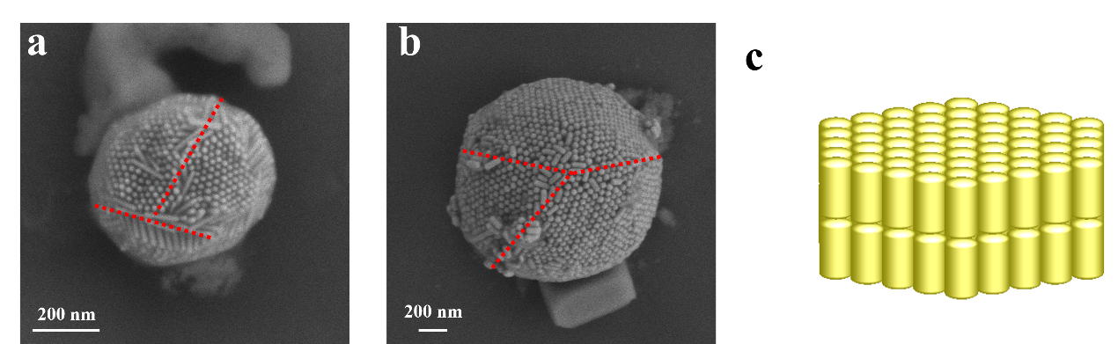
Figure S6 SEM images of superparticles and simulation structures. The image reveals many regions with gold nanorod arrays. This observed structure was used as the basis for designing the FDTD simulation structure.

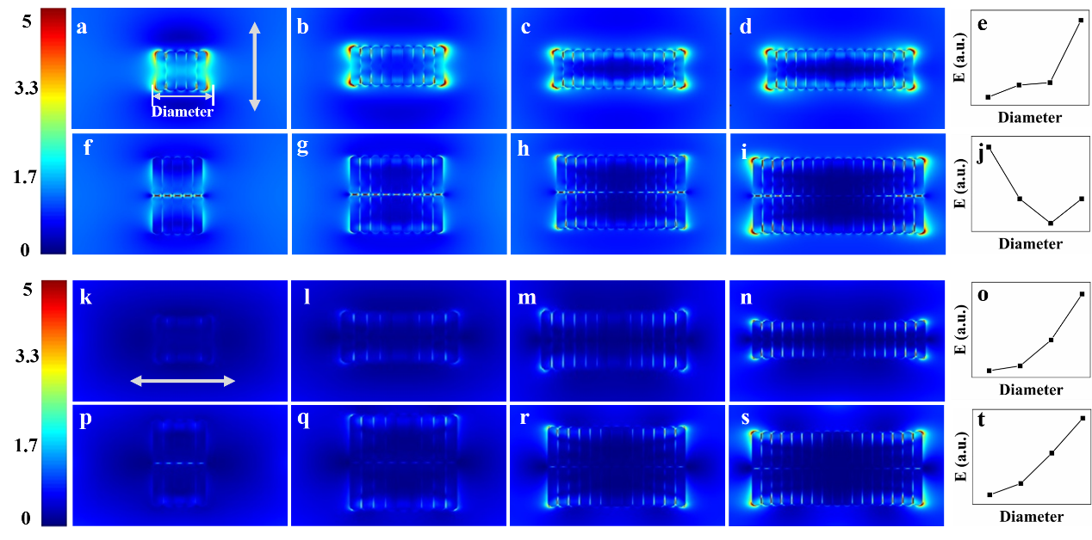
Figure S7 FDTD simulations of the electric field intensity in specific regions of superparticles. (a)-(d) Increasing number of GNRs in a single layer. (e) Graph of the relationship between diameter and electric field intensity. (f)-(i) Increasing number of GNRs in two layers. (j) Graph of the relationship between diameter and electric field intensity.(k)-(t) Same structures as (a)-(j) but with a different light polarization direction. In (a)-(j), the polarization direction of the light is parallel to the longitudinal axis of the gold nanorods, while in (k)-(t), the polarization direction is perpendicular to the longitudinal axis of the gold nanorods.

Table S1 Table of specific values for the size of superparticles assembled from lo-GNRs and the corresponding Raman signal intensity of Nile red.
Superpartical Diameter (µm) | Nile Red Raman signal strength
0.66 | 1090
0.87 | 3000
1.12 | 4300
1.32 | 7000
1.54 | 15000
2.7 | 22500
4.2 | 35000
4.76 | 75000
8 | 160000
9.35 | 200000

Table S2 Table of specific values for the size of superparticles assembled from hi-GNRs and the corresponding Raman signal intensity of Nile red.
Superpartical Diameter (µm) | Nile Red Raman signal strength
0.62 | 160
0.67 | 250
0.68 | 525
0.85 | 1400
1.24 | 4900
2.28 | 11000
2.57 | 12000
3.72 | 25000
6.1 | 30000
6.91 | 47250

Table S3 The highest electric field intensities simulated for each structure in Figure 5.
Number | Highest electric field strength | Number | Highest electric field strength
5a | 10.1 | 5f | 23.2
5b | 10.2 | 5g | 21.5
5c | 9.1 | 5h | 21.1
5d | 10.7 | 5i | 26.5

Number | Highest electric field strength | Number | Highest electric field strength
5k | 2 | 5p | 3.7
5l | 2.3 | 5q | 4.1
5m | 4 | 5r | 8.6
5n | 7.2 | 5s | 13.7

Table S4 The highest electric field intensities simulated for each structure in Figure S7.
Number | Highest electric field strength | Number | Highest electric field strength
S7a | 6.8 | S7f | 14.1
S7b | 8.01 | S7g | 12.2
S7c | 8.26 | S7h | 11.3
S7d | 14.5 | S7i | 12.2

Number | Highest electric field strength | Number | Highest electric field strength
S7k | 1.96 | S7p | 2.4
S7l | 2.29 | S7q | 4.07
S7m | 4.06 | S7r | 8.55
S7n | 7.19 | S7s | 13.7

