Supplementary Information

S_{N}2-Mediated Decoupled Precursor Provision Enables Large-Scale Production of Monodisperse Lead Halide Perovskite Quantum Dots in a Single Reactor

Jigeon Kim,^{1,2} Woongchan Kim,^{3,4} Jin Il Jang,² Wooyeon Kim,¹ Doheon Yoo,⁵ Min-Jae Choi,⁵ Jongmin Choi,⁶ Hyung Min Kim,² Sung Beom Cho,^{3,4} Min Jae Ko,^{1,7,}* and Younghoon Kim^{2,}*
¹ Department of Chemical Engineering, Hanyang University, Seoul, 04763, Republic of Korea
²Department of Chemistry, Kookmin University, Seoul, 02707, Republic of Korea
³Department of Materials Science and Engineering, Ajou University, Suwon, 16499, Republic of Korea
⁴Department of Energy Systems Research, Ajou University, Suwon, 16499, Republic of Korea
⁵Department of Chemical and Biochemical Engineering, Dongguk University, Seoul, 04620, Republic of Korea
⁶Department of Energy Science and Engineering, Daegu Gyeongbuk Institute of Science and Technology (DGIST), Daegu, 42988, Republic of Korea
*Correspondence:
mjko@hanyang.ac.kr (M. J. K.),
younghoon.kim@kookmin.ac.kr (Y. K.)

This PDF file includes:
Note S1 Simulations of synthetic variables
Note S2 Proton nuclear magnetic resonance measurements
Note S3 Quantitative calculation of Br– yields
Note S4 Effect of Cs:Pb feeding ratio
Figs. S1–S22
Tables S1–S3
References

Other Supplementary items for this manuscript include the following:
Video S1

Note S1 Simulations of synthetic variables
The finite element method (FEM) was used to model a hot-injection and heat-up process using COMSOL Multiphysics package. Three governing physics includes heat transfer via conduction and convection, mass transfer of ions, and laminar flow. By combining those three equations, the Multiphysics modeling was performed. The heat transfer is considered as follows
$$ρC_{p}\frac{∂T}{∂t}+ρC_{p}u∇T+∇∙q = Q$$
$$q= -k∇T$$
, where the $ρ$ is the density, u is the velocity vector, C_{p} is specific heat capacity. On the left side of the equation, the first term represents the change in temperature over time. The second term is for convection, which is the change in heat under the action of a reaction rate field. The third term is for heat conduction. Where q = –k▽T is Fourier's thermal conductivity, which is the change in heat under the action of the effective thermal conductivity.
In hot-injection method, the temperature of the externally injected Cs(oleate) soltuion (based on 1- octadecene (ODE) solvent) was set to 90 °C, while the internal PbX₂-solubilized solution (based on ODE solvent) was set to 180 °C [1]. In heat-up method, the temperature inside was set to 110 °C and the temperature of the heat source was set to 130 °C to simulate the temperature region where CsPbBr₃-QPNCs are formed.
The mass transfer equations account for the transport of chemical species by diffusion (Fick’s law) and convection. It is used to simulate the migration of ions mixed in the ODE in the hot-injection method, which affects the concentration. The Stokes-Einstein equation was used to calculate the diffusion coefficient of the injected Cs ions involved in the reaction:
$$D= \frac{k_{B}T}{6πrη}$$
, where η is the dynamic viscosity, r is the radius of the spherical particle. Using the diffusion coefficient from the above expression. After determining the diffusion coefficient, a mass balance equation was utilized, incorporating transport mechanisms associated with diffusion and convection:
$$\frac{∂c_{i}}{∂t}+∇∙J_{i}+u∙∇c_{i}=R_{i}$$
$$J_{i}=- D∙∇c_{i}$$
where $D$ is the diffusion coefficient of chemical species and $c_{i}$ is concentration, $J_{i}$ is flux, $R_{i}$ is a reaction rate expression, $u$ is mass averaged velocity vector.
The Laminar Flow model is used to compute the velocity and pressure fields for the flow of a single-phase fluid in the laminar flow regime. The model was used to simulate the hydrodynamic changes that would occur to the existing fluid if an injection were to occur externally. The injection speed is 0.1~0.6 m/s to consider the difference in fluid flow according to the injection speed. In this study, the Navier-Stokes equations were employed to describe the single-phase flow theory utilized:
$$\frac{∂ρ}{∂t}+ρ\left(u∙∇\right)u= ∇∙\left[-pI+ K\right]+F$$
where ρ is the density, u is the velocity vector, p is pressure, I is identity tensor, K is the viscous stress tensor and F is the volume force vector.
We used the FEM modeling to simulate the changes in temperature and concentration distributions after the Cs(oleate) solution during the hot-injection methods over time, assuming a consistent injection rate (Fig. S1). We observed that both temperature and concentration are not uniformly spread, but form serious gradients and distributions. The distribution of temperature and concentration showed similarity, indicating that heat and mass transfers by injection are primarily driven by convection rather than diffusion. Moreover, these transfer processes vary with the injection rate, but it was independent of the initial spread. As the injection approached saturation, the temperature and concentration gradients gradually decreased, but their uniformity remained imperfect due to the presence of partially concentrated areas. It is suggested that achieving a homogeneous temperature and concentration distribution via the hot-injection methods is challenging and quite tricky.
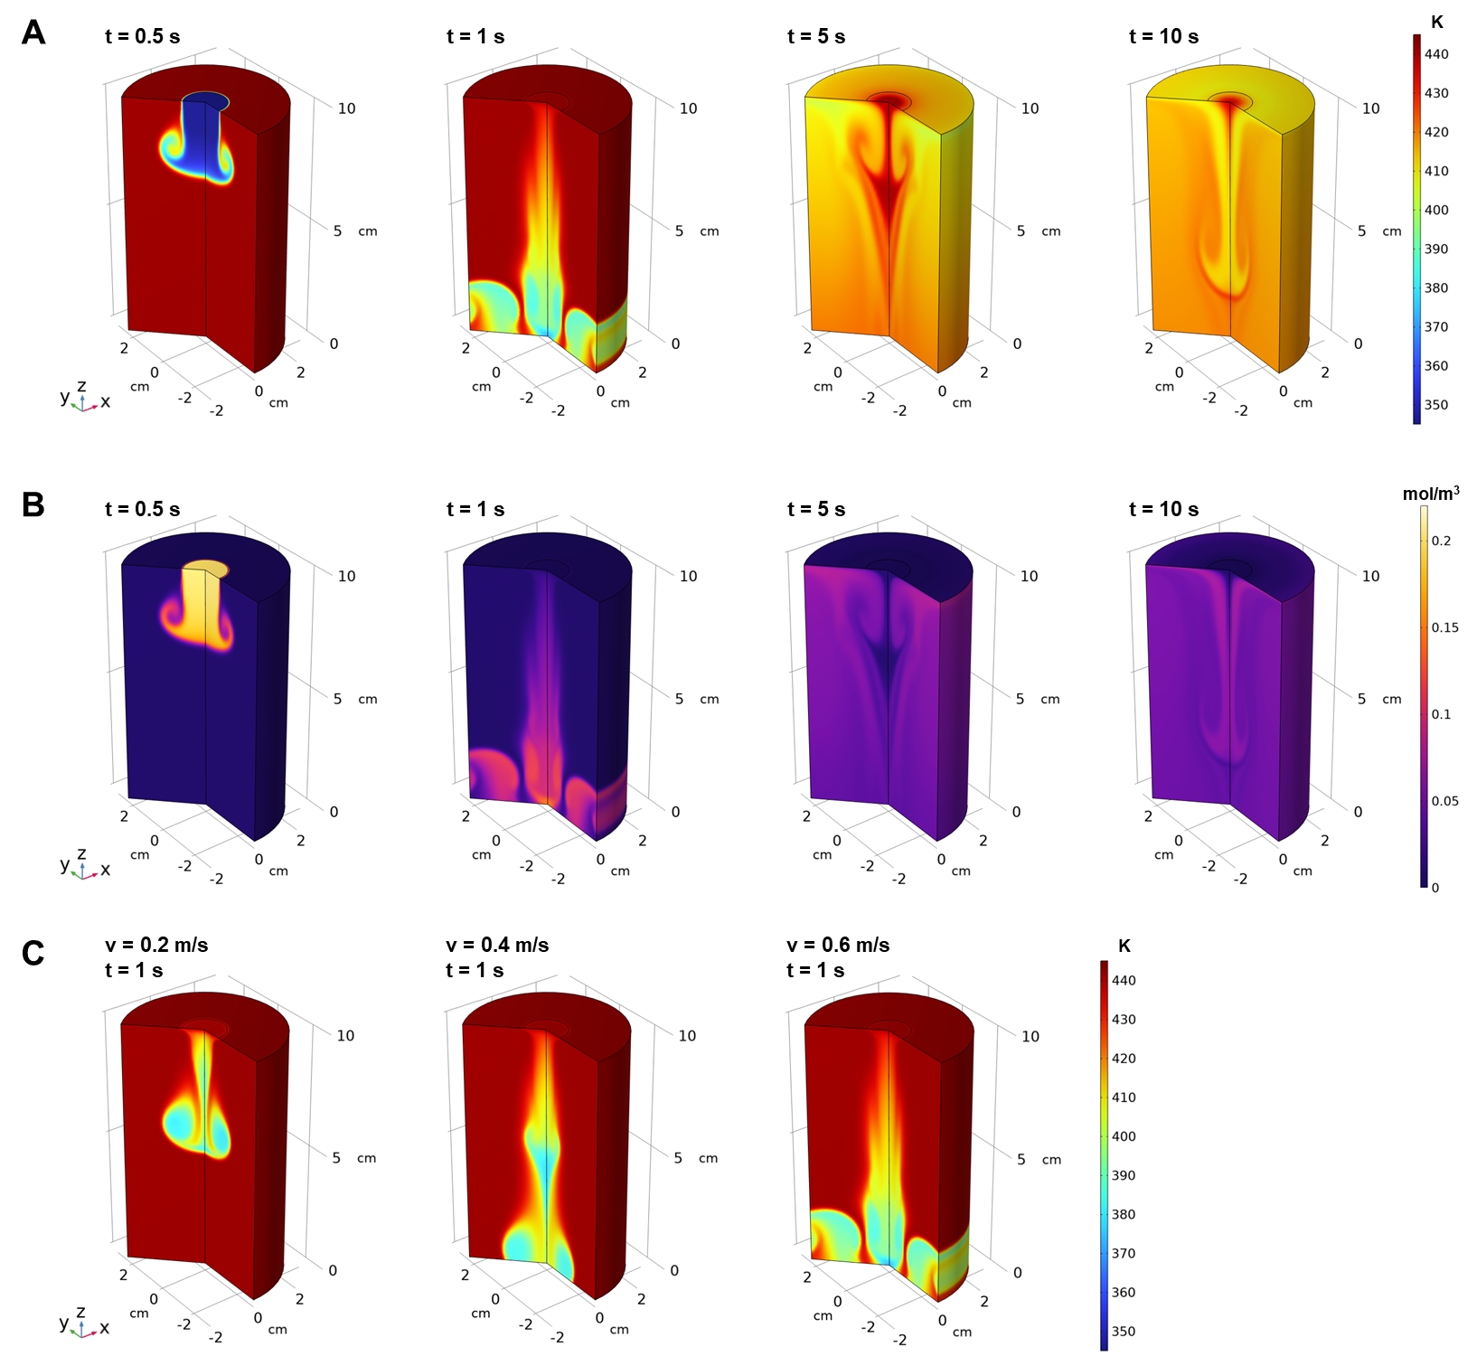
Fig. S1 FEM simulations of hot-injection synthesis of CsPbX₃-QPNC. a temperature and b concentration distributions as a function of time (t), assuming the injection speed (v) of Cs(oleate) solution to be 0.6 m/s. These FEM simulation results were partially extracted to organize Fig. 1b. c temperature distributions as a function of the injection speed, assuming time to be 1 s after the injection of Cs(oleate) solutions

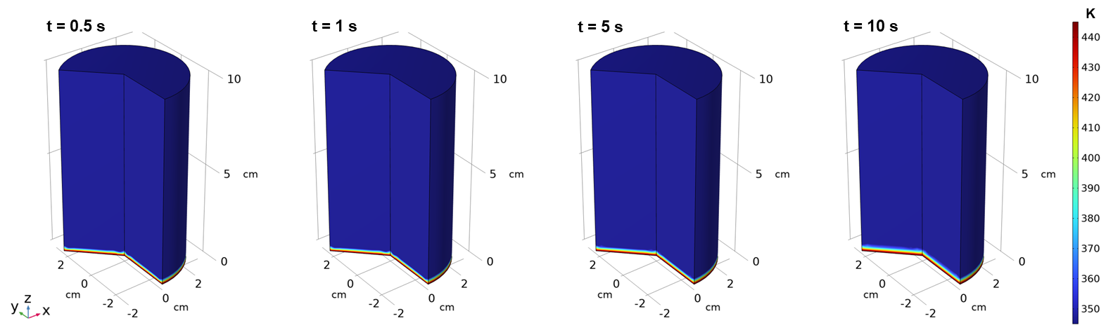
Fig. S2 FEM simulations of temperature distributions in heat-up synthesis of CsPbX₃-QPNCs. The detailed modeling methods for this FEM simulation of heat-up synthesis are explained in Note S1.

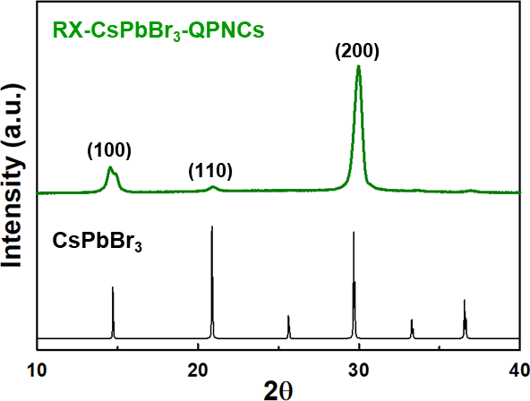
Fig. S3 Crystallographic property of heat-up CsPbBr₃-QPNCs. All the X-ray diffraction peaks of heat-up CsPbBr₃-QPNCs are indexed as the photo-active and cubic α-phase of CsPbBr₃ perovskite.

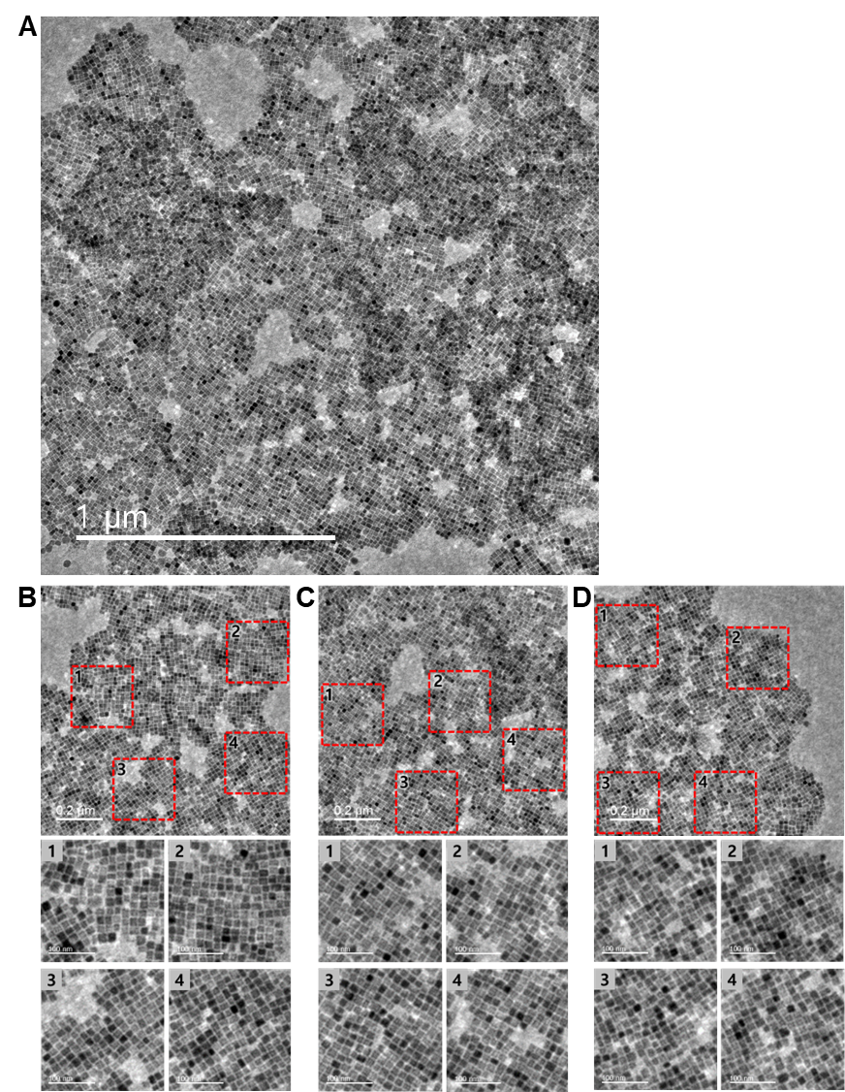
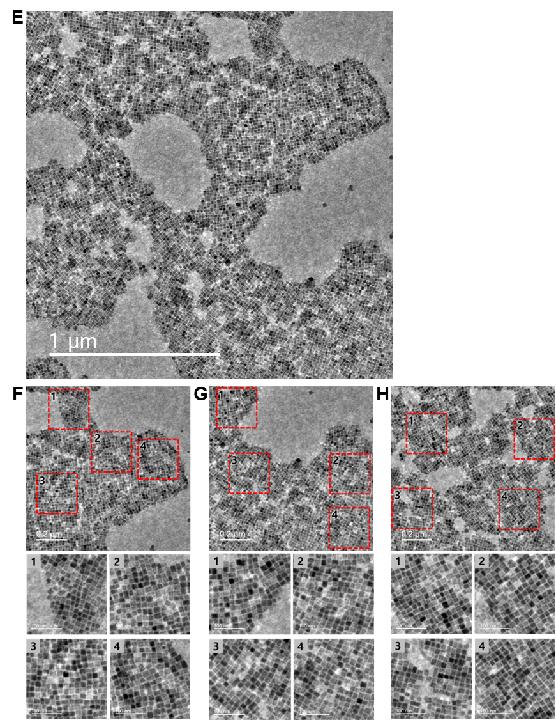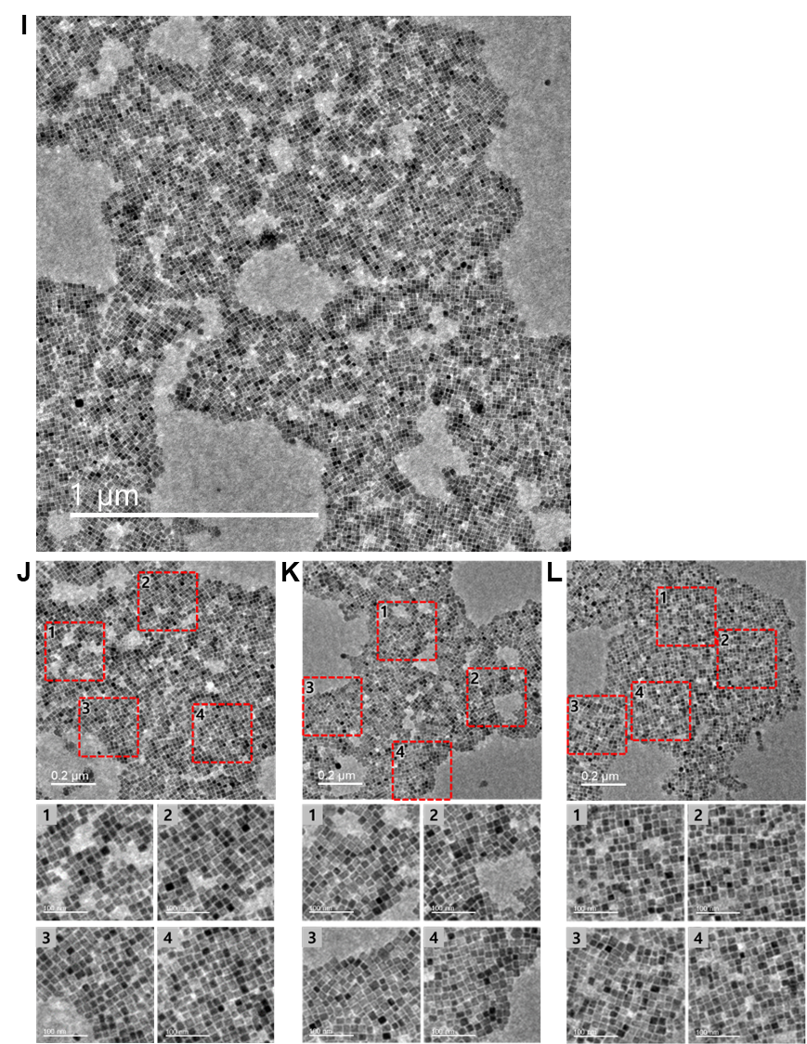
Fig. S4 Nano-scale morphologies of RX-CsPbBr₃-QPNCs. a–l Low-magnification and enlarged HR-TEM images of RX-CsPbBr₃-QPNCs, measured at various randomly selected positions from three different synthetic batches: a–d, e–h, and i–l

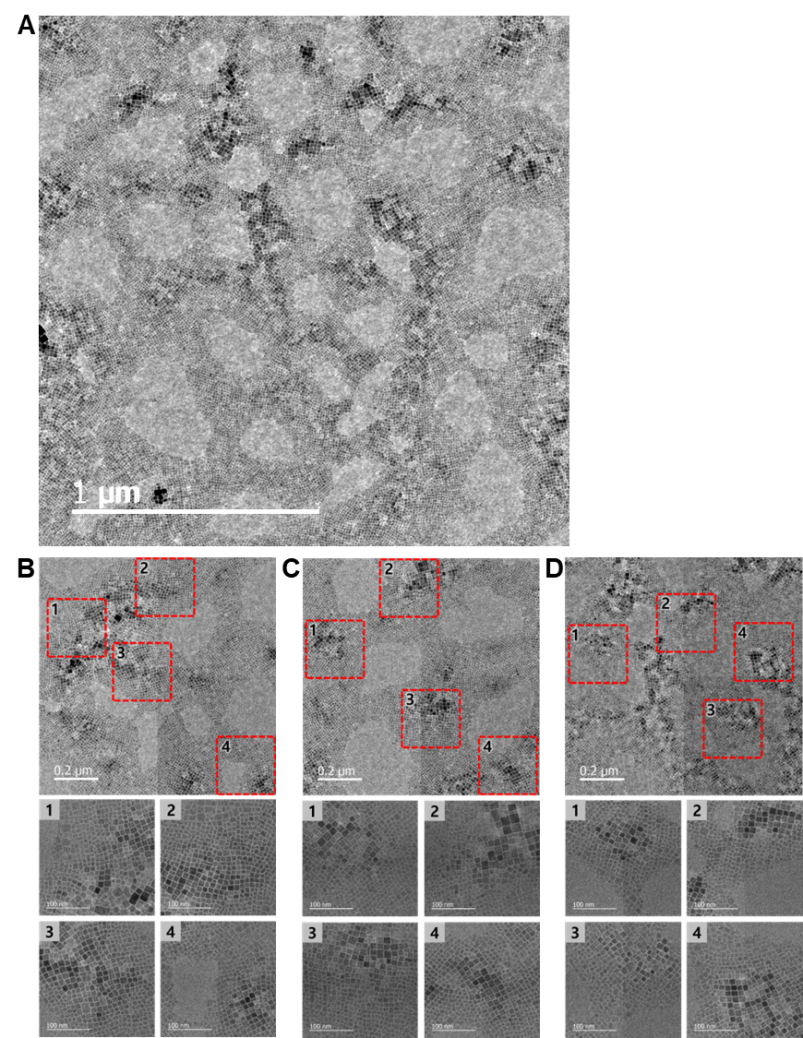
Fig. S5 Nanometer-scale morphologies of PbX₂-CsPbBr₃-QPNCs. a–d Low-magnification and enlarged HR-TEM images of PbX₂-CsPbBr₃-QPNCs, measured at various positions randomly selected

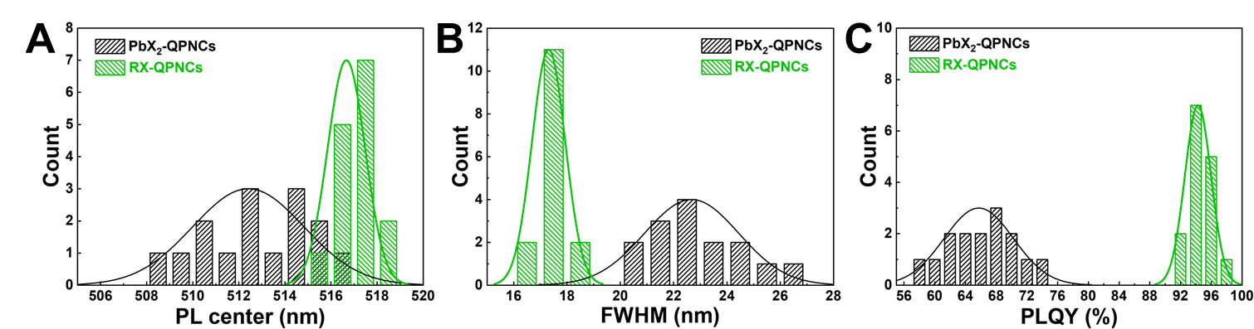
Fig. S6 Reproducibility of PL features of RX- and PbX₂-QPNCs. Histograms of a PL peak positions, b FWHMs, and c PLQYs of RX- and PbX₂-QPNCs, each synthesized over 15 batches

Table S1 Summarized fluorescence features of QPNCs prepared by diverse synthetic methods on a gram scale reported to date. Among the diverse synthetic methods using PbX₂ or RX precursors, the heat-up method using RX precursor exhibited the narrowest FWHM of 16.5 nm and the highest PLQY of 96.3%, as shown in Fig. 2c
Product | Synthesis method | Production  volume (mL) | Production  yield (g) | PL center  (nm) | FWHM  (nm) | PLQY  (%) | Ref.
CsPbBr₃ nanocubes | Room-temperature reaction using PbX₂ | 900 | - | 515 | 24 | - | [2]
CsPbBr₃ nanoplatelets | Microwave-induced reaction using PbX₂ | 330 | 7 | 458 | 22 | 29 | [3]
CsPbBr₃ nanocubes | Heat-up  using PbX₂ | 115 | 0.3294 | 525 | 18.2 | 73.56 | [4]
MA/FAPbBr₃ crystals | Ball milling  using PbX₂ | - | 10 | 533 | - | 24.9 | [5]
CsPbBr₃ nanocubes | Heat-up using PbX₂ in single reactor | 480 | 1.795 | - | 19 | - | [6]
Mn:CsPbCl₃ nanocubes | Hot-injection using PbX₂ | 460 | 1.78221 | - | - | - | [7]
CsPbBr₃ nanocubes | Hot-injection  using RX | 172.5 | 2.6598 | 514 | 20.5 | 86 | [8]
CsPbBr₃ nanocubes | ¹⁾LARP  using PbX₂ | 480 | - | 516 | 21 | - | [9]
FAPbBr₃ nanocubes | Ultrasonication-induce reaction using PbX₂ | 500 | 11.2189 | 530 | 23 | 88 | [10]
CsPbBr₃ nanoplatelets | Room-temperature reaction using PbX₂ | 800 | - | 460 | 18 | 78 | [11]
CsPbBr₃ nanocubes | LARP  using PbX₂ | 300 | 0.780 | 510 | 20 | 69 | [12]
CsPbBr₃ nanocubes | Microwave-induced reaction using PbX₂ | 100 | 0.165 | 515 | - | 94 | [13]
CsPbBr₃ nanocubes | Heat-up  using RX | 300 | 1.387 | 517 | 16.5 | 96.3 | This  work
¹⁾Ligand-assisted re-precipitation

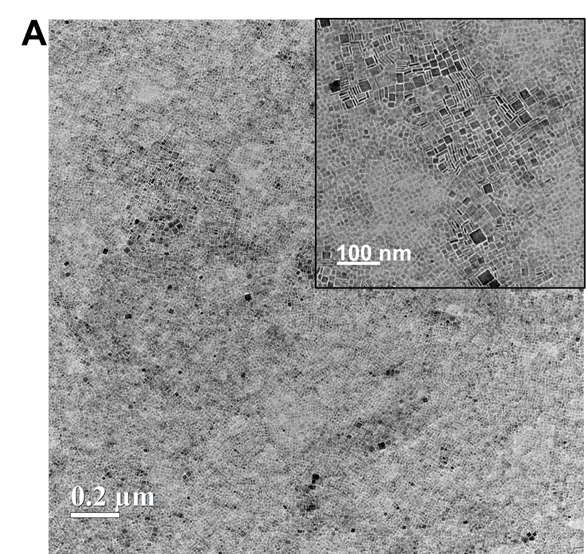
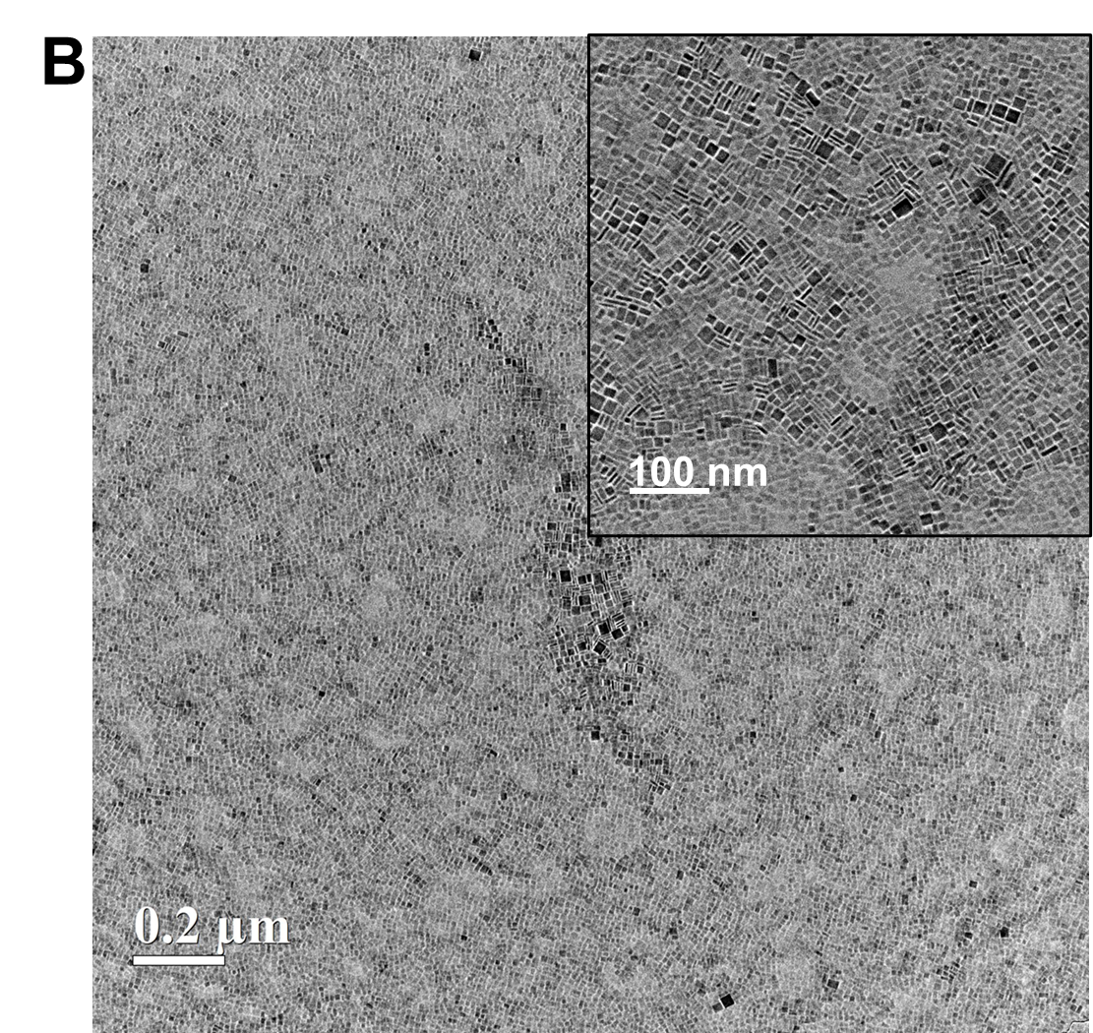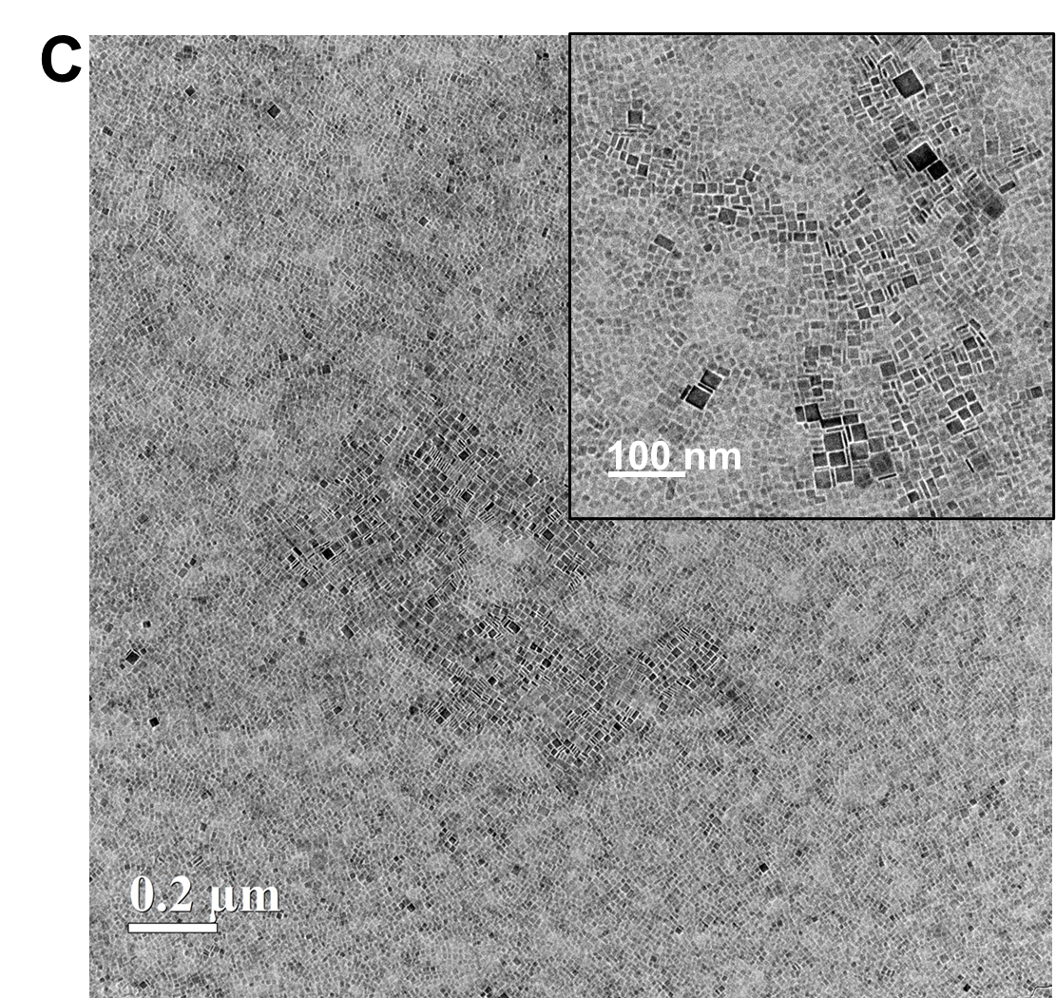
Fig. S7 Non-uniform size distribution of LS-PbX₂-CsPbBr₃-QPNCs. a–c Low-magnification HR-TEM images of LS-PbX₂-CsPbBr₃-QPNCs, measured at various randomly selected positions

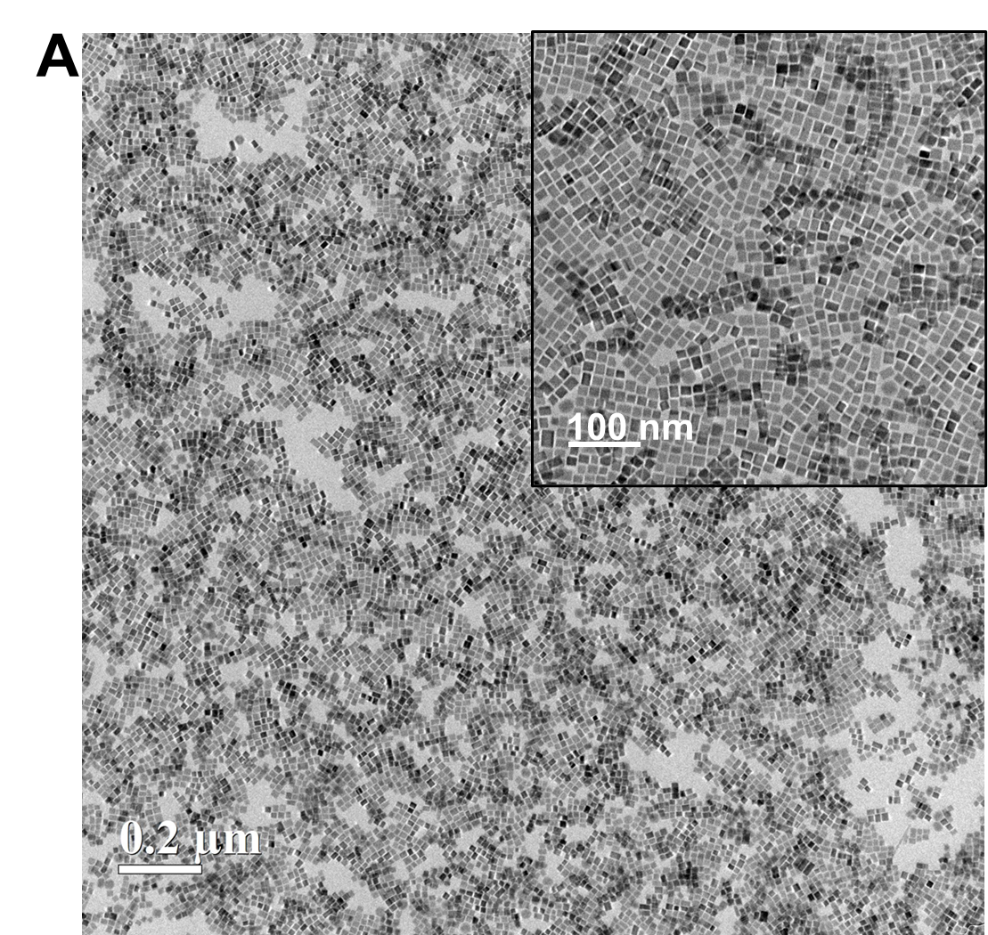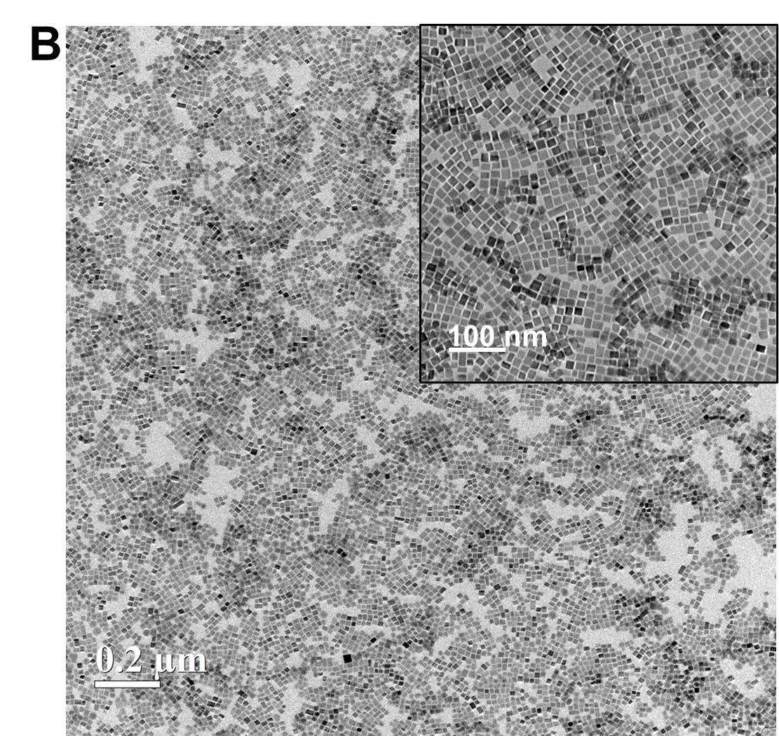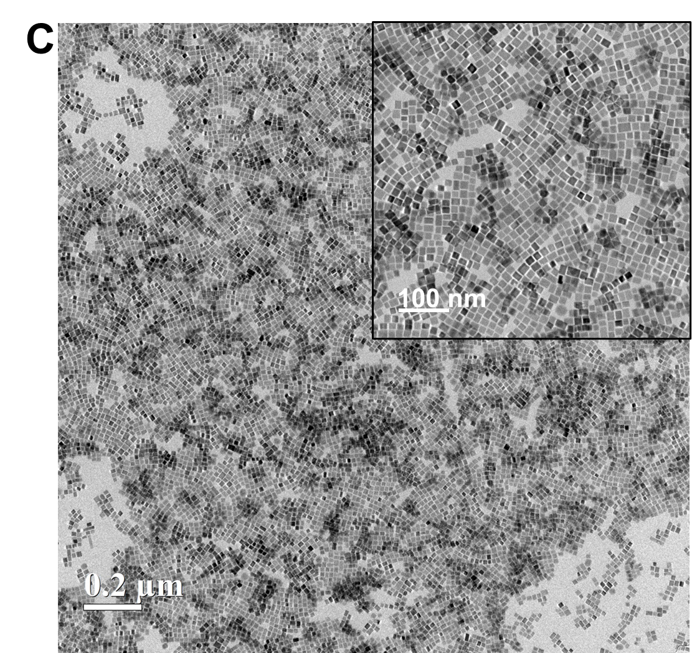
Fig. S8 Uniform size distribution of LS-RX-CsPbBr₃-QPNCs. a–c Low-magnification HR-TEM images of LS-RX-CsPbBr₃-QPNCs, measured at various randomly selected positions

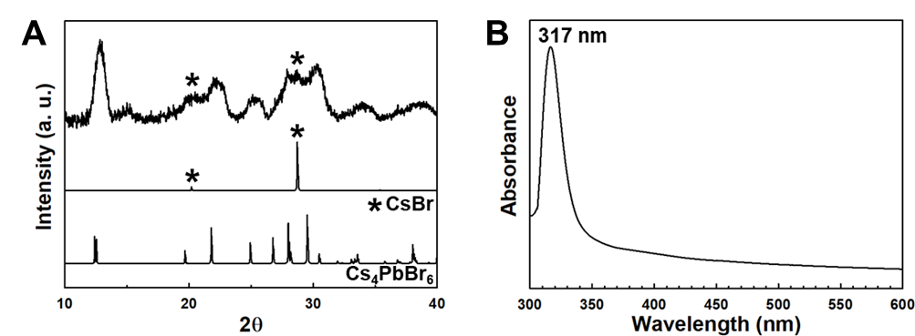
Fig. S9 Characterizations of white-color products obtained after room-temperature reaction without applying additional thermal energy. a XRD patterns and b UV–Vis absorption spectrum of white-color products obtained after room-temperature reaction for 10 hours

Note S2 Proton nuclear magnetic resonance (¹H-NMR) measurements
¹H-NMR measurements were carried out to investigate the degree of S_{N}2 reaction of Br-8 during the heat-up synthesis of CsPbX₃-QPNCs under various conditions (as-blended without any reaction, reacted at room temperature for 10 h, and heated-up to 60, 80, 100, and 120 ℃, respectively). All samples were diluted in chloroform-d solvent with a same concentration. The chloroform-d solvent contained tetramethyl silane (TMS) with a volume ratio of 0.03%. The full ¹H-NMR spectra of the respective samples were normalized using the areas of the respective TMS peaks appearing at 0 ppm, and provided in Figs. S10–S15. The degree of the S_{N}2 reaction can be estimated by tracing the amount of alkyl−nucleophile organic compounds (i.e., 2nd amine and ester compounds) generated with the same molar quantity as the halide anions. The 2nd amine and ester compounds can be detected using the characteristic α-CH₂ resonance peaks related to their functional groups (labelled with light-blue-colored C1 and C2 for 2nd amine compounds and pink-colored C1 and C2 for ester compounds in Figs. S10–S15 [14]

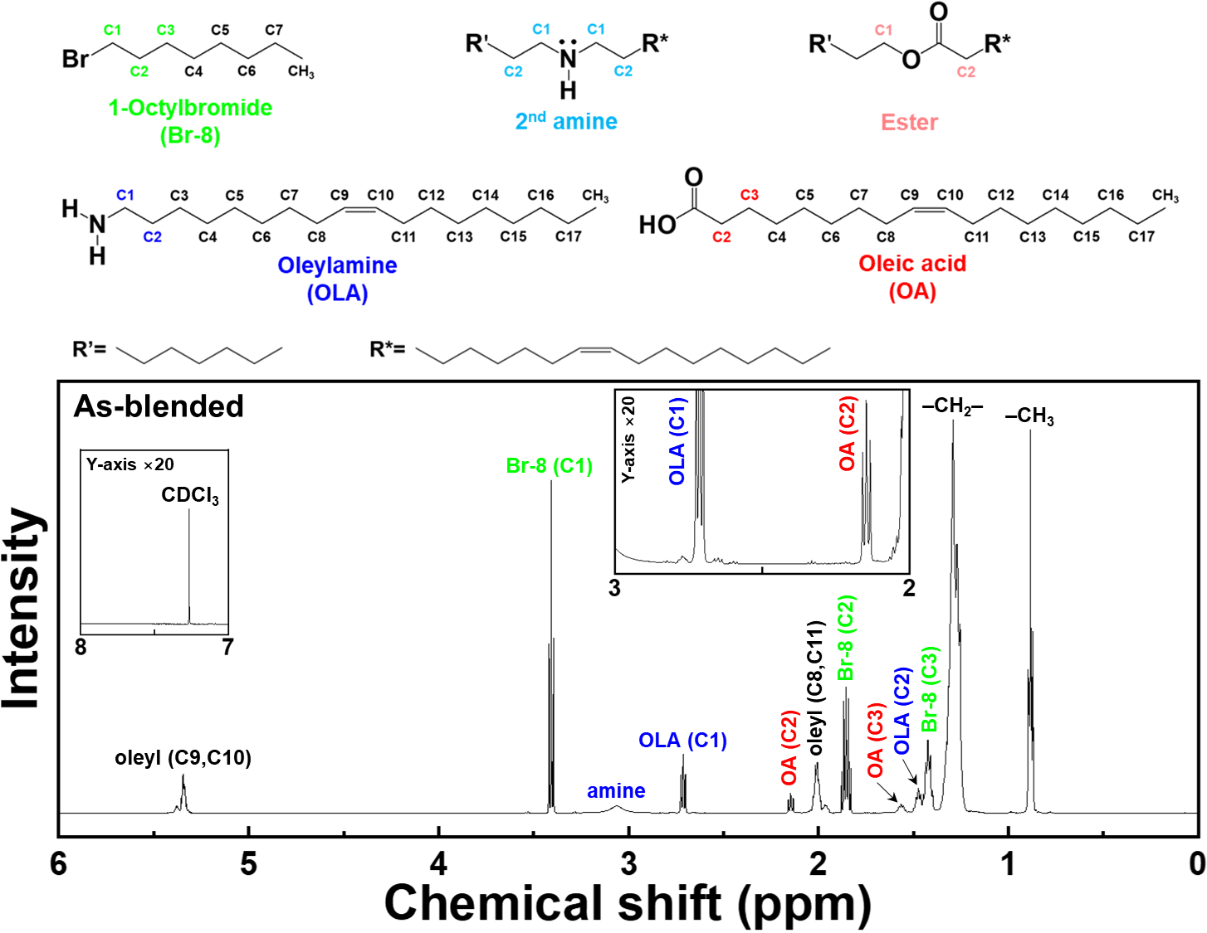
Fig. S10 ¹H-NMR full spectrum of as-blended precursor solution used for heat-up synthesis of CsPbBr₃-QPNCs. This ¹H-NMR spectrum of an as-blended precursor solution shows no α-CH₂ resonance peaks related to 2nd amine and ester compounds (labelled with light-blue-colored C1 and C2 for 2nd amine compounds and pink-colored C1 and C2 for ester compounds)

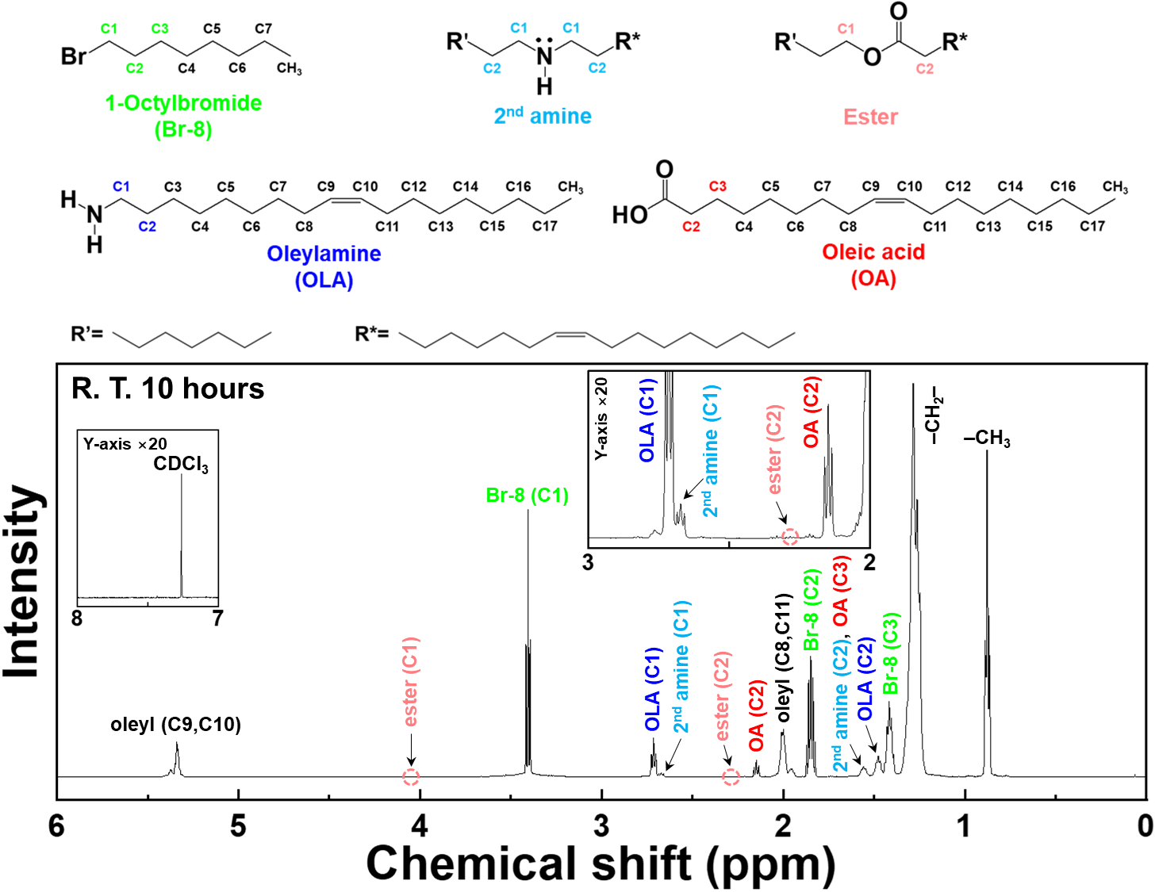
Fig. S11 ¹H-NMR full spectrum of the sample, reacted at room temperature for 10 h. This ¹H-NMR spectrum of the sample reacted at room temperature for 10 h shows higher α-CH₂ resonance peaks related to 2nd amine and ester compounds (labelled with light-blue-colored C1 and C2 for 2nd amine compounds and pink-colored C1 and C2 for ester compounds), compared to those of the as-blended precursor solution (Fig. S10)

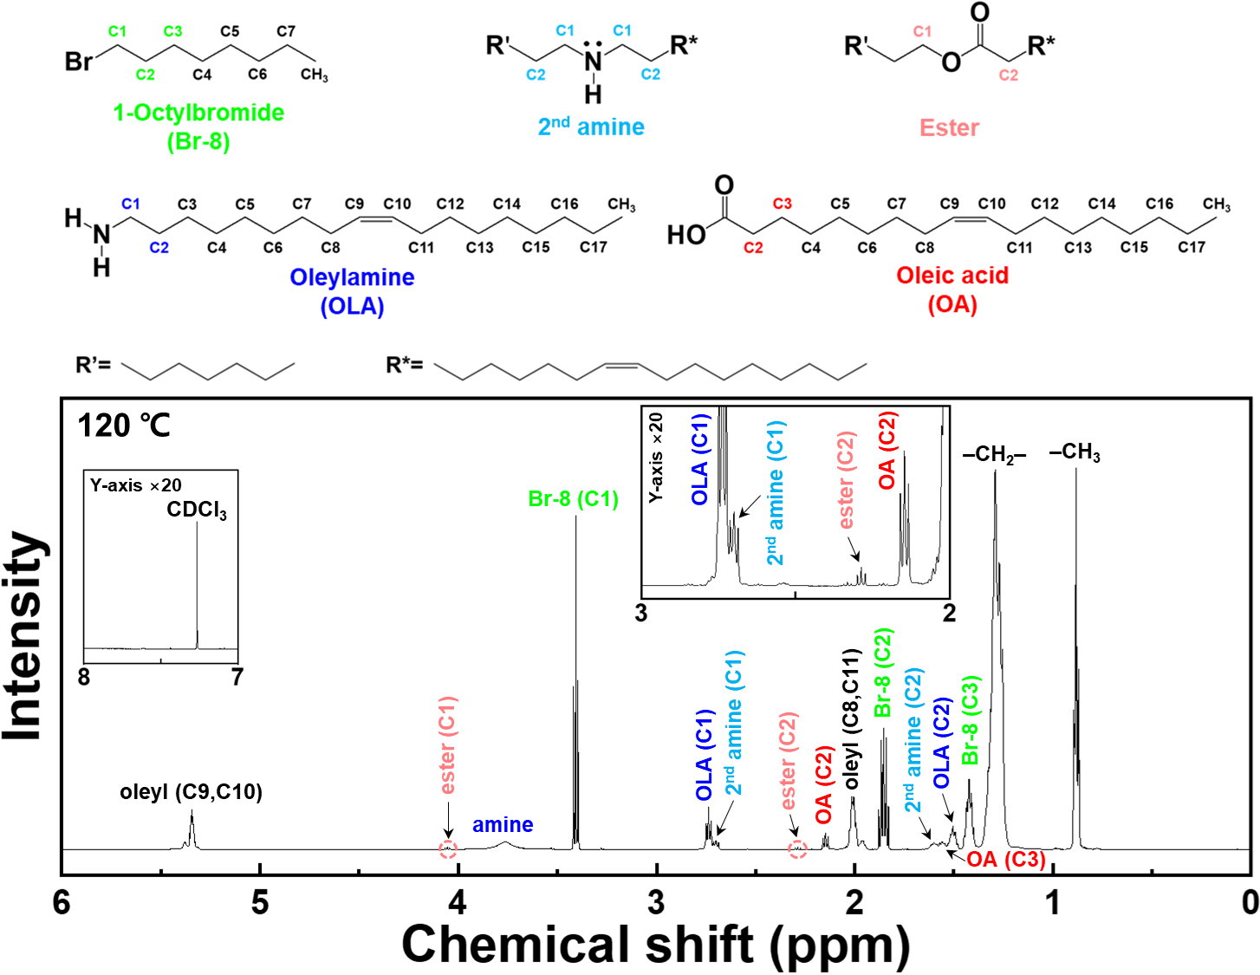
Fig. S12 ¹H-NMR full spectrum of a RX-CsPbBr₃-QPNCs synthesized by heating up to at 120 ℃. This ¹H-NMR spectrum shows higher α-CH₂ resonance peaks related to 2nd amine and ester compounds (labelled with light-blue-colored C1 and C2 for 2nd amine compounds and pink-colored C1 and C2 for ester compounds), compared to those of the sample reacted at room temperature for 10 h (Fig. S11)

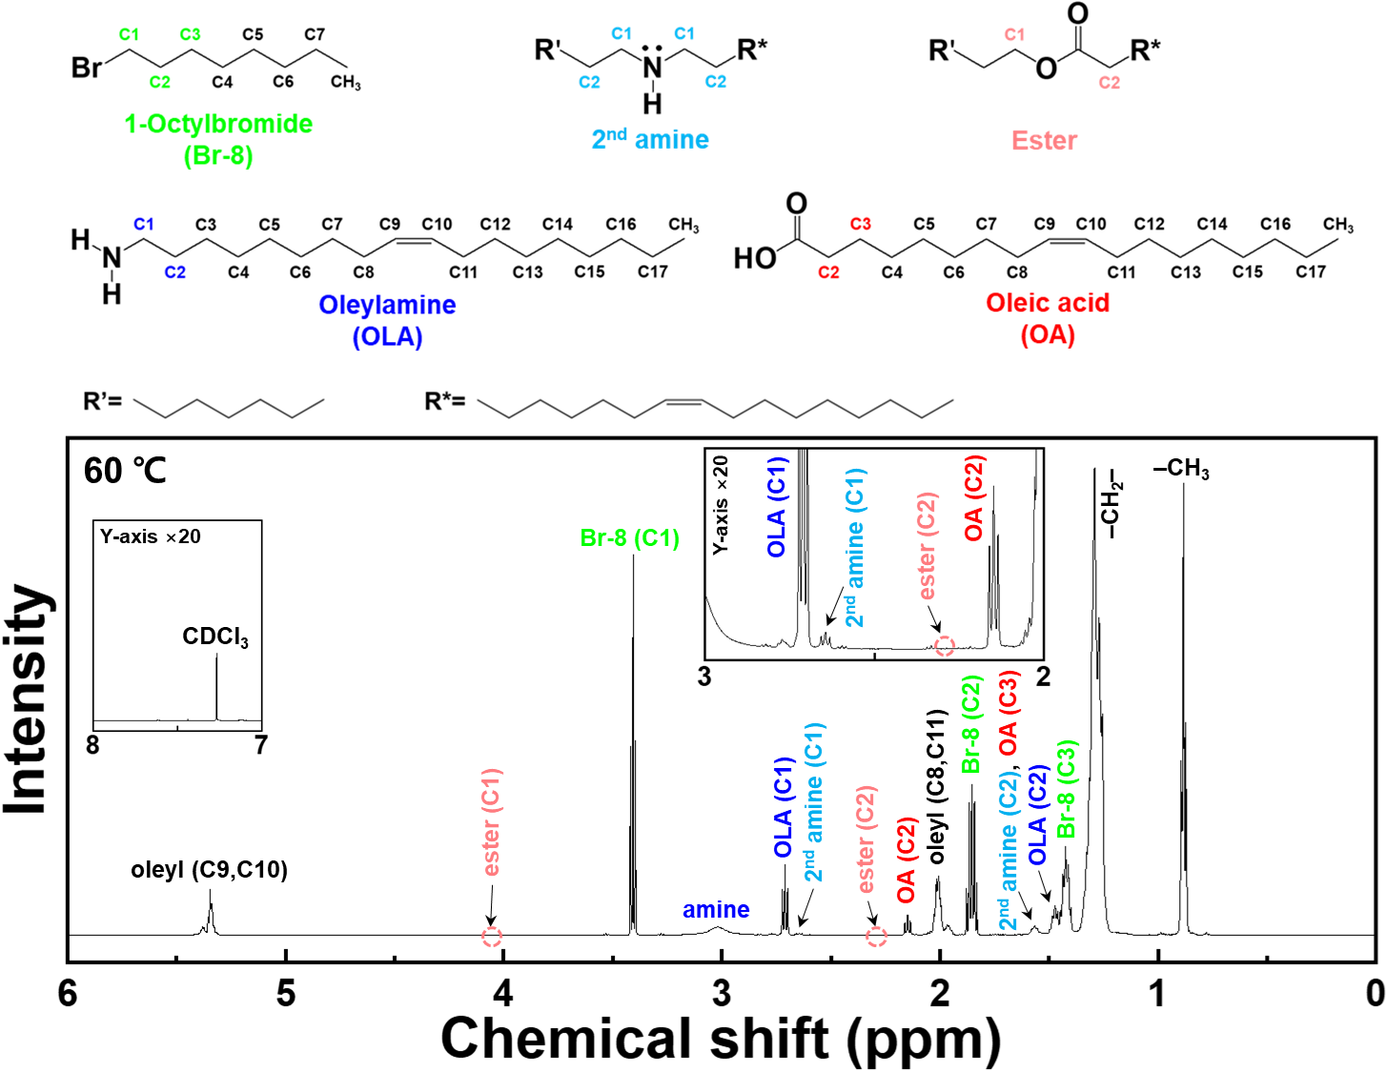
Fig. S13 ¹H-NMR full spectrum of the sample prepared by heating up to at 60 ℃. This ¹H-NMR spectrum shows higher α-CH₂ resonance peaks related to 2nd amine and ester compounds (labelled with light-blue-colored C1 and C2 for 2nd amine compounds and pink-colored C1 and C2 for ester compounds), compared to those of the as-blended precursor solution (Fig. S10)

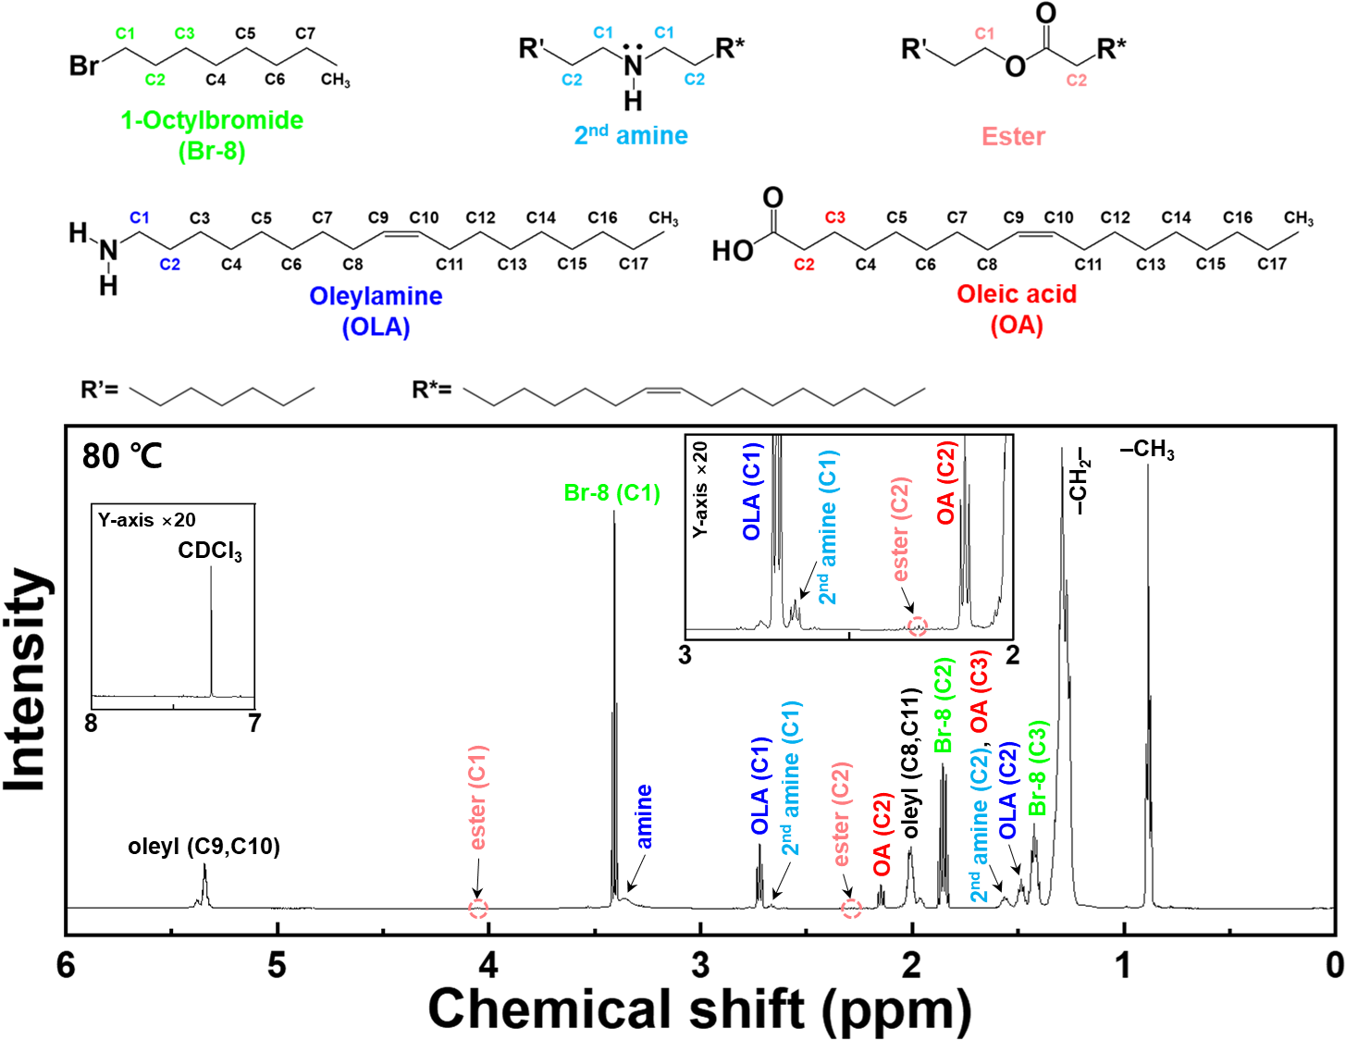
Figure S14 ¹H-NMR full spectrum of the sample prepared by heating up to at 80 ℃. This ¹H-NMR spectrum shows higher α-CH₂ resonance peaks related to 2nd amine and ester compounds (labelled with light-blue-colored C1 and C2 for 2nd amine compounds and pink-colored C1 and C2 for ester compounds), compared to those of the sample prepared by heating up to 60 ℃ (Fig. S13)

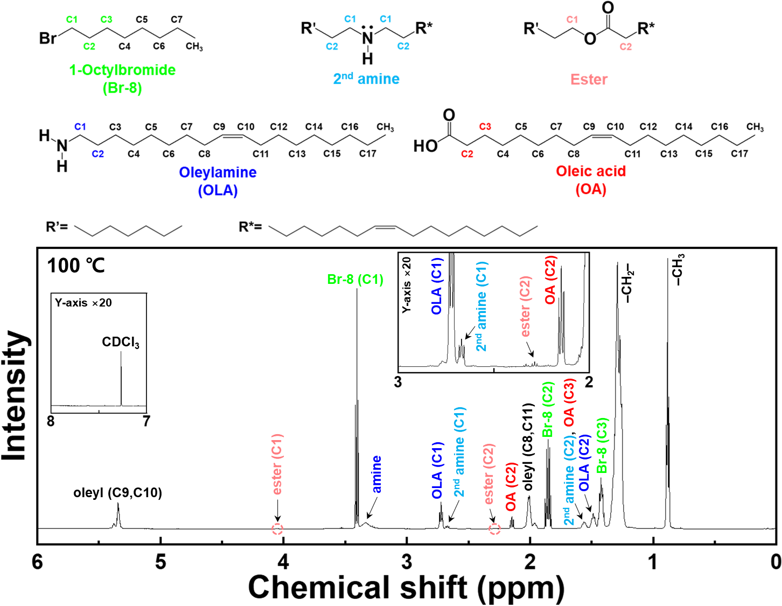
Fig. S15 ¹H-NMR full spectrum of the sample prepared by heating up to at 100 ℃. This ¹H-NMR spectrum shows higher α-CH₂ resonance peaks related to 2nd amine and ester compounds (labelled with light-blue-colored C1 and C2 for 2nd amine compounds and pink-colored C1 and C2 for ester compounds), compared to those of the sample prepared by heating up to 80 ℃ (Fig. S14)

Note S3 Quantitative calculation of Br– yields
The degree of the S_{N}2 reaction and the production yield of Br– during the heat-up synthesis of CsPbX₃-QPNCs under various reaction conditions (as-blended without any reaction, reacted at room temperature for 10 h, and heated-up to 60, 80, 100, and 120 ℃, respectively) were quantitatively calculated by using the triplet α-CH₂ resonance peak areas corresponding to the 2nd amine and ester compounds (light-blue-colored C1 for 2nd amine compounds and pink-colored C2 for ester compounds in ¹H-NMR spectra), respectively, and the quintet β-CH₂ resonance peak areas corresponding to Br-8 (green-colored C2 in ¹H-NMR spectra) in the respective ¹H-NMR spectra shown in Figs. S10–S15 [14]. The area of each resonance peak divided by the number of the included hydrogen atoms was proportional to moles of each organic molecule (i.e., 2nd amine and ester compounds, and Br-8). The area of each resonance peak was quantitatively calculated by integrating the corresponding peak in the respective ¹H-NMR spectra. The amount of each 2nd amine and ester compound produced is equal to the amount of each nucleophilic OLA and oleate that participated in this S_{N}2 reaction. The total of the 2nd amine and ester compounds produced is equal to the total yield of Br– produced in the S_{N}2 reaction because the amount of alkyl−nucleophile organic compounds is generated with the same molar quantity as the halide anions. The sum of the amount of released Br– and the amount of unreacted Br-8 is equal to the initial feeding amount of Br-8. By using the ratios of each amount of 2nd amine or ester compounds to the initial feeding amount of Br-8, the number of moles of Br– released by OLA and oleate, respectively, were calculated from the following equations:

$\left[Moles of {Br}^{-} released by OLA\right]= \frac{[2^{nd} amine]}{\left[2^{nd} amine\right] + \left[ester\right] + [Br\text{-8]}} × [Initial feeding moles of Br\text{-}8]$ (1)
$\left[Moles of {Br}^{-} released by oleate\right]= \frac{[ester]}{\left[2^{nd} amine\right] + \left[ester\right] + [Br\text{-8]}} × [Initial feeding moles of Br\text{-}8]$ (2)
$\left[Total yield of {Br}^{-}\right] = \left[Moles of {Br}^{-} released by OLA\right] + [Moles of {Br}^{-} released by oleate]$ (3)

where [2nd amine] is the area of α-CH₂ resonance peak of 2nd amine compound (light-blue-colored C1) divided by 4, [ester] is the area of α-CH₂ resonance peak of ester compound (pink-colored C2) divided by 2, and [Br-8] is the area of β-CH₂ resonance peak of Br-8 (green-colored C2) divided by 2, because the light-blue-colored C1 moieties of the 2nd amine compound have 4 hydrogen atoms, the pink-colored C2 moiety of the ester compound has 2, and the green-colored C2 moiety of Br-8 has 2, as shown in Figs. S10–S15. By dividing [Moles of Br– released by OLA], [Moles of Br– released by oleate], and [Total yield of Br–] by the volumes of synthesis solutions (approximately 30 mL if following the synthesis scale in experimental procedures), respectively, we determined the molarity of the 2nd amine and ester compounds and Br– produced under the respective reaction conditions (Table S2 and Fig. 3g)

Table S2 Molarity of 2nd amine and ester compounds and Br– anions produced under the respective reaction conditions. These quantitative calculations were achieved by integrating the related resonance peaks in the ¹H-NMR spectra of the respective samples (Figs. S11–S15), as explained in Note S3
Derivatives | R.-T. reaction  for 10 h | Temperature steps in heat-up process
Derivatives | R.-T. reaction  for 10 h | 60 °C | 80 °C | 100 °C | 120 °C
2nd amine compounds (mM) | 68.7 | 21.7 | 46.1 | 78.4 | 154.2
Ester compounds (mM) | 4.0 | 0.7 | 6.0 | 12.3 | 32.0
Yield of Br– (mM) | 72.7 | 22.4 | 52.1 | 90.8 | 186.2

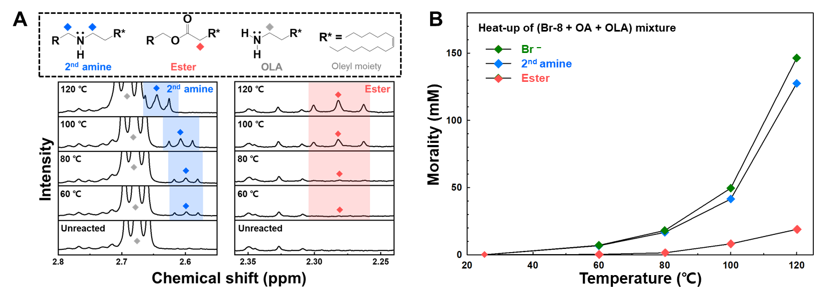
Fig. S16 Molarity of 2nd amine and ester compounds and Br⁻ anions produced at each temperature step duting the heat-up process of the mixture containing only Br-8, OA, and OLA. a ¹H-NMR spectra of a mixture containing only Br-8, OA, and OLA obtained at each temperature step during the heat-up process to 120 °C. b Plot of molarity of 2nd amine and ester compounds and Br⁻ anions produced at each temperature step during the heat-up process of the mixture, obtained based on Table S3

Table S3 Molarity of 2nd amine and ester compounds and Br⁻ anions produced at each temperature step during the heat-up process of the mixture containing only Br-8, OA, and OLA. These quantitative calculations were carried out, as detailed in Note S3
Derivatives | Temperature steps in heat-up process
Derivatives | 60 °C | 80 °C | 100 °C | 120 °C
2nd amine compounds (mM) | 6.7 | 16.6 | 41.5 | 127.5
Ester compounds (mM) | 0.3 | 1.4 | 8.1 | 18.8
Yield of Br– (mM) | 7.0 | 18.0 | 49.6 | 146.3

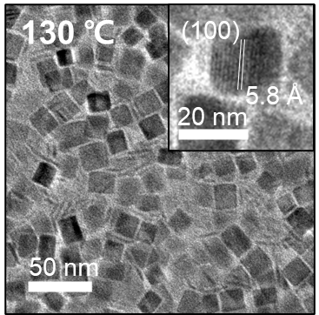
Fig. S17 HR-TEM image of the sample synthesized at 130 °C. Cuboidal RX-CsPbBr₃-QPNCs and 2D CsPbBr₃-NPLs were mixed, as confirmed by the UV–Vis absorption spectra in Fig. 4a

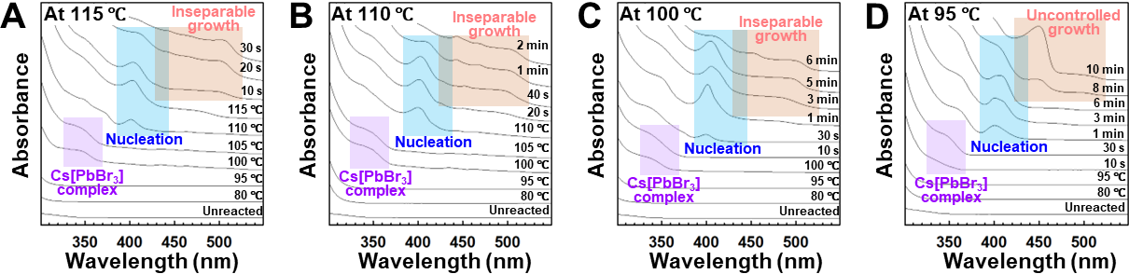
Fig. S18 S_{N}2-based heat-up synthesis maintaining respective target temperatures below 120 °C. UV–Vis absorption spectra of respective synthesis solutions, measured in the respective heat-up processes with different target temperatures of a 115 °C, b 110 °C, c 100 °C, and d 95 °C

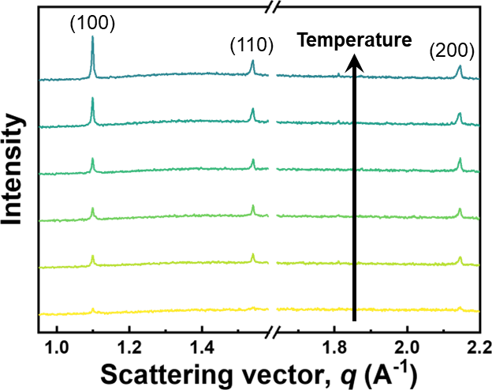
Fig. S19 Out-of-plane profiles extracted from six respective 2D grazing-incidence wide-angle X-ray scattering (GIWAXS) patterns measured at 110 °C, 112 °C, 114 °C, 116 °C, 118 °C, and 120 °C during the S_{N}2-based heat-up process. Over time, the intensities of the (100), (110), and (200) diffraction peaks increased, revealing the crystal growth and QPNC formation, consistent with the UV–Vis absorption spectra and TEM images in Fig. 4a, b

Note S4 Effect of Cs:Pb feeding ratio
To investigate the effect of the Cs:Pb feeding ratio on the S_{N}2-based heat-up synthesis, we performed the heat-up synthesis by increasing the Cs:Pb molar ratio from 1:9 to 1:3 while maintaining the total moles of Cs(oleate) and Pb(oleate)₂. For ~30 mL-scale synthesis, 17.3 mL of Br-8, 10 mL of OLA, 0.6 mL of OA, 0.7 mL (0.5 mmol) of Cs(oleate) stock solution, and 1.5 mL (1.5 mmol) of Pb(oleate)₂ stock solution (moles of Cs(oleate) + moles of Pb(oleate)₂ = 2 mmol) were input into a single reactor, and heated up to 100 ℃ and 120 ℃ (Fig. S20). As-synthesized NCs were collected using the centrifugation process, as detailed in experimental procedures.
Subsequently, HR-TEM, XRD and UV-Vis absorption spectrum measurements of the collected NCs were performed. Based on the results, Cs₄PbBr₆ nanopolyhedrons formed at 100 ℃, and they were still present in the resultant solutions that were heated up to 120 ℃ (Fig. S20). This indicates that the higher Cs:Pb molar ratio of 1:3, compared to 1:9, leads to increasing the amount of Cs⁺ released through thermolysis of Cs(oleate), and results in the production of the Cs-rich Cs₄PbBr₆ nanopolyhedrons at ~100 °C

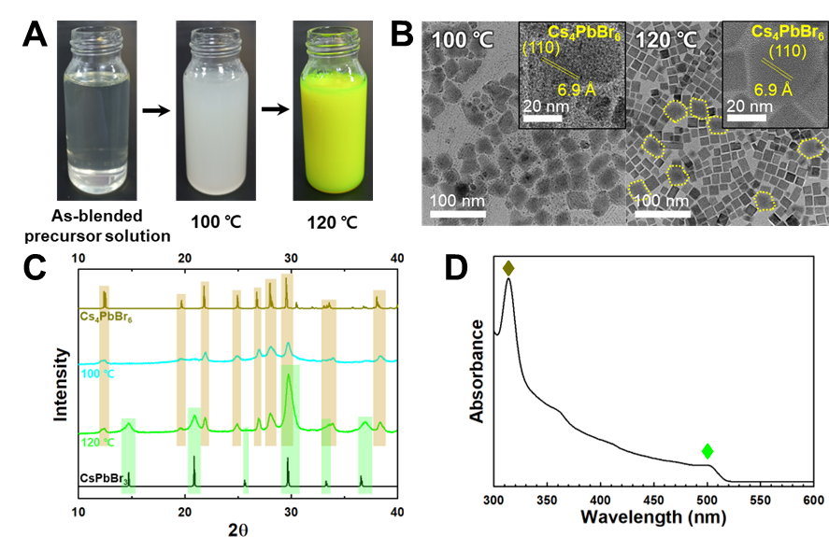
Fig. S20 Formation of Cs₄PbBr₆ NCs resulting from high Cs:Pb molar ratio of 1:3. a Photograph images of heat-up process using alkyl bromide with Cs:Pb molar ratio of 1:3. b HR-TEM images and c XRD patterns of respective products obtained at 100 ℃ and 120 ℃ during the heat-up process with Cs:Pb molar ratio of 1:3. d UV–Vis absorption spectrum of resultant products obtained after the heat-up process to 120 ℃.

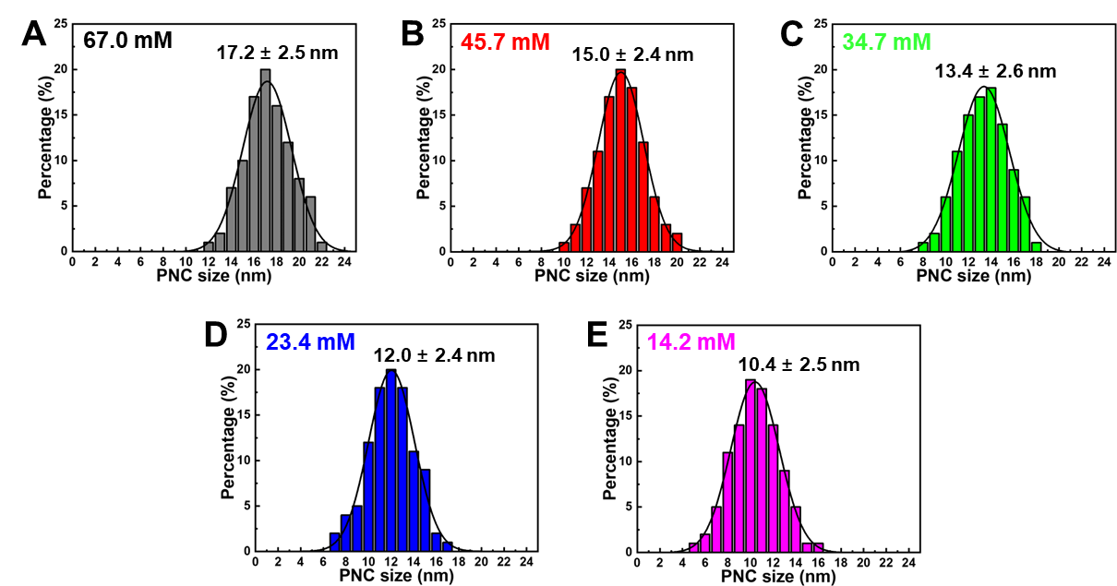
Fig. S21 QPNC size adjustment by varying concentration of metal precursors. Size distribution histograms of RX-CsPbBr₃-QPNCs with varying feeding molarity of metal precursors (i.e., Cs(oleate) and Pb(oleate)₂) from a 67.0 mM to b 45.7 mM, c 34.7 mM, d 23.4 mM, and e 14.2 mM, respectively. The size distribution histogram corresponding to 67.0 mM was estimated from the HR-TEM image in Fig. 1e, and the size distribution histograms corresponding to 45.7 mM, 34.7 mM, 23.4 mM, and 14.2 mM, respectively, were estimated from the respective HR-TEM images in Fig 5b

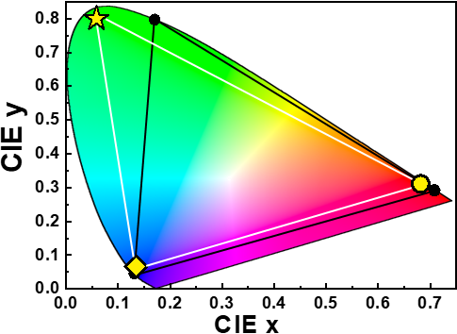
Fig. S22 RGB color gamut realized by RX-QPNCs. The International Commission on Illumination (CIE) 1931 color space chromaticity diagram showing CIE color coordinates (white lines) of green-emitting RX-CsPbBr₃-QPNCs (yellow star), blue-emitting RX-CsPbBr₃-NPLs (yellow diamond) and red-emitting RX-CsPbI₃-NPLs (yellow circle), compared with the standard Rec. 2020 color space (black circles and lines). These single-halide-composition RX-QPNCs realized high-color-purity RGB emissions fully covering the standard RGB color gamut proposed by Rec. 2020 without mixed halide compositions that can induce halide segregation.

References
- Protesescu, L. et al. Nanocrystals of cesium lead halide perovskites (CsPbX₃, X = Cl, Br, and I) novel optoelectronic materials showing bright emission with wide color gamut. Nano Lett. 15, 3692–3696 (2015).
- Akkerman, Q. A., et al. Strongly emissive perovskite nanocrystal inks for high-voltage solar cells. Nat. Energy 2, 16194 (2017).
- Shamsi, J. et al. Bright-emitting perovskite films by large-scale synthesis and photoinduced solid-state transformation of CsPbBr₃ nanoplatelets. ACS Nano 11, 10206–10213 (2017).
- Tsiwah, E. A. et al. One-pot scalable synthesis of all-inorganic perovskite nanocrystals with tunable morphology, composition and photoluminescence. CrystEngComm 19, 7041–7049 (2017).
- Yun, S., Kirakosyan, A., Yoon, S.-G. & Choi, J. Scalable synthesis of exfoliated organometal halide perovskite nanocrystals by ligand-assisted ball milling. ACS Sustainable Chem. Eng. 6, 3733–3738 (2018).
- Li, X. et al. Heterogeneous nucleation toward polar-solvent-free, fast, and one-pot synthesis of highly uniform perovskite quantum dots for wider color gamut display. Adv. Mater. Interfaces 5, 1800010 (2018).
- Liu, W. et al. Mass production of Mn²⁺-doped CsPbCl₃ perovskite nanocrystals with high quality and enhanced optical performance. Inorg. Chem. Front. 5, 2641–2647 (2018).
- Li, F. et al. Bromobenzene aliphatic nucleophilic substitution guided controllable and reproducible synthesis of high quality cesium lead bromide perovskite nanocrystals. Inorg. Chem. Front. 6, 3577–3582 (2019).
- Ng, C. K., Yin, W., Li, H. & Jasieniak, J. J. Scalable synthesis of colloidal CsPbBr₃ perovskite nanocrystals with high reaction yields through solvent and ligand engineering. Nanoscale 12, 4859–4867 (2020).
- Dou, Y. et al. Ten-gram-scale synthesis of FAPbX₃ perovskite nanocrystals by a high-power room-temperature ultrasonic-assisted strategy and their electroluminescence. Adv. Mater. Technol. 5, 1901089 (2020).
- Yoo, J.-H. et al. Room-temperature, homogeneous, single-step, and large-scale synthesis of perovskite nanoplatelets for blue light-emitting diodes. ACS Appl. Mater. Interfaces 15, 39461–39471 (2023).
- Mecca, S. et al. Multigram-scale synthesis of luminescent cesium lead halide perovskite nanobricks for plastic scintillators. ACS Appl. Nano Mater. 6, 9436–9443 (2023).
- Cho, S. et al. Gram-scale microwave-assisted synthesis of high-quality CsPbBr₃ nanocrystals for optoelectronic applications. Preprint at http://dx.doi.org/10.2139/ssrn.4604128 (2023).
- Wen, J.-R. et al. Chemical availability of bromide dictates CsPbBr₃ nanocrystal growth. Chem. Mater. 31, 8551–8557 (2019).

