Supplementary Figures

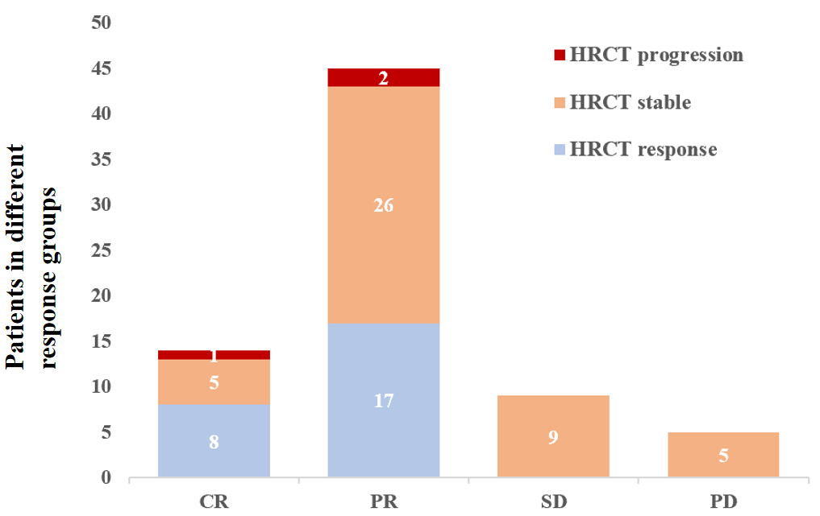
Figure S1 The high resolution chest computed tomography (HRCT) response of 73 evaluated LCH patients with pulmonary involvement in different overall response group. CR, complete response; PR, partial response; SD, stable disease; PD, progression disease.

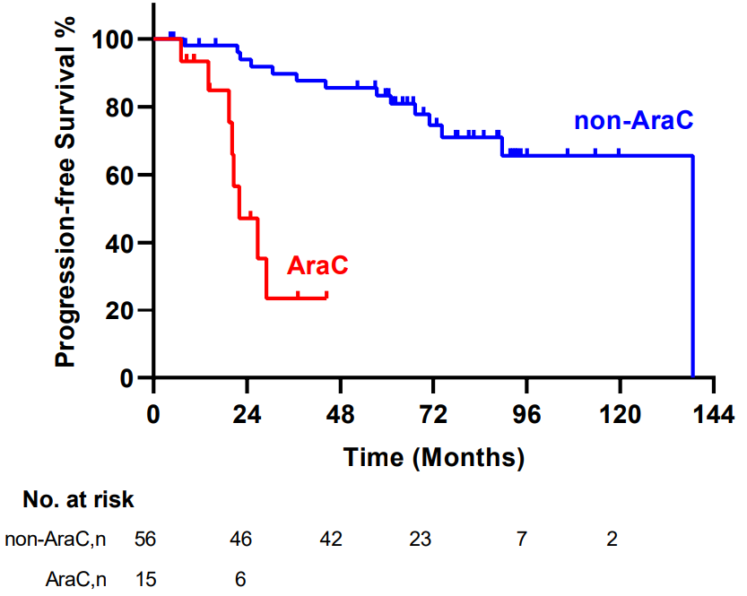
Figure S2 Progression-free survival (PFS) of 73 patients with pulmonary Langerhans cell histiocytosis according to initial therapy

Supplementary Tables
Table S1. Risk factors for progression-free survival according to univariate and multivariate Cox regression models
 | Univariate Cox |  | Multivariate Cox
 | HR (95% CI) | P value | HR (95% CI) | P value
Low dose cytarabine regimen | 6.717 (1.419-31.79) | ＜0.001 | 14.49 (4.464-47.62) | ＜0.001
HRCT score ≥10 | 3.060 (1.325-7.066) | 0.016 | 4.478 (1.559–12.862) | 0.005
CR after therapy | 0.158 (0.059-0.424) | 0.036 | 0.135 (0.018–1.023) | 0.053
CR: Complete remission; HR: hazard ratio; CI: confidence interval

