Healthcare Utilization Among Japanese Older Adults During Later Stage of Prolonged Pandemic

Online Appendix

Rong Fu, Sizhe Liu, Masato Oikawa, Haruko Noguchi, Akira Kawamura

Appendix A. Data Linkage Method
The data integration process combined our primary dataset, the Medical Claims Data with Income Tax Information (MCD-Tx), with three supplementary datasets tracking COVID-19 cases, hospital bed capacity, and emergency measures. The MCD-Tx comprised individual-level health insurance claims from Japan’s Latter-Stage Elderly Healthcare System (LSEH), collected separately from all 47 prefectures.
We began by standardizing temporal references across all datasets, extracting year and month information from date fields to create consistent temporal variables spanning from November 2021 to September 2022. This standardization ensured accurate temporal matching across all data sources.
The geographic integration strategy addressed Japan’s administrative structure, particularly the relationship between prefectures and Secondary Medical Regions (SMRs). For most prefectures, we implemented a two-step process: first merging COVID-19 case data at the SMR level, followed by hospital bed capacity data integration. This approach was highly effective, as demonstrated by Tokyo Prefecture, where we achieved matches for 14,540,133 records in the initial merge, with only 260 unmatched COVID-19 data records. The subsequent hospital bed data integration resulted in 19,485,913 matched records, representing a 92.2% success rate.
- Hokkaido and Tokushima prefectures use Shinkokyoku (Regional Development Bureaus) and Hokenkyoku (Regional Health Bureaus) respectively, rather than standard SMRs. For these prefectures, we performed data linkage at their respective administrative levels, achieving successful linkage rates of 92.4% and 91.8%.
- Six prefectures – Niigata, Fukui, Tottori, Hiroshima, Saga, and Nagasaki – reported COVID-19 cases at the prefecture level rather than the SMR level. For these areas, we first linked claims data with COVID-19 data at the prefecture level, then integrated hospital bed capacity data at the SMR level to maintain geographical precision in healthcare resource measurement.
After completing all regional-level data linkages, we integrated information about emergency measures (States of Emergency and States of Precautionary Emergency) at the prefecture level using prefecture codes and temporal identifiers (year and month). As these public health measures were implemented at the prefecture level, this merge achieved complete coverage with no unmatched records.
Linkage success varied across prefectures, with Fukui Prefecture achieving the highest match rate at 93.8% and Kagawa Prefecture the lowest at 89.2%, with a median match rate of 91.5%. From our initial 198,952,929 claims records, we successfully linked 189,841,257 records (95.4%). Unmatched records primarily resulted from geographic code mismatches (approximately 0.3% per prefecture), temporal misalignment (0.5%), and missing data in source files (0.2%).
The final integrated dataset maintained complete geographic coverage across all 47 prefectures while preserving individual-level healthcare utilization data and SMR-level COVID-19 metrics. This comprehensive integration enables analysis of healthcare utilization patterns among Japan’s oldest-old population during the pandemic’s convergence phase, considering both individual characteristics and regional factors such as COVID-19 prevalence, healthcare system capacity, and emergency measures implementation.

Appendix B. Robustness Checks
This appendix presents additional analyses conducted to examine the robustness of our main findings.
We estimate variations of our main models using different specifications of pandemic severity. Our baseline specification uses a quadratic function of COVID-19 cases (Equations 1 and 2). As a robustness check, we estimate B1 and B2 models using a linear specification of pandemic severity:
$$Y_{ijt}= β_{0}+ β_{1}SoPE_{jt}+β_{2}COVID_{jt}+ X_{ijt}^{'}γ + δ_{t}+ η_{j}+ τ_{j}t + ε_{ijt}. \left(B1\right)$$
$$Y_{ijt}= θ_{0}+ θ_{1}SoPE_{jt}+ θ_{2}COVID_{jt}+ θ_{3}SoPE_{jt}*COVID_{jt}+ X_{ijt}^{'}γ + δ_{t}+ η_{j}$$
$$+ τ_{j}t + ε_{ijt}. (B2)$$
Table B1 presents results from both specifications. Columns (1)-(4) show results for healthcare utilization outcomes, while columns (6)-(9) present results for cost outcomes. The patterns remain consistent across specifications, suggesting our findings are not sensitive to the functional form assumption for pandemic severity.
Table B1. Robustness Checks with Linear COVID-19 cases

 | Healthcare Utilization |  | Inpatient  Care |  | Outpatient  Care |  | Dental  Care
 | (1) |  | (2) |  | (3) |  | (4)
Measure | -0.008 | *** | 0.000 |  | -0.008 | *** | -0.003 | ***
 | (0.003) |  | (0.000) |  | (0.003) |  | (0.001)
Cases w/o Measure | -0.017 | * | -0.001 |  | -0.025 | ** | -0.051 | ***
 | (0.009) |  | (0.001) |  | (0.010) |  | (0.008)
Cases w Measure | 0.022 | * | 0.004 | ** | 0.017 |  | -0.173 | ***
 | (0.012) |  | (0.002) |  | (0.010) |  | (0.018)
N | 165,435,256 |  | 165,435,256 |  | 165,435,256 |  | 165,435,256
 | Total  Costs |  | Inpatient  Costs |  | Outpatient Costs |  | Dental  Costs
 | (6) |  | (7) |  | (8) |  | (9)
Measure | 0.376 | *** | 2.189 |  | -0.090 |  | 0.014
 | (0.130) |  | (1.423) |  | (0.058) |  | (0.049)
Cases w/o Measure | 4.109 |  | 65.206 | * | 0.541 |  | -0.275
 | (3.894) |  | (34.453) |  | (0.741) |  | (0.511)
Cases w Measure | 18.132 | ** | 236.188 | *** | -0.815 |  | -1.600
 | (7.924) |  | (78.310) |  | (2.014) |  | (1.411)
N | 138,995,943 |  | 9,053,534 |  | 129,347,324 |  | 33,807,355
Notes: Standard errors in parentheses are clustered at the SMR level. *Inference: *** p < 0.01; ** p < 0.05; * p < 0.1.

We also conduct subgroup analyses to examine potential heterogeneity in our findings. We split our sample into two age groups (75-84 and 85+) and re-estimate our main models. Figure B1 presents these results, showing consistent patterns across age groups. The negative correlation between SoPE measures and healthcare utilization remains robust, though with slightly larger magnitudes for the older group.
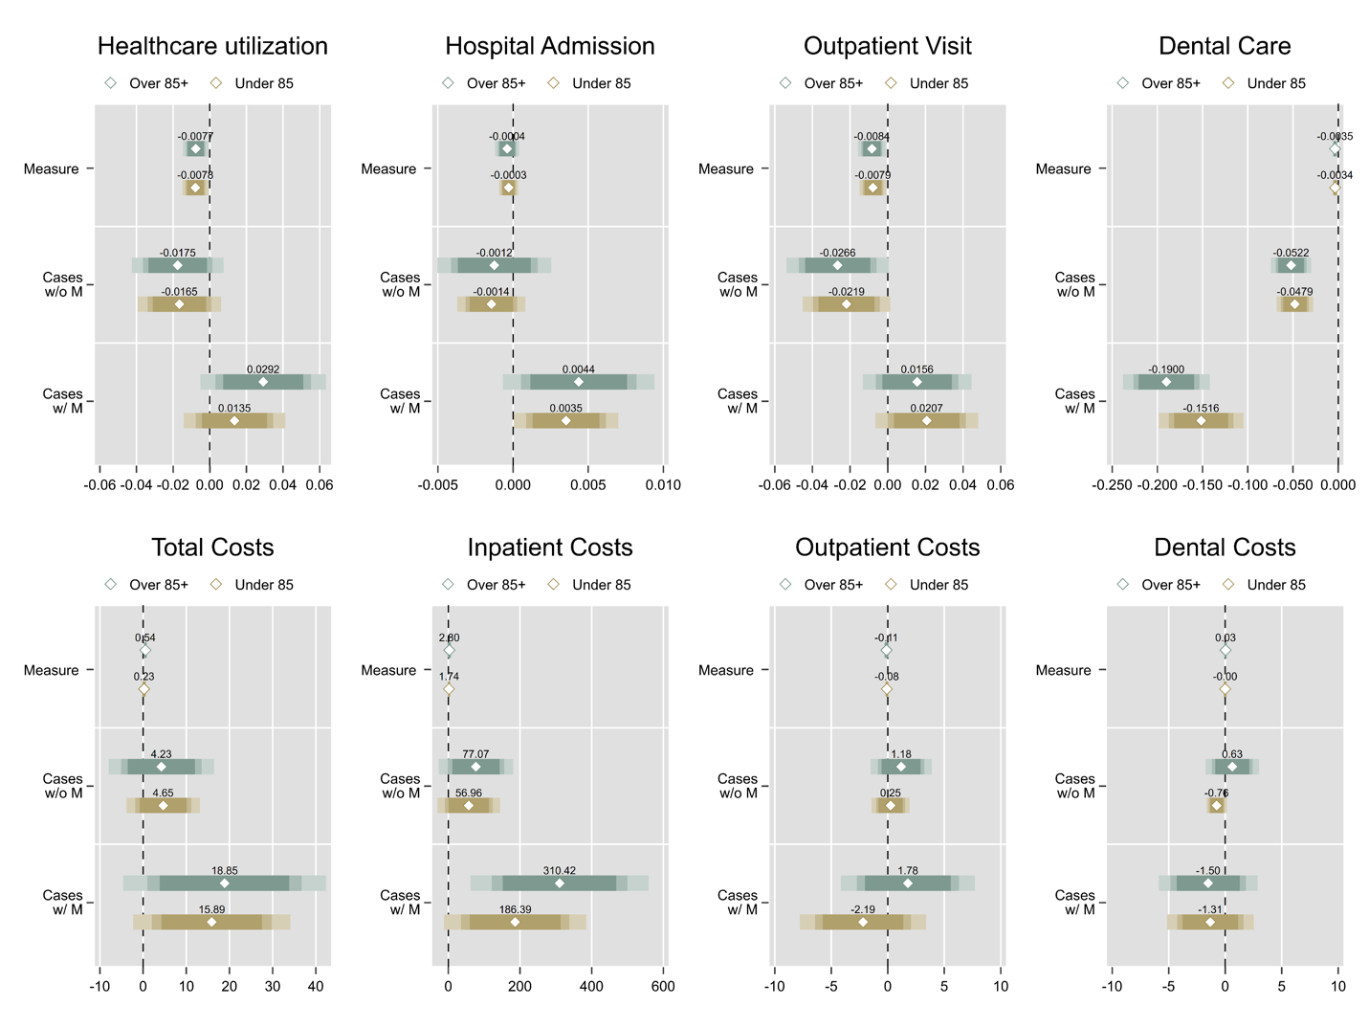
Figure B1. Relationship Between SoPE Measures and Healthcare Utilization Patterns by Age Group
Notes: Each graph is divided into three panels: “SoPE,” “Cases w/o SoPE,” and “Cases w/ SoPE.” The “SoPE” panel illustrates the marginal effect of SoPE measures as described in Equation (1). The panels “Cases w/o SoPE” and “Cases w/ SoPE” represent the marginal effects of changes in COVID-19 case numbers without and with SoPE measures, respectively, following the specification of Equation (2). Point estimate is presented for each marker, accompanied by bars depicting confidence intervals: the light color indicates a 95% confidence interval, and the darker color indicates a 90% confidence interval.
We further analyze patterns by gender, estimating separate models for male and female subsamples. Results presented in Figure B2 demonstrates similar relationships between pandemic severity and healthcare utilization across gender groups. Both males and females show comparable responses to SoPE measures, with only minor variations in magnitude.
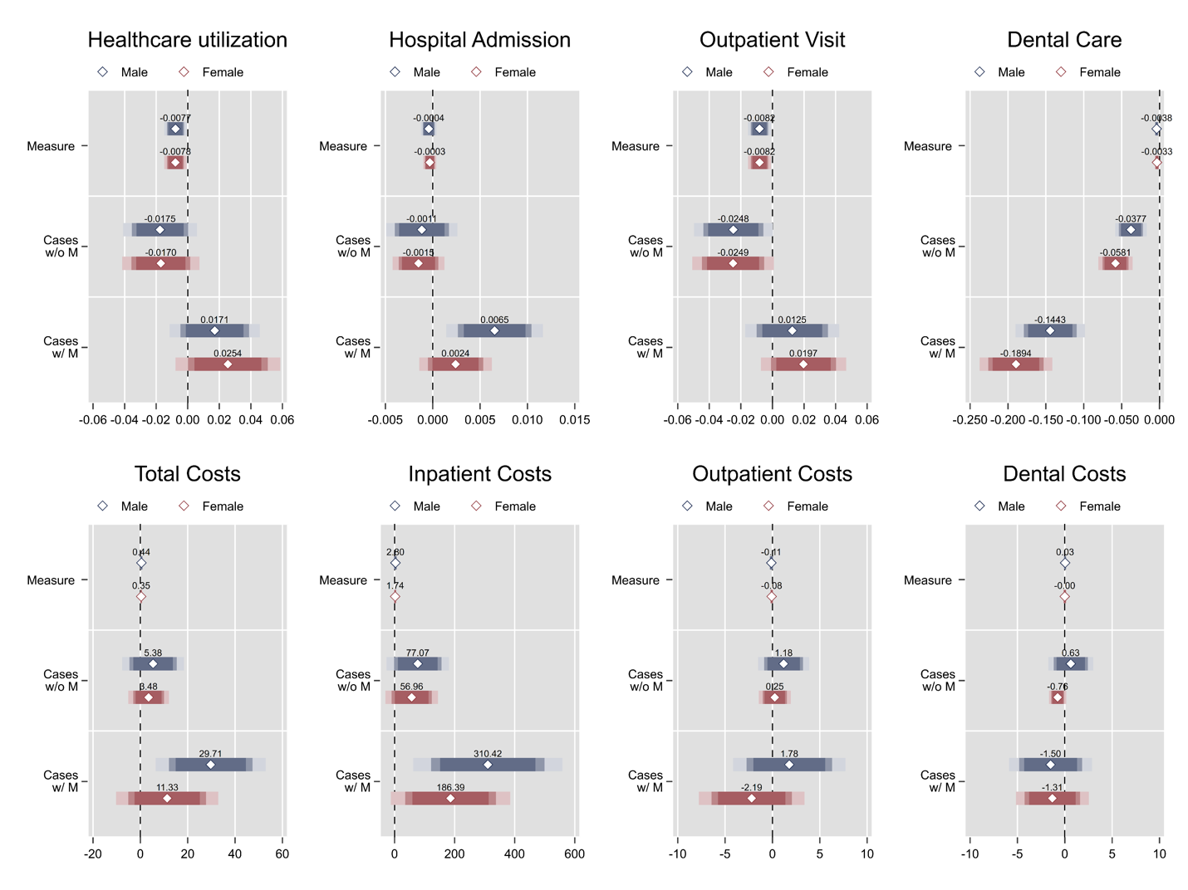
Figure B2. Relationship Between SoPE Measures and Healthcare Utilization Patterns by Gender
Notes: Each graph is divided into three panels: “SoPE,” “Cases w/o SoPE,” and “Cases w/ SoPE.” The “SoPE” panel illustrates the marginal effect of SoPE measures as described in Equation (1). The panels “Cases w/o SoPE” and “Cases w/ SoPE” represent the marginal effects of changes in COVID-19 case numbers without and with SoPE measures, respectively, following the specification of Equation (2). Point estimate is presented for each marker, accompanied by bars depicting confidence intervals: the light color indicates a 95% confidence interval, and the darker color indicates a 90% confidence interval.
These analyses across different specifications and subgroups provide support for the robustness of our main findings. The consistency of patterns across various demographic and socioeconomic groups suggests that our observed relationships between healthcare utilization, pandemic severity, and public health measures represent broader patterns rather than artifacts of particular subgroups or modeling choices.

