Supplementary Information for
Reticulating Node-Linker-Modulator Chemical Spaces for Modular Design of Glasses and Liquids

Ying Liu,¹ Chenghang Qi,¹ Rui-Fang Ma,² Yihui Zhu,³ Yin Zheng,² Ming-Hua Zeng,² Gengxin Liu,³ Yingbo Zhao^{1,4,*}
Contents
Methods
Supplementary Figures and Table
Supplementary Fig. 1: Digital image of Ti-TB-TMBA-x% network.
Supplementary Fig. 2: X-ray diffraction pattern (XRD) of Ti-TB, Ti-TB-TMBA-50%, Zr-TB, Zr-TB-TMBA-50% network and ligand TB.
Supplementary Fig. 3: Pair distribution function (PDF) of Ti-TB network
Supplementary Fig. 4: Different ratio of Ti-TB-TMBA Tg, Delta cp and viscosity summary.
Supplementary Fig. 5: Thermogravimetric analysis (TGA) of Ti-TB, Zr-TB, B-GDPA network.
Supplementary Fig. 6: Infrared Spectroscopy of Ti-TB network.
Supplementary Fig. 7: The viscosity of Ti-TB-TMBA-10%, 20%, 25%, 33%, 40%, 50% under different shear rates.
Supplementary Fig. 8: Pair distribution function (PDF) of Zr-TB network and Zr-TB-TMBA-10%.
Supplementary Fig. 9: The viscosity of Zr-TB-POE-10%, 20%, 25%, 33%, 40%, 50% under different shear rates.
Supplementary Fig. 10: The storage modulus and loss modulus of Zr-TB-POE- 20%, 25%, 33%, 40% under different angular frequencies.
Supplementary Fig. 11: Differential scanning calorimetry (DSC) of Ti-PEG5-TMBA-10%, 20%, 30% at scan rate of 10℃/min.
Supplementary Fig. 12: Differential scanning calorimetry (DSC) of Ti-PEG5-TMBA-30% at scan rate of 5, 10,15, 20, 25, 30, 40, 50℃/min.
Supplementary Fig. 13: Differential scanning calorimetry (DSC) of Ti-PEG5-POE-10%, 20%, 30%, 40%, 50% at scan rate of 10℃/min.
Supplementary Fig. 14: Differential scanning calorimetry (DSC) of Ti-PEG5-POE-30% at scan rate of 5, 10,15, 20, 25, 30, 40, 50℃/min.
Supplementary Fig.15: X-ray diffraction pattern (XRD) of B-GDPA, B-GDPA-TMBA-50%, network and ligand GDPA.
Supplementary references

Methods
Materials. TTIP (98%, J&K), Zirconium n-butoxide (80 wt. % in 1-butanol, Aladdin), Trimethyl Borate(B(OMe)₃, >98.0%(T), TCI), Pentaethylene Glycol (99%, Adamas), TB (97%, Yanshen Technology Co., Ltd.), GDPA (95+%, Yanshen Technology Co., Ltd.), 3,4,5-Trimethoxybenzyl Alcohol (TMBA, >98.0%, Aladdin), Phenoxyethanol (POE, 94%, Bide Pharmatech Ltd.) , Ethanol (99.5%, J&K), SiO₂/p++Si substrate(RDMICRO Co., Ltd.), Poly-l-lysine (Ted Pella, Inc.) and Nanotube (NanoIntegris, Inc).
The synthesis of Ti-TB/Zr-TB network. TB (109.5 mg, 0.25 mmol) was dissolved in 3 mL ethanol and stirred to achieve a uniform solution, TTIP (106.5 mg, 0.375 mmol) was then added. The reaction was carried out at 80 °C for 24 h. Then the mixture was poured into a petri dish at 80 °C for 1 hour to obtain glassy network.¹ For Zr-TB, zirconium butoxide butanol solution (119.7mg (contained 20% butanol), 0.25 mmol) was added instead of TTIP.
The synthesis of Ti-TB-TMBA series. Ti -TB-TMBA-10%: TB (109.5 mg, 0.25 mmol) and TMBA (1337.8mg, 6.75mmol) were dissolved in 3 mL ethanol and stirred to achieve a uniform solution, where the OH group from TB (0.75 mmol) accounts for 10% of all OH groups from linker and modulator combined (0.75 mmol from TB and 6.75 mmol from TMBA give overall OH group of 7.5 mmol). TTIP (106.5 mg, 0.375 mmol) is added to this solution. For other network ratio, the amount of TMBA is scaled down with respect to TB while the molar ratio of TB and Ti are kept at 2:3. The reaction was carried out at 80 °C for 24 h. The mixture was poured into a petri dish at 80 °C for 1 hour to obtain glassy network.
The synthesis of other node-linker-strut series. These syntheses were carried out in similar manners as the Ti-TB-TMBA series with the corresponding linkers and modulators. For Zr-based series, zirconium butoxide solution (179.85mg, contained 20% butanol, 0.375mmol) was added instead of 106.5 mg TTIP.² ³
The synthesis of B-GDPA-POE series. B-GDPA-POE-10%: GDPA (22.4 mg, 0.04 mmol) and POE (99.4mg, 0.72mmol) were dissolved in 2 mL ethanol and stirred to achieve a uniform solution, followed by the addition of B(OMe)₃ (4.2 mg, 0.04 mmol). The reaction was carried out at 80 °C for 24 h. The mixture was poured into a petri dish at 80 °C for 1 hour to obtain glassy network. The OH group from GDPA (0.08 mmol) accounts for 10% of all OH groups from linker and modulator combined (0.08 mmol from GDPA and 0.72 mmol from POE give overall OH group of 0.8 mmol). For other network ratio, the amount of POE is varied with respect to GDPA, while the molar ratio between boron and GDPA is kept at 1:1. The B-GDPA synthesis process is identical to B-GDPA-POE synthesis except for the added POE.
AC electroluminescence device. SiO₂/p++Si substrate with 100 nm oxide layer was washed by piranha solution, followed by O₂ plasma treatment for 3 min. Poly-l-lysine solution was dropped on the clean substrate and then washed with Ultrapure water. Afterwards, semiconducting carbon nanotubes solution was used to soak the substrate for 15 min followed by washing with ultrapure water. The substrates were annealed in a mixed gas (5% H₂ in Ar) atmosphere at 250℃ for 1 h. After deposition of the source electrodes (Au) using Ebeam (Electron Beam Evaporation), the metal electrodes were patterned to form the fork finger electrodes using ML3 (laser direct writing technique). Finally, carbon nanotubes outside the device area were etched with O₂ plasma using UV lithography⁴.The B-GDPA solution was stirred for 24 hours, dropped on the CNT top layer of the device and then heated at 80°C for 1 hr. The square wave AC signal to drive the device is generated from the ATG-2021H power signal generator of Aigtek Electronic Technology Co., Ltd.
X-ray diffraction and total scattering. Powder X-ray diffraction data were collected on a Rigaku MiniFlex using CuKα (λ = 1.5418 Å) radiation. The X-ray total scattering measurements were performed at room temperature using a Rigaku SmartLab Studio II high energy X-ray diffractometer with Ag anode. The samples were loaded in quartz glass capillaries with a diameter of 0.7 mm and a thickness of 0.01 mm. The diffraction data were collected by detectors in scattering angle range of 3º to 157º with speed of 0.1 º/min. The duration of the measurement was 26 h for each sample.
Differential scanning calorimetry and Thermogravimetric analysis. The glass temperature transition of samples was measured using a TA Instruments DSC 250 differential scanning calorimeter with RCS 90 cooler. The samples of approximately 5-10 mg were loaded in Tzero Aluminium hermitic pans. All samples were equilibrated first to -90 °C and then heated to 50 °C to erase the thermal history, before collecting the DSC data at a ramp rate of 10 °C min⁻¹. The data were acquired from the second heating cycle. Thermogravimetric analysis was conducted using a TA Instrument TGA 55 instrument under an Nitrogen atmosphere with a heating rate of 10 °C min⁻¹ in the temperature range from 30 °C to 800 °C.
Dynamic mechanical analysis. DMA was carried out by a PerkinElmer DMA8000 dynamic mechanical analysis machine with powder kits with 0.02mm strain at 1Hz and temperature range of -50 °C to 50 °C at a rate of 2 °C min⁻¹. The Tan delta was defined as the ratio of the loss modulus E" to the energy storage modulus E′.
Rheology measurements. The rheology measurements were performed on a TA Instrument ARES-G2 with a 25mm aluminum parallel plate, the low viscosity sample (e.g. Ti-TB-TMBA-10%, 20%, 25%, 33%) was measured by slow-sweep mode; otherwise samples with high modulus (e.g. Ti-TB-TMBA-40%, 50%) was measured by small amplitude oscillatory shear mode. all the samples were tested at 25 ℃ expect for varied temperature measurements. For slow sweep mode: shear rate 1 to 1001/s; points per decad: 5; off equilibration time 10.0 s; averaging time 30.0 s. In small amplitude oscillatory shear mode, active mode in axial force adjustment was used for compression, the samples were applied to 0.01% strain rate, and oscillated at a logarithmic sweep angular frequency of 100 to 0.1 rad/s with 6 points per decade. Variable temperature measurements was conducted by oscillation temperature ramp mode. The samples were applied with 10 rad/s angular frequency at 0.01% strain rate. The temperature was scanned from -40 ℃ to 120 ℃ with 5 ℃/min ramp rate. The data acquisition had 3s delay time in correlation mode.
Photoluminescence and infrared Spectroscopy. PL spectra were obtained with a Meta Test Corporation equipped with mLaser_C03. Infrared spectroscopy was measured with a Perkin Elmer FT-IR Spectrometer Frontier instrument.
Photoluminescence quantum yield (PLQY). HORIBA Fluorolog-3 is used to measure PLQY. The sample is evenly dispersed on a 5mm x 5mm x 1mm quartz glass substrate while taking a blank quartz glass sheet of the same size as the reference. The prepared sample is placed in the integrating sphere, and the monochromatic light of 350nm is introduced into the sample in the integrating sphere through the optical fiber. By keeping the excitation wavelength unchanged at 350nm, the number of photons absorbed by the sample can be determined by integrating the fluorescence spectrum of the sample and the blank reference at 330nm-370nm, and the number of photons emitted by the sample can be determined by integrating the fluorescence spectrum between 370nm-600nm with the same method.

Supplementary Figures

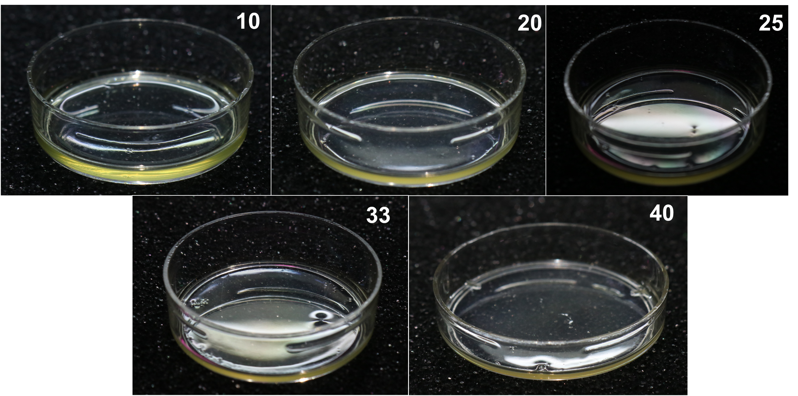
Supplementary Fig. 1: Digital Figures of Ti-TB-TMBA. The TMBA ratios in this figure are 10%, 20%, 25%, 33%, 40%.

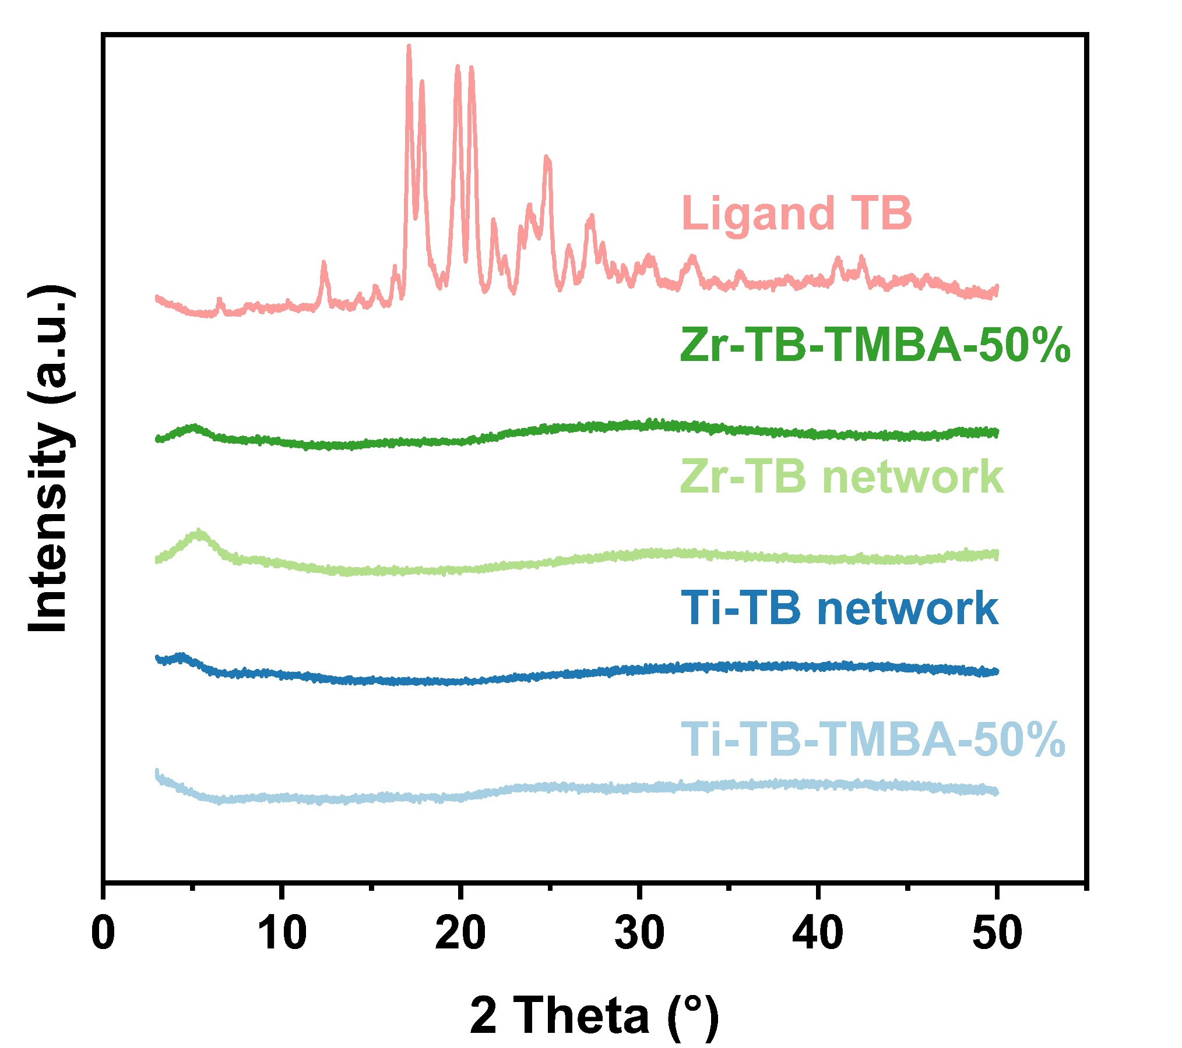
Supplementary Fig. 2: X-ray diffraction pattern of Ti-TB, Ti-TB-TMBA-50%, Zr-TB, Zr-TB-TMBA-50% network and ligand TB.
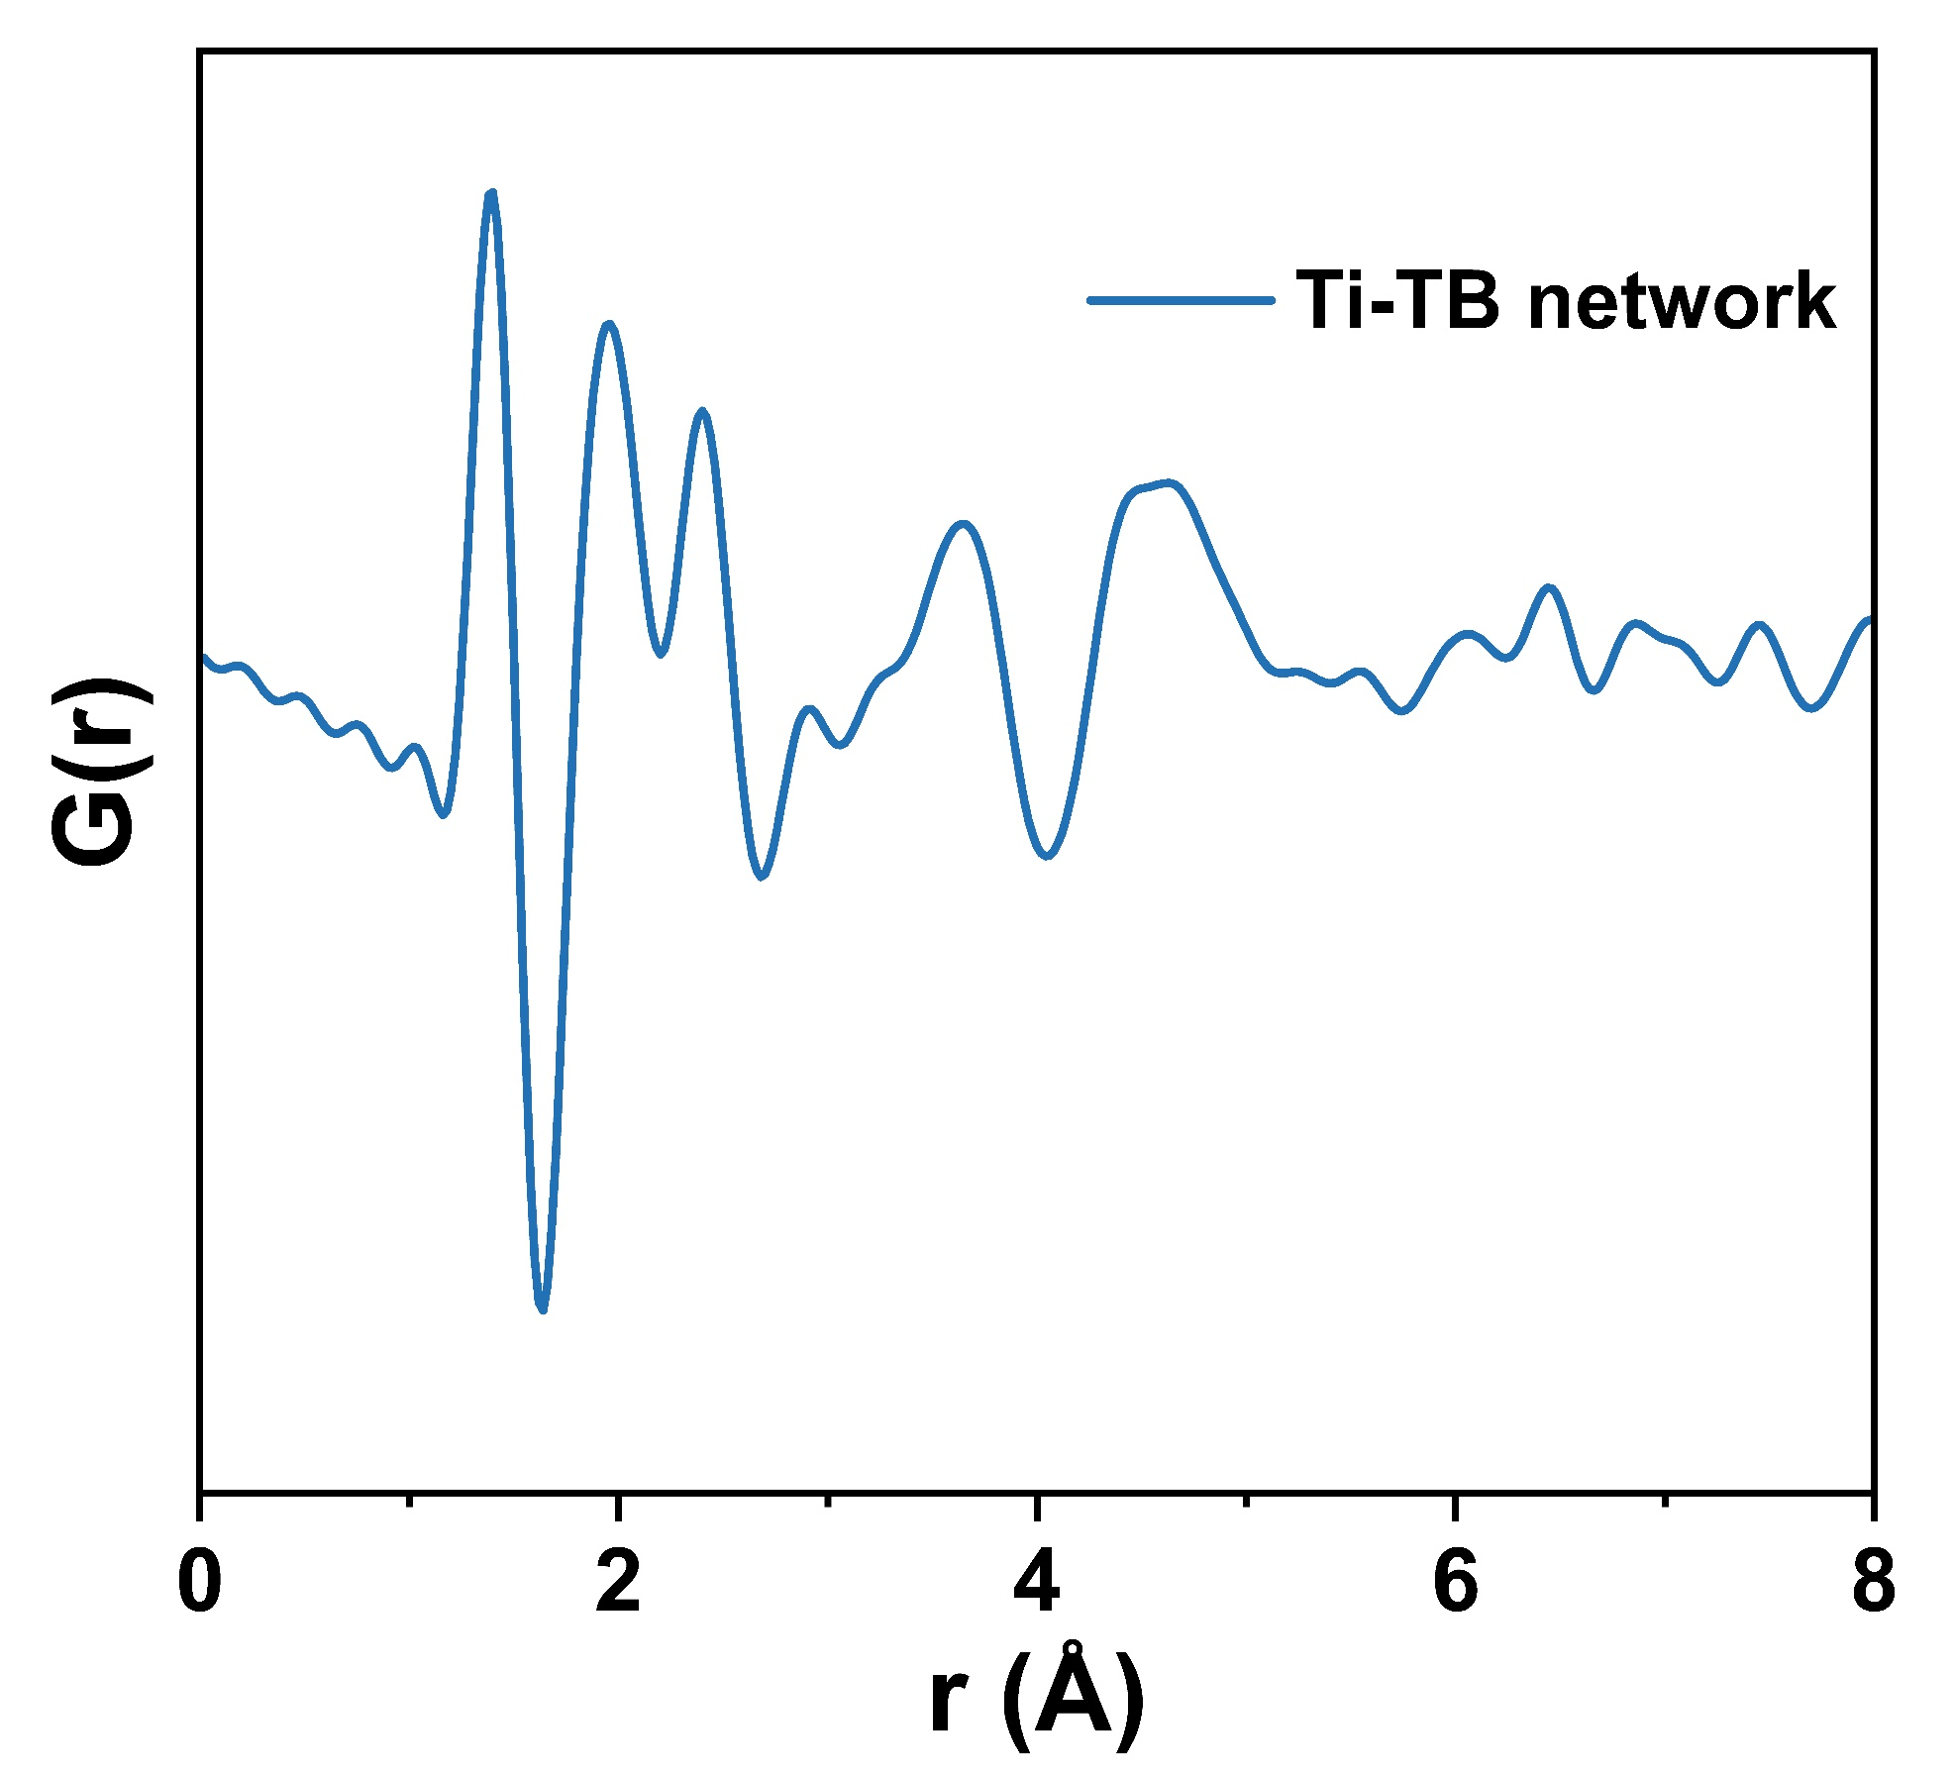
Supplementary Fig. 3: Pair distribution function of Ti-TB network. The pairs are assigned referring Ti₁₆O₁₆(oEt)₃₂ cluster⁵ : C-O/C~1.38-1.42Å; Ti-O~1.96Å; C-O-C~2.42Å; Ti…Ti~3.1-3.3Å.
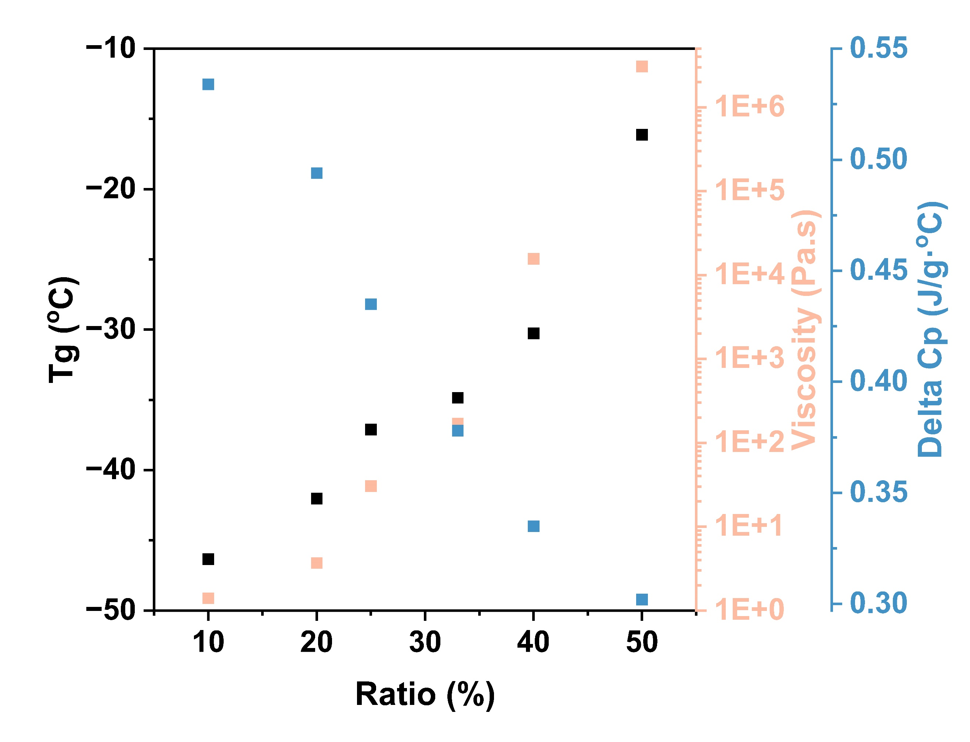
Supplementary Fig. 4: Scaling of the T_{g}, Delta cp and viscosity for the Ti-TB-TMBA series.

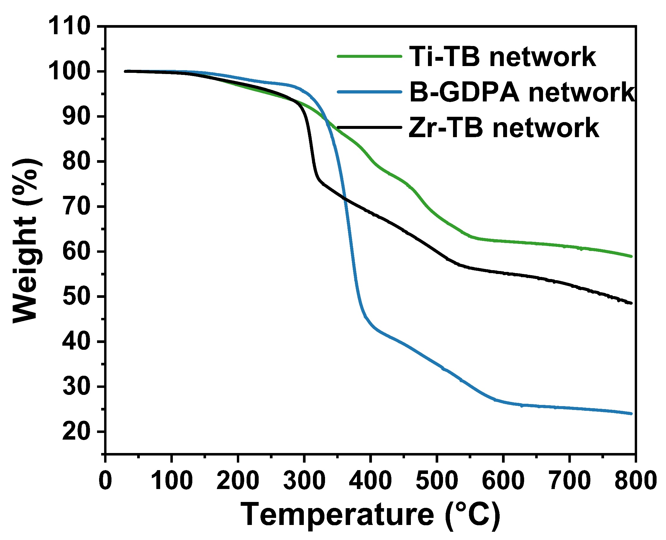
Supplementary Fig. 5: Thermogravimetric analysis of Ti-TB, Zr-TB, B-GDPA network.

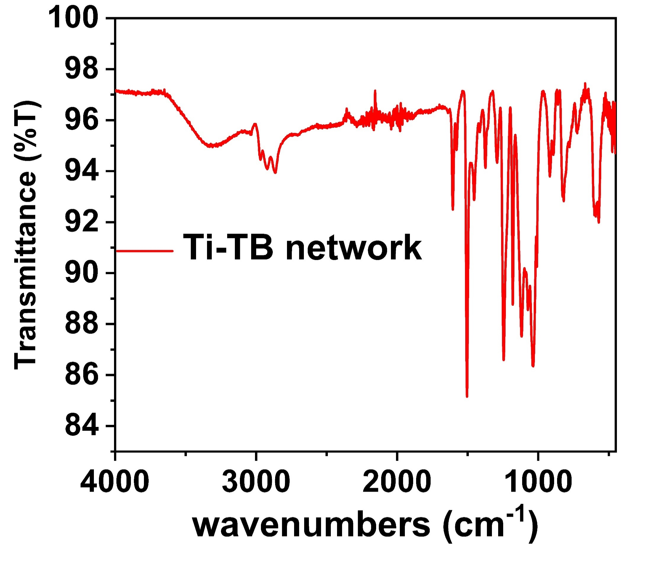
Supplementary Fig. 6: Infrared Spectroscopy of Ti-TB network.

A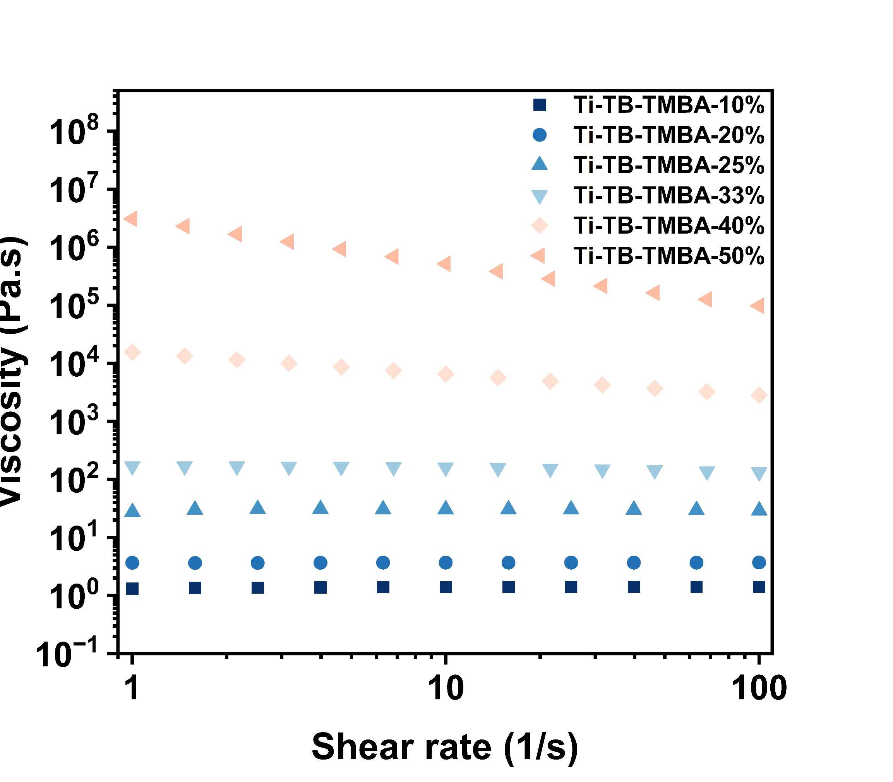
Supplementary Fig. 7: The viscosity of Ti-TB-TMBA-10%, 20%, 25%, 33%, 40%, 50% under different shear rates. Shear thinning is observed for Ti-TB-TMBA-40% and 50%, indicating the formation of polymeric networks.
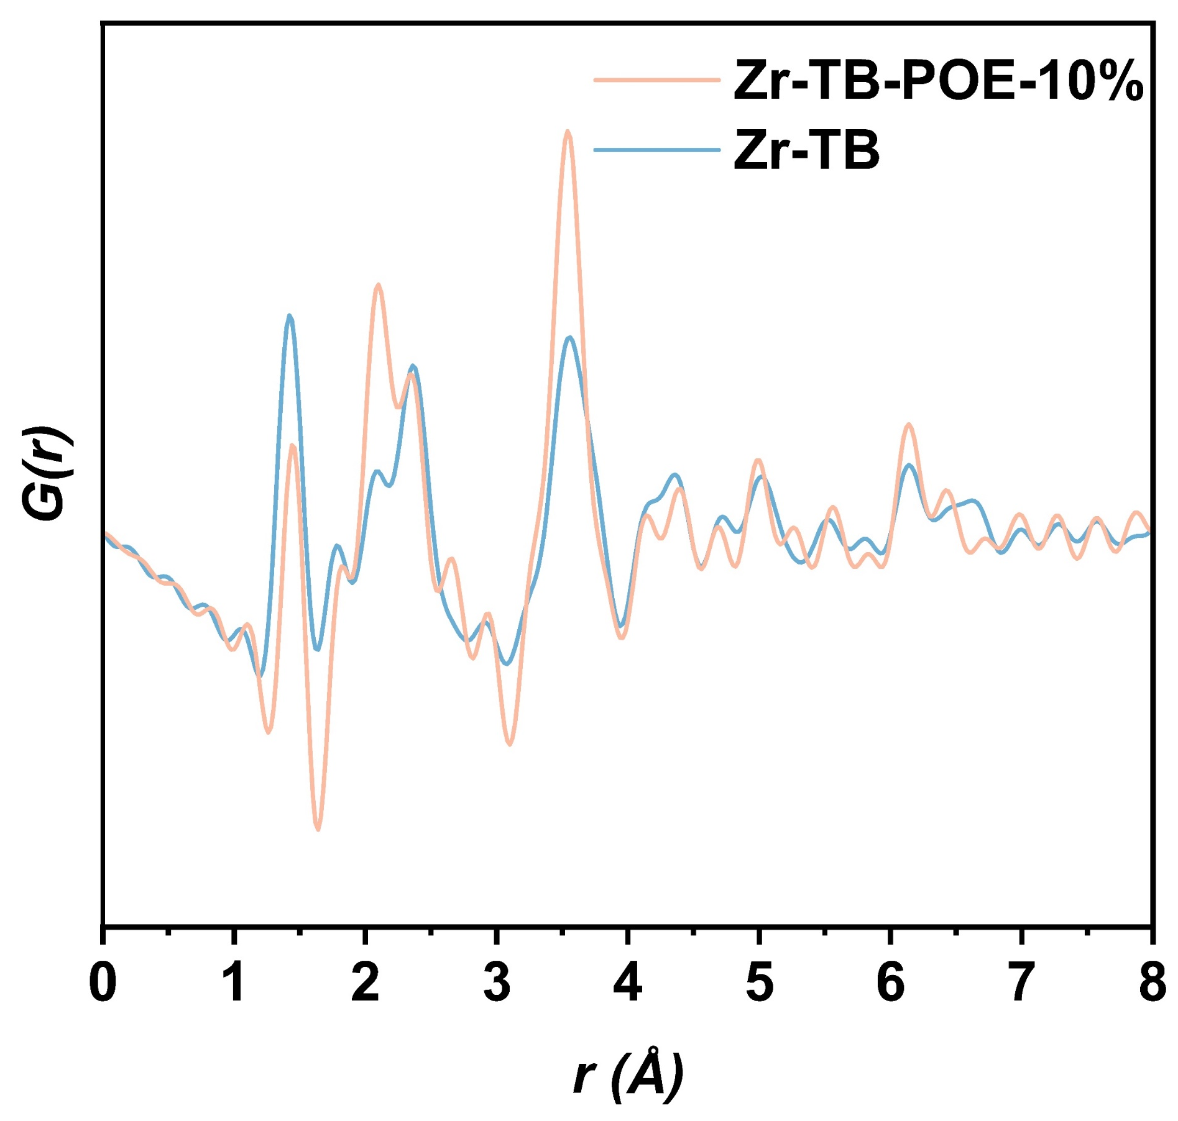
Supplementary Fig. 8: Pair distribution function of Zr-TB network and Zr-TB-TMBA-10%.

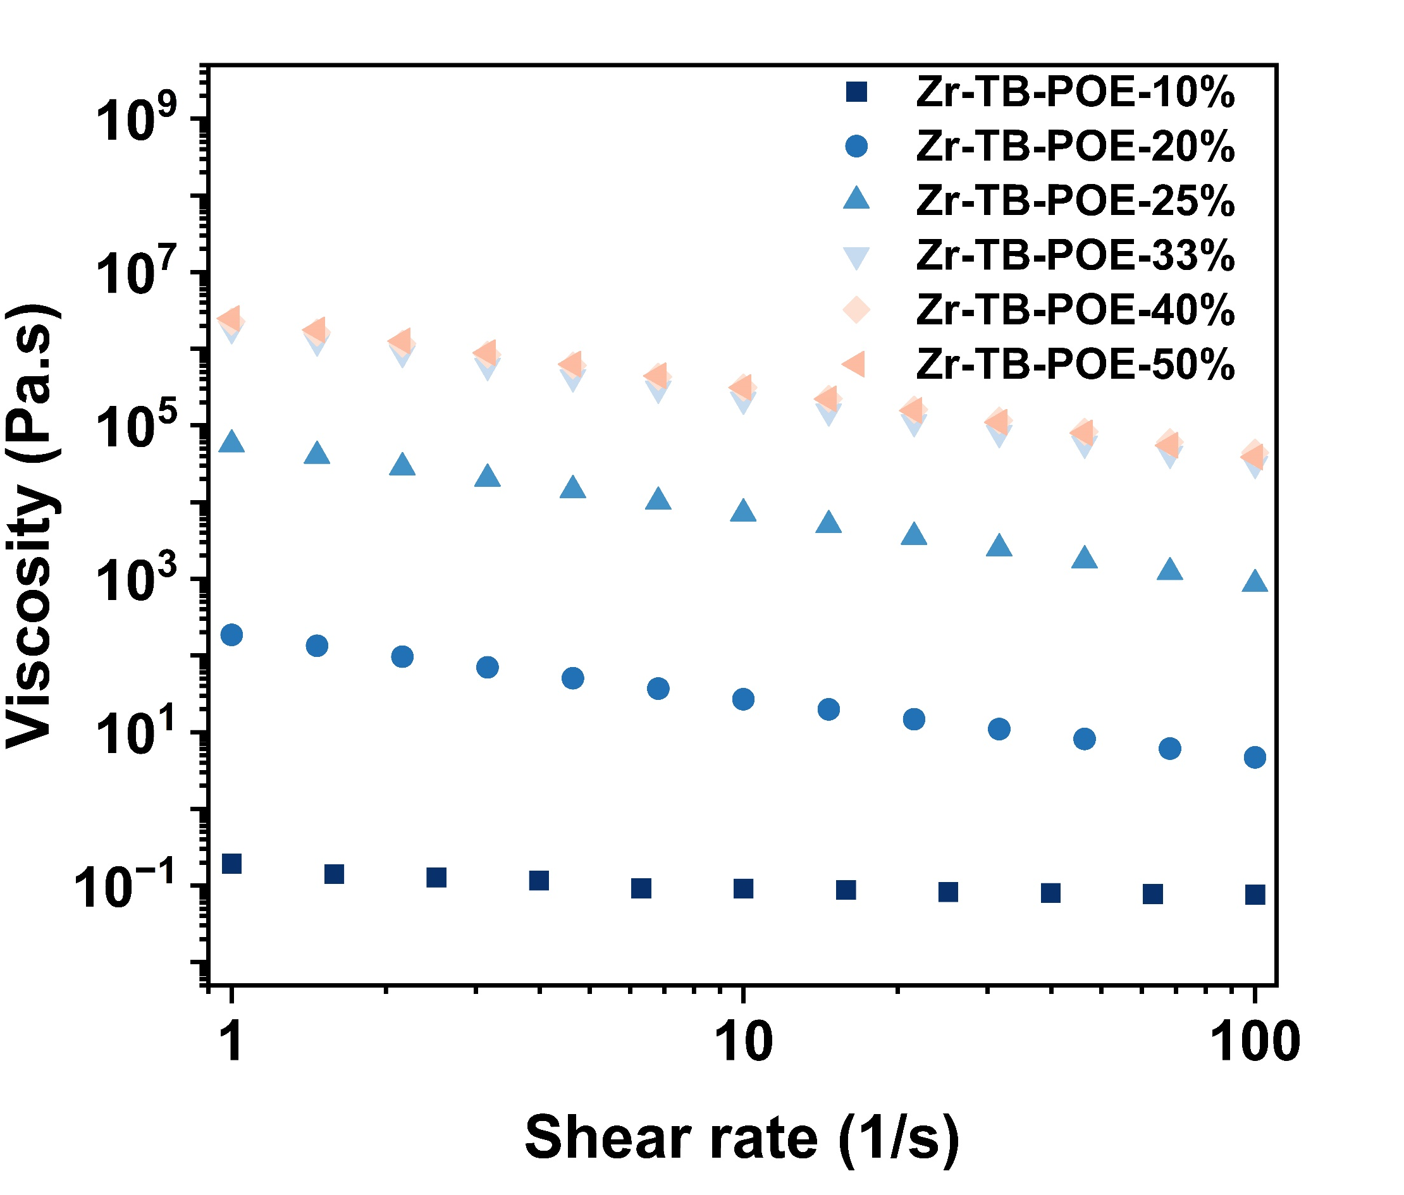
Supplementary Fig. 9: The viscosity of Zr-TB-POE-10%, 20%, 25%, 33%, 40%, 50% showing shear thinning.
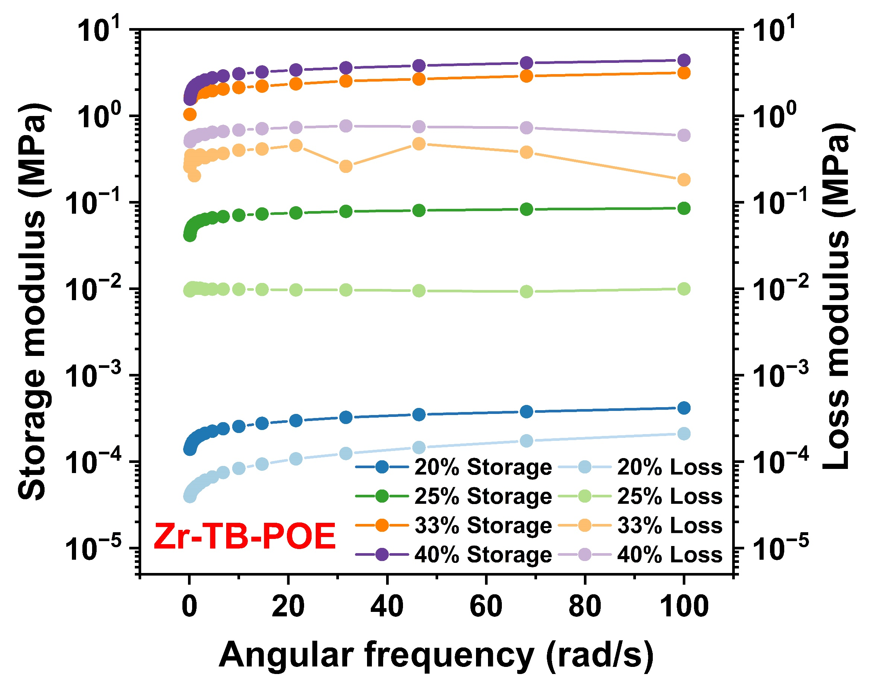
Supplementary Fig. 10: The storage modulus and loss modulus of Zr-TB-POE- 20%, 25%, 33%, 40% under different angular frequencies. The storage modulus were higher than loss modulus, which indicate all the samples behaved as elastic solid.

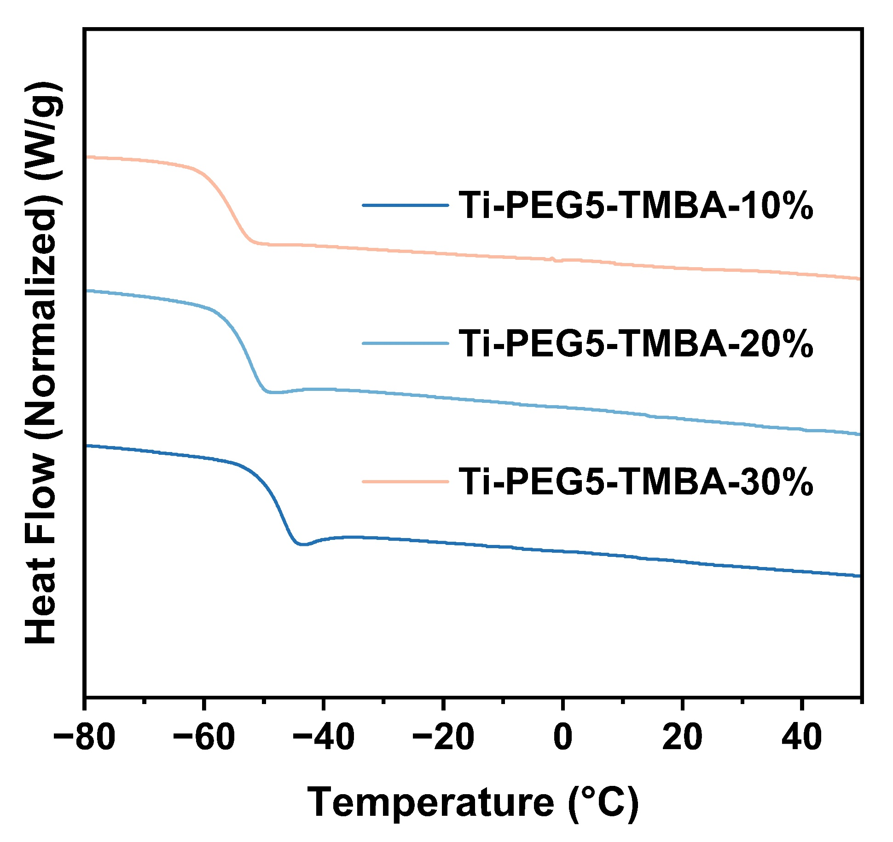
Supplementary Fig.11: Differential scanning calorimetry of Ti-PEG5-TMBA-10%, 20%, 30% at scan rate of 10 K/min.
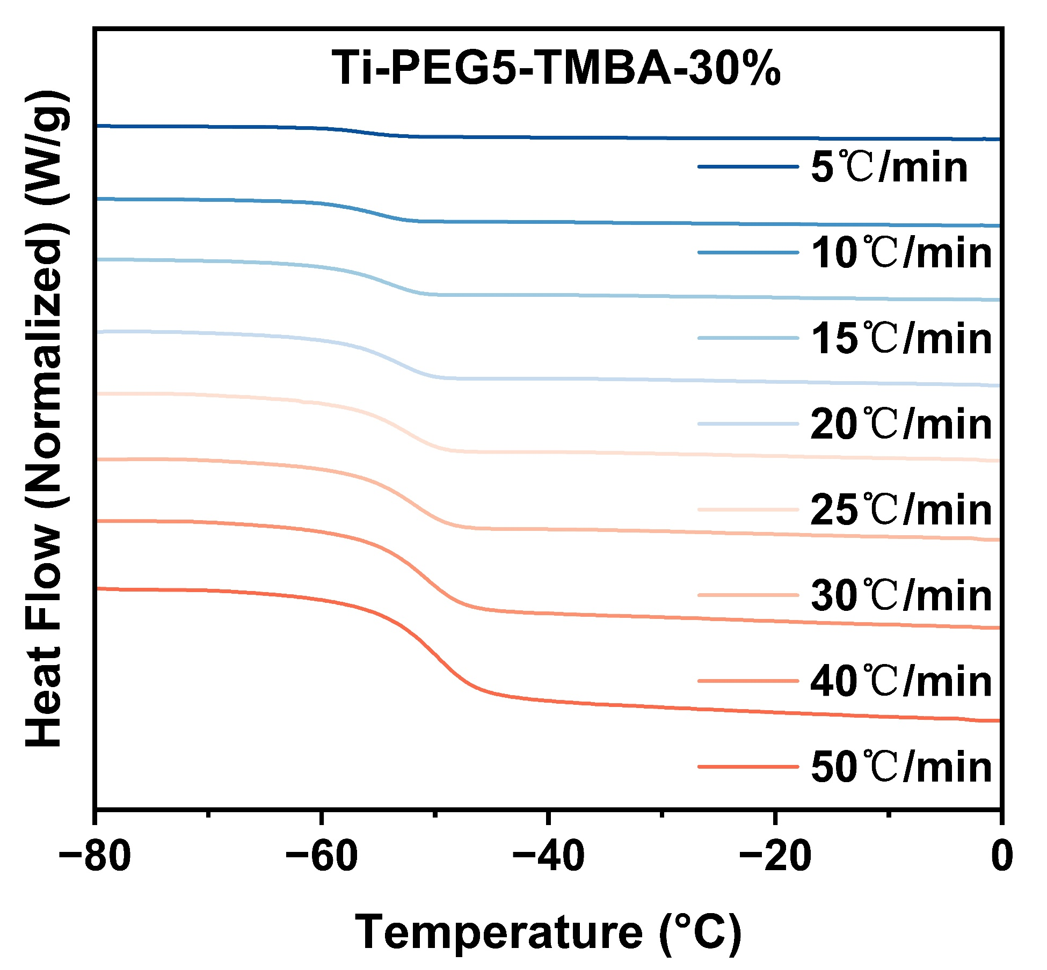
Supplementary Fig. 12: Differential scanning calorimetry of Ti-PEG5-TMBA-30% at scan rate of 5, 10,15, 20, 25, 30, 40, 50 K/min.
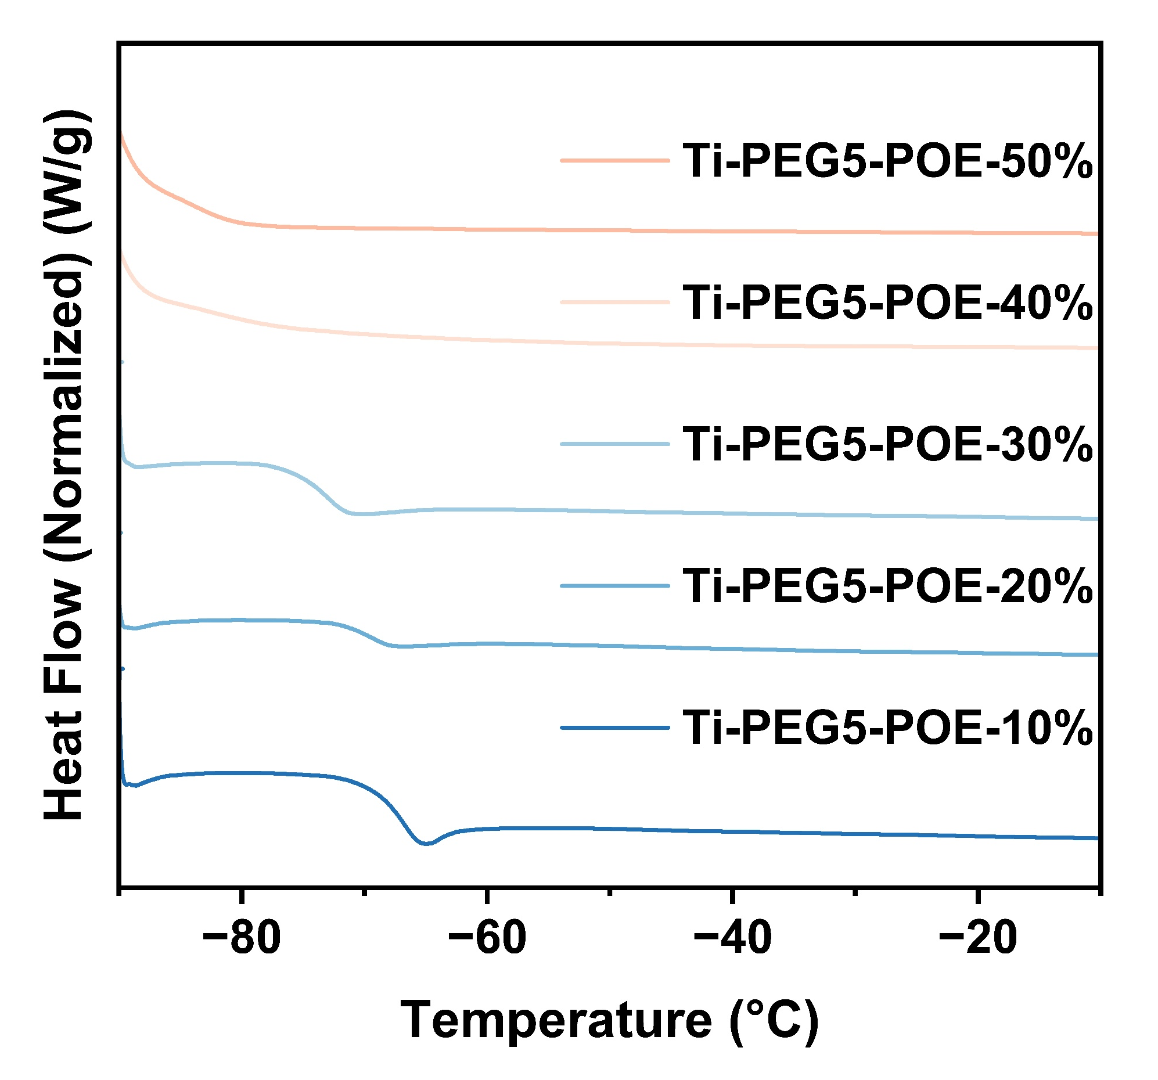
Supplementary Fig. 13: Differential scanning calorimetry of Ti-PEG5-POE-10%, 20%, 30%, 40%, 50% at scan rate of 10 K/min.
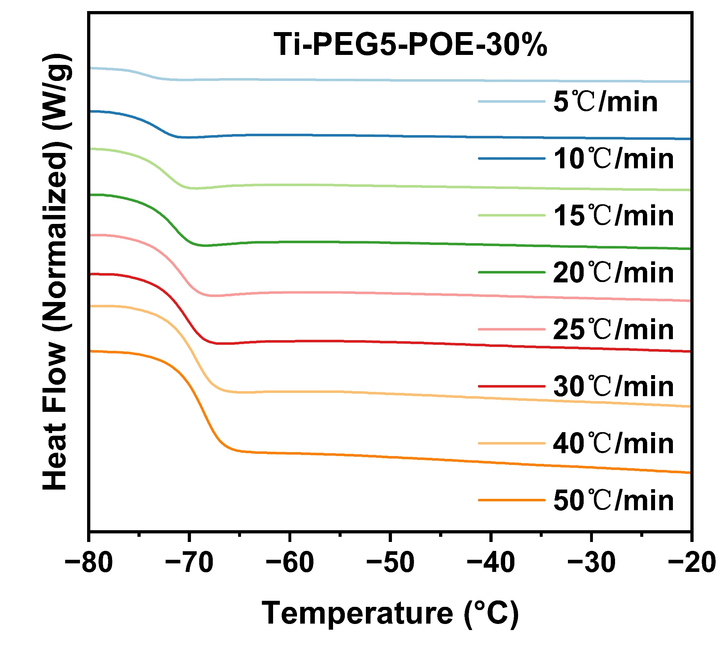
Supplementary Fig. 14: Differential scanning calorimetry of Ti-PEG5-POE-30% at scan rate of 5, 10,15, 20, 25, 30, 40, 50 K/min.

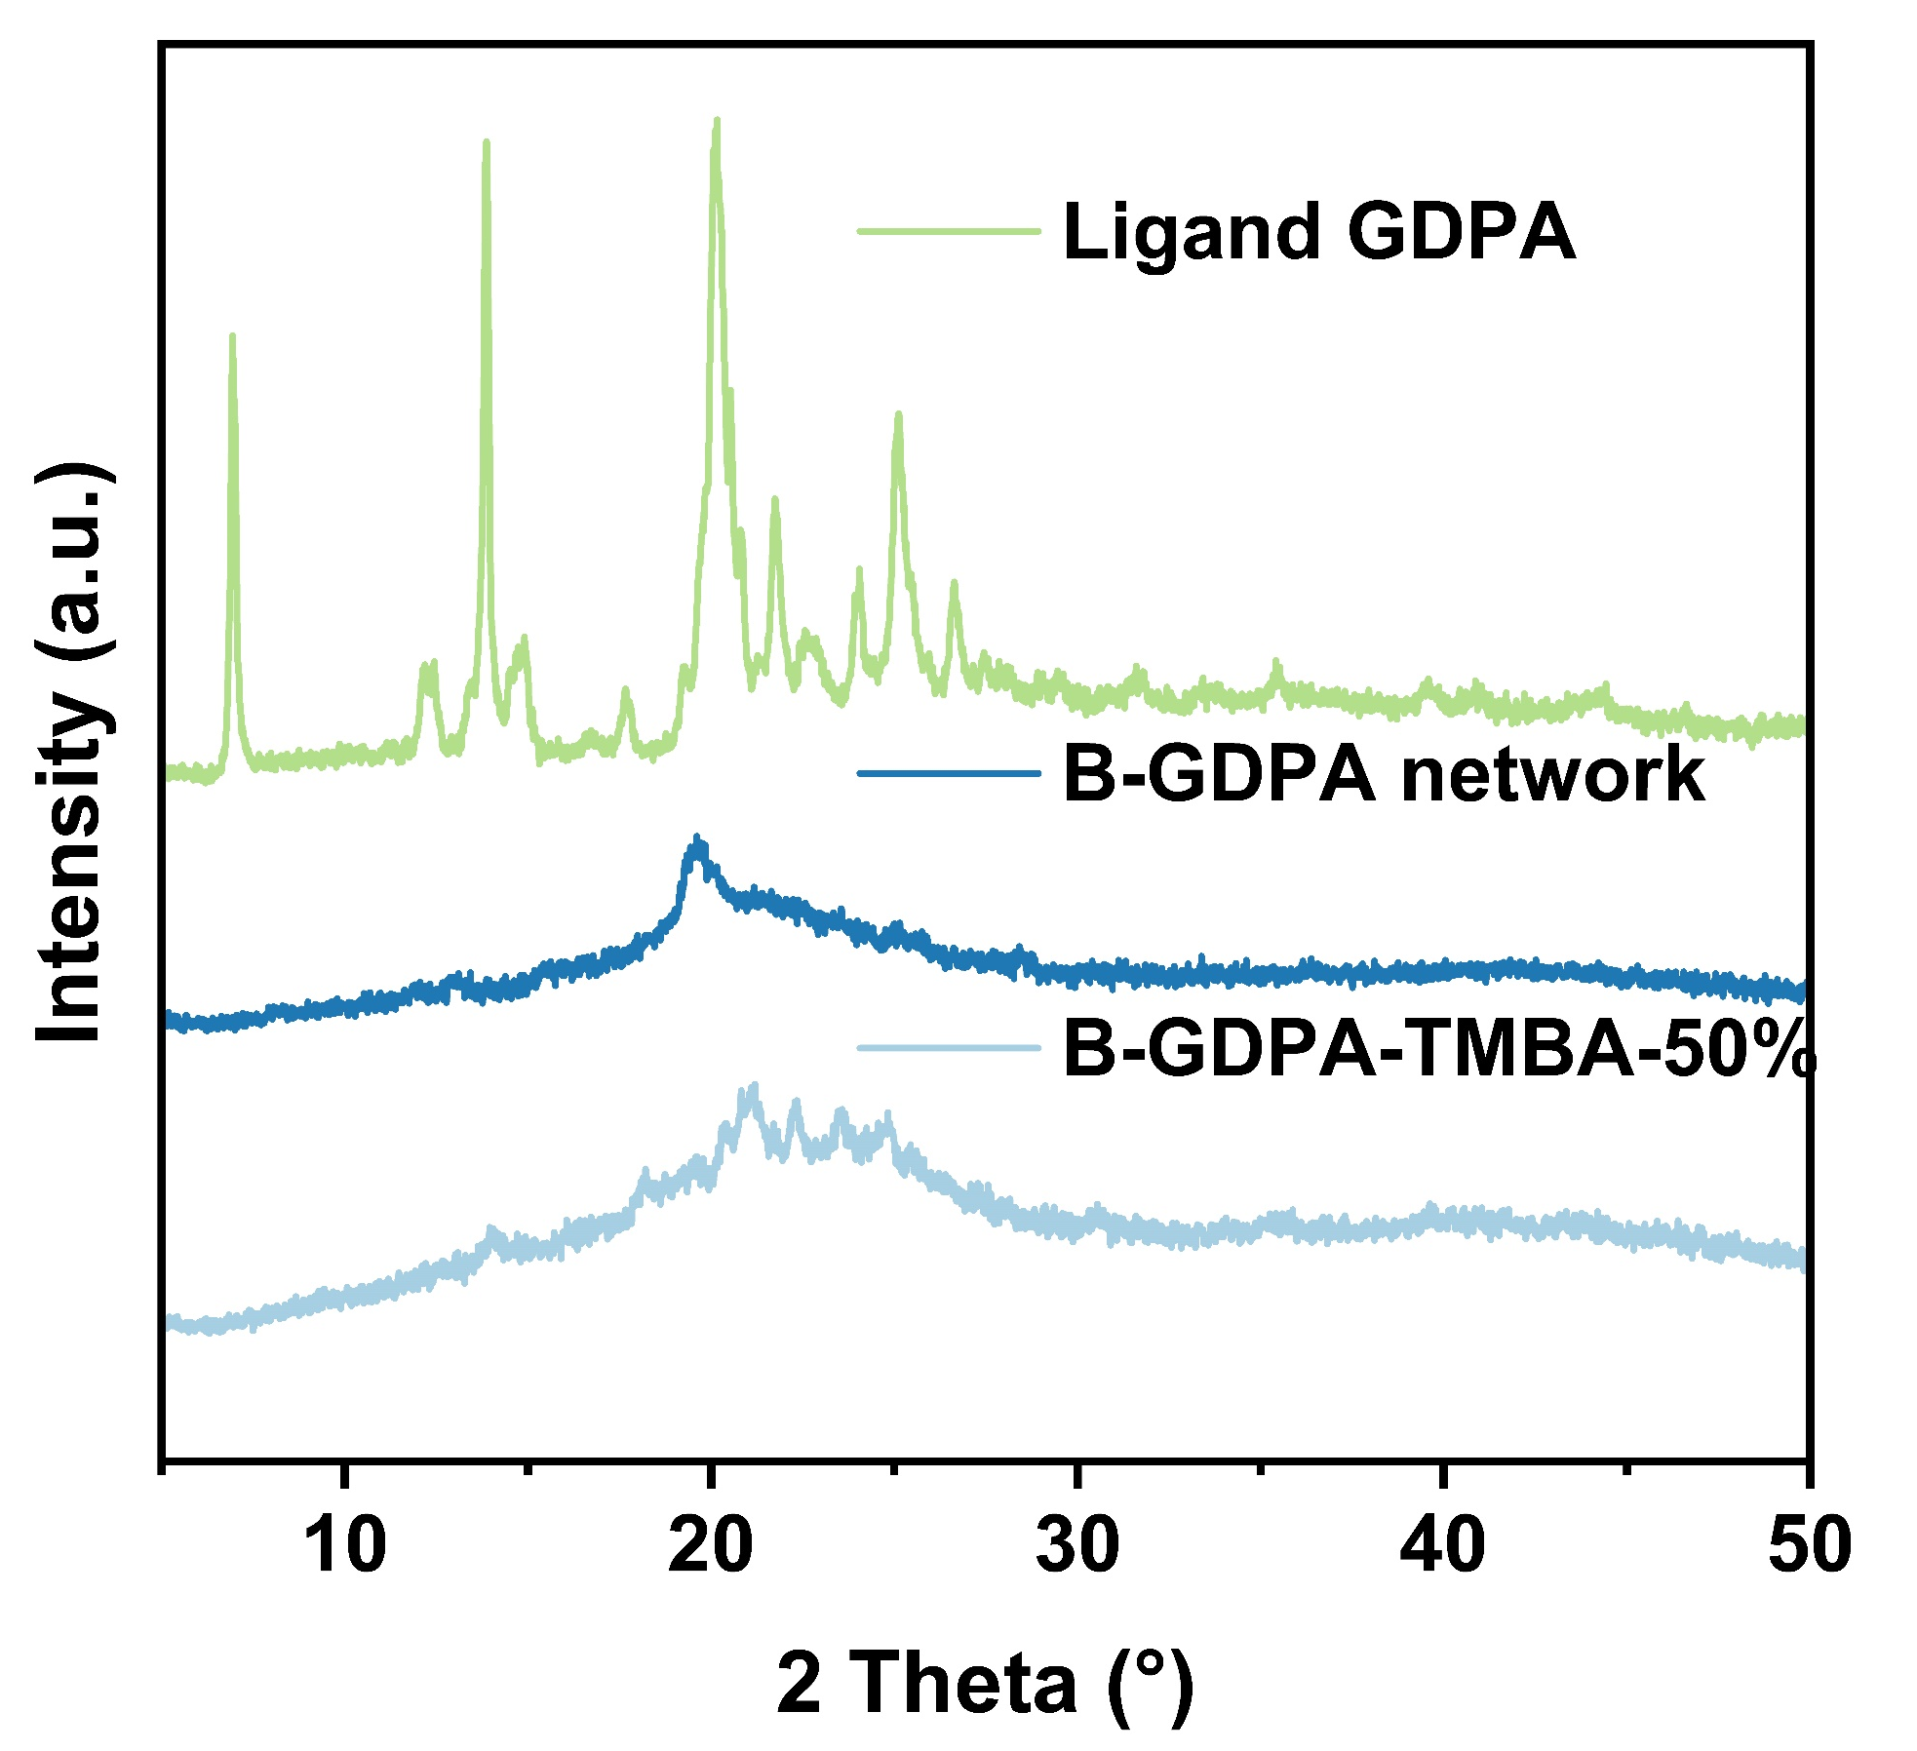
Supplementary Fig.15: X-ray diffraction pattern (XRD) of B-GDPA, B-GDPA-TMBA-50% and ligand GDPA.

Supplementary references
1 Zhang, Y. et al. Monolithic Titanium Alkoxide Networks for Lithium-Ion Conductive All-Solid-State Electrolytes. Nano Lett. 23, 4066-4073 (2023).
2 Zhao, Y., Lee, S. Y., Becknell, N., Yaghi, O. M. & Angell, C. A. Nanoporous Transparent MOF Glasses with Accessible Internal Surface. J. Am. Chem. Soc. 138, 10818-10821 (2016).
3 Xu, W. T. et al. High-Porosity Metal-Organic Framework Glasses. Angew. Chem. Int. Ed. 62, (2023).
4 Zhao, Y., Wang, V., Lien, D.-H. & Javey, A. A generic electroluminescent device for emission from infrared to ultraviolet wavelengths. Nat. Electron. 3, 612-621 (2020).
5 Fornasieri, G. et al. Reactivity of titanium oxo ethoxo cluster [Ti16O16(OEt)32].: Versatile precursor of nanobuilding block-based hybrid materials. J. Am. Chem. Soc. 127, 4869-4878 (2005).

