Table S1. Predictor variables and outcome variables

Predictor variables | Male | Female
Demographics
Age (Years) (Median, IQR) | ✓ | ✓
Country of birth | ✓ | ✓
Duration since arrival in Australia | ✓ | ✓
Sexual behaviours
Had unprotected anal sex after your last HIV test | ✓ | ✗
Sex oversea | ✓ | ✓
Ever MSM | ✓ | ✗
Had sex with men in the past 12 months | ✓ | ✓
Number of men you had sex with | ✓ | ✓
Had sex with women in the past 12 months | ✓ | ✓
Number of women you had sex with | ✓ | ✓
Condom use with male partner | ✓ | ✓
Condom use with female partner | ✓ | ✓
Anogenital skin symptoms
Itch | ✓ | ✓
Rash | ✓ | ✓
Lumps | ✓ | ✓
Spots | ✓ | ✓
Blisters and/ sores | ✓ | ✓
None of skin symptoms | ✓ | ✓
Site of skin symptoms | ✓ | ✓
Pain level of blisters and/sores | ✓ | ✓
2 Pictures of genital warts | ✓ | ✓
Picture of balanitis | ✓ | ✗
Picture of molluscum contagiosum | ✓ | ✓
Picture of syphilis | ✓ | ✗
2 Pictures of herpes simplex | ✓ | ✓
Picture of Tinea cruris | ✓ | ✓
Picture of pearly penile papule | ✓ | ✗
Picture of Fordyce spot | ✓ | ✗
Picture of Vestibular glands | ✗ | ✓
Urethral symptoms
Pain | ✓ | ✗
Pain scale | ✓ | ✗
Itch | ✓ | ✗
Unusual discharge | ✓ | ✗
None of urethral symptoms | ✓ | ✗
Type of discharge | ✓ | ✗
Urinary symptoms
Burning | ✓ | ✓
Urge to pass urine | ✓ | ✓
Blood | ✓ | ✓
Associated with fever | ✓ | ✓
No urinary symptom | ✓ | ✓
Duration of urinary symptoms | ✓ | ✓
Vaginal discharge symptoms
Unusual discharge | ✗ | ✓
Unusual smell | ✗ | ✓
Type of discharge | ✗ | ✓
Associated with itch | ✗ | ✓
Pelvic pain
Pain in Pelvic or genital area | ✗ | ✓
Location | ✗ | ✓
Pain scale | ✗ | ✓
Symptoms of Vaginal bleeding or dyspareunia
Bleeding during sex | ✗ | ✓
Spotting between period | ✗ | ✓
Pain during sex | ✗ | ✓
None of above symptoms | ✗ | ✓
Location of pain during sex | ✗ | ✓
Outcome variables
Diagnoses | Balanitis; Gonorrhoea; Herpes; Molluscum Contagiosum; Syphilis; NGU; UTI; Warts | Bacterial Vaginosis; Candidiasis; Cervicitis; Cystitis; Herpes; Molluscum Contagiosum; PID, Warts

Figure S1. Performance comparison of machine learning models during training and Validation in male clients

Figure S2. Performance comparison of machine learning models during training and validation in female clients

Table S2. Performance difference across validation, testing and external validation in male clients

- Syphilis (Male)
Anova: Two-Factor Without Replication
SUMMARY | Validation AUC | Testing AUC | Ext Testing AUC | Count | Sum | Average | Variance
GBC | 0.826 | 0.901 | 0.840 | 3 | 2.568 | 0.856 | 0.002
fine-tuned GBC | 0.849 | 0.901 | 0.840 | 3 | 2.590 | 0.863 | 0.001
Ensembled GBC | 0.827 | 0.903 | 0.865 | 3 | 2.595 | 0.865 | 0.001
Calibrated GBC | 0.824 | 0.880 | 0.842 | 3 | 2.545 | 0.848 | 0.001
XGBoost | 0.818 | 0.883 | 0.817 | 3 | 2.517 | 0.839 | 0.001
fine-tuned XGBoost | 0.782 | 0.883 | 0.817 | 3 | 2.481 | 0.827 | 0.003
Ensembled XGBoost | 0.820 | 0.913 | 0.855 | 3 | 2.588 | 0.863 | 0.002
Calibrated XGBoost | 0.825 | 0.912 | 0.829 | 3 | 2.566 | 0.855 | 0.002
RF | 0.816 | 0.889 | 0.925 | 3 | 2.631 | 0.877 | 0.003
fine-tuned RF | 0.847 | 0.889 | 0.925 | 3 | 2.662 | 0.887 | 0.002
Ensembled RF | 0.842 | 0.920 | 0.916 | 3 | 2.678 | 0.893 | 0.002
Calibrated RF | 0.823 | 0.911 | 0.833 | 3 | 2.568 | 0.856 | 0.002
ET | 0.802 | 0.876 | 0.849 | 3 | 2.527 | 0.842 | 0.001
fine-tuned ET | 0.836 | 0.876 | 0.849 | 3 | 2.560 | 0.853 | 0.000
Ensembled ET | 0.827 | 0.916 | 0.917 | 3 | 2.660 | 0.887 | 0.003
Calibrated ET | 0.814 | 0.900 | 0.860 | 3 | 2.574 | 0.858 | 0.002
Blended models | 0.832 | 0.918 | 0.895 | 3 | 2.645 | 0.882 | 0.002
Stacked model | 0.709 | 0.786 | 0.850 | 3 | 2.344 | 0.781 | 0.005
Validation AUC |  |  |  | 18 | 14.717 | 0.818 | 0.001
Testing AUC |  |  |  | 18 | 16.057 | 0.892 | 0.001
Ext Testing AUC |  |  |  | 18 | 15.524 | 0.862 | 0.001

ANOVA
Source of Variation | SS | df | MS | F | P-value | F crit
Rows | 0.03431368 | 17 | 0.002018451 | 3.26567067 | 0.00161495 | 1.93320683
Columns | 0.05056868 | 2 | 0.025284341 | 40.9077612 | 8.9352E-10 | 3.27589799
Error | 0.02101478 | 34 | 0.000618082
Total | 0.10589714 | 53

- Warts (Male)
Anova: Two-Factor Without Replication
SUMMARY | Validation AUC | Testing AUC | Ext Testing AUC | Count | Sum | Average | Variance
GBC | 0.873 | 0.877 | 0.866 | 3 | 2.616 | 0.872 | 0.000
fine-tuned GBC | 0.880 | 0.877 | 0.866 | 3 | 2.624 | 0.875 | 0.000
Ensembled GBC | 0.872 | 0.882 | 0.873 | 3 | 2.627 | 0.876 | 0.000
Calibrated GBC | 0.861 | 0.872 | 0.862 | 3 | 2.595 | 0.865 | 0.000
CatBoost | 0.866 | 0.870 | 0.864 | 3 | 2.599 | 0.866 | 0.000
fine-tuned CatBoost | 0.868 | 0.877 | 0.870 | 3 | 2.615 | 0.872 | 0.000
Ensembled CatBoost | 0.872 | 0.873 | 0.868 | 3 | 2.614 | 0.871 | 0.000
Calibrated CatBoost | 0.859 | 0.860 | 0.856 | 3 | 2.574 | 0.858 | 0.000
RF | 0.855 | 0.858 | 0.859 | 3 | 2.573 | 0.858 | 0.000
fine-tuned RF | 0.878 | 0.858 | 0.859 | 3 | 2.596 | 0.865 | 0.000
Ensembled RF | 0.866 | 0.869 | 0.869 | 3 | 2.604 | 0.868 | 0.000
Calibrated RF | 0.858 | 0.860 | 0.857 | 3 | 2.575 | 0.858 | 0.000
LR | 0.855 | 0.880 | 0.847 | 3 | 2.582 | 0.861 | 0.000
fine-tuned LR | 0.864 | 0.884 | 0.860 | 3 | 2.608 | 0.869 | 0.000
Ensembled LR | 0.855 | 0.880 | 0.849 | 3 | 2.584 | 0.861 | 0.000
Calibrated LR | 0.855 | 0.880 | 0.848 | 3 | 2.583 | 0.861 | 0.000
Blended models | 0.875 | 0.887 | 0.868 | 3 | 2.630 | 0.877 | 0.000
Stacked model | 0.853 | 0.860 | 0.843 | 3 | 2.556 | 0.852 | 0.000
Validation AUC |  |  |  | 18 | 15.565 | 0.865 | 0.000
Testing AUC |  |  |  | 18 | 15.704 | 0.872 | 0.000
Ext Testing AUC |  |  |  | 18 | 15.485 | 0.860 | 0.000

ANOVA
Source of Variation | SS | df | MS | F | P-value | F crit
Rows | 0.00254938 | 17 | 0.000149964 | 3.11578989 | 0.00233696 | 1.93320683
Columns | 0.00136281 | 2 | 0.000681405 | 14.1575245 | 3.3656E-05 | 3.27589799
Error | 0.00163643 | 34 | 4.81302E-05
Total | 0.00554862 | 53

- Urinary Tract Infection (Male)
Anova: Two-Factor Without Replication
SUMMARY | Validation AUC | Testing AUC | Ext Testing AUC | Count | Sum | Average | Variance
LR | 0.779 | 0.238 | 0.970 | 3 | 1.986 | 0.662 | 0.144
fine-tuned LR | 0.702 | 0.227 | 0.896 | 3 | 1.825 | 0.608 | 0.118
Ensembled LR | 0.796 | 0.220 | 0.973 | 3 | 1.989 | 0.663 | 0.155
Calibrated LR | 0.788 | 0.243 | 0.975 | 3 | 2.005 | 0.668 | 0.145
CatBoost | 0.744 | 0.000 | 0.701 | 3 | 1.445 | 0.482 | 0.174
fine-tuned CatBoost | 0.758 | 0.296 | 0.701 | 3 | 1.754 | 0.585 | 0.064
Ensembled CatBoost | 0.699 | 0.345 | 0.765 | 3 | 1.809 | 0.603 | 0.051
Calibrated CatBoost | 0.706 | 0.434 | 0.480 | 3 | 1.620 | 0.540 | 0.021
GBC | 0.710 | 0.718 | 0.973 | 3 | 2.400 | 0.800 | 0.022
fine-tuned GBC | 0.745 | 0.718 | 0.973 | 3 | 2.435 | 0.812 | 0.020
Ensembled GBC | 0.694 | 0.642 | 0.879 | 3 | 2.216 | 0.739 | 0.016
Calibrated GBC | 0.687 | 0.573 | 0.873 | 3 | 2.133 | 0.711 | 0.023
XGBoost | 0.663 | 0.818 | 0.939 | 3 | 2.420 | 0.807 | 0.019
fine-tuned XGBoost | 0.483 | 0.818 | 0.939 | 3 | 2.240 | 0.747 | 0.056
Ensembled XGBoost | 0.707 | 0.790 | 0.936 | 3 | 2.433 | 0.811 | 0.013
Calibrated XGBoost | 0.685 | 0.777 | 0.915 | 3 | 2.377 | 0.792 | 0.013
Blended models | 0.769 | 0.660 | 0.970 | 3 | 2.399 | 0.800 | 0.025
Stacked model | 0.751 | 0.194 | 0.992 | 3 | 1.936 | 0.645 | 0.168
Validation AUC |  |  |  | 18 | 12.862 | 0.715 | 0.005
Testing AUC |  |  |  | 18 | 8.709 | 0.484 | 0.071
Ext Testing AUC |  |  |  | 18 | 15.851 | 0.881 | 0.018

ANOVA
Source of Variation | SS | df | MS | F | P-value | F crit
Rows | 0.53654302 | 17 | 0.031561354 | 1.0070347 | 0.47469306 | 1.93320683
Columns | 1.42963444 | 2 | 0.714817222 | 22.807822 | 5.226E-07 | 3.27589799
Error | 1.06558994 | 34 | 0.03134088
Total | 3.0317674 | 53

- Non-Gonococcal Urethritis (Male)
Anova: Two-Factor Without Replication
SUMMARY | Validation AUC | Testing AUC | Ext Testing AUC | Count | Sum | Average | Variance
GBC | 0.903 | 0.900 | 0.912 | 3 | 2.715 | 0.905 | 0.000
fine-tuned GBC | 0.910 | 0.900 | 0.912 | 3 | 2.722 | 0.907 | 0.000
Ensembled GBC | 0.906 | 0.909 | 0.917 | 3 | 2.732 | 0.911 | 0.000
Calibrated GBC | 0.906 | 0.907 | 0.915 | 3 | 2.728 | 0.909 | 0.000
CatBoost | 0.910 | 0.914 | 0.906 | 3 | 2.730 | 0.910 | 0.000
fine-tuned CatBoost | 0.914 | 0.914 | 0.906 | 3 | 2.735 | 0.912 | 0.000
Ensembled CatBoost | 0.915 | 0.919 | 0.915 | 3 | 2.749 | 0.916 | 0.000
Calibrated CatBoost | 0.911 | 0.919 | 0.911 | 3 | 2.741 | 0.914 | 0.000
LR | 0.905 | 0.917 | 0.910 | 3 | 2.732 | 0.911 | 0.000
fine-tuned LR | 0.910 | 0.920 | 0.917 | 3 | 2.747 | 0.916 | 0.000
Ensembled LR | 0.905 | 0.916 | 0.909 | 3 | 2.730 | 0.910 | 0.000
Calibrated LR | 0.906 | 0.918 | 0.912 | 3 | 2.735 | 0.912 | 0.000
RF | 0.903 | 0.900 | 0.912 | 3 | 2.715 | 0.905 | 0.000
fine-tuned RF | 0.910 | 0.900 | 0.912 | 3 | 2.722 | 0.907 | 0.000
Ensembled RF | 0.906 | 0.909 | 0.917 | 3 | 2.732 | 0.911 | 0.000
Calibrated RF | 0.906 | 0.907 | 0.915 | 3 | 2.728 | 0.909 | 0.000
Blended models | 0.914 | 0.921 | 0.923 | 3 | 2.758 | 0.919 | 0.000
Stacked model | 0.907 | 0.919 | 0.918 | 3 | 2.744 | 0.915 | 0.000
Validation AUC |  |  |  | 18 | 16.347 | 0.908 | 0.000
Testing AUC |  |  |  | 18 | 16.410 | 0.912 | 0.000
Ext Testing AUC |  |  |  | 18 | 16.437 | 0.913 | 0.000

ANOVA
Source of Variation | SS | df | MS | F | P-value | F crit
Rows | 0.00074192 | 17 | 4.36425E-05 | 1.82527609 | 0.06642423 | 1.93320683
Columns | 0.00023627 | 2 | 0.000118134 | 4.94077464 | 0.01307219 | 3.27589799
Error | 0.00081294 | 34 | 2.39101E-05
Total | 0.00179113 | 53

- Gonorrhoea (Male)
Anova: Two-Factor Without Replication
SUMMARY | Validation AUC | Testing AUC | Ext Testing AUC | Count | Sum | Average | Variance
CatBoost | 0.926 | 0.944 | 0.903 | 3 | 2.773 | 0.924 | 0.000
fine-tuned CatBoost | 0.927 | 0.944 | 0.903 | 3 | 2.774 | 0.925 | 0.000
Ensembled CatBoost | 0.931 | 0.948 | 0.913 | 3 | 2.791 | 0.930 | 0.000
Calibrated CatBoost | 0.913 | 0.937 | 0.914 | 3 | 2.764 | 0.921 | 0.000
GBC | 0.922 | 0.938 | 0.924 | 3 | 2.785 | 0.928 | 0.000
fine-tuned GBC | 0.934 | 0.935 | 0.922 | 3 | 2.791 | 0.930 | 0.000
Ensembled GBC | 0.929 | 0.930 | 0.928 | 3 | 2.788 | 0.929 | 0.000
Calibrated GBC | 0.911 | 0.926 | 0.935 | 3 | 2.772 | 0.924 | 0.000
RF | 0.921 | 0.912 | 0.896 | 3 | 2.729 | 0.910 | 0.000
fine-tuned RF | 0.838 | 0.912 | 0.896 | 3 | 2.646 | 0.882 | 0.002
Ensembled RF | 0.930 | 0.939 | 0.912 | 3 | 2.781 | 0.927 | 0.000
Calibrated RF | 0.925 | 0.929 | 0.891 | 3 | 2.744 | 0.915 | 0.000
LR | 0.912 | 0.950 | 0.880 | 3 | 2.742 | 0.914 | 0.001
fine-tuned LR | 0.891 | 0.928 | 0.871 | 3 | 2.690 | 0.897 | 0.001
Ensembled LR | 0.914 | 0.948 | 0.881 | 3 | 2.744 | 0.915 | 0.001
Calibrated LR | 0.915 | 0.952 | 0.882 | 3 | 2.749 | 0.916 | 0.001
Blended model | 0.928 | 0.950 | 0.906 | 3 | 2.784 | 0.928 | 0.000
Stacked model | 0.895 | 0.946 | 0.859 | 3 | 2.701 | 0.900 | 0.002
Validation AUC |  |  |  | 18 | 16.465 | 0.915 | 0.001
Testing AUC |  |  |  | 18 | 16.868 | 0.937 | 0.000
Ext Testing AUC |  |  |  | 18 | 16.217 | 0.901 | 0.000

ANOVA
Source of Variation | SS | df | MS | F | P-value | F crit
Rows | 0.00906796 | 17 | 0.000533409 | 1.92300409 | 0.05136377 | 1.93320683
Columns | 0.01198537 | 2 | 0.005992683 | 21.6043343 | 8.8068E-07 | 3.27589799
Error | 0.00943103 | 34 | 0.000277383
Total | 0.03048436 | 53

- Herpes (Male)
Anova: Two-Factor Without Replication
SUMMARY | Validation AUC | Testing AUC | Ext Testing AUC | Count | Sum | Average | Variance
GBC | 0.804 | 0.811 | 0.810 | 3 | 2.425 | 0.808 | 0.000
fine-tuned GBC | 0.801 | 0.811 | 0.810 | 3 | 2.422 | 0.807 | 0.000
Ensembled GBC | 0.813 | 0.811 | 0.805 | 3 | 2.429 | 0.810 | 0.000
Calibrated GBC | 0.788 | 0.787 | 0.794 | 3 | 2.369 | 0.790 | 0.000
LR | 0.802 | 0.776 | 0.807 | 3 | 2.386 | 0.795 | 0.000
fine-tuned LR | 0.822 | 0.810 | 0.808 | 3 | 2.439 | 0.813 | 0.000
Ensembled LR | 0.803 | 0.780 | 0.806 | 3 | 2.388 | 0.796 | 0.000
Calibrated LR | 0.804 | 0.780 | 0.807 | 3 | 2.391 | 0.797 | 0.000
CatBoost | 0.783 | 0.737 | 0.787 | 3 | 2.306 | 0.769 | 0.001
fine-tuned CatBoost | 0.810 | 0.793 | 0.799 | 3 | 2.402 | 0.801 | 0.000
Ensembled CatBoost | 0.810 | 0.773 | 0.799 | 3 | 2.382 | 0.794 | 0.000
Calibrated CatBoost | 0.789 | 0.767 | 0.783 | 3 | 2.339 | 0.780 | 0.000
RF | 0.781 | 0.824 | 0.802 | 3 | 2.407 | 0.802 | 0.000
fine-tuned RF | 0.535 | 0.824 | 0.802 | 3 | 2.161 | 0.720 | 0.026
Ensembled RF | 0.790 | 0.832 | 0.808 | 3 | 2.430 | 0.810 | 0.000
Calibrated RF | 0.781 | 0.824 | 0.790 | 3 | 2.394 | 0.798 | 0.001
Blended model | 0.820 | 0.819 | 0.816 | 3 | 2.455 | 0.818 | 0.000
Stacked model | 0.793 | 0.785 | 0.806 | 3 | 2.383 | 0.794 | 0.000
Validation AUC |  |  |  | 18 | 14.126 | 0.785 | 0.004
Testing AUC |  |  |  | 18 | 14.344 | 0.797 | 0.001
Ext Testing AUC |  |  |  | 18 | 14.438 | 0.802 | 0.000

ANOVA
Source of Variation | SS | df | MS | F | P-value | F crit
Rows | 0.02482672 | 17 | 0.001460395 | 0.88109626 | 0.59836963 | 1.93320683
Columns | 0.0028439 | 2 | 0.001421948 | 0.85789991 | 0.43302715 | 3.27589799
Error | 0.05635415 | 34 | 0.001657475
Total | 0.08402476 | 53

- Balanitis (Male)
Anova: Two-Factor Without Replication
SUMMARY | Validation AUC | Testing AUC | Ext Testing AUC | Count | Sum | Average | Variance
LR | 0.872 | 0.890 | 0.864 | 3 | 2.625 | 0.875 | 0.000
fine-tuned LR | 0.868 | 0.890 | 0.862 | 3 | 2.620 | 0.873 | 0.000
Ensembled LR | 0.871 | 0.891 | 0.864 | 3 | 2.626 | 0.875 | 0.000
Calibrated LR | 0.872 | 0.890 | 0.864 | 3 | 2.627 | 0.876 | 0.000
GBC | 0.867 | 0.883 | 0.884 | 3 | 2.634 | 0.878 | 0.000
fine-tuned GBC | 0.850 | 0.883 | 0.884 | 3 | 2.617 | 0.872 | 0.000
Ensembled GBC | 0.869 | 0.889 | 0.893 | 3 | 2.650 | 0.883 | 0.000
Calibrated GBC | 0.850 | 0.878 | 0.862 | 3 | 2.591 | 0.864 | 0.000
CatBoost | 0.861 | 0.887 | 0.903 | 3 | 2.651 | 0.884 | 0.000
fine-tuned CatBoost | 0.856 | 0.887 | 0.903 | 3 | 2.646 | 0.882 | 0.001
Ensembled CatBoost | 0.869 | 0.893 | 0.886 | 3 | 2.648 | 0.883 | 0.000
Calibrated CatBoost | 0.840 | 0.853 | 0.804 | 3 | 2.498 | 0.833 | 0.001
RF | 0.851 | 0.852 | 0.882 | 3 | 2.584 | 0.861 | 0.000
fine-tuned RF | 0.863 | 0.852 | 0.882 | 3 | 2.596 | 0.865 | 0.000
Ensembled RF | 0.859 | 0.860 | 0.901 | 3 | 2.620 | 0.873 | 0.001
Calibrated RF | 0.851 | 0.842 | 0.905 | 3 | 2.597 | 0.866 | 0.001
Blended model | 0.876 | 0.891 | 0.884 | 3 | 2.651 | 0.884 | 0.000
Stacked model | 0.849 | 0.853 | 0.861 | 3 | 2.564 | 0.855 | 0.000
Validation AUC |  |  |  | 18 | 15.496 | 0.861 | 0.000
Testing AUC |  |  |  | 18 | 15.762 | 0.876 | 0.000
Ext Testing AUC |  |  |  | 18 | 15.786 | 0.877 | 0.001

ANOVA
Source of Variation | SS | df | MS | F | P-value | F crit
Rows | 0.00840321 | 17 | 0.000494306 | 1.94789101 | 0.04809974 | 1.93320683
Columns | 0.00288949 | 2 | 0.001444746 | 5.69324941 | 0.00736865 | 3.27589799
Error | 0.008628 | 34 | 0.000253765
Total | 0.0199207 | 53

- Molluscum Contagiosum (Male)
Anova: Two-Factor Without Replication
SUMMARY | Validation AUC | Testing AUC | Ext Testing AUC | Count | Sum | Average | Variance
GBC | 0.897 | 0.898 | 0.783 | 3 | 2.578 | 0.859 | 0.004
fine-tuned GBC | 0.889 | 0.898 | 0.783 | 3 | 2.571 | 0.857 | 0.004
Ensembled GBC | 0.899 | 0.895 | 0.764 | 3 | 2.558 | 0.853 | 0.006
Calibrated GBC | 0.873 | 0.896 | 0.750 | 3 | 2.519 | 0.840 | 0.006
RF | 0.890 | 0.862 | 0.743 | 3 | 2.495 | 0.832 | 0.006
fine-tuned RF | 0.787 | 0.862 | 0.743 | 3 | 2.392 | 0.797 | 0.004
Ensembled RF | 0.905 | 0.866 | 0.763 | 3 | 2.534 | 0.845 | 0.005
Calibrated RF | 0.901 | 0.869 | 0.750 | 3 | 2.520 | 0.840 | 0.006
CatBoost | 0.889 | 0.910 | 0.794 | 3 | 2.592 | 0.864 | 0.004
fine-tuned CatBoost | 0.888 | 0.910 | 0.794 | 3 | 2.591 | 0.864 | 0.004
Ensembled CatBoost | 0.899 | 0.914 | 0.813 | 3 | 2.626 | 0.875 | 0.003
Calibrated CatBoost | 0.889 | 0.906 | 0.796 | 3 | 2.592 | 0.864 | 0.004
ET | 0.887 | 0.827 | 0.750 | 3 | 2.464 | 0.821 | 0.005
fine-tuned ET | 0.893 | 0.827 | 0.750 | 3 | 2.470 | 0.823 | 0.005
Ensembled ET | 0.900 | 0.868 | 0.724 | 3 | 2.492 | 0.831 | 0.009
Calibrated ET | 0.893 | 0.850 | 0.756 | 3 | 2.499 | 0.833 | 0.005
Blended model | 0.909 | 0.886 | 0.489 | 3 | 2.284 | 0.761 | 0.056
Stacked model | 0.854 | 0.806 | 0.607 | 3 | 2.266 | 0.755 | 0.017
Validation AUC |  |  |  | 18 | 15.942 | 0.886 | 0.001
Testing AUC |  |  |  | 18 | 15.749 | 0.875 | 0.001
Ext Testing AUC |  |  |  | 18 | 13.352 | 0.742 | 0.006

ANOVA
Source of Variation | SS | df | MS | F | P-value | F crit
Rows | 0.05757681 | 17 | 0.003386871 | 1.5690491 | 0.12900801 | 1.93320683
Columns | 0.23124965 | 2 | 0.115624826 | 53.5659708 | 3.1011E-11 | 3.27589799
Error | 0.0733907 | 34 | 0.00215855
Total | 0.36221716 | 53

Figure S4. Performance difference across validation, testing and external validation in female clients

- Pelvic Inflammatory Disease (Female)
Anova: Two-Factor Without Replication
SUMMARY | Validation AUC | Testing AUC | Ext Testing AUC | Count | Sum | Average | Variance
GBC | 0.775 | 0.797 | 0.772 | 3 | 2.344 | 0.781 | 0.000
fine-tuned GBC | 0.726 | 0.797 | 0.772 | 3 | 2.295 | 0.765 | 0.001
Ensembled GBC | 0.779 | 0.801 | 0.768 | 3 | 2.348 | 0.783 | 0.000
Calibrated GBC | 0.751 | 0.793 | 0.758 | 3 | 2.301 | 0.767 | 0.001
RF | 0.766 | 0.764 | 0.703 | 3 | 2.233 | 0.744 | 0.001
fine-tuned RF | 0.756 | 0.764 | 0.703 | 3 | 2.222 | 0.741 | 0.001
Ensembled RF | 0.787 | 0.780 | 0.728 | 3 | 2.295 | 0.765 | 0.001
Calibrated RF | 0.777 | 0.768 | 0.689 | 3 | 2.234 | 0.745 | 0.002
ET | 0.764 | 0.725 | 0.692 | 3 | 2.181 | 0.727 | 0.001
fine-tuned ET | 0.653 | 0.725 | 0.692 | 3 | 2.070 | 0.690 | 0.001
Ensembled ET | 0.785 | 0.767 | 0.729 | 3 | 2.280 | 0.760 | 0.001
Calibrated ET | 0.773 | 0.734 | 0.742 | 3 | 2.248 | 0.749 | 0.000
LR | 0.761 | 0.769 | 0.768 | 3 | 2.298 | 0.766 | 0.000
fine-tuned LR | 0.757 | 0.769 | 0.768 | 3 | 2.294 | 0.765 | 0.000
Ensembled LR | 0.761 | 0.768 | 0.770 | 3 | 2.299 | 0.766 | 0.000
Calibrated LR | 0.763 | 0.771 | 0.770 | 3 | 2.305 | 0.768 | 0.000
Blended model | 0.791 | 0.781 | 0.769 | 3 | 2.341 | 0.780 | 0.000
Stacked model | 0.686 | 0.618 | 0.647 | 3 | 1.950 | 0.650 | 0.001
Validation AUC |  |  |  | 18 | 13.611 | 0.756 | 0.001
Testing AUC |  |  |  | 18 | 13.687 | 0.760 | 0.002
Ext Testing AUC |  |  |  | 18 | 13.240 | 0.736 | 0.002

ANOVA
Source of Variation | SS | df | MS | F | P-value | F crit
Rows | 0.05739292 | 17 | 0.003376054 | 5.73667648 | 7.8563E-06 | 1.93320683
Columns | 0.00635328 | 2 | 0.003176641 | 5.39782866 | 0.00920727 | 3.27589799
Error | 0.02000912 | 34 | 0.000588504
Total | 0.08375533 | 53

- Cervicitis (Female)
Anova: Two-Factor Without Replication
SUMMARY | Validation AUC | Testing AUC | Ext Testing AUC | Count | Sum | Average | Variance
RF | 0.610 | 0.602 | 0.547 | 3 | 1.759 | 0.586 | 0.001
fine-tuned RF | 0.609 | 0.602 | 0.547 | 3 | 1.758 | 0.586 | 0.001
Ensembled RF | 0.595 | 0.673 | 0.543 | 3 | 1.811 | 0.604 | 0.004
Calibrated RF | 0.610 | 0.659 | 0.575 | 3 | 1.843 | 0.614 | 0.002
XGBoost | 0.583 | 0.599 | 0.551 | 3 | 1.734 | 0.578 | 0.001
fine-tuned XGBoost | 0.553 | 0.599 | 0.551 | 3 | 1.704 | 0.568 | 0.001
Ensembled XGBoost | 0.596 | 0.662 | 0.466 | 3 | 1.724 | 0.575 | 0.010
Calibrated XGBoost | 0.575 | 0.650 | 0.454 | 3 | 1.678 | 0.559 | 0.010
ET | 0.580 | 0.622 | 0.533 | 3 | 1.734 | 0.578 | 0.002
fine-tuned ET | 0.500 | 0.500 | 0.500 | 3 | 1.500 | 0.500 | 0.000
Ensembled ET | 0.600 | 0.680 | 0.544 | 3 | 1.823 | 0.608 | 0.005
Calibrated ET | 0.596 | 0.616 | 0.581 | 3 | 1.792 | 0.597 | 0.000
LR | 0.577 | 0.605 | 0.516 | 3 | 1.698 | 0.566 | 0.002
fine-tuned LR | 0.575 | 0.613 | 0.511 | 3 | 1.699 | 0.566 | 0.003
Ensembled LR | 0.581 | 0.610 | 0.509 | 3 | 1.700 | 0.567 | 0.003
Calibrated LR | 0.580 | 0.606 | 0.513 | 3 | 1.699 | 0.566 | 0.002
Blended model | 0.609 | 0.666 | 0.508 | 3 | 1.782 | 0.594 | 0.006
Stacked model | 0.590 | 0.648 | 0.635 | 3 | 1.873 | 0.624 | 0.001
Validation AUC |  |  |  | 18 | 10.518 | 0.584 | 0.001
Testing AUC |  |  |  | 18 | 11.211 | 0.623 | 0.002
Ext Testing AUC |  |  |  | 18 | 9.584 | 0.532 | 0.002

ANOVA
Source of Variation | SS | df | MS | F | P-value | F crit
Rows | 0.03844093 | 17 | 0.002261231 | 2.35261271 | 0.01652444 | 1.93320683
Columns | 0.07413523 | 2 | 0.037067617 | 38.5656016 | 1.8027E-09 | 3.27589799
Error | 0.03267935 | 34 | 0.000961157
Total | 0.14525552 | 53

- Warts (Female)
Anova: Two-Factor Without Replication
SUMMARY | Validation AUC | Testing AUC | Ext Testing AUC | Count | Sum | Average | Variance
GBC | 0.865 | 0.900 | 0.923 | 3 | 2.689 | 0.896 | 0.001
fine-tuned GBC | 0.838 | 0.900 | 0.923 | 3 | 2.662 | 0.887 | 0.002
Ensembled GBC | 0.868 | 0.904 | 0.904 | 3 | 2.676 | 0.892 | 0.000
Calibrated GBC | 0.862 | 0.897 | 0.887 | 3 | 2.646 | 0.882 | 0.000
ET | 0.849 | 0.895 | 0.897 | 3 | 2.640 | 0.880 | 0.001
fine-tuned ET | 0.532 | 0.895 | 0.897 | 3 | 2.324 | 0.775 | 0.044
Ensembled ET | 0.863 | 0.925 | 0.931 | 3 | 2.719 | 0.906 | 0.001
Calibrated ET | 0.858 | 0.920 | 0.894 | 3 | 2.671 | 0.890 | 0.001
RF | 0.847 | 0.938 | 0.928 | 3 | 2.714 | 0.905 | 0.002
fine-tuned RF | 0.797 | 0.938 | 0.928 | 3 | 2.664 | 0.888 | 0.006
Ensembled RF | 0.868 | 0.927 | 0.931 | 3 | 2.726 | 0.909 | 0.001
Calibrated RF | 0.862 | 0.936 | 0.899 | 3 | 2.697 | 0.899 | 0.001
CatBoost | 0.836 | 0.906 | 0.891 | 3 | 2.633 | 0.878 | 0.001
fine-tuned CatBoost | 0.864 | 0.898 | 0.915 | 3 | 2.677 | 0.892 | 0.001
Ensembled CatBoost | 0.854 | 0.902 | 0.925 | 3 | 2.681 | 0.894 | 0.001
Calibrated CatBoost | 0.857 | 0.868 | 0.868 | 3 | 2.593 | 0.864 | 0.000
Blended model | 0.869 | 0.929 | 0.932 | 3 | 2.730 | 0.910 | 0.001
Stacked model | 0.768 | 0.808 | 0.905 | 3 | 2.480 | 0.827 | 0.005
Validation AUC |  |  |  | 18 | 14.956 | 0.831 | 0.006
Testing AUC |  |  |  | 18 | 16.288 | 0.905 | 0.001
Ext Testing AUC |  |  |  | 18 | 16.377 | 0.910 | 0.000

ANOVA
Source of Variation | SS | df | MS | F | P-value | F crit
Rows | 0.05540206 | 17 | 0.003258945 | 1.51758042 | 0.14697239 | 1.93320683
Columns | 0.07037222 | 2 | 0.03518611 | 16.3849818 | 1.0405E-05 | 3.27589799
Error | 0.07301367 | 34 | 0.002147461
Total | 0.19878796 | 53

- Herpes (Female)
Anova: Two-Factor Without Replication
SUMMARY | Validation AUC | Testing AUC | Ext Testing AUC | Count | Sum | Average | Variance
RF | 0.870 | 0.881 | 0.933 | 3 | 2.684 | 0.895 | 0.001
fine-tuned RF | 0.871 | 0.881 | 0.933 | 3 | 2.686 | 0.895 | 0.001
Ensembled RF | 0.874 | 0.891 | 0.938 | 3 | 2.703 | 0.901 | 0.001
Calibrated RF | 0.879 | 0.877 | 0.935 | 3 | 2.691 | 0.897 | 0.001
ET | 0.865 | 0.868 | 0.932 | 3 | 2.664 | 0.888 | 0.001
fine-tuned ET | 0.848 | 0.868 | 0.932 | 3 | 2.647 | 0.882 | 0.002
Ensembled ET | 0.873 | 0.891 | 0.936 | 3 | 2.701 | 0.900 | 0.001
Calibrated ET | 0.872 | 0.879 | 0.929 | 3 | 2.680 | 0.893 | 0.001
GBC | 0.858 | 0.881 | 0.899 | 3 | 2.638 | 0.879 | 0.000
fine-tuned GBC | 0.869 | 0.881 | 0.899 | 3 | 2.649 | 0.883 | 0.000
Ensembled GBC | 0.864 | 0.891 | 0.922 | 3 | 2.677 | 0.892 | 0.001
Calibrated GBC | 0.837 | 0.849 | 0.907 | 3 | 2.592 | 0.864 | 0.001
XGBoost | 0.852 | 0.880 | 0.896 | 3 | 2.629 | 0.876 | 0.001
fine-tuned XGBoost | 0.840 | 0.880 | 0.896 | 3 | 2.616 | 0.872 | 0.001
Ensembled XGBoost | 0.876 | 0.894 | 0.906 | 3 | 2.676 | 0.892 | 0.000
Calibrated XGBoost | 0.869 | 0.885 | 0.939 | 3 | 2.693 | 0.898 | 0.001
Blended model | 0.885 | 0.887 | 0.936 | 3 | 2.707 | 0.902 | 0.001
Stacked model | 0.765 | 0.776 | 0.859 | 3 | 2.400 | 0.800 | 0.003
Validation AUC |  |  |  | 18 | 15.467 | 0.859 | 0.001
Testing AUC |  |  |  | 18 | 15.741 | 0.875 | 0.001
Ext Testing AUC |  |  |  | 18 | 16.527 | 0.918 | 0.000

ANOVA
Source of Variation | SS | df | MS | F | P-value | F crit
Rows | 0.02819825 | 17 | 0.001658721 | 12.4131432 | 5.6633E-10 | 1.93320683
Columns | 0.03367332 | 2 | 0.016836658 | 125.998217 | 1.8924E-16 | 3.27589799
Error | 0.00454329 | 34 | 0.000133626
Total | 0.06641486 | 53

- Cystitis (Female)
Anova: Two-Factor Without Replication
SUMMARY | Validation AUC | Testing AUC | Ext Testing AUC | Count | Sum | Average | Variance
RF | 0.834 | 0.887 | 0.791 | 3 | 2.512 | 0.837 | 0.002
fine-tuned RF | 0.836 | 0.887 | 0.791 | 3 | 2.514 | 0.838 | 0.002
Ensembled RF | 0.844 | 0.902 | 0.799 | 3 | 2.545 | 0.848 | 0.003
Calibrated RF | 0.838 | 0.901 | 0.785 | 3 | 2.524 | 0.841 | 0.003
ET | 0.834 | 0.887 | 0.791 | 3 | 2.512 | 0.837 | 0.002
fine-tuned ET | 0.836 | 0.887 | 0.791 | 3 | 2.514 | 0.838 | 0.002
Ensembled ET | 0.844 | 0.902 | 0.799 | 3 | 2.545 | 0.848 | 0.003
Calibrated ET | 0.838 | 0.901 | 0.785 | 3 | 2.524 | 0.841 | 0.003
LR | 0.829 | 0.907 | 0.819 | 3 | 2.555 | 0.852 | 0.002
fine-tuned LR | 0.831 | 0.907 | 0.819 | 3 | 2.557 | 0.852 | 0.002
Ensembled LR | 0.828 | 0.909 | 0.820 | 3 | 2.557 | 0.852 | 0.002
Calibrated LR | 0.830 | 0.908 | 0.819 | 3 | 2.556 | 0.852 | 0.002
GBC | 0.826 | 0.922 | 0.842 | 3 | 2.590 | 0.863 | 0.003
fine-tuned GBC | 0.816 | 0.888 | 0.845 | 3 | 2.550 | 0.850 | 0.001
Ensembled GBC | 0.840 | 0.928 | 0.843 | 3 | 2.611 | 0.870 | 0.003
Calibrated GBC | 0.818 | 0.894 | 0.821 | 3 | 2.533 | 0.844 | 0.002
Blended model | 0.845 | 0.921 | 0.825 | 3 | 2.591 | 0.864 | 0.003
Stacked model | 0.764 | 0.828 | 0.704 | 3 | 2.296 | 0.765 | 0.004
Validation AUC |  |  |  | 18 | 14.930 | 0.829 | 0.000
Testing AUC |  |  |  | 18 | 16.165 | 0.898 | 0.000
Ext Testing AUC |  |  |  | 18 | 14.488 | 0.805 | 0.001

ANOVA
Source of Variation | SS | df | MS | F | P-value | F crit
Rows | 0.02448955 | 17 | 0.001440562 | 7.16420787 | 6.3625E-07 | 1.93320683
Columns | 0.08396041 | 2 | 0.041980203 | 208.776121 | 8.0372E-20 | 3.27589799
Error | 0.00683664 | 34 | 0.000201078
Total | 0.11528659 | 53

- Bacterial Vaginosis (Female)
Anova: Two-Factor Without Replication
SUMMARY | Validation AUC | Testing AUC | Ext Testing AUC | Count | Sum | Average | Variance
GBC | 0.778 | 0.773 | 0.735 | 3 | 2.286 | 0.762 | 0.001
fine-tuned GBC | 0.790 | 0.773 | 0.735 | 3 | 2.298 | 0.766 | 0.001
Ensembled GBC | 0.784 | 0.788 | 0.735 | 3 | 2.307 | 0.769 | 0.001
Calibrated GBC | 0.755 | 0.745 | 0.732 | 3 | 2.231 | 0.744 | 0.000
CatBoost | 0.772 | 0.790 | 0.742 | 3 | 2.303 | 0.768 | 0.001
fine-tuned CatBoost | 0.777 | 0.790 | 0.742 | 3 | 2.308 | 0.769 | 0.001
Ensembled CatBoost | 0.778 | 0.794 | 0.748 | 3 | 2.320 | 0.773 | 0.001
Calibrated CatBoost | 0.750 | 0.750 | 0.733 | 3 | 2.232 | 0.744 | 0.000
LR | 0.770 | 0.794 | 0.763 | 3 | 2.327 | 0.776 | 0.000
fine-tuned LR | 0.771 | 0.794 | 0.763 | 3 | 2.328 | 0.776 | 0.000
Ensembled LR | 0.769 | 0.793 | 0.762 | 3 | 2.324 | 0.775 | 0.000
Calibrated LR | 0.770 | 0.794 | 0.763 | 3 | 2.327 | 0.776 | 0.000
RF | 0.765 | 0.780 | 0.746 | 3 | 2.291 | 0.764 | 0.000
fine-tuned RF | 0.784 | 0.780 | 0.746 | 3 | 2.310 | 0.770 | 0.000
Ensembled RF | 0.782 | 0.784 | 0.755 | 3 | 2.322 | 0.774 | 0.000
Calibrated RF | 0.775 | 0.772 | 0.754 | 3 | 2.301 | 0.767 | 0.000
Blended model | 0.783 | 0.800 | 0.750 | 3 | 2.333 | 0.778 | 0.001
Stacked model | 0.753 | 0.786 | 0.752 | 3 | 2.290 | 0.763 | 0.000
Validation AUC |  |  |  | 18 | 13.905 | 0.773 | 0.000
Testing AUC |  |  |  | 18 | 14.080 | 0.782 | 0.000
Ext Testing AUC |  |  |  | 18 | 13.455 | 0.747 | 0.000

ANOVA
Source of Variation | SS | df | MS | F | P-value | F crit
Rows | 0.00486242 | 17 | 0.000286025 | 3.01135752 | 0.00303271 | 1.93320683
Columns | 0.0115536 | 2 | 0.0057768 | 60.8199284 | 5.8761E-12 | 3.27589799
Error | 0.00322939 | 34 | 9.4982E-05
Total | 0.01964541 | 53

- Candidiasis (Female)
Anova: Two-Factor Without Replication
SUMMARY | Validation AUC | Testing AUC | Ext Testing AUC | Count | Sum | Average | Variance
GBC | 0.785 | 0.763 | 0.772 | 3 | 2.320 | 0.773 | 0.000
fine-tuned GBC | 0.762 | 0.763 | 0.772 | 3 | 2.298 | 0.766 | 0.000
Ensembled GBC | 0.792 | 0.766 | 0.777 | 3 | 2.336 | 0.779 | 0.000
Calibrated GBC | 0.767 | 0.726 | 0.773 | 3 | 2.266 | 0.755 | 0.001
LR | 0.784 | 0.766 | 0.778 | 3 | 2.328 | 0.776 | 0.000
fine-tuned LR | 0.783 | 0.765 | 0.779 | 3 | 2.327 | 0.776 | 0.000
Ensembled LR | 0.786 | 0.768 | 0.777 | 3 | 2.330 | 0.777 | 0.000
Calibrated LR | 0.785 | 0.766 | 0.779 | 3 | 2.330 | 0.777 | 0.000
RF | 0.774 | 0.754 | 0.738 | 3 | 2.266 | 0.755 | 0.000
fine-tuned RF | 0.793 | 0.754 | 0.738 | 3 | 2.285 | 0.762 | 0.001
Ensembled RF | 0.787 | 0.762 | 0.751 | 3 | 2.300 | 0.767 | 0.000
Calibrated RF | 0.783 | 0.741 | 0.729 | 3 | 2.253 | 0.751 | 0.001
CatBoost | 0.765 | 0.762 | 0.756 | 3 | 2.282 | 0.761 | 0.000
fine-tuned CatBoost | 0.791 | 0.761 | 0.771 | 3 | 2.323 | 0.774 | 0.000
Ensembled CatBoost | 0.783 | 0.758 | 0.767 | 3 | 2.308 | 0.769 | 0.000
Calibrated CatBoost | 0.743 | 0.700 | 0.739 | 3 | 2.182 | 0.727 | 0.001
Blended model | 0.792 | 0.773 | 0.775 | 3 | 2.340 | 0.780 | 0.000
Stacked model | 0.768 | 0.753 | 0.732 | 3 | 2.253 | 0.751 | 0.000
Validation AUC |  |  |  | 18 | 14.024 | 0.779 | 0.000
Testing AUC |  |  |  | 18 | 13.602 | 0.756 | 0.000
Ext Testing AUC |  |  |  | 18 | 13.703 | 0.761 | 0.000

ANOVA
Source of Variation | SS | df | MS | F | P-value | F crit
Rows | 0.0094018 | 17 | 0.000553047 | 4.11052903 | 0.00022284 | 1.93320683
Columns | 0.00539059 | 2 | 0.002695294 | 20.0328061 | 1.7851E-06 | 3.27589799
Error | 0.0045745 | 34 | 0.000134544
Total | 0.01936689 | 53

- Molluscum Contagiosum (Female)
Anova: Two-Factor Without Replication
SUMMARY | Validation AUC | Testing AUC | Ext Testing AUC | Count | Sum | Average | Variance
RF | 0.939 | 0.901 | 0.950 | 3 | 2.790 | 0.930 | 0.001
fine-tuned RF | 0.926 | 0.901 | 0.950 | 3 | 2.777 | 0.926 | 0.001
Ensembled RF | 0.943 | 0.893 | 0.949 | 3 | 2.784 | 0.928 | 0.001
Calibrated RF | 0.937 | 0.889 | 0.949 | 3 | 2.774 | 0.925 | 0.001
XGBoost | 0.929 | 0.841 | 0.943 | 3 | 2.713 | 0.904 | 0.003
fine-tuned XGBoost | 0.913 | 0.841 | 0.943 | 3 | 2.697 | 0.899 | 0.003
Ensembled XGBoost | 0.940 | 0.871 | 0.947 | 3 | 2.758 | 0.919 | 0.002
Calibrated XGBoost | 0.931 | 0.876 | 0.882 | 3 | 2.688 | 0.896 | 0.001
ET | 0.923 | 0.875 | 0.938 | 3 | 2.736 | 0.912 | 0.001
fine-tuned ET | 0.917 | 0.875 | 0.938 | 3 | 2.731 | 0.910 | 0.001
Ensembled ET | 0.940 | 0.891 | 0.945 | 3 | 2.775 | 0.925 | 0.001
Calibrated ET | 0.940 | 0.900 | 0.943 | 3 | 2.783 | 0.928 | 0.001
CatBoost | 0.915 | 0.879 | 0.955 | 3 | 2.750 | 0.917 | 0.001
fine-tuned CatBoost | 0.931 | 0.879 | 0.955 | 3 | 2.765 | 0.922 | 0.001
Ensembled CatBoost | 0.919 | 0.885 | 0.968 | 3 | 2.773 | 0.924 | 0.002
Calibrated CatBoost | 0.916 | 0.855 | 0.959 | 3 | 2.730 | 0.910 | 0.003
Blended model | 0.944 | 0.869 | 0.947 | 3 | 2.760 | 0.920 | 0.002
Stacked model | 0.891 | 0.849 | 0.922 | 3 | 2.662 | 0.887 | 0.001
Validation AUC |  |  |  | 18 | 16.693 | 0.927 | 0.000
Testing AUC |  |  |  | 18 | 15.771 | 0.876 | 0.000
Ext Testing AUC |  |  |  | 18 | 16.983 | 0.943 | 0.000

ANOVA
Source of Variation | SS | df | MS | F | P-value | F crit
Rows | 0.00774457 | 17 | 0.000455563 | 2.11482808 | 0.03094029 | 1.93320683
Columns | 0.04449948 | 2 | 0.022249739 | 103.288452 | 3.5795E-15 | 3.27589799
Error | 0.00732406 | 34 | 0.000215414
Total | 0.05956811 | 53

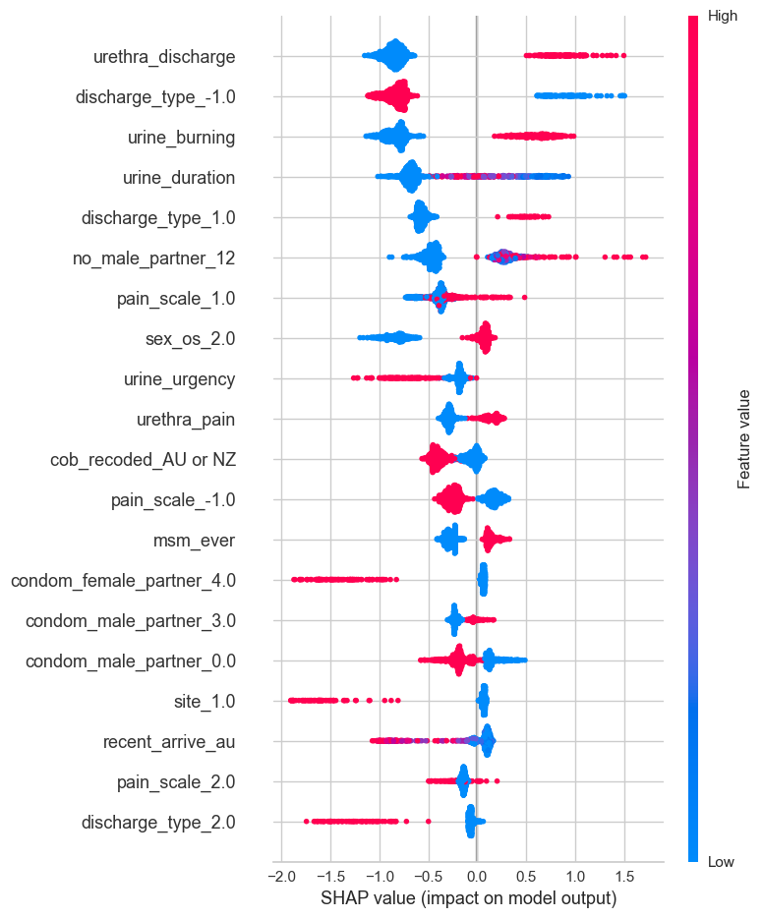
Figure S3. Interpretation of machine learning models for conditions in males
- Random Forest (Male, Gonorrhoea)

The Random Forest model identified the following factors in order of importance as strongly indicative of a positive gonorrhoea diagnosis in males:
- Presence of unusual urethral discharge
- Painful or uncomfortable urination
- Thick, green, or yellow urethra discharge occurring 1-2 days after sexual intercourse
- Mild pain during urination
- Pain or discomfort at the tip of urethra
- Country of birth outside Australia and New Zealand
- Being a man who has sex with men (MSM)
- Never using condom with casual male partners within the past 12 months
The presence of these factors increased the SHAP (Shapley Additive exPlanations) values, which contributed to a higher likelihood of a positive gonorrhoea prediction by the model.

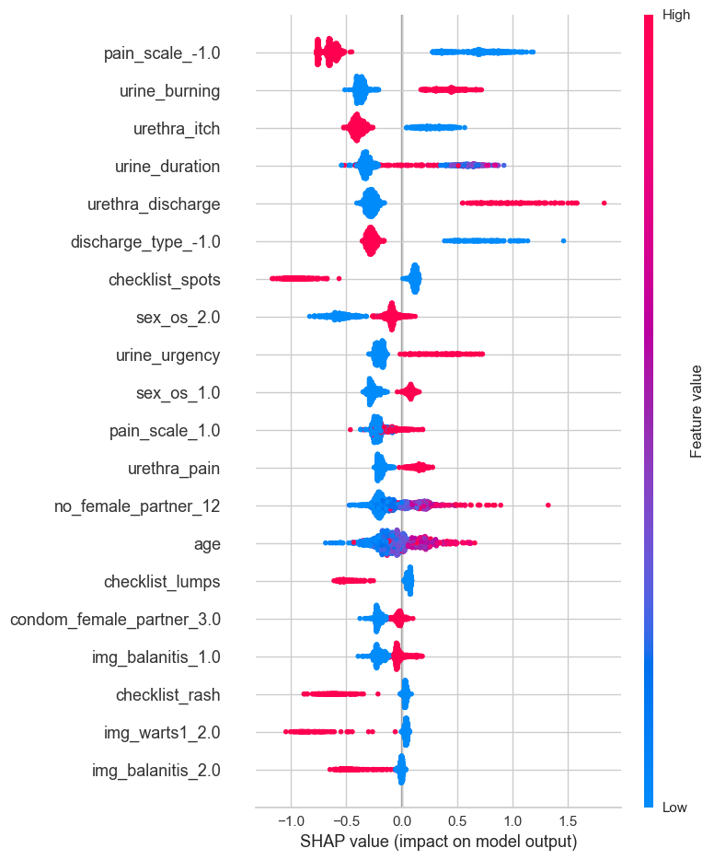
- CatBoost (Male, Non-gonococcal Urethritis)

The CatBoost model identified the following factors in order of importance as strongly indicative of a positive urethritis diagnosis in males:
- Painful or uncomfortable urination
- Absence of itchiness at the tip of urethra
- Presence of unusual urethral discharge
- Absence of anogenital skin lesion (spot, lumps)
- Urge or frequent urination
- Having had sexual intercourse oversea in the past 12 months
- Mild pain during urination
- Pain or discomfort at the tip of urethra
- Higher number of casual female sexual partners within the past 12 months
The presence of these factors increased the SHAP values, which contributed to a higher likelihood of a positive NGU prediction by the model.

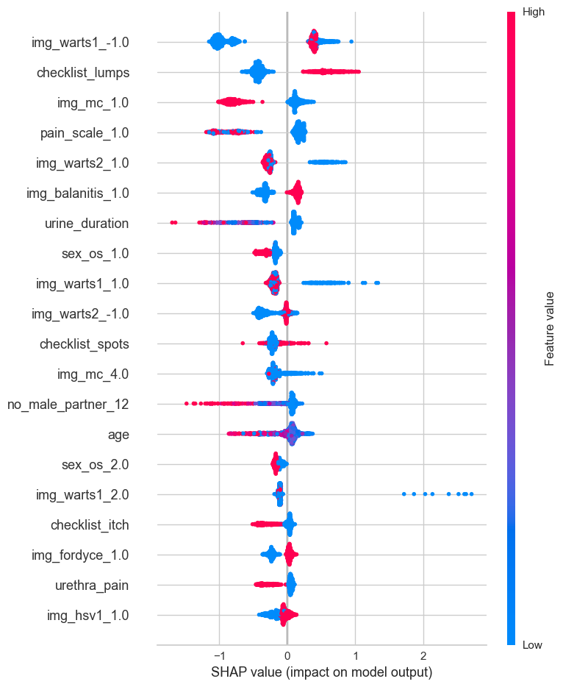
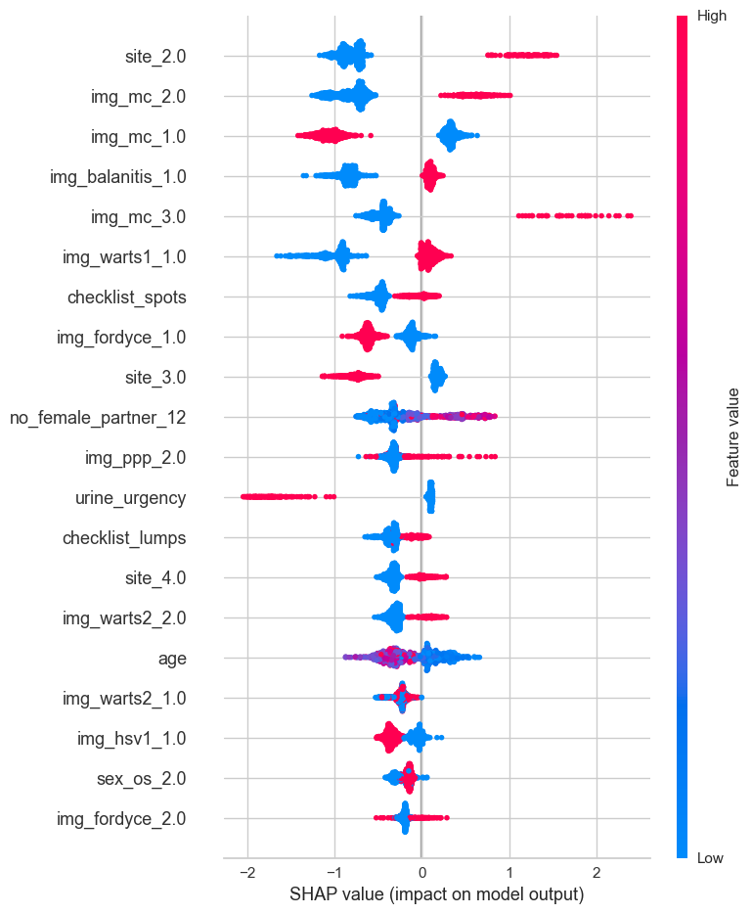
- CatBoost (Male, Genital Warts)

The CatBoost model identified the following factors in order of importance as strongly indicative of a positive genital warts diagnosis in males:
- Presence of anogenital skin lesion (lumps, spots)
- Lesions not resembling the presented images of balanitis, herpes and Fordyce spots
- Lesion resembling the presented image of warts
- Absence of itchiness and urethral pain
The presence of these factors increased the SHAP values, which contributed to a higher likelihood of a positive genital warts prediction by the model.

- CatBoost (Male, Molluscum Contagiosum)

The CatBoost model identified the following factors in order of importance as strongly indicative of a positive molluscum contagiosum diagnosis in males:
- Presence of lesions at the groin crease
- Lesions closely resembling or an exact match to the presented molluscum image
- Lesions not resembling the presented images of balanitis or warts
- Presence of anogenital skin lesion (spots)
- Absence of lesions at the glans penis
- Higher number of casual female sexual partners within the past 12 months
- Lesions partially resembling penile papules of warts images
- Absence of urinary symptoms (urgency or frequency)
The presence of these factors increased the SHAP values, which contributed to a higher likelihood of a positive molluscum contagiosum prediction by the model.

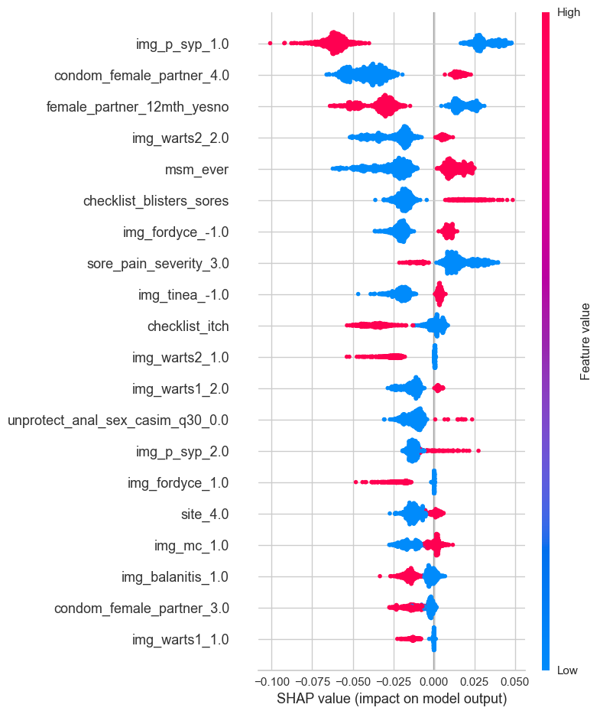
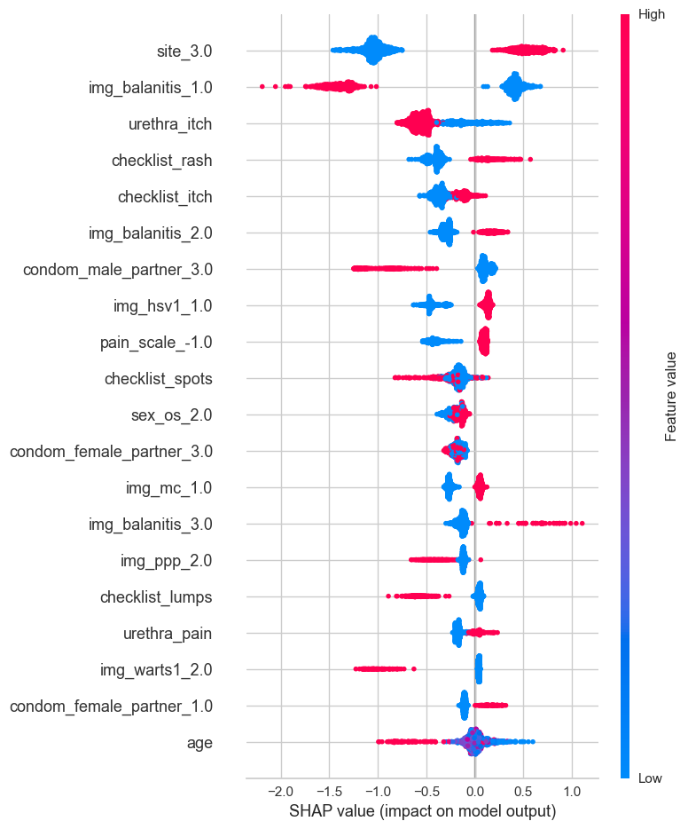
- Random Forest (Male, Syphilis)

The Random Forest model identified the following factors in order of importance as strongly indicative of a positive balanitis diagnosis in males:
- Lesions resembling the presented images of syphilis
- Lesion partially resembling to the presented images of warts
- Being a MSM
- Lesions presented as blisters or sores
- Absence of itchiness at the lesion site
- Lesions not resembling Fordyce spots, warts, molluscum contagiosum or balanitis
- Having had unprotected anal sex
The presence of these factors increased the SHAP values, which contributed to a higher likelihood of a positive syphilis prediction by the model.

- CatBoost (Male, Balanitis)

The CatBoost model identified the following factors in order of importance as strongly indicative of a positive balanitis diagnosis in males:
- Presence of lesions on the glans penis
- Lesions resembling the presented images of balanitis
- Presence of anogenital skin lesion (rash and itching)
- Consistent condom use with casual female sexual partners with the past 12 months
- Lesions not resembling the presented images of herpes and molluscum
- Presence of pain at the tip of urethra
- older age
The presence of these factors increased the SHAP values, which contributed to a higher likelihood of a positive balanitis prediction by the model.

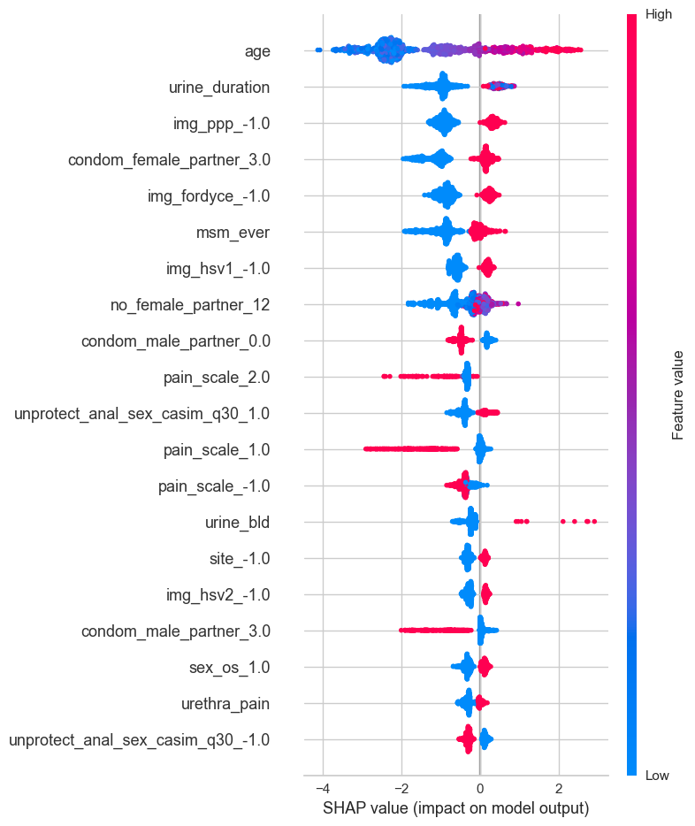
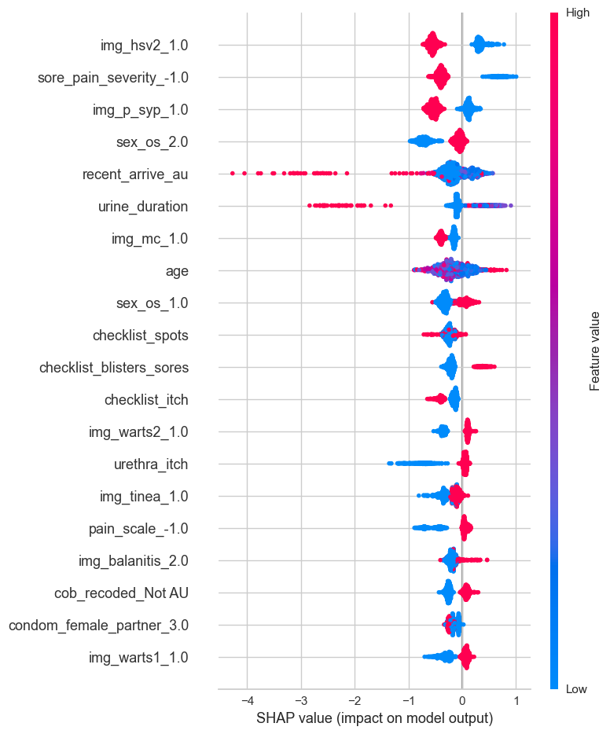
- CatBoost (Male, UTI)

The CatBoost model identified the following factors in order of importance as strongly indicative of a positive UTI diagnosis in males:
- Older age
- Longer duration of urinary symptoms
- Consistent condom uses with casual female sexual partners within past 12 months
- Being a MSM
- Higher number of casual female sexual partners
- Having had unprotected anal sex
- Inconsistent condom uses with casual male sexual partners within past 12 months
The presence of these factors increased the SHAP values, which contributed to a higher likelihood of a positive UTI prediction by the model.

- CatBoost (Male, Herpes)

The CatBoost model identified the following factors in order of importance as strongly indicative of a positive herpes diagnosis in males:
- Lesions resembling the presented images of herpes
- Presence of painful sores or blisters
- Shorter duration of urinary symptoms
- Lesions not resembling syphilis, molluscum, warts, or tinea cruris
- Having had sexual intercourse oversea with 12 months
- Presence of itchiness at urethra
- Country of birth outside Australia or New Zealand
The presence of these factors increased the SHAP values, which contributed to a higher likelihood of a positive herpes prediction by the model.

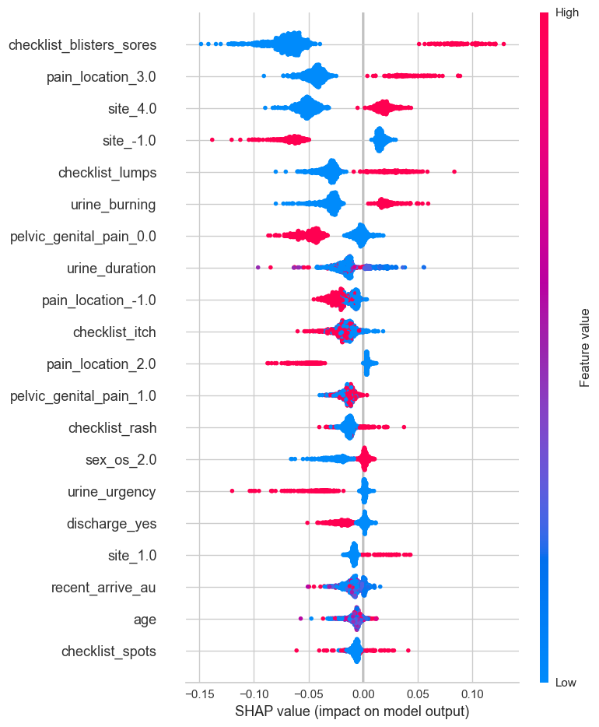
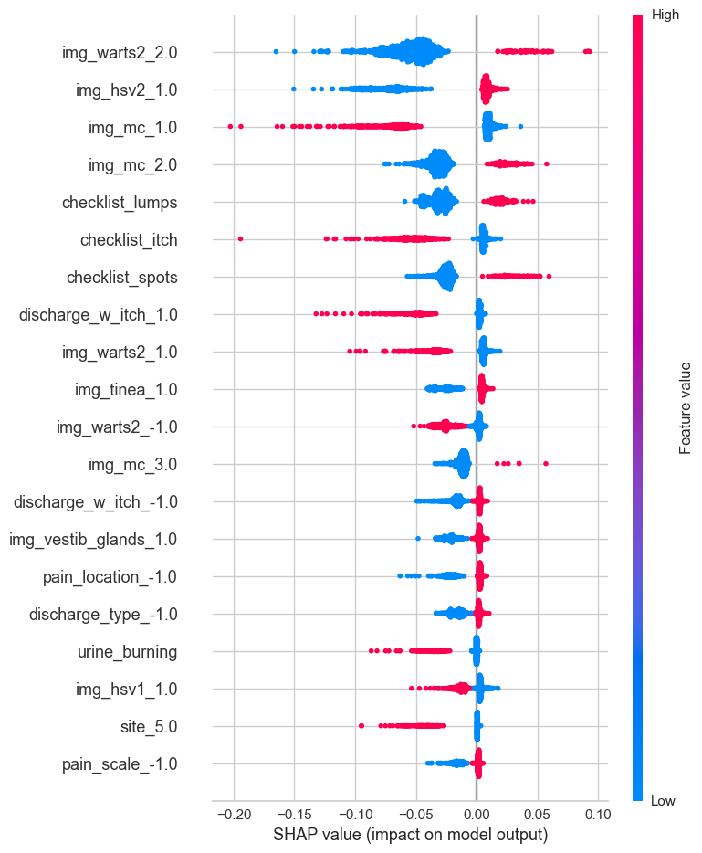
- Random Forest (Female, Herpes)

The Random Forest model identified the following factors in order of importance as strongly indicative of a positive herpes diagnosis in females:
- Presence of anogenital lesions (blister, sores, lump or rash)
- Lesion location near public hair area, vulva, around the bottom or anus
- Presence of painful or uncomfortable urination
- Absence of pelvic pain
- Absence of itchiness at the lesion area
- Presence of pain at vulva or vagina
- Absence of urinary symptoms (frequency or urgency) and unusual vaginal discharge
The presence of these factors increased the SHAP values, which contributed to a higher likelihood of a positive herpes contagiosum prediction by the model.

- Random Forest (Female, Molluscum Contagiosum)

The Random Forest model identified the following factors in order of importance as strongly indicative of a positive molluscum contagiosum diagnosis in females:
- Lesions partially resembling the presented images of molluscum contagiosum or warts
- Lesions not resembling herpes or vestibular glands
- Presence of anogenital lesion (lumps or spots)
- Absence of itchiness at the lesion site
- Absence of painful or uncomfortable urination
The presence of these factors increased the SHAP values, which contributed to a higher likelihood of a positive molluscum contagiosum prediction by the model.

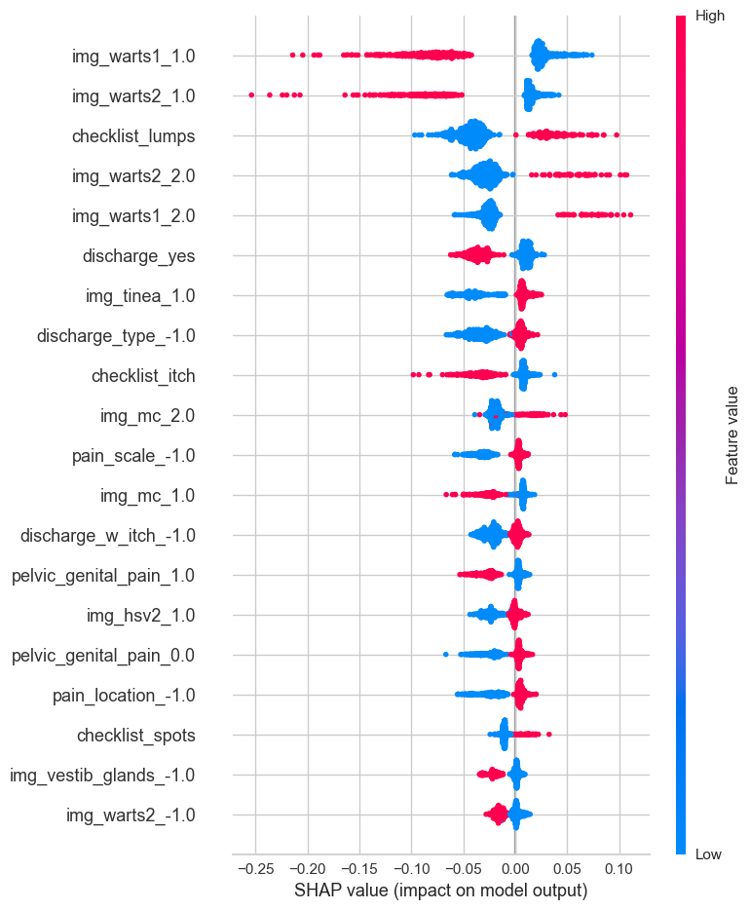
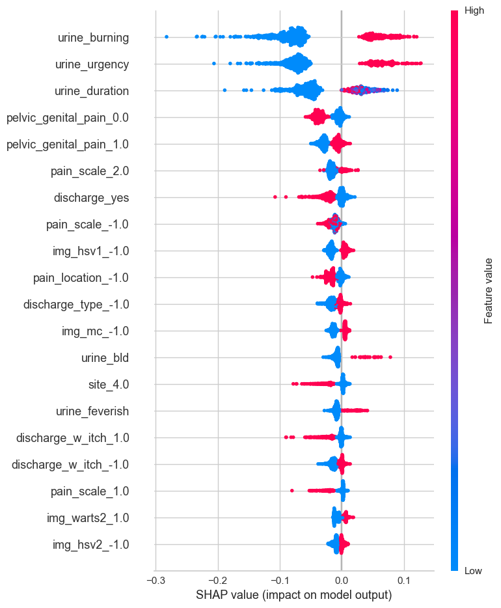
- Random Forest (Female, Warts)

The Random Forest model identified the following factors in order of importance as strongly indicative of a positive warts diagnosis in females:
- Lesions resembling the presented image of genital warts
- Presence of anogenital lesion (lump or spots)
- Absence of unusual vaginal discharge
- Lesions not resembling to the images of tinea cruris, herpes or vestibular glands
- Lesions partially resembling molluscum contagiosum
- Absence of itchiness at the lesion area or pelvic pain
The presence of these factors increased the SHAP values, which contributed to a higher likelihood of a positive warts prediction by the model.

- Random Forest (Female, Cystitis)

The Random Forest model identified the following factors in order of importance as strongly indicative of a positive cystitis diagnosis in females:
- Presence of painful or uncomfortable urination and increased frequency/urgency of urination
- Presence of moderate pain in pelvic or genital area
- Absence of itchy discharge
- Presence of blood in the urine
- Absence of pain in the vulva
- Associated with fever
The presence of these factors increased the SHAP values, which contributed to a higher likelihood of a positive cystitis contagiosum prediction by the model.

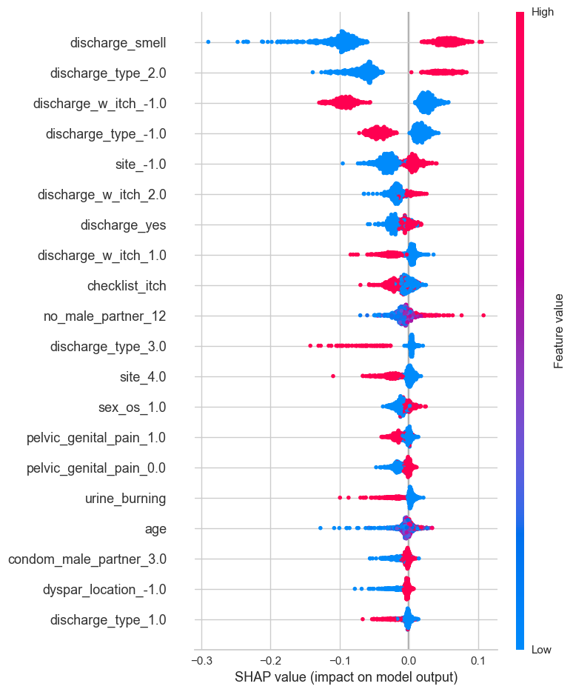
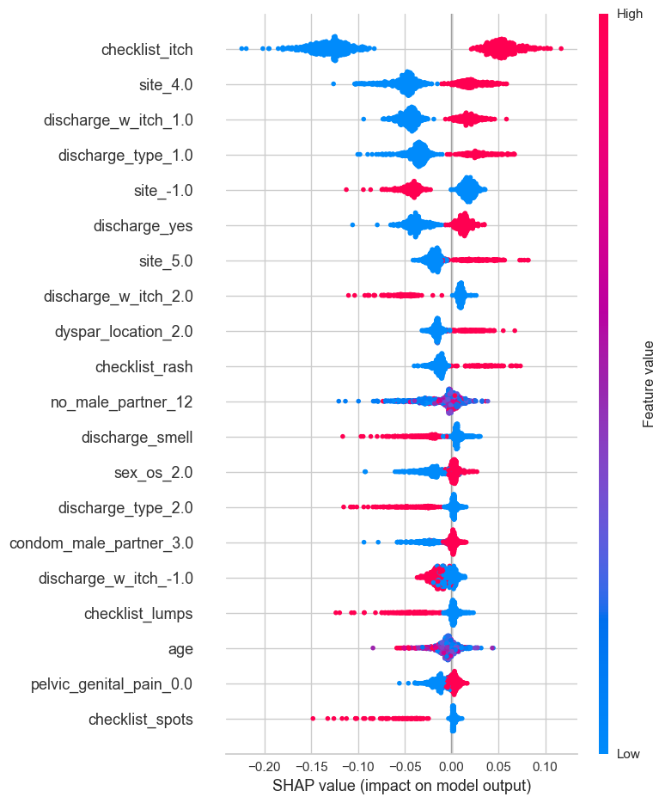
- Random Forest (Female, Bacterial Vaginosis)

The Random Forest model identified the following factors in order of importance as strongly indicative of a positive bacterial vaginosis diagnosis in females:
- Presence of unusual vaginal discharge with unpleasant smell
- Presence of pale or greyish discharge with fishy smell
- Absence of discharge associated with itchiness
- Absence of anogenital skin lesion (itching)
- Higher number of casual male sexual partners within 12 months
- Absence of pelvic pain
- Absence of painful or uncomfortable urination
- Consistent condom use with casual male partners within the past 12 months
- Absence of thickish, clumpy or white discharge
The presence of these factors increased the SHAP values, which contributed to a higher likelihood of a positive bacterial vaginosis prediction by the model.

- Random Forest (Female, Candidiasis)

The Random Forest model identified the following factors in order of importance as strongly indicative of a positive candidiasis diagnosis in females:
- Presence of itchiness at the vulva or inside the vagina
- Presence of discharge associated with itchiness
- Absence of dyspareunia at vulva or vagina
- Presence of anogenital rash
- Absence of unusual vaginal discharge with unpleasant smell
- No sexual intercourse overseas within past 12 months
- Absence of pale or greyish discharge with fishy smell
- Consistent condom use with casual male partners within the past 12 months
- Absence of pelvic pain
The presence of these factors increased the SHAP values, which contributed to a higher likelihood of a positive candidiasis prediction by the model.

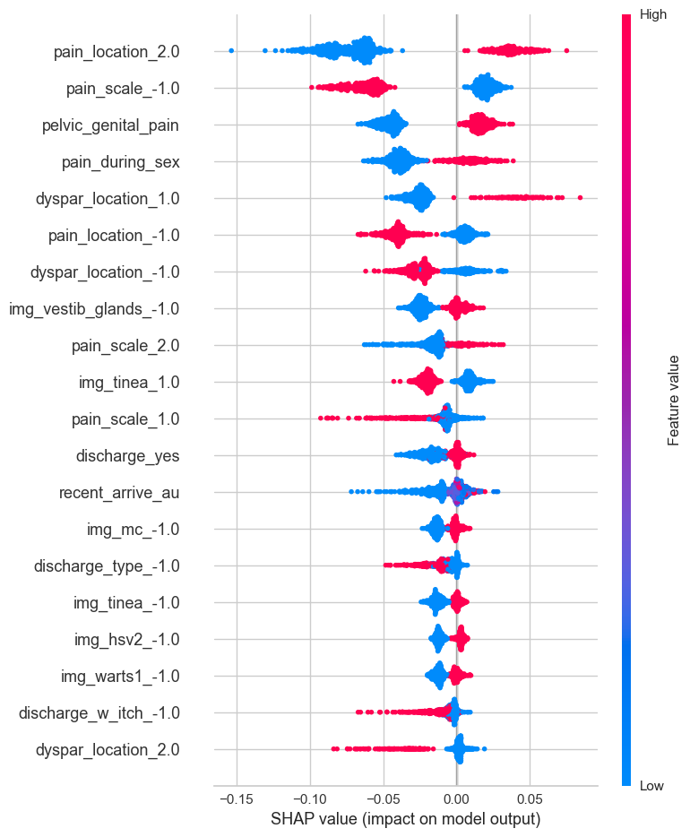
- Random Forest (Female, Pelvic Inflammatory Disease)

The Random Forest model identified the following factors in order of importance as strongly indicative of a positive PID diagnosis in females:
- Presence of pain in pelvis or lower part of tummy
- Presence of pain during sex
- Presence of moderate pain
- Presence of unusual vaginal discharge
- Absence of anogenital skin lesion
The presence of these factors increased the SHAP values, which contributed to a higher likelihood of a positive PID prediction by the model.

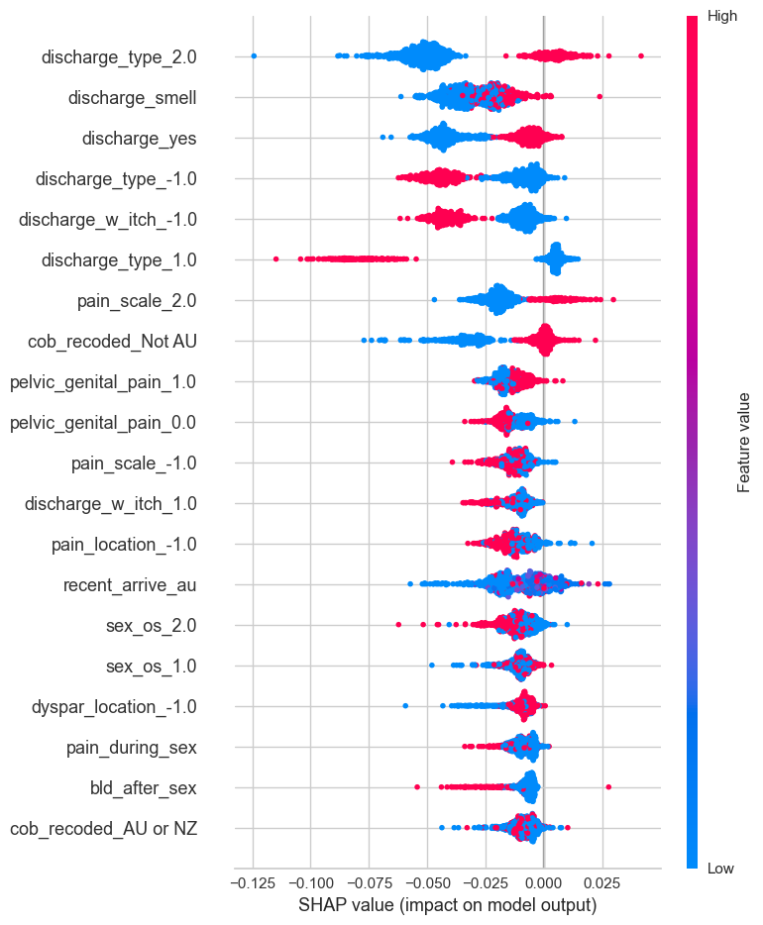
- Random Forest (Female, Cervicitis)

The Random Forest model identified the following factors in order of importance as strongly indicative of a positive cervicitis diagnosis in females:
- Presence of pale or greyish discharge with fishy smell
- Presence of moderate pain
- Country of birth outside Australia or New Zealand
The presence of these factors increased the SHAP values, which contributed to a higher likelihood of a positive cervicitis prediction by the model.

Figure S4. Precision-Recall and Sensitivity-Specificity curves for Bayesian and Machine learning models for each disease condition

A.1. Bayesian Model (Male, Syphilis)
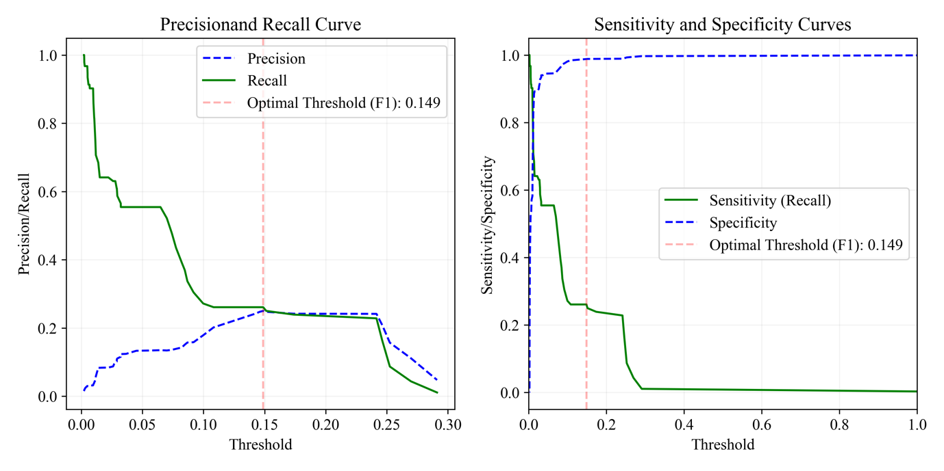

A.2. Machine Learning Model (Male, Syphilis)

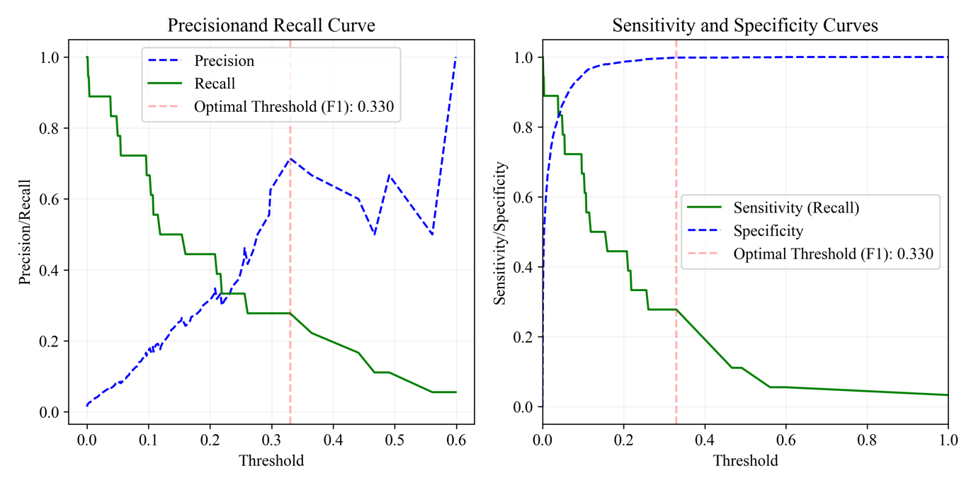

B.1. Bayesian Model (Male, Warts)

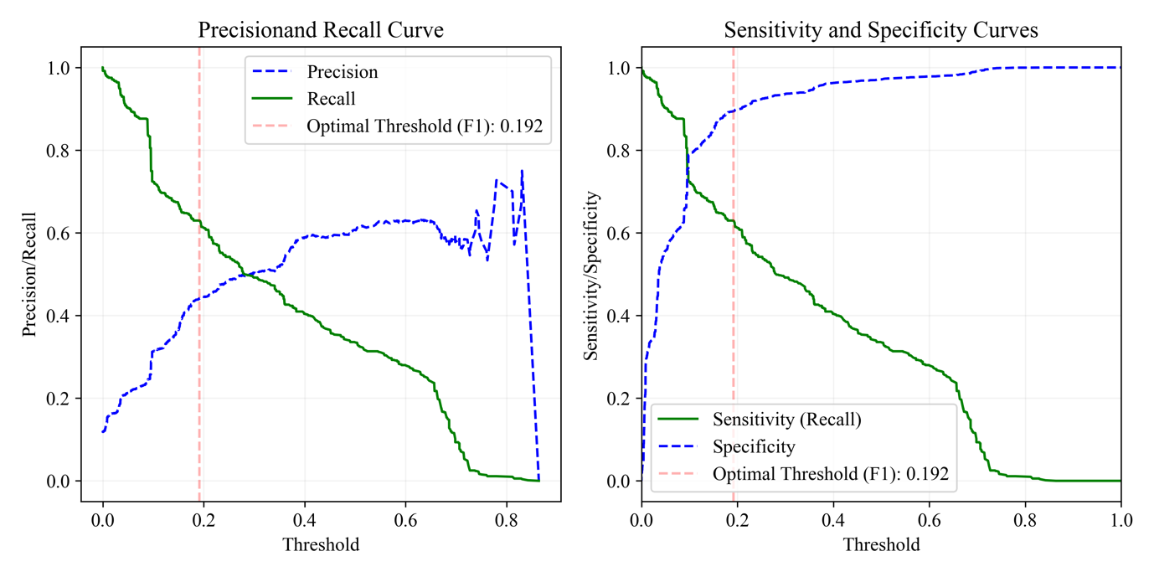

B.2. Machine Learning Model (Male, Warts)
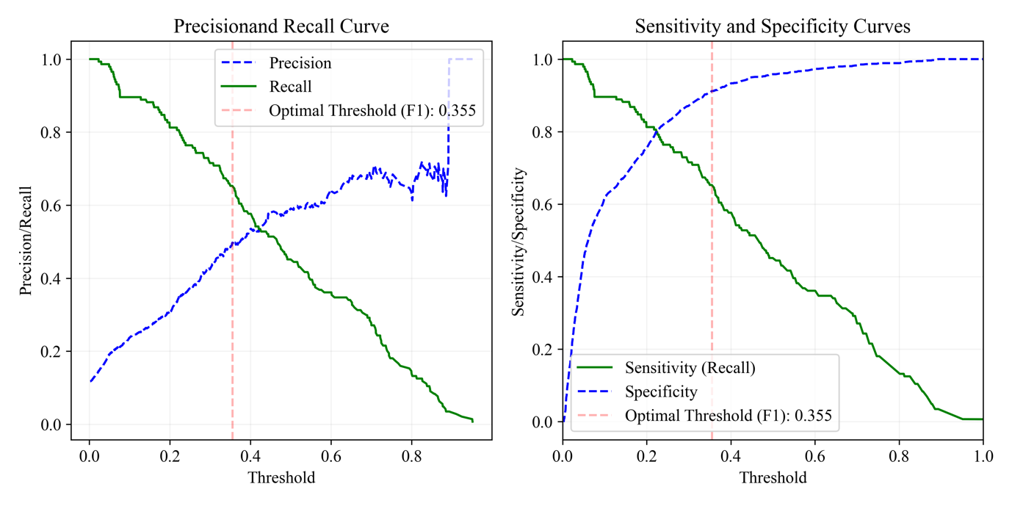

C.1. Bayesian Model (Male, NGU)
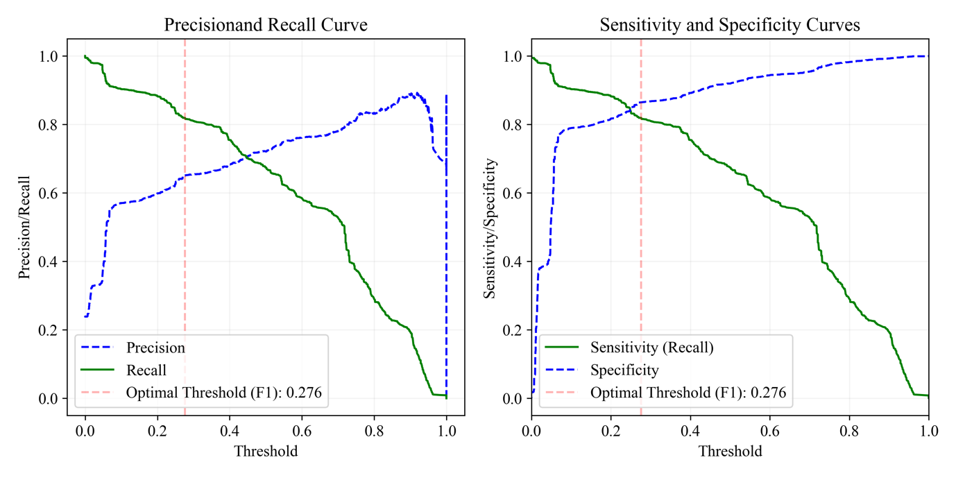

C.2. Machine Learning Model (Male, NGU)

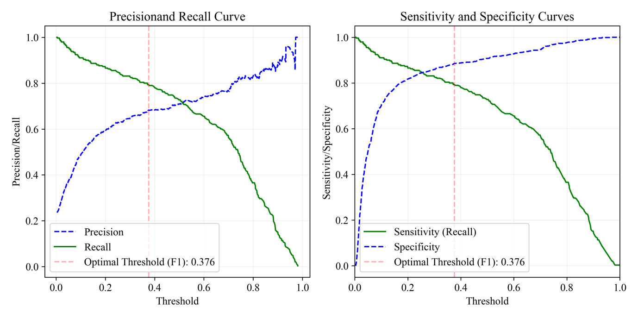

D.1. Bayesian Model (Male, Gonorrhoea)
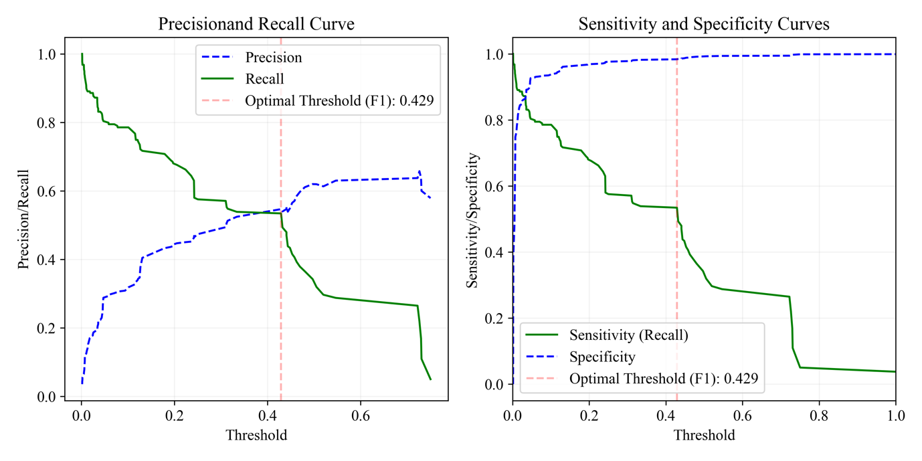

D.2. Machine Learning Model (Male, Gonorrhoea)
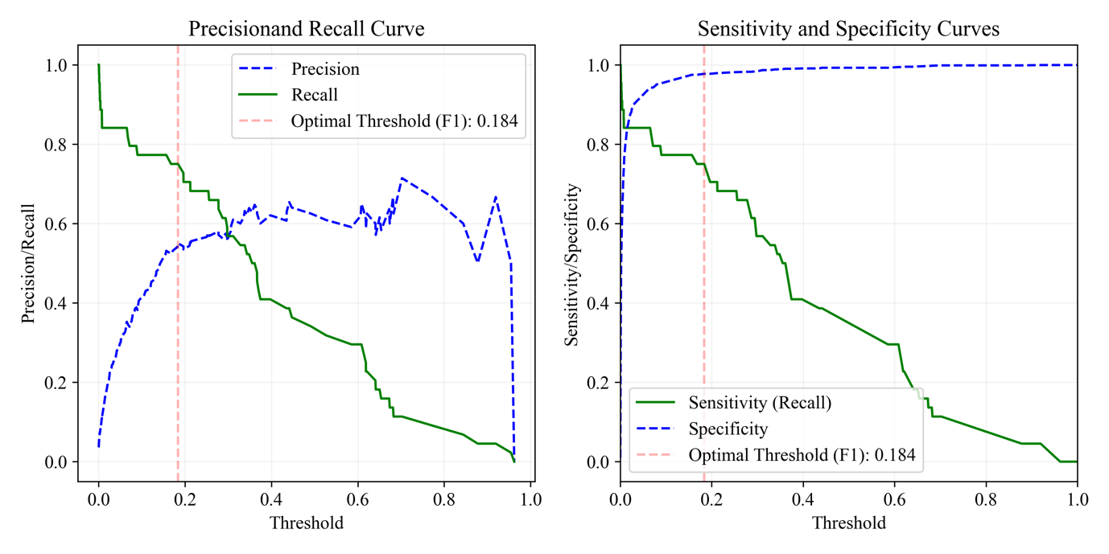
E.1. Bayesian Model (Male, Herpes)
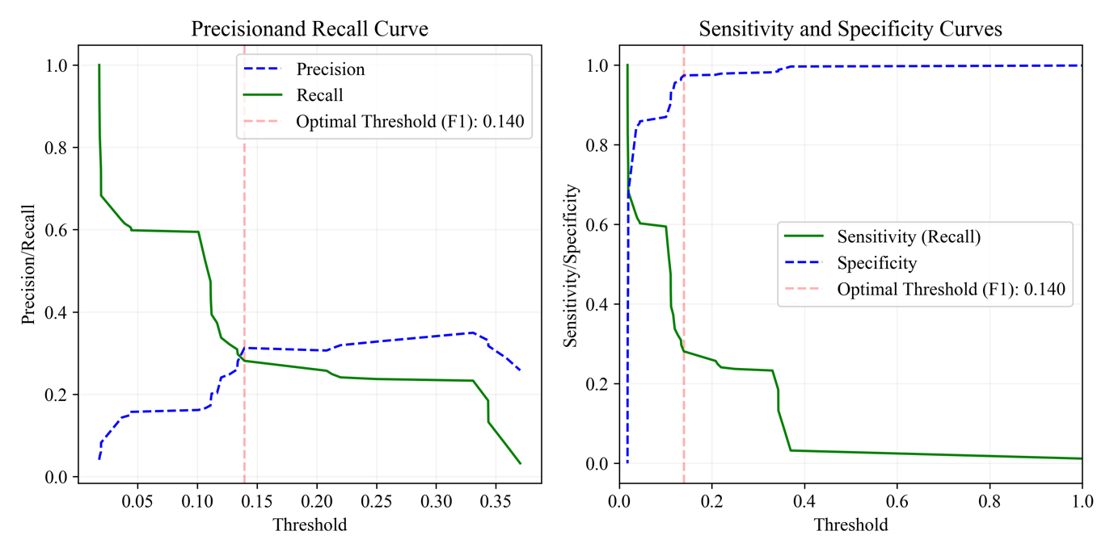

E.1. Machine Learning Model (Male, Herpes)
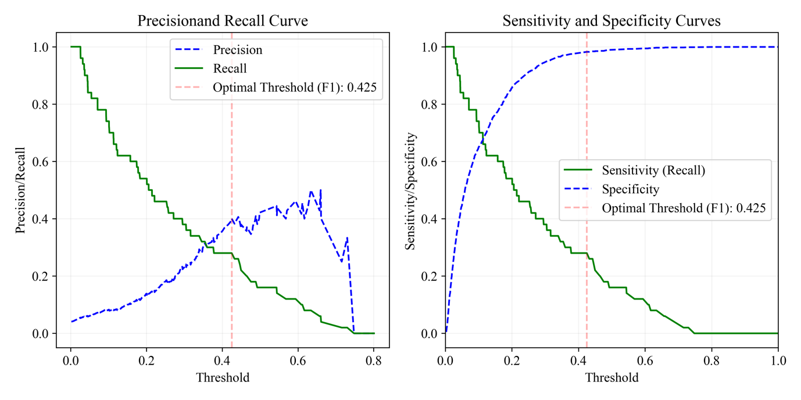

F.1. Bayesian Model (Male, Balanitis)

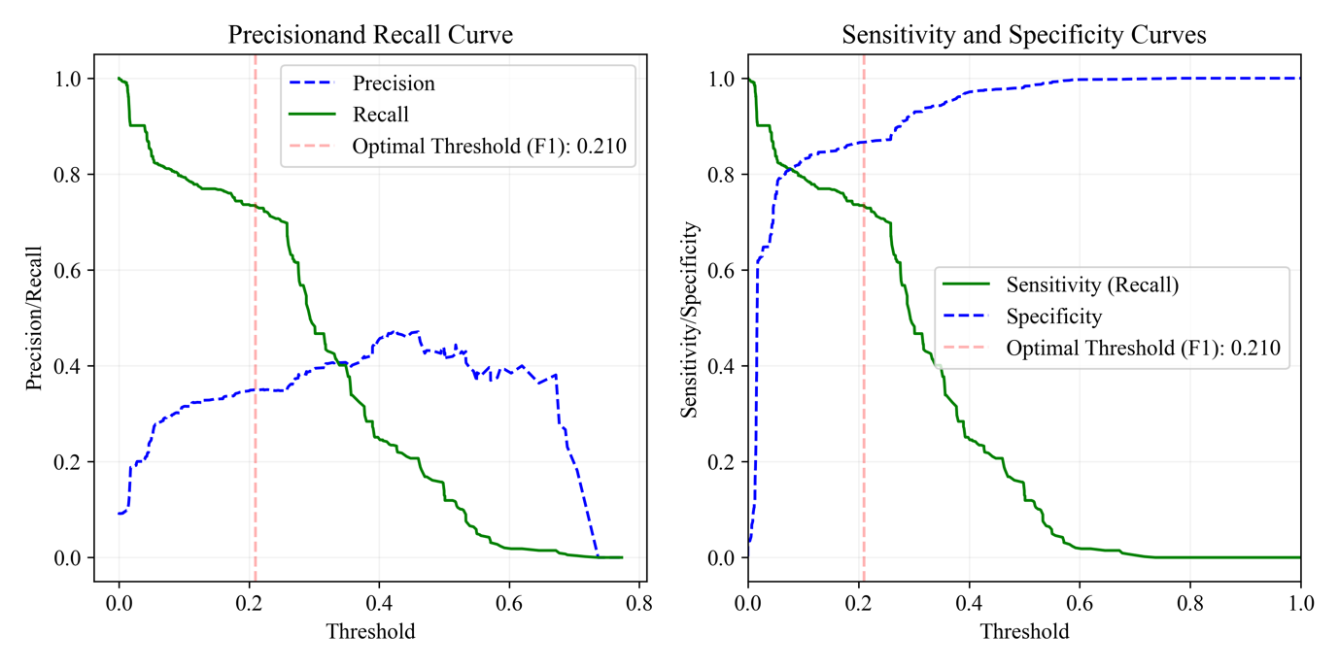

F.1. Machine Learning Model (Male, Balanitis)

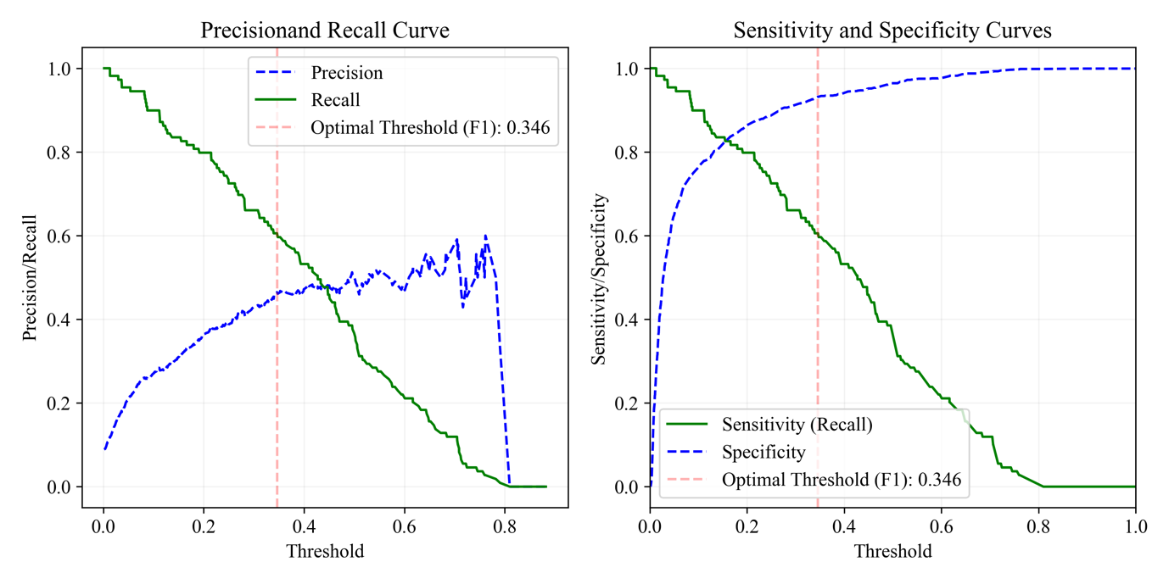
G.1. Bayesian Model (Male, Molluscum Contagiosum)

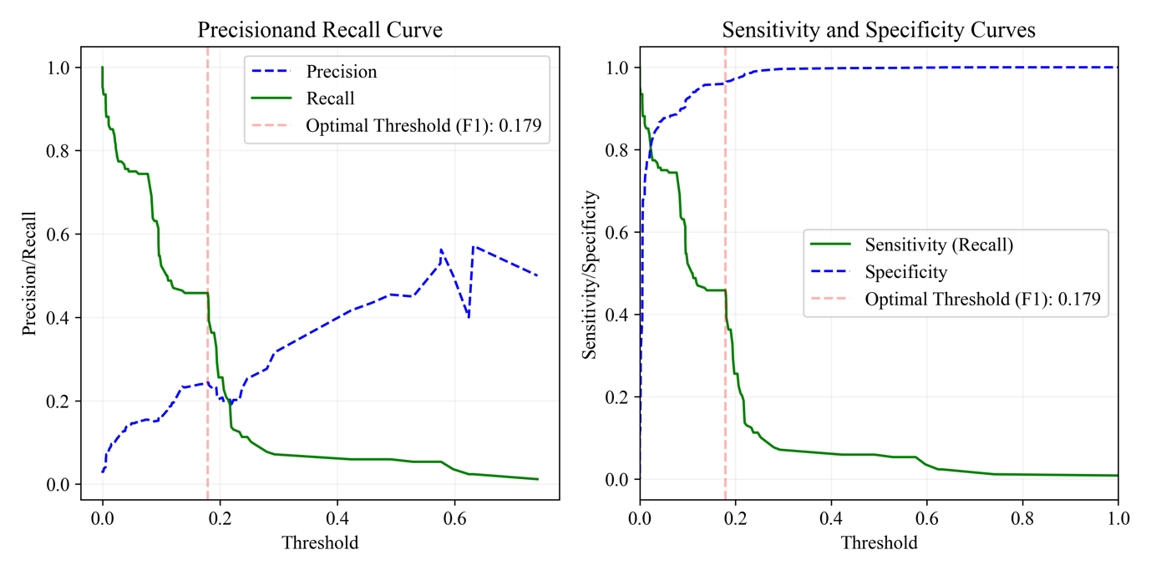

G.2. Machine Learning Model (Male, Molluscum Contagiosum)

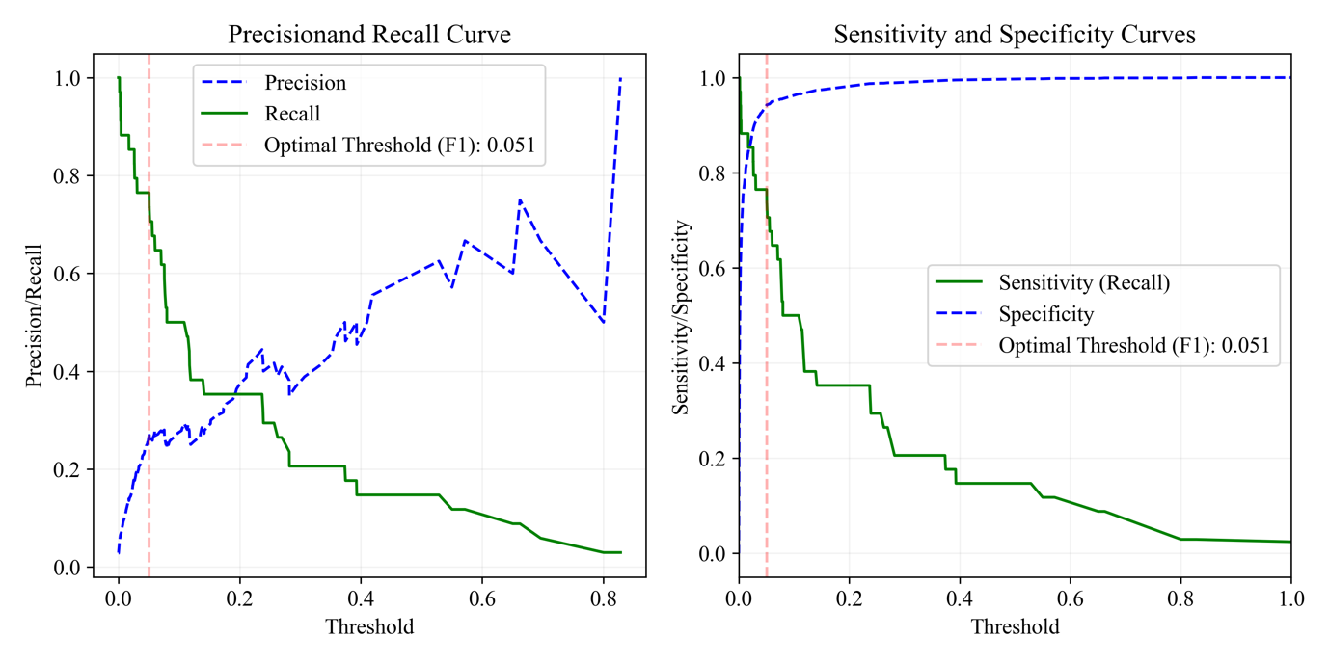
H.1. Bayesian Model (Female, PID)

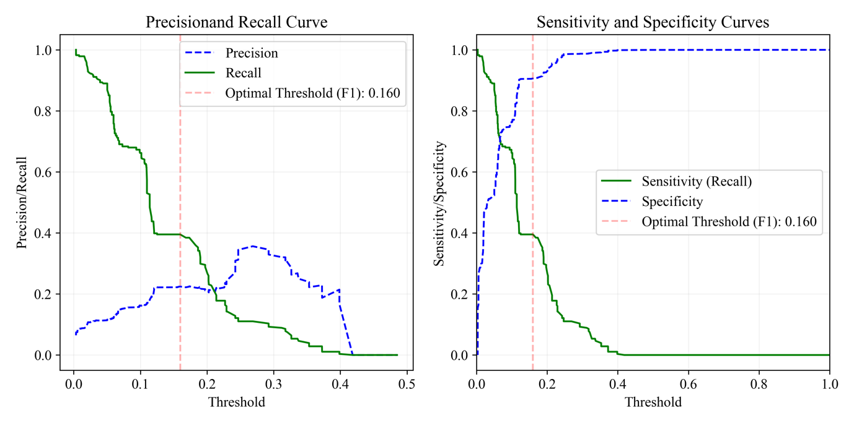

H.2. Machine Learning Model (Female, PID)

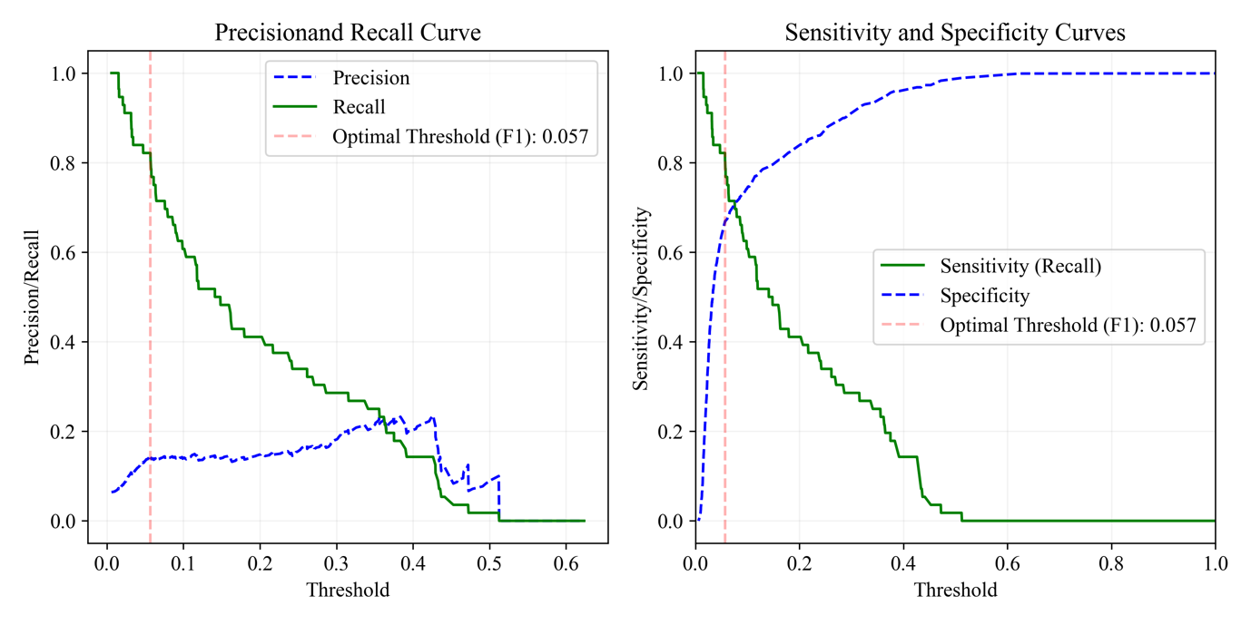
I.1. Bayesian Model (Female, Warts)

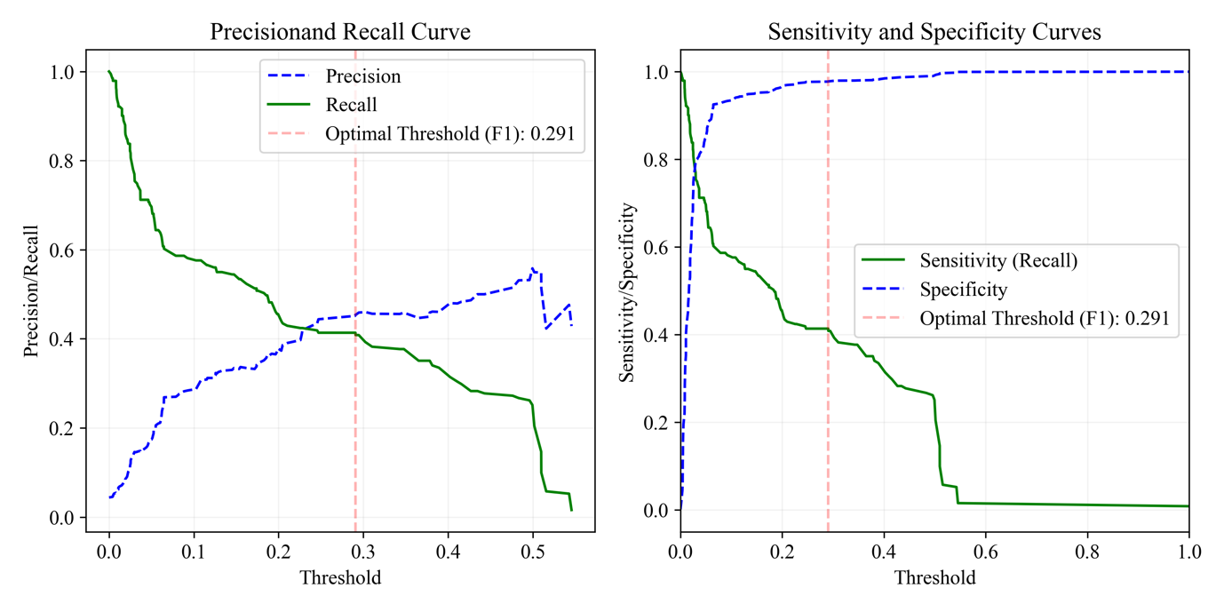

I.2. Machine Learning Model (Female, Warts)
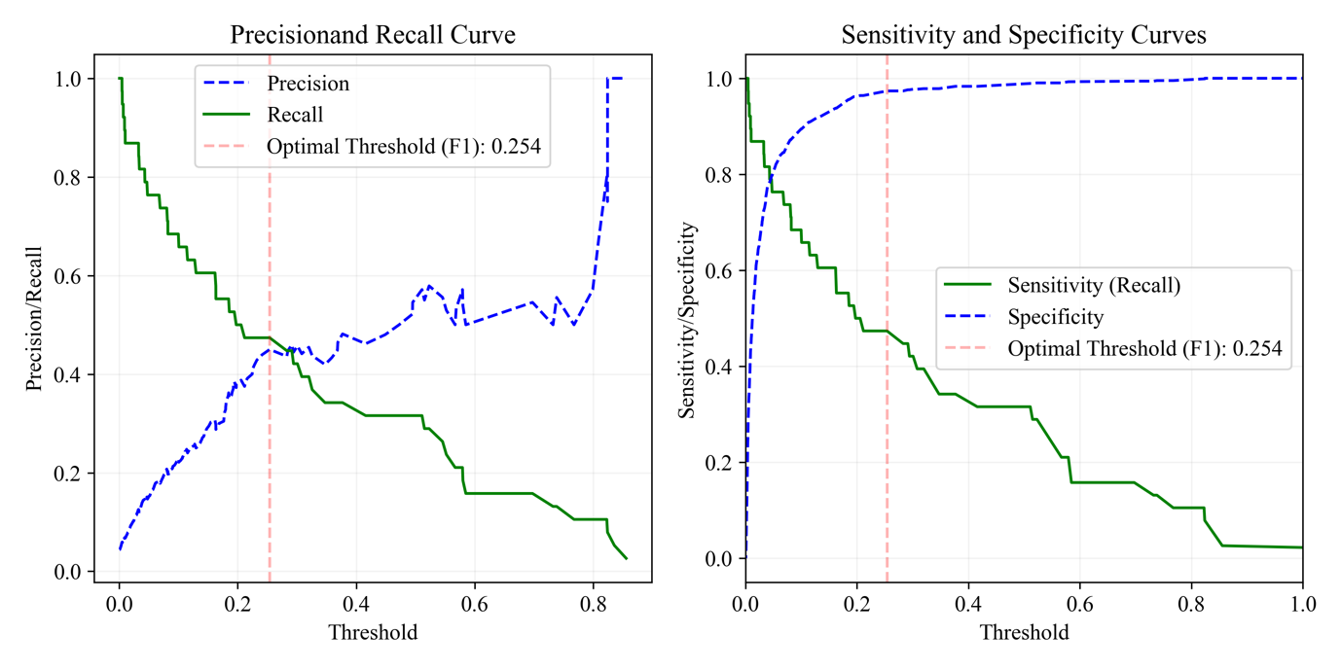
J.1. Bayesian Model (Female, Herpes)

J.2. Machine Learning Model (Female, Herpes)

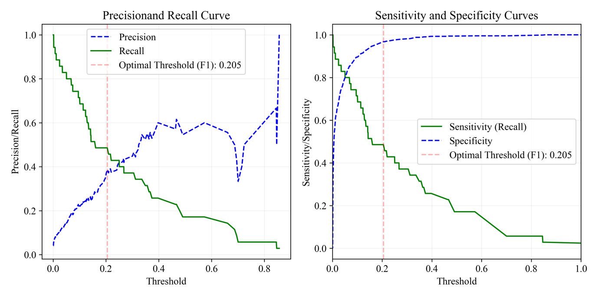
K.1. Bayesian Model (Female, Cystitis)

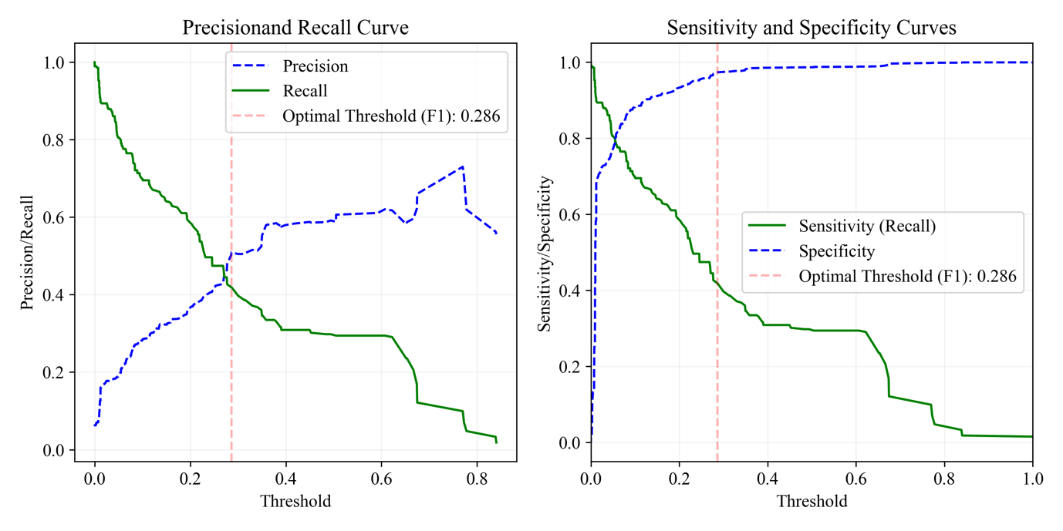

K.2. Machine Learning Model (Female, Cystitis)

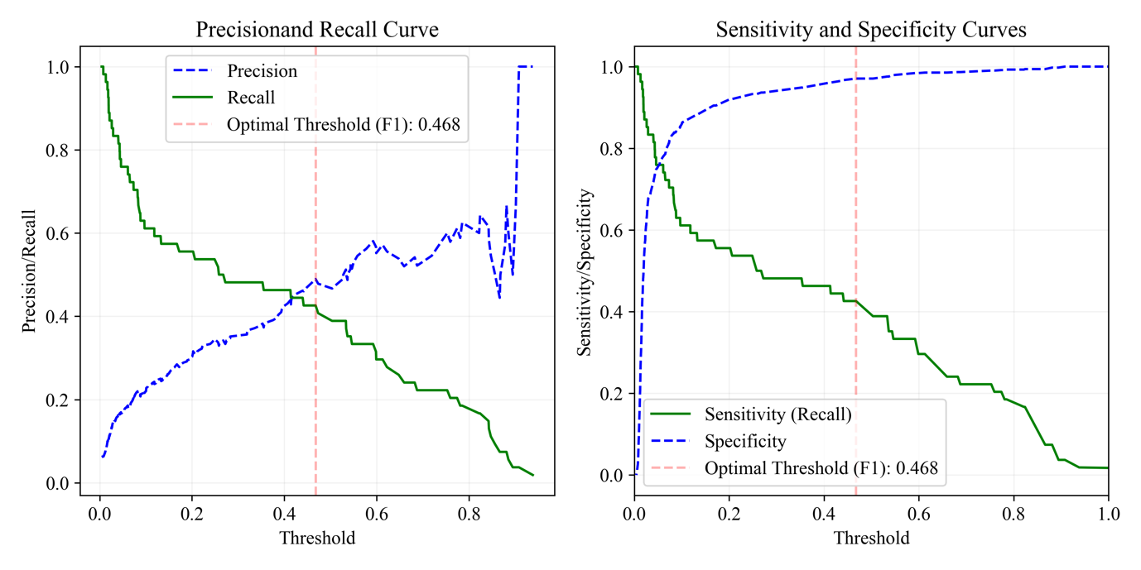
L.1. Bayesian Model (Female, Bacterial Vaginosis)

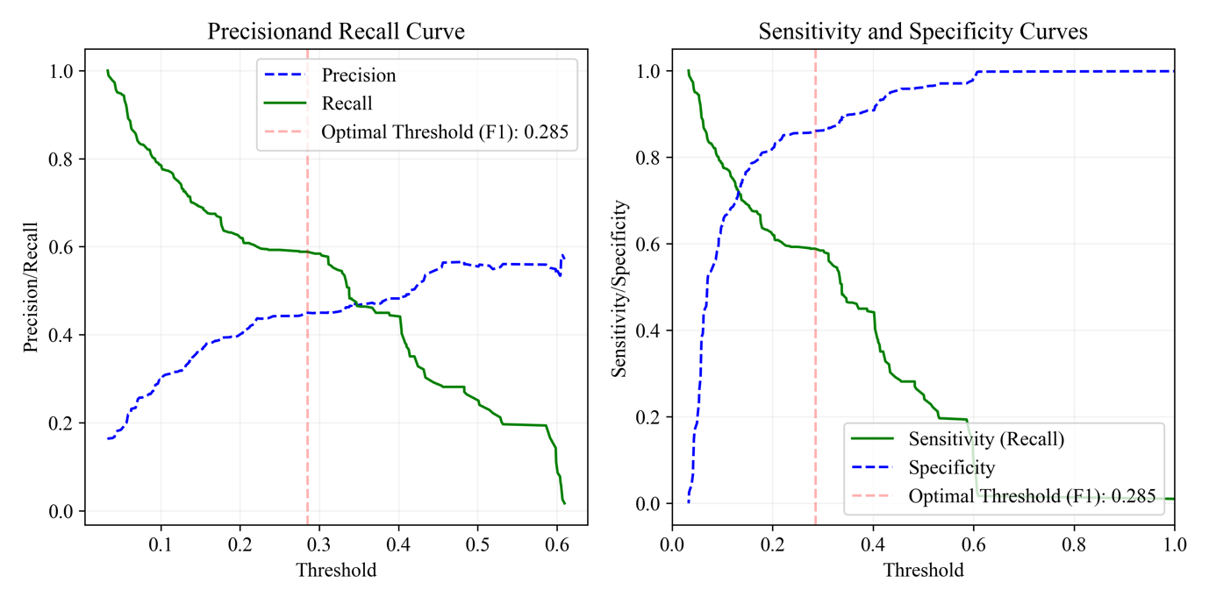

L.2. Machine Learning Model (Female, Bacterial Vaginosis)

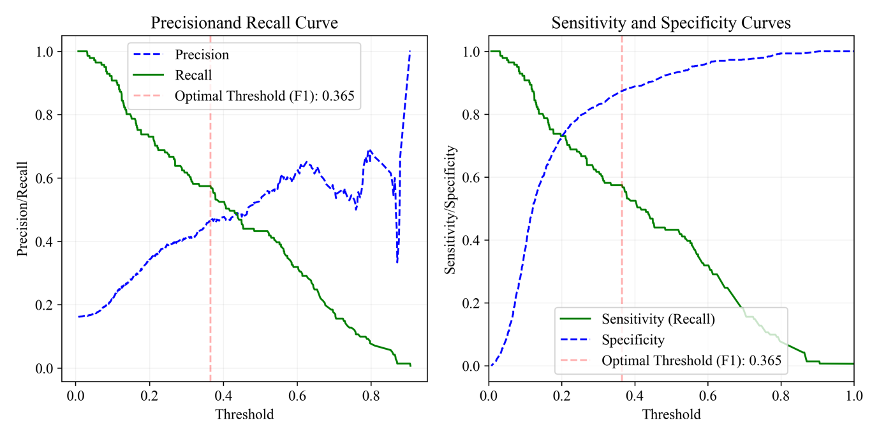
M.1. Bayesian Model (Female, Candidiasis)

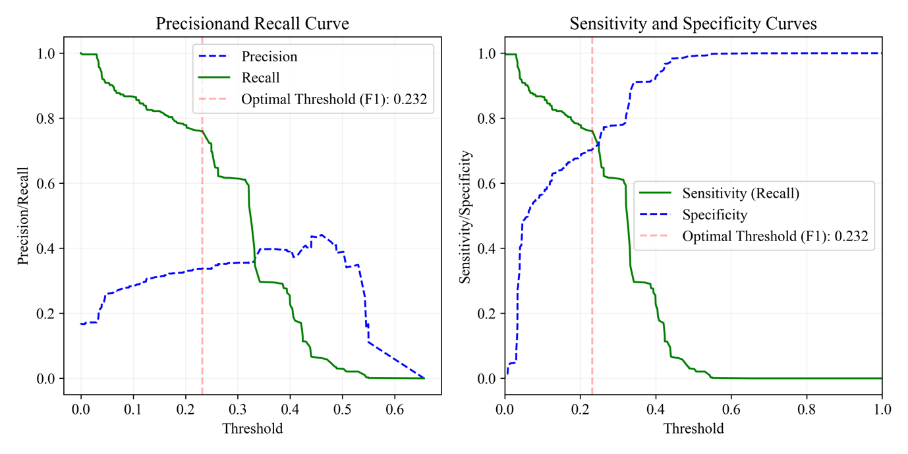

M.2. Machine Learning Model (Female, Candidiasis)
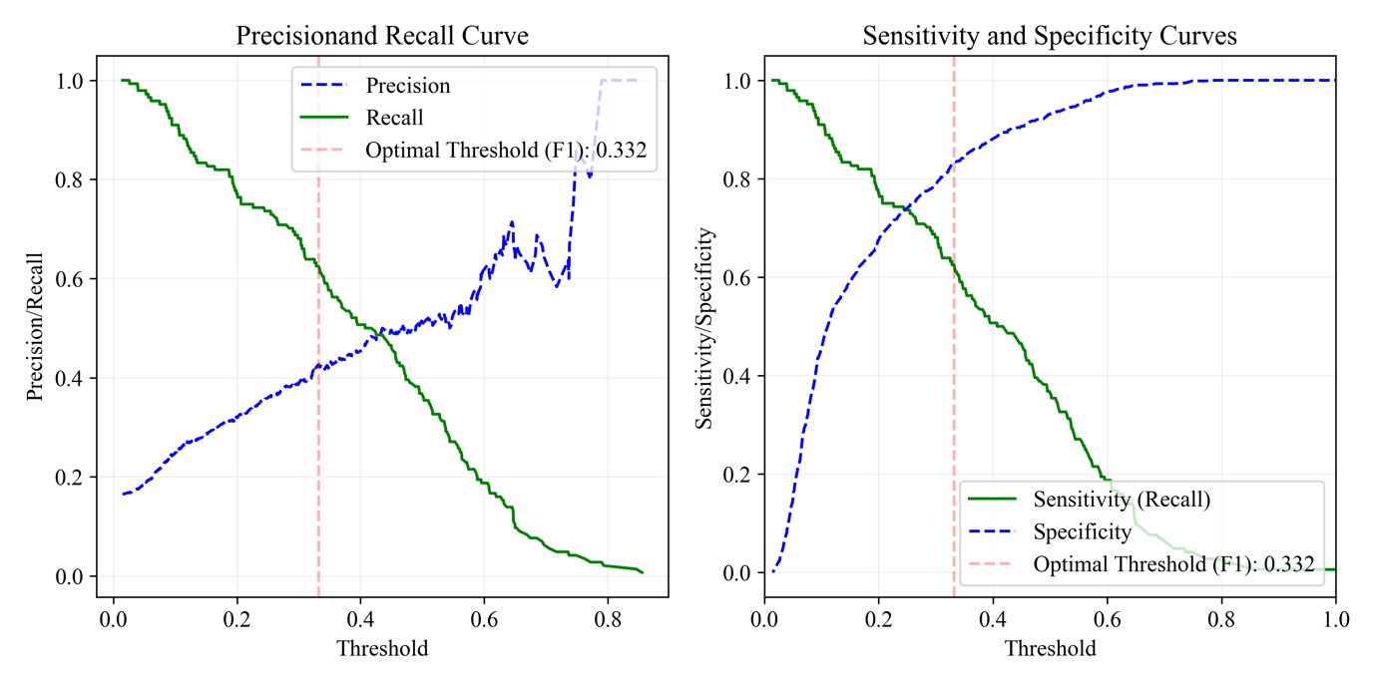
N.1. Bayesian Model (Female, Molluscum Contagiosum)

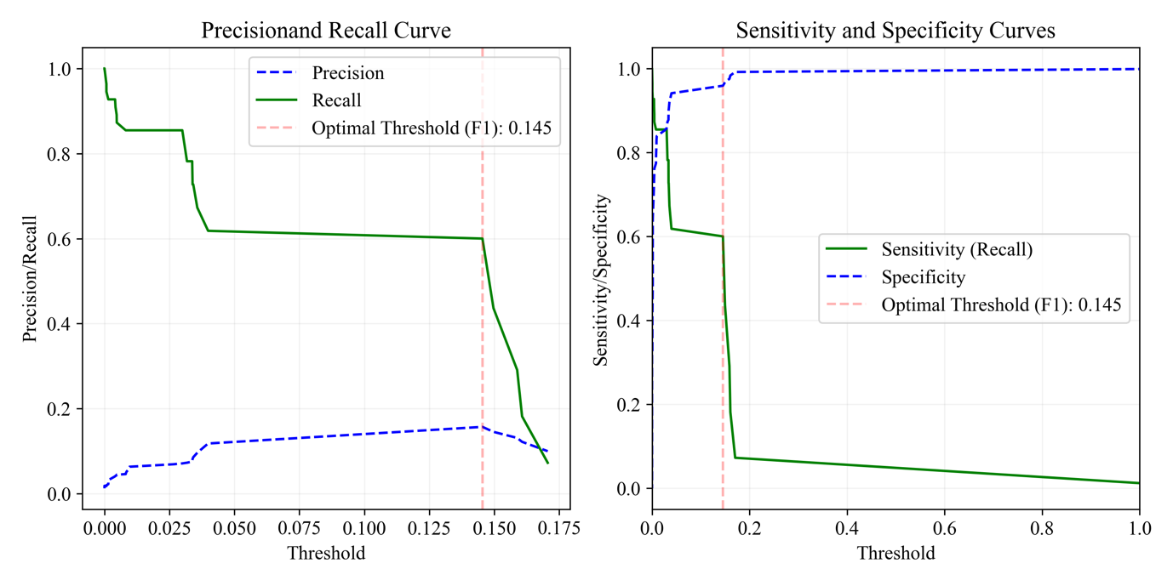

N.2. Machine Learning Model (Female, Molluscum Contagiosum)

