Additional information

Extended Data Figures
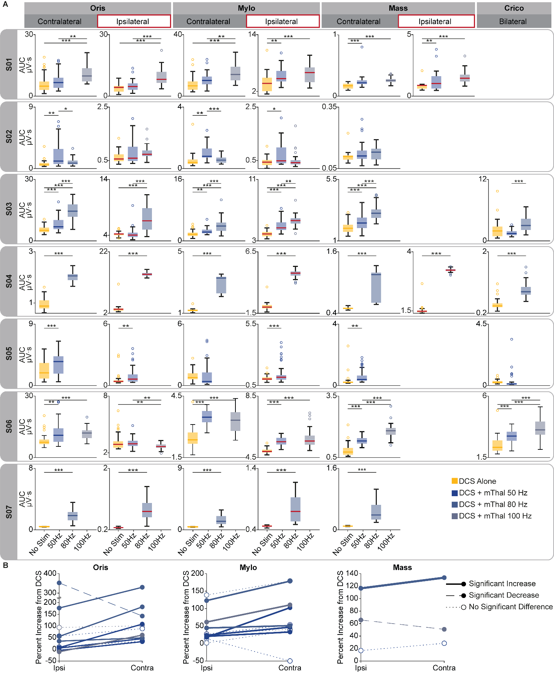
Extended Data Figure 1 | Stimulation of the motor thalamus potentiates MEPs of contralateral and ipsilateral orofacial muscles. (a) Boxplots of MEPs AUC amplitudes of different muscles (either contralateral, i.e., on the other side of the face from DCS and motor thalamus stimulation, or ipsilateral, i.e., on the same side of the face, or bilateral) with DCS alone and DCS paired with motor thalamus stimulation at 50, and/or 80 Hz, and/or 100 Hz. All subjects (S01-S07) are reported. Repetitions per condition for each patient: S01 n=30, S02 n =31, S03 n = 31, S04 n = 35, S05 n = 46, S06 n = 31, S07 n = 41. Mass: masseter, Oris: orbicularis oris, Mylo:, mylohyoid, Crico: cricothyroid. For all boxplots, the whiskers extend to the maximum spread excluding outliers. Central, top, and bottom lines represent median, 25th, and 75th percentile, respectively. (b) Comparison of the percent increase of AUC for motor thalamus stimulation ON as compared to no stimulation for ipsilateral and contralateral pairs of muscles for all patients pulled together. Lines are colored by motor thalamus stimulation intensity (i.e., 50, 80, or 100Hz). Bolded lines represent MEPs for which contralateral potentiation was greater than ipsilateral potentiation (p<0.05); dashed lines represent MEPs for which ipsilateral potentiation was greater than contralateral (p<0.05); and dotted lines represent no significant difference between contralateral and ipsilateral muscles. For all panels, statistical significance was assessed with two-tail bootstrapping with Bonferroni correction: p<0.05 (*), p<0.01 (**), p<0.001(***). Artifact contamination from DCS in the ipsilateral masseter muscle prevented data collection in several cases. The cricothyroid muscle was only assessed after data collection for the first two study participants to increase the ability to quantify potential speech improvements physiologically.

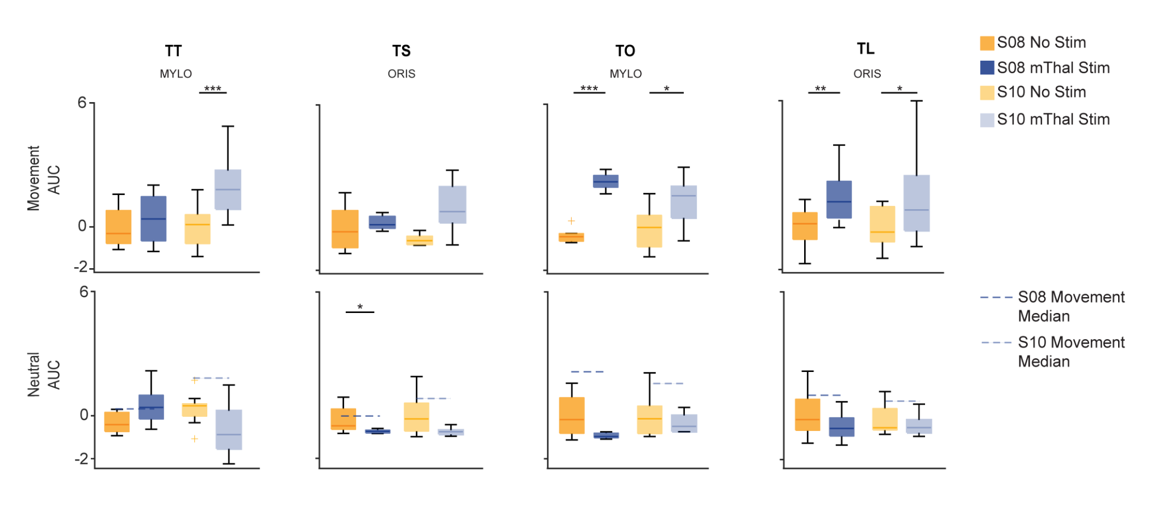
Extended Data Figure 2 | EMG activation during facial tasks and at rest. Top: Boxplots of z-score of EMG AUC for mylohyoid and orbicularis oris during movement phase of facial tasks (n=2) without (yellow) and with (blue) motor thalamus stimulation. This is the same plot of Figure 2c. Bottom: Boxplots of z-score of EMG AUC for mylohyoid and orbicularis oris during neutral phase of facial tasks. Dotted line represents median AUC from movement phase of respective facial tasks with stimulation.

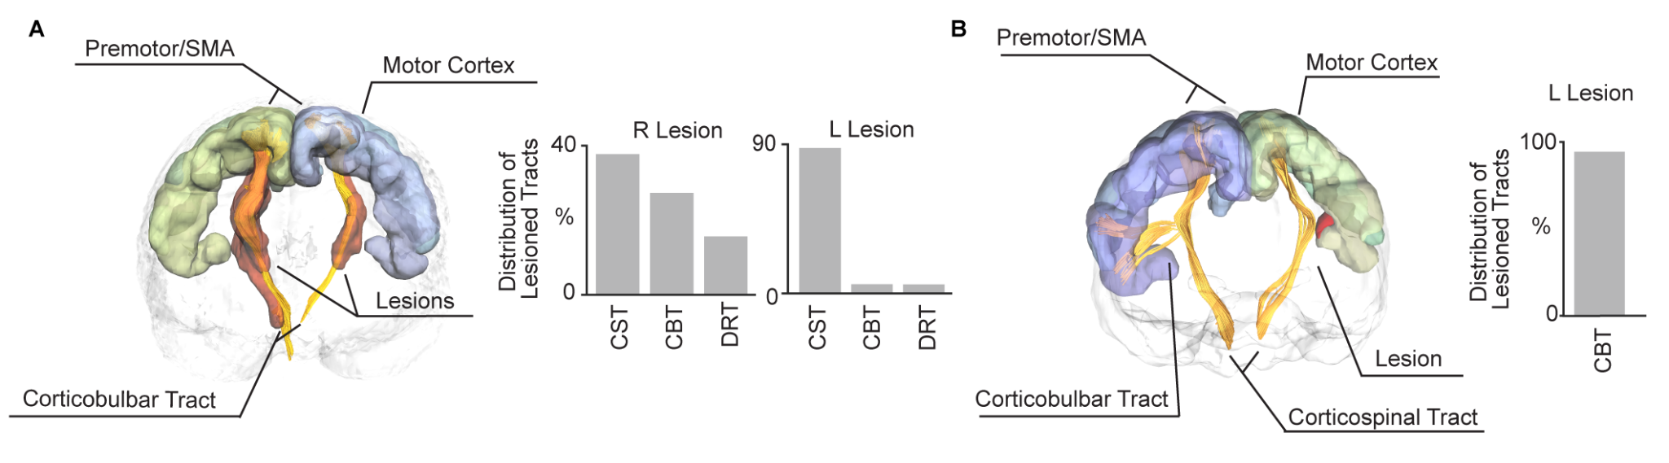
Extended Data Figure 3 | Lesioned white-matter fibers for TBI01 and TBI02. (a) Left: Tractography with lesion highlighted in red for TBI01. Right: Amount of lesioned tracts for both hemispheres (CST: corticospinal tract, CBT: corticobulbar tract, DRT: dentatorubrothalamic tract). This panel was adjusted from Ho & Grigsby et al., 2024¹⁸. (b) Left: Tractography with lesion highlighted in red for TBI02. Right: Amount of lesioned tracts in the left hemisphere (unilateral damage).
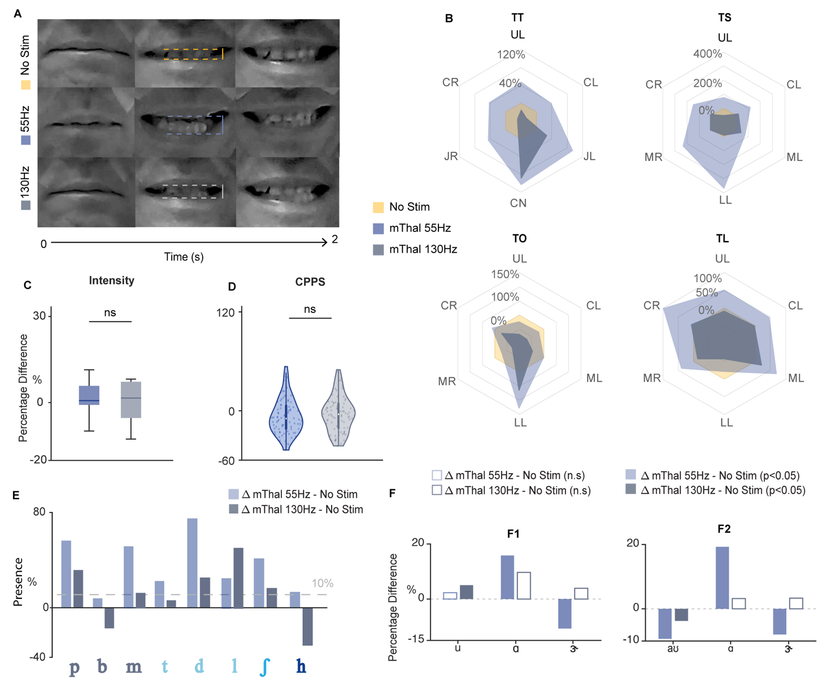
Extended Data Figure 4 | Comparison of effects for motor thalamus DBS at 55 and 130 Hz for TBI01. (a) Frame captures from video showing TBI01 maximum range of motion of the lips during smile task for no stimulation (yellow), motor thalamus (mThal) stimulation at 55 Hz (blue), and motor thalamus stimulation at 130 Hz (grey). (b) Radial plots of normalized change in amplitude of facial articulators during the four facial tasks for motor thalamus stimulation at 55Hz (blue) and motor thalamus stimulation at 130 Hz (gray). Facial articulators include upper lip (UL), jaw left (JL), jaw right (JR), cheek left (CL), cheek right (CR), mouth left (ML), mouth right (MR), chin (CN), and lower lip (LL). (c) Boxplots of speech intensity for stimulation ON at 55 Hz (light blue) and stimulation ON at 130 Hz (gray) conditions for single words. (d) Violin plot of CPPS for motor thalamus stimulation at 55 Hz and 130 Hz for single words. Each dot (n = 22) represents the trial average of a single word from a single session. For panels c and d, statistical significance was assessed with two-tailed bootstrapping with Bonferroni correction. No significant difference was found between the two conditions. (e) Percentage of perceptual presence for consonants tested when stimulation was ON at 55 Hz or 130 Hz, as compared to stimulation OFF. All bars are normalized to their stimulation OFF average. (f) Percentage of change in F1 and F2 formant frequencies between stimulation OFF and stimulation ON at 55Hz or 130Hz, respectively. Filled bars correspond to statistically significant changes (p<0.05), while empty bars correspond to non-significant changes. Statistical significance was assessed with two-tailed bootstrapping with Bonferroni correction. All bars are normalized to their stimulation OFF average.

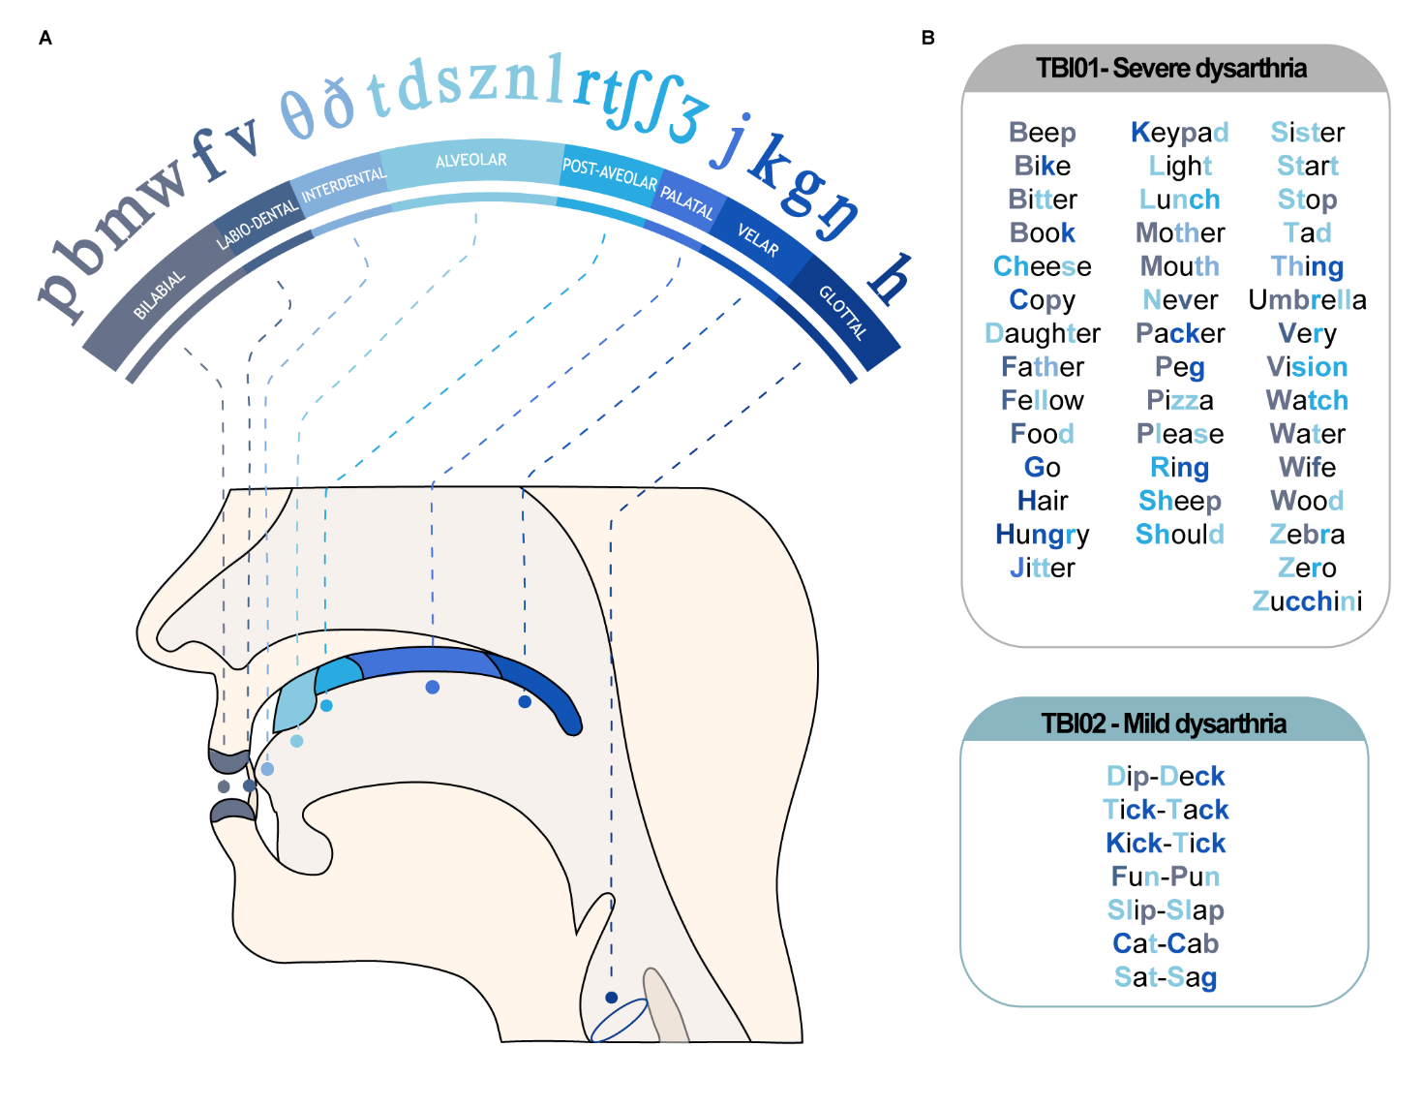
Extended Data Figure 5 | Words tested over the different sessions for TBI01 and TBI02. (a) Left: International Phonetic Alphabet schematic⁹² of consonant phonemes distribution. (b) Right Top: All words tested for TBI01. Right Bottom: All words tested for TBI02. For both tables, consonant phonemes within each word color coded corresponding to the International Phonetic Alphabet schematic.

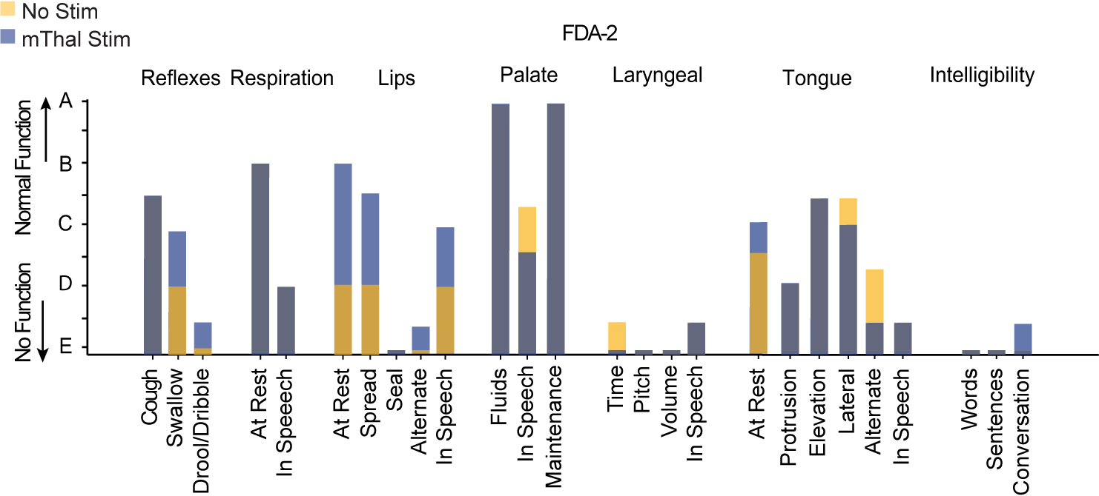
Extended Data Figure 6 | Frenchay Dysarthria Assessment-2 of TBI01. FDA-2 results of TBI01 conducted by blinded SLP for DBS motor thalamus stimulation OFF (yellow) and ON (blue) conditions. For each item, bars are overlapped between the two conditions.

SUPPLEMENTARY TABLES:

Subject | Lesion damage | Speech and swallowing deficits | Experiments performed
S01 | – | – | DCS MEPs
S02 | – | – | DCS MEPs
S03 | – | – | DCS MEPs
S04 | – | – | DCS MEPs
S05 | – | – | DCS MEPs
S06 | – | – | DCS MEPs
S07 | – | – | DCS MEPs
S08 | – | – | Facial expression tasks
S09 | – | – | Facial expression tasks
S09 | – | – | Facial expression tasks
TBI01 | Bilateral CBT and CST damage | Profound dysarthria  Moderate dysphagia | Facial expression tasks  Videofluoroscopic swallow study  Speech tasks
TBI02 | Unilateral CBT damage | Mild dysarthria  No dysphagia | Speech tasks
Supplementary Table 1 | Summary of clinical details of the participants enrolled in the study and of the behavioral experiments performed. The latter were selected for each participant based on their deficits and time available for experiments. For additional information about CBT and CST damage see Extended Data Figure 3. For additional details about speech deficits for TBI01 and TBI02 see Results and Methods.

Subject | Etiology | DCS intensity | Motor thalamus frequencies tested | Facial Muscles showing clear MEPs with DCS alone
S01 | ET | 9 mA | 50 Hz, 100 Hz | Mass/Mylo/Oris
S02 | PD | 2 mA | 50 Hz, 80 Hz | Mass/Mylo/Oris
S03 | ET | 8 mA | 50 Hz, 80 Hz | Mass/Mylo/Oris
S04 | ET | 11 mA | 50 Hz, 80 Hz | Mass/Mylo/Oris/Crico
S05 | PD | 6 mA | 50 Hz | Mass/Mylo/Oris/Ment/Crico
S06 | ET | 11 mA | 50 Hz, 100 Hz | Mass/Mylo/Oris
S07 | ET | 13 mA | 80 Hz | Mass/Mylo/Oris/Ment
Supplementary Table 2 | Stimulation parameters for M1-DCS and motor thalamus stimulation in participants undergoing DBS implantation (S01-S07). The amplitude of stimulation of the motor thalamus was always at 4mA and the pulse width at 100us.

Subject | Stimulation Parameters | Facial Muscles
S08 | 1 mA, 100 Hz, 100 us | Mass/Mylo/Oris
S09 | 2.5mA, 100 Hz, 100 us | Mass/Mylo/Oris
S10 | 1mA, 50 Hz, 100 us | Mass/Mylo/Oris
TBI01 | 2-4mA, 55Hz, 90-100 us | –
TBI01 (130 Hz) | 2.0mA, 130Hz, 100us | –
TBI02 | 1.5-5.5mA, 50 Hz, 100us | –
Supplementary Table 3 | Motor thalamus stimulation parameters for subjects S08-S10 and TBI01-TBI02.

Subject | Session | Tasks
TBI01 | Session 1 | Single Words
TBI01 | Session 2 | Single Words
TBI01 | Session 3 | Single Words
TBI01 | Session 4 | Facial expression tasks
TBI01 | Session 5 | Single Words,  Passage Reading,  Two-word phrases
TBI01 | Session 6 | Facial expression tasks,  Single Words,  Two-word phrases
TBI01 | Session 7 | Single Words,  Sentences
TBI01 | Session 8 | Single Words,  Sentences
TBI01 | Session 9 | Facial expression tasks,  Single Words
TBI01 | Session 10 | Assessment of Intelligibility of Dysarthric Speech (AIDS)
TBI01 | Session 11 | Assessment of Intelligibility of Dysarthric Speech (AIDS)
TBI01 | Session 12 | Assessment of Intelligibility of Dysarthric Speech (AIDS)
TBI01 | Session 13 | Frenchay Dysarthria Assessment-2  (FDA-2)
 | Session 14 | Videofluoroscopic swallow study
TBI02 | Session 1 | Tongue Twister,  Spontaneous conversation
TBI02 | Session 2 | Tongue Twister,  Spontaneous conversation
Supplementary Table 4: Behavioral tests analyzed broken down by sessions fo

