Higher spatial resolution is not always better: evaluating satellite-sensed sea surface temperature products for a west Pacific coral reef system
Liam Lachs^{1,2}*, Simon Donner², Alasdair J. Edwards¹, Yimnang Golbuu^{3,4}, James Guest¹
¹ School of Natural and Environmental Sciences, Newcastle University, Newcastle upon Tyne, UK
² Department of Geography / Institute for Resources Environment and Sustainability, University of British Columbia, Vancouver, British Columbia, Canada
³ Palau International Coral Reef Center, Koror, Palau
⁴ The Nature Conservancy, Micronesia and Polynesia, Koror, Palau
* Corresponding author: liamlachs@gmail.com

Supplementary Information
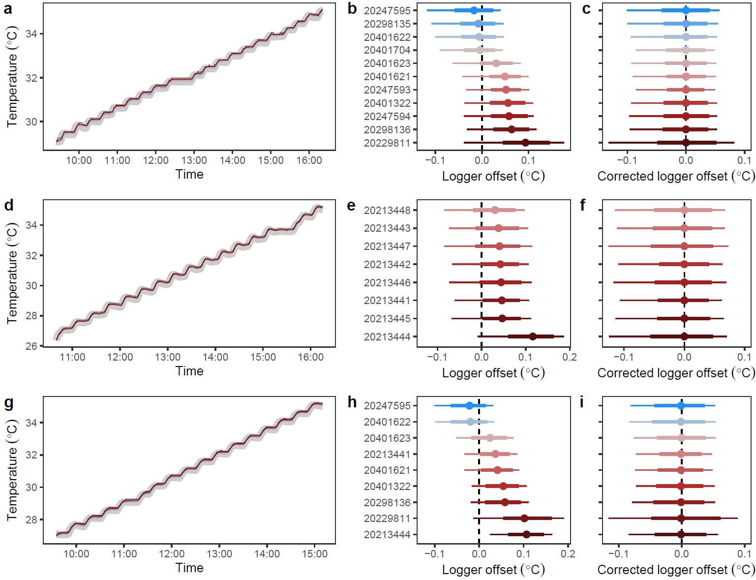
Figure S1. HOBO WaterTemp Pro v2 logger calibration and accuracy from three calibrations performed in August 2018 (a-c), September 2018 (d-f), May 2019 (g-i). (a,d,g) Calibration time series of temperature measured in water bath warmed at 0.5°C increments from the certified digital TR-1050 thermometer (broad grey line) and the raw HOBO loggers (fine coloured lines, ID codes as in b, e, and h). (b,e,h) Logger offset (HOBO logger minus TR-1050) for each HOBO logger (y axis) coloured by offset. (c,f,i) HOBO logger precision (Corrected HOBO logger minus TR-1050) is within ±0.1°C. Error bar panels show the mean offset (point) the interquartile range (bold feather) and the 95% range (2.5th to 97.5th percentiles, fine feather).
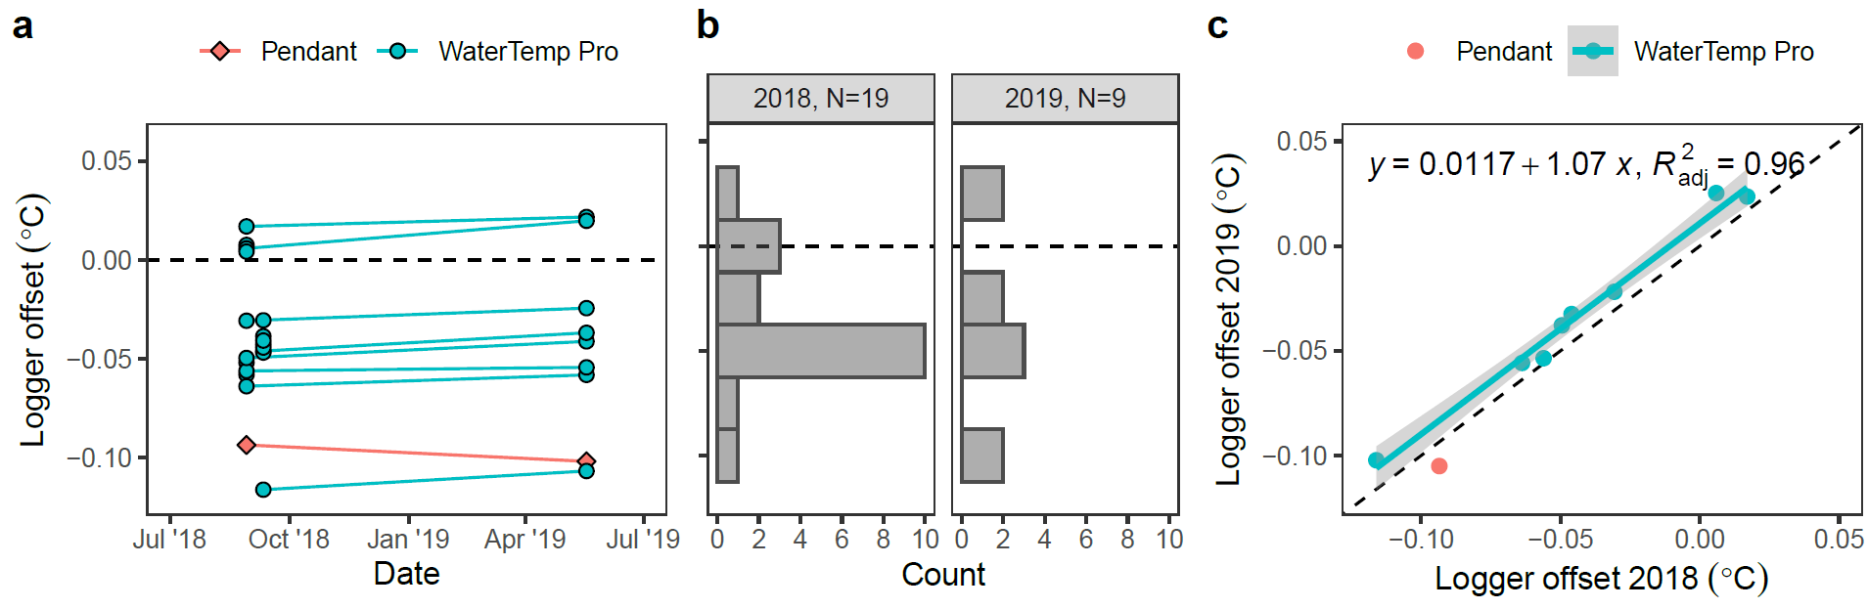
Figure S2. Temporal consistency of HOBO WaterTemp Pro v2 logger bias. (a) Calibration offsets for individual loggers deployed in this study in 2018 and in 2019. (b) Histograms of thermal offsets between years. (c) Correlation between 2018 offset and 2019 offset (corrected for each logger to be show annual drift assuming it is consistent, rather than 8-months later drift).

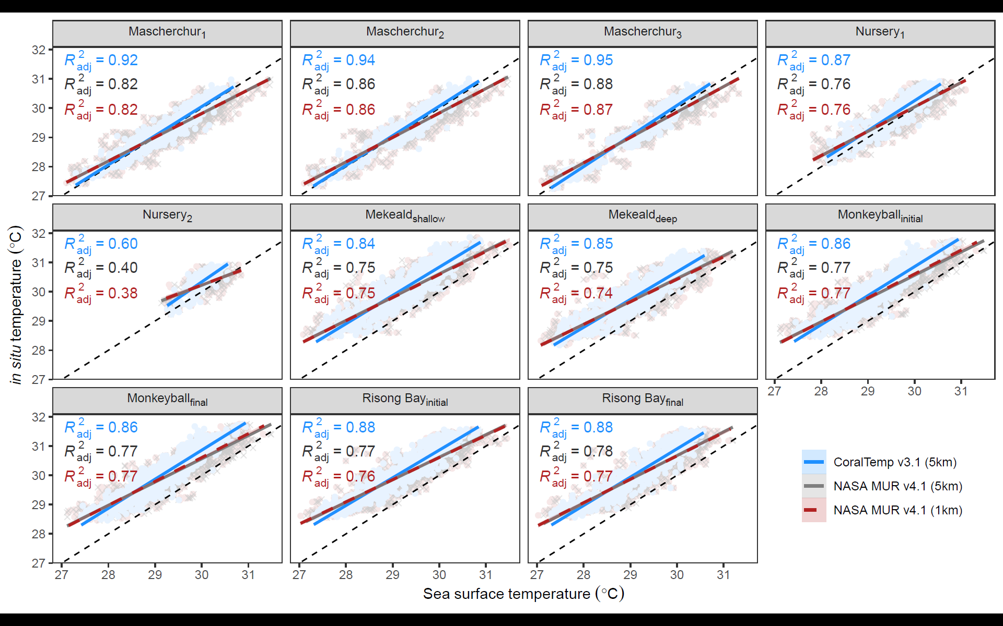
Figure S3. Site-specific linear regressions between sea surface temperature (SST) and nightly average in situ logged temperatures supporting Fig. 2b-d. Raw data (points), model predictions (lines), and the proportion of in situ temperature variability explained by SST data (adjusted R²) are shown for CoralTemp (blue), MUR (red), and MUR re-gridded at CoralTemp resolution (grey).

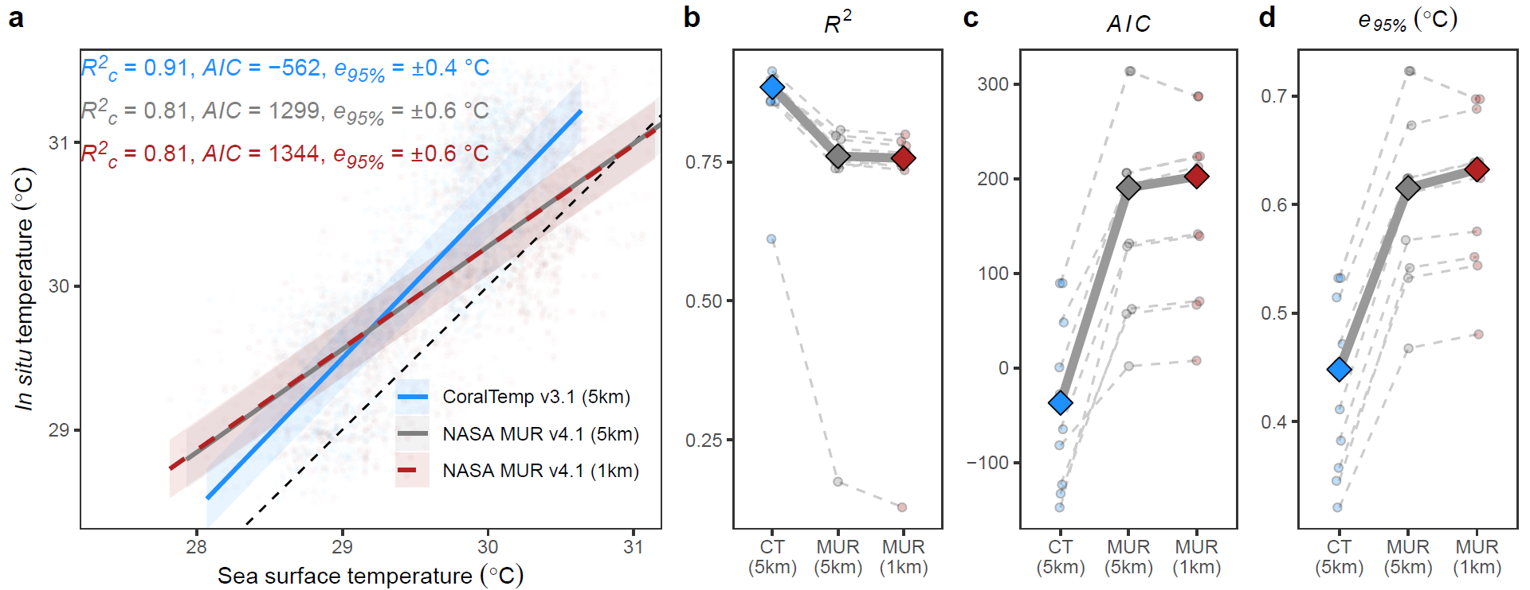
Figure S4. Reanalysis of SST ability to predict in situ logged temperatures across 11 deployed loggers at 5 sites for only the warm season (June – September). To be comparable to SST data, in situ data are first summarised as nightly averages. Panels descriptions the same as Fig. 2.

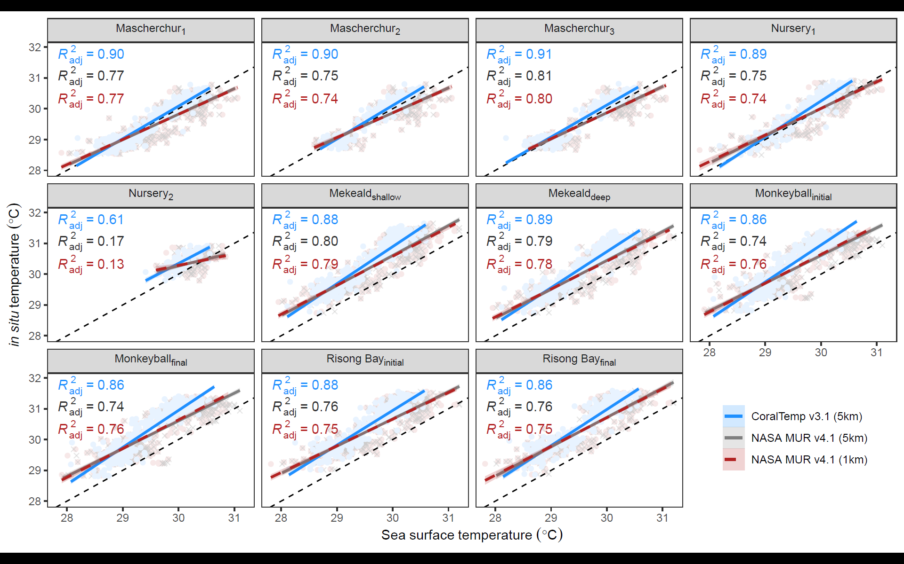
Figure S5. Reanalysis of site-specific linear regressions between sea surface temperature (SST) and nightly average in situ logged temperatures, but for only the warm season (June – September). Raw data (points), model predictions (lines), and the proportion of in situ temperature variability explained by SST data (adjusted R²) are shown for CoralTemp (blue), MUR (red), and MUR re-gridded at CoralTemp resolution (grey).

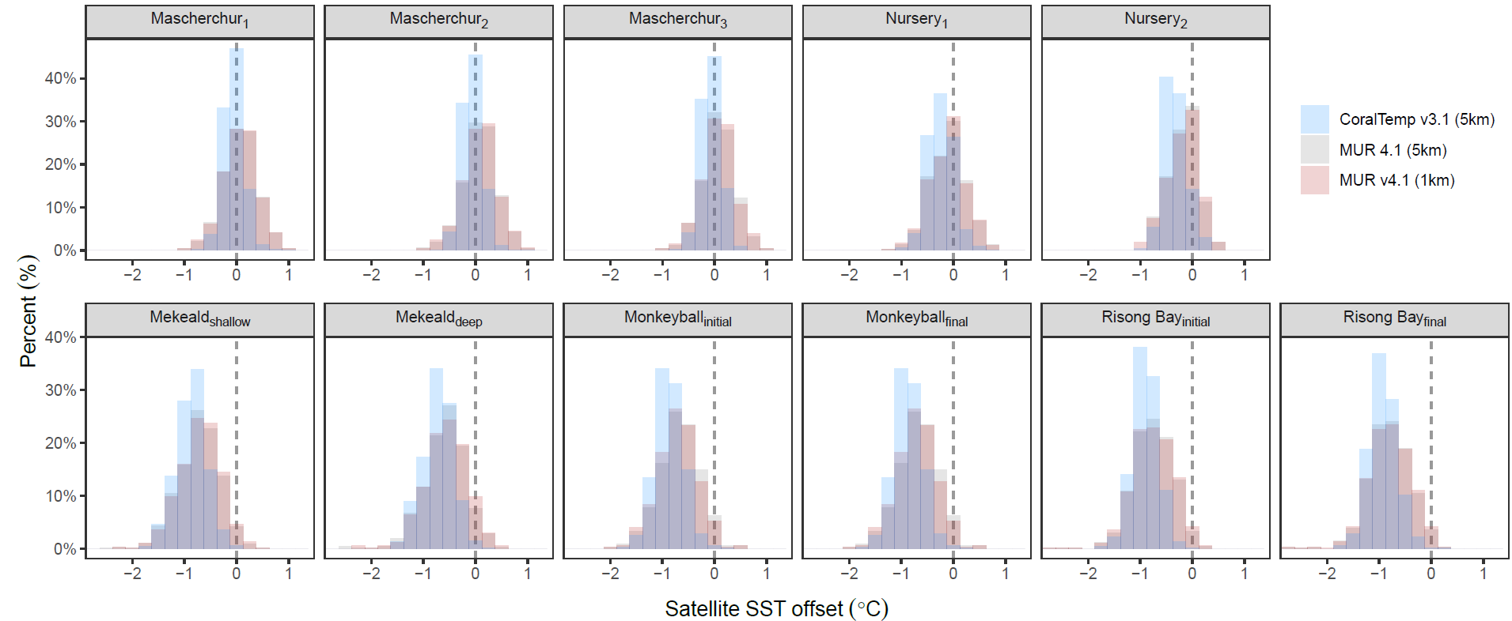
Figure S6. Histograms showing the accuracy and precision of SST data from CoralTemp (blue), MUR (red), and MUR re-gridded at CoralTemp resolution (grey), supporting Fig. 3.

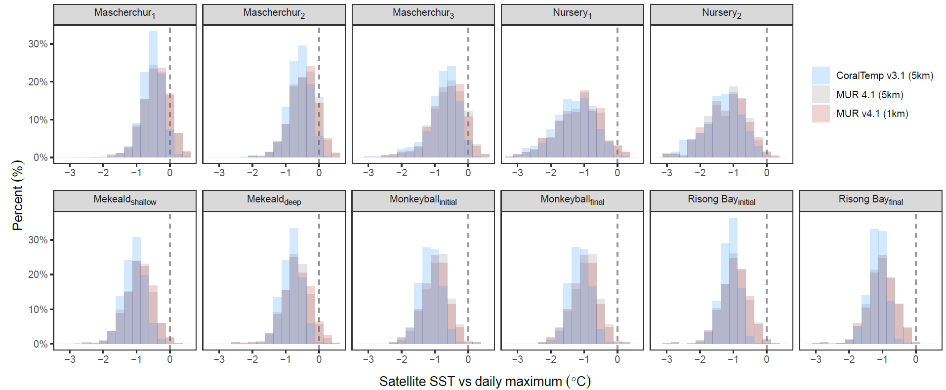
Figure S7. Histograms showing the difference between night-time SST data and in situ daily maximum from hourly logger data for CoralTemp (blue), MUR (red), and MUR re-gridded at CoralTemp resolution (grey), supporting Fig. 4.

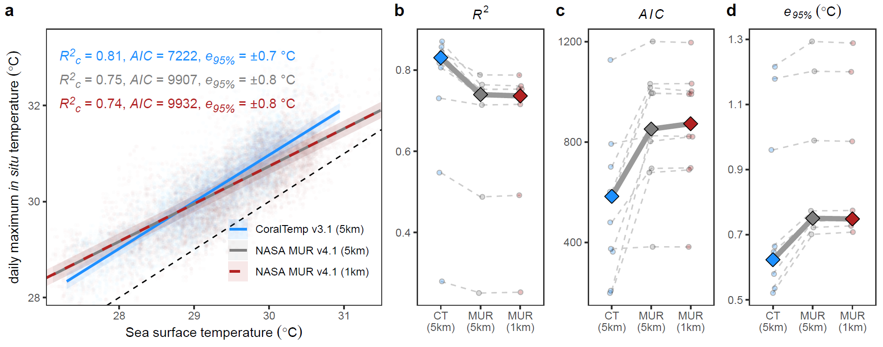
Figure S8. Ability of SST datasets to predict daily maximum in situ logged temperatures across 11 deployed loggers at 5 sites. (a) The overall relationship between daily maximum in situ temperatures (based on hourly data) and SST from CoralTemp (blue), MUR (red), and MUR re-gridded at CoralTemp resolution (grey), modelled with a linear mixed effects model, allowing for random intercepts for site and year. Model evaluation metrics show the proportion of in situ temperature variance explained by SST and random effects (conditional R²), overall goodness of fit (Akaike Information Criterion), and model error shown as a 95% error range (e_{95%}, 1.96 × standard deviation of residuals). (b-d) The same summary statistics shown in (a) except based on linear regressions fitted for each site independently.

Table S1. Temperature logger positions and deployment times. Subscript numbers refer to location number with a site and subscript letters correspond to the following: s (shallow), d (deep), i (initial part of transect), and f (final part of transect).
Site | Reef habitat | Longitude | Latitude | Depth (m) | Deployment start | Deployment end | Missing data (%)
Mascherchur₁ | Outer | 134.5189 | 7.291679 | 2-3m | 12/11/2017 | 22/04/2022 | 0%
Mascherchur₂ | Outer | 134.5197 | 7.291233 | 2-3m | 29/11/2017 | 15/01/2021 | 37%
Mascherchur₃ | Outer | 134.5204 | 7.291106 | 2-3m | 30/11/2017 | 15/01/2021 | 39%
Nursery₁ | Patch | 134.5019 | 7.3055 | 2-3m | 15/05/2019 | 31/03/2022 | 0%
Nursery₂ | Patch | 134.5019 | 7.3055 | 2-3m | 11/06/2020 | 31/03/2022 | 0%
Mekeald_{s} | Lagoon | 134.4412 | 7.291456 | 2-3m | 19/11/2017 | 18/11/2020 | 0%
Mekeald_{d} | Lagoon | 134.4408 | 7.291264 | 9m | 05/06/2018 | 18/11/2020 | 0%
Risong Bay_{i} | Lagoon | 134.4841 | 7.306793 | 2-3m | 30/11/2017 | 19/11/2020 | 0%
Risong Bay_{f} | Lagoon | 134.4844 | 7.306465 | 2-3m | 09/09/2018 | 19/11/2020 | 0%
Monkeyball_{i} | Lagoon | 134.3719 | 7.230912 | 2-3m | 07/06/2018 | 18/11/2020 | 0%
Monkeyball_{f} | Lagoon | 134.3732 | 7.22968 | 2-3m | 28/11/2017 | 18/11/2020 | 0.04%

