Supplementary Material
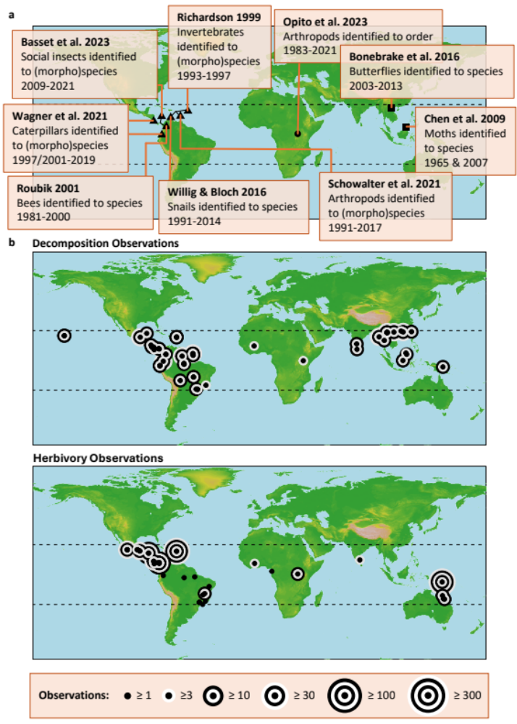-
S1. Maps of the data utilized in our analysis. The pantropical region is contained by the horizontal dashed lines at the Tropics of Cancer and Capricorn. S1a. Invertebrate diversity time series locations. We used data from six studies of the Americas (Costa Rica, Ecuador, Panama and Puerto Rico), one from Africa (Uganda) and two from Asia (Vietnam and Malaysia). S1b. Invertebrate decomposition/herbivory measurement locations. We used 2,156 leaf litter decomposition observations from 36 studies and 2,117 leaf herbivory observations from 40 studies.
S2. Time-series data used in the modelling of generalized invertebrate diversity at ordinal-level through time. Filled cells under Sampling Years indicate when sampling of the relevant invertebrate Order in the respective study was conducted. Circles, triangles and squares indicate sampling in Africa, the Americas and Asia respectively.
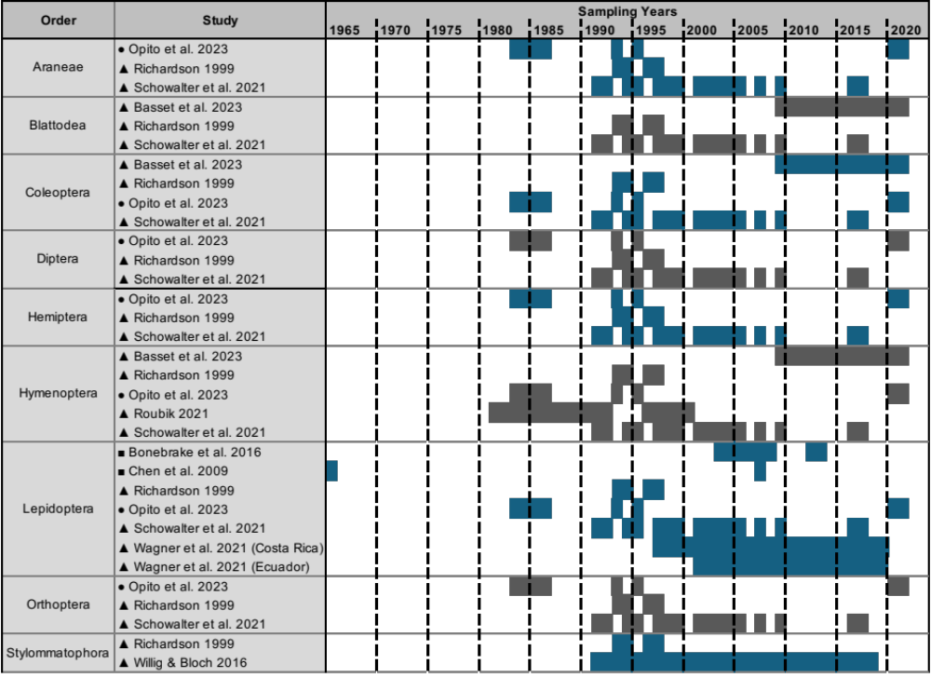
S3. Table of parametric coefficient estimates for the generalized Tweedie model predicting invertebrate diversity across time. Estimates are on the log link scale. P is the probability that t is significantly different from 0. Significance is indicated at the P < 0.05, P < 0.01 and P < 0.001 levels by *, ** and *** respectively.

Parameter | Estimate | Standard Error | t | P
Order: Araneae (Intercept, year 2000) | -0.339 | 0.035 | -9.695 | < 0.001 ***
Order: Blattodea (Intercept, year 2000) | -0.348 | 0.038 | -9.071 | < 0.001 ***
Order: Coleoptera (Intercept, year 2000) | -0.149 | 0.033 | -4.560 | < 0.001 ***
Order: Diptera (Intercept, year 2000) | -0.267 | 0.035 | -7.640 | < 0.001 ***
Order: Hemiptera (Intercept, year 2000) | -0.258 | 0.036 | -7.268 | < 0.001 ***
Order: Hymenoptera (Intercept, year 2000) | -0.209 | 0.036 | -5.846 | < 0.001 ***
Order: Lepidoptera (Intercept, year 2000) | -0.240 | 0.025 | -9.559 | < 0.001 ***
Order: Orthoptera (Intercept, year 2000) | -0.162 | 0.037 | -4.418 | < 0.001 ***
Order: Stylommatophora (Intercept, year 2000) | -0.094 | 0.010 | -8.977 | < 0.001 ***
Araneae El Niño Effect (per ONI unit) | 0.128 | 0.045 | 2.833 | 0.005 **
Blattodea El Niño Effect (per ONI unit) | 0.009 | 0.054 | 0.177 | 0.859
Coleoptera El Niño Effect (per ONI unit) | 0.011 | 0.043 | 0.251 | 0.802
Diptera El Niño Effect (per ONI unit) | 0.060 | 0.045 | 1.339 | 0.181
Hemiptera El Niño Effect (per ONI unit) | -0.113 | 0.046 | -2.467 | 0.014 *
Hymenoptera El Niño Effect (per ONI unit) | 0.008 | 0.046 | 0.167 | 0.867
Lepidoptera El Niño Effect (per ONI unit) | -0.214 | 0.030 | -7.121 | < 0.001 ***
Orthoptera El Niño Effect (per ONI unit) | -0.105 | 0.047 | -2.216 | 0.027 *
Stylommatophora El Niño Effect (per ONI unit) | 0.038 | 0.013 | 2.830 | 0.005 **
Araneae Long-Term Shift (per year) | -0.013 | 0.005 | -2.951 | 0.003 **
Blattodea Long-Term Shift (per year) | 0.002 | 0.005 | 0.432 | 0.666
Coleoptera Long-Term Shift (per year) | -0.012 | 0.004 | -3.129 | 0.002 **
Diptera Long-Term Shift (per year) | 0.003 | 0.005 | 0.642 | 0.521
Hemiptera Long-Term Shift (per year) | -0.023 | 0.005 | -5.038 | < 0.001 ***
Hymenoptera Long-Term Shift (per year) | -0.013 | 0.004 | -3.465 | < 0.001 ***
Lepidoptera Long-Term Shift (per year) | -0.019 | 0.003 | -7.375 | < 0.001 ***
Orthoptera Long-Term Shift (per year) | -0.002 | 0.005 | -0.498 | 0.618
Stylommatophora Long-Term Shift (per year) | 0.005 | 0.001 | 3.739 | < 0.001 ***
Effect of Order-Level Resolution on Long-Term Shift (per year) | 0.011 | 0.003 | 3.443 | < 0.001 ***
Interaction: Araneae El Niño Effect Shift Over Time | 0.006 | 0.006 | 0.953 | 0.341
Interaction: Blattodea El Niño Effect Shift Over Time | -0.024 | 0.010 | -2.486 | 0.013 *
Interaction: Coleoptera El Niño Effect Shift Over Time | -0.002 | 0.005 | -0.416 | 0.678
Interaction: Diptera El Niño Effect Shift Over Time | 0.012 | 0.006 | 2.060 | 0.039 *
Interaction: Hemiptera El Niño Effect Shift Over Time | -0.015 | 0.006 | -2.498 | 0.013 *
Interaction: Hymenoptera El Niño Effect Shift Over Time | 0.002 | 0.005 | 0.294 | 0.769
Interaction: Lepidoptera El Niño Effect Shift Over Time | -0.005 | 0.002 | -1.914 | 0.056
Interaction: Orthoptera El Niño Effect Shift Over Time | 0.009 | 0.006 | 1.561 | 0.119
Interaction: Stylommatophora El Niño Effect Shift Over Time | 0.002 | 0.002 | 0.944 | 0.345

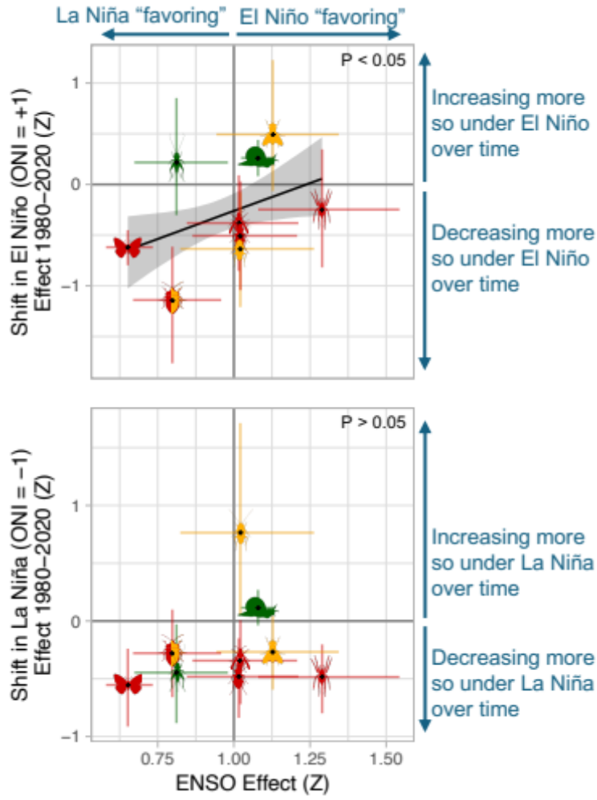
S4. Estimated shifts in relative EL Niño (top) and La Niña (bottom) impact on invertebrate richness over the 1980-2020 period. Colored vertical and horizontal error bars around estimates represent 95% confidence intervals derived from 10,000 bootstrapping samples of the generalized diversity model. Black model lines and grey 95% confidence bands (top panel only) are derived from 10,000 linear regressions fitted to bootstrapped parameter estimates.

S5. Years of data collection for studies quantifying leaf litter decomposition by invertebrates in the tropics.

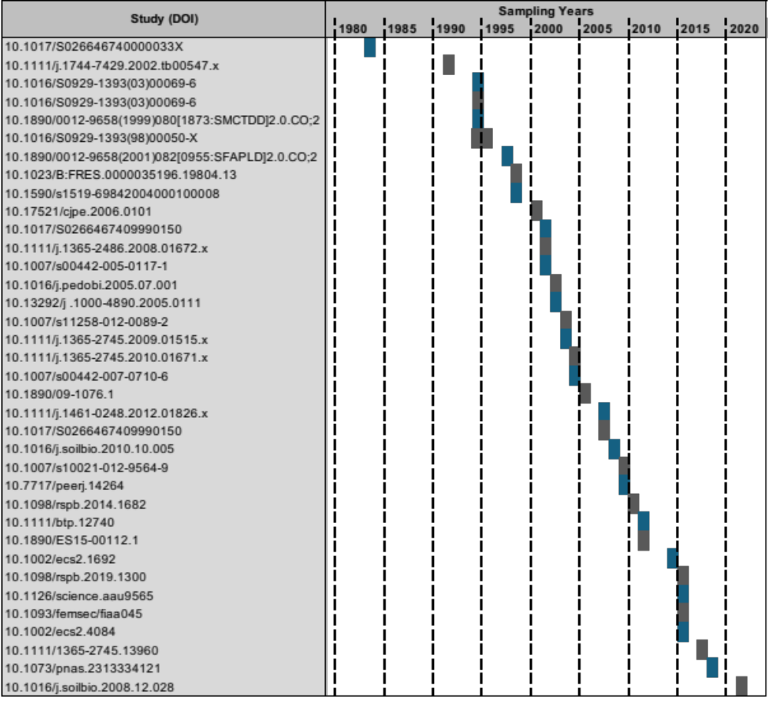
S6. Years of data collection for studies quantifying leaf herbivory by invertebrates in the tropics.

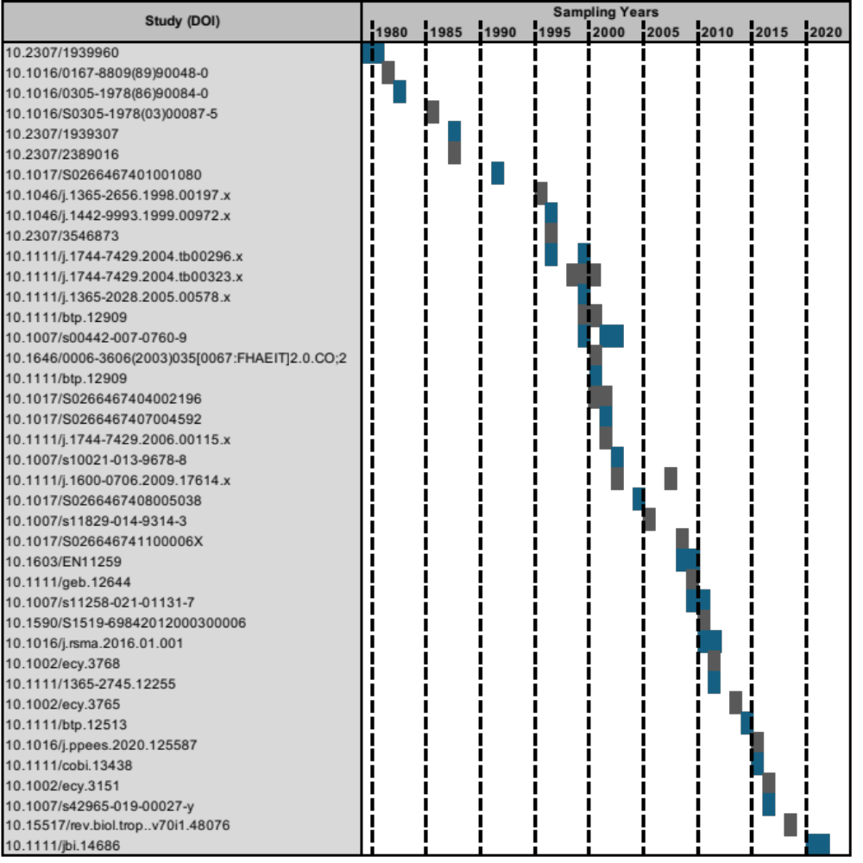

S7. Table of parametric coefficient estimates for the generalized gaussian model predicting invertebrate leaf litter decomposition rate over time. P is the probability that t is significantly different from 0. Significance is indicated at the P < 0.05, P < 0.01 and P < 0.001 levels by *, ** and *** respectively.

Parameter | Estimate | Standard Error | t | P
(Intercept, year 2000) | 0.196 | 0.083 | 2.366 | 0.029 *
Long-Term Shift (per year) | 0.016 | 0.006 | 2.573 | 0.019 *
Annual ONI Maximum (per ONI unit) | 0.098 | 0.063 | 1.565 | 0.135
Interaction: Long-Term Shift x Annual ONI Max. | -0.014 | 0.005 | -2.818 | 0.011 *

S8. Table of parametric coefficient estimates for the generalized gamma model predicting invertebrate leaf litter decomposition rate over time. Estimates are on the log link scale. P is the probability that t is significantly different from 0. Significance is indicated at the P < 0.05, P < 0.01 and P < 0.001 levels by *, ** and *** respectively.

Parameter | Estimate | Standard Error | t | P
(Intercept, year 2000) | -1.591 | 0.160 | -9.943 | < 0.001 ***
Long-Term Shift After 2000 (per year) | -0.095 | 0.006 | -14.687 | < 0.001 ***

