Supplementary Materials

Supplementary Figure 1: Association of IDO1 expression and driving gene mutation or immune checkpoint expression.
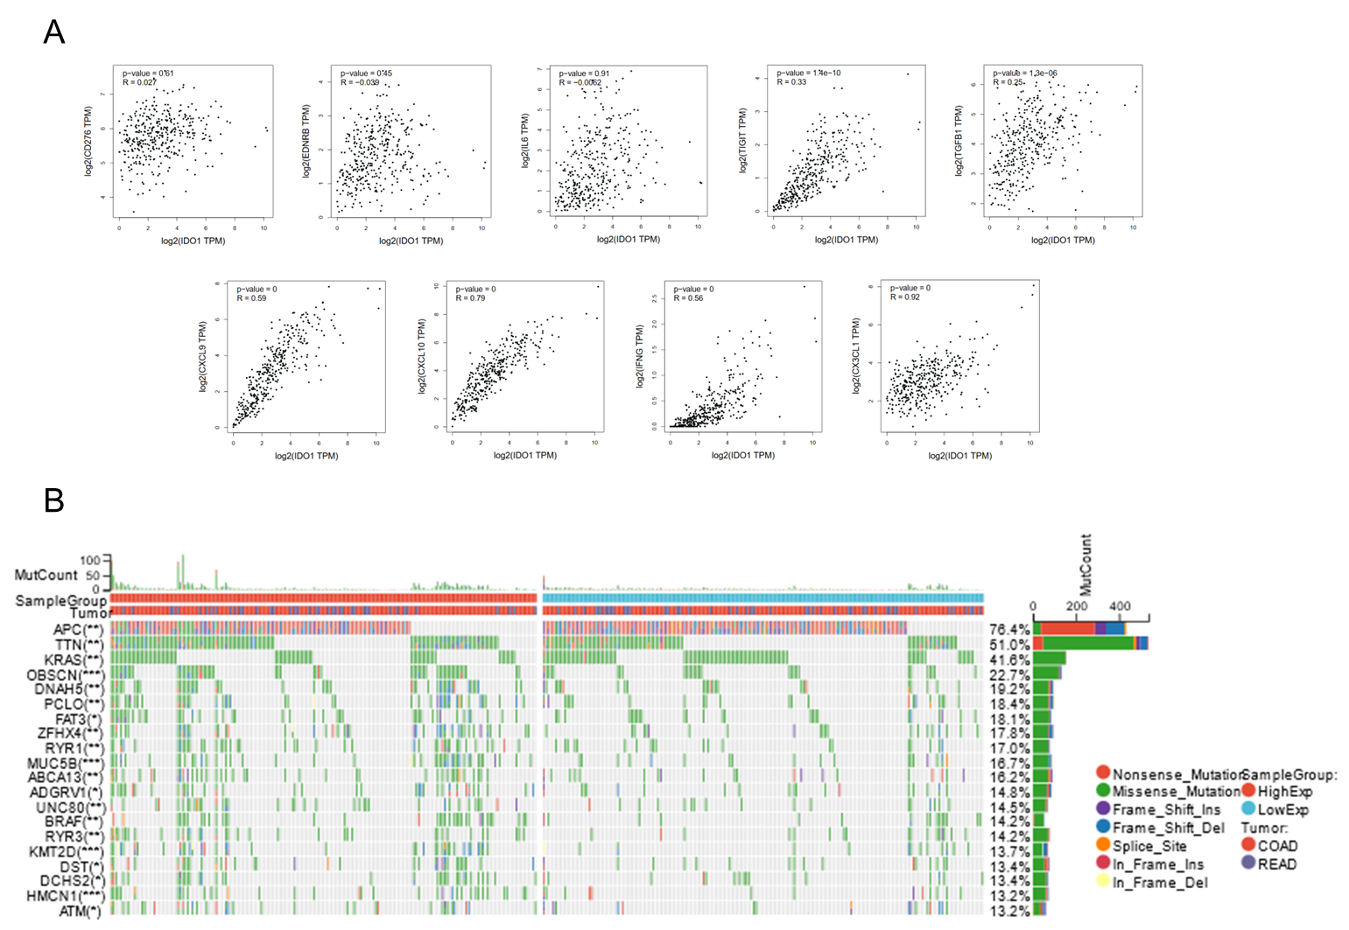
A: Scatterplots of IDO1 and other commonly studied immune checkpoints (CD276, EDNRB, IL6, TIGIT, TGFB1, CXCL9, CXCL10, IFNG, CX3CL1).
B: Landscape of IDO1 expression and driving gene mutation in TCGA-COAD and TCGA-READ.

Supplementary Figure 2: IDO1 inhibitor also promote the effect of PD-1 blockade therapy in MSI-H colon cancer.
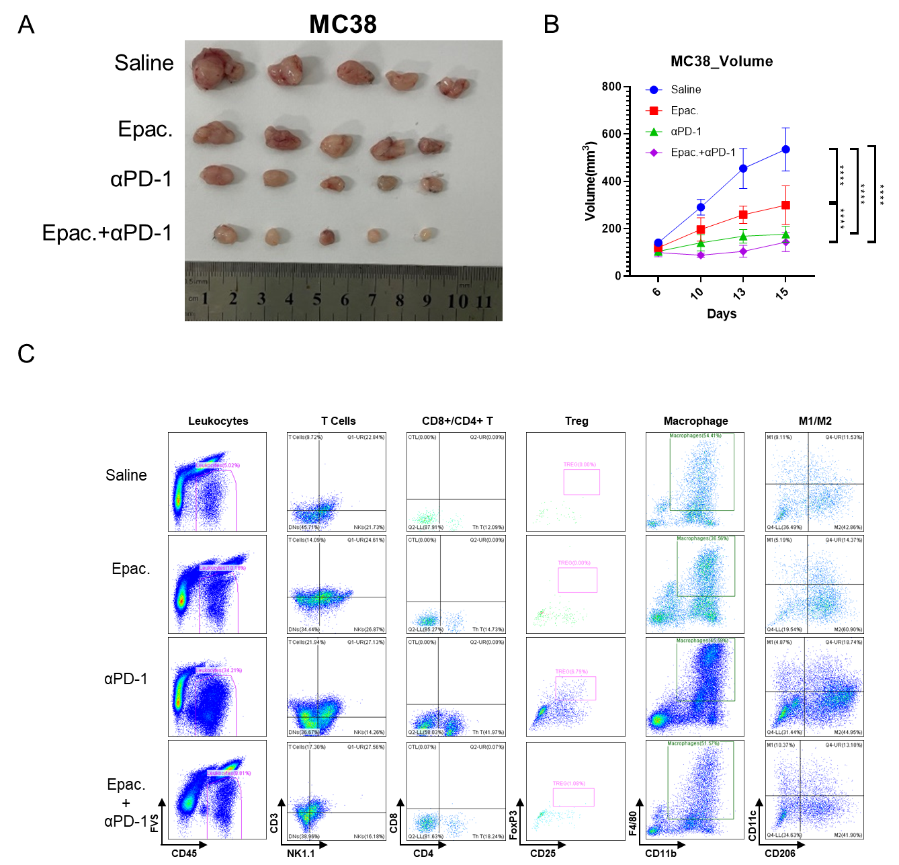
A: Snapshot of tumor size of MC38 being treated by either epacadostat or PD-1 monoclonal antibody.
B: Tumor size statistics of MC38 and the increase of tumor volume with time post-inoculation (n=5, data was presented as mean ± SEM)
C: Scatterplots of flow cytometry analysis of TILs in tumor receiving different treatments.

Supplementary Figure 3: Knockdown of IDO1 in MSI-H tumor promote the effect of PD-1 blockade therapy.
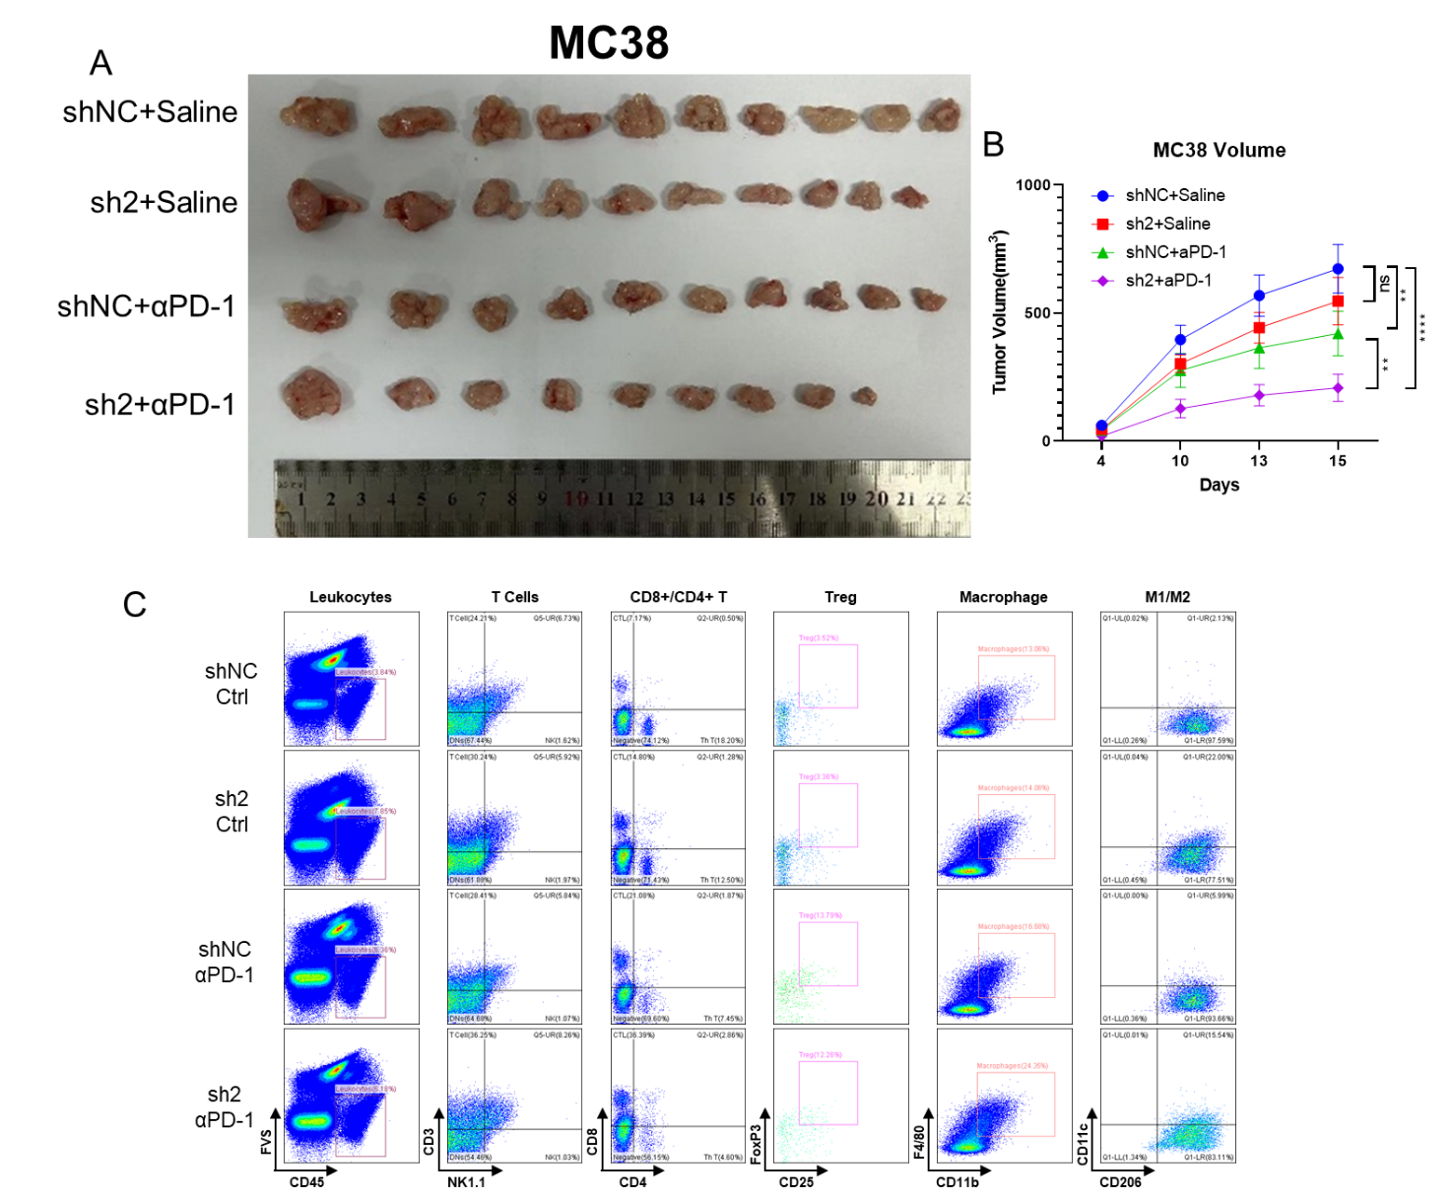

A: Snapshot of tumor size of MC38 shNC or shIDO1 treated with or without PD-1 monoclonal antibody.
B: Tumor size statistics of MC38 and the increase of tumor volume with time post-inoculation(n=9, data was presented as mean ± SEM);
C: Scatterplots of flow cytometry analysis of TILs in tumor receiving different treatments.

Target | Sequence (5’ to 3’)
Mouse IDO1 -1 | sense | GCAAUAGUAGAUACUUACA
 | antisense | UGUAAGUAUCUACUAUUGC
Mouse IDO1 -2 | sense | CAAUGAAGACUUGACGAAA
 | antisense | UUUCGUCAAGUCUUCAUUG
Human IDO1 -1 | sense | GGAUGUUCAUUGCUAAACA
 | antisense | UGUUUAGCAAUGAACAUCC
Human IDO1 -2 | sense | GCUGUUGGAAAUAGCUUCU
 | antisense | AGAAGCUAUUUCCAACAGC

Supplementary Table 1 RNAi sequences
Target | Sequence (5’ to 3’)
Mouse Ido1 | forward | GCTTTGCTCTACCACATCCAC
 | reverse | CAGGCGCTGTAACCTGTGT
Human IDO1 | forward | GCCAGCTTCGAGAAAGAGTTG
 | reverse | ATCCCAGAACTAGACGTGCAA
Mouse Actb | forward | GGCTGTATTCCCCTCCATCG
 | reverse | CCAGTTGGTAACAATGCCATGT
Human ACTB | forward | CATGTACGTTGCTATCCAGGC
 | reverse | CTCCTTAATGTCACGCACGAT
Human JAK2 | forward | TCTGGGGAGTATGTTGCAGAA
 | reverse | AGACATGGTTGGGTGGATACC
Human STAT3 | forward | CAGCAGCTTGACACACGGTA
 | reverse | AAACACCAAAGTGGCATGTGA

Supplementary Table 2 primer sequences

Supplementary Table 3 Antibodies for WB/IF/IHC
Antibody name | Category No. | Manufacturer | Dilution
IDO1 mouse monoclonal antibody | 66528-1-IG | Proteintech | 1:5000 in WB  1:1000 in IHC
GAPDH rabbit monoclonal antibody | ab181602 | Abcam | 1:10000 in WB
β-actin（MG3）mouse monoclonal antibody | RM2001 | Beijing Ray Antibody Biotech | 1:10000 in WB
AHR rabbit polyclonal antibody | AF6165 | Beyotime | 1:1000 in WB
Histone H3 antibody (rabbit) | 9715S | Cell Signaling Technology | 1:1000 in WB
Caspase-3 antibody (rabbit) | 9662S | Cell Signaling Technology | 1:1000 in WB
PD-L1 rabbit monoclonal antibody | AG4974 | Beyotime | 1:1000 in WB
IL6 rabbit polyclonal antibody | AF7236 | Beyotime | 1:1000 in WB  1:50 in FCS  1:100 in IF
CD163 Rabbit Polyclonal Antibody | AF6453 | Beyotime | 1:100 in IF
iNOS Rabbit Polyclonal Antibody | AF7281 | Beyotime | 1:1000 in WB
Anti-F4/80 Rabbit pAb | GB113373 | Servicebio | 1:500 in IHC
Anti-CD206 Rabbit pAb | GB113497 | Servicebio | 1:400 in IHC
Anti-IL-6 Rabbit pAb | GB11117 | Servicebio | 1:200 in IHC

Supplementary Table 4 Antibodies/Reagents used for FCS analysis
Antibody name | Category No. | Manufacturer
Alexa Fluor® 700 anti-mouse CD45 | 103128 | BioLegend
Brilliant Violet 650™ anti-mouse CD4 | 100555 | BioLegend
Brilliant Violet 421™ anti-mouse CD25 | 102043 | BioLegend
PE anti-mouse/rat/human FOXP3 | 320008 | BioLegend
APC/Fire™ 750 anti-mouse NK-1.1 | 108752 | BioLegend
APC/Fire™ 750 anti-mouse CD49b (pan-NK cells) | 108926 | BioLegend
Brilliant Violet 785™ anti-mouse/human CD11b | 101243 | BioLegend
Brilliant Violet 605™ anti-mouse CD11c | 117334 | BioLegend
APC anti-mouse F4/80 | 123116 | BioLegend
PE/Cyanine7 anti-mouse CD206 (MMR) | 141720 | BioLegend
Spark UV™ 387 anti-mouse CD8a | 100798 | BioLegend
Brilliant Violet 510™ anti-mouse CD3 | 100234 | BioLegend
Zombie Red™ Fixable Viability Kit | 423109 | Biolegend
Fixable Viability Stain 700 | 564997 | BD Pharmingen
Purified Rat Anti-Mouse CD16/CD32 (Mouse BD Fc Block™) | 553141 | BD Pharmingen
Purified NA/LE Hamster Anti-Mouse CD3e | 553057 | BD Pharmingen
Purified NA/LE Hamster Anti-Mouse CD28 | 553294 | BD Pharmingen
APC-Cy™7 Rat Anti-Mouse CD45 | 557659 | BD Pharmingen
BB700 Armenian Hamster Anti-Mouse CD3e | 566494 | BD Pharmingen
BV510 Hamster Anti-Mouse CD49b | 740133 | BD Pharmingen
Alexa Fluor 647 Rat Anti-Mouse CD206 | 565250 | BD Pharmingen
BV421 Rat Anti-Mouse CD25 | 564370 | BD Pharmingen
BV605 Rat Anti-Mouse CD4 | 563151 | BD Pharmingen
BV510 Mouse Anti-Mouse NK-1.1 | 563096 | BD Pharmingen
FITC Rat Anti-Mouse CD8a | 553030 | BD Pharmingen
Anti-Rat and Anti-Hamster Ig κ /Negative Control Compensation Particles Set | 552845 | BD Pharmingen
BV650 Rat Anti-Mouse F4/80 | 743282 | BD Pharmingen
BUV395 Hamster Anti-Mouse CD11c | 744180 | BD Pharmingen
BV786 Rat Anti-CD11b | 740861 | BD Pharmingen
PE Rat anti-Mouse Foxp3 | 563101 | BD Pharmingen

