Supplementary Material

The development of functional connectivity along the hippocampal long-axis in infants

Sam Audrain¹, Shawn C. Milleville¹, Jenna M. Wilson¹, Jude Baffoe-Bonnie¹, Stephen J. Gotts¹, Alex Martin¹

1. Section on Cognitive Neuropsychology, Laboratory of Brain and Cognition, National Institute of Mental Health, NIH, Bethesda, MD 20892

Corresponding author: Sam Audrain, samantha.audrain@mcgill.ca

Abstract
We do not remember events experienced as infants. Infancy is a critical period of development for the memory system, yet we know little about the functional neural changes that occur during this time. In adults, hippocampal-neocortical coupling is needed to establish long-term memories, and differs along the anteroposterior axis. We investigated hippocampal-neocortical functional connectivity along the long-axis at rest in 212 infants. We found that functional differentiation of the anterior and posterior hippocampus occurs very early on (<6 months old). We also identified numerous cortical regions where connectivity with the hippocampus was changing with age. A clustering analysis revealed that anteroposterior hippocampal connectivity was changing with cortical regions associated with memory, but also with canonical networks associated with salience and attention. These findings raise the possibility that infantile amnesia is in part a disorder of immature functional interaction between memory, attention, and salience systems that engender memory formation in adults.

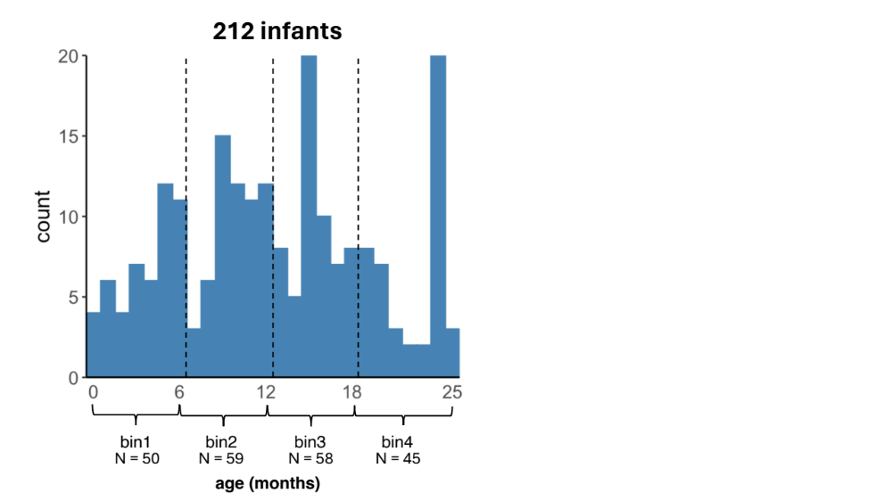
Supplementary Figure 1. Age distribution of infants in each age bin.

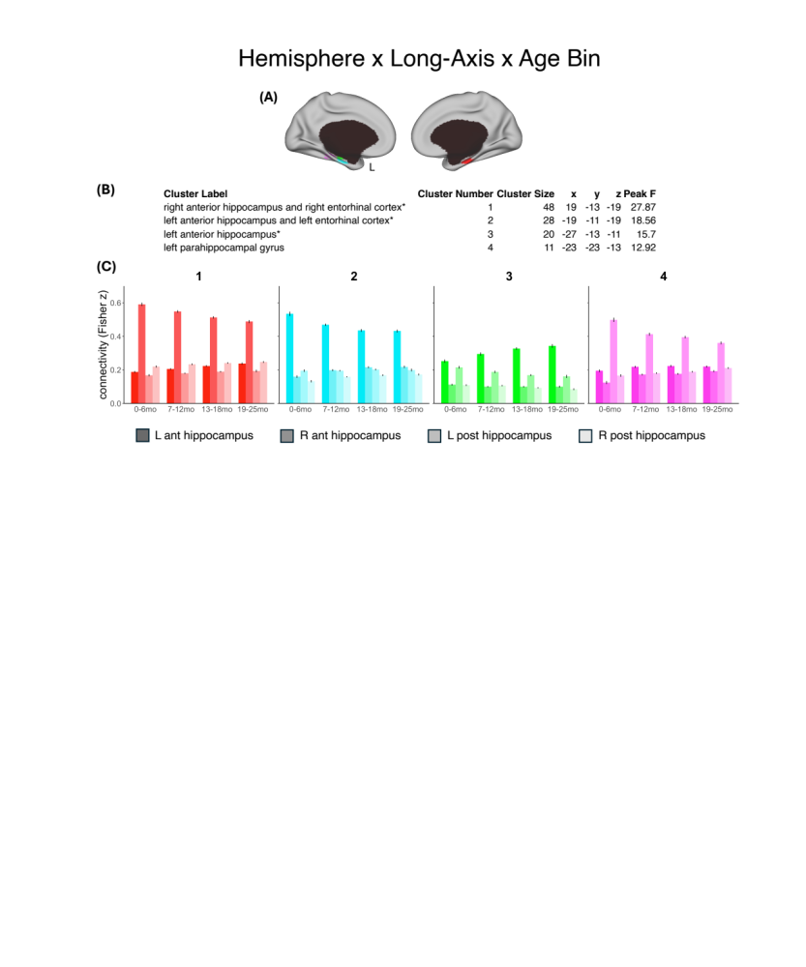
Supplementary Figure 2. Significant voxel-wise interaction between hemisphere, hippocampal long-axis, and age bin on connectivity. (A) significant voxels surviving the three-way interaction between hemisphere (right/left), hippocampal long-axis (anterior/posterior) and age bin (0-6 months/7-12 months/13-18 months/19-25 months) on connectivity at q<0.01, k = 10. (B) descriptive information for each identified region. (C) Plots depicting the interaction for each region. Asterisks (*) indicate that the region identified overlapped with the hippocampal masks that were used as seeds in this analysis. Ant: anterior; L: left; mo: months; post: posterior; R: right

Supplementary Figure 3. Significant voxel-wise interaction between hemisphere and hippocampal long-axis on connectivity. A) Regions of significant two-way interaction between hemisphere (left/right) and hippocampal long-axis (anterior/posterior) on connectivity at q<0.01, k = 10. B) descriptive information for each identified region. C) Plots depicting the interaction for each region. Asterisks (*) indicate that the region identified overlapped with the hippocampal masks that were used as seeds in this analysis. Ant: anterior; L: left; mo: months; post: posterior; R: right

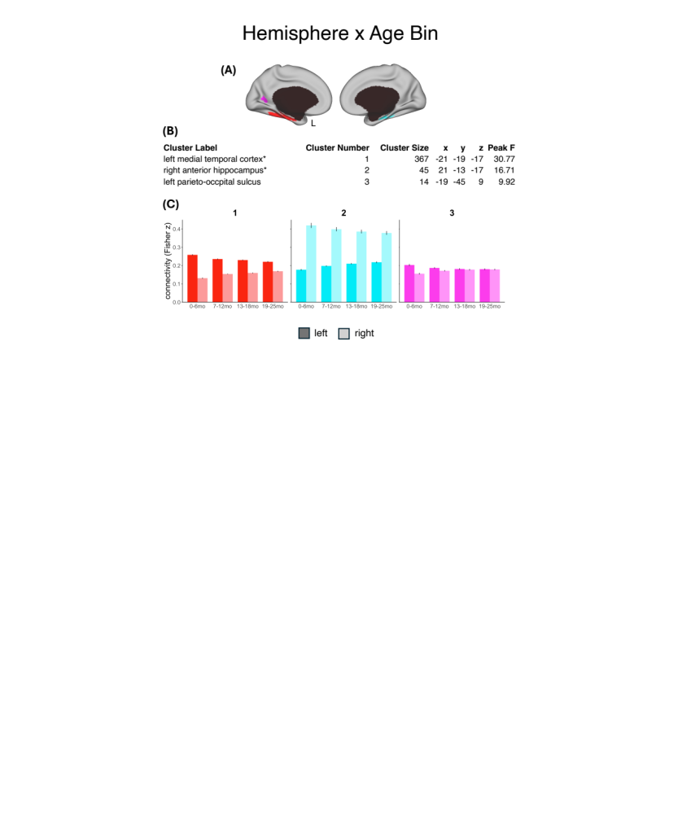
Supplementary Figure 4. Significant voxel-wise interaction between hemisphere and age bin on connectivity. (A) Regions of significant two-way interaction between hemisphere (right/left) and age bin (0-6 months/7-12 months/13-18 months/19-25 months) on connectivity at q<0.01, k = 10. (B) Descriptive information for each identified region. (C) Plots depicting the interaction for each region. Asterisks (*) indicate that the region identified overlapped with the hippocampal masks that were used as seeds in this analysis. Ant: anterior; L: left; mo: months; post: posterior; R: right

Supplementary Methods 1
While our aim in identifying superclusters was to facilitate interpretation by summarizing the different patterns of long-axis by age bin interaction across the 44 neocortical clusters, there was of course some variability within superclusters across the neocortical clusters contained within. We present the connectivity profiles for each neocortical cluster contributing to the superclusters in Supplementary Figures 6-11 for the interested reader. Visual inspection of these cluster-wise connectivity profiles suggested our clustering solution was doing a reasonable job of sorting neocortical clusters into superclusters sharing similar profiles. A 2D plot of the first two dimensions of a principal components analysis shows the 6 identified superclusters are reasonably distinct (Supplementary Figure 5.C). We also calculated silhouette statistics to assess overall supercluster quality (Supplementary Figure 5.D). The silhouette statistic in this case is a measure of how similar a neocortical cluster is to its designated supercluster (cluster cohesion) compared to how similar it is to other superclusters (cluster separation), and ranges from -1 to 1 ³⁰. Higher positive values mean the neocortical cluster is well-matched to its supercluster and poorly matched to other superclusters, while negative values indicate a neocortical cluster may better fit with another supercluster. The average silhouette width across all 44 neocortical clusters was 0.33, indicating a reasonable clustering solution for the superclusters. The silhouette statistic for each supercluster was as follows: medial parietal supercluster = 0.55, entorhinal supercluster = 0.46, cingulo-opercular supercluster = 0.37, dorsal frontal parietal supercluster = 0.33, vmPFC-STS supercluster = 0.21, parahippocampal supercluster = 0.12. The cluster quality of the superior temporal supercluster and parahippocampal supercluster was relatively poor. The parahippocampal supercluster had a lower silhouette statistic because one out of the two neocortical clusters included in this supercluster (i.e. 50% of the component clusters) was a better fit with the medial parietal supercluster (the left parahippocampus, neocortical cluster 5 in Supplementary Table 1 and Supplementary Figure 7). This is perhaps not surprising given that the parahippocampus and medial parietal regions are highly functionally connected^{31,32}, and show generally similar cluster profiles (Figure 3, main manuscript). It is possible that these two superclusters are not particularly separable and could be lumped together. Three out of the ten neocortical clusters in the superior temporal supercluster (30%) also had a negative silhouette coefficient due to greater similarity with the medial parietal supercluster. These included neocortical clusters located on the left and right superior temporal gyrus (the most posterior clusters), as well as a cluster in the cerebellum (neocortical clusters 23, 29, 33 of Supplementary Table 1 and Supplementary Figure 11). Lastly, one out of 18 neocortical clusters comprising the dorsal frontal parietal supercluster (5%), a cluster in the left middle frontal gyrus (anterior), was more similar to the cingulo-opercular supercluster (neocortical cluster 16 of Supplementary Table 1 and Supplementary Figure 10). Thus, overall there were relatively few neocortical clusters that did not fit with their assigned supercluster.
Finally, we verified that the clustering solution was not driven by subject-level noise. Specifically, we repeated the hierarchical clustering analysis 212 times using a leave-one-subject-out cross-validation analysis, and constructed “bias-free” estimates of supercluster patterns using the weighted average of only those pairs of clusters that were grouped together 100% of the time. We ran a linear mixed effects model predicting weighted average connectivity from long-axis, age bin, and supercluster (cingulo-opercular, dorsal frontal-parietal, vmPFC-STS, medial parietal, entorhinal) with a random intercept for each subject. We did not include the parahippocampal supercluster in this analysis, as the two rois comprising this supercluster were only clustered together 87% of the time across leave-one-out iterations. We again observed a significant 3-way interaction between long-axis, age bin, and supercluster (F(12,1872)=10.92, p<0.0001). We plot the weighted averages for each supercluster across long-axis and age bin in Supplementary Figure 13, and present the post-hoc pairwise statistical comparisons in Supplementary Tables 4 and 5. Overall we observed the same pattern of results, with only one pairwise comparison differing in statistical significance. Namely, our original results indicated significantly greater posterior than anterior hippocampal connectivity with the vmPFC-STS supercluster at 0-6 months, which became non-significant in the leave-one-out validation analysis. The high similarity of the full and cross-validated results indicates that the differences in supercluster patterns is not due to subject-level noise bias in the supercluster selection.

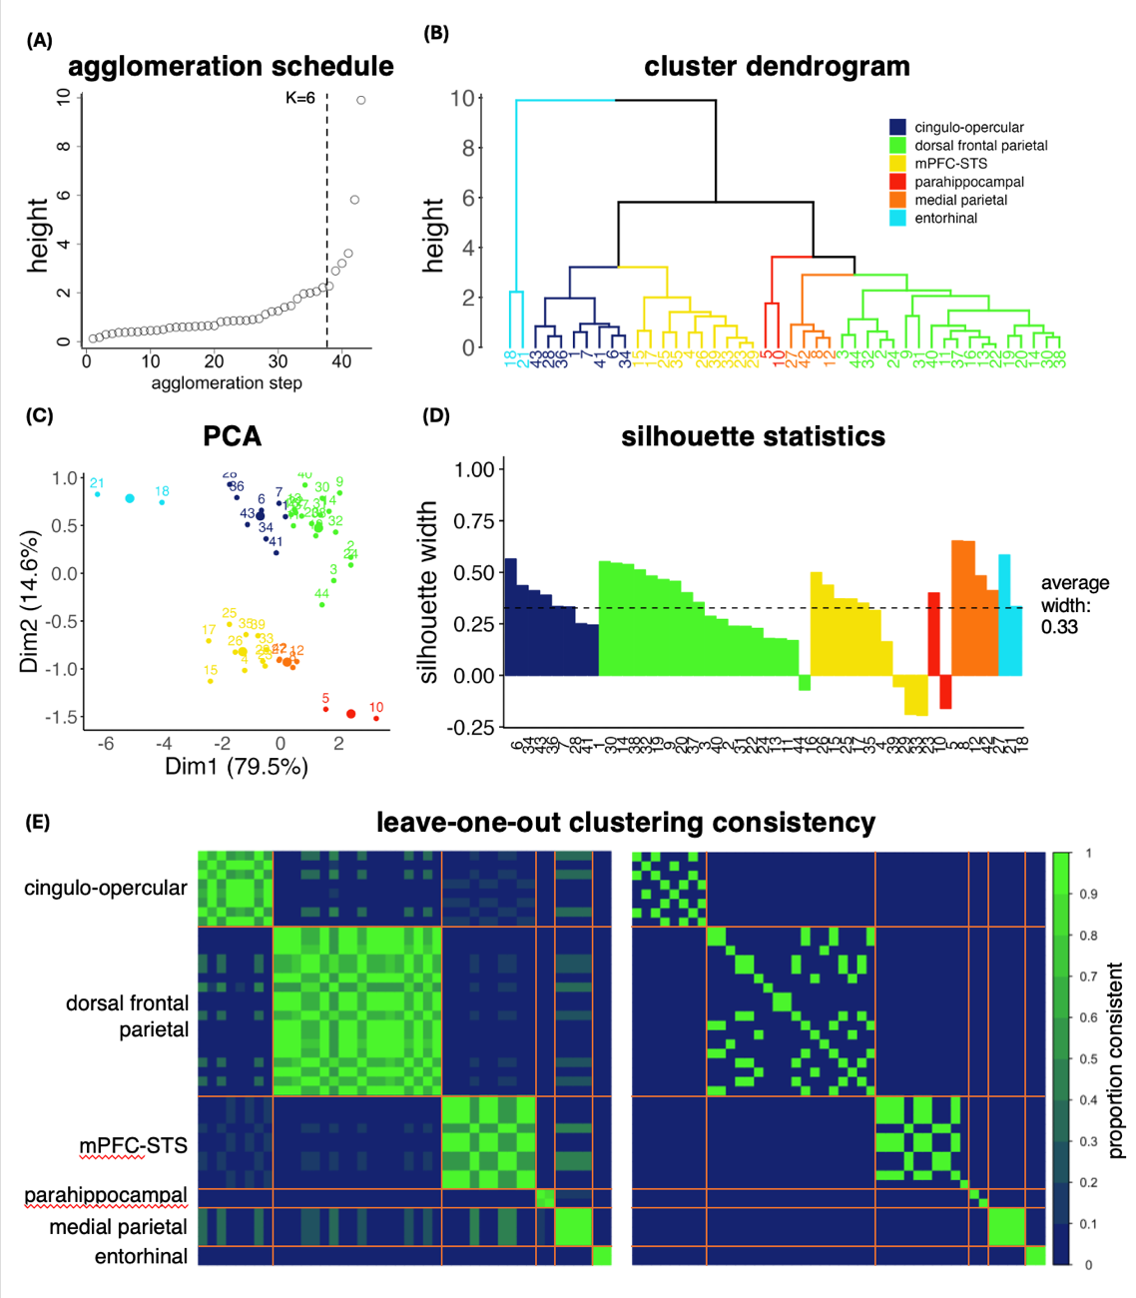

Figure 5. Hierarchical clustering quality. Hierarchical clustering was used to cluster neocortical clusters elicited by a significant interaction between hippocampal long-axis and age bin on connectivity (44 cortical areas). (A) Six superclusters were identified based on the point in the agglomeration schedule where there was a jump in distance between combined superclusters. (B) Dendrogram of the 6-supercluster solution. (C) Principal components analysis shows the distribution of the 44 neocortical clusters separated into 6 superclusters on a 2D plot. Colors denote the superclusters, large circles represent the center of each supercluster, and small circles with numbers represent the component neocortical clusters. (D). Silhouette statistics for the clustering solution. (E) Consistency of the hierarchical clustering solution across 212 iterations using leave-one-out validation. The matrix on the left is unthresholded, and the one on the right is thresholded at 100% consistency. Numbers along the x-axis of (B) and (D) and within the plot in (C) represent neocortical clusters that comprise each supercluster, the descriptive labels of which can be found in Table 1.

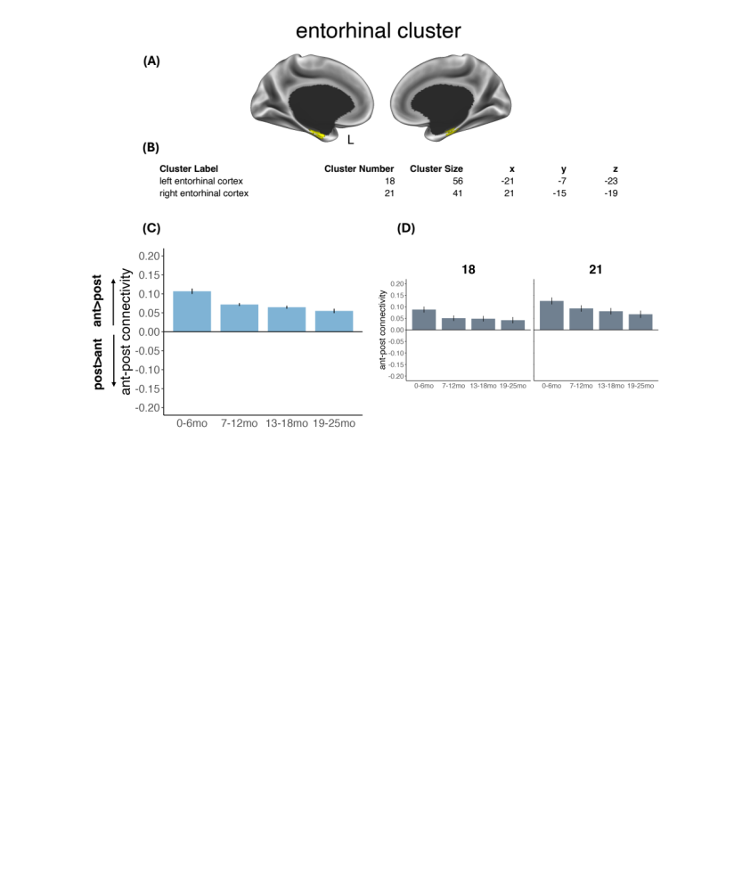
Supplementary Figure 6. Entorhinal supercluster. (A) Entorhinal supercluster plotted on the surface of the brain. (B) Descriptive information regarding the neocortical clusters included in the supercluster. Coordinates refer to peak activation of each neocortical cluster using the LPI convention in MNI space of the median age template (11-14 months). These neocortical clusters were identified based on the interaction between hippocampal long-axis and age bin on connectivity at k=10 voxels, q<0.01. (C) Average difference in anterior-posterior connectivity across the neocortical clusters included in the supercluster. (D) difference in anterior-posterior connectivity for each neocortical cluster included in the supercluster. L: left; mo: months.

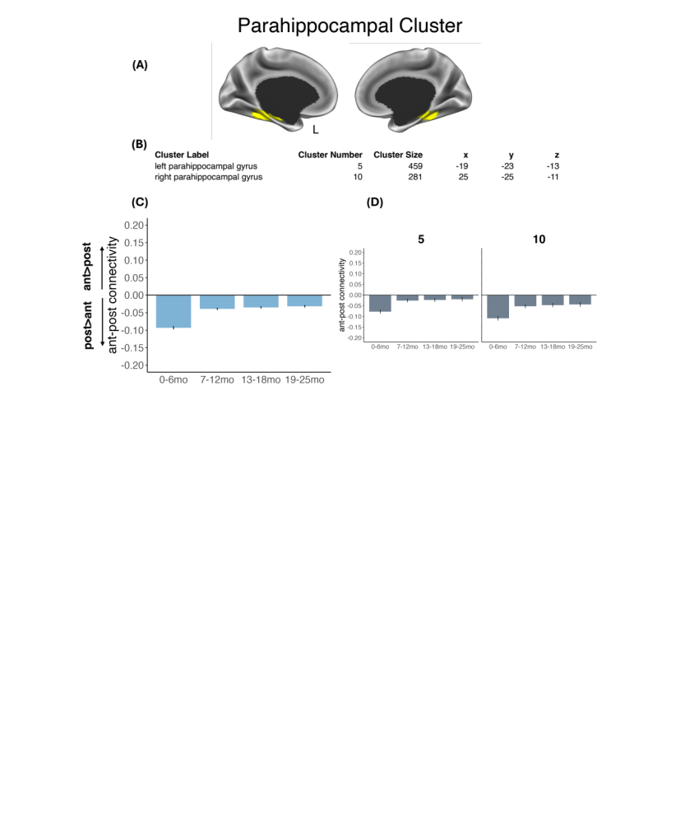
Supplementary Figure 7. Parahippocampal supercluster. (A) Parahippocampal supercluster plotted on the surface of the brain. (B) Descriptive information regarding the neocortical clusters included in the supercluster. Coordinates refer to peak activation of each neocortical cluster using the LPI convention in MNI space of the median age template (11-14 months). These neocortical clusters were identified based on the interaction between hippocampal long-axis and age bin on connectivity at k=10 voxels, q<0.01. (C) Average difference in anterior-posterior connectivity across the neocortical clusters included in the supercluster. (D) difference in anterior-posterior connectivity for each neocortical cluster included in the supercluster. L: left; mo: months.

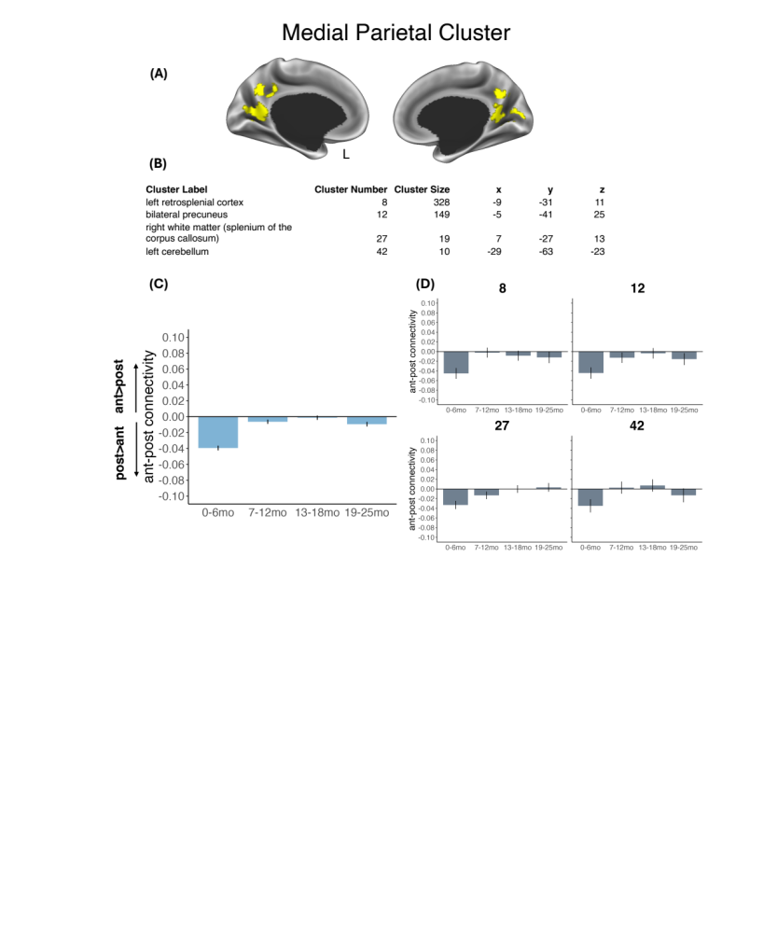
Supplementary Figure 8. Medial parietal supercluster. (A) The media parietal supercluster plotted on the surface of the brain. (B) Descriptive information regarding the neocortical clusters included in the supercluster. Coordinates refer to peak activation of each neocortical cluster using the LPI convention in MNI space of the median age template (11-14 months). These neocortical clusters were identified based on the interaction between hippocampal long-axis and age bin on connectivity at k=10 voxels, q<0.01. (C) Average difference in anterior-posterior connectivity across the neocortical clusters included in the supercluster. (D) difference in anterior-posterior connectivity for each neocortical cluster included in the supercluster. L: left; mo: months.

Supplementary Figure 9. Cingulo-opercular supercluster. (A) The cingulo-opercular supercluster plotted on the surface of the brain. (B) Average difference in anterior-posterior connectivity across the neocortical clusters included in the supercluster. (C) Descriptive information regarding the neocortical clusters included in the supercluster. Coordinates refer to peak activation of the neocortical clusters using the LPI convention in MNI space of the median age template (11-14 months). These regions were identified based on the interaction between hippocampal long-axis and age bin on connectivity at k=10 voxels, q<0.01. (D) difference in anterior-posterior connectivity for each neocortical cluster included in the supercluster. L: left; mo: months.

Supplementary Figure 10. Dorsal frontal parietal supercluster. (A) The dorsal frontal parietal supercluster plotted on the surface of the brain. (B) Average difference in anterior-posterior connectivity across the neocortical clusters included in the supercluster. (C) Descriptive information regarding the neocortical clusters included in the supercluster. Coordinates refer to peak activation of the neocortical clusters using the LPI convention in MNI space of the median age template (11-14 months). These regions were identified based on the interaction between hippocampal long-axis and age bin on connectivity at k=10 voxels, q<0.01. (D) difference in anterior-posterior connectivity for each neocortical cluster included in the supercluster. L: left; mo: months.
Supplementary Figure 11. vmPFC-STS supercluster. (A) The vmPFC-STS supercluster plotted on the surface of the brain. (B) Average difference in anterior-posterior connectivity across the neocortical clusters included in the supercluster. (C) Descriptive information regarding the neocortical clusters included in the supercluster. Coordinates refer to peak activation of the neocortical clusters using the LPI convention in MNI space of the median age template (11-14 months). These regions were identified based on the interaction between hippocampal long-axis and age bin on connectivity at k=10 voxels, q<0.01. (D) difference in anterior-posterior connectivity for each neocortical cluster included in the supercluster. L: left; mo: months.

Supplementary Table 1. Peak regions reflecting the voxel-wise interaction between hippocampal long-axis and age bin.
Supercluster Label | Neocortical Cluster Label | Neocortical Cluster Number | Cluster Size | x | y | z | Peak F
cingulo-opercular | bilateral superior medial frontal gyrus | 1 | 2013 | -3 | 27 | 27 | 17.68
cingulo-opercular | right anterior insula | 6 | 375 | 25 | 15 | -7 | 13.09
cingulo-opercular | left anterior insula | 7 | 364 | -45 | 11 | 1 | 14.27
cingulo-opercular | left perirhinal cortex | 28 | 18 | -15 | 3 | -19 | 8.16
cingulo-opercular | right white matter (posterior superior longitudinal fasciculus) | 34 | 16 | 17 | -23 | 25 | 8.19
cingulo-opercular | right perirhinal cortex | 36 | 14 | 13 | -3 | -23 | 8.71
cingulo-opercular | right anterior cingulate | 41 | 11 | 11 | 25 | 7 | 7.52
cingulo-opercular | right inferior temporal sulcus (anterior) | 43 | 10 | 41 | -7 | -25 | 7.39
dorsal frontal parietal | left parietal lobule | 2 | 801 | -29 | -47 | 47 | 15.34
dorsal frontal parietal | right parietal lobule | 3 | 599 | 29 | -45 | 25 | 12.39
dorsal frontal parietal | left prefrontal gyrus | 9 | 325 | -39 | -3 | 43 | 11.68
dorsal frontal parietal | right middle frontal gyrus | 11 | 268 | 17 | 47 | 23 | 15.58
dorsal frontal parietal | right inferior temporal gyrus | 13 | 96 | 53 | -23 | -19 | 9.73
dorsal frontal parietal | left lateral occipital cortex | 14 | 83 | -41 | -49 | -3 | 10.87
dorsal frontal parietal | left middle frontal gyrus (anterior) | 16 | 75 | -23 | 43 | 25 | 8.23
dorsal frontal parietal | right lateral occipital cortex | 19 | 46 | 41 | -43 | -3 | 12.96
dorsal frontal parietal | right inferior frontal gyrus (pars Triangularis) | 20 | 42 | 41 | 37 | 3 | 18.26
dorsal frontal parietal | left middle frontal gyrus (posterior) | 22 | 31 | -35 | 27 | 31 | 8.85
dorsal frontal parietal | left postcentral gyrus | 24 | 29 | -53 | -21 | 35 | 7.97
dorsal frontal parietal | right inferior frontal gyrus (pars Opercularis) | 30 | 18 | 47 | 13 | 9 | 7.78
dorsal frontal parietal | bilateral cuneus | 31 | 17 | -1 | -75 | 17 | 9.95
dorsal frontal parietal | right inferior occipital gyrus | 32 | 16 | 45 | -47 | -15 | 7.79
dorsal frontal parietal | left inferior temporal gyrus | 37 | 14 | -47 | -25 | -25 | 7.95
dorsal frontal parietal | right superior occipital gyrus | 38 | 12 | 15 | -71 | 15 | 8.15
dorsal frontal parietal | left brain stem | 40 | 11 | -5 | -15 | -29 | 8.15
dorsal frontal parietal | right postcentral gyrus | 44 | 10 | 21 | -33 | 43 | 6.96
vmPFC-STS | bilateral primary occpital cortex | 4 | 551 | -21 | -81 | -9 | 13.58
vmPFC-STS | left superior temporal sulcus (middle) | 15 | 82 | -53 | -7 | -7 | 12.36
vmPFC-STS | right superior temporal sulcus (anterior) | 17 | 61 | 47 | 1 | -13 | 10.5
vmPFC-STS | left cerebellum | 23 | 30 | -19 | -69 | -27 | 10.86
vmPFC-STS | left ventral medial prefrontal cortex | 25 | 21 | -5 | 41 | -7 | 6.99
vmPFC-STS | left superior temporal sulcus (anterior) | 26 | 19 | -41 | -3 | -15 | 8.36
vmPFC-STS | left superior temporal gyrus (posterior) | 29 | 18 | -47 | -29 | 5 | 7.65
vmPFC-STS | right superior temporal gyrus (posterior) | 33 | 16 | 41 | -27 | 7 | 8.2
vmPFC-STS | left superior temporal sulcus (posterior) | 35 | 15 | -51 | -41 | 9 | 8.94
vmPFC-STS | right angular gyrus | 39 | 12 | 41 | -65 | 21 | 7.6
parahippocampal | left parahippocampal gyrus | 5 | 459 | -19 | -23 | -13 | 22.17
parahippocampal | right parahippocampal gyrus | 10 | 281 | 25 | -25 | -11 | 28.92
medial parietal | left retrosplenial cortex | 8 | 328 | -9 | -31 | 11 | 14.14
medial parietal | bilateral precuneus | 12 | 149 | -5 | -41 | 25 | 10.95
medial parietal | right white matter (splenium of the corpus callosum) | 27 | 19 | 7 | -27 | 13 | 11.53
medial parietal | left cerebellum | 42 | 10 | -29 | -63 | -23 | 8.81
entorhinal | left entorhinal cortex | 18 | 56 | -21 | -7 | -23 | 11.71
entorhinal | right entorhinal cortex | 21 | 41 | 21 | -15 | -19 | 12.04
Coordinates refer to peak activation of each neocortical cluster using the LPI convention in MNI space of the median age template (11-14 months). Neocortical clusters were identified at k=10, q<0.01. Superclusters were identified using a hierarchical clustering approach.

Supplementary Table 2. Pairwise contrasts between anterior and posterior hippocampal connectivity within each age bin and supercluster.
supercluster | age bin | contrast | df | t | p-value
cingulo-opercular | 0-6mo | ant-post | 2288 | 5.78 | <.0001*
cingulo-opercular | 7-12mo | ant-post | 2288 | 2.67 | 0.008*
cingulo-opercular | 13-18mo | ant-post | 2288 | 0.95 | 0.341
cingulo-opercular | 19-25mo | ant-post | 2288 | -4.15 | <.0001*
dorsal frontal parietal | 0-6mo | ant-post | 2288 | -1.75 | 0.081~
dorsal frontal parietal | 7-12mo | ant-post | 2288 | -7.82 | <.0001*
dorsal frontal parietal | 13-18mo | ant-post | 2288 | -5.70 | <.0001*
dorsal frontal parietal | 19-25mo | ant-post | 2288 | -6.03 | <.0001*
vmPFC-STS | 0-6mo | ant-post | 2288 | -2.63 | 0.009*
vmPFC-STS | 7-12mo | ant-post | 2288 | 5.31 | <.0001*
vmPFC-STS | 13-18mo | ant-post | 2288 | 3.62 | 0.0003*
vmPFC-STS | 19-25mo | ant-post | 2288 | 1.32 | 0.187
parahippocampal | 0-6mo | ant-post | 2288 | -11.38 | <.0001*
parahippocampal | 7-12mo | ant-post | 2288 | -5.32 | <.0001*
parahippocampal | 13-18mo | ant-post | 2288 | -5.74 | <.0001*
parahippocampal | 19-25mo | ant-post | 2288 | -4.62 | <.0001*
medial parietal | 0-6mo | ant-post | 2288 | -5.33 | <.0001*
medial parietal | 7-12mo | ant-post | 2288 | -1.12 | 0.263
medial parietal | 13-18mo | ant-post | 2288 | -0.27 | 0.791
medial parietal | 19-25mo | ant-post | 2288 | -1.66 | 0.097~
entorhinal | 0-6mo | ant-post | 2288 | 10.94 | <.0001*
entorhinal | 7-12mo | ant-post | 2288 | 7.85 | <.0001*
entorhinal | 13-18mo | ant-post | 2288 | 7.59 | <.0001*
entorhinal | 19-25mo | ant-post | 2288 | 5.54 | <.0001*
*asterisks denote statistical significance (p<0.05 FDR corrected), ~tilda denotes marginal statistical significance (0.05<p<0.1 FDR corrected). ant: anterior; mo: months; post: posterior

Supplementary Table 3. Pairwise contrasts of connectivity between age bins for anterior and posterior hippocampi with each supercluster.
supercluster | axis | contrast | df |  | t |  | p-value
cingulo-opercular | anterior | 0-6mo vs 7-12mo | 208 |  | 0.46 |  | 0.810
cingulo-opercular | anterior | 0-6mo vs 13-18mo | 208 |  | 0.08 |  | 0.941
cingulo-opercular | anterior | 0-6mo vs 19-25mo | 208 |  | 2.74 |  | 0.020*
cingulo-opercular | anterior | 7-12mo vs 13-18mo | 208 |  | -0.42 |  | 0.810
cingulo-opercular | anterior | 7-12mo vs 19-25mo | 208 |  | 2.51 |  | 0.026*
cingulo-opercular | anterior | 13-18mo vs 19-25mo | 208 |  | 2.89 |  | 0.020*
cingulo-opercular | posterior | 0-6mo vs 7-12mo | 208 |  | -2.29 |  | 0.046*
cingulo-opercular | posterior | 0-6mo vs 13-18mo | 208 |  | -3.69 |  | 0.002*
cingulo-opercular | posterior | 0-6mo vs 19-25mo | 208 |  | -3.27 |  | 0.004*
cingulo-opercular | posterior | 7-12mo vs 13-18mo | 208 |  | -1.48 |  | 0.211
cingulo-opercular | posterior | 7-12mo vs 19-25mo | 208 |  | -1.12 |  | 0.316
cingulo-opercular | posterior | 13-18mo vs 19-25mo | 208 |  | 0.29 |  | 0.776
dorsal frontal parietal | anterior | 0-6mo vs 7-12mo | 208 |  | 1.03 |  | 0.625
dorsal frontal parietal | anterior | 0-6mo vs 13-18mo | 208 |  | 1.59 |  | 0.625
dorsal frontal parietal | anterior | 0-6mo vs 19-25mo | 208 |  | 1.01 |  | 0.625
dorsal frontal parietal | anterior | 7-12mo vs 13-18mo | 208 |  | 0.60 |  | 0.673
dorsal frontal parietal | anterior | 7-12mo vs 19-25mo | 208 |  | 0.01 |  | 0.992
dorsal frontal parietal | anterior | 13-18mo vs 19-25mo | 208 |  | -0.58 |  | 0.673
dorsal frontal parietal | posterior | 0-6mo vs 7-12mo | 208 |  | -3.53 |  | 0.003*
dorsal frontal parietal | posterior | 0-6mo vs 13-18mo | 208 |  | -2.00 |  | 0.104
dorsal frontal parietal | posterior | 0-6mo vs 19-25mo | 208 |  | -1.96 |  | 0.104
dorsal frontal parietal | posterior | 7-12mo vs 13-18mo | 208 |  | 1.51 |  | 0.170
dorsal frontal parietal | posterior | 7-12mo vs 19-25mo | 208 |  | 1.48 |  | 0.170
dorsal frontal parietal | posterior | 13-18mo vs 19-25mo | 208 |  | 0.00 |  | 0.998
vmPFC-STS | anterior | 0-6mo -7-12mo | 208 |  | -6.20 |  | <.0001*
vmPFC-STS | anterior | 0-6mo vs 13-18mo | 208 |  | -5.17 |  | <.0001*
vmPFC-STS | anterior | 0-6mo vs 19-25mo | 208 |  | -2.61 |  | 0.015*
vmPFC-STS | anterior | 7-12mo vs 13-18mo | 208 |  | 0.87 |  | 0.387
vmPFC-STS | anterior | 7-12mo vs 19-25mo | 208 |  | 3.44 |  | 0.001*
vmPFC-STS | anterior | 13-18mo vs 19-25mo | 208 |  | 2.51 |  | 0.016*
vmPFC-STS | posterior | 0-6mo vs 7-12mo | 208 |  | -0.98 |  | 0.756
vmPFC-STS | posterior | 0-6mo vs 13-18mo | 208 |  | -0.81 |  | 0.756
vmPFC-STS | posterior | 0-6mo vs 19-25mo | 208 |  | -0.13 |  | 0.905
vmPFC-STS | posterior | 7-12mo vs 13-18mo | 208 |  | 0.12 |  | 0.905
vmPFC-STS | posterior | 7-12mo vs 19-25mo | 208 |  | 0.83 |  | 0.756
vmPFC-STS | posterior | 13-18mo vs 19-25mo | 208 |  | 0.67 |  | 0.756
parahippocampal | anterior | 0-6mo vs 7-12mo | 208 |  | -4.30 |  | 0.0001*
parahippocampal | anterior | 0-6mo vs 13-18mo | 208 |  | -4.75 |  | <.0001*
parahippocampal | anterior | 0-6mo vs 19-25mo | 208 |  | -1.82 |  | 0.085~
parahippocampal | anterior | 7-12mo vs 13-18mo | 208 |  | -0.17 |  | 0.863
parahippocampal | anterior | 7-12mo vs 19-25mo | 208 |  | 2.46 |  | 0.022*
parahippocampal | anterior | 13-18mo vs 19-25mo | 208 |  | 2.78 |  | 0.012*
parahippocampal | posterior | 0-6mo vs 7-12mo | 208 |  | 1.60 |  | 0.134
parahippocampal | posterior | 0-6mo vs 13-18mo | 208 |  | 1.95 |  | 0.080~
parahippocampal | posterior | 0-6mo vs 19-25mo | 208 | 4.59 |  | <.0001*
parahippocampal | posterior | 7-12mo vs 13-18mo | 208 | 0.32 |  | 0.750
parahippocampal | posterior | 7-12mo vs 19-25mo | 208 | 3.34 |  | 0.003*
parahippocampal | posterior | 13-18mo vs 19-25mo | 208 | 3.19 |  | 0.003*
medial parietal | anterior | 0-6mo vs 7-12mo | 208 | -6.10 |  | <.0001*
medial parietal | anterior | 0-6mo vs 13-18mo | 208 | -5.43 |  | <.0001*
medial parietal | anterior | 0-6mo vs 19-25mo | 208 | -3.86 |  | 0.0003*
medial parietal | anterior | 7-12mo vs 13-18mo | 208 | 1.08 |  | 0.282
medial parietal | anterior | 7-12mo vs 19-25mo | 208 | 2.30 |  | 0.034*
medial parietal | anterior | 13-18mo vs 19-25mo | 208 | 1.37 |  | 0.205
medial parietal | posterior | 0-6mo vs 7-12mo | 208 | -1.88 |  | 0.160
medial parietal | posterior | 0-6mo vs 13-18mo | 208 | -0.41 |  | 0.864
medial parietal | posterior | 0-6mo vs 19-25mo | 208 | -0.17 |  | 0.864
medial parietal | posterior | 7-12mo vs 13-18mo | 208 | 1.76 |  | 0.160
medial parietal | posterior | 7-12mo vs 19-25mo | 208 | 1.89 |  | 0.160
medial parietal | posterior | 13-18mo vs 19-25mo | 208 | 0.25 |  | 0.864
entorhinal | anterior | 0-6mo vs 7-12mo | 208 | 0.01 |  | 0.989
entorhinal | anterior | 0-6mo vs 13-18mo | 208 | 1.34 |  | 0.218
entorhinal | anterior | 0-6mo vs 19-25mo | 208 | 4.02 |  | 0.0002*
entorhinal | anterior | 7-12mo vs 13-18mo | 208 | 1.50 |  | 0.205
entorhinal | anterior | 7-12mo vs 19-25mo | 208 | 4.42 |  | 0.0001*
entorhinal | anterior | 13-18mo vs 19-25mo | 208 | 3.09 |  | 0.005*
entorhinal | posterior | 0-6mo vs 7-12mo | 208 | -3.55 |  | 0.003*
entorhinal | posterior | 0-6mo vs 13-18mo | 208 | -2.85 |  | 0.010*
entorhinal | posterior | 0-6mo vs 19-25mo | 208 | -0.03 |  | 0.976
entorhinal | posterior | 7-12mo vs 13-18mo | 208 | 0.84 |  | 0.482
entorhinal | posterior | 7-12mo vs 19-25mo | 208 | 3.36 |  | 0.003*
entorhinal | posterior | 13-18mo vs 19-25mo | 208 | 2.68 |  | 0.012*
*asterisks denote statistical significance (p<0.05 FDR corrected), ~tilda denotes marginal statistical significance (0.05<p<0.1 FDR corrected). mo: months.

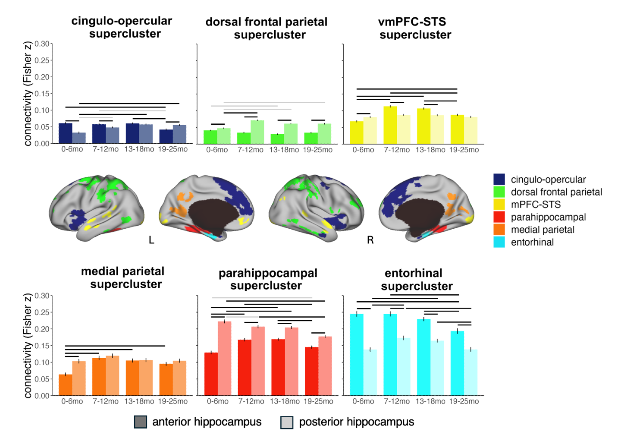

Supplementary Figure 12. Superclusters of neocortical regions sharing similar patterns of changing connectivity along the hippocampal long-axis with age, with full pairwise statistical comparisons denoted. Hierarchical clustering was used to group neocortical clusters (n=44) elicited by a significant interaction between hippocampal long-axis and age bin on connectivity (k=10, p<0.01 FDR corrected) into superclusters (k=6) sharing similar patterns of connectivity. Brain images show the clustering solution, where each color is a different supercluster. Bar charts show average connectivity of each supercluster with the anterior and posterior hippocampus for each age bin. Error bars reflect standard error across participants. This figure presents the same data as presented in Figure 2 of the main manuscript, but additionally includes indicators of statistical significance. Black lines denote statistically significant differences (p<0.05 FDR corrected) and grey lines denote marginal differences (0.05<p<0.1 FDR corrected). Data were surface projected using Connectome Workbench software (Marcus et al., 2011) to the adult MNI surface for visualization. L: left hemisphere; mo: months; R: right hemisphere.

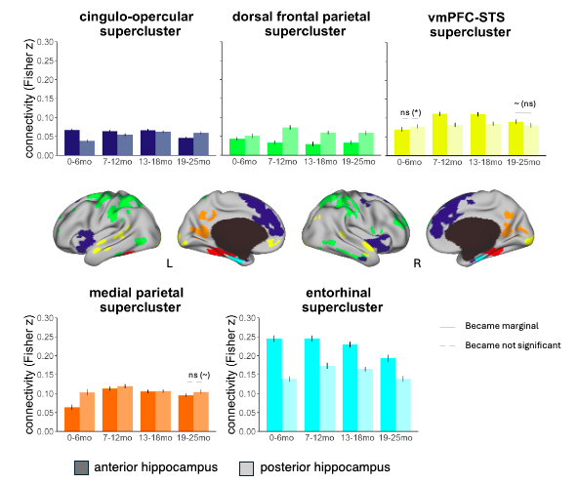
Supplementary Figure 13. Results of leave-one-out validation analysis. We re-clustered the neocortical clusters (n=44) 212 times, leaving one participant out of the analysis each time. We computed a weighted average of neocortical clusters consistently clustered together 100% of the time across leave-one-out iterations to validate that the observed pattern of results across superclusters is not driven by subject-level bias. Brain images show the superclusters, where each color is a different supercluster. Bar charts show average weighted connectivity of each supercluster with the anterior and posterior hippocampus for each age bin. Error bars reflect standard error across participants. Grey lines denote changes in pairwise results of these weighted means compared to the original analysis averaged across all participants, with the statistical significance of the original results for the comparison in brackets. We did not plot the parahippocampal cortex as the two ROIs that comprise this cluster were not clustered together 100% of the time, and so this supercluster is less reliable across participants. Data were surface projected using Connectome Workbench software (Marcus et al., 2011) to the adult MNI surface for visualization. L: left hemisphere; mo: months; R: right hemisphere.

Table 4. Pairwise contrasts between anterior and posterior hippocampal connectivity within each age bin and supercluster for weighted connectivity as determined by leave-one-out validation.

supercluster | age bin | contrast | estimate | SE | df | t.ratio | p.value
cingulo-opercular | 0-6mo | ant-post | 0.03 | 0.00 | 1872 | 6.60 | <.0001*
cingulo-opercular | 7-12mo | ant-post | 0.01 | 0.00 | 1872 | 3.75 | 0.000*
cingulo-opercular | 13-18mo | ant-post | 0.00 | 0.00 | 1872 | 1.28 | 0.201
cingulo-opercular | 19-25mo | ant-post | -0.01 | 0.00 | 1872 | -4.86 | <.0001*
dorsal frontal parietal | 0-6mo | ant-post | -0.01 | 0.00 | 1872 | -2.32 | 0.020*
dorsal frontal parietal | 7-12mo | ant-post | -0.04 | 0.00 | 1872 | -8.21 | <.0001*
dorsal frontal parietal | 13-18mo | ant-post | -0.03 | 0.01 | 1872 | -5.62 | <.0001*
dorsal frontal parietal | 19-25mo | ant-post | -0.03 | 0.00 | 1872 | -6.65 | <.0001*
vmPFC-STS | 0-6mo | ant-post | -0.01 | 0.01 | 1872 | -1.54 | 0.124
vmPFC-STS | 7-12mo | ant-post | 0.03 | 0.01 | 1872 | 5.83 | <.0001*
vmPFC-STS | 13-18mo | ant-post | 0.02 | 0.01 | 1872 | 4.18 | <.0001*
vmPFC-STS | 19-25mo | ant-post | 0.01 | 0.01 | 1872 | 1.78 | 0.076~
medial parietal | 0-6mo | ant-post | -0.04 | 0.01 | 1872 | -5.17 | <.0001*
medial parietal | 7-12mo | ant-post | -0.01 | 0.01 | 1872 | -0.98 | 0.326
medial parietal | 13-18mo | ant-post | 0.00 | 0.01 | 1872 | -0.25 | 0.804
medial parietal | 19-25mo | ant-post | -0.01 | 0.01 | 1872 | -1.55 | 0.121
entorhinal | 0-6mo | ant-post | 0.11 | 0.01 | 1872 | 10.82 | <.0001*
entorhinal | 7-12mo | ant-post | 0.07 | 0.01 | 1872 | 7.79 | <.0001*
entorhinal | 13-18mo | ant-post | 0.06 | 0.01 | 1872 | 7.42 | <.0001*
entorhinal | 19-25mo | ant-post | 0.06 | 0.01 | 1872 | 5.44 | <.0001*
*asterisks denote statistical significance (p<0.05 FDR corrected), ~tilda denotes marginal statistical significance (0.05<p<0.1 FDR corrected). mo: months.

Table 5. Pairwise contrasts of connectivity between age bins for anterior and posterior hippocampi with each supercluster for weighted connectivity as determined by leave-one-out validation.

supercluster | axis | contrast | estimate | SE | df | t.ratio | p.value
cingulo-opercular | anterior | bin1-bin2 | 0.00 | 0.01 | 208 | 0.41 | 0.894
cingulo-opercular | anterior | bin1-bin3 | 0.00 | 0.01 | 208 | 0.11 | 0.912
cingulo-opercular | anterior | bin1-bin4 | 0.02 | 0.01 | 208 | 3.13 | 0.005*
cingulo-opercular | anterior | bin2-bin3 | 0.00 | 0.01 | 208 | -0.33 | 0.894
cingulo-opercular | anterior | bin2-bin4 | 0.02 | 0.01 | 208 | 3.04 | 0.005*
cingulo-opercular | anterior | bin3-bin4 | 0.02 | 0.01 | 208 | 3.27 | 0.005*
cingulo-opercular | posterior | bin1-bin2 | -0.02 | 0.01 | 208 | -2.55 | 0.023*
cingulo-opercular | posterior | bin1-bin3 | -0.02 | 0.01 | 208 | -3.79 | 0.001*
cingulo-opercular | posterior | bin1-bin4 | -0.02 | 0.01 | 208 | -3.27 | 0.004*
cingulo-opercular | posterior | bin2-bin3 | -0.01 | 0.01 | 208 | -1.39 | 0.247
cingulo-opercular | posterior | bin2-bin4 | -0.01 | 0.01 | 208 | -0.92 | 0.432
cingulo-opercular | posterior | bin3-bin4 | 0.00 | 0.01 | 208 | 0.41 | 0.686
dorsal frontal parietal | anterior | bin1-bin2 | 0.01 | 0.01 | 208 | 1.50 | 0.293
dorsal frontal parietal | anterior | bin1-bin3 | 0.01 | 0.01 | 208 | 1.88 | 0.293
dorsal frontal parietal | anterior | bin1-bin4 | 0.01 | 0.01 | 208 | 1.46 | 0.293
dorsal frontal parietal | anterior | bin2-bin3 | 0.00 | 0.01 | 208 | 0.44 | 0.789
dorsal frontal parietal | anterior | bin2-bin4 | 0.00 | 0.01 | 208 | -0.05 | 0.959
dorsal frontal parietal | anterior | bin3-bin4 | 0.00 | 0.01 | 208 | -0.49 | 0.789
dorsal frontal parietal | posterior | bin1-bin2 | -0.02 | 0.01 | 208 | -3.19 | 0.010*
dorsal frontal parietal | posterior | bin1-bin3 | -0.01 | 0.01 | 208 | -1.25 | 0.319
dorsal frontal parietal | posterior | bin1-bin4 | -0.01 | 0.01 | 208 | -1.08 | 0.337
dorsal frontal parietal | posterior | bin2-bin3 | 0.01 | 0.01 | 208 | 1.92 | 0.111
dorsal frontal parietal | posterior | bin2-bin4 | 0.01 | 0.01 | 208 | 2.12 | 0.105
dorsal frontal parietal | posterior | bin3-bin4 | 0.00 | 0.01 | 208 | 0.18 | 0.858
vmPFC-STS | anterior | bin1-bin2 | -0.04 | 0.01 | 208 | -5.55 | <.0001*
vmPFC-STS | anterior | bin1-bin3 | -0.04 | 0.01 | 208 | -5.21 | <.0001*
vmPFC-STS | anterior | bin1-bin4 | -0.02 | 0.01 | 208 | -2.63 | 0.014*
vmPFC-STS | anterior | bin2-bin3 | 0.00 | 0.01 | 208 | 0.19 | 0.850
vmPFC-STS | anterior | bin2-bin4 | 0.02 | 0.01 | 208 | 2.67 | 0.014*
vmPFC-STS | anterior | bin3-bin4 | 0.02 | 0.01 | 208 | 2.42 | 0.020*
vmPFC-STS | posterior | bin1-bin2 | 0.00 | 0.01 | 208 | -0.55 | 0.838
vmPFC-STS | posterior | bin1-bin3 | -0.01 | 0.01 | 208 | -0.96 | 0.838
vmPFC-STS | posterior | bin1-bin4 | 0.00 | 0.01 | 208 | -0.39 | 0.838
vmPFC-STS | posterior | bin2-bin3 | 0.00 | 0.01 | 208 | -0.45 | 0.838
vmPFC-STS | posterior | bin2-bin4 | 0.00 | 0.01 | 208 | 0.14 | 0.890
vmPFC-STS | posterior | bin3-bin4 | 0.00 | 0.01 | 208 | 0.56 | 0.838
medial parietal | anterior | bin1-bin2 | -0.05 | 0.01 | 208 | -5.82 | <.0001*
medial parietal | anterior | bin1-bin3 | -0.04 | 0.01 | 208 | -5.29 | <.0001*
medial parietal | anterior | bin1-bin4 | -0.03 | 0.01 | 208 | -3.75 | 0.001*
medial parietal | anterior | bin2-bin3 | 0.01 | 0.01 | 208 | 1.02 | 0.309
medial parietal | anterior | bin2-bin4 | 0.02 | 0.01 | 208 | 2.18 | 0.046*
medial parietal | anterior | bin3-bin4 | 0.01 | 0.01 | 208 | 1.33 | 0.222
medial parietal | posterior | bin1-bin2 | -0.02 | 0.01 | 208 | -1.81 | 0.197
medial parietal | posterior | bin1-bin3 | 0.00 | 0.01 | 208 | -0.40 | 0.867
medial parietal | posterior | bin1-bin4 | 0.00 | 0.01 | 208 | -0.17 | 0.867
medial parietal | posterior | bin2-bin3 | 0.01 | 0.01 | 208 | 1.66 | 0.197
medial parietal | posterior | bin2-bin4 | 0.01 | 0.01 | 208 | 1.78 | 0.197
medial parietal | posterior | bin3-bin4 | 0.00 | 0.01 | 208 | 0.24 | 0.867
entorhinal | anterior | bin1-bin2 | 0.00 | 0.01 | 208 | 0.01 | 0.989
entorhinal | anterior | bin1-bin3 | 0.02 | 0.01 | 208 | 1.33 | 0.220
entorhinal | anterior | bin1-bin4 | 0.05 | 0.01 | 208 | 3.99 | 0.000*
entorhinal | anterior | bin2-bin3 | 0.02 | 0.01 | 208 | 1.49 | 0.206
entorhinal | anterior | bin2-bin4 | 0.05 | 0.01 | 208 | 4.39 | 0.000*
entorhinal | anterior | bin3-bin4 | 0.04 | 0.01 | 208 | 3.06 | 0.005*
entorhinal | posterior | bin1-bin2 | -0.03 | 0.01 | 208 | -3.49 | 0.003*
entorhinal | posterior | bin1-bin3 | -0.03 | 0.01 | 208 | -2.78 | 0.012*
entorhinal | posterior | bin1-bin4 | 0.00 | 0.01 | 208 | -0.03 | 0.976
entorhinal | posterior | bin2-bin3 | 0.01 | 0.01 | 208 | 0.82 | 0.493
entorhinal | posterior | bin2-bin4 | 0.03 | 0.01 | 208 | 3.31 | 0.003*
entorhinal | posterior | bin3-bin4 | 0.03 | 0.01 | 208 | 2.61 | 0.015*
*asterisks denote statistical significance (p<0.05 FDR corrected), ~tilda denotes marginal statistical significance (0.05<p<0.1 FDR corrected). mo: months.

