Supplementary figures and tables
Supplementary figure 1: Morphological differentiation and anti-proliferation effects of dexamethasone in CAD cells cultured in 8% FBS and 1% FBS-supplemented media.
(A) Representative images of CAD cells cultured in DMEM/F12 supplemented with 8% FBS, 8% FBS + 100 µM Dex, 1% FBS, or 1% FBS +100 µM Dex for 3 days. Scale bar is 100 µm. The rate of cell proliferation in each condition measured by BrdU assay at (B) 24 h and (C) 48 h (n=3). Flow cytometry revealing the percentage of cell population in each phase of cell cycle at (D) 24 h and (E) 48 h (n=3). * P< 0.05, ** P<0.01, *** P<0.001, and **** P<0.0001 vs. 8% FBS. ## P< 0.01 vs. 8% FBS + 100 µM Dex (One-way ANOVA for B, C and Two-way ANOVA for D, E with Tukey’s multiple comparison test).

Supplementary figure 2: Expression of Glucocorticoid receptor in the proliferative and dexamethasone-differentiated CAD cells.
(A) Western blot representing the expression of glucocorticoid receptor (GR) in undifferentiated cells or proliferative (Pro) and dexamethasone-differentiated cells (Dex) cultured for 3 days. GAPDH was used as a loading control. (B) Graph quantifying the expression of GR normalized to GAPDH (n=3). ** P< 0.01 vs. Undiff (Student’s t-test). (C) Representative inverted and fluorescent images showing the localization of GR (red) in Pro and Dex induced for 24 h. DAPI indicates nuclei (blue). Scale bars are 50 µm.

Supplementary figure 3: The effects of dexamethasone on CAD cells cultured in serum-free media.
(A) Representative images showing the morphology and viability of CAD cells cultured in serum-free media (SF), SF + 100 µM Dex, or 1% FBS +100 µM Dex at day 0, 3, and 5 days. (B) Representative images showing the presence of dead cells marked by propidium iodide (PI) and live cells marked by calcein-AM in CAD cells cultured in each indicated condition for 5 days. Scale bar is 500 µm.

Supplementary figure 4: The steps of RNA-sequencing and gene set enrichment analysis for this study and the number of differentially expressed genes in dexamethasone-differentiated CAD cells.
(A) Diagram depicting steps to analyze differentially expressed genes (DEGs) and biological pathways using RNA-seq and bioinformatics tools described in materials and methods. (B) The volcano plot representing the number of significant DEGs that were upregulated and downregulated in Dex-differentiated CAD cells compared to undifferentiated cells. The cut-off criteria are false discovery rate (FDR) <0.01 and |log₂[fold change] |> 2.

Supplementary Figure 5: The statistical profiles of DEGs between the undifferentiated (Pro) and Dex-differentiated (Dex) CAD cells
(A) The sample-to-sample distance calculated from Rolg-transformed values and was used for clustering the group of overall gene expression. Darker colors indicate more similar expression. (B) A principle component analysis (PCA) plot using the normalized sequence libraries to show the similarity between and within submitted samples. (C) The Bland-Altman (MA) graph analyzed using R program (DESeq2) to visualize DEGs in Dex-differentiated CAD cells relative to undifferentiated CAD cells. Each point represents a transcript. Above the center horizontal line are genes that were relatively more abundant and below are genes that were present in relatively lower quantities in Dex-differentiated CAD cells. The red colors represent genes that were significantly differentially expressed at FDR < 0.01.

Supplementary Table 1: Primer pairs (Macrogen, Seoul, South Korea) used for validation
Supplementary Table 2: Number of raw reads (unit in million) per sample. Pro is the proliferating/undifferentiated groups and Dex is Dex-differentiated group. Number 1, 2, and 3 indicates three independent samples of each group.
Supplementary Table 3: The upregulated pathways from KEGG
Supplementary Table 4: The downregulated pathways from KEGG
Supplementary Table 5: The upregulated biological processes from GO
Supplementary Table 6: The upregulated cellular components from GO
Supplementary Table 7: The upregulated molecular functions from GO
Supplementary Table 8: The downregulated biological processes from GO
Supplementary Table 9: The downregulated cellular components from GO
Supplementary Table 10: The downregulated molecular functions from GO

Supplementary Figure 1
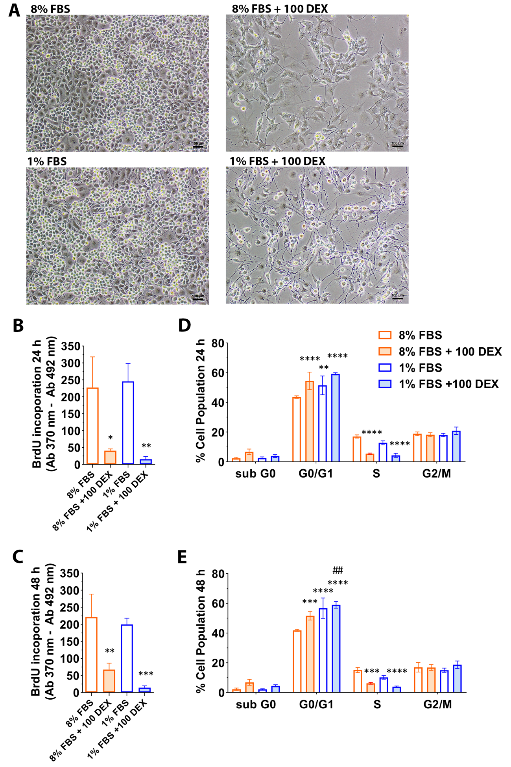
Supplementary Figure 2
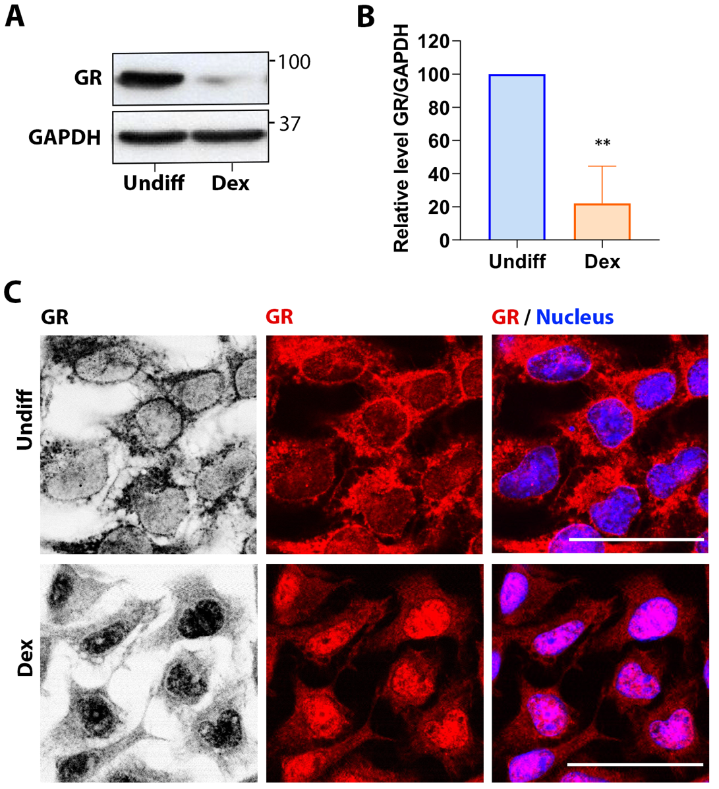

Supplementary Figure 3
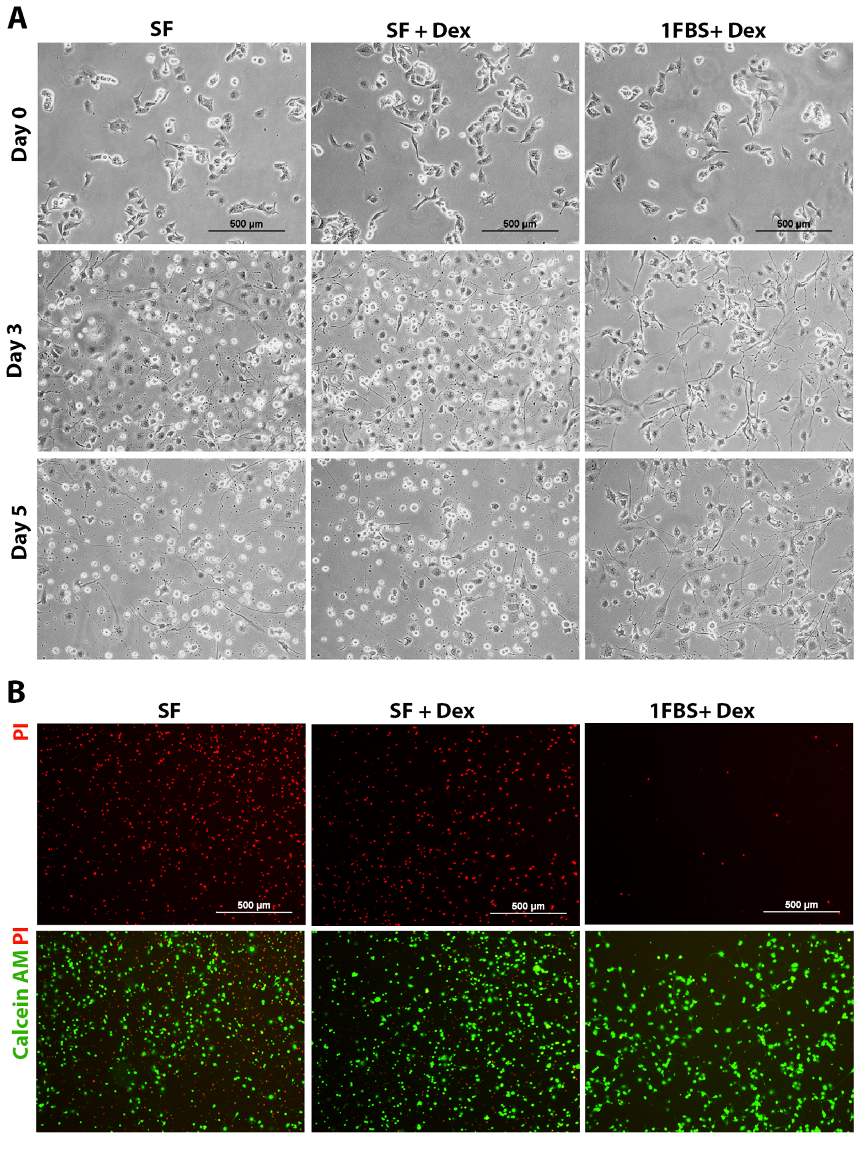

Supplementary Figure 4

Supplementary Figure 5

Supplementary Table 1
Gene | FW (5’3’) | RW (5’ 3’)
CEBPB | CAACCTGGAGACGCAGCACAAG | GCTTGAACAAGTTCCGCAGGGT
NDRG2 | CGCGATATGCTCTGAACCAC | TTCCTGGCTGAAAAGATGTCC
FGF1 | GTAGTTTCCTAGAGGCAGGTTG | TGATAAAGTGGAGTGAAGAGAGC
IL6 | TACCACTTCACAAGTCGGAGGC | CTGCAAGTGCATCATCGTTGTTC
PPARA | GTACTGTCGGTTTCAGAAGTGCC | ATCTCCGCCAACAGCTTCTCCT
GSTA3 | AGATCGACGGGATGAAACTGG | CAGATCCGCCACTCCTTCT
SCN1A | CATGTATGCTGCAGTTGATTCCA | AACAGGTTCAGGGTAAAGAAGG
KCNT1 | CTGCTGTGCCTGGTCTTCA | AAGGAGGTCAGCAGGTTCAA
HCN1 | AGGTTAATCAGATACATACACC | GAGTGCGTAGGAATATTGTTTT
SYT2 | GGCGGCGAGATGTGATACT | GGGTGTCTATGATGGCATCAA
GADD45b | CACCCTGATCCAGTCGTTCT | TGACAGTTCGTGACCAGGAG
CDK2 | CCAGGAGTTACTTCTATGCC | ATAGTGCAGCATTTGCGA
CCNE2 | TGCATTCTAGCCATCGAC | GCACCATCCAGTCTACAC
E2F2 | GCGCATCTATGACATCACCA | CGGGTGGGGTCTTCAAATAG
NR3C1 | GACTCCAAAGAATCCTTAGCTCC | CTCCACCCCTCAGGGTTTTAT
FKBP5 | GTACAACAAAGCCGTGGAGTG | GCCCTGTTCTGAGGATTGACT
TUBB3 | ATTCTGGTGGACTTGGAACCT | ACTCTTTCCGCACGACATCT
GAP43 | GGAGAAAGACGCTGTAGACGA | ATGTTCTTGGTCAGCCTCGG
Synaptophysin | CTGCGTTAAAGGGGGCACTA | GGAAGTCCATCATTGGCCCT
Tyrosine hydroxylase | AAGATCAAACCTACCAGCCG | TACGGGTCAAACTTCACAGAG
MAP-2 | GCCAGCCTCGGAACAAACA | GCTCAGCGAATGAGGAAGGA
Mapt (tau) | CCTGAGCAAAGTGACCTCCAAG | CAAGGAGCCAATCTTCGACTGG
GAPDH | TGTGTCCGTCGTGGATCTGA | CCTGCTTCACCACCTTCTTGA

Supplementary Table 2

Sample name | Number of raw reads (million)
Pro1 | 10.5
Pro2 | 11.2
Pro3 | 9.8
Dex1 | 10.4
Dex2 | 10.9
Dex3 | 10.6

Supplementary Table 3

Term |  | Gene number | P-Value | Fold Enrichment | DEGs
mmu04151 | PI3K-Akt signaling pathway | 23 | 3.90E-03 | 1.9 | IL6, FGF14, EFNA3, ITGB4, FGF11, TLR2, ITGA2, TLR4, FGF21, ITGB3, PCK2, COL5A3, DDIT4, IL6RA, VEGFC, TNR, COMP, CREB3L3, GNB3, GNG4, FGF1, FN1, ITGA2B
mmu03320 | PPAR signaling pathway | 8 | 1.80E-02 | 2.9 | ACOX2, SCD1, SLC27A1, PPARA, CYP27A1, FABP3, PCK2, PLTP
mmu04911 | Insulin secretion | 8 | 2.60E-02 | 2.7 | KCNMA1, TRPM4, ADCY4, KCNN1, KCNN3, CREB3L3, ITPR3, KCNJ11
mmu01100 | Metabolic pathways | 56 | 2.90E-02 | 1.3 | ACOX2, TM7SF2, HEXA, HEXB, PTGS1, ACOT2, ANPEP, ACSS2, CMBL, ASAH2, HPSE, SYNJ2, IDUA, 4930438A08RIK, ALDH6A1, NMNAT2, LPIN1, PNPLA3, LPIN3, CTH, PTGDS, CYP27A1, PLA2G2E, XDH, ALPL, GALNT3, ALDOC, EXTL1, ALDH3A1, DGKA, MTM1, CBR2, INPP5J, PLCH2, ENO2, ETNK2, B3GNT3, ND6, GALNT14, ADSSL1, MSMO1, A4GALT, SPHK1, HOGA1, CYP4F13, UAP1L1, PCK2, KHK, RDH12, GGT5, AKR1B7, HMGCS2, GFPT2, COX6A2, BCO1, NNMT
mmu00480 | Glutathione metabolism | 6 | 3.80E-02 | 3.2 | GGT5, GSTA3, OPLAH, ANPEP, MGST1, GSTM7

Supplementary Table 4

Term |  | Gene number | P-Value | Fold Enrichment | DEGs
mmu04110 | Cell cycle | 30 | 5.00E-24 | 12.2 | E2F2, DBF4, TTK, CHEK1, PTTG1, CCNE2, CDC45, MCM7, BUB1, CCNA2, ORC1, CDC7, CDK1, CDC6, ESPL1, CDC20, MCM2, MCM3, CDC25C, MCM4, MCM5, CDK2, MCM6, CCNB1, CCNB2, MAD2L1, PLK1, PCNA, BUB1B, GADD45B
mmu03030 | DNA replication | 20 | 7.80E-24 | 27.8 | LIG1, POLE, POLA1, POLA2, MCM2, MCM3, MCM4, RNASEH2C, MCM5, MCM6, PRIM1, RFC5, DNA2, RPA2, RFC4, MCM7, POLE2, POLD1, PCNA, FEN1
mmu00240 | Pyrimidine metabolism | 14 | 2.40E-08 | 7.6 | PRIM1, TYMS, UMPS, POLE2, RRM2, POLD1, POLE, RRM1, POLA1, CAD, POLA2, DCTPP1, DUT, TK1
mmu03410 | Base excision repair | 8 | 3.60E-06 | 11.8 | POLE2, LIG1, NEIL3, UNG, POLD1, POLE, PCNA, FEN1
mmu03430 | Mismatch repair | 7 | 4.20E-06 | 15.2 | EXO1, RFC5, RPA2, RFC4, LIG1, POLD1, PCNA
mmu04115 | p53 signaling pathway | 10 | 4.60E-06 | 7.7 | CCNE2, CCNB1, CDK1, CCNB2, RRM2, CHEK1, PIDD1, GADD45B, GTSE1, CDK2
mmu03440 | Homologous recombination | 7 | 1.40E-05 | 12.5 | RPA2, BLM, POLD1, EME1, RAD54B, RAD54L, RAD51
mmu03420 | Nucleotide excision repair | 8 | 2.20E-05 | 9.1 | RFC5, RPA2, RFC4, POLE2, LIG1, POLD1, POLE, PCNA

Supplementary Table 5

Term |  | Gene number | P-Value | Fold Enrichment | DEGs
GO:0055085 | Transmembrane transport | 31 | 3.90E-05 | 2.3 | SLC2A13, SLC16A14, KCNC1, SLC9A7, SCN1A, MFSD9, SLC22A18, PANX2, SLC22A15, SLC45A1, MFSD4A, SLC26A10, HVCN1, KCNQ4, TAP2, SLC22A4, HCN4, SCN5A, SLC43A2, HCN1, KCNMA1, TRPM4, SVOP, TRPM5, KCND1, ITPR3, CNGA3, SLC17A7, SLC41A3, KCNH3, CACNA1B
GO:0034765 | Regulation of ion transmembrane transport | 15 | 4.80E-04 | 3 | KCNMA1, HCN1, KCNC1, SCN1A, SCN1B, TRPM5, KCND1, CACNG5, HVCN1, KCNJ11, KCNQ4, HCN4, SCN5A, KCNH3, CACNA1B
GO:0071805 | Potassium ion transmembrane transport | 12 | 4.80E-04 | 3.6 | KCNMA1, HCN1, KCNC1, SLC9A7, KCNQ4, KCNT1, KCND1, HCN4, KCNJ11, KCNH3, KCNK12, KCNK10
GO:0032722 | Positive regulation of chemokine production | 6 | 6.70E-04 | 8.1 | IL6, TLR2, TLR3, TLR4, LGALS9, IL6RA
GO:0051592 | Response to calcium ion | 10 | 8.60E-04 | 4 | KCNMA1, HCN1, TXNIP, IL6, APOBEC1, S100A16, SYT3, GIPR, PCDH15, ITPR3
GO:0030968 | Endoplasmic reticulum unfolded protein response | 8 | 1.80E-03 | 4.5 | ATF3, STC2, WFS1, CASP12, FGF21, CREB3L3, PPP1R15A, DDIT3
GO:0006814 | Sodium ion transport | 12 | 6.30E-03 | 2.6 | HCN1, SLC17A7, SLC9A7, SLC4A10, SCN1A, SCN1B, SLC38A7, ASIC4, SLC22A4, SLC10A6, HCN4, SCN5A
GO:0034976 | Response to endoplasmic reticulum stress | 9 | 6.90E-03 | 3.2 | CREBRF, CEBPB, STC2, WFS1, FLOT1, TRIB3, FAM129A, PPP1R15A, DDIT3
Term(continued) |  | Gene number | P-Value | Fold Enrichment | DEGs
GO:0006813 | Potassium ion transport | 12 | 7.50E-03 | 2.6 | KCNMA1, HCN1, KCNC1, SLC9A7, KCNQ4, KCNT1, KCND1, KCNN1, KCNN3, HCN4, KCNJ11, KCNH3
GO:0071320 | Cellular response to cAMP | 7 | 1.00E-02 | 3.8 | HCN1, DMTN, AQP9, AKAP6, RAPGEF3, ITPR3, HCN4
GO:0060850 | Regulation of transcription involved in cell fate commitment | 3 | 1.30E-02 | 16.2 | CEBPB, RORC, RORA
GO:0010628 | Positive regulation of gene expression | 25 | 1.40E-02 | 1.7 | ERBB3, MST1, TLR2, TLR3, HFE, TLR4, ITGB3, CALCOCO1, C1QTNF1, TRP53INP1, WNT6, RAB27A, FN1, PID1, WNT10A, IL6, RNF207, PTGFR, GAS6, LGALS9, DDX58, LCN2, ATF3, ADM2, PPP1R15A
GO:0006887 | Exocytosis | 10 | 1.60E-02 | 2.6 | EXOC3L4, CPLX2, SYT4, SRCIN1, SYT3, LGI3, VAMP1, TNFAIP2, SYTL1, RAB27A
GO:1901215 | Negative regulation of neuron death | 7 | 1.70E-02 | 3.4 | PPARA, IL6, SERPINF1, NTRK1, ESR1, FGF21, GPNMB
GO:0030154 | Cell differentiation | 41 | 2.40E-02 | 1.4 | CPLX2, SYT4, CATSPERD, FHL1, SYT2, SYT3, RORC, PAQR8, ANPEP, TNFSF12, CSPG5, TAF7L, ANGPTL6, PBXIP1, DNER, DMKN, SEMA3B, NDRG2, FGF1, CREBL2, OBSCN, CEBPB, CPNE5, MMP19, NTNG2, EDA2R, PTPRU, FRZB, SLIT1, ADGRG1, PSMB8, VEGFC, CHRDL2, RGS20, SEMA4G, SEMA4F, NTRK1, BRDT, TNFAIP2, NHLH1, CHL1
GO:0051971 | Positive regulation of transmission of nerve impulse | 3 | 2.50E-02 | 11.6 | IL6, TNR, ITGA2
GO:0042391 | Regulation of membrane potential | 9 | 2.70E-02 | 2.5 | KCNMA1, HCN1, TRPM4, SCN1A, CNGA3, HCN4, SLC26A10, KCNJ11, KCNH3
GO:0034220 | Ion transmembrane transport | 6 | 2.90E-02 | 3.4 | TRPM4, P2RX4, TRPM5, AQP9, SLC24A2, CNGA3
GO:1903861 | Positive regulation of dendrite extension | 4 | 3.10E-02 | 5.7 | SYT4, CPNE5, SYT2, SYT3
GO:0034706 | Sodium channel complex | 3 | 3.30E-02 | 10.2 | SCN1A, SCN1B, SCN5A
GO:0006749 | Glutathione metabolic process | 6 | 3.40E-02 | 3.3 | GGT5, GSTA3, CTH, OPLAH, MGST1, GSTM7
Term(continued) |  | Gene number | P-Value | Fold Enrichment | DEGs
GO:0033198 | Response to ATP | 4 | 3.60E-02 | 5.4 | P2RX4, P2RX3, CASP1, KCNJ11
GO:0019228 | Neuronal action potential | 5 | 3.60E-02 | 4 | KCNMA1, P2RX4, SCN1A, P2RX3, SCN5A
GO:0032868 | Response to insulin | 7 | 4.70E-02 | 2.7 | KHK, RBP4, SLC27A1, PPARA, IL6, TLR2, PTPRN
GO:0008285 | Negative regulation of cell proliferation | 22 | 4.90E-02 | 1.5 | IL6, NFE2, NACC2, KLF11, TLR2, INCA1, ZBTB16, PTPRU, TIMP2, FRZB, ADORA1, ADGRG1, CDH5, VEGFC, ATF5, CTH, TNS2, NTRK1, TRP53INP1, BCL6, NDRG1, WNT9A

Supplementary Table 6

Term |  | Gene number | P-Value | Fold Enrichment | DEGs
GO:0043025 | Neuronal cell body | 47 | 8.80E-08 | 2.4 | KCNC1, ACHE, SCN1A, CPLX2, RAP1GAP, SYT4, SRCIN1, SLC38A7, TIMP2, KCNJ11, ADORA1, NAIP6, SEZ6L2, DNER, NAIP5, SNPH, SRR, ENO2, RAPGEF3, HCN4, HCN1, TRPM4, KCNMA1, TRPM5, KCND1, CPNE5, PSD2, CD40, ITPR3, PTPRN, CNGA3, P2RX4, KIF1A, EFHC1, SKOR1, SLC4A10, LRP1, SERPINF1, KCNN1, KCNN3, P2RX3, NTRK1, PSEN2, RIN1, GFRA1, NRSN2, CACNA1B
GO:0030424 | Axon | 30 | 1.20E-04 | 2.2 | ACHE, SCN1A, RAP1GAP, SYT4, SRCIN1, SLC38A7, SYT2, ALDOC, GRIK4, PINK1, SDC3, AVIL, SYNJ2, KLHL24, HCN4, HCN1, CRYAB, STMN4, SPHK1, NFASC, NTNG2, ITGA2, P2RX4, NCAM2, KIF1A, SERPINF1, P2RX3, NTRK1, HPCA, GFRA1
GO:0043005 | Neuron projection | 32 | 2.00E-04 | 2.1 | ACHE, SRCIN1, SYT4, TIMP2, SDC3, NAIP6, SYNPR, PACSIN1, KCNQ4, NAIP5, SNPH, ENO2, AVIL, LGI3, HCN4, CASP1, S100A1, CPNE5, SPHK1, STMN4, ESR1, SLC17A7, CTSL, KIF1A, EPS8, TENM2, P2RX3, KCNN3, GNB3, VAMP1, CACNA1B, OPRD1
GO:0070062 | Extracellular exosome | 131 | 4.60E-04 | 1.3 | FAM20A, MMP9, PTGS1, PDLIM2, ALDH1L2, CMBL, GSTM7, SBSN, RRAS, PLA1A, RAPGEF3, PI16, GNG4, SMIM1, RAB27A, IDUA, ALDH6A1, CRYAB, CRTAC1, CD40, HDAC11, PIK3IP1, TCN2, PRELP, THY1, LYNX1, SERPINF1, CST6, TMEM106A, PRCP, CAR6, ITGA2B, TPPP3, ITGAL, RBP4, ALDOC, ITGB4, MST1, EPHA10, NAPB, ITGB3, TIMP2, CD74, AHSG, ANGPTL6, ACE, LGALS3BP, NAGA, NDRG1, NDRG2, ENTPD2, FN1, S100A16, CPNE5, DUSP23, PCDH15, ENDOD1, ADGRG1, ECM1, GAS6, PSMB8, LCN2, PDZK1IP1, P2RX4, DUSP26, EPS8, THSD4, CD274, FABP3, TGFBR3, H2-T23, SYTL1, PLEKHA1, CYB5R1, AEBP1, OPCML, HEXA, IGFBP6, HEXB, ACOT2, ANPEP, MAN2B2, SEMA3G, DMKN, ACOT11, SEMA3B, ESAM, FAM129A, DPP7, KCNMA1, PBLD2, H2-K1, ADGRE5, FLOT1, TTC38, PADI2, NECTIN4, CTSL, CTH, PTGDS, GRN, SLPI, GNB3, WNT9A, CHL1, ALPL, GALNT3, CCL28, MTM1, NAIP2, COMP, ENO2, CRIM1, MYO5C, GSTA3, A4GALT, HOGA1, NFASC, MXRA8, COL5A3, PCK2, LSP1, KHK, PROM1, CAPG, ARSA, C1RL, GFRA1, CP, H2-DMA, C1S1
Term (continued) |  | Gene number | P-Value | Fold Enrichment | DEGs
GO:0030425 | Dendrite | 34 | 6.70E-04 | 1.9 | ADCY4, KCNC1, CPLX2, ACHE, RAP1GAP, SRCIN1, SYT4, WFS1, GRIK4, ADORA1, CTLA2A, TRIM9, DNER, KIF21B, AATK, RAB27A, HCN1, KCNMA1, TRPM5, KCND1, PSD2, ITPR3, CNGA3, THY1, P2RX4, SKOR1, LYNX1, LRP1, TENM2, NTRK1, RIN1, GNB3, CHL1, CACNA1B
GO:0043195 | Terminal bouton | 13 | 9.40E-04 | 3.1 | KCNMA1, P2RX4, CPLX2, PACSIN1, SYT2, P2RX3, PTPRN2, GRIK4, ESR1, HCN4, VAMP1, SYNGR1, ADORA1
GO:0045202 | Synapse | 33 | 2.10E-03 | 1.8 | ACHE, CPLX2, SYT4, SRCIN1, SYT2, MYO7A, GRIK4, SYNGR1, ADORA1, SYNPR, PACSIN1, SH2D5, TRIM9, PRRT1, SNPH, LGI3, OLFM2, HCN1, NMNAT2, SVOP, CRYAB, PTPRN2, CACNG5, PCDH15, PTPRN, SLC17A7, P2RX4, COLQ, EPS8, SEMA4F, TENM2, VAMP1, FAIM2
GO:0005783 | Endoplasmic reticulum | 69 | 3.30E-03 | 1.4 | TM7SF2, SLC27A1, GPR85, JPH3, JPH2, ARSG, FAM20A, WFS1, SGPP2, PTGS1, TLR3, PCDHA1, CSPG5, KCNJ11, ADORA1, SEZ6L2, RESP18, CALCRL, CREB3L3, TRPM4, KCNMA1, H2-K1, STC2, FA2H, CERCAM, TRIQK, LPIN1, THY1, CCDC3, PTGDS, SEMA4F, PSEN2, PPP1R15A, MAMDC2, MRAP, APH1C, HACD4, RSAD2, EXTL1, CD74, ALDH3A1, FNDC5, ZDHHC22, TAP2, ALOX5AP, MR1, SCN5A, HHATL, AATK, SCD1, SOAT2, MOGAT2, PRSS56, GABARAPL1, MSMO1, GIMAP8, EPM2A, EPHX1, CYP4V3, ITPR3, PROM1, TMEM117, TMEM8B, ATP2A3, TENM2, GRINA, CASP12, TGFBR3, MGST1
GO:0030141 | Secretory granule | 11 | 8.40E-03 | 2.7 | ANGPTL6, RAB11FIP5, CTSL, RAB37, RESP18, PTPRN2, PTPRN, CHGB, MYO5C, RAB27A, SCG2
Term (continued) |  | Gene number | P-Value | Fold Enrichment | DEGs
GO:0032590 | Dendrite membrane | 5 | 1.40E-02 | 5.2 | HCN1, KCNC1, GABARAPL1, HPCA, OPRD1
GO:0008021 | Synaptic vesicle | 11 | 1.80E-02 | 2.4 | SLC17A7, SYNPR, SVOP, SYT4, TRIM9, SYT2, SPHK1, LGI3, PTPRN, SYNGR1, APBA1
GO:0030672 | Synaptic vesicle membrane | 7 | 2.40E-02 | 3.1 | SLC17A7, SVOP, SYT4, SYT2, PTPRN2, VAMP1, SYNGR1
GO:0070382 | Exocytic vesicle | 4 | 2.70E-02 | 6 | SYT4, SYT3, SYTL1, RAB27A
GO:0043679 | Axon terminus | 8 | 3.90E-02 | 2.5 | HCN1, PACSIN1, ITGA2, SYNJ2, RAPGEF3, PTPRN, CACNA1B, OPRD1

Supplementary Table 7

Term |  | Gene number | P-Value | Fold Enrichment | DEGs
GO:0005509 | Calcium ion binding | 58 | 2.90E-08 | 2.2 | PCDHA8, PCDHA9, MASP1, SYT4, SYT2, SYT3, PCDHA1, MMP28, GM19410, SLC24A2, CIB2, S100A1, MATN2, PCDHB9, PCDHB5, CRTAC1, PCDHB3, ADGRE5, LRP1B, MMP19, PCDHB2, PADI2, SLIT1, EFHC1, PPEF1, PLA2G2E, GALNT3, DHH, REPS2, PCDHB14, PCDHB13, PCDHB12, PCDHB11, PCDHB10, CDH5, DGKA, PRRG1, PCDHB18, COMP, PLCH2, DNER, PCDHB17, SRR, S100A16, PCDH10, PCDH15, CELSR1, ITPR3, GAS6, LRP1, TENM2, HPCA, ARSA, RHBDL3, C1S1, SYTL1, CDH10, CACNA1B
GO:0005216 | Ion channel activity | 19 | 7.20E-05 | 3 | KCNMA1, HCN1, TRPM4, KCNC1, SCN1A, TRPM5, KCND1, GRIK4, ITPR3, FXYD5, CNGA3, HVCN1, P2RX4, KCNQ4, P2RX3, HCN4, SCN5A, KCNH3, CACNA1B
GO:0005244 | Voltage-gated ion channel activity | 16 | 1.50E-04 | 3.2 | KCNMA1, HCN1, TRPM4, KCNC1, SCN1A, SCN1B, TRPM5, KCND1, CACNG5, HVCN1, KCNJ11, KCNQ4, HCN4, SCN5A, KCNH3, CACNA1B
GO:0005102 | Receptor binding | 31 | 4.30E-04 | 2 | ACOX2, NXPH3, DMTN, FGF14, FGF11, ACOT2, HFE, ABCA1, CDH5, GSTM7, RSPO1, MPV17L, FGF1, WNT6, IDUA, H2-K1, WNT10A, IL6, FGF21, NECTIN4, SLIT1, WIPI1, GAS6, LGALS9, EML2, P2RX4, TNS2, TENM2, MAP7, H2-T23, WNT9A
GO:0005272 | Sodium channel activity | 7 | 7.50E-04 | 6.2 | HCN1, SCN1A, TRPM5, SCN1B, ASIC4, HCN4, SCN5A
GO:0005249 | Voltage-gated potassium channel activity | 10 | 1.20E-03 | 3.8 | KCNMA1, HCN1, KCNC1, KCNQ4, KCNT1, KCND1, CNGA3, HCN4, KCNJ11, KCNH3
GO:0005267 | Potassium channel activity | 10 | 3.00E-03 | 3.3 | KCNMA1, HCN1, KCNC1, KCNQ4, TRPM5, KCNT1, KCND1, HCN4, KCNH3, KCNK10
GO:0004725 | Protein tyrosine phosphatase activity | 11 | 3.40E-03 | 3 | MTM1, PTP4A3, DUSP26, PTPRN2, EPM2A, DUSP23, DUSP10, PTPRT, PTPRU, PTPRN, DUSP8
GO:0005248 | Voltage-gated sodium channel activity | 5 | 5.90E-03 | 6.7 | HCN1, SCN1A, SCN1B, HCN4, SCN5A
Term (continued) |  | Gene number | P-Value | Fold Enrichment | DEGs
GO:0015269 | Calcium-activated potassium channel activity | 4 | 2.80E-02 | 5.9 | KCNMA1, KCNT1, KCNN1, KCNN3
GO:0000149 | SNARE binding | 7 | 3.20E-02 | 2.9 | EXOC3L4, CPLX2, SYT4, TRIM9, SYT3, VAMP1, TNFAIP2
GO:0044325 | Ion channel binding | 10 | 3.70E-02 | 2.2 | KCNC1, PIRT, FHL1, GRINA, AKAP6, RNF207, RAPGEF3, KCNJ11, SCN5A, CDH5
GO:0005516 | Calmodulin binding | 13 | 4.20E-02 | 1.9 | TRPM4, OBSCN, AEBP1, CTH, KCNN1, WFS1, PHKG1, MYO7A, KCNN3, PNCK, SPHK1, DAPK2, SCN5A

Supplementary Table 8

Term |  | Gene number | P-Value | Fold Enrichment | DEGs
GO:0006270 | DNA replication initiation | 14 | 2.30E-17 | 31.2 | CDC7, CCNE2, CDC6, CDC45, MCM7, POLA1, TOPBP1, POLA2, MCM2, MCM3, MCM10, MCM4, MCM5, MCM6
GO:0007059 | Chromosome segregation | 16 | 7.30E-15 | 17 | CENPN, NEK2, BIRC5, PMF1, KNSTRN, ESCO2, BRCA1, SPC25, OIP5, INCENP, MIS18A, CDCA2, SKA3, CENPW, SKA2, SKA1
GO:0051301 | Cell division | 12 | 2.30E-09 | 12.2 | KIF14, CDC6, NCAPH, SPAG5, CKS2, CDCA2, SPDL1, BIRC5, SKA2, SKA1, MASTL, NCAPD
GO:0007076 | Mitotic chromosome condensation | 7 | 3.70E-08 | 29.8 | NCAPH, NCAPG, NUSAP1, CDCA5, SMC2, NCAPD2,SMC4
GO:0007018 | Microtubule-based movement | 12 | 6.30E-08 | 9.1 | KIF14, KIF23, KIF22, KIF2C, KIFC1, KIF24, KIF15, KIF20B, KIF18A, KIF18B, CENPE, KIF20A
GO:0006268 | DNA unwinding involved in DNA replication | 6 | 2.20E-07 | 35.1 | MCM7, MCM2, TOP2A, MCM4, MCM6, RAD51
GO:0007052 | Mitotic spindle organization | 7 | 4.90E-06 | 14.9 | SPC25, STIL, WDR62, PCNT, AURKA, NDC80, AURKB
GO:0000724 | Double-strand break repair via homologous recombination | 9 | 1.10E-05 | 8.3 | MMS22L, BLM, TONSL, GEN1, RAD54B, PALB2, RAD54L, BRCA1, RAD51
GO:0000086 | G2/M transition of mitotic cell cycle | 7 | 1.40E-05 | 12.6 | NES, PLK1, FOXM1, CHEK1, BIRC5, MASTL, CDC25C
GO:003129 | Replication fork processing | 6 | 1.50E-05 | 17.6 | FANCM, MMS22L, BLM, TONSL, EME1, RTEL1
GO:0000278 | Mitotic nuclear division | 8 | 1.60E-05 | 9.6 | CENPN, NUF2, CENPW, SKA3, SKA2, SKA1, MASTL, ASPM
GO:0006260 | DNA replication | 8 | 2.60E-5 | 8.9 | RFC5, BLM, TICRR, POLD1, POLE, FAM111A, RRM1, BRCA1
Term (continued) |  | Gene number | P-Value | Fold Enrichment | DEGs
GO:0034501 | Protein localization to kinetochore | 5 | 3.80E-05 | 23.4 | CDK1, KNL1, BUB1B, SPDL1, AURKB 263
GO:0000281 | Mitotic cytokinesis | 6 | 6.40E-05 | 13.4 | CKAP2, KIF23, PLK1, NUSAP1, ANLN, KIF20A
GO:0031572 | G2 DNA damage checkpoint | 5 | 3.80E-04 | 13.8 | CLSPN, PLK1, DTL, CHEK1, BRCA1
GO:0006281 | DNA repair | 8 | 6.40E-04 | 5.4 | BLM, FANCI, FANCD2, FAAP24, CHEK1, BRCA1, RTEL1, UBE2T
GO:0007019 | Microtubule depolymerization | 4 | 7.30E-04 | 20.8 | KIF2C, KIF24, KIF18A, KIF18B
GO:0007095 | Mitotic G2 DNA damage checkpoint | 4 | 1.00E-03 | 18.7 | CDK1, BLM, FANCI, TOPBP1
GO:0006974 | Cellular response to DNA damage stimulus | 8 | 2.00E-03 | 4.5 | MCM7, TIMELESS, WDR76, MASTL, MCM10, TOP2A, UBE2T, RAD51
GO:0000082 | G1/S transition of mitotic cell cycle | 5 | 1.00E-02 | 5.9 | CCNE2, POLE, CDKN3, CDCA5, CDK2
GO:0006302 | Double-strand break repair | 5 | 1.10E-02 | 5.7 | EME1, MND1, CDCA5, ESCO2, TRIP13
GO:0051726 | Regulation of cell cycle | 6 | 1.20E-02 | 4.3 | CCNE2, FIGNL1, DTL, PRR11, MASTL, GADD45B
GO:0006284 | Base-excision repair | 4 | 1.40E-02 | 7.8 | DNA2, LIG1, NEIL3, FEN1
GO:0008283 | Cell proliferation | 7 | 4.30E-02 | 2.7 | CDK1, MCM7, E2F8, CKS2, POLA1, TACC3, MCM10

Supplementary Table 9

Term |  | Gene number | P-Value | Fold Enrichment | DEGs
GO:0005654 | Nucleoplasm | 78 | 1.00E-19 | 3.1 | KIF23, CLSPN, CYTIP, PRC1, CAD, AURKB, FOS, HSPH1, MCM7, DDX11, FANCI, CDCA2, MASTL, LOXL2, NUP35, TOP2A, CCNA2, CDCA5, CDC7, CDC6, DTL, LIG1, NEIL3, POLE, TPX2, GRHL3, MCM2, MCM3, CEP152, MCM4, MCM5, NCAPD2, MCM6, RAD51, SGO1, RAD18, RANGRF, KPNA2, DSCC1, HAUS3, HAUS6, LMNB1, TICRR, LIN9, FOXM1, POLA1, TIPIN, HAT1, NFYC, ANLN, CHEK1, POLA2, MYBL2, BUB1, FBXO5, WDHD1, PALB2, DNMT3B, FEN1, ERCC6L, EXO1, SMAD7, NASP, CENPQ, CDC20, PMF1, RAD54L, SMC4, KNL1, POLD1, PARPBP, PCNA, KIF20B, CHTF18, ID3, CHAF1B, BARD1, DUT
GO:0000776 | Kinetochore | 14 | 3.40E-11 | 12.9 | NEK2, KIF18A, NUP85, AURKB, KNSTRN, CENPI, CENPH, KIF2C, MAD2L1, CENPA, SPAG5, SGO1, INCENP, CENPW
GO:0005876 | Spindle microtubule | 11 | 3.90E-10 | 17.1 | CDK1, PLK1, SPAG5, PSRC1, SKA3, NUSAP1, BIRC5, SKA2, AURKA, SKA1, AURKB
GO:0000922 | Spindle pole | 13 | 1.30E-09 | 11.1 | CDC6, NEK2, PSRC1, TPX2, KNTC1, SPDL1, CEP128, AUNIP, POC1A, DDX11, PLK1, WDR62, SGO1
GO:0005813 | Centrosome | 26 | 2.30E-09 | 4.3 | KIF23, HAUS3, HAUS6, NEK2, CHEK1, AUNIP, CDC45, NCAPG, MASTL, ERCC6L, CKAP2, CDK1, DTL, SMAD7, GEN1, TOPBP1, ESPL1, MCM3, CEP152, WDR62, SGO1, PLK1, CKAP2L, KIF20B, PCNA, RAD18
GO:0000793 | Condensed chromosome | 6 | 2.20E-05 | 16.6 | HMGB2, FANCD2, NCAPG, TOP2A, CDK2, RAD51
GO:0072686 | Mitotic spindle | 7 | 3.00E-05 | 11.2 | KIF22, CDK1, MAD2L1, SPAG5, ESPL1, AURKA, KNSTRN
GO:0010369 | Chromocenter | 5 | 4.70E-05 | 22.6 | CDCA8, OIP5, INCENP, AURKB, ESCO2
GO:0032133 | Chromosome passenger complex | 4 | 7.70E-05 | 39.8 | CDCA8, BIRC5, AURKA, AURKB
Term (continued) |  | Gene number | P-Value | Fold Enrichment | DEGs
GO:0000778 | Condensed nuclear chromosome kinetochore | 4 | 7.70E-05 | 39.8 | CENPA, BUB1B, NDC80, MIS18BP1
GO:0000790 | Nuclear chromatin | 12 | 1.30E-04 | 4.2 | HMGB2, DDX11, TIMELESS, NASP, EME1, EZH2, TIPIN, HAT1, CHAF1A, CDCA5, CHAF1B, RAD51
GO:0031298 | Replication fork protection complex | 4 | 1.50E-04 | 33.1 | GINS2, CDC45, TIPIN, MCM10
GO:0005730 | Nucleolus | 25 | 2.30E-04 | 2.3 | HMGB2, BLM, MKI67, DTL, SMAD7, LYAR, CENPP, POLA1, NUSAP1, MCM10, SMC2, RAD51, SPC24, CDCA8, DAB1, TIMELESS, DDX11, FANCD2, PLK1, SAPCD2, KIF20B, CHAF1A, ORC1, TOP2A, FEN1
GO:0005680 | Anaphase-promoting complex | 4 | 7.10E-03 | 9.9 | ANAPC15, CDC20, UBE2C, UBE2S
GO:0005815 | Microtubule organizing center | 5 | 9.70E-03 | 5.9 | DAB1, SPDL1, CENPU, CEP152, RAD51
GO:0015630 | Microtubule cytoskeleton | 6 | 1.40E-02 | 4.2 | GAS2L3, CDC7, TIMELESS, ID3, MCM2, TACC3
GO:0035371 | Microtubule plus-end | 3 | 2.00E-02 | 13.6 | KIF2C, SPAG5, KNSTRN
GO:0005667 | Transcription factor complex | 8 | 3.70E-02 | 2.6 | FOS, SMAD7, TBX2, E2F7, SMAD6, E2F8, HDAC9, CDK2
GO:0045171 | Intercellular bridge | 4 | 4.00E-02 | 5.2 | CDC7, KIF23, CDCA8, AURKB

Supplementary Table 10

Term |  | Gene number | P-Value | Fold Enrichment | DEGs
GO:0005524 | ATP binding | 62 | 3.50E-15 | 3 | KIF23, KIF22, KIFC1, KIF24, FIGNL1, PASK, TTK, AURKA, CAD, AURKB, FANCM, KIF2C, HSPH1, MCM7, DDX11, MASTL, ORC1, TOP2A, RTEL1, CDC7, KIF14, CDK1, CDC6, LIG1, KIF15, MCM2, PBK, UBE2C, MCM3, MCM4, MCM5, CDK2, MCM6, RAD51, RFC5, RFC4, RRM1, UBE2S, MELK, UBE2T, BLM, NEK2, CHEK1, TK1, BUB1, HELLS, RUNX3, ERCC6L, TRIP13, KIF18A, KIF18B, BRIP1, ATAD5, CENPE, RAD54L, SMC2, SMC4, PLK1, KIF20B, CHTF18, RAD54B, KIF20A
GO:0003682 | Chromatin binding | 26 | 1.00E-10 | 4.9 | TICRR, POLA1, FAAP24, DEK, CITED1, FANCM, FOS, CDC45, LOXL2, TOP2A, ORC1, CDCA5, HELLS, EXO1, CDK1, SMAD6, POLE, RBMX, MCM5, NCAPD2, RAD51, DLX2, POLD1, CKS2, PCNA, UBE2T
GO:0003677 | DNA binding | 32 | 1.50E-09 | 3.5 | HMGB2, BLM, POLA1, TIPIN, DEK, POLA2, MYBL1, FANCM, POLE2, WDR76, TIGD3, PALB2, RUNX3, FEN1, RTEL1, EXO1, TBX2, GEN1, LIG1, EME1, POLE, BRIP1, MCM2, MCM3, BRCA1, MXD3, RFC5, DNA2, POLD1, CENPW, MIS18BP1, TMPO
GO:0003697 | Single-stranded DNA binding | 12 | 2.60E-09 | 12.2 | CDC45, HMGB2, MCM7, RAD51AP1, DDX11, BLM, NEIL3, MCM10, NUP35, MCM4, MCM6, RAD51
GO:0003697 | Single-stranded DNA-dependent ATPase activity | 7 | 2.70E-09 | 42.6 | RFC5, DNA2, RFC4, CHTF18, RAD18, DSCC1, RAD51
GO:0003777 | Microtubule motor activity | 11 | 7.70E-08 | 10.4 | KIF14, KIF23, KIF22, KIF2C, KIFC1, KIF24, KIF15, KIF20B, KIF18B, CENPE, KIF20A
GO:0003678 | ATP-dependent DNA helicase activity | 6 | 1.30E-05 | 18.3 | MCM7, DDX11, BRIP1, MCM4, RTEL1, MCM6
GO:0003887 | DNA-directed DNA polymerase activity | 5 | 2.60E-04 | 15.2 | POLE2, POLD1, POLE, POLA1, POLA2
GO:0016887 | ATPase activity | 9 | 3.30E-04 | 5.2 | KIF14, KIF23, KIF22, KIF2C, KIFC1, KIF24, KIF15, KIF20B, KIF20A
Term (continued) |  | Gene number | P-Value | Fold Enrichment | DEGs
GO:0042393 | Histone binding | 5 | 4.10E-04 | 13.7 | CKS2, HAT1, DEK, CHAF1B, NCAPD2
GO:0003688 | DNA replication origin binding | 4 | 4.60E-04 | 24.4 | CDC45, MCM2, MCM10, MCM5
GO:0003690 | Double-stranded DNA binding | 6 | 5.10E-04 | 8.9 | HMGB2, RAD51AP1, DDX11, NEIL3, MND1, RAD51
GO:0070182 | DNA polymerase binding | 3 | 9.70E-04 | 54.8 | FANCI, FANCD2, RAD51
GO:0003684 | Damaged DNA binding | 6 | 1.70E-03 | 6.9 | HMGB2, NEIL3, UNG, POLD1, PCNA, BRCA1
GO:0008574 | ATP-dependent microtubule motor activity, plus-end-directed | 4 | 1.90E-03 | 15.7 | KIF14, KIF20B, KIF18A, KIF18B
GO:0003678 | DNA helicase activity | 3 | 4.70E-03 | 27.4 | MCM2, MCM3, MCM5
GO:0001135 | Transcription factor activity, RNA polymerase II transcription factor recruiting | 3 | 6.50E-03 | 23.5 | MYBL1, MYB, MYBL2
GO:0008301 | DNA binding, bending | 3 | 1.30E-02 | 16.4 | HMGB2, HMGB3, TOP2A
GO:0000400 | Four-way junction DNA binding | 3 | 2.60E-02 | 11.7 | HMGB2, HMGB3, RAD51
GO:0004712 | Protein serine/threonine/tyrosine kinase activity | 3 | 3.00E-02 | 11 | TTK, AURKA, AURKB
GO:0008408 | 3'-5' exonuclease activity | 3 | 3.30E-02 | 10.3 | POLD1, POLE, POLA1

