Supplementary Material

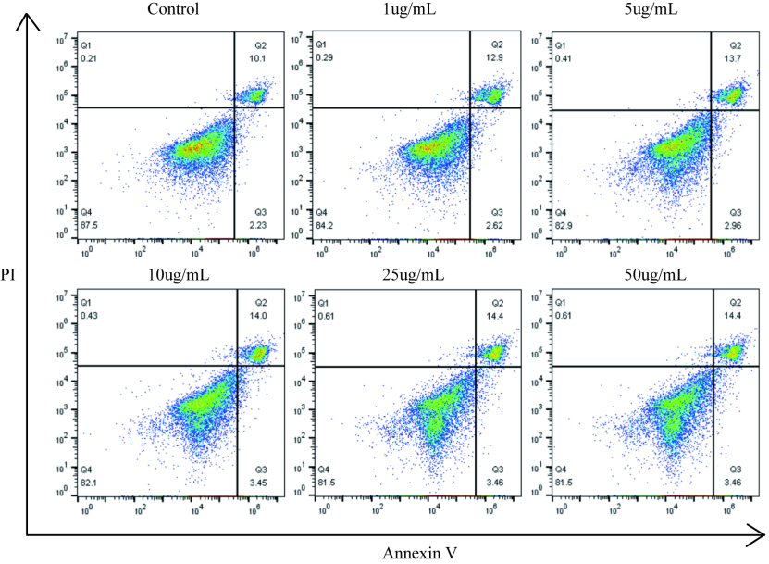

Figure S1. Flow cytometry analysis of apoptotic rates of macrophages incubated with different concentrations of AuNPs@PEG-Peptide-Cy5.5 (0–50 μg/mL) for 24 h.

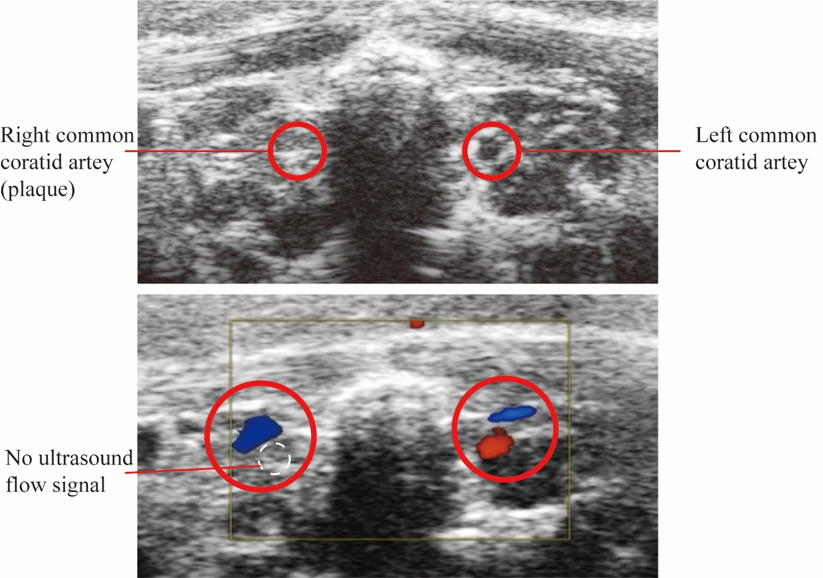

Figure S2. Microultrasound views of a 12-week atherosclerosis model mouse, in which the plaque almost blocked the whole lumen of the right common carotid artery.

