Supplementary Information for
A Photonic Crystal Receiver for Rydberg Atom-Based Sensing
Hadi Amarloo, Mohammad Noaman, Su-Peng Yu, Donald Booth, Somayeh Mirzaee, Rajesh Pandiyan, and James P. Shaffer, Quantum Valley Ideas Laboratories, 485 Wes Graham Way, Waterloo, Ontario, Canada N2L 0A7
In this supplementary section, we provide additional information regarding the details of the off-resonant detection of the RF field enhancement and tuning of the PCR resonance frequency.
Off-resonant detection:
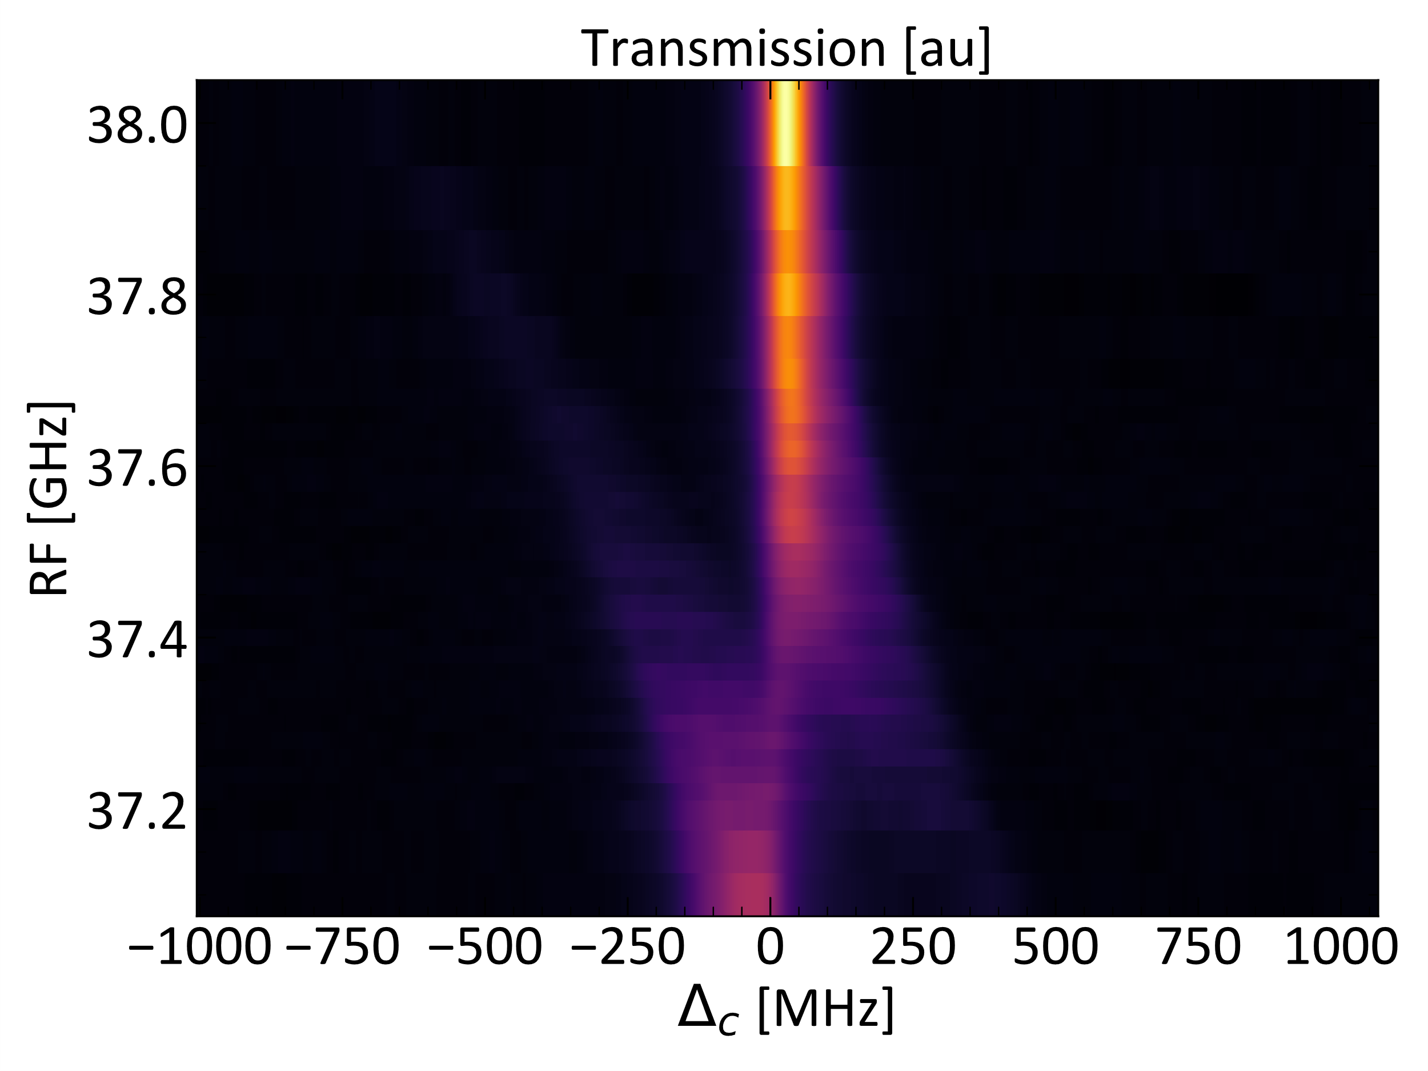
Probing the RF field enhancement around the PCR’s gain profile provides detailed insight about the PCR’s characteristics. RF sensing using Rydberg EIT/EIA utilizes discrete Rydberg states. It is a challenging task to perform a calibration-free measurement of the RF field response over the entire frequency band of the PCR near an atomic transition. We utilized off-resonant, RF field detection and developed methods to perform calibration-free characterization of the PCR. The methods allow for a continuous measurement of the gain of the PCR over a ~1 GHz RF spectral bandwidth. The technique is especially useful in cases where the Stark shifts present in the photonic crystal slot are important, due to Cs sticking to the walls. By analyzing the avoided crossing associated with the RF field interacting with the Cs atoms, the resonance frequency of the PCR can be estimated. Using the avoided crossing is a useful way to obtain the RF field gain. The contour map in Fig. S1 shows the EIT/AT signal as a function of RF frequency inside the PCR. The figure is plotted as a function of detuning of the 509 nm coupling laser from resonance. The measurement is done using elongated probe and coupling beams which capture several nodes/anti-nodes of the RF field inside the PCR. The RF field addressed by the large beam sizes is non-uniform. The measured gain results in a spectrum that is a weighted average of the spatial RF field variations that occur in the PCR. The maximum EIT peak frequency splitting yields the maximum gain of the device. As the RF fields are tuned to different frequencies, the EIT/AT signal frequency splitting shows a peak that is unaffected by the RF field. The unshifted peak results from the presence of RF field nodes along the channel, while the maximally shifted peaks arise from atoms in the antinodes. We fit a 3-Lorentzian peak model to obtain the splitting and hence the RF field. The gain is obtained by comparing the results with a conventional reference vapor cell.
Figure S1: Avoided crossing shows two split peaks and an undeflected central peak. The undeflected peak results from nodes in the RF field in the channel.
We estimate the amplification by taking the ratio of the Autler-Townes splitting due to the RF field inside the PCR to that of a commercial vapor cell. Our PCR shows a Stark shift from a background DC electric field of ~200 mV/cm, which is accounted for when calculating the amplification. In cases where different Rydberg states were used for the amplification calculations, the Stark shift corresponding to each of the states is estimated to obtain the gain.
The off-resonance gain is calculated by analyzing the generalized Rabi splitting:
${Ω }_{g}^{2} = Ω^{2} + Δ_{RF}^{2}$
The data is averaged 300 times to minimize the error.
Three-Level model:
To interpret results from the spatial scan along the channel of the PCR, which are complicated by a nearby ${47\text{P}}_{3/2}$ energy level, we implemented a three-level model which includes the effect of the nearby energy level. The Hamiltonian for this system has the form:
$$H=\left(\begin{matrix}0 & \frac{ℏΩ_{12}}{2} & \frac{ℏΩ_{13}}{2} \\ \frac{ℏΩ_{12}^{*}}{2} & -ℏΔ_{2} & 0 \\ \frac{ℏΩ_{13}^{*}}{2} & 0 & -ℏΔ_{3}\end{matrix}\right) ,$$
where $Ω_{ij}$ is the Rabi frequency of the transition from state $i$ to $j$ and $Δ_{i}$ is the detuning of the excitation field to the state $i$. The Rabi frequency is given by the dipole matrix element $μ_{ij}$ of the atomic transition and the strength of the electric field $E$ driving the transition,
$$Ω_{ij}=-\frac{μ_{ij}}{ℏ}E .$$
The detuning is defined as
$$Δ_{i}=ω-ω_{ij} ,$$
where $ω$ is the frequency of the driving field and $ω_{ij}$ the frequency of the transition.
We can calculate the lines for a given driving field by calculating the eigenvalues of $H/ℏ$. The differences between these eigenvalues are the state splittings, which can be compared to the measured Autler-Townes splitting in the reference cell and the PCR to calculate the driving electric field that matches the measured splitting. The E field in the reference cell is approximately constant with respect to the RF frequency, and the E field in the PCR is influenced by the photonic crystal. We can calculate the power enhancement by taking the ratio of the square of the E field in the PCR and the squared mean of the E field in the reference cell:
$Power enhancement=\frac{E_{PCR}^{2}}{{E_{ref}^{2}}_{ }}$.

Cell resonance tuning:
Due to manufacturing tolerance, design and fabrication of the PCR can suffer from a mismatch between the device resonance and a target Rydberg state resonance. To facilitate the coincidence of the PCR resonance and that of the atom, the PCR resonance frequency can be tuned by an external glass plate. The tuning can be achieved after the photonic crystal is fabricated. Figure S2 shows the how the PCR tuning works. A glass plate interacts with the evanescent RF field leaking out of the device. The glass plate changes the resonance frequency when it interacts with the RF field. A tuning curve, as the glass plate is moved in the vicinity of the device is shown in Fig. S2 (b).
Fig. S2: (a) Illustration of the test tuning setup, where a tuning glass plate is translated to the two-port test device using a plastic holder. The plastic holder and glass plate are mounted on a micrometer-driven positioning stage (not shown). (b) Observed frequency tuning of the band-edge as function of the displacement from the smallest tuning gap allowed by the setup geometry.

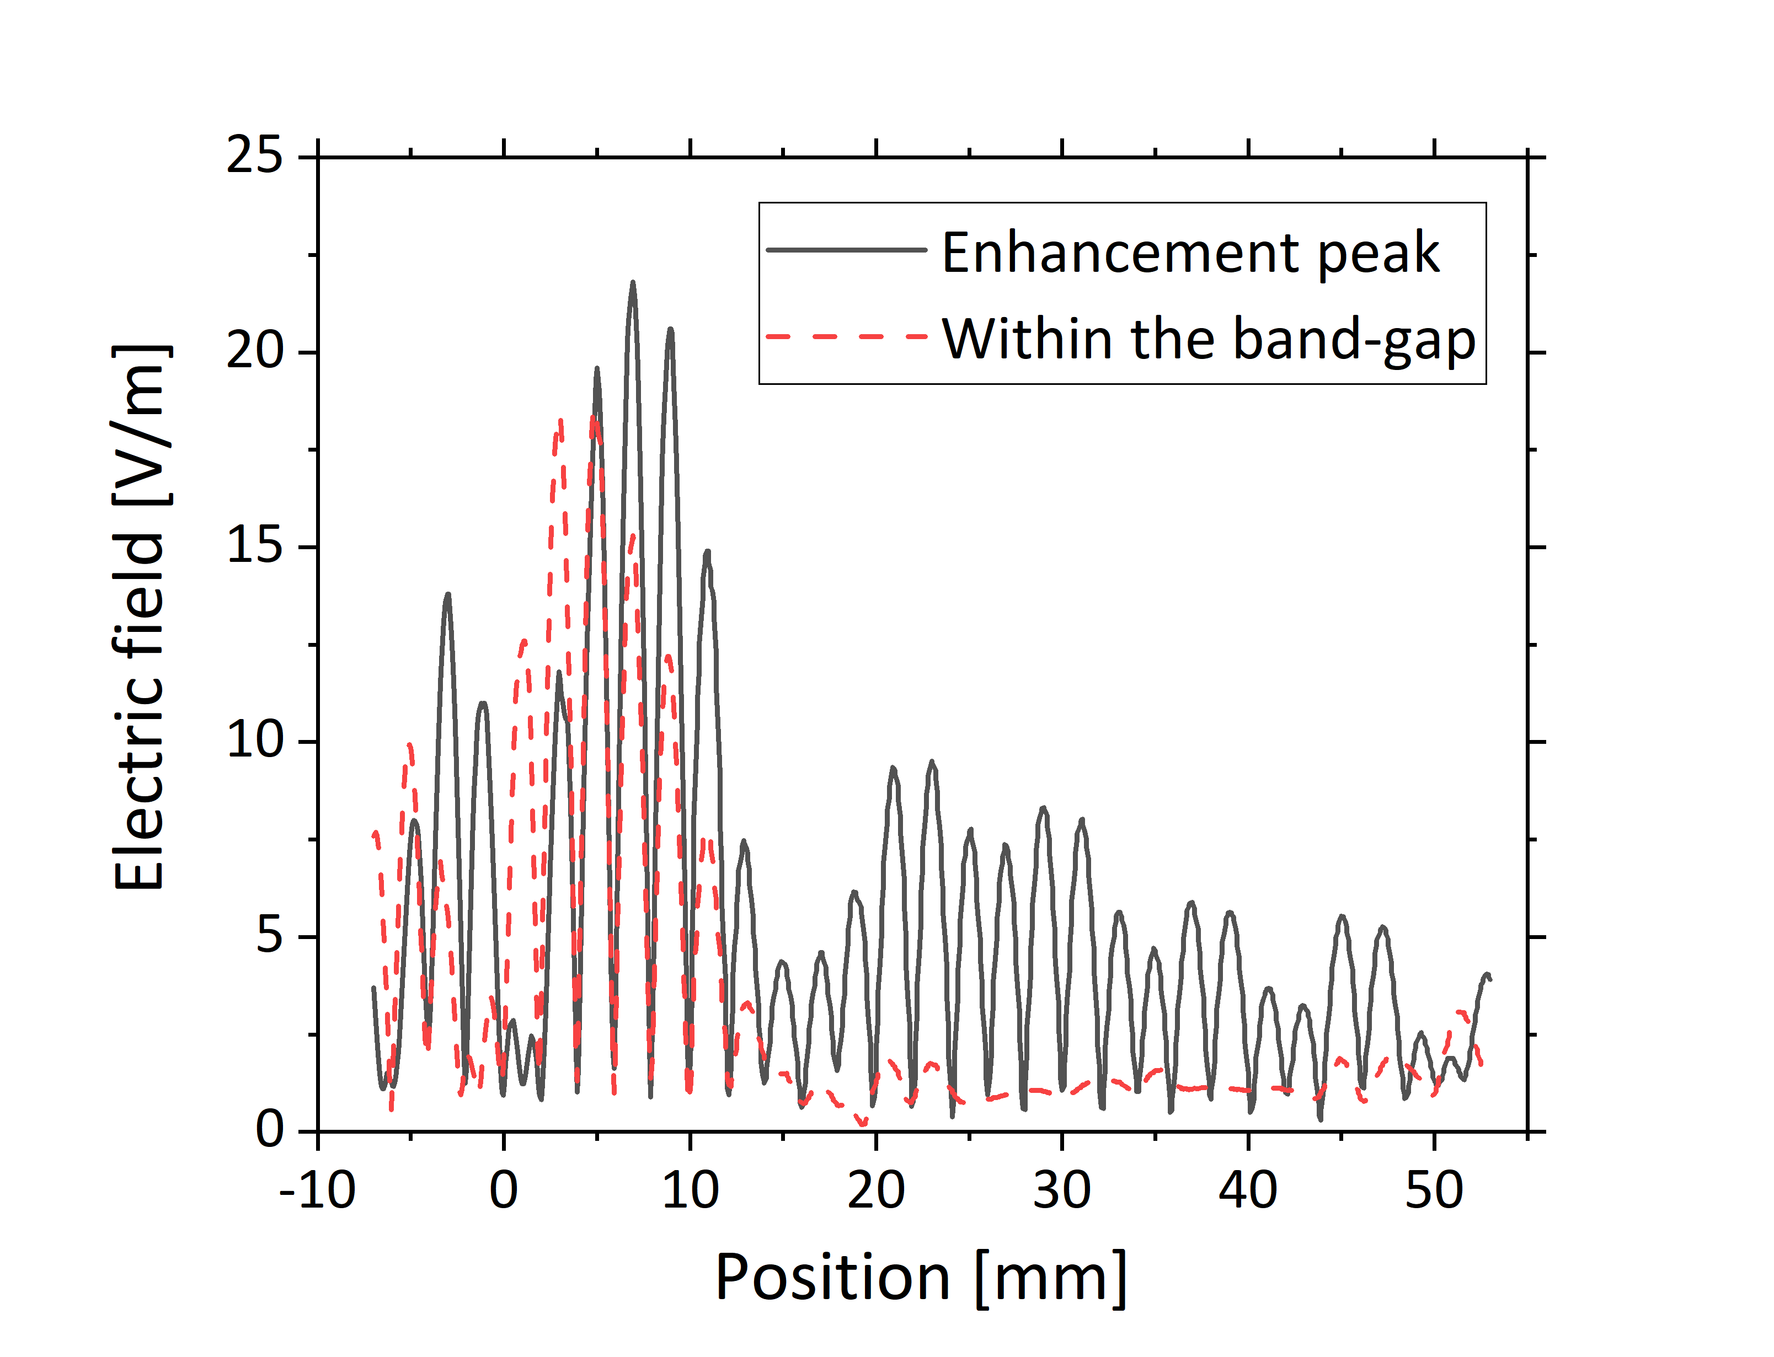
Figure S3: Electric field distribution along a line passing through the center of the PCR at the enhancement peak shown in Fig. 3 (solid black line) and a frequency within the band-gap (dashed red line).

Effect of deviations in hole positions
The gain variations as a function of frequency in Figure 6 indicate that the impedance matching between the input coupler and the photonic crystal is not ideal. The behavior shown in Fig. 6 can arise from fabrication imperfection, such as deviation of hole positions from the ideal lattice. Photonic crystal hole variation has been shown to impede propagation particularly in slow-light systems.¹ The accuracy of the hole pattern of the photonic crystal can lead to an impedance mismatch. The hole positions have a measured standard deviation of around 20 μm. We performed simulations with this standard deviation of the hole pattern. The simulations show that the RF electric field will build up in the region between the coupler and the photonic crystal as the impedance mismatch can form a cavity. This behavior could also be compared to localization seen in other disordered photonic crystal systems.² Figure S3 shows the calculated electric field distribution for the simulation along a line passing though the center of the PCR for two different frequencies; one at the peak of the enhancement shown in Fig. 3, and a point within the band-gap of the PCR device. The RF electric field build-up at the input of the PCR is observed in Fig. S3 in the case where the photonic crystal hole pattern has manufacturing variation. For the frequency in the bandgap, there is no RF electric field in the PCR because there is no coupling into the core of the device. When the incoming RF wave is on resonance with the device, there is coupling into the core of the device.

References
1. Smolka, S., Garcia, P. D. & Lodahl, P. Controlling Anderson localization in disordered photonic crystal waveguides. in CLEO/QELS: 2010 Laser Science to Photonic Applications 1–2 (2010). doi:10.1364/QELS.2010.QMG4.
2. Mookherjea, S., Park, J. S., Yang, S.-H. & Bandaru, P. R. Localization in silicon nanophotonic slow-light waveguides. Nature Photonics 2, 90–93 (2008).

