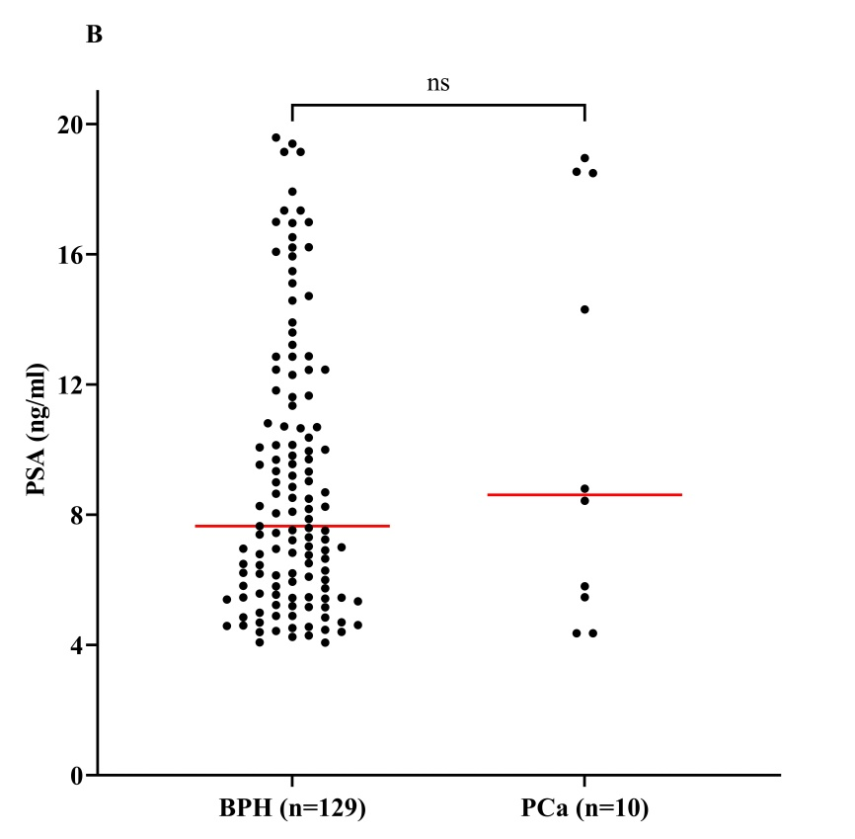
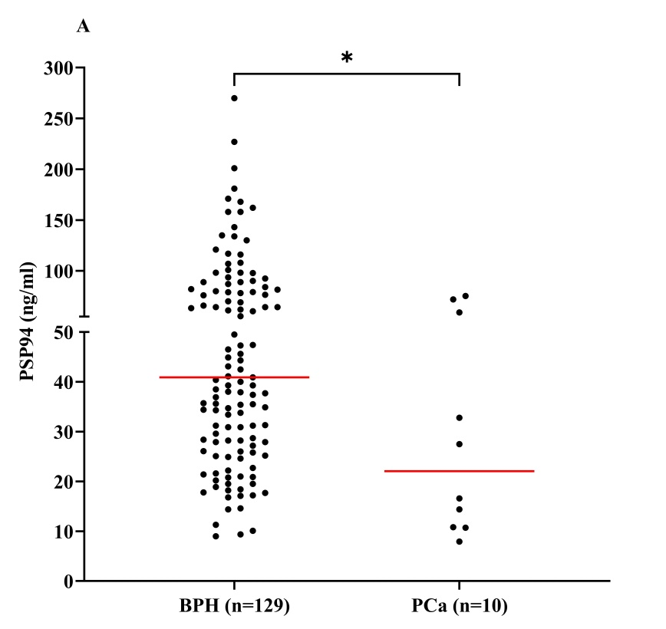
Supplementary Data
Figure 1- Comparison of PSP94 levels (A), PSA levels (B) and PP Index (C) in BPH & prostate cancer

