Table 1:
Serial No. |  | Patient 1 | Patient 2
1 | Histopathology | This section reveals tumor composed of spindle cells arranged in sheets and bundles. The spindle cells have abundant eosinophilic cytoplasm and oval to spindle shaped hyperchromatic nuclei. Few cells show fbrillary cytoplasm  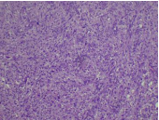 | The section reveals multiple fragments of brain tissue with prominent reactive gliosis. Adjacent areas show sheets of atypical astrocytes, increased cellularity, and necrosis. Spindled regions with pleomorphism are also present. These features suggest a high-grade malignant neoplasm, consistent with gliosarcoma, WHO Grade 4.  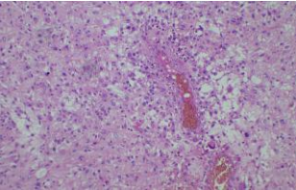
2 | ATRX | Retained  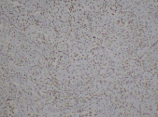 | Retained  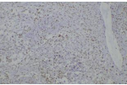
3. | Ki 67 | 8%  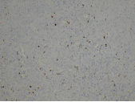 | 25%  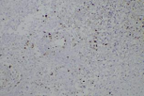
4. | IDH1 | Wild type  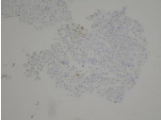 | Wild type  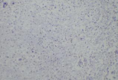
5. | P53 | Negative  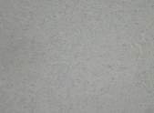 | Positive  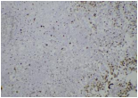
6. | EGFR | Negative  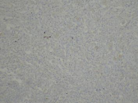 | Partially positive  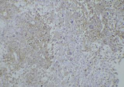
7. | GFAP | Positive in glial cells | Positive in glial cells  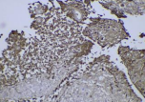
8. | Vimentin | Positive in sarcomatous, chondroid and glial areas  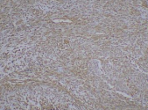 | Positive in spindled cells  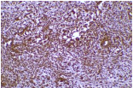
9. | S100 | Positive in chondroid areas  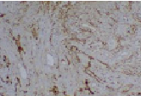 | Positive in glial elements and spindled cells  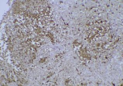
10 | MGMT promoter methylation | Detected | Not detected
11 | Diagnosis | Gliosarcoma with chondroid areas, WHO grade IV | Gliosarcoma, WHO Grade IV
Table 2:
MLPA
Chromosome | Genes | Patient 1 | Patient 2
4p | PDGFRA | Amplified | Normal
9p | CDKN2A/ CDKN2B | Normal | Partial amplification
10q | PTEN | Heterozygous deletion | Normal
12q | CDK4, MDM2 | Amplified | Partial heterozygous deletion
14q | NFKBIA | Amplified | Normal
17p | TP53 | Amplified | Normal
1p | TNFRSF14-8, TP73-1, WNT4-2,PTAFR-3, FAF1-4, CDKN2C-1, DPYD-1, GTF2B-2 | Amplified | Partial Amplification
1q | LMNA, CRB1, TNNT2 | Amplified | Partial Amplification
19q | PDCD5, ZNF296-2, CIC-10, BAX4, CHMP2A-2 | Normal | Partial Amplification
2q | IDH1 (p. R132H) | Wild type | Wild type (Normal)
15q | IDH2 (p. R172K,p.R172M) | Wild type | Wild type (Normal)

