Supplementary Information for “Atlantic overturning collapses in global warming projections after 2100”

 | Number of runs | Number of runs | Number of runs | Number of runs | Number of runs | Number of runs
Model name | SSP1-26 till 2100 | SSP1-26 extended | SSP2-45 till 2100 | SSP2-45 extended | SSP5-85 till 2100 | SSP5-85 extended
ACCESS-CM2 | 9 | 1 | 10 |  | 9 | 1
ACCESS-ESM1-5 | 30 | 10 | 30 |  | 30 | 10
CESM2 | 3 |  | 3 |  | 3
CESM2-FV2 |  |  |  |  | 1
CESM2-WACCM |  | 1 | 5 |  | 4 | 1
CIESM | 1 |  | 1 |  | 1
CMCC-CM2-SR5 | 1 |  | 1 |  | 1
CMCC-ESM2 | 1 |  | 1 |  | 1
CNRM-CM6-1 | 6 |  | 6 |  | 6
CNRM-ESM2-1 | 5 |  | 10 |  | 5
CanESM5 | 49 | 1 | 50 |  | 49 | 1
CanESM5-1 |  |  |  |  | 18
CanESM5-CanOE | 3 |  | 3 |  | 3
EC-Earth3 |  |  | 15
EC-Earth3-CC |  |  | 8
EC-Earth3-Veg |  |  | 1
FGOALS-f3-L | 2 |  | 1 |  | 2
FGOALS-g3 | 4 |  | 2 |  | 4
GFDL-CM4 |  |  |  |  | 1
GFDL-ESM4 | 1 |  | 1 |  | 1
GISS-E2-1-G | 6 | 5 | 11 | 14 | 5 | 5
GISS-E2-1-G-CC | 1 |  | 1
GISS-E2-2-G |  | 5 |  | 5 | 5
HadGEM3-GC31-LL | 1 |  | 5 |  | 4
HadGEM3-GC31-MM | 1 |  |  |  | 4
INM-CM4-8 | 1 |  | 1 |  | 1
INM-CM5-0 | 1 |  | 1 |  | 1
IPSL-CM6A-LR | 5 | 1 | 11 |  | 6 | 1
MIROC-ES2L | 10 |  | 30 |  | 10
MIROC6 | 3 |  | 3 |  | 3
MPI-ESM1-2-LR | 28 |  | 30 |  | 30
MRI-ESM2-0 | 3 | 1 | 4 |  | 4 | 1
NorESM2-LM | 1 |  | 3 |  | 1
NorESM2-MM | 1 |  | 2 |  |  | 1
UKESM1-0-LL | 15 | 1 | 5 |  | 1 | 5
UKESM1-1-LL | 1

Supplementary Table 1, indicating the number of runs downloaded and analyzed per model and SSP-scenario for the AMOC and related metrics.

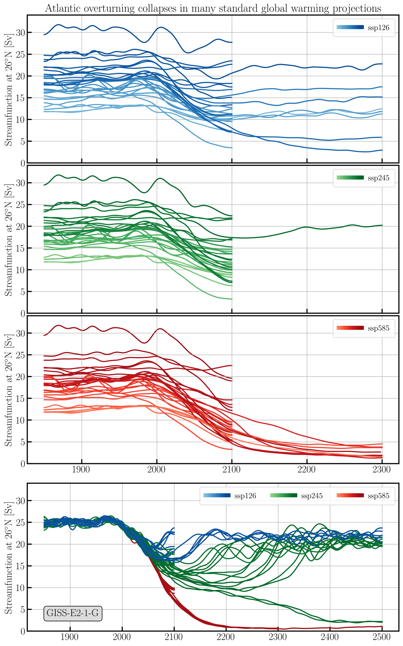

Supplementary Figure 1. Upper 3 panels: AMOC evolution in all model-runs analyzed with ensemble mean values in case of multiple ensemble members for the three emissions scenarios, excluding the GISS-E2-1-G model. Lower panel: All ensemble members of the GISS-E2-1-G model for the three emissions scenarios.

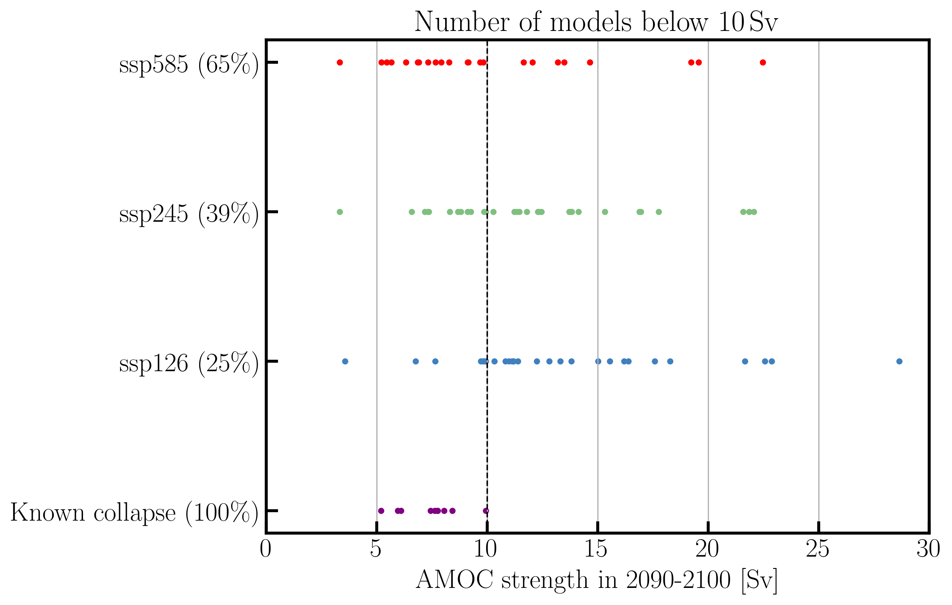

Supplementary Figure 2. Percentage of models on the route to collapse at 2100 or collapsing after 2100 in extended runs.
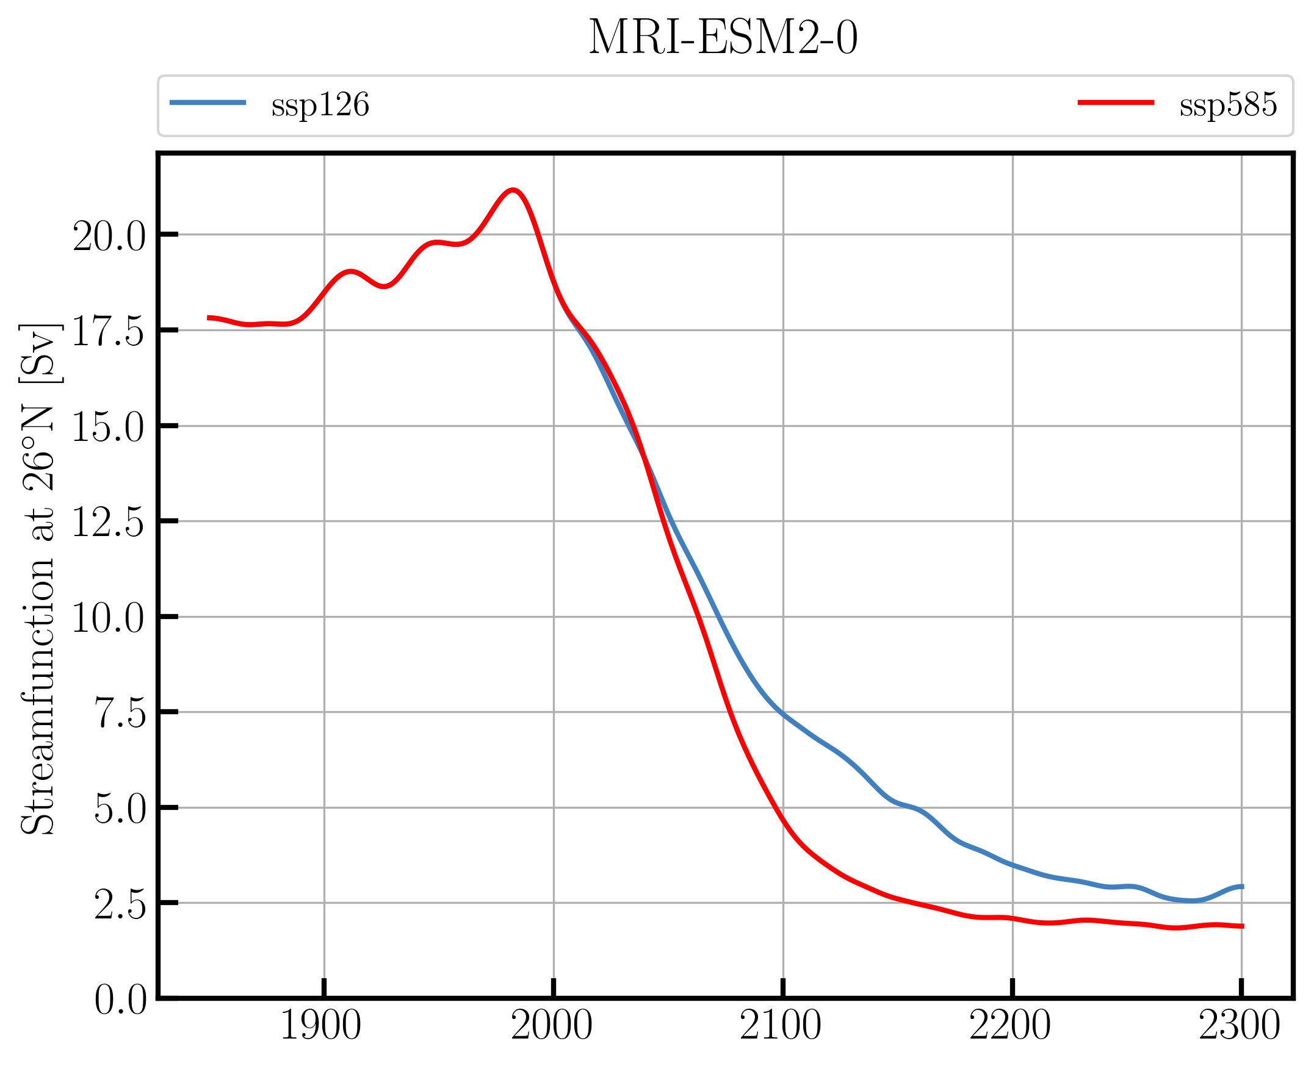

Supplementary Figure 3. The AMOC evolution in the MRI model for the high and low emissions scenario.

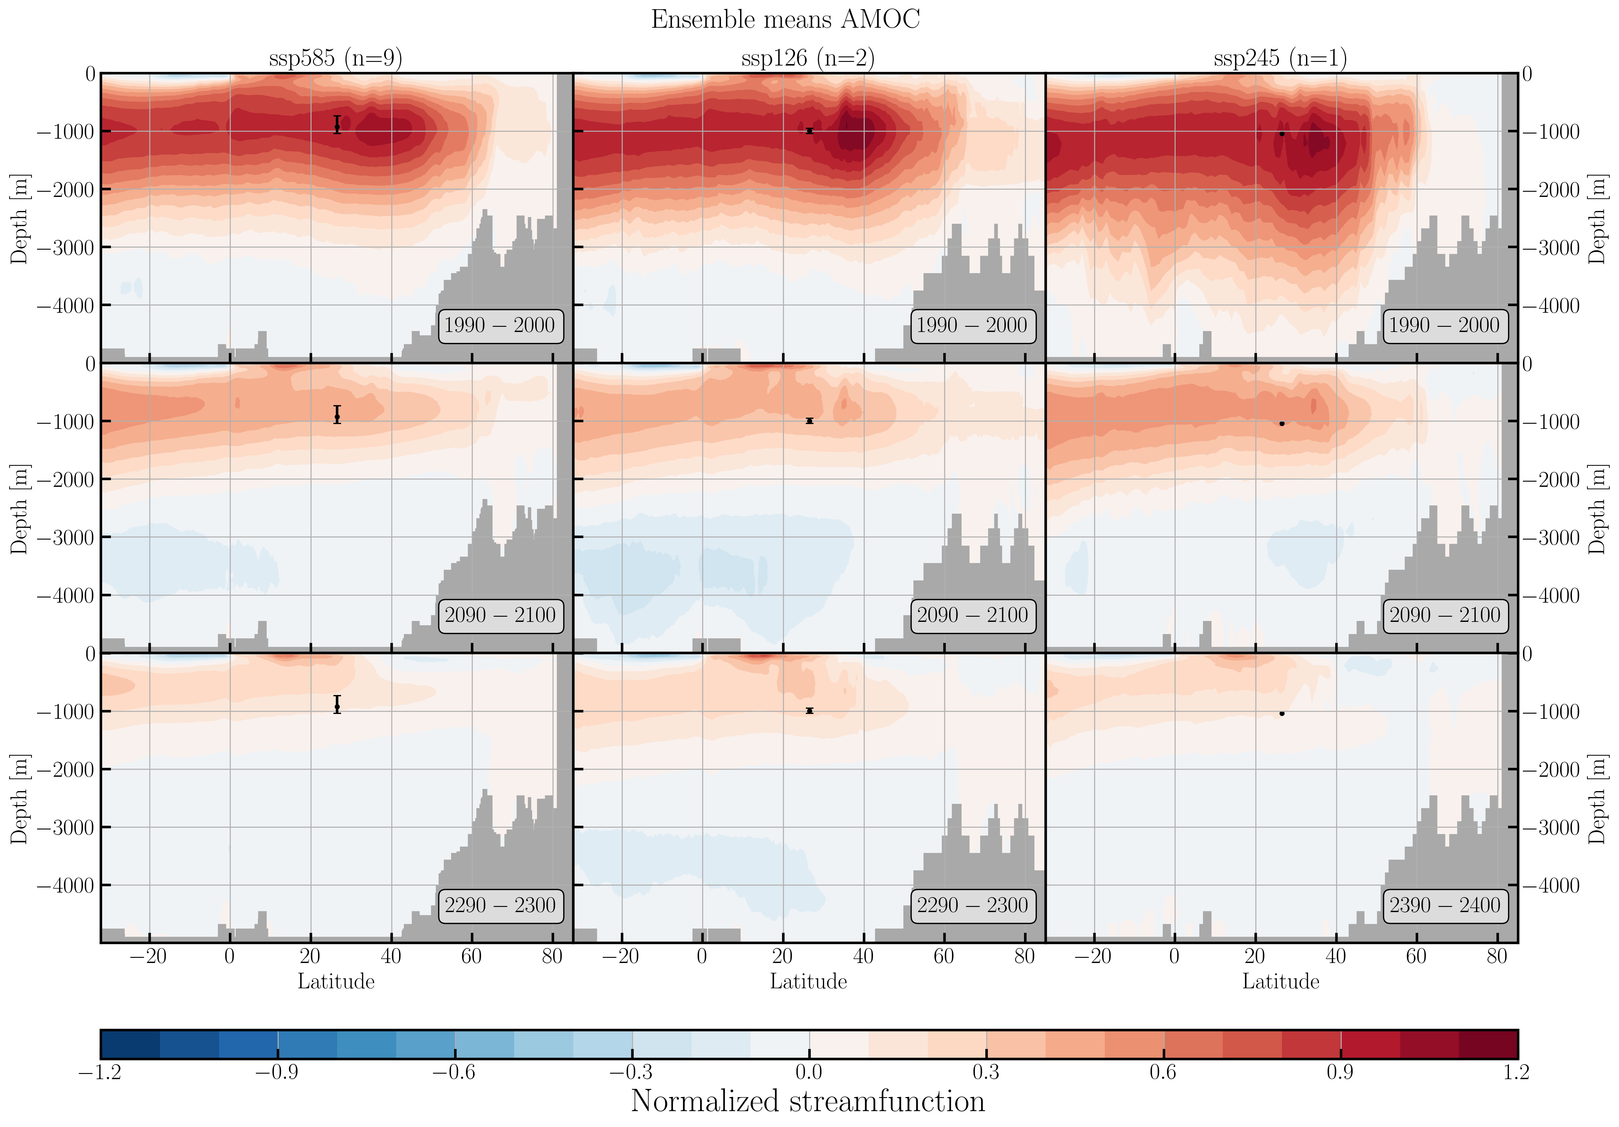Supplementary Figure 4. Upper panel: The multi model mean AMOC streamfunction for the three emissions scenarios scaled by the 1950-2000 mean value at 26°N.

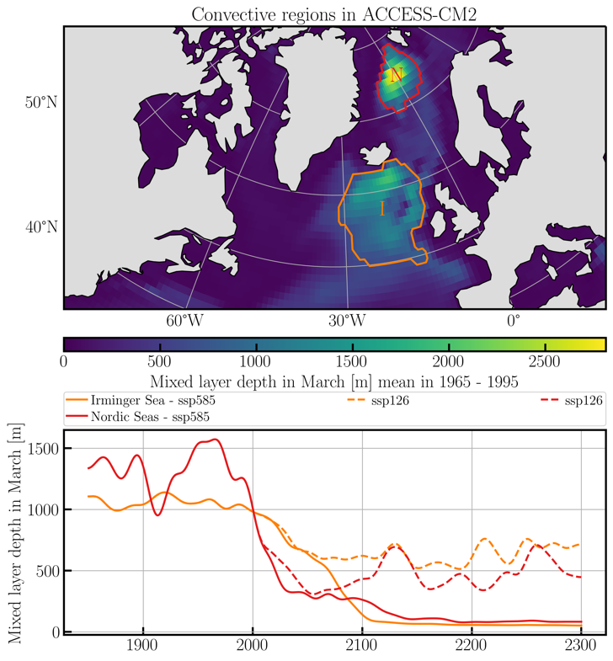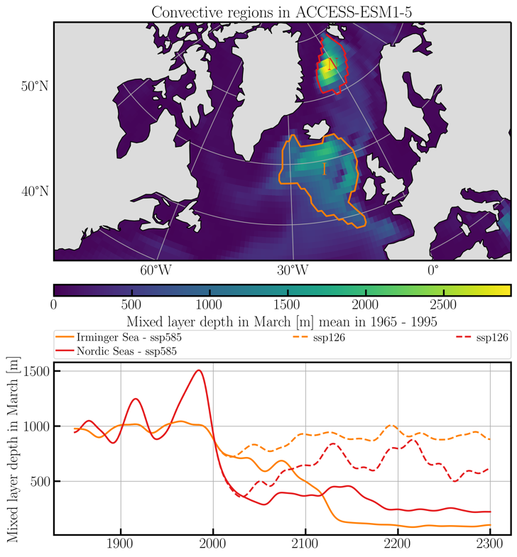

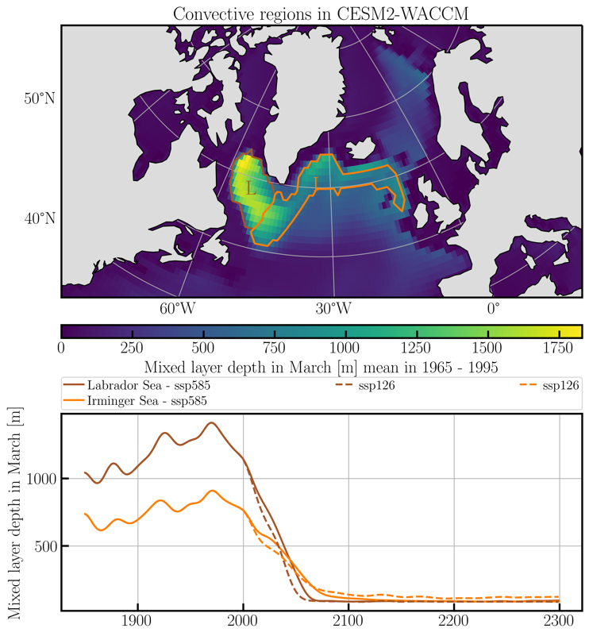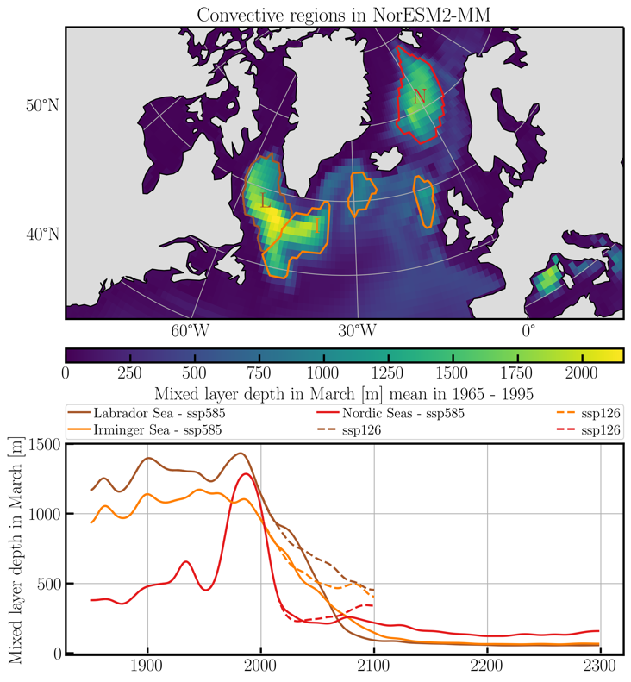

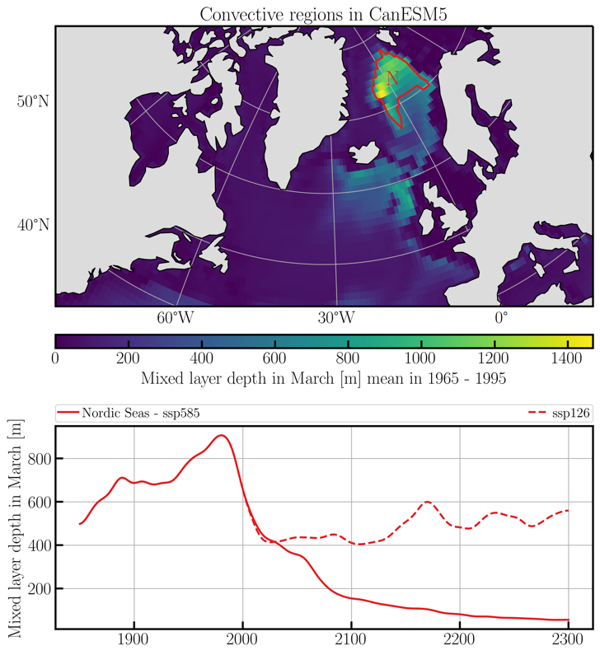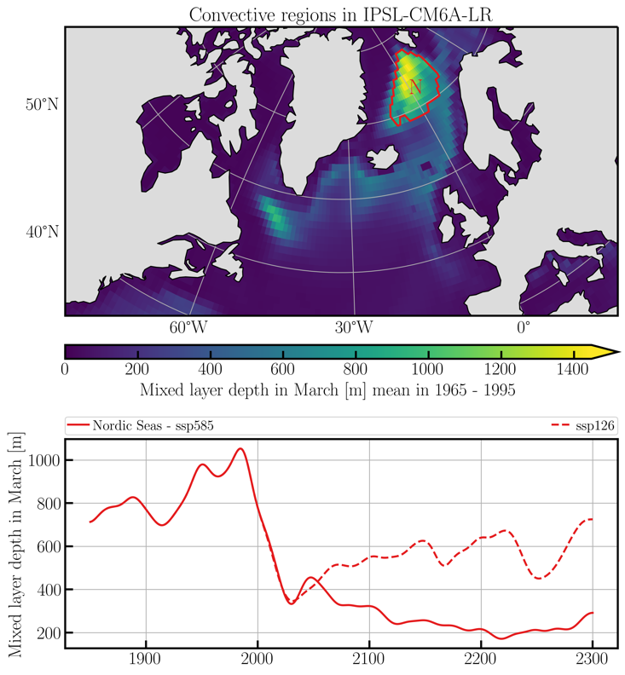

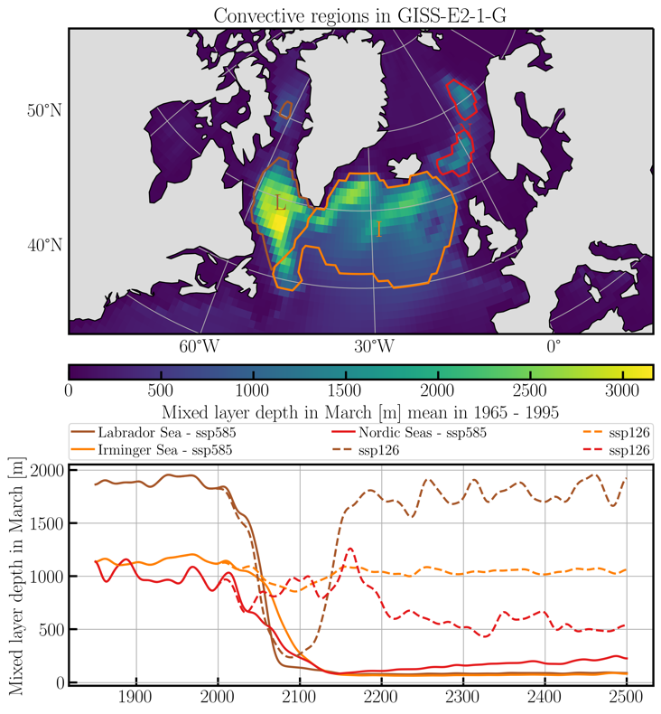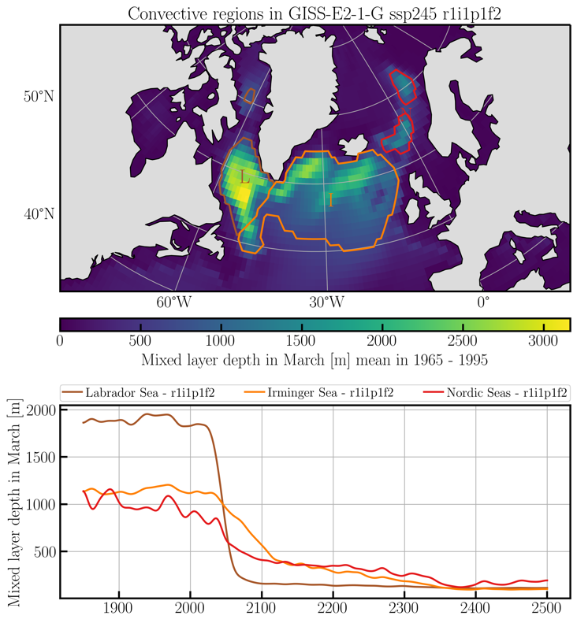

Supplementary Figure 5. Maps of deep mixing or convection and time series of mixing depths in all other models than MRI and UKESM (Figure 2) with extended runs.

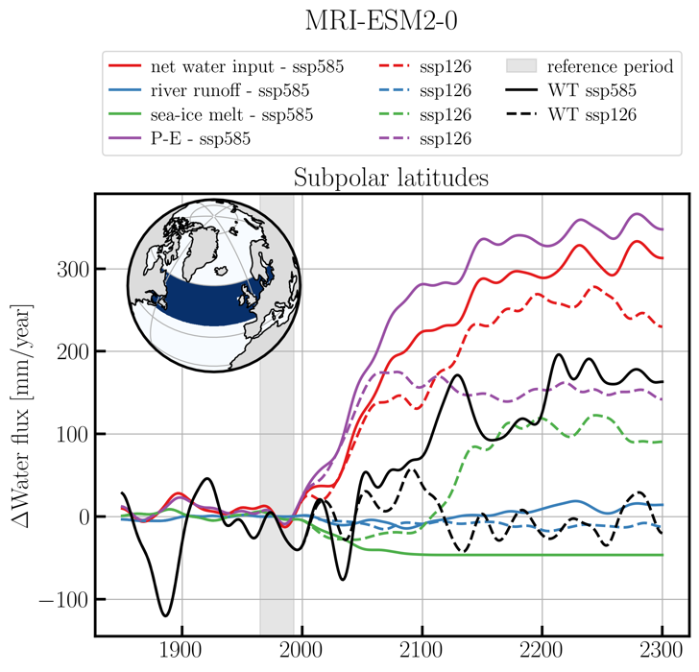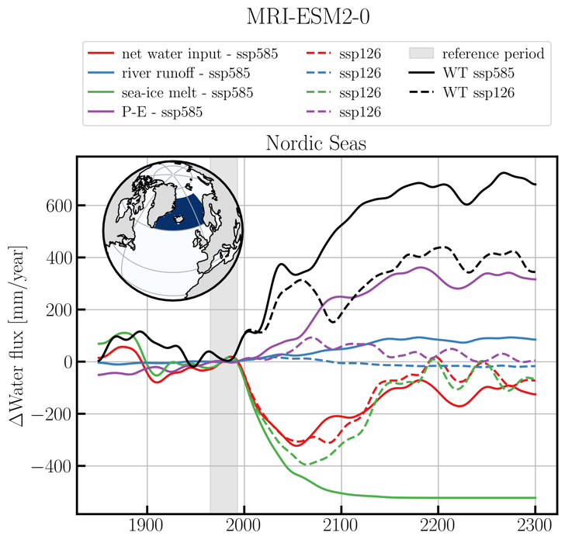

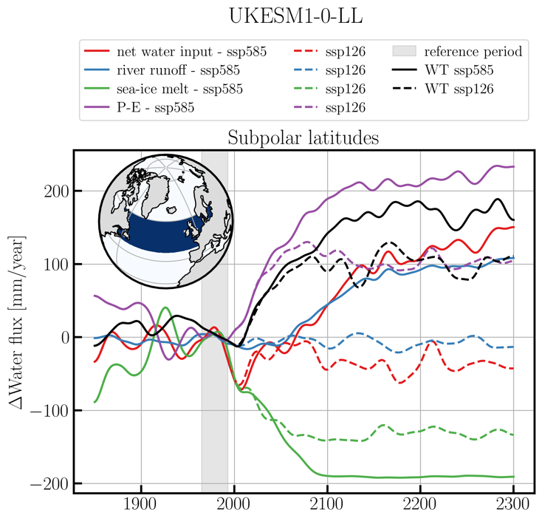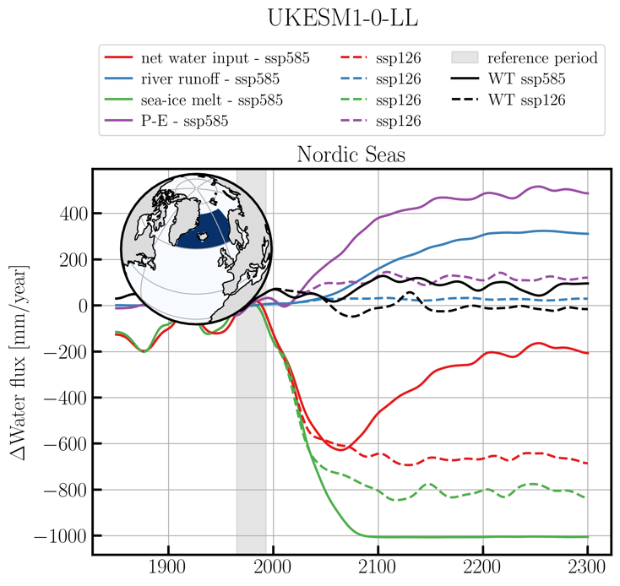

Supplementary Figure 6: Freshwater forcing in the subpolar gyre (left panels) and Nordic Seas (right panels) in the MRI model (upper panels) and UKESM model lower panels. In the subpolar gyre where the Labrador and Irminger convection sites are situated the purple curve increases steeper than the black curve, showing that P-E increase is the driver, with advection being a feedback. In UKESM the negative feedback from decreasing meltwater from sea-ice makes the rec curve less steep than the black curve, but this is not relevant for the initial freshening of the convection sites as the signal of sea-ice melt is limited to the fast southward flowing Labrador Current near the western boundary of the basin, not much affecting the convection sites. In the Nordic Seas the advective feedback from a declining AMOC is dominant, triggered by the AMOC reaction caused by freshening in the subpolar gyre.

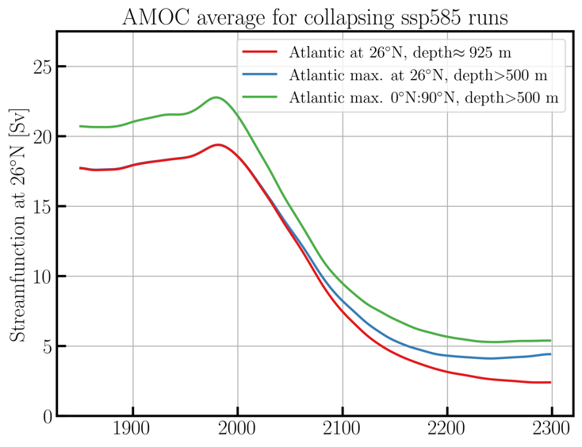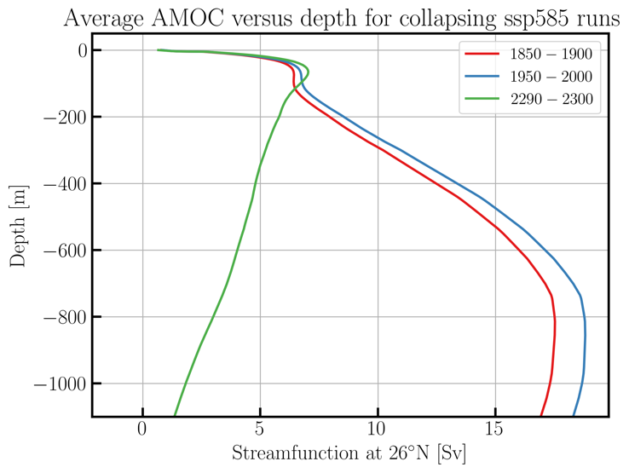

Supplementary Figure 7. Left: The multi-model mean AMOC metric used in this manuscript for collapsing models in the extended high emissions scenario runs (red curve) versus two alternative metrics showing that the main message is not sensitive to this choice. We prefer to use the AMOC at 26°, to make it comparable to the Rapid observations and to choose a fixed depth (1950-2000 maximum), to avoid that our metric starts picking up the maximum of the shallow wind-driven Ekman cell in the AMOC, as it is the thermohaline part of the AMOC that collapses, not the wind-driven part. Right: Same models (only red line from the left panel) panel showing the AMOC as function of depth at three different times, illustrating the disappearance of the deeper thermohaline part of the AMOC and upward movement of the maximum AMOC as the wind-driven cell takes over the dominance of the AMOC at 26°.

