Title
Long-term outcome of laparoscopic ventral rectopexy for full-thickness rectal prolapse: The PEXITY Study
Authors
Morgane Barra¹, Bertrand Trilling^{1,2}, Giorgia Mastronicola¹, Pierre-Yves Sage¹, Anouk Roudier¹, Alison Foote¹, Fatah Tidadini¹, Joey Fournier³, Jean-Luc Faucheron^{1,2}*
Affiliations
1 - Colorectal Surgery Unit, Department of Digestive and Emergency Surgery, Grenoble Alpes University Hospital, 38000 Grenoble, France
2 - University Grenoble Alpes, CNRS, UMR 5525, VetAgro Sup, Grenoble INP, TIMC, 38000 Grenoble, France
3 - Clinical Investigation Centre, INSERM CIC 1406, Grenoble Alpes University Hospital, Grenoble, France

Corresponding author
Prof. Jean-Luc Faucheron, Colorectal Unit, Department of Surgery, Michallon Hospital, Grenoble Alpes University Hospital, CS 10 217, 3843 Grenoble cedex, France - Tel: 33.4.76.76.53.71. Fax: 33.4.76.76.87.80. E-mail: JLFaucheron@chu-grenoble.fr
ORCID ID: 0000-0002-0837-2277

Supplementary Materials - Index

Supplementary Methods
Supplement 1  Supplement 2 | Page 2  Page 2
Supplementary Figures and tables
Fig. S1  Fig. S2 | Page 3  Page 3

Supplementary Methods

Supplement 1 Reasons for open or perineal approach in patients with RP in our previously published series²⁰

Laparotomy was chosen as the first-intention approach in 2 patients with a history of brain surgery (resection of an oligodendroglioma in one and treatment of an intracerebral aneurysm with epileptic sequalae in the other), in 7 patients with recurrent RP after laparotomy performed in another institution, in 4 patients treated for postoperative complications after pelvic surgery, and in 1 patient with a recent history of myocardial infarction.
The perineal approach was chosen in 17 patients because of their age and/or major comorbid conditions that were incompatible with general anaesthesia.

Supplement 2 Procedure for LVR used for the study²⁰

The table is tilted in a marked Trendelenbourg position to facilitate small-bowel abdominal retraction. The anterior aspect of the promontory is then exposed on the right of the mesosigmoid using a hook dissector with monopolar diathermy, over a surface measuring 3 cm wide and 2 cm high, avoiding damage to the superior hypogastric plexus. The peritoneum of the Douglas pouch is excised to free 8 cm of the anterior rectal muscular wall and the entire posterior vaginal wall in female patients, reaching the pelvic floor. No posterior or lateral dissection of the rectum is performed to avoid any nerve damage. A synthetic mesh measuring 20 x 3 cm (Parietex Prosup Tyco Healthcare, United States Surgical, Norwalk, CT) is fixed onto the anterior aspect of the lower rectum using six 4-mm titanium staples (Endo Universal 65° 4.0 mm, ref 173,054, Autosuture, Tyco Healthcare, United States Surgical, Norwalk, CT), and fixed to the right side of the promontory using 3 spiked chromium staples (Protack 5.0 mm, ref 174,006, Autosuture, Tyco Health care, United States Surgical, Norwalk, CT) (Fig. S2). Lastly, the peritoneum is closed with a continuous nonabsorbable suture over the mesh to isolate it from the abdominal cavity and to create a shallow Douglas neopouch. Local anaesthetic (ropivacaine) is systematically injected into the trocar orifices to reduce postoperative pain²⁰.

Supplementary Figures and Tables

Fig. S1 Laparoscopic approach for an anterior rectopexy to the promontory
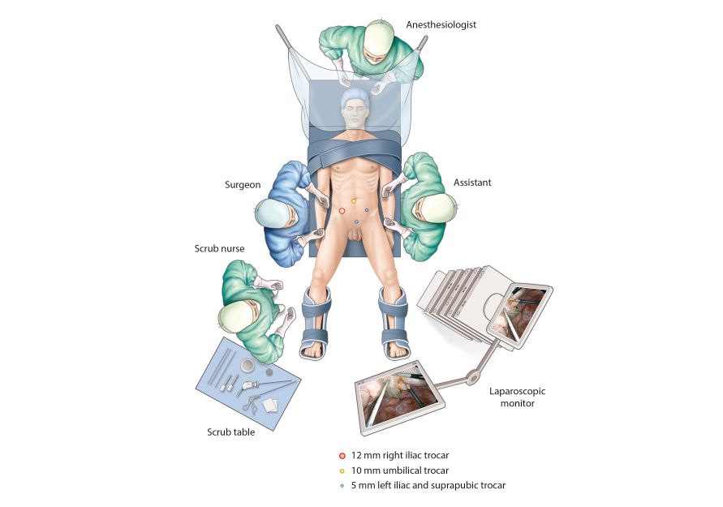

Fig. S2 Operative photograph of the mesh fixed to the lower part of the rectum and the promontory in a male patient. Note that the peritoneum from the Douglas pouch has been stripped from the deep pelvis
