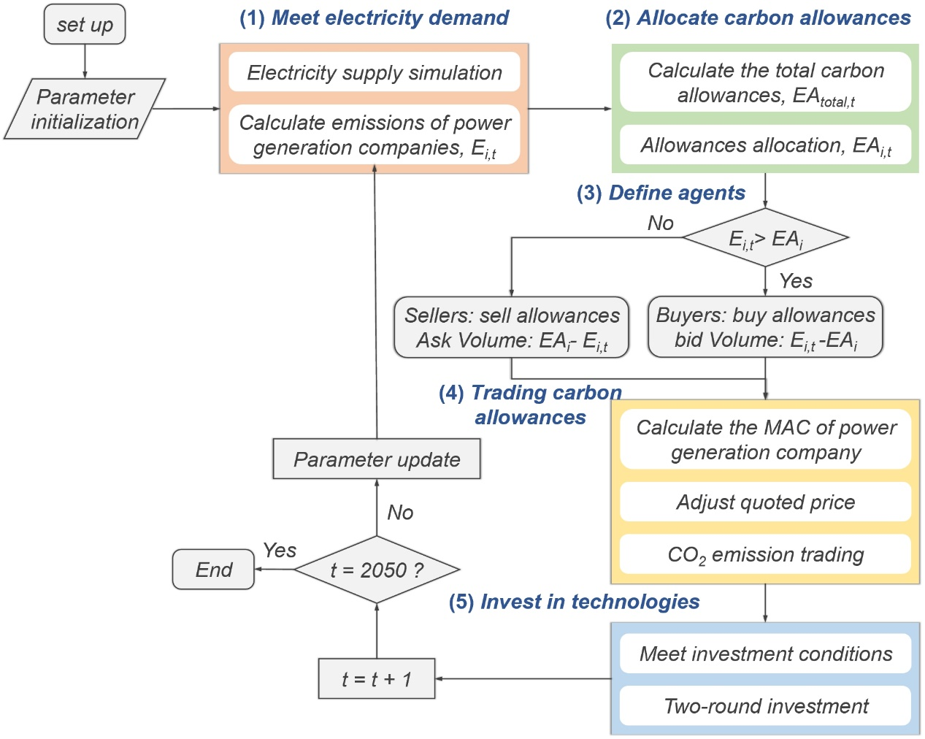
Extended Data Fig.1 | The iterative procedure of the developed ABM. The baseline period for the simulation is set at 2015, with a forecast period extending from 2016 to 2050. In each simulation period, the outcomes of electricity supply and carbon allowances trading influence the technological investments of companies. Subsequently, the results of these technological investments affect the electricity supply and emission levels of companies in subsequent periods.
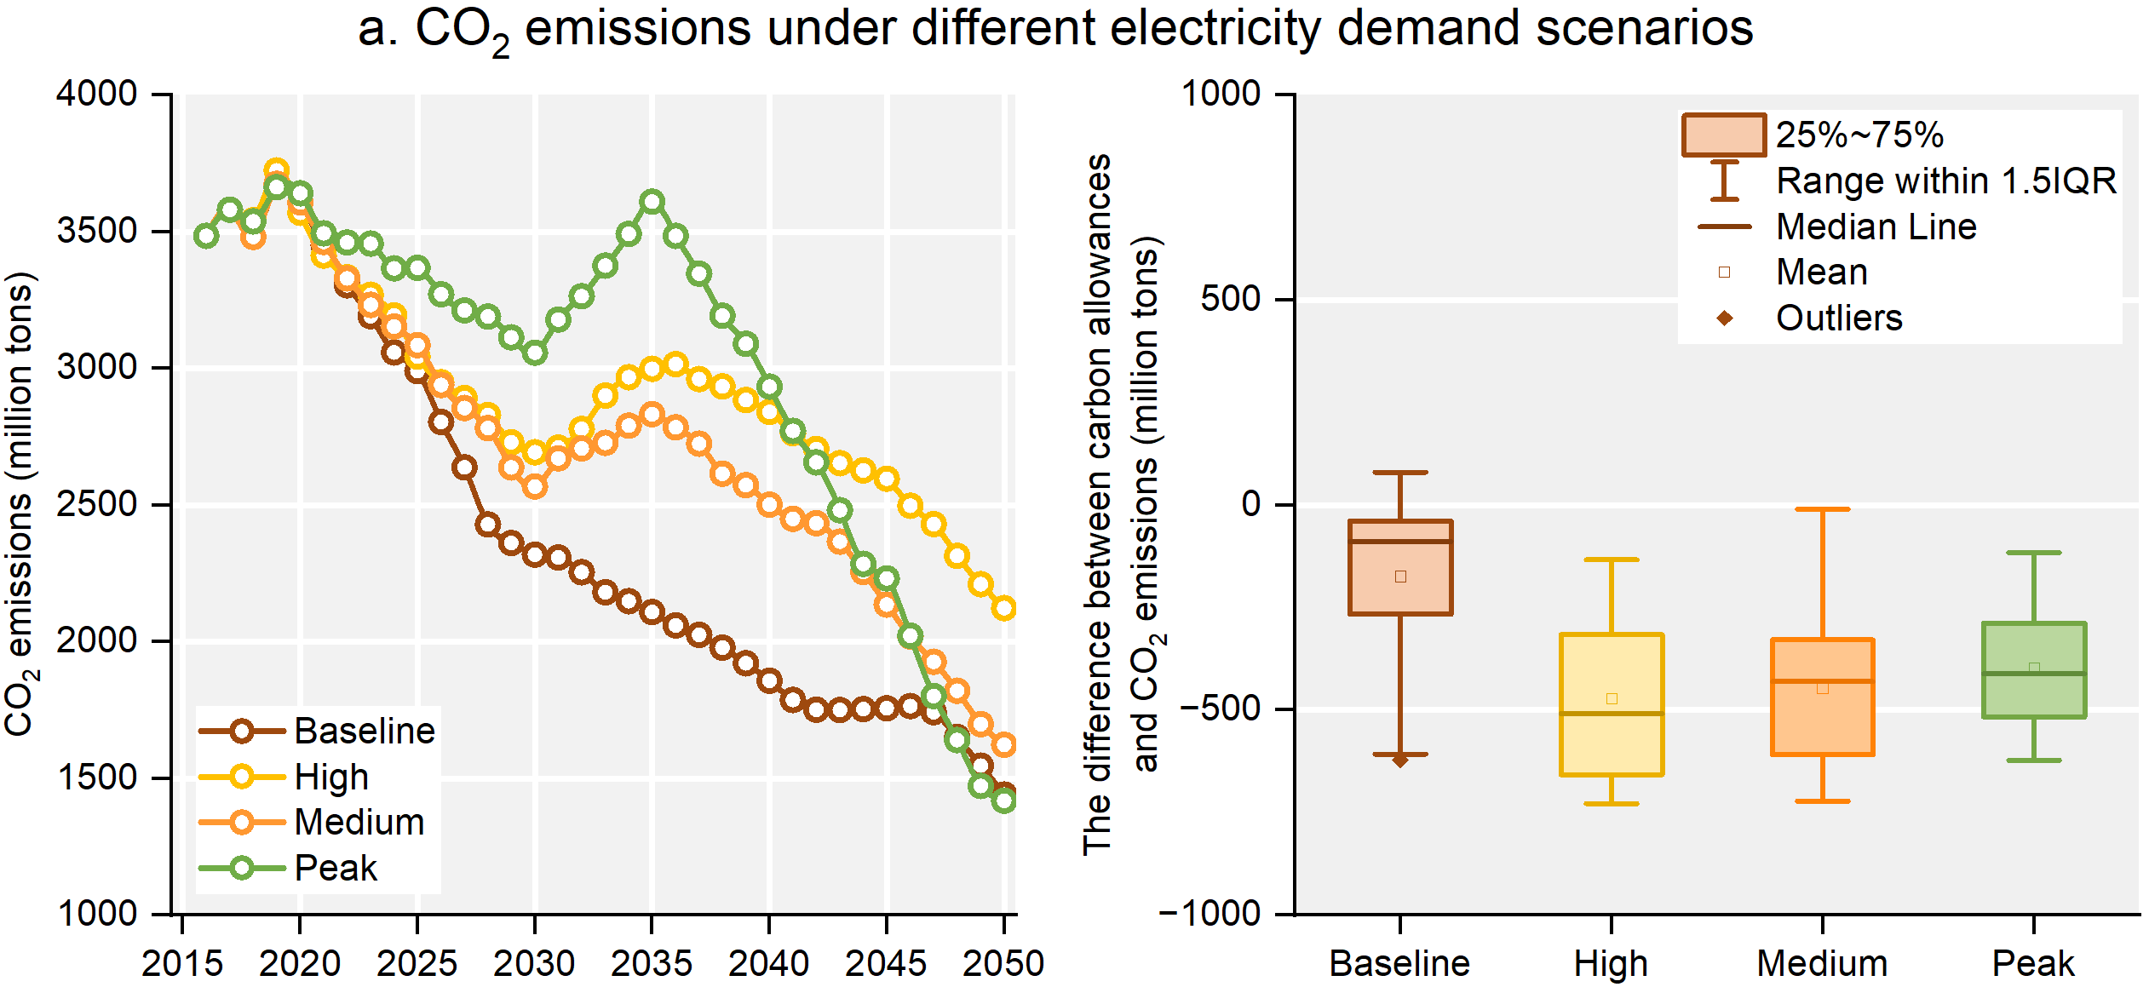
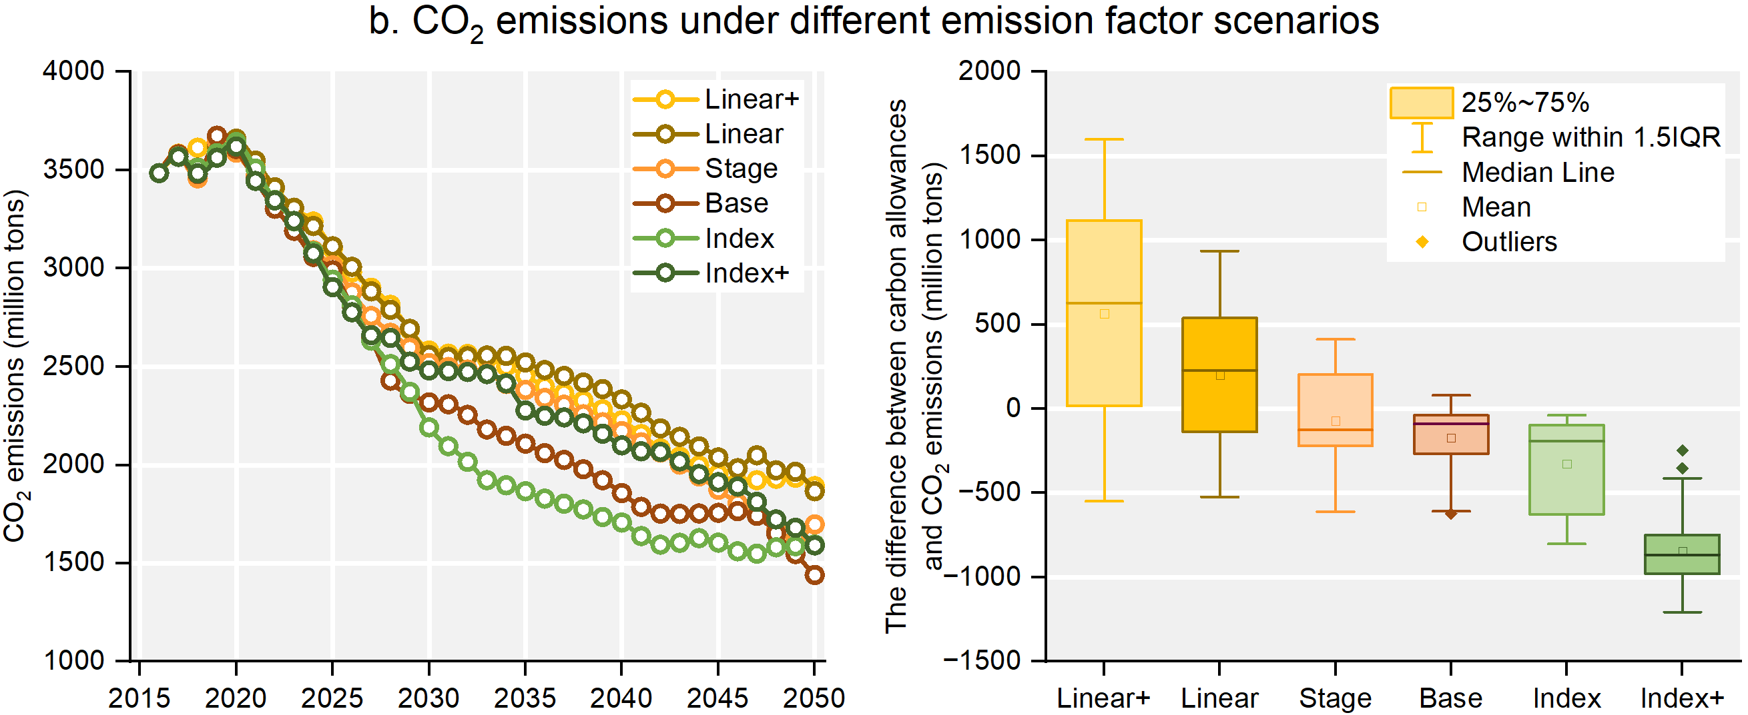
Extended Data Fig.2 | The total CO₂ emissions from companies under various scenarios. a. Electricity demand possesses a limited capacity to alter the originally planned trajectory of carbon allowances. However, a surge in electricity demand (Peak scenario) can lead to a rebound in CO₂ emissions. This rebound is also a potential issue associated with the slow phase-out of coal-fired power technology. b. In scenarios of emission factor, the timing and trends of peak emissions are similar. However, the variation in sectoral emissions from the annually planned carbon allowances is quite pronounced under different scenarios. Consequently, accurately estimating the long-term trend of CO₂ emissions per unit power generation becomes crucial for the effective operation of the cap-and-trade system, ensuring a balance between supply and demand of carbon allowances.
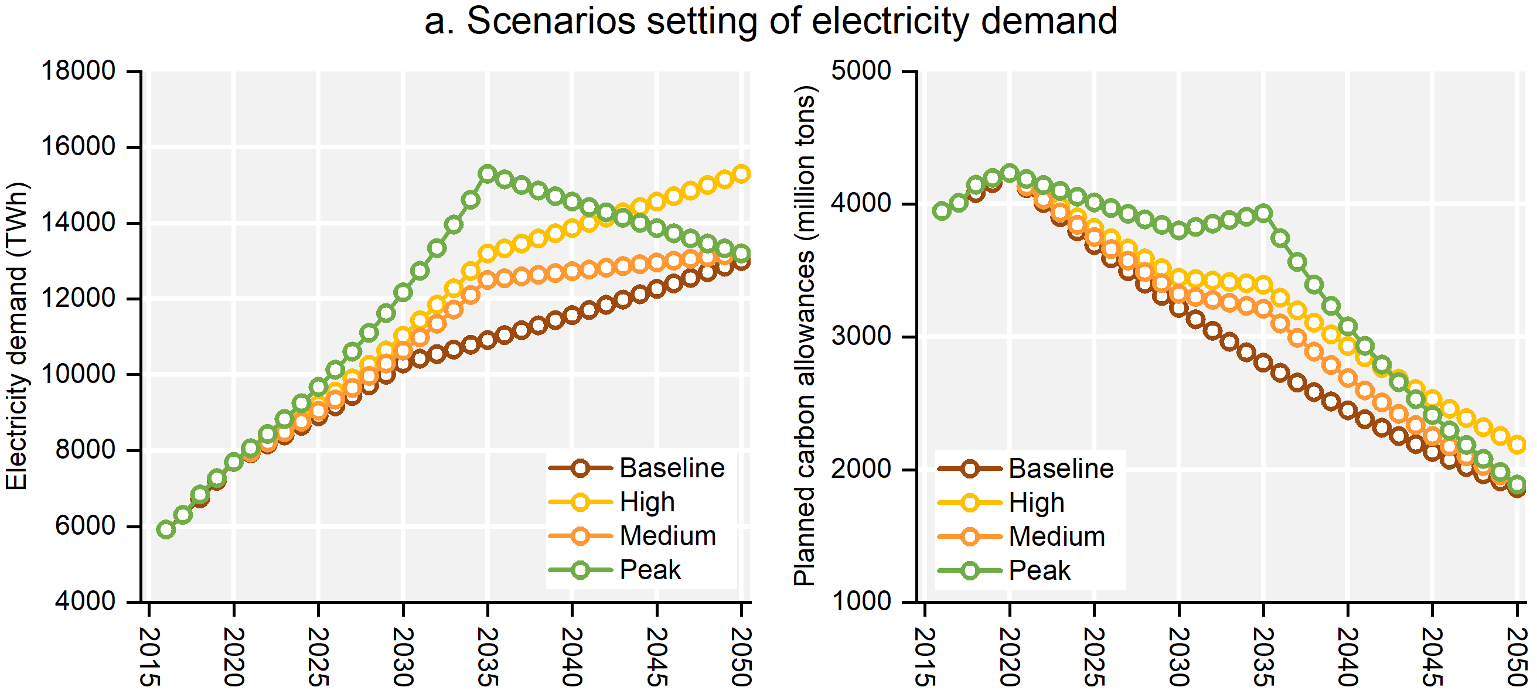
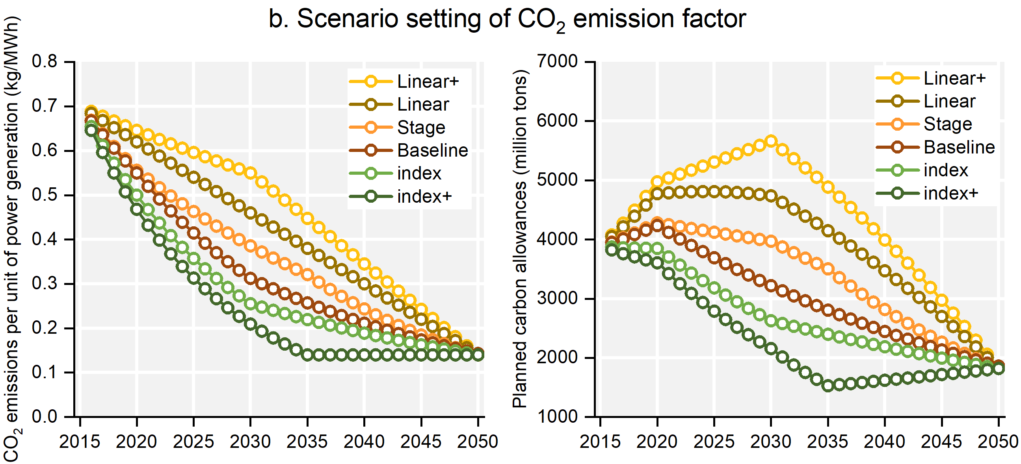
Extended Data Fig.3 | Scenario setting of electricity demand and CO₂ emission factor. Electricity demand and the CO₂ emission factor are two critical factors influencing the companies’ investment and emission reduction behaviours. These are essential for designing the total carbon allowances and the MSR.
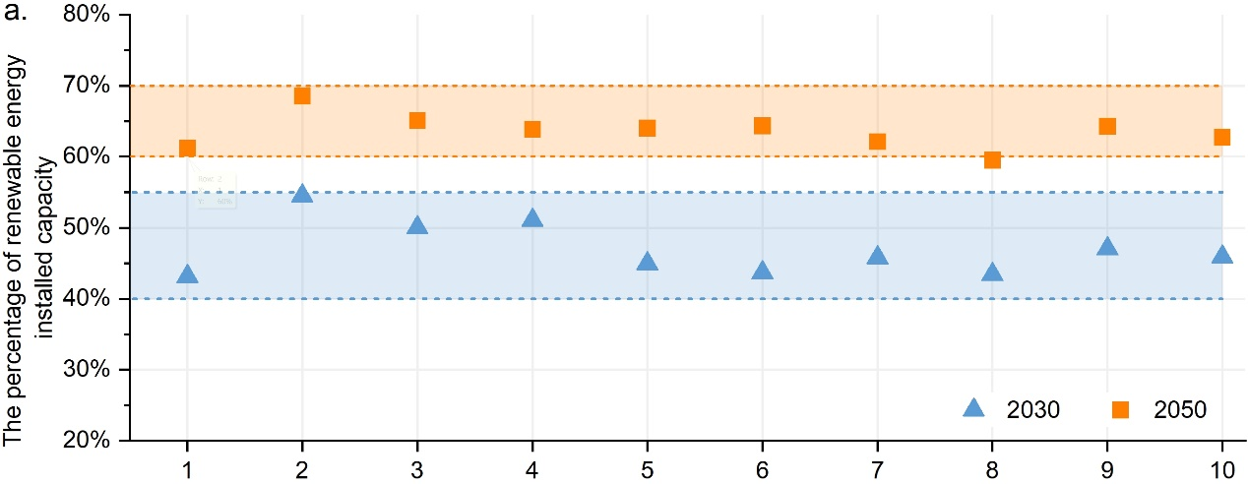
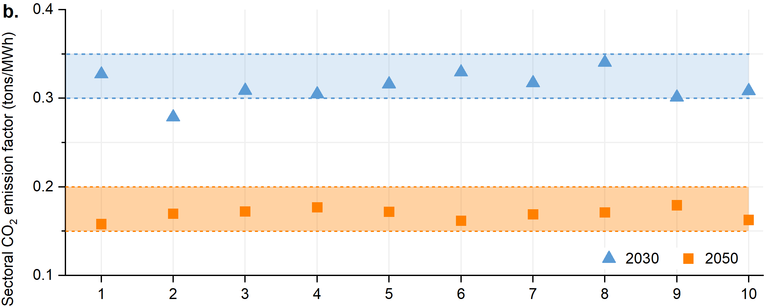
Extended Data Fig.4 | Simulation results of renewable energy percentage and sectoral CO₂ emissions considering the randomness of important variables. To investigate the impact of the randomness of some important variables including capacity factor, generation cost and on-grid price of renewable energy technologies. Numbers 1-10 are chosen as the range of random seeds in Netlogo software. The percentage of renewable installed capacity fluctuates in the range of 40-55% in 2030 and 60-70% in 2050. The emission factor in the scenarios of different random seeds fluctuates in the range of 0.30-0.35 t/MWh in 2030 and 0.15-0.20 t/MWh in 2050. The randomness of the variables has a small impact on the macro results. Meanwhile, the small fluctuation serves as evidence of the validity of the ABM developed in this study.
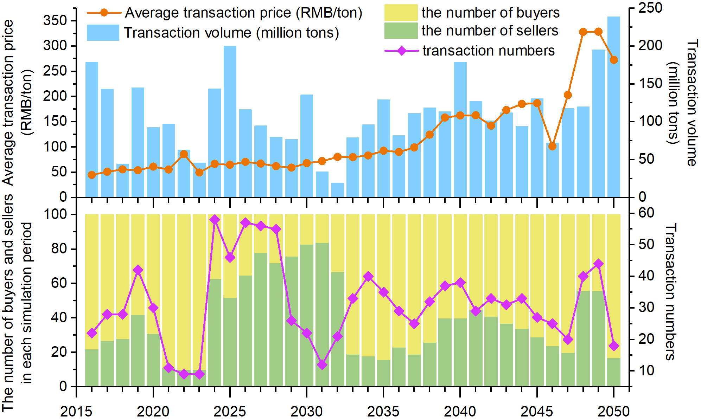
Extended Data Fig.5 | The market operation of the CO₂ emission trading. The average price of carbon allowances exhibits a gently increasing trend initially, followed by dramatic fluctuations in later stages. This is primarily due to some companies gradually reducing their emissions, thereby raising the marginal cost of further reductions. Additionally, the stringent carbon allowance planning is designed to steer the electricity production of companies towards a low-carbon supply. This situation thus fosters the creation of a seller’s market, which, in turn, encourages a virtuous cycle between emission trading and emission reduction. If companies wish to lower the cost burden of purchasing carbon allowances, they must reduce emissions over several consecutive years and strive to maintain their status as sellers as much as possible.
Extended Data Table 1 | The results of China’s future electricity demand (thousand TWh) from different studies
Resource | 2015 | 2020 | 2025 | 2030 | 2035 | 2040 | 2045 | 2050
This study | 5.64 | 7.70 | 8.91 | 10.30 | 10.92 | 11.57 | 12.26 | 13.00
State Grid Energy Research Institute Co. Ltd. (2018) | 5.70 | 7.50 | 9.10 | 10.30 | 10.90 | 11.60 | 12.00 | 12.40
State Grid Energy Research Institute Co. Ltd. (2018) | 5.70 | 7.70 | 9.50 | 11.10 | 12.10 | 12.80 | 13.50 | 13.90
China Electric Power Planning & Engineering Institute (2018) |  | 7.40 |  |  | 10.5-11.1 |  |  | 11.3-12.5
Shan, et al. (2015) | 5.89 | 7.65-8.45 |  | 10.03-11.75
Zhou, et al. (2013) |  |  |  | 7.83 |  |  |  | 9.10
Xu, et al. (2012) | 5.94-6.07 | 7.41-7.73 |  | 9.48-9.84
In the baseline scenario, the electricity demand in 2030 and 2050 is estimated to be 10.3 and 13.0 thousand TWh, respectively. The demand in other years is calculated according to the average growth rate. Compared with the results of other studies, the similar increasing trend demonstrates the validity and accuracy of our estimation of China’s electricity demand.

