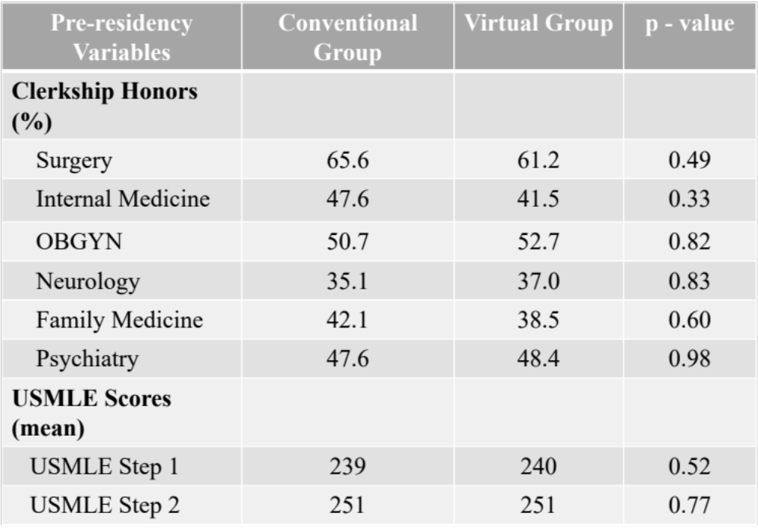
Table 1. Intergroup analysis of pre-residency variables showing no significant differences between groups at the baseline.
OBGYN = Obstetrics and Gynecology
USMLE =. United States Medical Licensing Examination

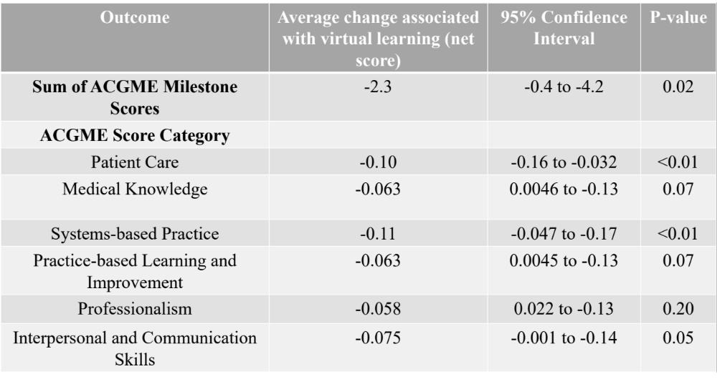
Table 2. compares the ACGME milestone scores between groups. Virtual learning was associated with statistically significant decrease in the sum of ACGME milestone scores. It was also associated with significant decrease in the ACGME competencies of patient care, systems-based practice, and interpersonal and communication skills.
ACGME = Accreditation Council of Graduate Medical Education

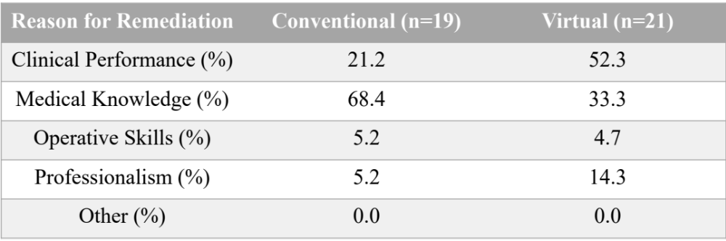
Table 3. Reasons for remediation for residents in the two groups.

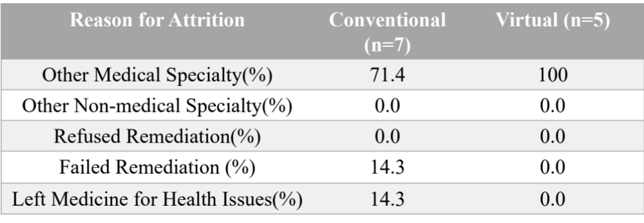
Table 4. Reasons for resident attrition in the two groups

