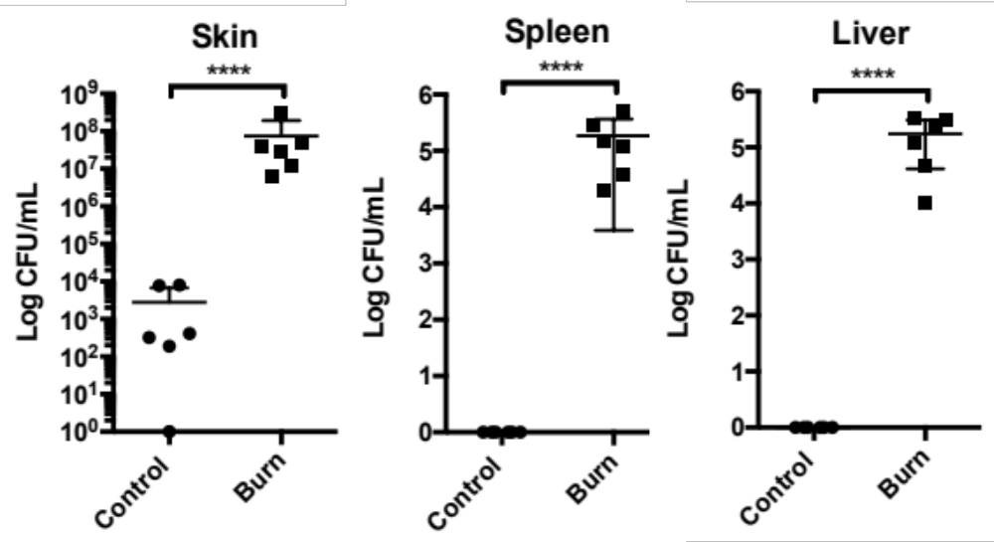

Supplemental Figure 1: Burned and controls mice infected with ΔodsAB exhibited reduced skin colonization compared to WT PAO1, along with impaired dissemination to both the spleen and liver. Statistical analyses were performed using a two-tailed Student’s t-test.

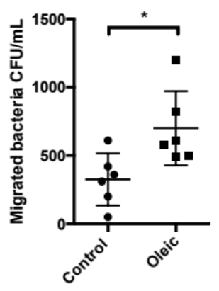

Supplemental Figure 2: An in vitro trans-well assay measuring the ability of an equal number of bacteria to cross a confluent monolayer of vascular endothelial cells in the presence or absence of oleic acid. Statistical analyses were performed using a two-tailed Student’s t-test.

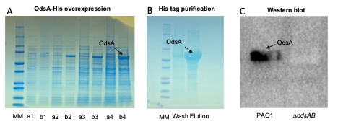

Supplemental Figure 3: Production of a mouse OdsA polyclonal antibody. A) OdsA tagged with histidine (His-tag) was cloned into the pet23a vector and subsequently overexpressed in E. coli strain BL21. Lane a represents the uninduced control, while lane b shows the IPTG-induced samples. Numbers represent hours post-induction B) OdsA-His was then purified using a His-trap column. C) A western blot analysis showed that serum obtained from mice infected with purified OdsA specifically recognized OdsA in the supernatant of PAO1 but not in the ΔodsAB strain.

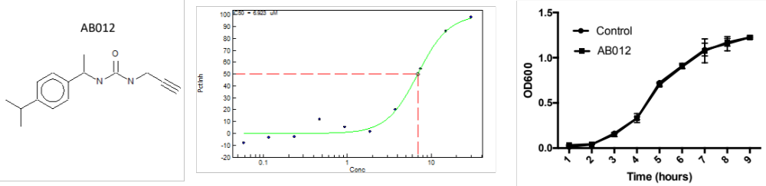

Supplemental Figure 4: Structure of AB012 compound and dose inhibition results. A) The chemical structure of the AB12 compound is illustrated. B) Graph depicting the dose inhibition results, where various concentrations of AB12 were tested for their inhibitory effects.

