Supplementary File

Supplementary I

APN Questionnaire
Q1 At which university / university of applied science do you study?
- Berner FH
- Kalaidos FH
- Ostschweizer FH
- Scuola universitaria professionale della Svizzera italiana (SUPSI)
- Universität Basel
- Université de Lausanne
- Zürcher Hochschule für Angewandte Wissenschaften (ZHAW)

Q2 What was the most important reason(s) for studying at this institution? (Multiple answers possible)
- There is a specialization offered in the degree program that interests me.
- I have already completed a degree program at this institution.
- The institution is close to where I live.
- Friend study at this institution.
- The institution has a good reputation.
- My preferred institution for study was not available.
- Others: __________________________________________________

Q3 What education did you previously complete? (Multiple answers possible)
- University (Bachelor)
- Fachhochschule (FH, Tertiär A)
- Höhere Fachschule (HF, Tertiär B)
- Education Abroad
- Specialization in nursing
- Other: __________________________________________________

Q4 Which major did you choose in your studies?
- Advanced Nursing Practice
- Research
- Clinical Nurse Specialist (CNS)
- Nurse Practitioner (NP)
- Psychiatric Mental Health Nurse Practitioner (PMHNP)
- Mental health
- Adult Health
- Peadriatric Care
- Primary Care
- I have not yet chosen a major
- There is no major in my degree program
- Other: __________________________________________________

Q5 In which semster are you currently?
- 1
- 2
- 3
- 4
- 5
- 6
- 7+

Q6 Please indicate which workplace/work environment you are currently considering. (Multiple answers possible)
- General practice
- Practice with specialization
- Spitex
- University/ Research
- Hospital
- Psychiatric clinic
- Nursing and retirement home
- Other: __________________________________________________

Q7 The following factors are important for my career choice: [Likert scale: fully agree, agree, neutral, disagree, do not agree at all]
- Duration of education
- Research opportunity
- Flexibility in location
- Reasonable working hours
- Career development
- Professional status
- Job satisfaction
- Close relationship with patients
- Community-based working
- Interprofessional cooperation
- Income potential
- Regulated billing rate
- Work-life balance
- Other

Q8 Which of the above (Q7) influencing factors do you think is the most important factor for your career choice?
- Duration of education
- Research opportunity
- Flexibility in location
- Reasonable working hours
- Career development
- Professional status
- Job satisfaction
- Close relationship with patients
- Community-based working
- Interprofessional cooperation
- Income potential
- Regulated billing rate
- Work-life balance
- Q7

Q9 Please briefly explain your attitude toward the option of working personally in primary care (e.g., general practice, specialty practice, Spitex).
- positiv: __________________________________________________
- negativ: __________________________________________________
- neutral: __________________________________________________

Q10 Who or what has positively or negatively influenced your attitude toward the option of working in primary care (e.g., general practice, specialty practice, Spitex)? [Likert scale: Very positive, Positive, Neither positive or negative, Negative, Very negative]
- Family doctor
- Doctors in hospital
- Other APNs
- Tutors in the university/ HS
- Offer of the Uni /HS
- Politics
- Current billing rate situation
- Media
- Other:

Q11 Do you think APNs will play a major role in primary care (e.g., general practice, specialty practice, Spitex) in the future?
- Yes
- No
- No opinion

Q12 In which country would you like to work after completing your education?
- Switzerland
- Germany
- Austria
- France
- Itlay
- Other foreign countries
- No answer

Q12 How old are you?
________________________________________________________________

Q13 Please specify your gender.
- male
- female
- non binary
- No answer

Q14 In which canton do you live?
- Aargau | - Genf | - Obwalden | - Uri
- Appenzell A.Rh. | - Glarus | - Sankt Gallen | - Waadt
- Appenzell I.Rh. | - Graubünden | - Schaffhausen | - Wallis
- Basel-Landschaft | - Jura | - Schwyz | - Zug
- Basel-Stadt | - Luzern | - Solothurn | - Zürich
- Bern | - Neuenburg | - Tessin | - Foreign Country
- Freiburg | - Nidwalden | - Thurgau

Supplementary II

Characteristics of surveyed APN students stratified by considering primary care as a workplace

Future Workplace: Primary Care | No | Yes | p-value | Overall
n | 66 | 112 |  | 178
Sex (%) |  |  | 0.352
Female | 56 (84.8) | 100 (89.3) |  | 156 (87.6)
Male | 9 (13.6) | 12 (10.7) |  | 21 (11.8)
Sex not specified | 1 (1.5) | 0 (0.0) |  | 1 (0.6)
Age (median [IQR]) | 31.00 [28.00, 36.00] | 30.00 [27.00, 35.00] | 0.212 | 31.00 [28.00, 35.00]
Age not specified (%) | 5 (7.6) | 4 (3.6) | 0.41 | 9 (5.1)
Country to work in future (%) |  |  | 0.254
Switzerland | 65 (98.5) | 108 (96.4) |  | 173 (97.2)
Not Switzerland | 1 (1.5) | 4 (3.6) |  | 5 (2.8)
Universities (%) |  |  | 0.001
University of Basel | 3 (4.5) | 5 (4.5) |  | 8 (4.5)
Bern University of Applied Sciences | 20 (30.3) | 51 (45.5) |  | 71 (39.9)
Kalaidos University of Applied Sciences | 4 (6.1) | 9 (8.0) |  | 13 (7.3)
University of Lausanne | 11 (16.7) | 3 (2.7) |  | 14 (7.9)
Eastern Swiss University of Applied Sciences | 2 (3.0) | 6 (5.4) |  | 8 (4.5)
Scuola universitaria professionale della Svizzera italiana (SUPSI) | 11 (16.7) | 4 (3.6) |  | 15 (8.4)
Zurich University of Applied Sciences (ZHAW) | 15 (22.7) | 34 (30.4) |  | 49 (27.5)
Semester (%) |  |  | 0.713
<4 | 32 (35.2) | 59 (64.8) |  | 91 (51.5)
>3 | 34 (51.5) | 53 (47.3) |  | 87 (48.9)
Chosen Major (%) |  |  | <0.001
Advanced practice nurse | 16 (24.2) | 9 (8.0) |  | 25 (14.0)
Clinical nurse specialist | 23 (34.8) | 24 (21.4) |  | 47 (26.4)
No Major | 11 (16.7) | 22 (19.6) |  | 33 (18.5)
Nurse practitioner | 4 (6.1) | 40 (35.7) |  | 44 (24.7)
Other | 5 (7.6) | 10 (8.9) |  | 15 (8.4)
Research | 7 (10.6) | 7 (6.2) |  | 14 (7.9)
Previous Education (%)
Bachelor (University of Applied Science) | 41 (62.1) | 95 (84.8) | 0.001 | 136 (76.4)
Bachelor (University) | 18 (27.3) | 11 (9.8) | 0.005 | 29 (16.3)
Federal Diploma (College of Higher Education) | 9 (13.6) | 17 (15.2) | 0.951 | 26 (14.6)
Specialization in Nursing | 15 (22.7) | 17 (15.2) | 0.287 | 32 (18.0)
Attitude toward working in primary care (%) |  |  | <0.001
negativ | 10 (16.1) | 1 (0.9) |  | 11 (6.5)
neutral | 16 (25.8) | 2 (1.9) |  | 18 (10.7)
positive | 36 (58.1) | 104 (97.2) |  | 140 (82.8)
Reason for the university (%)
Major = 1 (%) | 28 (42.4) | 72 (64.3) | 0.007 | 100 (56.2)
Near Home = 1 (%) | 36 (54.5) | 41 (36.6) | 0.03 | 77 (43.3)
Stayed at University= 1 (%) | 29 (43.9) | 46 (41.1) | 0.828 | 75 (42.1)
Reputation = 1 (%) | 17 (25.8) | 25 (22.3) | 0.735 | 42 (23.6)
Friends = 1 (%) | 10 (15.2) | 13 (11.6) | 0.653 | 23 (12.9)
Second Choice = 1 (%) | 1 (1.5) | 2 (1.8) | 1 | 3 (1.7)
NP_future (%) |  |  | 0.099
Yes | 62 (93.9) | 111 (99.1) |  | 173 (97.2)
No | 2 (3.0) | 1 (0.9) |  | 3 (1.7)
No opinion | 2 (3.0) | 0 (0.0) |  | 2 (1.1)
Place of residence (%) |  |  | 0.001
Aargau | 4 (6.1) | 12 (10.7) |  | 16 (9.0)
Abroad | 3 (4.5) | 1 (0.9) |  | 4 (2.2)
Appenzell A.Rh. | 0 (0.0) | 2 (1.8) |  | 2 (1.1)
Basel-Landschaft | 1 (1.5) | 1 (0.9) |  | 2 (1.1)
Basel-Stadt | 1 (1.5) | 4 (3.6) |  | 5 (2.8)
Bern | 10 (15.2) | 27 (24.1) |  | 37 (20.8)
Freiburg | 5 (7.6) | 0 (0.0) |  | 5 (2.8)
Genf | 1 (1.5) | 0 (0.0) |  | 1 (0.6)
Graubünden | 0 (0.0) | 6 (5.4) |  | 6 (3.4)
Luzern | 2 (3.0) | 10 (8.9) |  | 12 (6.7)
Neuenburg | 0 (0.0) | 1 (0.9) |  | 1 (0.6)
Niwalden | 1 (1.5) | 0 (0.0) |  | 1 (0.6)
Sankt Gallen | 3 (4.5) | 11 (9.8) |  | 14 (7.9)
Schwyz | 1 (1.5) | 2 (1.8) |  | 3 (1.7)
Solothurn | 1 (1.5) | 0 (0.0) |  | 1 (0.6)
Tessin | 9 (13.6) | 3 (2.7) |  | 12 (6.7)
Thurgau | 0 (0.0) | 1 (0.9) |  | 1 (0.6)
Waadt | 3 (4.5) | 0 (0.0) |  | 3 (1.7)
Wallis | 5 (7.6) | 3 (2.7) |  | 8 (4.5)
Zug | 1 (1.5) | 0 (0.0) |  | 1 (0.6)
Zurich | 15 (22.7) | 28 (25.0) |  | 43 (24.2)

Supplementary III

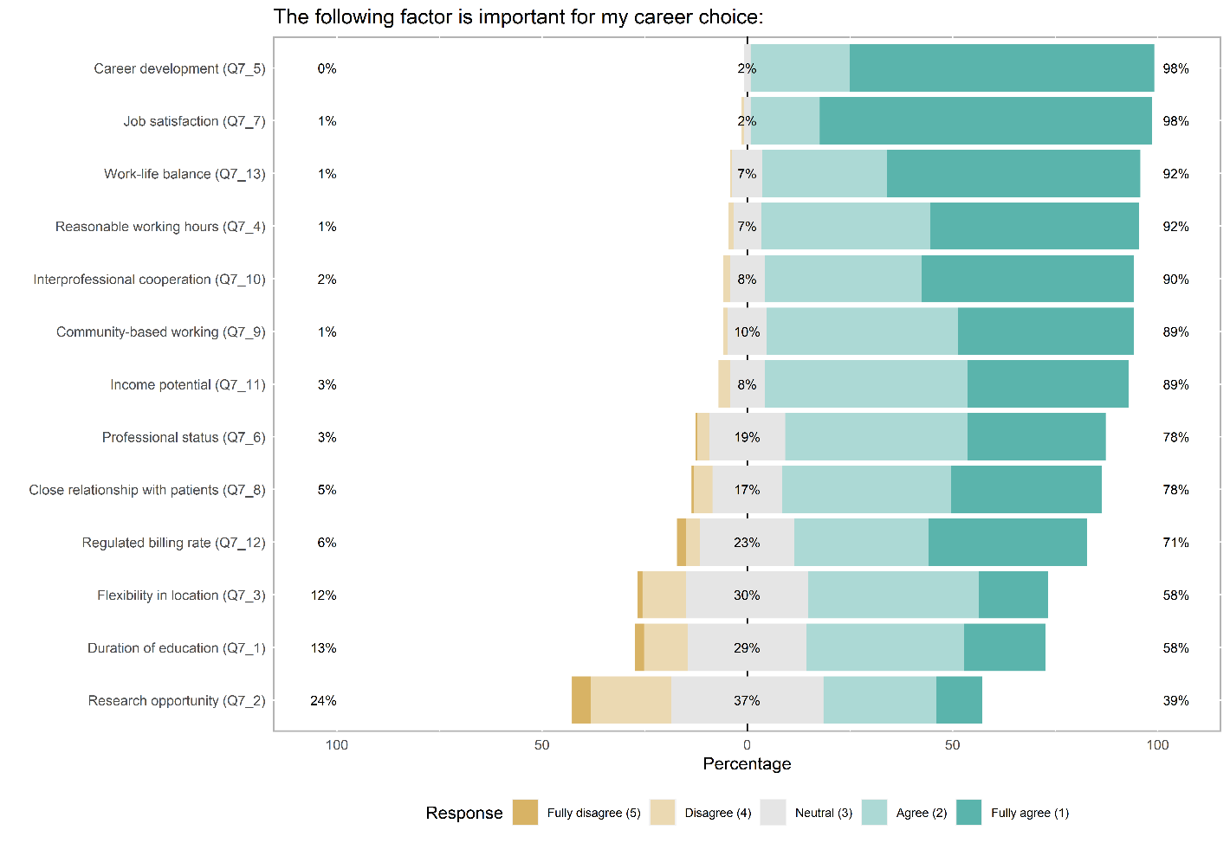
Figure 4: Overall: APN student ranking on important factors for their career choice (n=178)

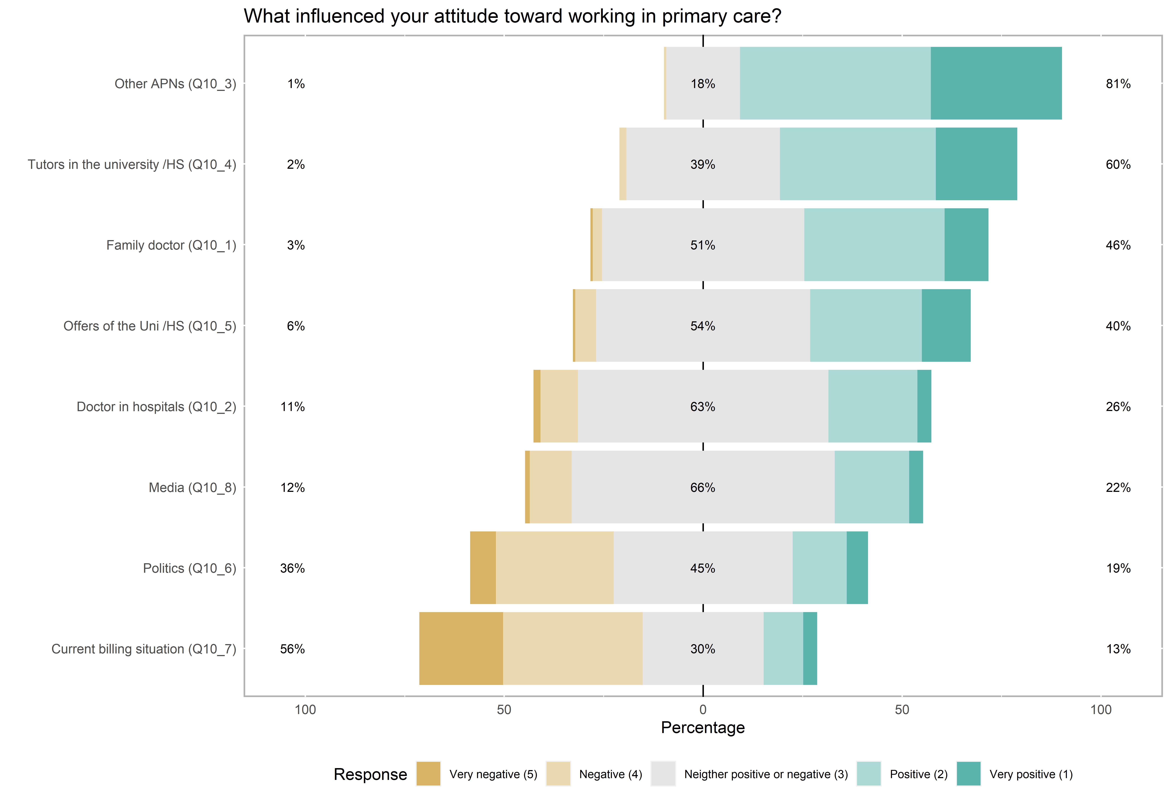

Figure 5: Overall: APN Student ranking on influencing factors on working in primary care (n=178)
Supplementary IV

Logistic regression:
Outcome: Consideration to work in primary care
Variable | OR | (95% CI) | Stat. sign.
Aged 22-28 | Ref
Aged 29-33 | 0.44 | (0.15,1.23)
Aged 34-58 | 0.54 | (0.16,1.72)
Female | Ref
not Female | 0.94 | (0.30,3.10)
Major: Advanced practice nurse / Clinical nurse specialist | Ref
No major | 2.46 | (0.70,9.09)
Major: Nurse practitioner /Primary Care | 15.46 | (3.80,94.96) | *
Major: Other/ PMHNP/ Research | 2.69 | (0.92,8.53)
Negative /Neutral | Ref
Positive | 28.67 | (8.44,137.69) | *
Semester <4 | Ref
Semester >3 | 1.17 | (0.47,2.91)
Other Universities | Ref
Bern University of Applied Sciences | 1.37 | (0.48,3.90)
Zurich University of Applied Sciences (ZHAW) | 1.36 | (0.42,4.40)

OR: odds ratio
95%CI: 95% confidence interval
Stat. sign.: statistically significant
Ref: reference=1

PMHNP | Psychiatric mental health Nurse practitioner
Other Universities | University of Basel, Kalaidos University of Applied Sciences,  University of Lausanne, Eastern Swiss University of Applied Sciences, Scuola universitaria professionale della Svizzera italiana (SUPSI)

Age distribution
Aged 22-28 | 57
Aged 29-33 | 58
Aged 34-58 | 54

Supplementary V

Q7 The following factors are important for my career choice:
Logistic regression:

Outcome: Consideration to work in primary care

Variable | OR | (95% CI) | Stat. sign.
Duration of education | 0.63 | (0.41,0.94) | *
Research opportunity | 0.55 | (0.37,0.81) | *
Flexibility in location | 0.88 | (0.57,1.35)
Reasonable working hours | 1.57 | (0.79,3.21)
Career development | 0.76 | (0.32,1.77)
Professional status | 1.08 | (0.66,1.74)
Job satisfaction | 0.76 | (0.31,1.80)
Close relationship with patients | 1.14 | (0.72,1.82)
Community-based working | 1.95 | (1.05,3.77) | *
Interprofessional cooperation | 0.74 | (0.41,1.31)
Income potential | 0.78 | (0.42,1.39)
Regulated billing rate | 1.72 | (1.15,2.66) | *
Work-life balance | 1.06 | (0.51,2.17)

OR: odds ratio
95%CI: 95% confidence interval
Stat. sign.: statistically significant

Supplementary VI

Q10 Who or what has positively or negatively influenced your attitude toward the option of working in primary care?
Logistic regression:

Outcome: Consideration to work in primary care

Variable | OR | (95% CI) | Stat. sign.
Family_doctor | 1.02 | (0.63,1.68)
Doctor_in_hospitals | 0.92 | (0.55,1.53)
Other_APNs | 1.41 | (0.86,2.32)
Tutors_in_the_university/HS | 1.31 | (0.78,2.22)
Offers_of_the_Uni/HS | 0.90 | (0.54,1.48)
Politics | 1.07 | (0.67,1.73)
Current_billing_situation | 0.82 | (0.55,1.22)
Media | 2.30 | (1.25,4.48) | *

OR: odds ratio
95%CI: 95% confidence interval
Stat. sign.: statistically significant

Supplementary VII

Q9 Please briefly explain your attitude toward the option of working personally in primary care (e.g., general practice, specialty practice, Spitex).
Categories of free test answers
Positive
Category | Amount
Strengthening primary care | 26
Working autonomously | 25
Working with patients | 25
Holistic approach | 24
Profession with future | 19
Interprofessional work | 16
Regulated working hours | 15
Using competencies | 14
APN Role Strengths | 13
Diversity | 11
Development potential | 11
Variety | 11
Active in primary care | 9
Meaningful | 6
Responsibility | 6
Interesting | 5
Care of chronic diseases | 4
Potential for improvement | 4
Relief | 4
Exchange | 3
Increase quality of care | 3
Strengthening prevention | 3
The challenge | 3
Appreciation | 2
Flexible | 2
Innovative care | 2
Lean structures | 2
Billing Rate | 1
Evidence-based work | 1
Generalized work | 1
Improving quality of life | 1
Job satisfaction | 1

Negative
Category | Amount
Other setting preferred | 3
No patient contact preferred | 2
No jobs | 1
No development opportunities | 1
No legal regulation | 1
Poor image | 1
Billing problems | 1
No specialization in studies | 1
Role too undefined | 1

Neutral
Category | Amount
No outpatient experience | 6
Future opportunity, but later in career | 4
Other focus | 3
Other needs | 1
No regional option | 1
Delegation from doctor | 1
Interesting | 1
No appreciation | 1
Active in primary care | 1
Above competencies | 1

