Supplemental section A: Binning ancient MAGs
The Metagenome Assembled Genome (MAG) contig bins were aimed to be collected with sensitive settings since false positives could be filtered out downstream during MAG refinement, whereas false negatives would be irrevocably lost. The “completion” and “redundancy” in the bin was ascertained as described in Table 3 by the percentage complete set of and redundant copies of single-copy core genes (SCG), which had been compiled by Anv’io for prokaryotes from the GTDB database¹.
During manual refinement, contigs that stand out are identified as contaminant and removed, until “redundancy” is minimised at minimum detriment to the “completion” score and so the total length of sequences in the contigs and GC content align with the taxa being recovered (Additional File 4)².
“non-redundant” contaminant contigs that only have genes that convey a non-critical function can still be deemed present after manual refinement, if there is an abnormal amount of genes called in the MAG, relative to the normal span of genes found in the taxa being recovered. This contamination is detected using GUNC, which assigns each detected gene in the contigs to a taxonomic lineage. How well genes fit with those in the database is quantified by the Reference Representation Score (RRS).
Provided there is a high RRS (>0.5), it is possible to quantify the chimerism of contigs by the Cluster Separation Score (CSS), which is the diversity of taxonomic lineages of genes in a contig, compared with the diversity of lineages across the MAG overall. If this score is at all taxonomic levels from kingdom to genus <=0.45, and the genes assigned to other taxonomic clades than the major clade is <0.02, a MAG will pass the GUNC filter (Table 2)³.
Otherwise, contigs detected as having heightened chimerism are removed as “non-redundant” contamination, until the filter is passed (See Figure SA1).

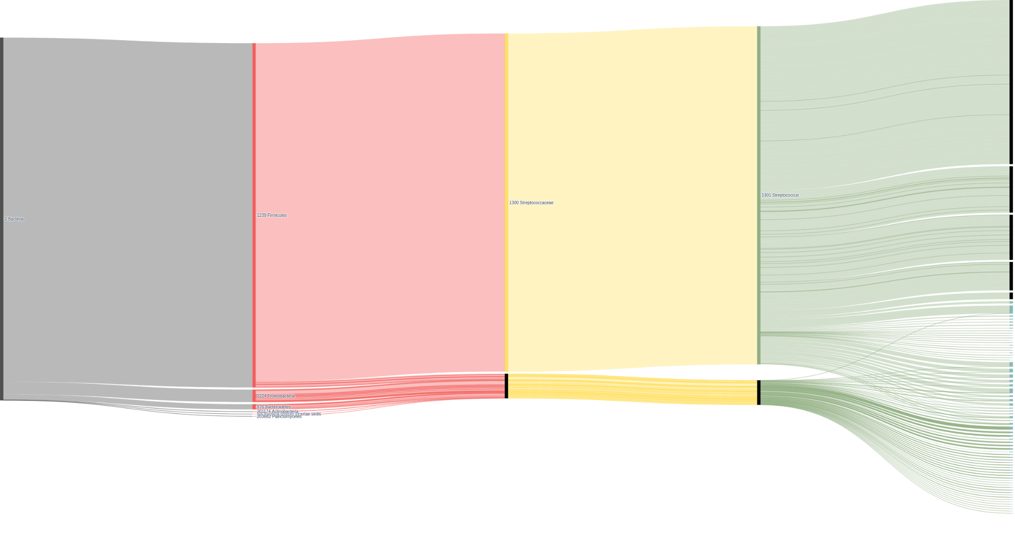Figure SA1: A visualization of the GUNC output for NEO105 created by the “gunc plot” function³, which shows how the genes are assigned to taxonomic lineages down to genus level, where some assigned to different genera end up being assigned to the same contigs.
Since we do not know fully what there is to know about all the genes that exist in biology, it is impossible to be completely sure, when you have the perfect MAG. Refining a comprehensive bin down the final assembly of contigs is a balancing act between minimising the amount of false positives, without increasing false negatives.

- Chen, L. X., Anantharaman, K., Shaiber, A., Murat Eren, A., & Banfield, J. F. (2020). Accurate and complete genomes from metagenomes. Genome Research, 30(3), 315–333. https://doi.org/10.1101/GR.258640.119/-/DC1
- Parks, D. H., Imelfort, M., Skennerton, C. T., Hugenholtz, P., & Tyson, G. W. (2015). CheckM: assessing the quality of microbial genomes recovered from isolates, single cells, and metagenomes. Genome Research, 25(7), 1043–1055. https://doi.org/10.1101/GR.186072.114
- Orakov, A., Fullam, A., Coelho, L. P., Khedkar, S., Szklarczyk, D., Mende, D. R., Schmidt, T. S. B., & Bork, P. (2021). GUNC: detection of chimerism and contamination in prokaryotic genomes. Genome Biology, 22(1), 1–19. https://doi.org/10.1186/S13059-021-02393-0/FIGURES/3

Supplemental Section B: Molecular dating of S mutans

Working with ancient Streptococcus presents two challenges in finding a molecular clock:
- Streptococcus species exchange DNA through horizontal transfer, which artificially inflates the rate of substitutions in some regions of the genome, as a result of homologous recombination.
- aDNA is short and damaged, and is only recovered from metagenomic samples, which can have many different strains of the same organism present in a sample. Which can lead to a detection of false positive substitutions.
To deal with the first issue, we used the recombination-corrected tree obtained from Gubbins. To deal with the second issue, this tree only included ancient samples that had a high depth of coverage, which would smooth over the random accumulation of sequencing errors. We also only chose samples with a low multi-allele rate in genotype calls, to ensure that the S. mutans reads were not from a chimeric mix of different strains.
As a baseline model in Figure SB1, we rerooted the phylogenetic tree by maximising the root-to-tip correlation with the known sample dates, and estimated an evolutionary rate and root-date through a linear regression analysis. This gave an R2 value of 0.54 and a Most-Recent-Common-Ancestor estimate approximately the same as our oldest sample included. With this approach NEO137 is placed near the root, which is inconsistent with the phylogenetic results in this and previous studies¹.
We calculated a molecular clock model through Bayesian statistics using Bactdating ², which gave us a proposed root date magnitudes higher than our baseline model around 70.000B.C. As can be seen in the trace plots in Figure SB2, the model was unable to converge to neither a stable root-branch, nor a clock-rate nor a root date.
To evaluate whether the temporal signal was stronger at a smaller evolutionary scale, we reran the analysis on an individual clade of the phylogenetic tree. We chose the clade assigned to chromopainter cluster D, as it included among 38 samples, 3 of our 4 ancient samples. As with the whole phylogeny, we recomputed both the linear regression and bayesian statistical models for a molecular clock, the results of which are summarised in Table 1 and 2.
The large disparity in root estimates between model types, and its similarity between the whole tree and the subtree, lead us to believe that we could not find a robust temporal signal. We suspect that the primary reason it is difficult to establish a molecular clock for S. mutans is because of the high rate of recombination³.

Tree: | Root date: | Clock rate: | R2: | p-value:
Gubbins tree | 5683B.C. | 1.04 | 0.54 | 0.0002
Chromopainter cluster D | 5668B.C. | 0.92 | 0.92 | 0.0184
Table SB1: Comparison of molecular clock estimates using root-to-tip correlation rooting and linear regression analysis for the whole phylogenetic tree and the Chromopainter cluster C subtree. Both models have similar root dates and clock rates, as well as good p-values and R2 values.

Tree: | Root branch probability: | Root date: | Clock rate: | DIC: | DIC (control):
Gubbins tree | 0.46 | -61181.64 [-72869.59;-46400.56] | 7.26e-02 [6.08e-02;9.35e-02] | 6475.30 | 6463.60
Chromopainter cluster D | 0.72 | -70920.24 [-77698.55;-64343.03] | 5.50e-02 [4.98e-02;6.08e-02] | 1010.14 | 974.51
Table SB2: Comparison of molecular clock and root time estimates using Bactdating for the whole phylogenetic tree and the chromopainter cluster C subtree. The control model is defined as the same tree with tip-dates all set to 2022. Both models find a similar root date, but the subtree model has better confidence intervals regarding clock rate and root date as well as a better root branch probability. Deviance Information Criterion estimates for both models show that neither outperform compared with a control
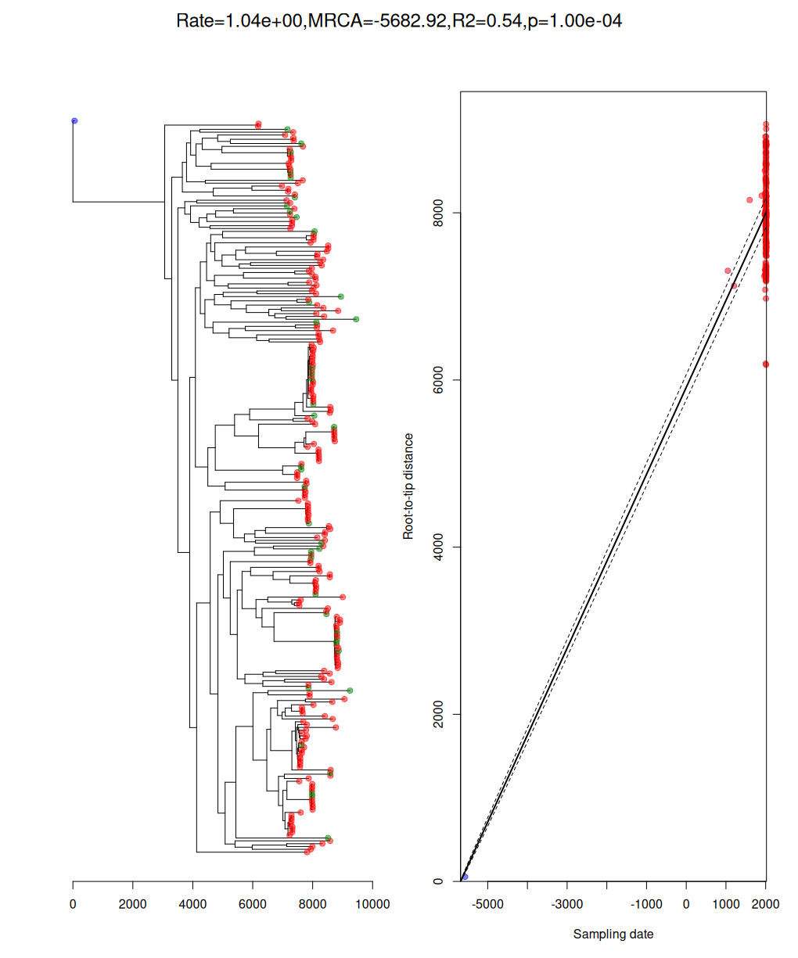
Figure SB1: root-to-tip linear regression analysis of the phylogenetic tree created by Gubbins after rerooting to maximise root-to-tip correlation. Here, the oldest ancient sample NEO137 was redefined as basal to all other S. mutans. The tips are colored based on their age using a red-blue color scale, whereas the tips where we do not have sample dates are colored green. The p-value is calculated through 10000 permutation tests

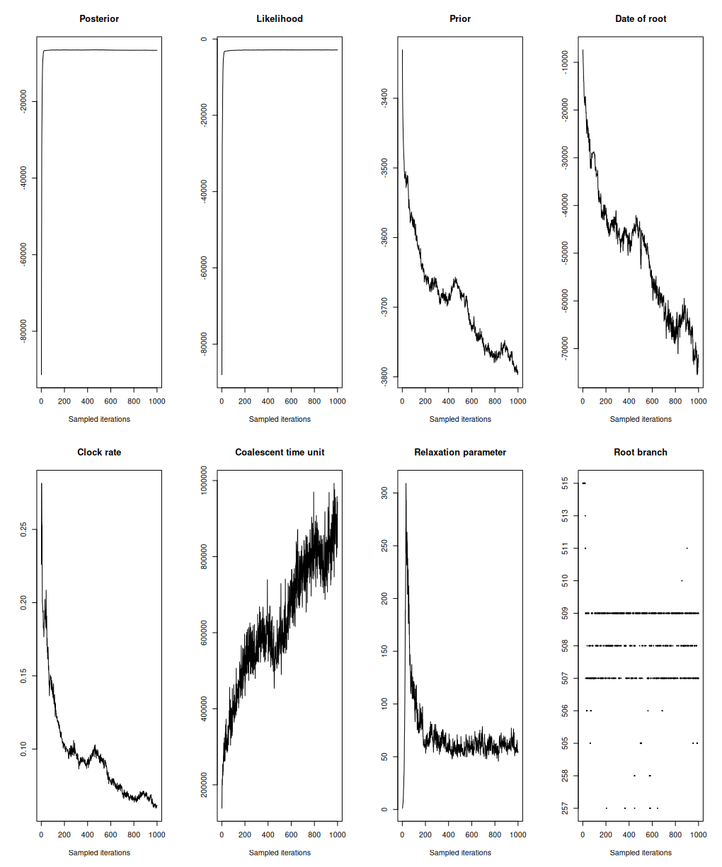
Figure SB2: Trace plots for Bactdate model parameters through 1000 samples of the 10.000 iterations of Markov-Chain Monte Carlo random sampling on the posterior distribution for the clock model using the recombination corrected phylogenetic tree computed through Gubbins. Several metrics do not converge on a stable value throughout the sampled iterations.

References:
- Cornejo OE, Lefébure T, Bitar PD, Lang P, Richards VP, Eilertson K, Do T, Beighton D, Zeng L, Ahn SJ, Burne RA, Siepel A, Bustamante CD, Stanhope MJ. Evolutionary and population genomics of the cavity causing bacteria Streptococcus mutans. Mol Biol Evol. 2013 Apr;30(4):881-93
- Didelot et al (2018). Bayesian inference of ancestral dates on bacterial phylogenetic trees. Nucleic Acids Research, 46:e134.
- Lee, I.P.A., Andam, C.P. Frequencies and characteristics of genome-wide recombination in Streptococcus agalactiae, Streptococcus pyogenes, and Streptococcus suis. Sci Rep 12, 1515 (2022). https://doi.org/10.1038/s41598-022-04995-5

Supplemental Section C: Bootstrapping
For checking the statistical support for the branches in our phylogenetic trees, we used the standard Felsenstein bootstrap metric offered by Raxml-ng (See Figure S4)¹.
Bootstrapping is based on resampling with replacement from the loci included in the Multiple Sequence Alignment to check for sampling variance. Since we are computing our tree on a genome wide core genome defined by 500k bp out of a genome of 1.8m bp, bootstrapping branch support is more likely to warn us about the presence of low quality samples, rather than the biological validity of our Multiple Sequence Alignment (MSA)^{1,2}.
An alternative way to validate our tree is to quantify genealogical concordance through site Concordance Factor (sCF), which quantifies how many decisive loci agree with a branch in a tree³. We calculated this using IQTree2 on our final phylogenetic tree which used the Gubbins-masked MSA:
“iqtree -te strep_mutans_asm5_4.GCF_009738105.1_ASM973810v1.raxml.bestTree -s strep_mutans_asm5_4.GCF_009738105.1_ASM973810v1.masked.aln --scfl 100 --prefix strep_mutans_asm5_4 -T AUTO”
IQtree built a tree based on the “TVM+F+I+R5” substitution model using our final RaxML-ng tree (“GTR+G” substitution model) as a starting tree and computed sCF values for each non-terminal branch in the tree.
In Figure SC1 for the shallow branches of the IQ-Tree, the sCF is either ≃100% or >33%. Since sCF is calculated by sampling quartets from internal nodes, this means that only three alternative models are tested for the decisive loci. In the case where there is no consensus between the loci, we would expect an sCF ≃33%. When the sCF is below that, the likelihood favors a different branch split than the one in the tree⁴. Since we get high bootstrap values at the same branches, they must be statistically consistent across our resampled MSA, but the actual site-level signal for it is weak or highly conflicted. This could indicate that at the variable sites which define these branches, there is still a significant level of recombination, which had not been adequately masked by 20 iterations of the Gubbins algorithm on the original MSA³.
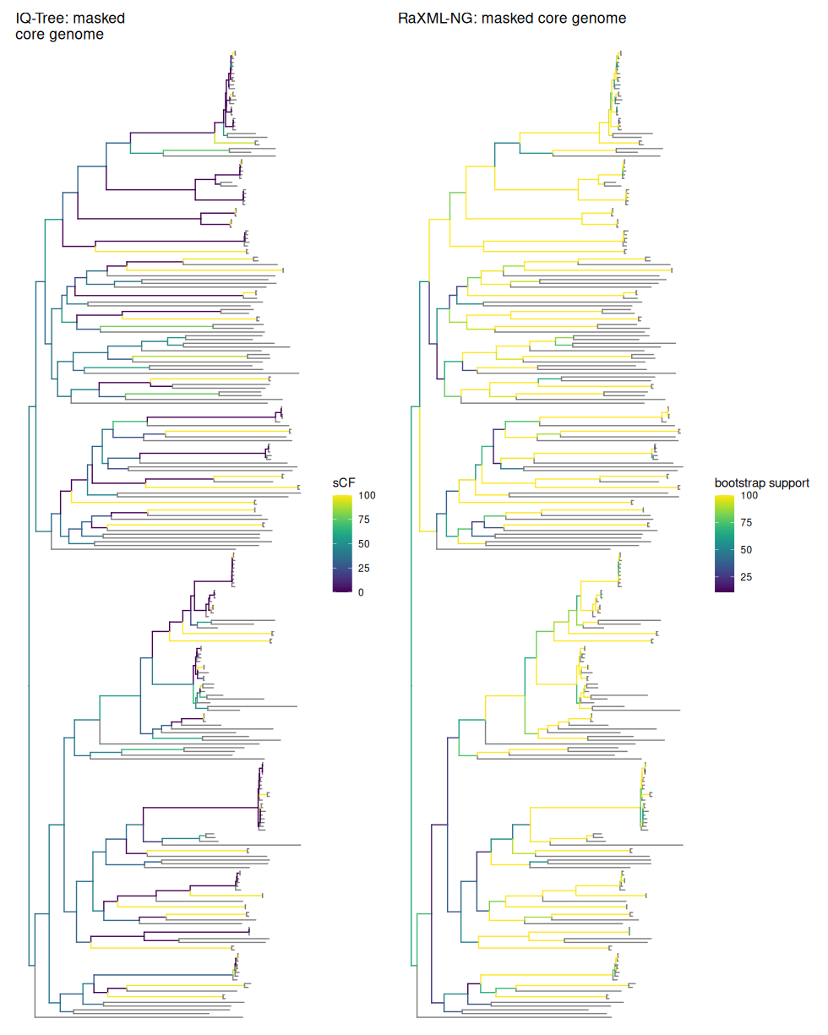
Figure SC1: Comparison of phylogenetic tree computed on the Gubbins masked MSA for S. mutans using IQ-tree and RaxML-NG where we have done midpoint rooting of both trees. IQ-tree computes sCF values for each branch, most of the values of which for the deep clades lie between 50 and 75, with higher or lower values in the end. This is in contrast to the bootstrap values for our final tree as computed by RaXML-NG, where there is generally lower support, the deeper you go in the tree.

References:
- Paul Zaharias, Frédéric Lemoine, Olivier Gascuel, Robustness of Felsenstein’s Versus Transfer Bootstrap Supports With Respect to Taxon Sampling, Systematic Biology, Volume 72, Issue 6, November 2023, Pages 1280–1295, https://doi.org/10.1093/sysbio/syad052
- Robert Lanfear, Matthew W Hahn, The Meaning and Measure of Concordance Factors in Phylogenomics, Molecular Biology and Evolution, Volume 41, Issue 11, November 2024, msae214, https://doi.org/10.1093/molbev/msae214
- Bui Quang Minh, Matthew W Hahn, Robert Lanfear, New Methods to Calculate Concordance Factors for Phylogenomic Datasets, Molecular Biology and Evolution, Volume 37, Issue 9, September 2020, Pages 2727–2733, https://doi.org/10.1093/molbev/msaa106
- Yu K Mo, Robert Lanfear, Matthew W Hahn, Bui Quang Minh, Updated site concordance factors minimize effects of homoplasy and taxon sampling, Bioinformatics, Volume 39, Issue 1, January 2023, btac741, https://doi.org/10.1093/bioinformatics/btac741

Supplemental Section D: CGG101233

As can be seen from Table 1, we got a remarkable coverage for S. mutans for CGG101233, which is unprecedented in ancient paleomicrobiology. Although the metaDMG Z-score authenticates it as ancient, it has remarkably well preserved reads, which is why we could assemble it from only 26 contigs.
It is well-known from the literature that Streptococcus mutans is strongly associated with cavitated lesions predominantly in dentin¹. The reason for that is that S. mutans possess the virulence factors needed to thrive in the acidic and anaerobic environment of the deep caries lesion^{2,3}.
Hence, the most obvious reason for the finding of a hitherto unprecedented coverage of S. mutans in the present ancient tooth is that this most likely was affected by a deep caries lesion, wherein the bacteria was entombed and preserved. Although the root of CGG101233 was destroyed during sampling (See Archaeological Information for CGG105519), we still had access to the crown of the tooth (See Figure SD1). From the top of the crown, it can be seen that one of the occlusal fissures is more dark and rough in texture (yellow arrow), as compared to the other fissure, which appears more smooth and lighter in color. These findings suggest presence of a caries lesion corresponding to the dark fissure, which would be an excellent habitat for S. mutans.
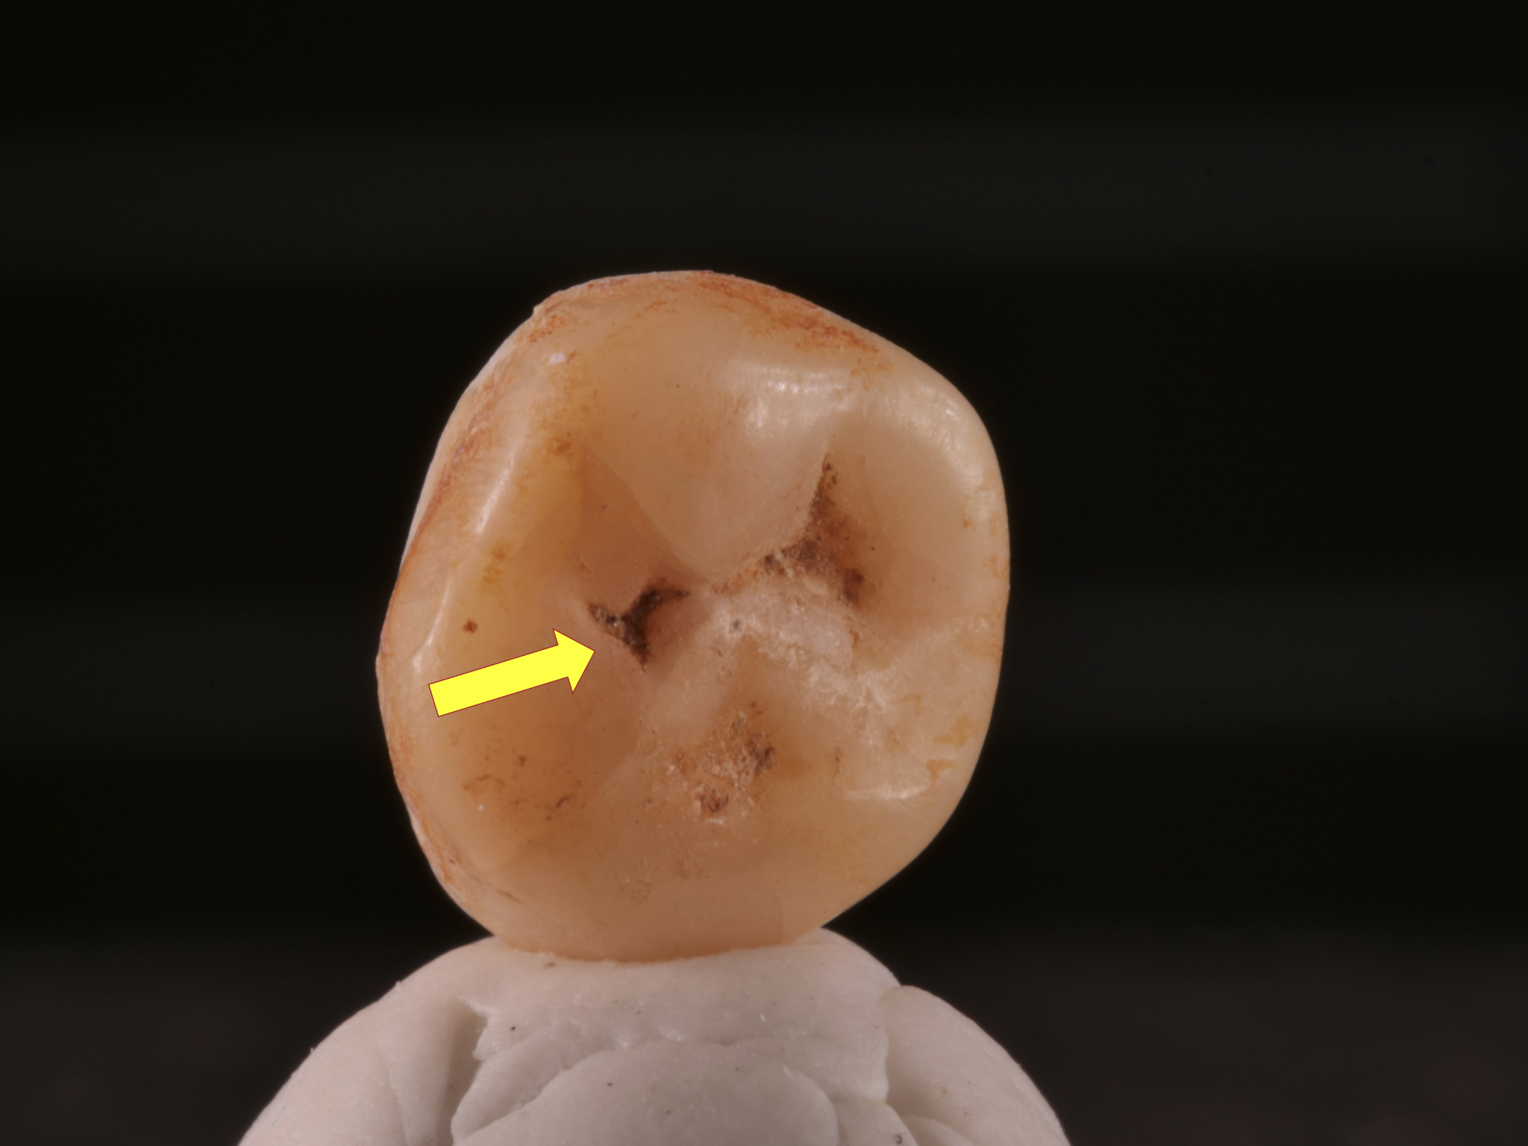
Figure SD1: Crown of the tooth for CGG101233 with yellow arrow pointing towards evidence of caries lesion
It is known from the literature that S. mutans is known to be able to invade dentin tubules^{4,5}, and subsequently the pulp, which would be a possible explanation for our findings of a high S. mutans coverage, despite that the actual caries lesion was not part of the material sampled.
References:
- Loesche WJ. Role of Streptococcus mutans in human dental decay. Microbiol Rev. 1986 Dec;50(4):353-80.
- Krzyściak W, Jurczak A, Kościelniak D, Bystrowska B, Skalniak A. The virulence of Streptococcus mutans and the ability to form biofilms. Eur J Clin Microbiol Infect Dis. 2014 Apr;33(4):499-515.
- Lemos JA, Palmer SR, Zeng L, Wen ZT, Kajfasz JK, Freires IA, Abranches J, Brady LJ. The Biology of Streptococcus mutans. Microbiol Spectr. 2019 Jan;7(1):10.1128/microbiolspec.gpp3-0051-2018.
- Aas JA, Griffen AL, Dardis SR, Lee AM, Olsen I, Dewhirst FE, Leys EJ, Paster BJ. Bacteria of dental caries in primary and permanent teeth in children and young adults. J Clin Microbiol. 2008 Apr;46(4):1407-17.
- Kouchi Y, Ninomiya J, Yasuda H, Fukui K, Moriyama T, Okamoto H. Location of Streptococcus mutans in the dentinal tubules of open infected root canals. J Dent Res. 1980 Dec;59(12):2038-46.

Supplemental Figures:
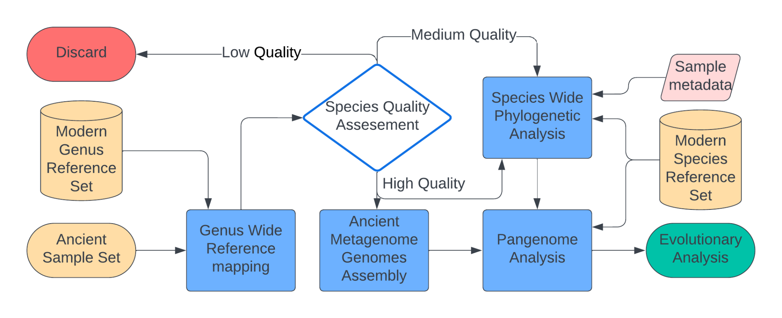

Figure S1. Conceptualization of the study workflow.
Each ancient sample available is mapped to reference species from a given genus being studied. From comparing mapping statistics between reference species, the quality of the sample regarding the species of interest in particular is evaluated. If a sample is of low quality, it is discarded. If it is of high quality, it will be analyzed if a MAG can be constructed, which can inform a pangenomic analysis comparing ancient and modern isolates. High quality samples are also used to create a phylogenetic tree, into which medium quality samples are placed. In the end an evolutionary analysis is conducted from the pangenomic and phylogenetic analysis, which in this study is described for S. mutans.

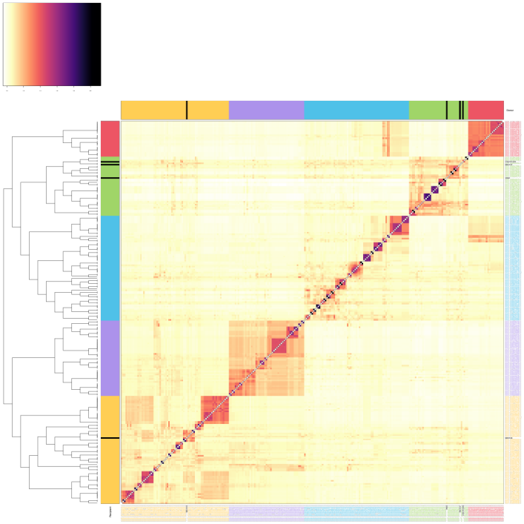

Figure S2. Haplotype chunk sharing matrix. Heatmap showing average haplotype chunk sharing rates (indicated by cell color) between donor (columns) and recipient (rows) genomes. Row dendrogram shows inferred fineSTRUCTURE clustering hierarchy for recipient genomes. Side bar and label colours indicate the five high level fineSTRUCTURE clusters (ancient S. mutans genomes highlighted in black).
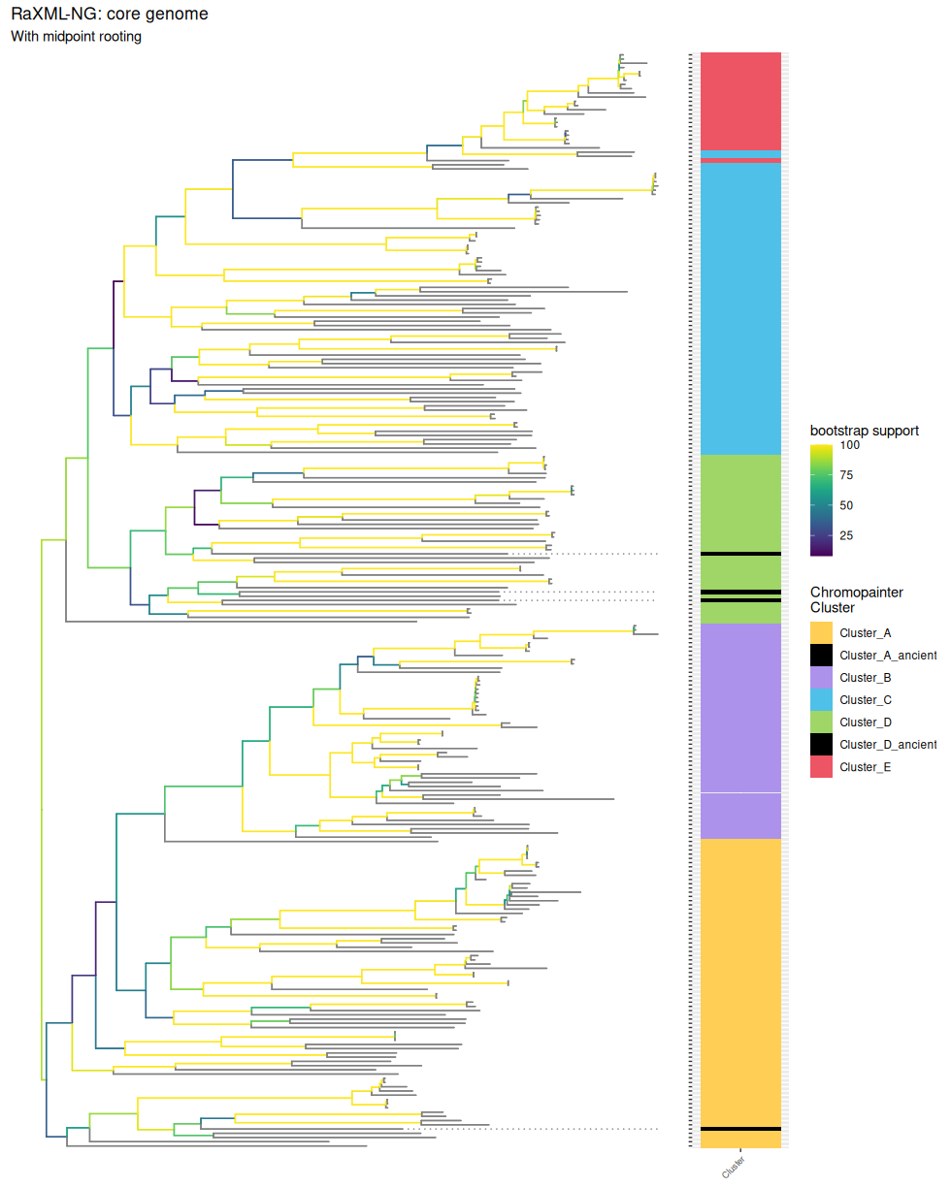

Figure S3. Phylogenetic tree created using RAXml-NG with 200 bootstraps and midpoint rooting based on the shared core genome between modern isolates and high-quality ancient samples. There is an agreement between phylogenetic topology and fineSTRUCTURE clusters, but low bootstrap support for the deep clusters.
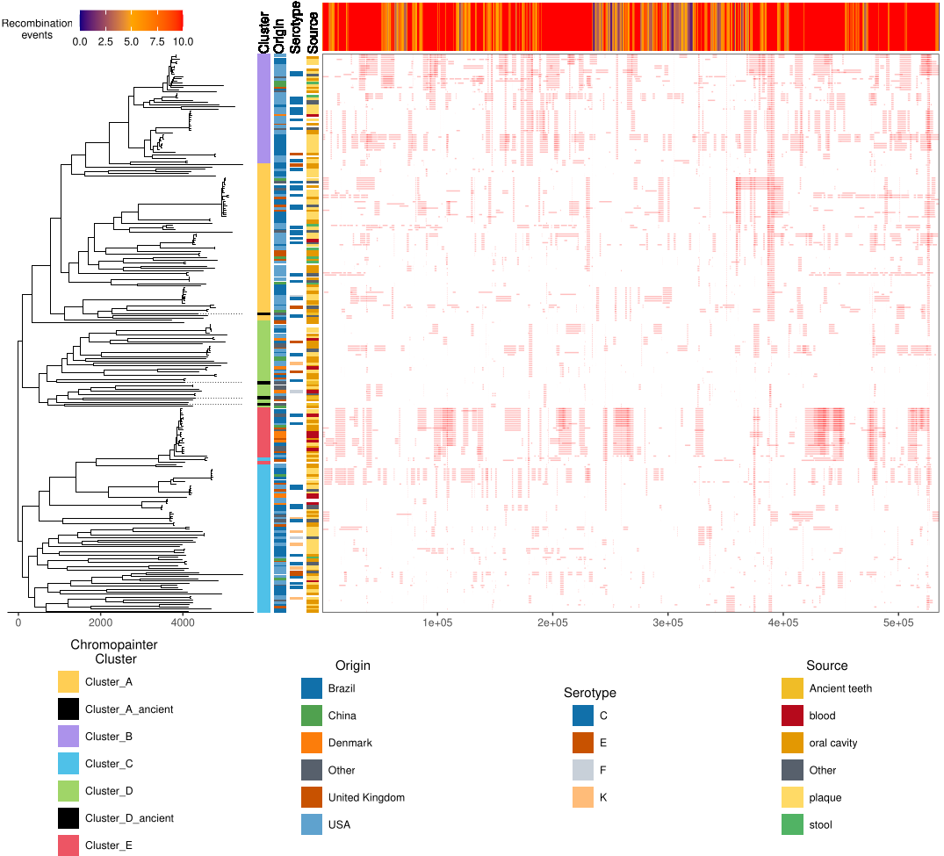

Figure S4. Phylogenetic tree for the modern isolates and high-quality ancient samples using Gubbins, with a heatmap of recombination across the shared core genome. Chromopainter cluster, Sampling sourcing metadata and serotype is added in columns between the tree and the heatmap.The ancient samples are highlighted with dotted lines in the phylogenetic tree. There is a connection between phylogeny and patterns of recombination, but not with any of the metadata associated with the samples. The overall rate of recombination to mutation was estimated ~25%.
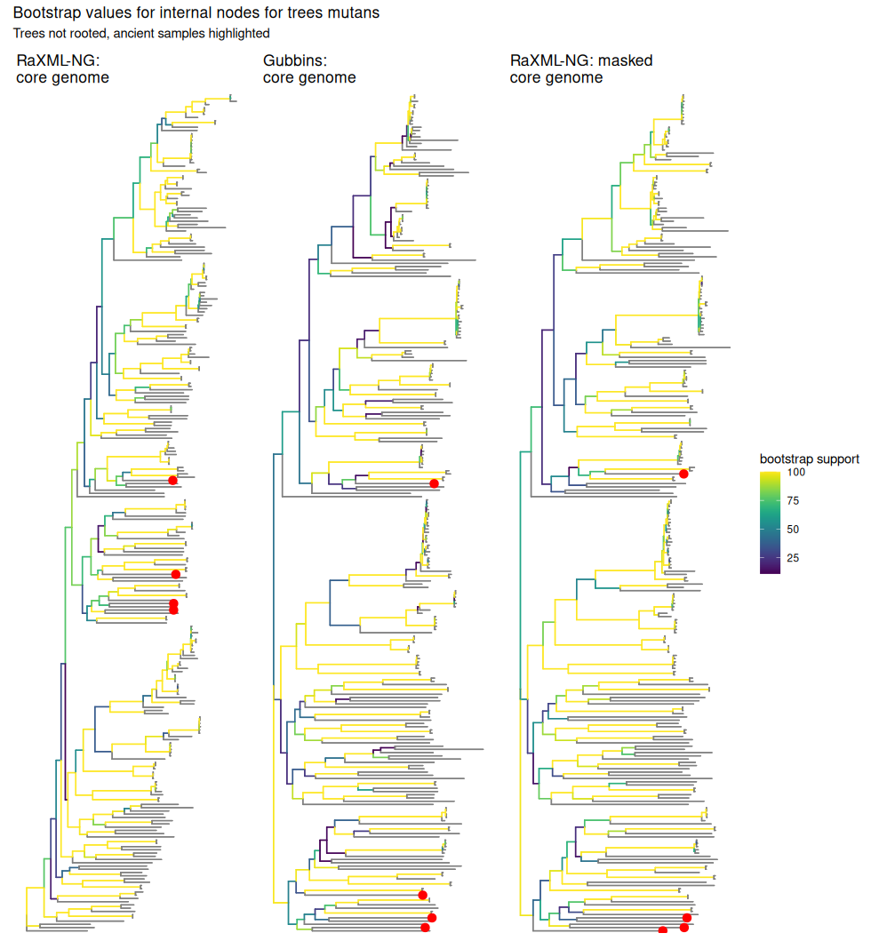

Figure S5. Comparison between the three phylogenetic tree methods used in this study evaluated by bootstrap support. The gubbins tree used the RaXML-NG core genome final tree as a starting tree, while the second RaXML-NG tree used the masked core genome from gubbins as input instead of the shared core genome-wide

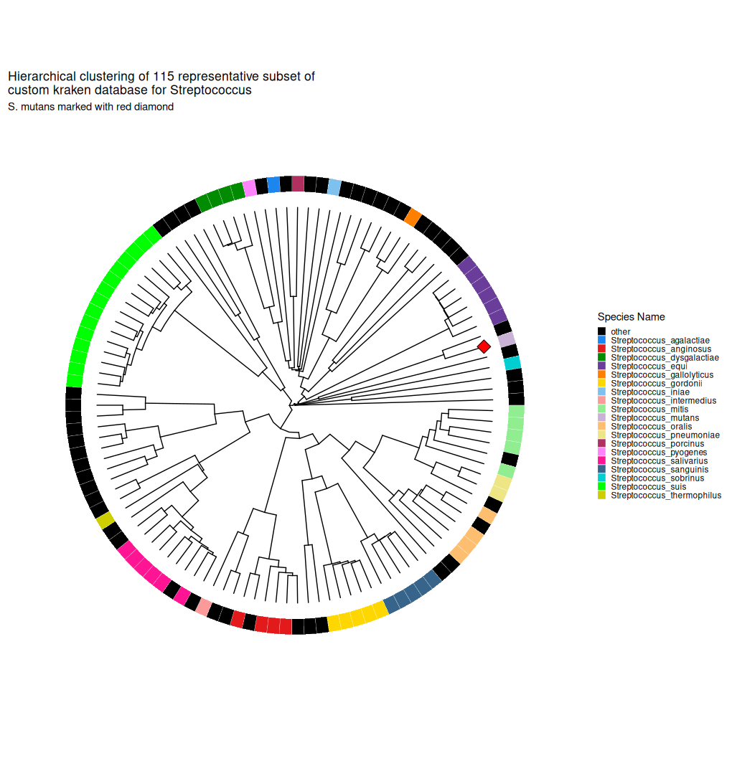

Figure S6. Neighbour-joining tree of representative species genomes of the genus Streptococcus, inferred using pairwise distance matrix obtained from fastANI. The S. mutans reference genome used in this study is marked by a red diamond.

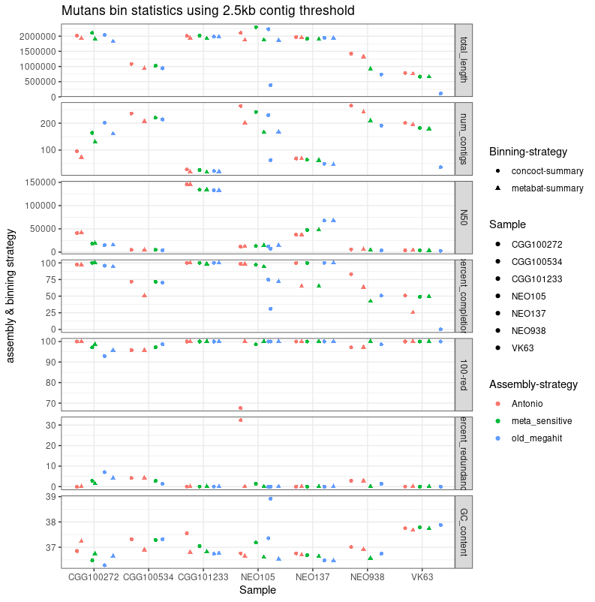

Figure S7. Assembly statistics for the 7 MAGs created in this study comparing the performance of different assembly strategies with a 2.5kb contig cutoff.
total_length: length of all contigs in MAG ( the length of S. mutans reference GCF_009738105.1 is 2.08mb).
num_contigs: number of contigs in MAG.
N50: Sequence length of the shortest contig at 50% of the total assembly length.
percent_completion: completion of the MAG calculated by the number of single-copy core genes associated with the domain the MAG belongs to. A completion of 80% is the usual threshold for a MAG to be complete.
100-red: 100 – percentage redundancy, where redundancy is quantified by single-copy core genes which are found to have more than one copy.
percent_redundancy: see above.
GC_content: The amount of bases in the MAG that are either Guanine or Cytosine.
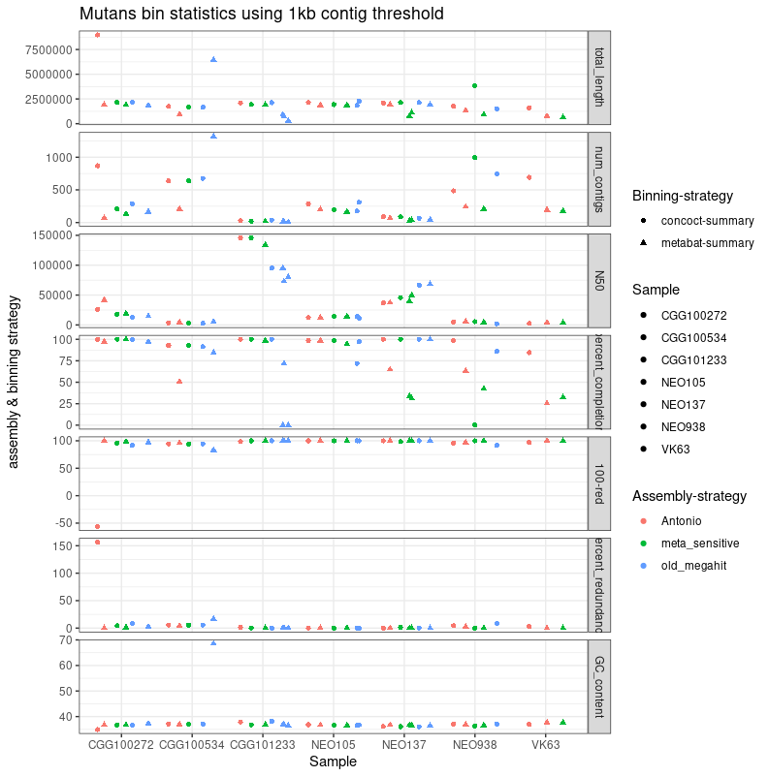

Figure S8. Assembly statistics for the 7 MAGs created in this study comparing the performance of different assembly strategies as in Figure S7 changed to have a 1kb contig cutoff.
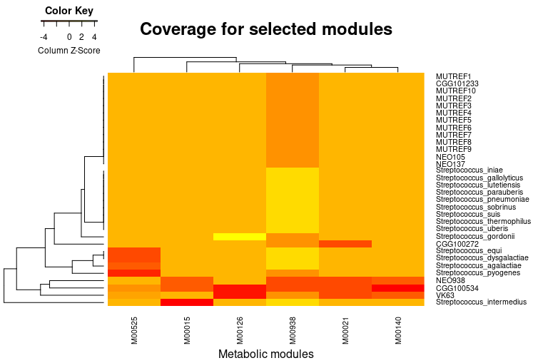

Figure S9. Pangenomic analysis of the seven S. mutans MAGs, 10 modern S. mutans isolates, and 15 modern isolates from across the Streptococcus genus. Focusing on gene cluster coverage against metabolic modules from KEGG, there were 6 modules which differed in gene cluster recruitment between the genomes. As is visualized in the figure, 4 of the MAGs differ from the modern S. mutans, which coincidently are the lowest quality MAGs assembled in this study.
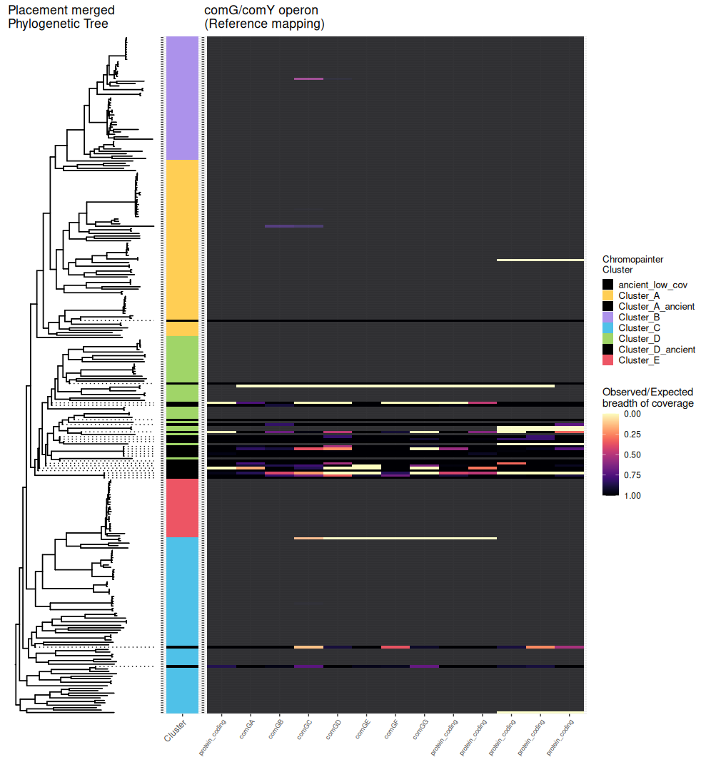

Figure S10: The comG/comY operon conveys competency for internalizing DNA from the surrounding environment (See Figure S4)⁶⁴. Reference mapping shows drops in coverage among ancient samples along the region expressing genes in this operon, which suggests that this operon could have looked very different in ancient S. mutans.
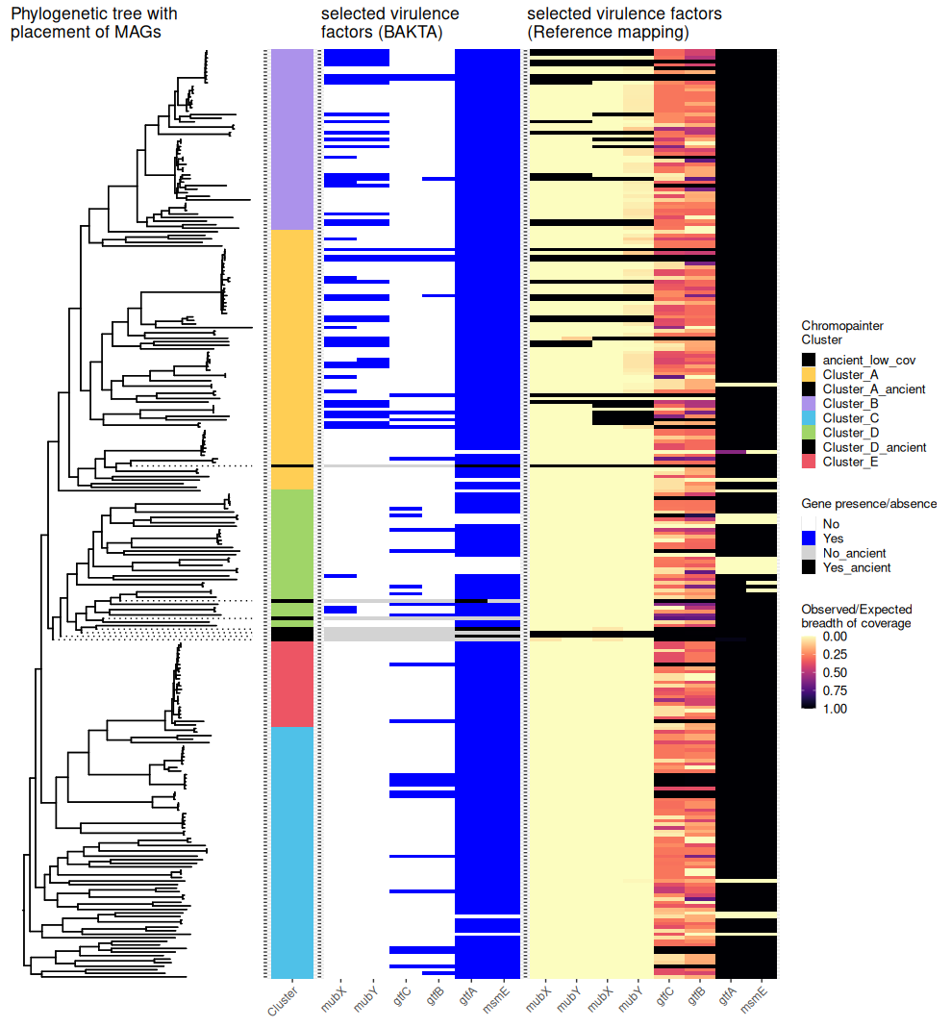

Figure S11: Comparison between reference mapping results and BAKTA annotation for selected genes.
In pangenomics, different methods impart different biases. Reference mapping constraints which genes can be examined by whatever is present in the reference being mapped against, but results derived from reference mapping are generally more trustworthy.
Usually, if a gene can be found through both methods, they will show up in the same pattern, with the general rule that a gene might be missing due to missing gene content in the MAG (msmE).
Other genes might have high genetic variation, which will make it difficult for gene annotators to detect them (gtfC, gtfB). In other cases still, genes might be in regions that make them difficult to be picked up in a MAG, such as if they are present in more copies along the genome (mubX and mubY)
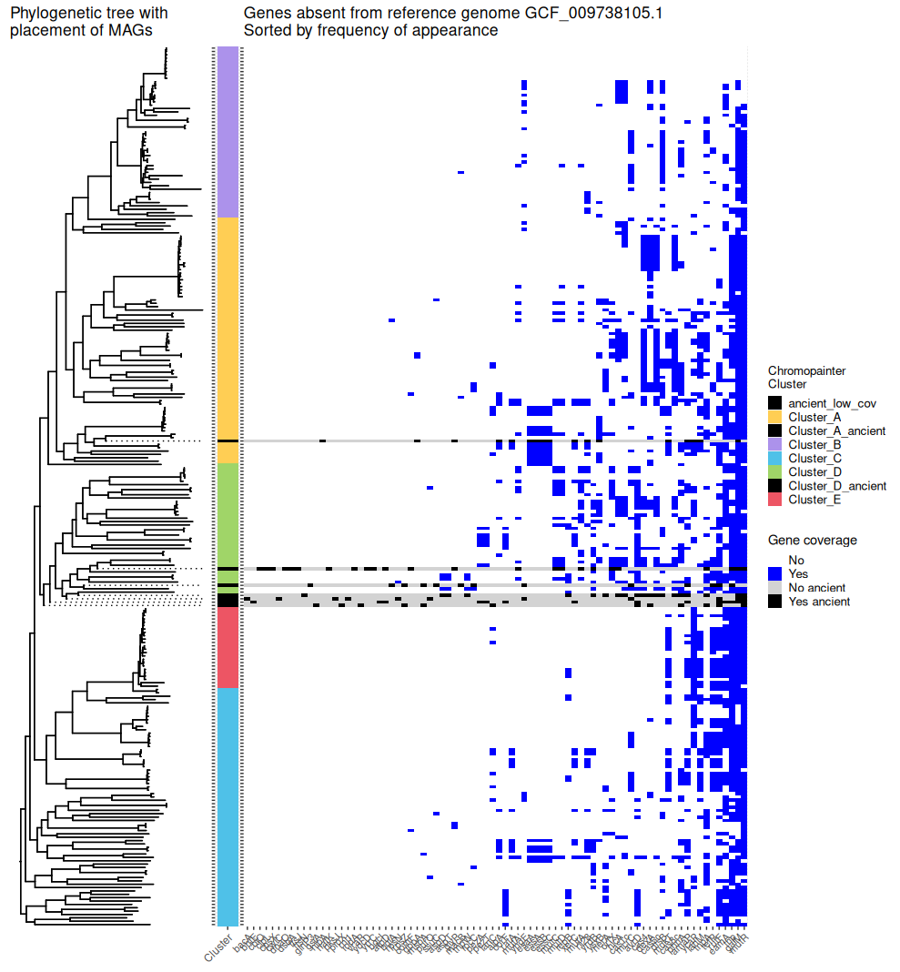

Figure S12. Phylogenetic tree including 3 placements for the ancient samples for which MAGs were assembled, compared with the chromopainter clustering and BAKTA gene annotation.
The BAKTA annotations have been sorted by rarity among the modern isolates and seven MAGs.

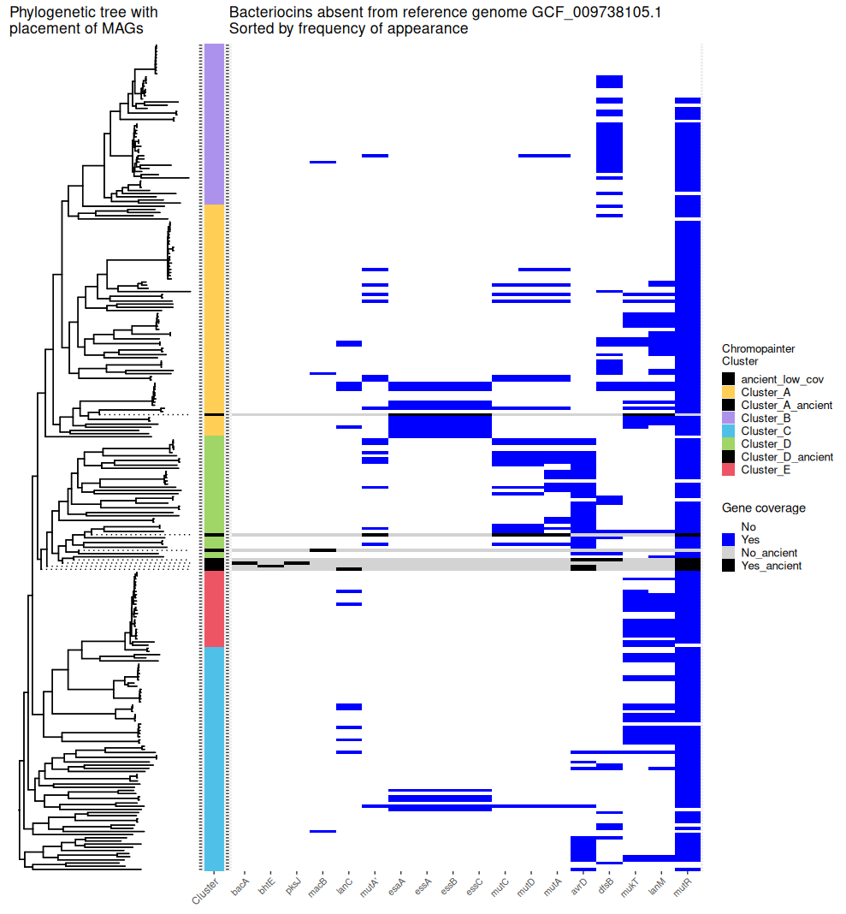
Figure S13. Phylogenetic tree including 3 placements for the ancient samples for which MAGs were assembled, with heatmap showing presence of BAKTA genes described as bacteriocins in (Lemos et al., 2019) not found in the S. mutans reference genome GCF_009738105.1. Every MAG has coverage for at least one of the bacteriocins included here.

