Methodology

Sample processing and library preparation

Total amount of 70-120mg of the drilled tooth or petrous bones have been used for aDNA extraction following (Allentoft et al.2015) in a dedicated aDNA clean room at the Centre for GeoGenetics. Pre-digestion step has been carried out before DNA extraction in order to increase the chance of retrieving more endogenous DNA with less surface contamination (Damgaard et al.2015). To confirm the presence of aDNA damage and fragments, a blunt-end non-user-treated library has been built for each extraction based on (Meyer et al.2010). Two different user-treated library methodologies have been used for the extractions with authenticated aDNA endogenous molecules such as double and single-stranded libraries.
Total amount of 15-20 ul of the extracted has been used to build each dslib while this amount was around 7-10 ul for sslib2.0.
Single-stranded libraries have been mostly used in this case with the purpose of increasing the ancient endogenous yield following (Gansauge et al.2017). Thereafter, qPCR step was carried out on each library to determine the concentration of the fragments that could turn into library fragments and next, they were dual-indexed based on qPCR results. Quality and concentration of library fragments have been measured using a fragment analyser instrument. Finally, Sequencing has been done on each library using Novaseq 6000 by the Danish National High-Throughput DNA Sequencing Centre.

Reference:

1- Damgaard, P., Margaryan, A., Schroeder, H. et al. Improving access to endogenous DNA in ancient bones and teeth. Sci Rep 5, 11184 (2015). https://doi.org/10.1038/srep11184

2- Gansauge MT, Gerber T, Glocke I, et al. Single-stranded DNA library preparation from highly degraded DNA using T4 DNA ligase. Nucleic Acids Res. 2017;45(10):e79. doi:10.1093/nar/gkx033

3- M. Meyer, M. Kircher, Illumina sequencing library preparation for highly multiplexed target capture and sequencing. Cold Spring Harb. Protoc. 10.1101/pdb.prot5448 (2010). doi:10.1101/pdb.prot5448 Medline

4- M. E. Allentoft, M. Sikora, et al. Population genomics of Bronze Age Eurasia. Nature 522, 167–172 (2015). doi:10.1038/nature14507 Medline

##################################################

Context information for the samples:

Afghanistan “CGG105519”

Shahr‐ i Gholgholah

The fortified citadel of Shahr‐ i Gholgholah covers an area of 400mx400m (160.000m²=16ha). It is located on a natural hill in the center of the Bamiyan Valley where the Kakrak Valley joins Bamiyan Valley overlooking the main cliff to the north‐ west. The site of Shahr-i Gholghola, located at 34.82 latitude and 67.83 longitude, is traditionally considered the Islamic capital of the territories of Bamiyan, It is assumed that the city dates to the Islamic Ghurid or Ghaznavid period (11th12th century CE). It is a town in the center of the Bamiyan Valley that sits atop a natural hill rising to more than 2600 m in altitude. It is a strongly fortified city surrounded by several large stone masonry and mudbrick walls. Nowadays, the city has an oval-shaped ground plan and stands on a hill approximately 150m above the average ground level of Bamiyan Valley.

It is at the top of the site, excavation no. 2, at a depth of more than 1 m, under the rubble and layers of collapsed debris, that a pile of human bones was discovered. These were from three incomplete individuals (3 adults and a child). The studied individual, SG18_S01_CH2_SEP, dates back to 1042-1222 CE with 95,4% confidence.

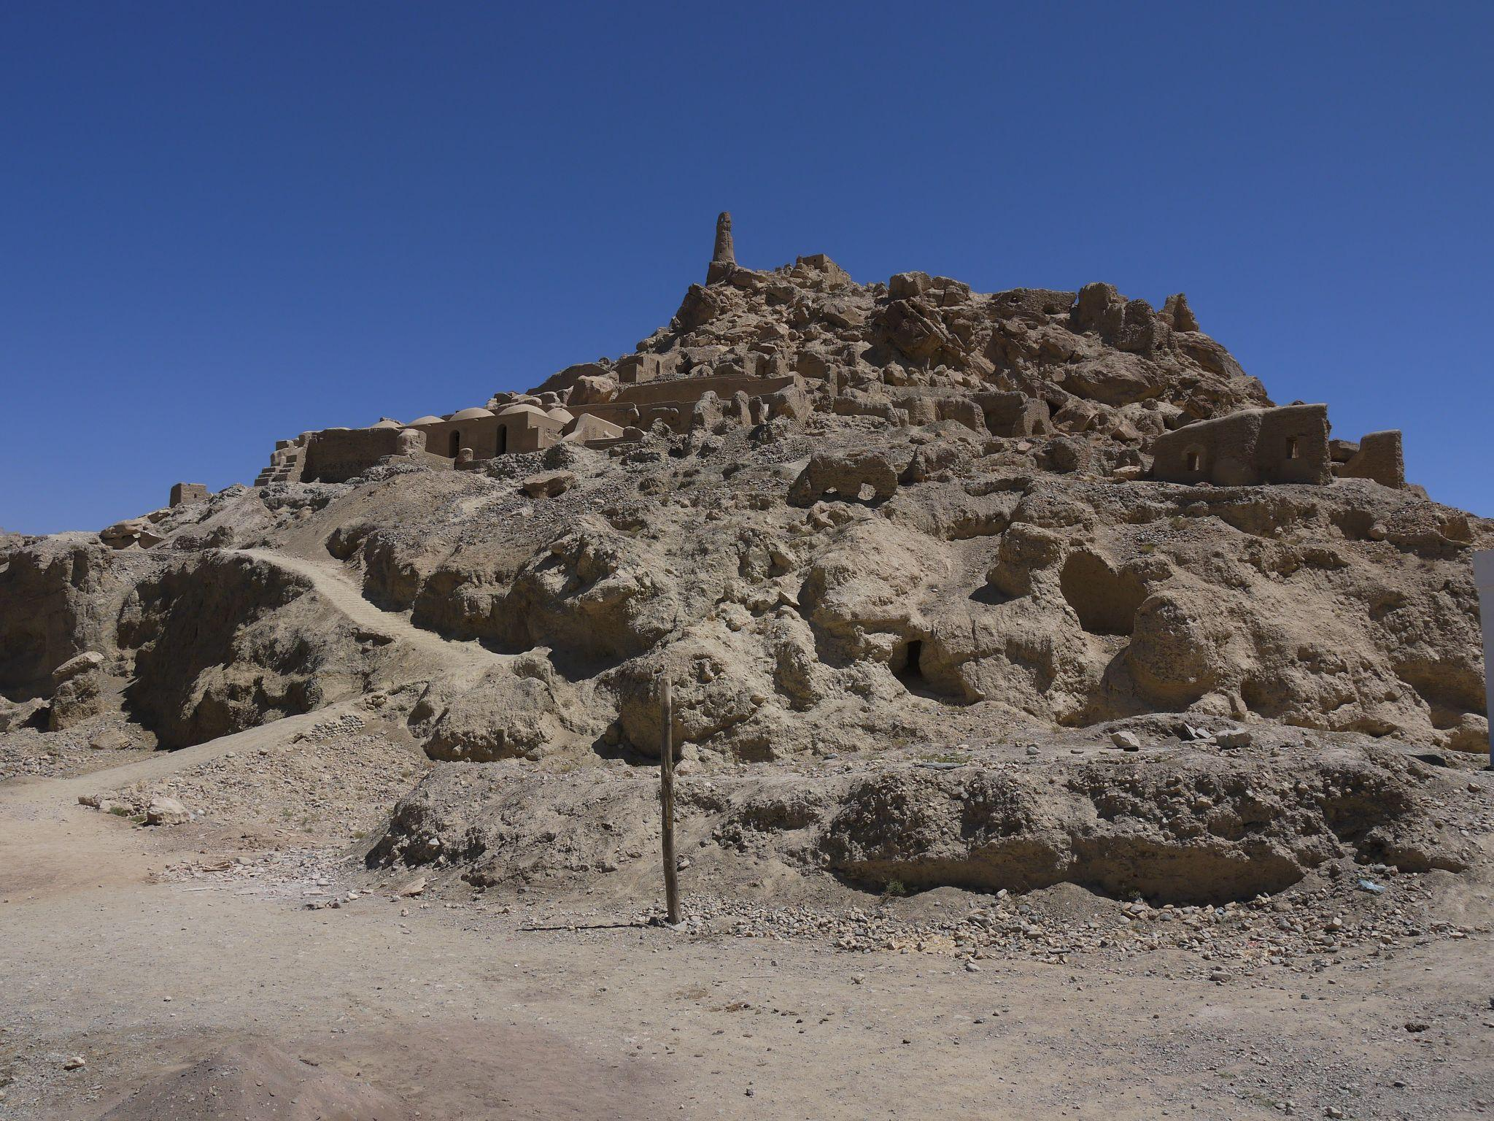
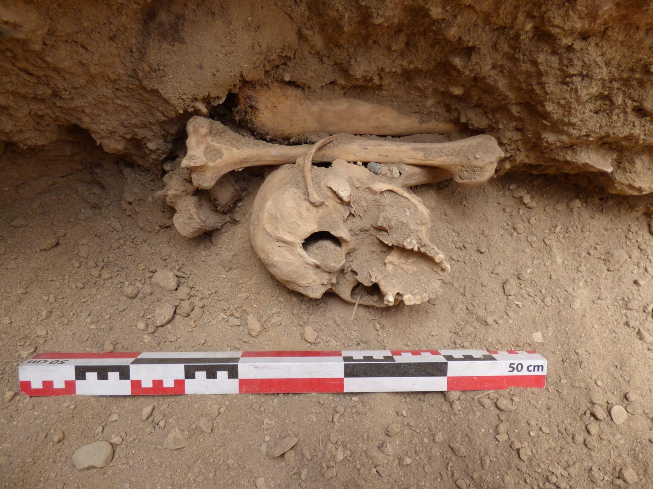

References

Bendezu-Sarmiento (in press), Archaeological Survey and First Preliminary Results of the Site of Shahr-i Gholghola (Afghanistan) – the Bamiyan Valley as a Centre of Trade and Cultural Exchange, Second International Conference on Central Asian Archaeology held at the University of Bern, Switzerland, 13-15 February 2020.

Gardin J.-C., 1957, Poteries de Bamiyan, in Ars Orientalis, vol. 2, p. 227-245.

####################################

Kültepe Sareyn

Kültepe Sareyn is a multi-period mounded site in the Sabalan Mountain highlands, 35 kilometers west of the city of Ardabil. It comprises a mound and a Medieval Islamic Cemetery, located in the western part of the modern city of Sareyn (Figure 1), covering about 2 hectares and rising nearly 15 meters at its highest point (Ebrahimi, 2021). The site is situated atop a natural elevation at geographic coordinates approximately 48.02 longitude and 38.03 latitude. There are nine perennial warm water springs within a distance of less than 500 meters to the east of this site, with varying discharge rates (Мансури-Фар, 2019; Badirzadeh et al., 2011), and the formation of settlements in this region in different eras is due to the existence of this boiling spring from prehistoric times until now. The first season of Kültepe Sareyn excavation was carried out in summer 2019. The initial aim was to expose a stratigraphically defined sequence of occupations at this site and provide a preliminary insight into the cultural sequence of Ardabil Plain.

Kültepe Cultural Sequence

Kültepe Sareyn was first occupied in the Early Bronze Age by Kura-Araxes Communities at the beginning of the early third millennium B.C. The artifacts from this period are recognized by their rounded architecture and Black Burnished and Brown potteries (Ebrahimi, Incoming). Overlying the latest layers of the Early Bronze Age (Kura-Araxes III phase), specific and clear architectural phases from the Late Iron Age period with distinctive huge stone buildings have been established (Ebrahimi, 2021). Seven architectural phases dating back to the Iron Age until the Late antiquity (Sassanid) and Medieval Islamic have been identified in Trench I. Based on architectural developments as well as comparative ceramic studies, the Late Iron Age layers exhibit only a huge deposit. This phase includes a stone architecture constructed with large stone slabs comparable to Late Iron Age defensive settlements in the Ardabil region (Azarnosh and Rezaloo, 2006; Rezaloo, 2007; Pourfaraj, 2017; Hejebri Nobari et al., 2020). With a short gap, this mound was occupied again in the Post-Achaemenid and Sassanid periods, and it is recognized by a type of decorated pottery known as Triangular Ware and the Ardabil Style pottery (Ebrahimi et al., 2020; Dyson, 1999).

Burial 182

This burial represents the last evidence of human settlement from the final phase of the Iron Age at Trench I. The burial pit was simple, and no burial pattern can be inferred for this skeleton (Figure 2). The evidence and the manner of placement of the bone specimens suggest secondary burial practices for this grave, and no cultural materials or burial offerings were found together with the skeleton. The pottery fragments recovered from the layer of this burial (Figure 3) are more comparable to the pottery of Iron Age II and III commonly found in the northwestern regions of Iran, especially in the Ardabil and Qarah Dagh regions (Rezaloo 2007). This individual has been dated to 761-540 CalBC with 95% confidence.

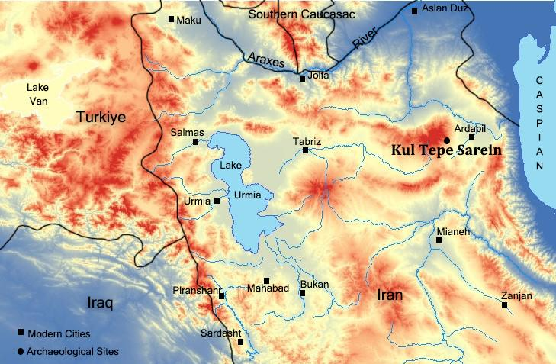
Figure 1: Location of the site

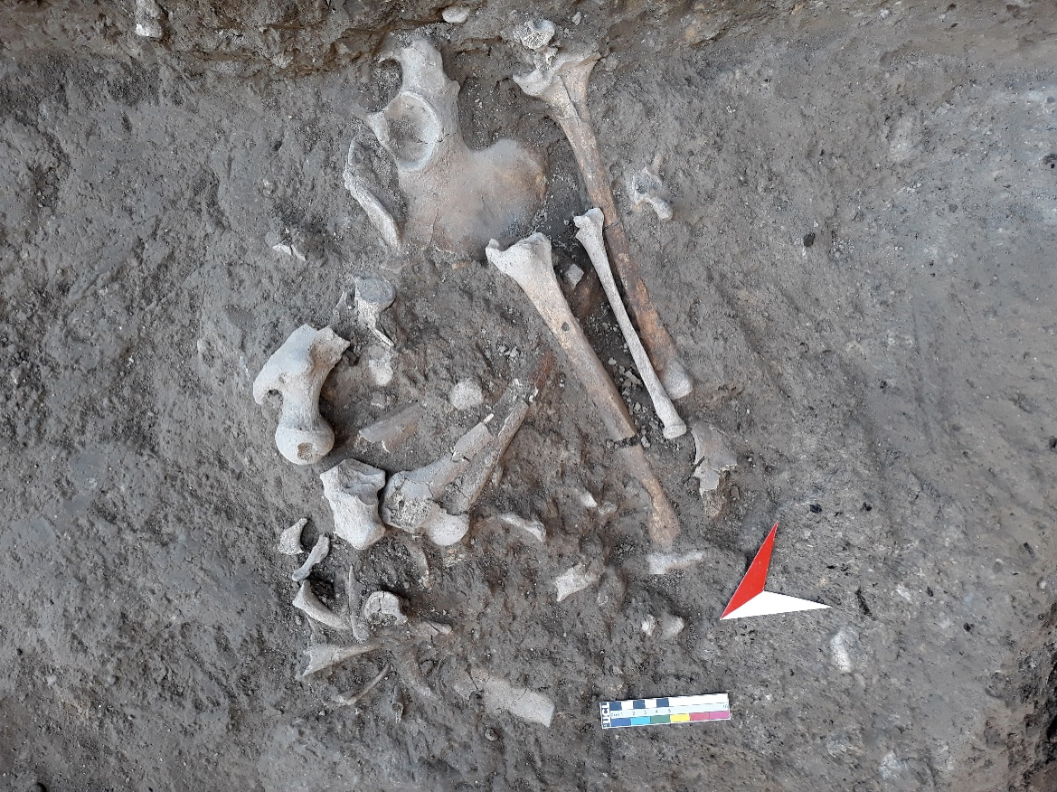
Figure 2: Remains of the disturbed human skeleton, locus 182

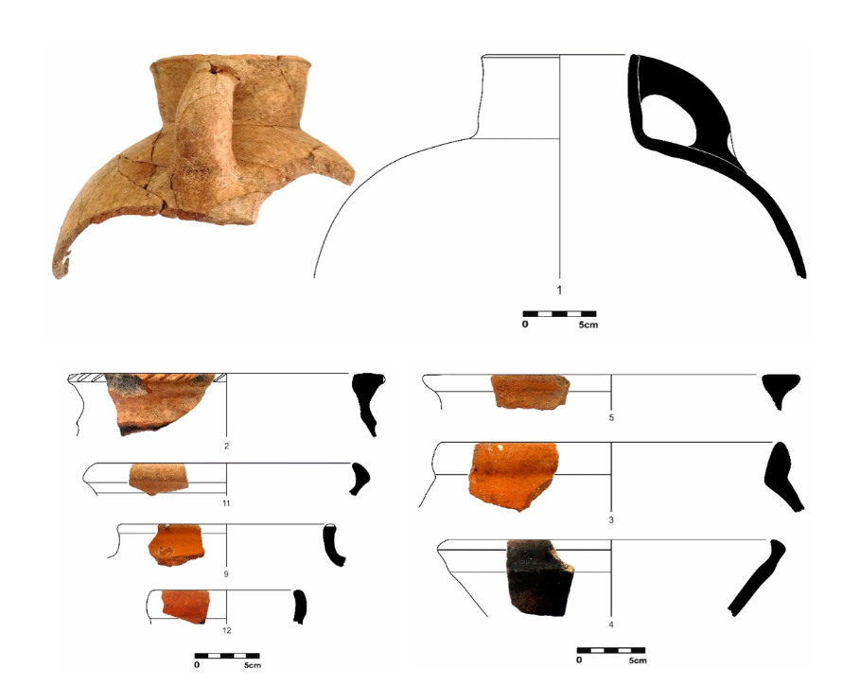
Figure 3: Iron Age pottery from the upper layer of the burial 182

References:

References:
1- Badirzadeh, A., Niyyati, M., Babaei, Z., Amini, H., Badirzadeh, H. and Rezaeian, M., 2011. Isolation of free-living amoebae from Sareyn hot springs in ardebil province, iran. Iranian journal of parasitology, 6(2), p.1-8.
2- Dyson, R.H., 1999. The Achaemenid painted pottery of Hasanlu IIIA. Anatolian studies, 49, pp.101-110.
3- Ebrahimi, Gh., 2021. Kültepe Sareyn (Anahita) Strategraphic Excavation and Sounding Report. In Ruhollah Shirazi (Ed.). 18th Annual Symposium on the Iranian Archaeology. Tehran: Research Institute of Cultural Heritage & Tourism. Pp. 242-245. (In Persian)
4- Ebrahimi, Ghader (Incoming) Excavation at Kül Tape Sareyn: New Light into Kura-Araxes to Iron Age in Ardabil Region, Iranian Azerbaijan.
5- Hejebri Nobari, A., Khanali, H., Yilmaz, A. and Mosavi Kohpar, S.M., 2020. Archaeological analysis and investigations on Shaharyeri in Ardabil province. Journal of Archaeological Studies, 12(2), pp.267-283.
6- Pourfaraj, A., 2017. A Chronological Explanation of The First Millennium BC Cultures of Nir County, Ardebil. Journal of Archaeological Studies, 9(1), pp.37-54.
7- Rezaloo, Reza 2007. The Emergence of Complex Society during Late Bronze Age in Southern Regions of Aras River: Case Study Qalla Khosrow. Ph.D. Thesis in Archaeology, Tehran: Tarbiat Modares University.
8- zarnosh, M. and Rezaloo, R., 2006. Reviewing the Chronology of Northwestern Iran in the Bronze Age, Case Study: Qalla Khosrow. The International Journal of Humanities, 13(3), pp.1-15.
9- Мансури-Фар, С., 2019. Geothermal regime and geochemistryof hot springs in Mount Sabalan (Northwest of Iran). Природные ресурсы, (2), pp.23-33.

