Additional File 4: Manual Refinement
Anvi’o visualization of our ancient MAGs.
Each layer in these circular plots represents a statistics for each contig. The contigs are clustered together in a tree by 4-mer frequencies.
The green layer represents the GC content.
The black layers describe the number of reads from each library in the sample which can be mapped to the contig.
The outermost black layer (damage) describes the average local damage for each read used to assemble this contig as calculated through metaDMG
The familiarity layer is a binary layer which describes whether a gene cluster annotated within the contig can be found in any of the other 6 MAGs through a pangenome analysis before manual refinement is started.
Any contig marked as contaminant is mapped to the NCBI database of genes, to confirm that these cannot be mapped to S. mutans.

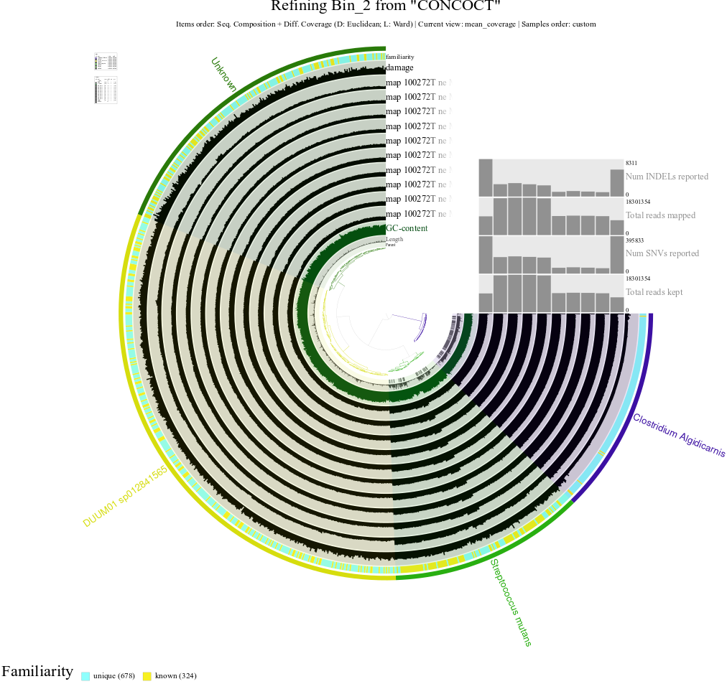
CGG100272: First Iteration

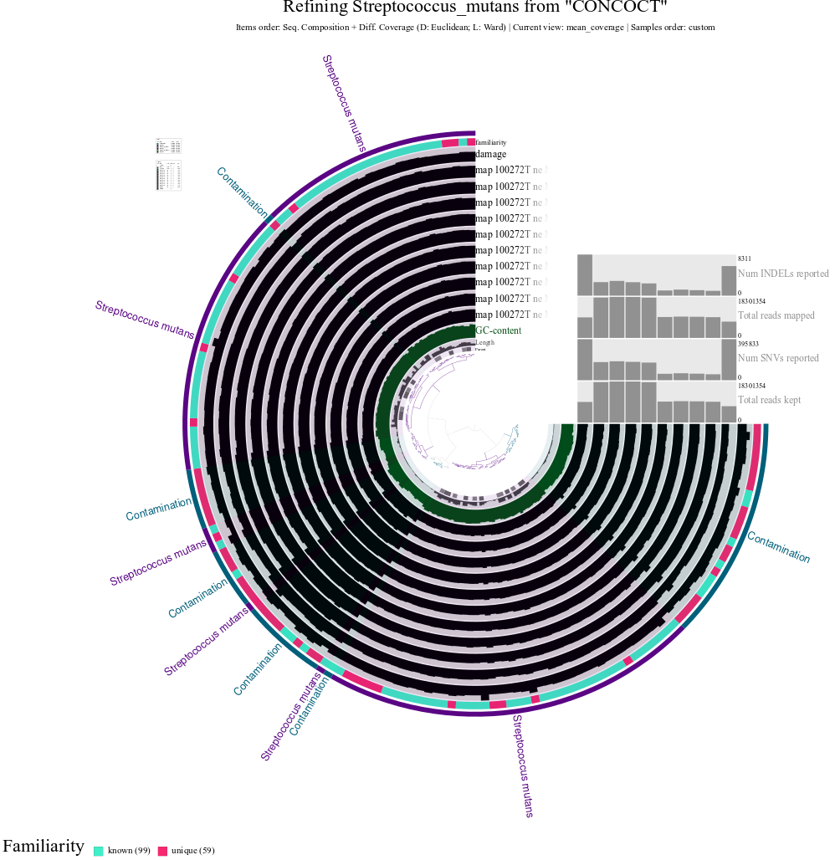
CGG100272: Second Iteration

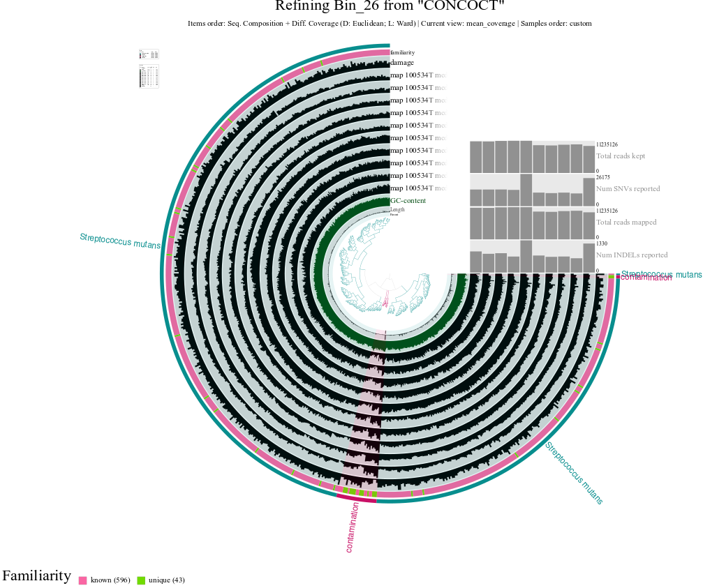
CGG100534

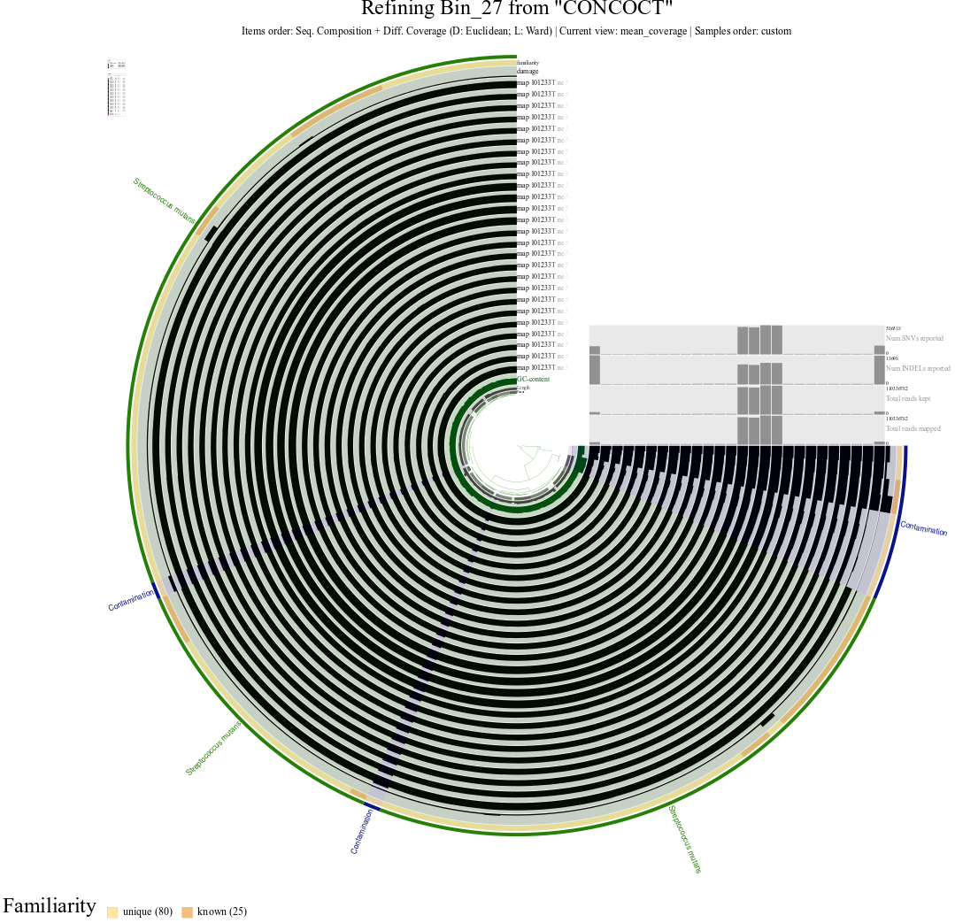
CGG101233

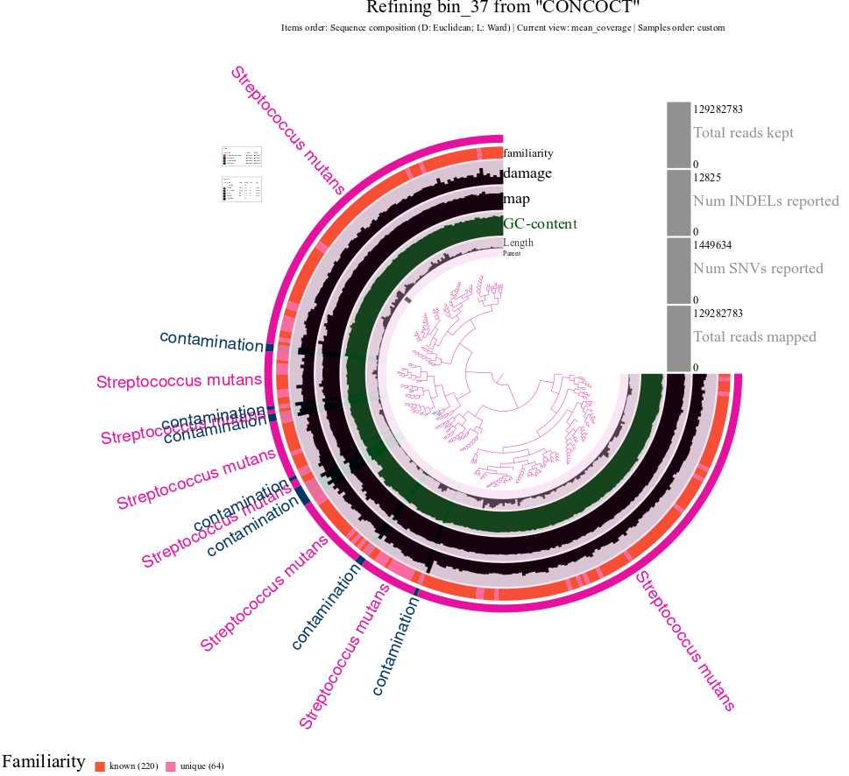
NEO105

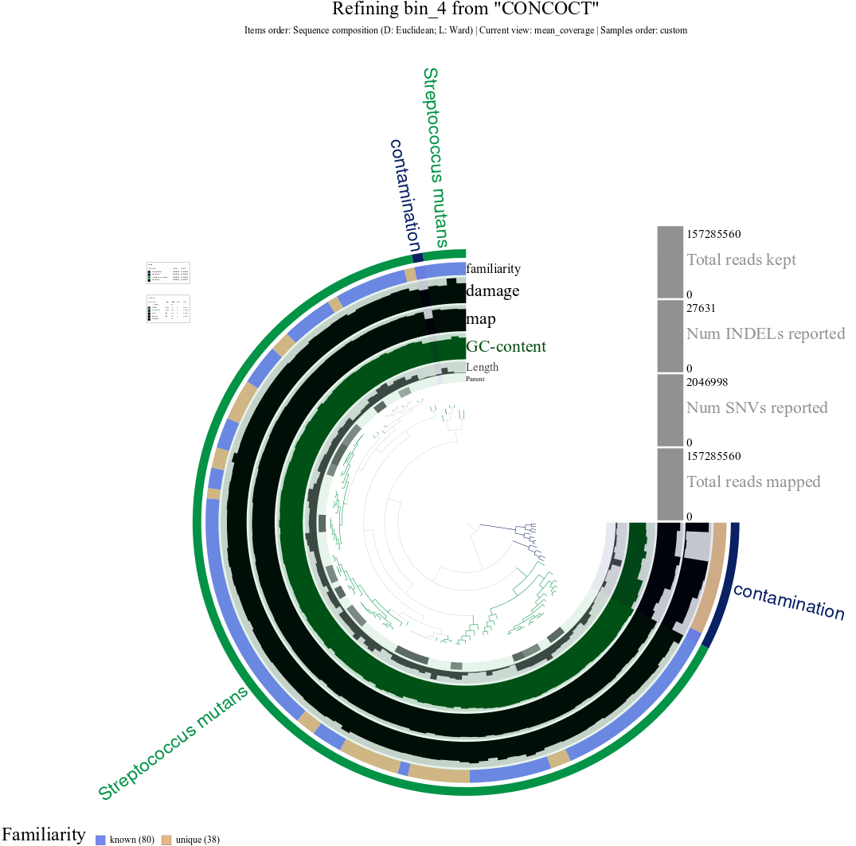
NEO137

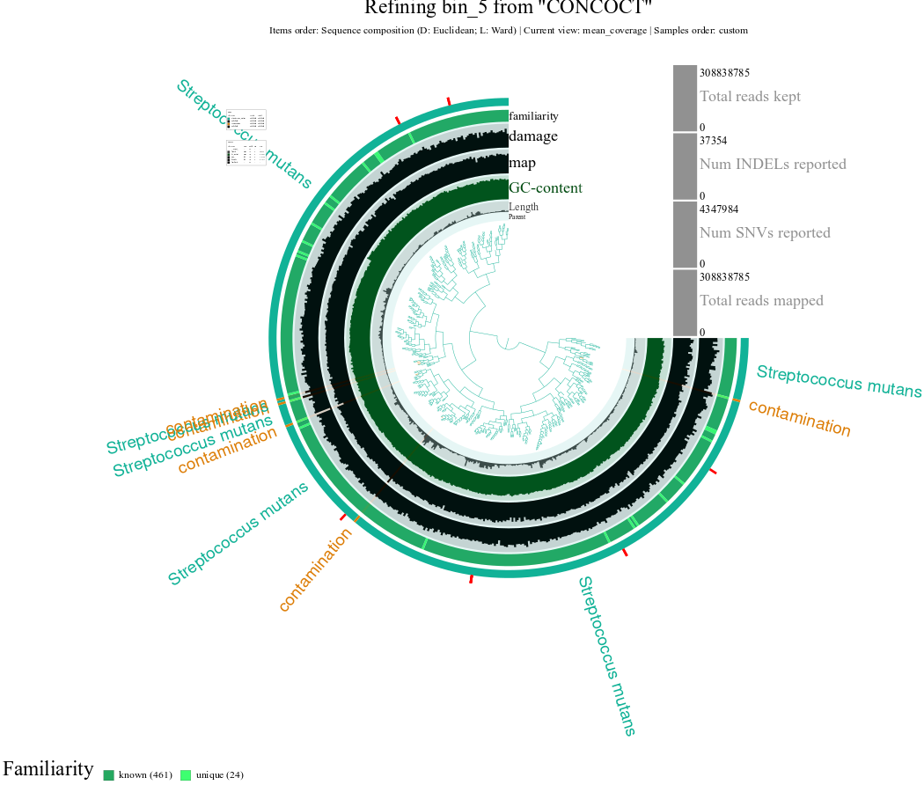
NEO938

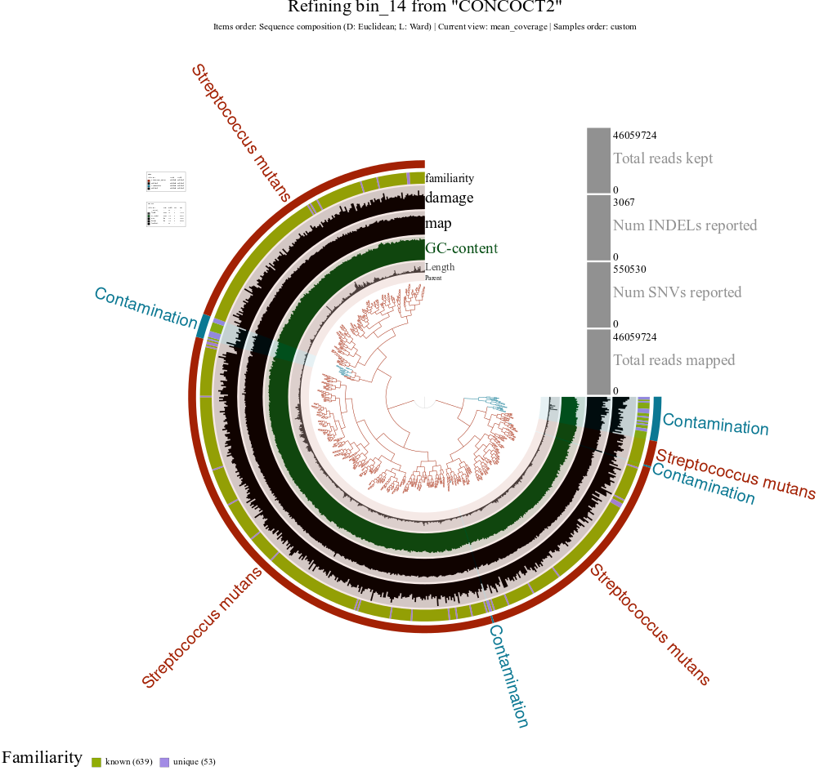
VK63

