Supplementary material – Quantification of fructans in bioethanol stillage based on a simplified analytical method, Zimmermann et Kaltschmitt

Choice of HPLC column. All used columns within the scope of this study were purchased from Agilent and belong to the Hi-Plex series (length 300 mm) with the respective stationary phases. The applied HPLC method parameters (eluent, flow rate, column temperature) were adjusted based on the manufacturer’s standard conditions. In case of promising stationary phases, the HPLC conditions were additionally varied in terms of column temperature and flow rate with the aim of maximising the peak resolution of the monosaccharides. If permitted by the manufacturer, the eluent composition was varied as well and modifies such as acetonitrile were used. However, changes in column temperature and/or flow rate have not led to significant improvements of the peak resolution in case of the tested columns. Drawbacks like coelution of monosaccharides may slightly differ from manufacturer to manufacturer. However, spot checks of other manufactures (e.g. Bio-rad Aminex, Knauer Eurokat) revealed these drawbacks to be generally stationary phase related.

Table 1 shows the fructan content depending on the hydrolysis time for constant sulphuric acid concentration and temperature confirming the numerically determined optimum as a maximum is obtained at 80 min hydrolysis time.
Table 1 Measured fructan content in stillage for varying hydrolysis times with 0.25%(wt) H₂SO₄ at 100 °C.
Time | Fructan content
min | %DM
70 | 2.87
80 | 2.92
90 | 2.87
100 | 2.86
110 | 2.84

Figure 1 shows a chromatogram confirming (almost) full hydrolysis of commercial inulin and fructooligosaccharides (FOS) as no significant amounts of polymers are left after hydrolysis.

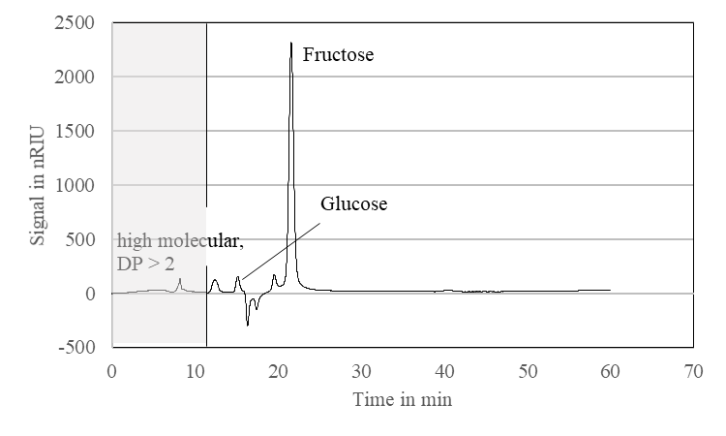 | 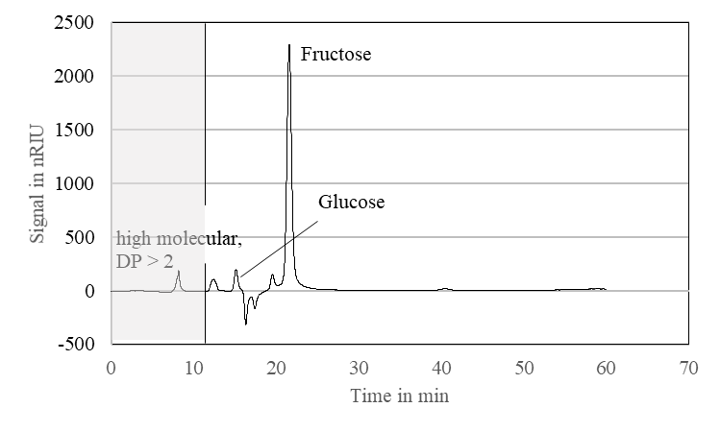
Figure 1 Hydrolysis of inulin (l.) and fructooligosaccharides (r.) using 0.25%(wt) H₂SO₄ at 100 °C for 80 min.

The limit of detection (LOD) and the limit of quantification (LOQ) are calculated according to the following equations (NATA Technical Note 17, National Association of Testing Authorities, Australia, 2013).

$LOD=3.3∙\frac{s_{RG}}{m_{RG}}$ and respectively $LOQ=10∙\frac{s_{RG}}{m_{RG}}$
in which s_{RG} is the standard error of the response and m_{RG} is the slope of the regression curve.

This LOD and LOQ value has been averaged over regression curves determined as triplicate. For the monosaccharides a LOD of 0.13 ± 0.3 g/l and a LOQ 0.38 ± 0.1 g/l is obtained and thus these are the respective limits of this method.

Figure 2 shows the hydrolysis of starch (ca. 10 g/l) using the optimised hydrolysis conditions. It can be concluded that the released glucose is below the detection limit and thus starch degradation can be neglected under these conditions.

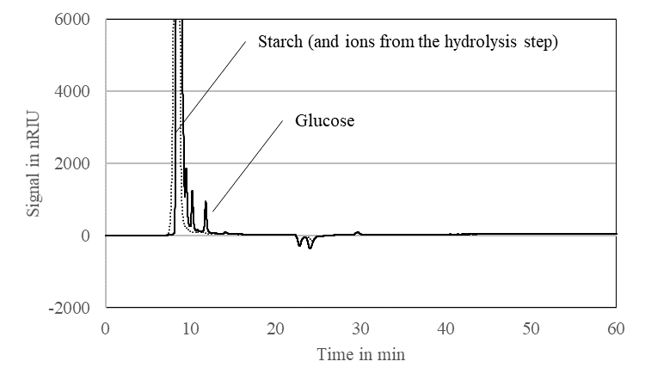 | Figure 2 Degradation of starch (ca. 10 g/l) under the optimised conditions: 0.25%(wt) H₂SO₄, 100 °C, 80 min. Starch (dotted line), hydrolysed starch (solid line). Analysis via Hi-Plex H, 60 °C, 0.5 ml/min 5 mM H₂SO₄ with RID 55 °C

Figure 3a shows exemplary chromatograms for the release of xylose and arabinose next to fructose and glucose both on the H column and on the Pb column. Figure 3b shows the chromatographic separation of the monomeric sugars using both columns.
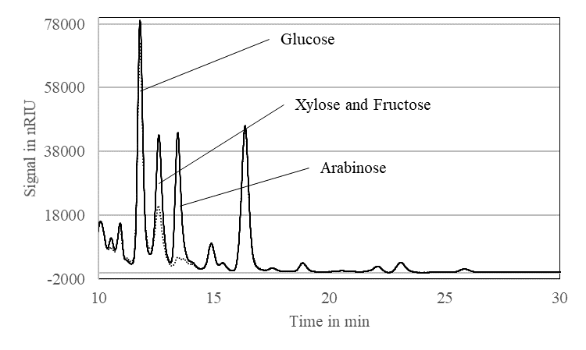 | 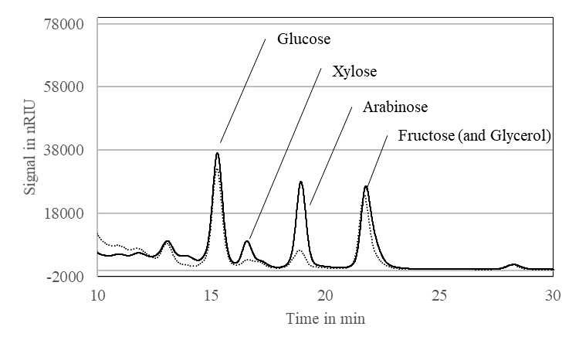
Figure 3a Release of glucose, fructose, xylose and arabinose from stillage using the optimised hydrolysis conditions: 0.25%(wt) H₂SO₄ at 100 °C for 80 min and subsequent neutralisation with CaCO₃. Corresponding chromatograms before (dotted lines) and after hydrolysis (solid lines) using Hi-Plex H, 60 °C, 0.5 ml/min 5 mM H₂SO₄ with RID 55 °C (l.) and Hi-Plex Pb, 80 °C, 0.6 ml/min H₂S with RID 55 °C (r.). Details from respective chromatograms.

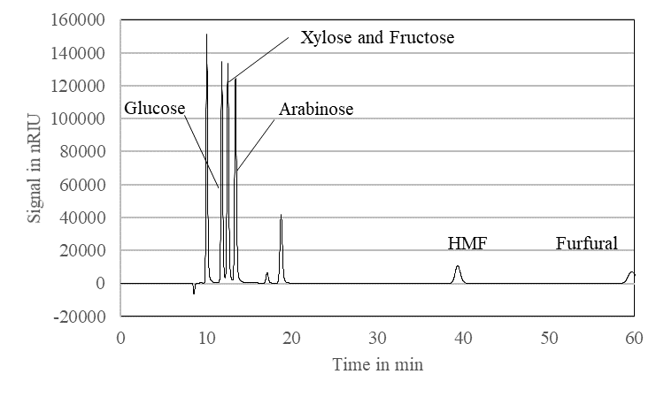 | 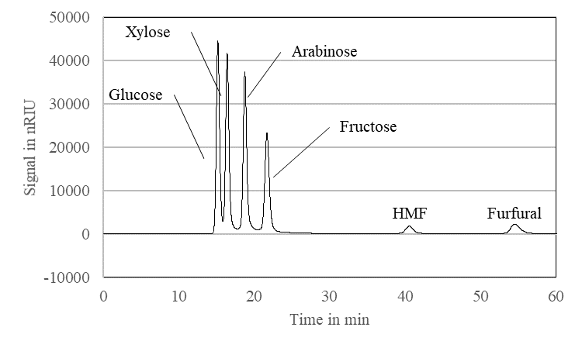
Figure 3b Standards of glucose, fructose, xylose and arabinose separated on a Hi-Plex H column, 60 °C, 0.5 ml/min 5 mM H₂SO₄ with RID 55 °C (l.) and a Hi-Plex Pb column, 80 °C, 0.6 ml/min H₂S with RID 55 °C (r.).

Table 2 shows severity factors calculated from fructan hydrolysis conditions reported in literature. For the corresponding references please refer to the original publication.
Table 2 Comparison of different fructan hydrolysis conditions for analytical purpose with regard to severity factor
Literature | Acid | Concentration | Unit | Concentration | pH | Temperature | Time | Log₁₀(R0) | Log₁₀(R0")
- | - | - | - | mol(H⁺)/L | - | °C | min | - | -
Zimmermann et Kaltschmitt | H2SO4 | 0.25 | %(wt) | 0.051 | 1.3 | 100 | 80 | 1.9 | 7.6
Nguyen2009 | H2SO4 | 0.2 | %(wt) | 0.041 | 1.4 | 121 | 60 | 2.4 | 8.0
Liu2011 | HCl | 150 | mM | 0.15 | 0.8 | 80 | 90 | 1.4 | 7.5
Liu2014 | HCl | 1 | M | 1 | 0.0 | 90 | 60 | 1.5 | 8.5
Verspreet2012 | HCl | 60 | mM | 0.06 | 1.2 | 70 | 90 | 1.1 | 6.9
Michel-Cuello2008 | H2SO4 |  |  |  | 1.0 | 80 | 120 | 1.5 | 7.5
Maharjan2017 | H2SO4 | 0.04 | M | 0.04 | 1.4 | 80 | 120 | 1.5 | 7.1
 |  |  |  |  |  |  |  | Mean | 7.6

